**AWS Solutions Architect**

1. Should be able to design a architecture which are highly resiliant, fault tolerance, cost efficient, security, achieve operational excellence etc
2. Get maximum performance from the architecture
3. Takes high level business and custom requirement and turns those into architectureal design which follows best architecture
4. Besides designing the solution, AWS architect is expeted to be an ongoing resource for the deployment and operation of the infrastructure
5. Make sure the best pratcies are followed throughout the life cycle of the project

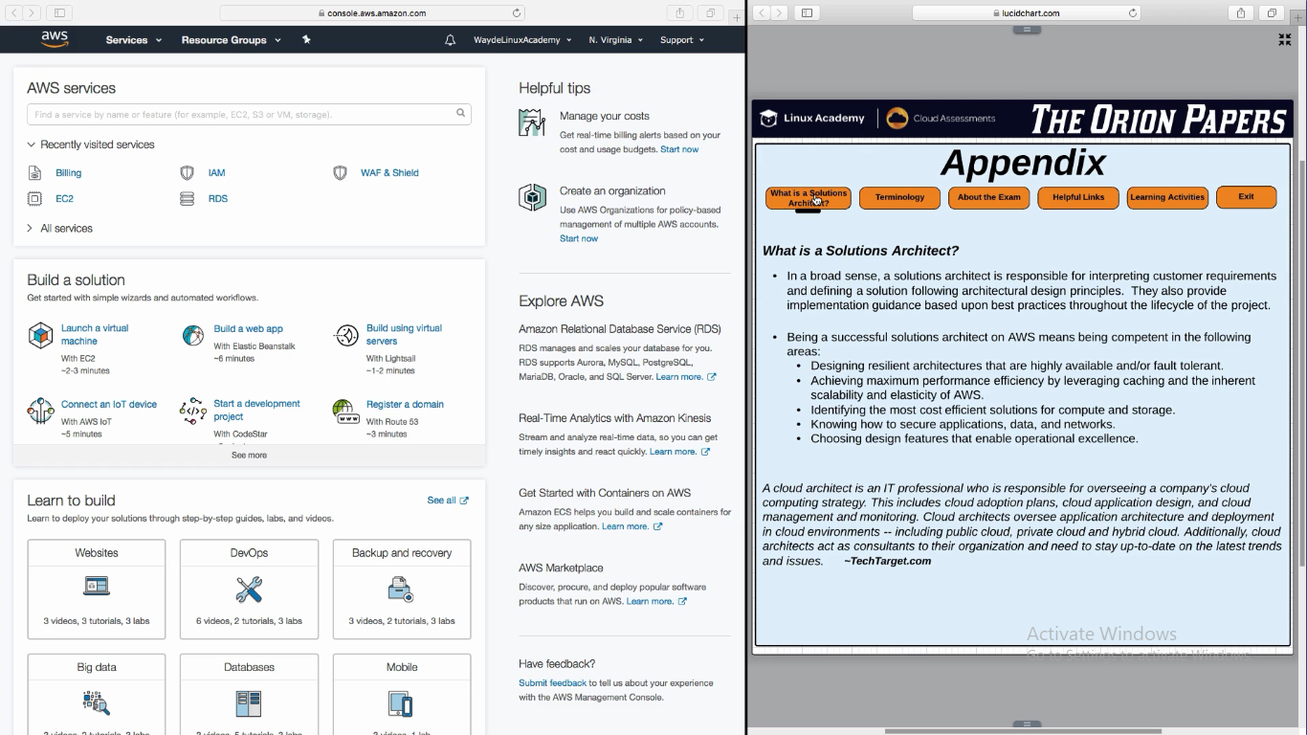

**Well Architected Framework**

To be a successful solutions architect, we have to follow AWS well architected framework features

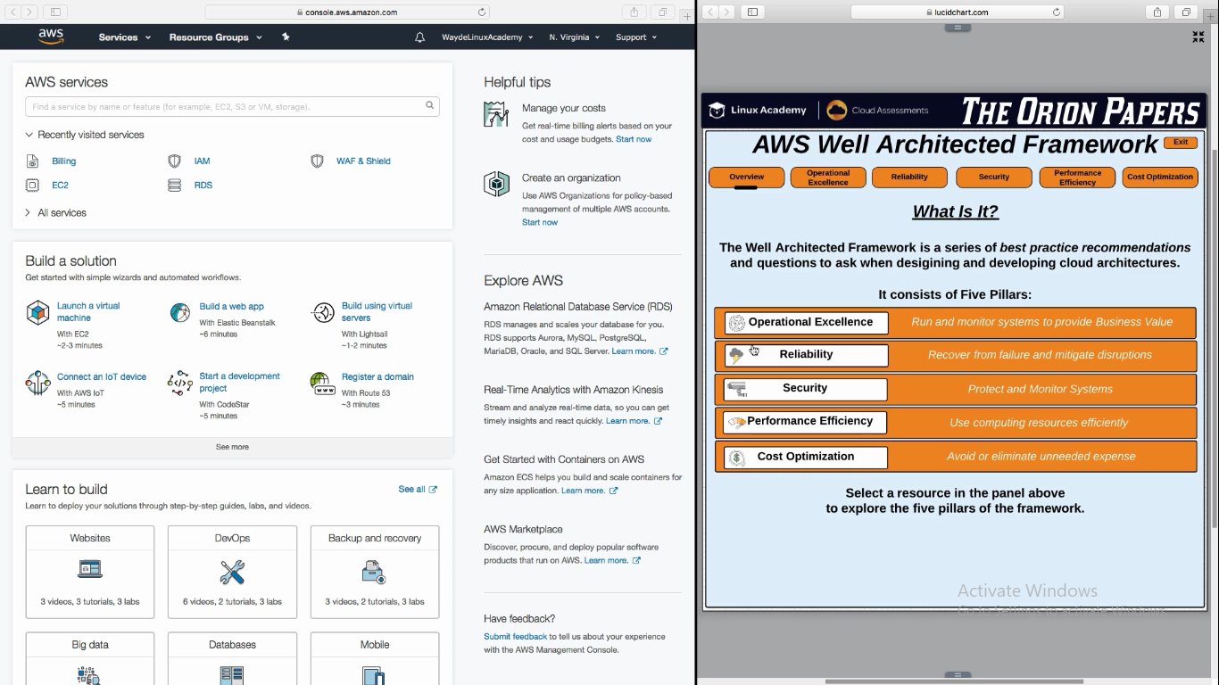

**5 pillars in AWS Well Architected Framework:**

**Operation Excellence**

1. Monitoring, logging and using that information for business value
   1. Understanding how much load in system, when is peak load, any adjustment need to be done in original architecture based on monitoring metrics
2. **Reliability**
   1. Creating highly available and fault tolerance architecture. If a component failure, system failure, or entire region failure, application will stay available or recover quickly
3. **Security**
   1. Encryption, in transit encryption and at rest limiting access to sensitive data or application
4. **Performance**
   1. Efficience of compute resource. Make sure we have correct size or cpu and instances running at all time
5. **Cost**
   1. Identify areas to trim cost
   2. Dev can have lots of AZ or it should have only for prod? Decide on the need or resources