Installing Docker in windows7:

As mine is windows 7, it does not have vdi virtual box support. Hence I used docker Toolbox for installation. It is a customized docker installation which includes virtual box installation.

Windows 10, can use docker for windows installer

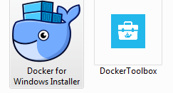

Docker is dependent on below two things.
- OS should have VM support feature. Virtual box utility
- OS should have network adapter utility to establish connection from OS where we install docker to the container which are going to run

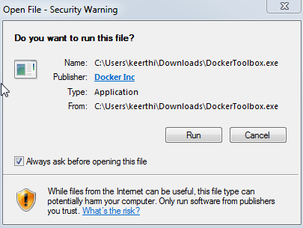

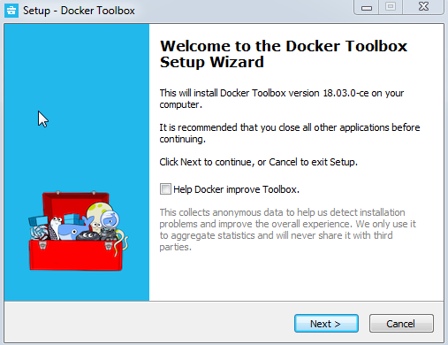

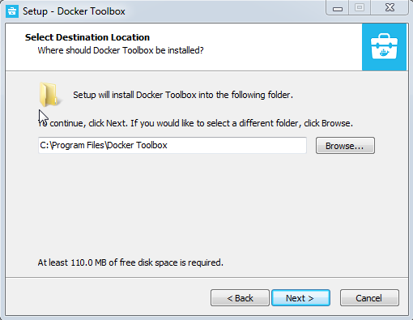

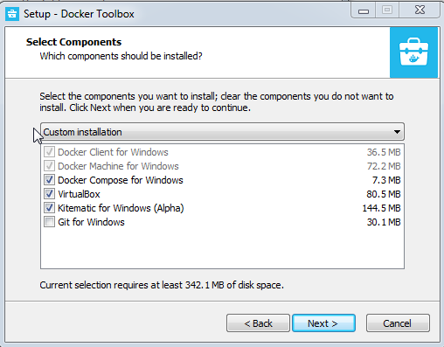

Windows 7 does not have virtual box support feature. In below screenshot I am purposefully avoiding virtualbox installation to see what error occurs
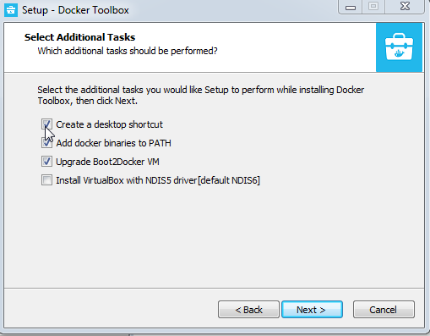

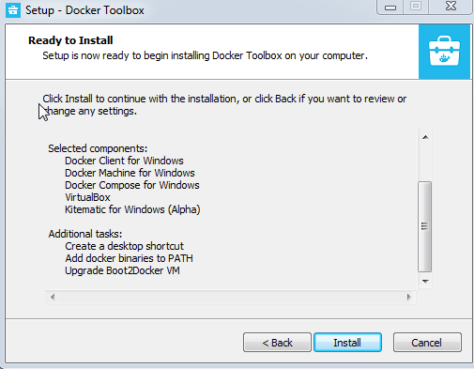

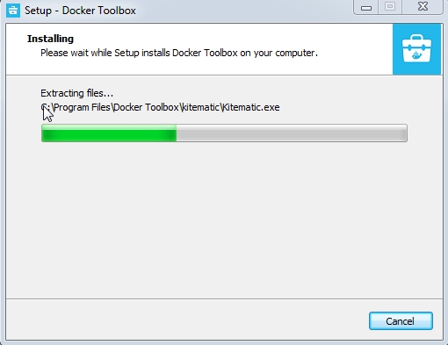

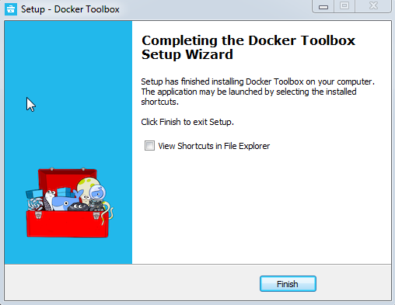

Click on below icon to go to docker command line terminal. Or you can open any cmd, cygwin, poweshell window etc and use docker commands
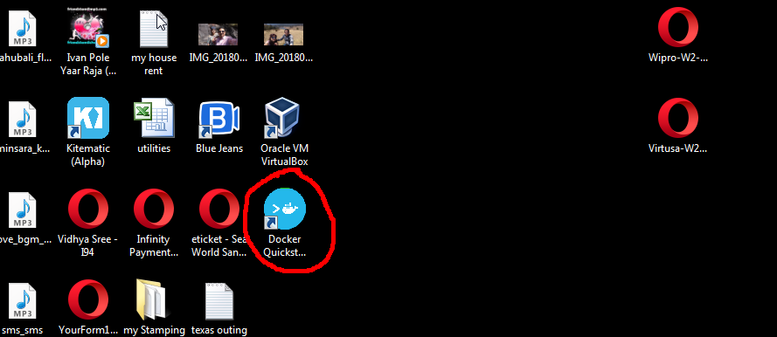

It throws below error as we dint choose virtual box option

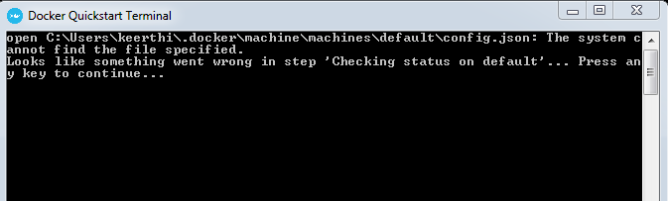

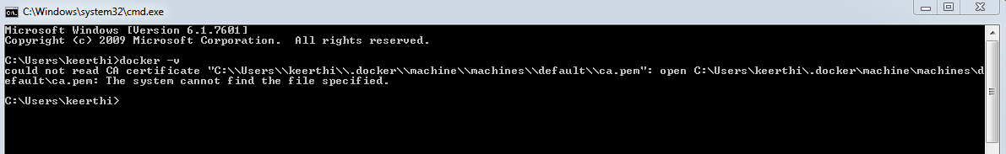

Re-installed without uninstalling (1)
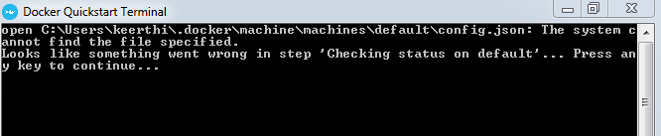

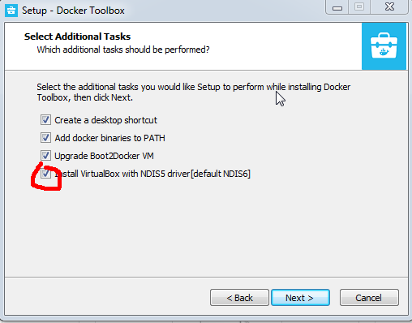

Even after re-installing virtualbox, I got same error as in (1). Reason is in next screenshot.
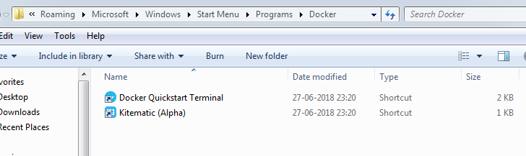

Kill these three services and try to access docker in terminal
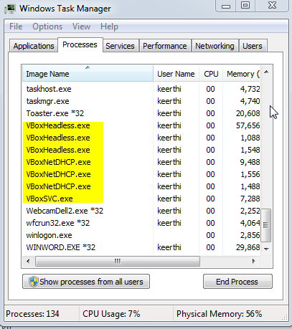

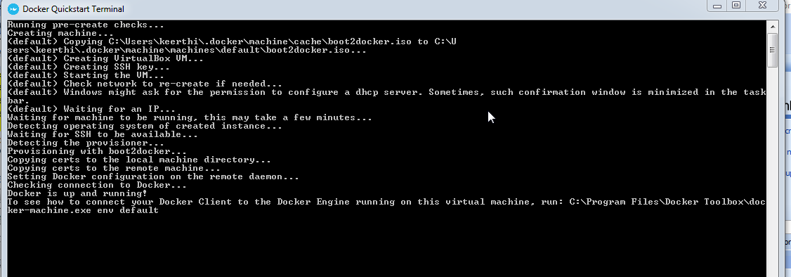

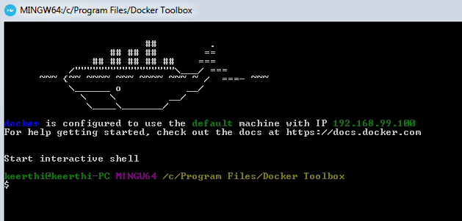

We are good and IP remains same on each docker startup for this windows 7 server.
Downloading ubuntu container

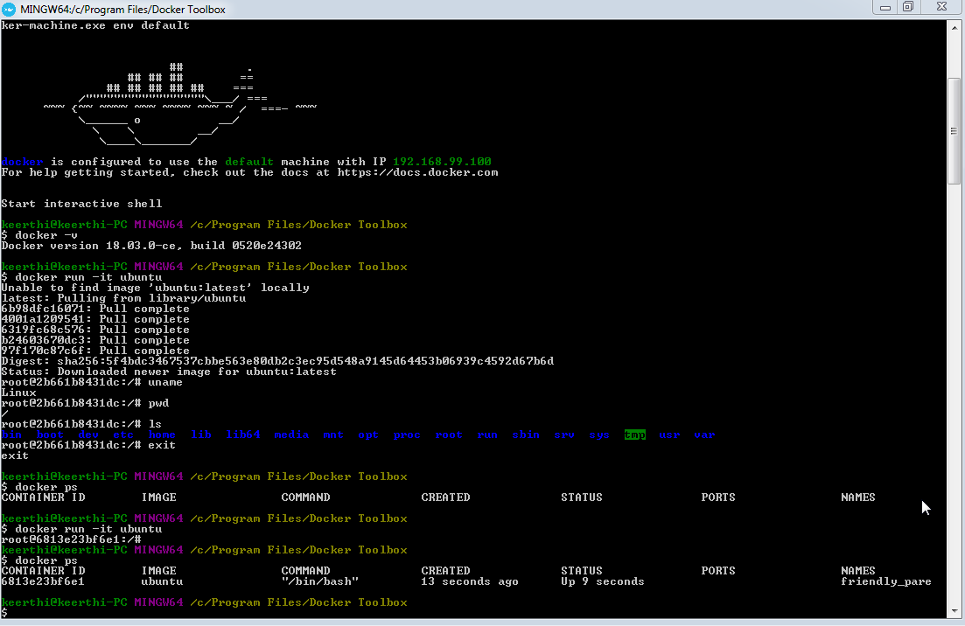

Opened ubuntu container in three terminals. Hence I can see same ubuntu container having three instances. (docker ps)

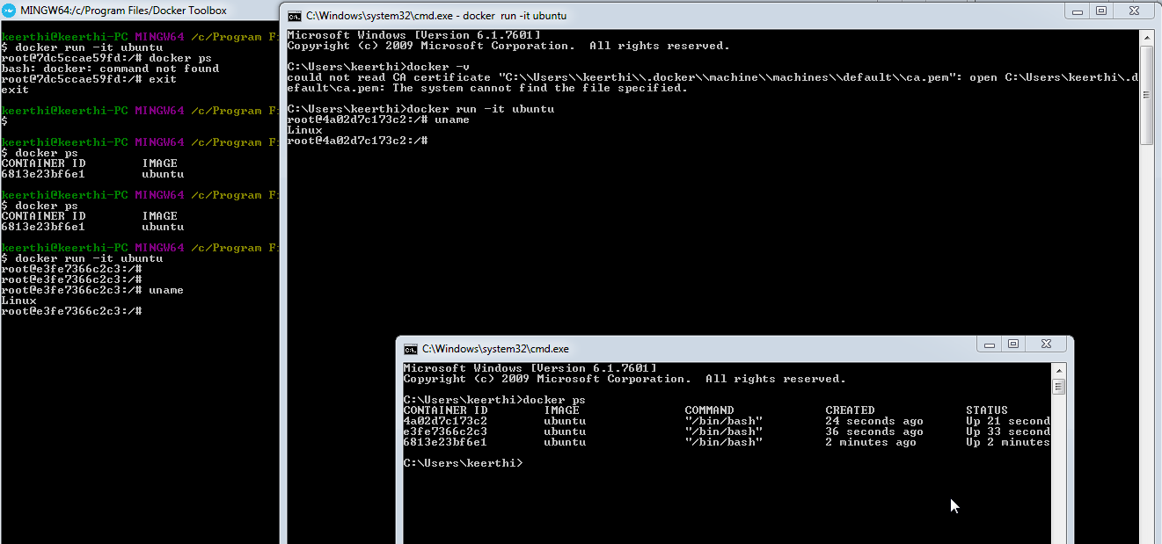

Each container session has its default name
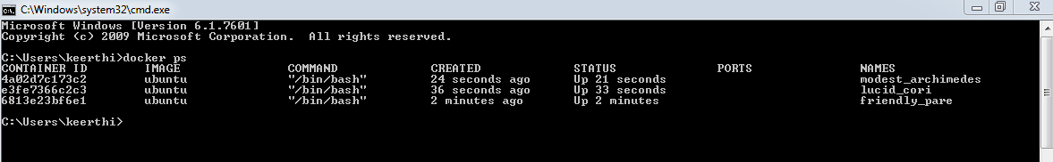

Killing a container session with its default name
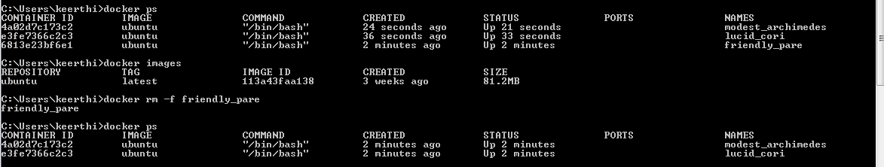

Assiging a name to a container
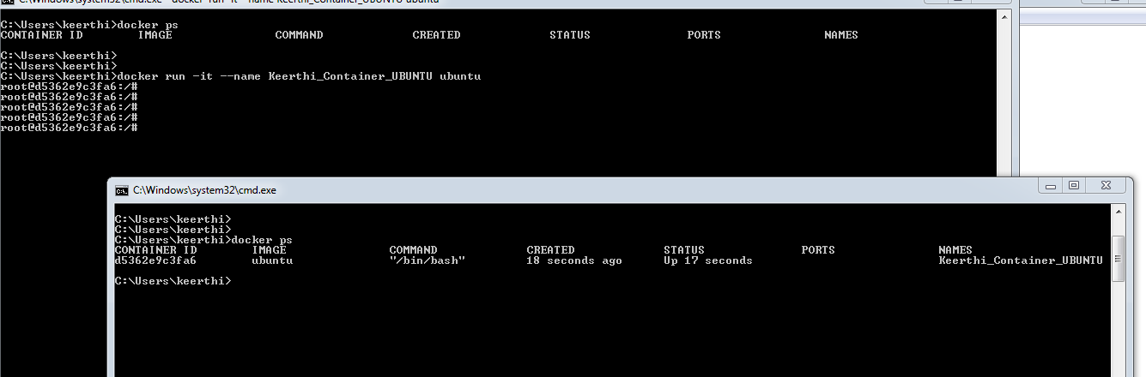

Trying to remove a image, when its container session is running.
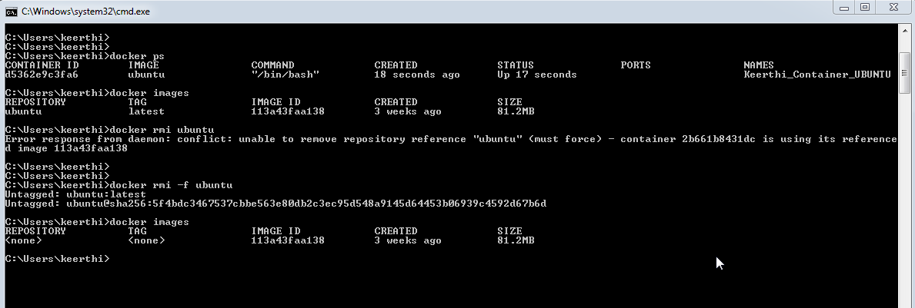

Tasks:
======
1. Install jenkins in your laptop. Capture steps, errors, solutions with screenshot
2. Install git in your laptop. Capture steps, errors, solutions with screenshot
3. Install docker in your laptop. Capture steps, errors, solutions with screenshot
a. Architecture and basics of Docker
b. Try to install docker in various OS and capture steps, errors, solutions with screenshot
c. Try docker basic commands learnt in session one - 16-June-18
d. Explore these commands and its attributes: docker run, docker ps, docker images, docker rm, docker rmi
Session 2 Plan:
===============
1. Share ur experience about 3a,3b,3c.3d - Each person 10 min
Docker Installation Dependencies:
=================================
1. OS should support VDI - Virtual box. By default not avaialble in Windows 7. Available in windows 10
2. OS should support network adapter. This is to establish connection to the docker container and OS
Check docker version:
=====================
docker -v
Docker version 18.03.0-ce, build 0520e24302
Command to install ubuntu container:
====================================
docker run -it ubuntu
-i = interactive
-t = terminal allocation to server
End of this command, will take us to ubuntu containter cmd prompt
Give a name to the container:
=============================
docker run -it --name ubuntu-container-APP1 ubuntu
If we dont give a name and start the container, docker itself will assign a name
To exit a container and come out:
=================================
ctrl P + Q
container will still be running in the background
type exit
container will no more be running after executing above command
(or call below command out side the container - from any other window)
docker rm -f <docker name>
docker rm -f ubuntu-container-APP1
To see running container:
=========================
docker ps
It will list all the container which are currently running
To see all docker images installed:
===================================
docker images
It will list all available docker images desipite they are not running.
To remove a container:
======================
docker rmi -f <container name>
docker rmi -f ubuntu
docker rmi -f hello-world
(or)
docker rmi hello-world

