**To run Jenkins in multiple ports from one image**

**(Or)**

**Running an application in multiple containers from one image**

1. Download and save the attached Dockerfile. Go to that directory and run below cmd.

docker build –t jenkinsms .



**Content of Dockerfile:**

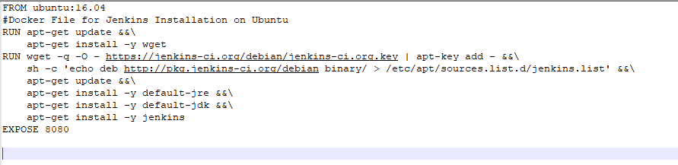

1. It will download Ubuntu
2. Apt-get update to update the available packages
3. Install wget (needed for downloading Jenkins key for Ubuntu)
4. Install Jenkins in Ubuntu
   1. Download jenkins key
   2. Add the key
   3. Make entry in Jenkins.list file
5. Install jre
6. Install jdk
7. Install Jenkins
8. Expose Jenkins to port 8080
9. Highlighted the created image

E:\ubuntu>docker images

REPOSITORY TAG IMAGE ID CREATED SIZE

jenkinsms latest a17e80bf1dbc About a minute ago 580MB

ubuntu 16.04 5e8b97a2a082 4 weeks ago 114MB

ubuntu latest 113a43faa138 4 weeks ago 81.2MB

alpine latest 3fd9065eaf02 5 months ago 4.15MB

1. Run the image in port 2222

docker run –it –name jenkins1 –p 2222:8080 jenkinsms

1. In the jenkins1 container start Jenkins

Service start Jenkins

root@a6f90a652ad3:/# service jenkins start

Correct java version found

* Starting Jenkins Automation Server jenkins [ OK ]

root@a6f90a652ad3:/#

1. Open internet explorer in browser. Type below url and we should see Jenkins page

<http://localhost:2222>

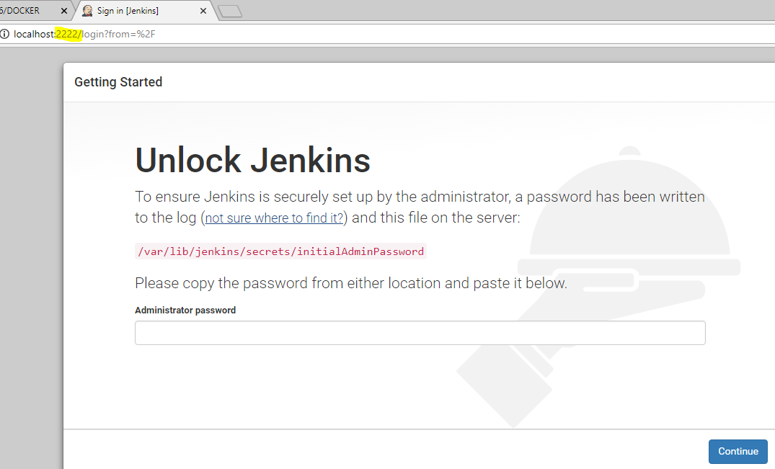

1. Repeat step 6 and run it in 3333 port. Start Jenkins and access Jenkins in http://localhost:3333 port.
2. Execution_log.txt attached of above steps



**Task:**

1. Write Jenkins file to download Jenkins in aix/linux/windows
2. Start and stop docker service in windows/linux
3. What is docker-machine restart ?
4. What is com.docker.service in windows?
5. How to start/stop Jenkins service in windows gui
6. Explore docker build arguments
7. How to stop/restart/remove a container
8. Why highlighted below error occurred? What is the solution?

C:\Users\keerthi>docker run -it -p 5555:8080 jenkinsms

docker: Error response from daemon: driver failed programming external connectivity on endpoint competent_shannon (f1d58d3536de50ed51de107ffb3ae53f67b3cafd21118effdf7f1b0e24370ae8): Error starting userland proxy: mkdir /port/tcp:0.0.0.0:5555:tcp:172.17.0.2:8080: input/output error.

C:\Users\keerthi>docker images

error during connect: Get http://%2F%2F.%2Fpipe%2Fdocker_engine/v1.37/images/json: open //./pipe/docker_engine: The system cannot find the file specified. In the default daemon configuration on Windows, the docker client must be run elevated to connect. This error may also indicate that the docker daemon is not running.

C:\Users\keerthi>

1. In below scenario, why highlighted error occurred? What is the solution?

C:\Users\keerthi>docker ps

CONTAINER ID IMAGE COMMAND CREATED STATUS PORTS NAMES

8018f1926c5e 5e8b97a2a082 "/bin/bash" 11 minutes ago Up 11 minutes 0.0.0.0:6060->8080/tcp tet

C:\Users\keerthi>

C:\Users\keerthi>

C:\Users\keerthi>docker images

REPOSITORY TAG IMAGE ID CREATED SIZE

jenkinsms latest a17e80bf1dbc 22 hours ago 580MB

ubuntu 16.04 5e8b97a2a082 4 weeks ago 114MB

ubuntu latest 113a43faa138 4 weeks ago 81.2MB

alpine latest 3fd9065eaf02 5 months ago 4.15MB

C:\Users\keerthi>docker run -it --name jenkins1 -p 2222:8080 jenkinsms

docker: Error response from daemon: Conflict. The container name "/jenkins1" is already in use by container "59052fe9a750ac1c62c922f147d18d3bcdb909a6dc2b077d464a175026ba05bf". You have to remove (or rename) that container to be able to reuse that name.

See 'docker run --help'.

C:\Users\keerthi>

C:\Users\keerthi>docker rm -f 59052fe9a750ac1c62c922f147d18d3bcdb909a6dc2b077d464a175026ba05bf

59052fe9a750ac1c62c922f147d18d3bcdb909a6dc2b077d464a175026ba05bf

C:\Users\keerthi>

C:\Users\keerthi>docker run -it --name jenkins1 -p 2222:8080 jenkinsms

root@a6f90a652ad3:/#