1. Download and UnZip SonarCube from <https://www.sonarqube.org/downloads/>

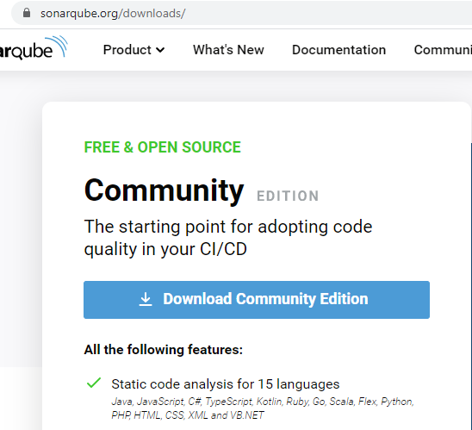

1. Download and install Java JDK from <https://www.oracle.com/java/technologies/javase-jdk11-downloads.html>

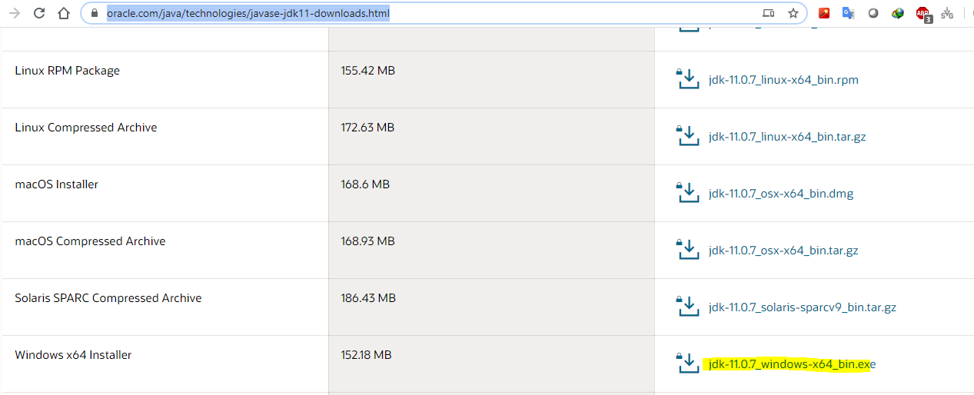

1. Set Java Home variable as given below System Properties -> Environment Variable

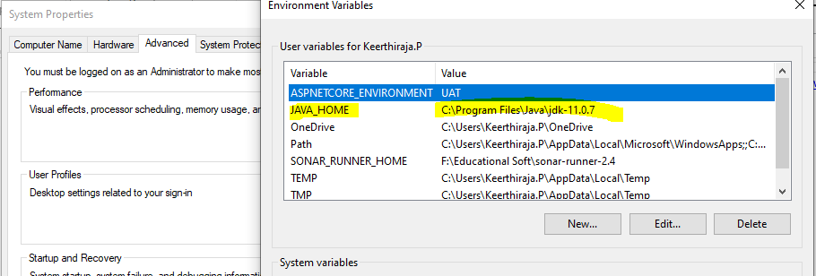

1. Set Java JDK installation path in wrapper.conf in the config folder of SonarCube unzip folder

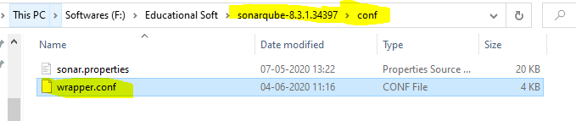

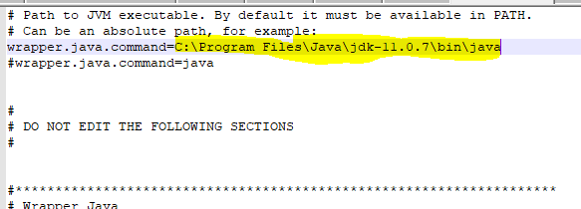

1. Run SonarCube batch file from unzip folder as Adminstrator

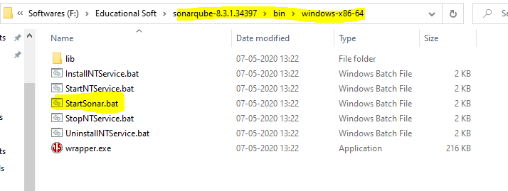

1. Browse http://localhost:9000 in the browser and you will be able to see the landing page of SonarQube. Default UserName and Password is admin

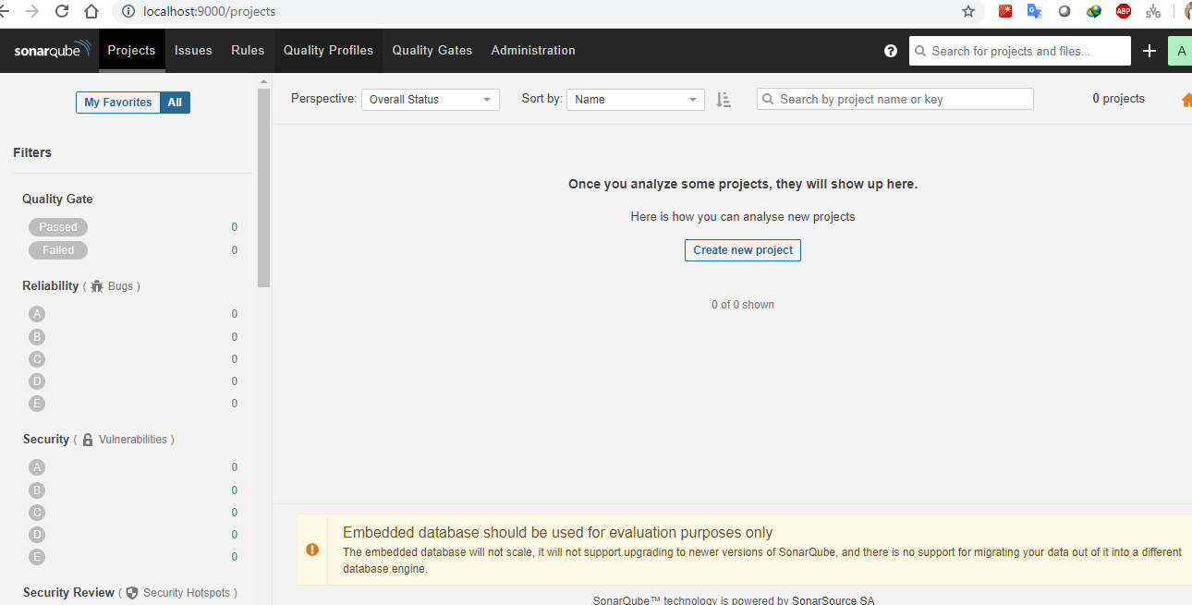

1. Creating a Project -> Click on the project in the main menu. Click on + button mentioned on the right side of the page and click on "Create New Project".

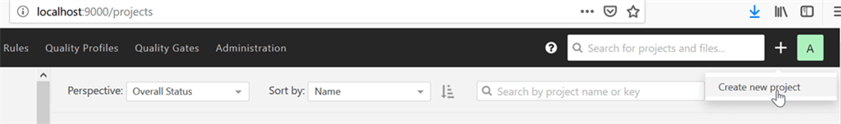

1. Provide the project key and display name. Click on the "Set Up" button.

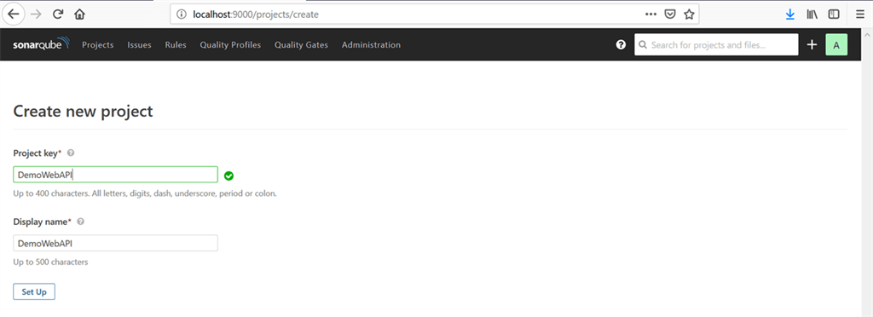

1. Click on the "Generate" button to generate the token.

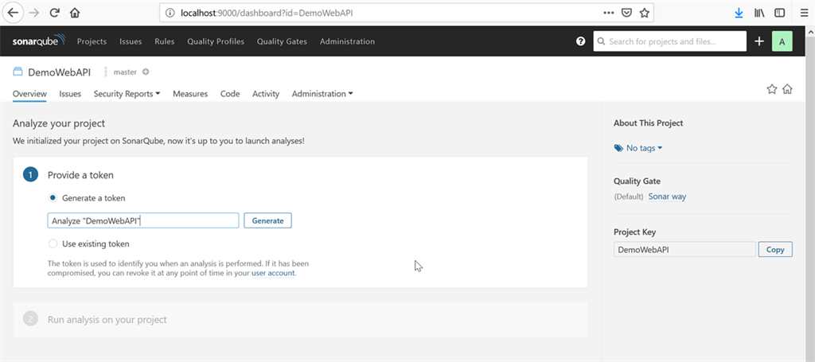

1. A token is generated and you can make a note of that for future use.

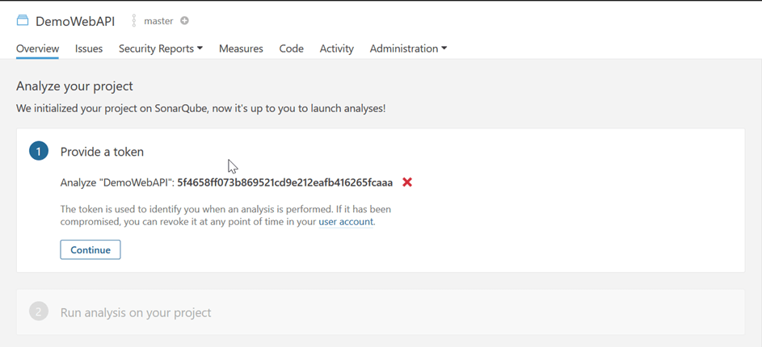

1. Click on the recently created project and click on "Overview". Provide the recently created token. In the next step, select your project language and click on "Download" to download the Scanner for MSBuild.

