**Coding Activity Solutions 1.1**

**Task 1**

**Step1:**

**Open the Variables-01 folder and add code to the variables01.js file to do the following:**

**Create a variable called myFriend using one of the variable declarations described above.**

**Set the variable you created to contain your friend's name.**

**Inside the greetings function, return the string: "Greetings [your-friend's-name]."**

**Note: The following line of code console.log('results: ', greetings()); will print the result of your code to the console. You will learn more about how this works later on in the course.**

**Solution for Step 1:**

**Code:** *var myFriend = "Rajhan";*

*function greeting(){*

*return `greetings! ${myFriend}`;*

*}*

*console.log(greeting());*

**Screenshot:**

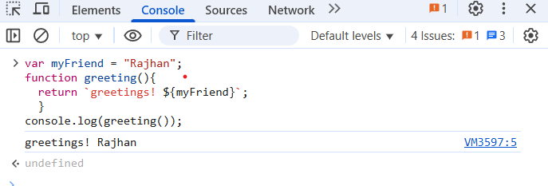

**Step 2:**

Your task in this activity is to declare a variable named currentYear using let. This variable should have the current year as a value (ex. 1991).

Note: This line of code console.log('current year result: ', currentYear); will print the value of your variable to the console.

**Solution for Step 2:**

**Code:**

*let currentYear = 1991;*

*console.log(`current year result: `, currentYear);*

**Screenshot:**

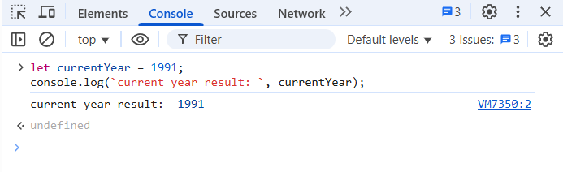

**Step 3:**

In this activity, you will declare variables with **let**and **const** keywords. The function **testBestFlavor** needs to print the message: "**Ana says, lacroix orange is a better flavor than lacroix grapefruit.**"

To make this function complete, you need to declare two constants:

* **lacroix1:** This needs to be declared outside the scope of the function testBestFlavor using **const** and it needs to have the value "**grapefruit**".
* **lacroix2:** This needs to be declared inside the scope of the function testBestFlavor using **const** and it needs to have the value "**orange**".

**Solution for Step 3:**

**Code:**

*const lacroix1 = "Grapefruit";*

*function testBestFlavor(){*

*const lacroix2 = "Orange";*

*console.log(`Ana says, lacroix ${lacroix2} is a better flavor than lacroix ${lacroix1}.`);*

*}*

*testBestFlavor();*

**Screenshot:**

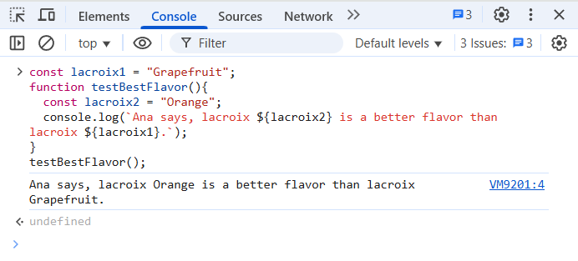

**\*\*\*\*\*\*\*\*\*\*\*\*\*\*\*\*\*\*\*\*\*\*\*\*\*\*\*\*\*\*\*\*\*END OF THE DOC\*\*\*\*\*\*\*\*\*\*\*\*\*\*\*\*\*\*\*\*\*\*\*\*\*\*\*\***