**Coding Activity Solution 1.2**

**Task:**

**In this activity you are given an array named numArray that contains numbers 1 through 10. Your task is to do the following:**

* **Using the Javascript let keyword declare a new variable called elementAtIndexFive. The value of this variable should be the element with index 5 in the numArray array.**

**Solution:**

**Code:**

*let numArray=[1,2,3,4,5,6,7,8,9,10];*

*let elementAtIndexFive=numArray[5];*

*console.log(elementAtIndexFive);*

**Screenshot:**

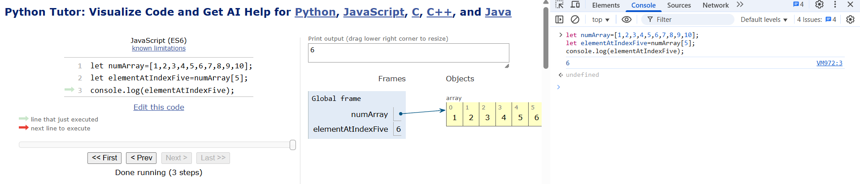

**\*\*\*\*\*\*\*\*\*\*\*\*\*\*\*\*\*\*\*\*\*\*\*\*\*\*\*\*\*\*\*\*\*\*\*END OF THE DOC\*\*\*\*\*\*\*\*\*\*\*\*\*\*\*\*\*\*\*\*\*\*\*\*\*\*\*\*\*\*\*\*\***