**Coding Activity Solution 1.3**

**Task:**

**Your task in this activity is to create a function that checks if a person is old enough to vote by checking their age. This function is called isOldEnoughToVote(age) and has the following specifications:**

**It takes an argument called age representing the age of the person.**

**It checks if the age is greater than or equal to 18.**

**If returns true or false based on that comparison.**

**Solution:**

**Code:**

*function isOldEnoughToVote(age)*

*{*

*if(age>=18)*

*{*

*return true;*

*}*

*else*

*{*

*return false;*

*}*

*}*

*console.log(isOldEnoughToVote(36));*

**Screenshot:**

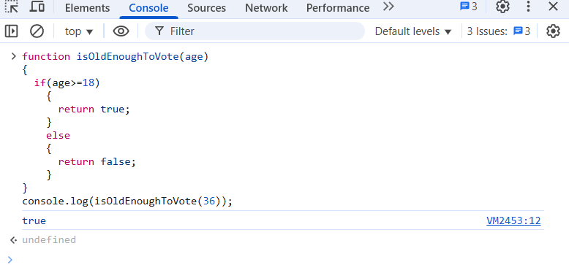

**\*\*\*\*\*\*\*\*\*\*\*\*\*\*\*\*\*\*\*\*\*\*\*\*\*\*\*\*\*\*\*\*\*\*END OF THE DOC\*\*\*\*\*\*\*\*\*\*\*\*\*\*\*\*\*\*\*\*\*\*\*\*\*\*\*\*\*\*\*\*\*\***