**Coding Activity Solutions 1.4**

**Task 1**

**Step 1:**

**You task in this activity is to complete the implementation of the function add. This function needs to do the following:**

**It takes two parameters x and y**

**It returns the sum of the two parameters x and y.**

**Note: You can calculate the sum of two numbers simply adding them: x + y**

**Solution for Step 1:**

**Code:**

*function add(x,y){*

*return x+y;*

*}*

*console.log(add(5,96));*

**Screenshot:**

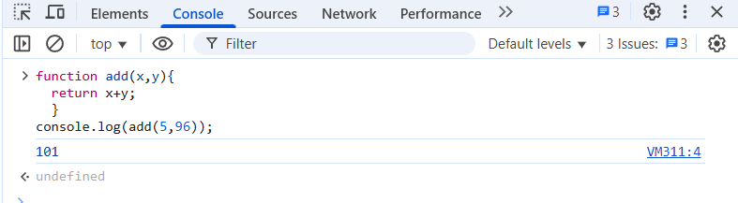

**callback Function**

**Code:**

*var addTen = function(x){*

*return x+10;*

*}*

*console.log(addTen(451));*

**Screenshot:**

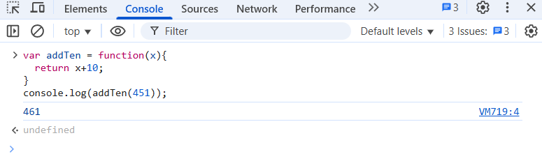**Step 2:**

**Now try writing a function that welcomes a friend.**

**To complete this task, you will need to implement the greet() function. This function needs to have a parameter called name and return a message that welcomes the person with that name.**

**For example, if you call the function as follow: greet("Dani"), the result should be: "Hello Dani" or "Greetings Dani'**

**Your code should be added to the greet.js file inside the functions-02 folder.**

**Code:**

*function greet(name){*

*return "Greetings " + name;*

*}*

*console.log(greet('Rajhan'));*

**Screenshot:**

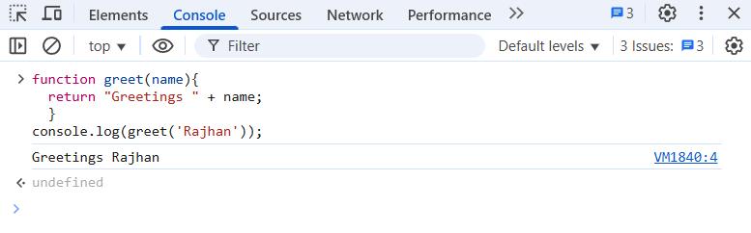

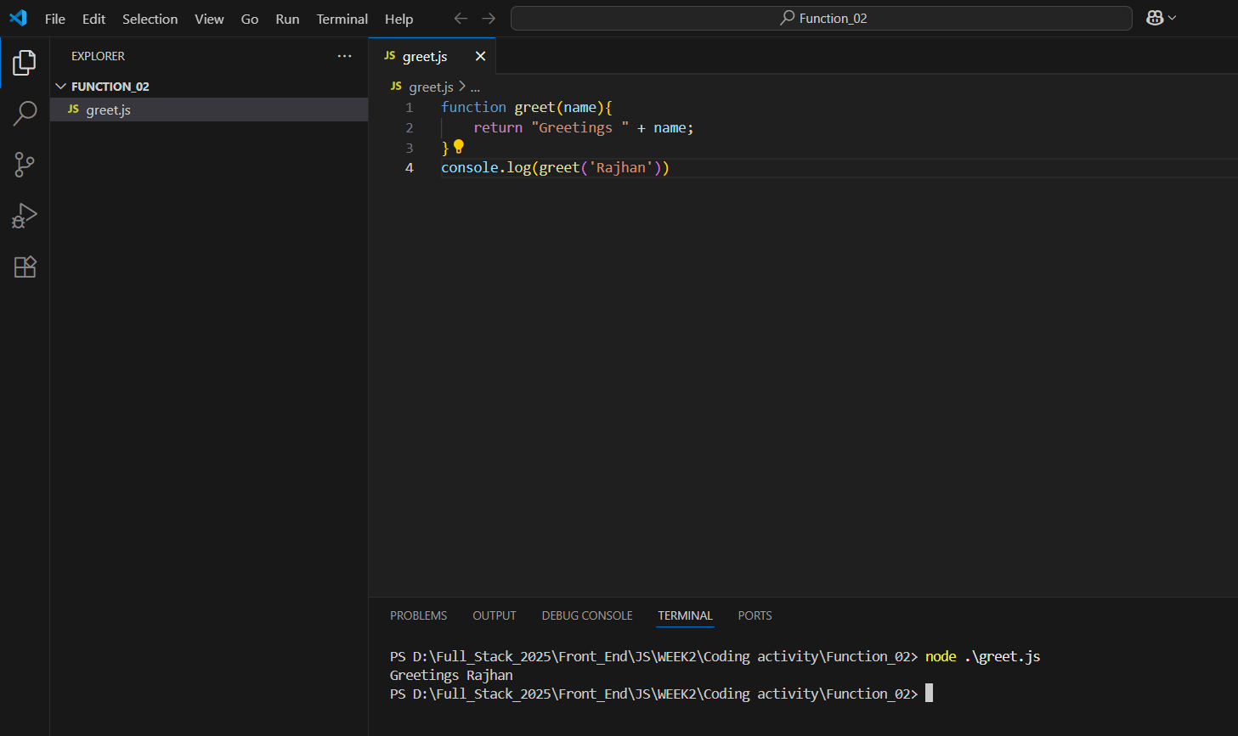

**Step 3:**

**Your task in this activity is to create a function called isString that takes three arguments (a, b, c). This function does the following:**

**It uses the typeof operator and strict equality comparison to check if the type of all three parameters a, b and c is string.**

**If each argument is a string it returns the message strings.**

**If any of the three parameters is not a string, then it returns the message not strings.**

**Hint: Read about the typeof built-in function to help you solve the exercise.**

**Code:**

*function isString(a,b,c){*

*if(typeof a ==="string" && typeof b === "string" && typeof c === "string"){*

*return "String";*

*}*

*else{*

*return "Not String";*

*}*

*}*

*console.log(isString("Banana", "Orange", "Apple"));*

*console.log(isString("Lemon", 97950, "Tea"));*

**Screenshot:**

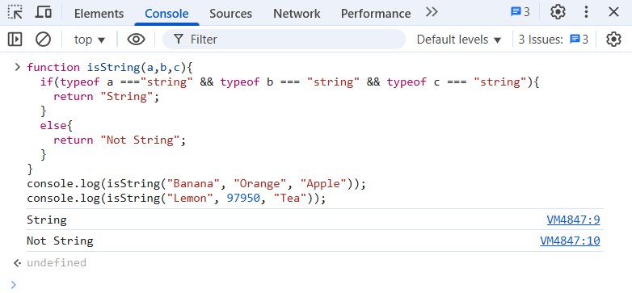

**\*\*\*\*\*\*\*\*\*\*\*\*\*\*\*\*\*\*\*\*\*\*\*\*\*\*\*\*\*\*\*\*\*\*\*\*END OF THE DOC\*\*\*\*\*\*\*\*\*\*\*\*\*\*\*\*\*\*\*\*\*\*\*\*\*\*\*\*\*\*\*\***