Explainable AI-Based Clinical Decision Support for Preliminary Dermatological Disease Diagnosis

Keerthi Reddy M V
Department ofiComputer Science and Engineering
Sri Venkateshwara College of Engineering, Bengaluru, Karnataka, India
VisvesvarayaITechnological University
Email:1ve23cs079@svcengg.edu.in
Mr. Rajesh S
Department ofoComputer Science and Engineering
Sri Venkateshwara College of Engineering, Bengaluru, Karnataka, India
VisvesvarayaiTechnological University
Email: rajesha.srinivas@gmail.com
Keerthana H R
Departmentoof Computer Science and Engineering
Sri Venkateshwara College of Engineering, Bengaluru, Karnataka, India
VisvesvarayaiTechnological University
Email: 1ve23cs077@svcengg.edu.in

Prakruthi C R
Department offComputer Science and Engineering
Sri Venkateshwara College of Engineering, Bengaluru, Karnataka, India
Visvesvaraya Technological University
Email:1ve23cs124@svcengg.edu.in
Neha S D
Department of ComputerkScience and Engineering
Sri Venkateshwara College of Engineering, Bengaluru, Karnataka, India
Visvesvaraya Technological University
Email:1ve23cs115@svcengg.edu.in

Abstract— Skin conditions share many common features in appearance, making their diagnosis a challenging task. Deep learning helps to implement skin-image classification tasks, while Explainable AI provides better explanation of predictions [1], [3], [5]. In this paper,owe propose an Explainable AI-based Clinical Decision Support System (CDSS) for preliminary skin disease diagnosis. We use dermatological images after preprocessing and use EfficientNet-B0 for Benign/Malignant classification along with confidence measure [4]. For the image localization task, Grad-CAM is used [5]. Web-based application is considered to provide easy preliminary diagnoses.
The CDSS is developed to serve as support, but not replacement, of medical specialists, with emphasis on classification accuracy, explainability, and user-friendliness [2].
Key Words— Skin Disease Classification, Deep Learning, EfficientNet-B0, CDSS, Explainable AI, Grad-CAM.
I. INTRODUCTION
This paper recognizes the problem in accurate diagnostics of dermatological conditions and the lack of experts' access in underdeveloped regions; hence, AI-powered skin images analytics is proposed [1], [2]. CNNs and other types of deep learningomodels can extract meaningful visual features, and the publicly accessible dataset HAM10000 can be usedpto automate the classification process [9]–[11].
Current research studies are dedicated to EfficientNet, transfer learning, attention-based models, transformers, and various explainable AI (XAI) techniques like Grad-CAM and LIME [3]–[7]. However, there are still some doubts concerning clinical applicability, transparency, and effectiveness on different skin tones [1], [2].
This research proposes an Explainable AI–Based Clinical Decision Support System (CDSS) to diagnose skin conditions. The system combines deep-learning-powered classification with confidence metrics and visual interpretation to help doctors with their diagnoses.
II. RELATED WORK
Recent researchesohave made use of convolutional neural networks (CNNs) and deepIlearning in classifying skin diseases automatically [9], [10]. Feature fusion, EfficientNet, attention models, and transformer methods have been used to make further improvements in image-based classification [3], [4], [6], [7]. Grad-CAM and LIME explainable AI approaches have been applied in visualizing the areas that affect model predictions and interpretability [3]-[5]. Furthermore, some researches have considered the applications of clinical decision-making and point of care systems powered by AI for dermatological diagnosis [1], [2], [8]. Overall, the existing literature suggests much potential of AI for skin analyses; however, more works should be done in combining the discussed components.
Table I. Summary of Related Work
Ref. | Approach | Main Focus
[1] | Deep Learning | Skin disease diagnosis across skin tones
[2] | AI Point-of-Care System | Real-time clinical support
[3] | Feature Fusion + XAI | Skin disease classification and interpretability
[4] | Transformer + XAI | Classification and explainability
[5] | CNN + Grad-CAM | Explainable skin disease detection
[6] | EfficientNet + Attention | Multimodal skin disease classification
[8] | AI-based CDSS | Melanoma detection in primary care
[9] | Deep Learning Review | Overview of skin disease recognition

III. RESEARCH GAP
Although there is some literature, a numberpof problems still arise:
- Lack of XAI in AI: Even though classification models may give precise results, the parts of theKimages that contribute to the decisions are difficult to interpret [3]-[5].
- Clinical relevance: There are studies that focus on classification rather than integration of predictions with decision support information [1], [2], [8].
- Reporting of prediction confidence: The analysis does not provide prediction confidence information explicitly.
- A need for an integrated framework: A framework combining classification, prediction confidence, visual explanation and decision support is needed.
This research will seek to fill the gaps through the creation of a web-based framework.

V. OBJECTIVES
4A. MAIN OBJECTIVES
To develop an Explainable Artificial Intelligence-Based Clinical Decision SupportLSystem for the classification of dermatological skin lesions through deep learning, with interpretable predictions and decision support information.
4B. SEPCIFIC OBJECTIVES
- Preprocess and classify skin-lesion images using EfficientNet-B0.
- Solve class imbalance by implementing class-weighted loss function.
- Calculate prediction confidence score for classification results.
- Create visual explanation for predictions with the use of Grad-CAM and LIME.
- Implement model and visual explanations on the web interface.
- Provide preliminary decision support information without replacing professional diagnosis.
V. METHODOLOGY
Workflow of the suggested methodology goes as follows:
Dataset -> Preprocessing -> Lesion-Aware Splitting -> Data Augmentation -> EfficientNet-B0 -> Classification -> Confidence Score -> Grad-CAM/LIME -> Clinical Decision Support -> Web Interface
Processing Steps
1. Dataset Preparation: HAM10000 dataset imagesyare divided into benign and malignant classes.
2. Data Splitting: ImagesKare split into train, validate and test sets with the help of lesion-aware splitting.
3. Preprocessing: Images are resized to 224 × 224 and normalized by the ImageNet distribution.
4. Data Augmentation: Train images are flipped horizontally and vertically and rotated.
5. Model Training: Pretrained EfficientNet-B0 is trained for binary classification task.
6. Class Imbalance: Class-weighted cross entropy loss is used to solve class imbalance problem.
7. Prediction: After training the model, the output produced by the model will be a prediction of benign/malignant lesion along with a confidence score.
8. Explanation: For explanation of the prediction, Grad-CAM and LIME techniques are used.
9. Decision Support: Decision support is provided through the user-friendly web interface.

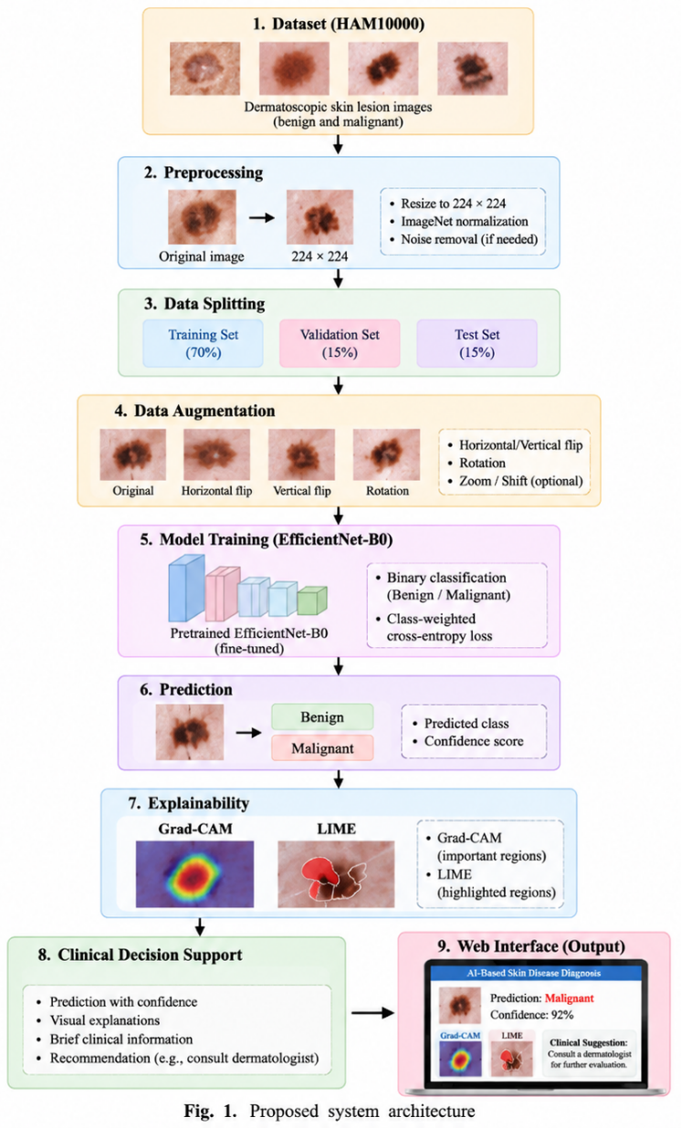

VI. PROPOSED ALGORITHM

Input: Dermatoscopic skin lesion image
Step 1: Resize the image to 224×224 pixels.
Step 2: Normalize the image using ImageNet statistics.
Step 3: Feed the normalized image to the trained EfficientNet-B0 model.
Step 4: Extract the predicted class – Benign or Malignant.
Step 5: Calculate the confidence of the prediction.
Step 6: Create Grad-CAM and LIME explanations.
Step 7: Display the prediction, confidence and explanation via the web-based interface.
Step 8: Deliver the preliminary decision support data.
Output: Preliminary explainable diagnosis.

VI. DATASET DESCRIPTION
The HAM10000 dataset was used in the dermatological image classification task. The original dataset had been filtered to obtain usable images of benign and malignant lesions to finally yield a dataset size of 11,571 images
Class | Images
Benign | 9,415
Malignant | 2,156
Total | 11,571

The dataset wasKsplit into training (6,943), validation (2,314) and test (2,314) sets. Such a splitting process was done using lesion aware stratification based on lesion IDs to ensure that images from the same lesion do not fall under different subsets. The labels assigned are binary in nature with 0 representing Benign and 1 representing Malignant.

VII. IMPLEMENTATION DETAILS
The experiment wasOperformed using Python language in Google Colab platform based on PyTorch library withKthe help of NVIDIA Tesla T4 GPU for the model training.
Parameter | Configuration
Model | Pretrained EfficientNet-B0
Framework | PyTorch
Optimizer | AdamW
Learning Rate | 0.0001
Batch Size | 16
Epochs | 5
Loss Function | Class-weighted Cross-Entropy Loss
Input Size | 224 × 224
Classes | Benign, Malignant
Training Platform | Google Colab
GPU | NVIDIA Tesla T4

The final classifier for EfficientNet-B0 model was tuned to give two outputs for each image – benign and malignant. TheKmodel having the highestKvalidation F1-score was saved as best_model.path.

VIII. PERFORMANCE EVALUATION METRICS
The model performance was evaluated using accuracy, precision, recall, F1-score, and confusion matrix. Particular attention was given to malignant-class recall and F1-score because detecting malignant lesions is important for preliminary screening.
- Accuracy: Overall proportion of correctly classified images.
- Precision: Proportion of predicted malignant cases that were actually malignant.
- Recall: Proportion of actual malignant cases correctly identified.
- F1-score: Harmonic meanKof precision and recall.
- Confusion Matrix: Shows correct and incorrect predictions for benign and malignant classes.

IX. RESULTS AND DISCUSSION
The trained EfficientNet-B0 model was evaluated on the independent test set of 2,314 images.
Metric | Result
Accuracy | 86.47%
Malignant Recall | 84.92%
Malignant F1-score | 70.05%
The confusion matrix showed 1,635 benign and 366 malignant images correctly classified. 248 benign images were classified as malignant, while 65 malignant images were classified as benign. The 65 false-negative cases indicate that further improvement is required before clinical use.
Note: Grad-CAM and LIME were not yet applied to the reported experimental results, so didn’t not claim XAI results in this section yet.

X. APPLICATIONS
The proposed system can be used for:
Multiple roles are served by the proposed system:
- Image-based screening of cutaneous lesions.
- Clinical decision making support providing predictions and accompanying confidence metrics.
- Explainable diagnostic support using Grad-CAM and LIME.
- Web-based availability allowing users to submit images and view results.
- Teledermatology assistance in areas with scarce resources for dermatologists.
The system is meant as a supporting tool, not as a replacement for professional diagnostics.

X. CONCLUSION
EfficientNet-B0 was used for the initial classification into benignLand malignant skin lesions in the proposed system. In the testing on an independent test set, the system demonstrated an accuracy of 86.47%, malignant recall of 84.92% and malignant F1 score of 70.05%. This proves that there is considerable promise in using deep learning for the initial dermatological diagnostics, but the false negative rate necessitates additional development.
The addition of Grad-CAM, LIME, predictions with confidence and web-based decision support is planned.

XII. FUTURE WORK
- Integrate Grad-CAM and LIME for visual explanation of model predictions.
- Add confidence scores and preliminary decision-support information.
- Complete the web-based deployment of the trained model.
- EvaluateOmodel performance across different skin-tone groups when suitable data are available.
- Improve the model using larger and more diverse datasets.
- Conduct further validation before considering any real-world clinical use.

REFERENCES
[1] Deep learning-aidedLdecision support for diagnosis of skin disease acrossLskin tones
[2] A Point-of-Care, Real-Time Artificial Intelligence System to Support Clinician Diagnosis of a WideORange of Skin Diseases
[3] Feature Fusion and Explainable Deep Learning Framework for Intelligent SkinODisease Classification Using Clinical Dermatology Images
[4] Enhancing Skin Disease Classification Leveraging Transformer-based Deep Learning Architectures and Explainable AI
[5] Explainable CNN Framework with Grad-CAM Analysis for Real-Time Skin Disease Detection
[6] Attention-guided Multimodal Skin Disease Classification Using DiscountedoDempster-Shafer Fusion and EfficientNet
[7] FUSCANet: Enhancing Skin Disease Classification Through Feature Fusion and Spatial-Channel Attention Mechanisms
[8] Exploring thekFeasibility of an Artificial Intelligence Based Clinical Decision Support System for Cutaneous Melanoma Detection in Primary Care – A Mixed Method Study
[9] Skin Disease Recognition Basedkon Deep Learning Algorithms: A Review
[10] A Machine LearningkModel for Skin Disease Classification Using Convolution Neural Network
[11] The HAM10000iDataset, a Large Collection of Multi-Source Dermatological Images of Common Pigmented Skin Lesion

