**Project Charter**

**A. General Information**

| ***Project Title:*** | MEME (Mall Experience Made Easy) | | |
| --- | --- | --- | --- |
| ***Brief Project***  ***Description:*** | **Mall Management System** is a web app providing easy access to mall services. It acts as a platform for users and the admin to perform various tasks, reducing waiting times and crowds through smart service management. | | |
| ***Prepared By:*** | Charan Kasala, Kavya Sree Katakam, Keerthi Reddy Tummalapelly, Manojna Borra, Nikhitha Bijjala, Vamsi Krishna Changala. | | |
| ***Date:*** | 1-31-2023 | ***Version:*** | 1 |

**B. Project Objectives:**

* To build an easy interface to access various mall management services.
* To allow users to priorly book movie tickets in advance without having to wait in queues.
* To enable the visitors to check for a parking lot availability and reserve their spaces ahead of time.
* To make it possible for customers to pre-order food from any location and pick it up when the food is ready to be served.
* To make it simple for customers to learn about special offers, recharge their gaming cards, and use credits with ease.
* To keep the users posted on the event updates and mega flash deals.
* To make it easier to publish information about employment opportunities in the mall.

**C. Assumptions and Constraints:**



**Constraints on the user profile:**

* Authorization for every user profile (It can be customer/admin) in the web application should be done with no flaws.
* Unregistered user authorization should not be successful and there should be no grant access for them to the web application services.
* All the collected data in the database (movie booking history, parking space booking history and food ordering history etc.) should be very transparent over the web application.
* Admin services like any payment issues, registration problems etc. should be resolved by 24/7 for each problem that is encountered by the users.
* Admin should list the menu according to the food availability.
* Admin should update the movie list and show timings in the database whenever required.
* Admin should follow up on store specifics, the newest offers, career openings, and events, and the database should be updated periodically.

**Assumptions that can be drawn on this Web Application:**

* All the services should be available for every user with no issues in this web application.
* The customer should have pre-existing gaming card for utilizing gaming services.
* Despite of any circumstances customers should receive accurate information on the store specifics, latest deals, event updates and job opportunities.

**D. Project Scope**



* Easy access to mall services via web application.
* Platform for customers and administrators to perform various tasks.
* Reduction of crowds and waiting times through smart service management.
* Improved efficiency and reliability of mall services.

**E. Project Backlog:**

Sprint 1 Backlog:

* As a customer, I should be able to register/ sign up.
* As a customer, I should be able to login/ logout.
* As an admin, I should be able to login/ logout.
* As an admin, I should be able to view/add/update/delete a movie.
* As a customer, I should be able to filter a movie based on category and language.
* As a customer, I should be able to select and book a movie ticket.
* As a customer, I should be able to view the booked movie ticket.
* As an admin, I should be able to view/add/update/delete parking lot details.
* As a customer, I should be able to select and book parking space.

**F. Project Milestones**

| **Milestones** | **Deliverables** | **Date** |
| --- | --- | --- |
| Sprint I | * Development of the user profiles. * Implementation of administrator roles related to movie ticketing and parking space booking. * Customer should be able to book a movie tickets. * Customer should be able to book and cancel the parking space. | 02/21/2023 |
| Sprint II | * Implementation of administrator roles related to food pre-order service. * Customer should be able to order the food in advance to avoid the queues. * Customer should be able to view the latest updates on offers, events and job openings. * Administrator must be able to update store specifics, events, career opportunities and the newest deals. * Customer should be able to view the store details. | 03/21/2023 |
| Final Presentation | * Integration * End-To-End Testing | 04/18/2023 |

**G. Roles and Responsibilities**

| **Scrum Master** | | | |
| --- | --- | --- | --- |
| **Name** | | **Email / Phone** | |
| **Kavya Sree Katakam** | | kkatakam@albany.edu  +1 (518) 951-4969 | |
| **Team Member** | | | |
| **Name** | **Responsibility** | | **Email / Phone** |
| Nikhitha Bijjala | Developing front end website architecture | | [nbijjala@albany.edu](mailto:nbijjala@albany.edu)  +1 (838) 746-9185 |
| Keerthi Reddy Tummalapelly | Developing back-end website application | | [ktummalapelly@albany.edu](mailto:ktummalapelly@albany.edu)  +1 (838) 934-7730 |
| Kavya Sree Katakam | Designing user interactions | | [kkatakam@albany.edu](mailto:kkatakam@albany.edu)  +1 (518) 951-4969 |
| Vamsi Krishna Changala | Web design features and deployment | | [vchangala@albany.edu](mailto:vchangala@albany.edu)  +1 (518) 764-7996 |
| Charan Kasala | Web performance testing | | [ckasala@albany.edu](mailto:ckasala@albany.edu)  +1 (518) 870-9067 |
| Manojna Borra | Website and Database Administration | | [mborra2@albany.edu](mailto:mborra2@albany.edu)  +1 (518) 764-7978 |

**H. Work Breakdown Structure**

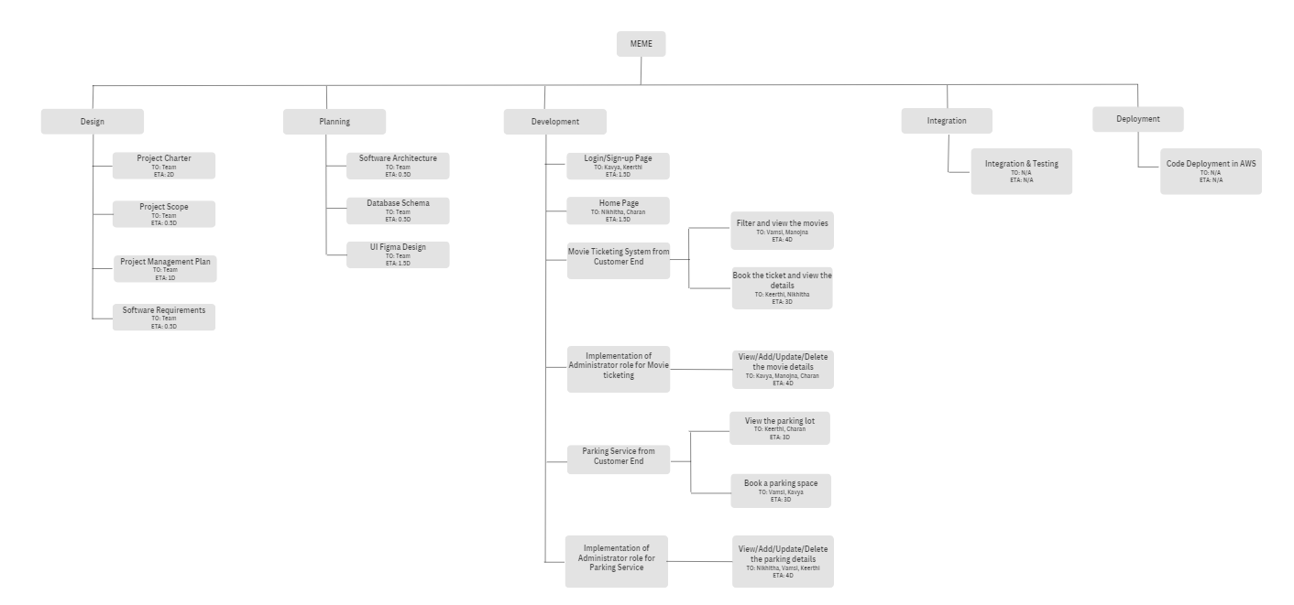

**Project Charter**

**I. Signatures**

The signatures of the people below document approval of the formal Project Charter. The project manager is empowered by this charter to proceed with the project as outlined in the charter.

| ***Project Owner*** | | | | | |
| --- | --- | --- | --- | --- | --- |
|  | **Name** |  | **Signature** |  | **Date** |
| Vamsi Krishna Changala | | Vamsi Krishna Changala | | 02/05/2023 | |
| ***Scrum Master*** | | | | | |
|  | **Name** |  | **Signature** |  | **Date** |
| Kavya Sree Katakam | | Kavya Sree Katakam | | 02/05/2023 | |