**Program 1**

**Develop a program to draw a line using Bresenham’s line drawing technique**

#include<GL/glut.h>

#include<stdio.h>

int x1, y1, x2, y2;

void draw_pixel(int x, int y)

{

glColor3f(1.0,0.0,0.0);

glBegin(GL_POINTS);

glVertex2i(x, y);

glEnd();

}

void bresenhams_line_draw(int x1, int y1, int x2, int y2)

{

int dx = x2 - x1; // x difference

int dy = y2 - y1; // y difference

int m = dy/dx; // slope

if (m < 1)

{

int decision_parameter = 2*dy - dx;

int x = x1; // initial x

int y = y1; // initial y

if (dx < 0) // decide the first point and second point

{

x = x2; // making second point as first point

y = y2;

x2 = x1;

}

draw_pixel (x, y); // plot a point

while (x < x2) // from 1st point to 2nd point

{

if (decision_parameter >= 0)

{

x = x+1;

y = y+1;

decision_parameter = decision_parameter + 2*dy - 2*dx * (y+1 - y);

}

else

{

x = x+1;

y = y;

decision_parameter = decision_parameter + 2*dy - 2*dx * (y - y);

}

draw_pixel (x, y);

}

}

else if (m > 1)

{

int decision_parameter = 2*dx - dy;

int x = x1; // initial x

int y = y1; // initial y

if (dy < 0)

{

x = x2;

y = y2;

y2 = y1;

}

draw_pixel (x, y);

while (y < y2)

{

if (decision_parameter >= 0)

{

x = x+1;

y = y+1;

decision_parameter = decision_parameter + 2*dx - 2*dy * (x+1 - x);

}

else

{

y = y+1;

x = x;

decision_parameter = decision_parameter + 2*dx - 2*dy * (x- x);

}

draw_pixel(x, y);

}

}

else if (m == 1)

{

int x = x1;

int y = y1;

draw_pixel (x, y);

while (x < x2)

{

x = x+1;

y = y+1;

draw_pixel (x, y);

}

}

}

void init()

{

glClearColor(1,1,1,1);

gluOrtho2D(0.0, 500.0, 0.0, 500.0); // left ->0, right ->500, bottom ->0, top ->500

}

void display()

{

glClear(GL_COLOR_BUFFER_BIT);

bresenhams_line_draw(x1, y1, x2, y2);

glFlush();

}

int main(int argc, char **argv)

{

printf( "Enter Start Points (x1,y1)\n");

scanf("%d %d", &x1, &y1); // 1st point from user

printf( "Enter End Points (x2,y2)\n");

scanf("%d %d", &x2, &y2); // 2nd point from user

glutInit(&argc, argv); // initialize graphics system

glutInitDisplayMode(GLUT_SINGLE|GLUT_RGB); //single buffered mode with RGB colour variants

glutInitWindowSize(500, 500); // 500 by 500 window size

glutInitWindowPosition(220, 200); // where do you wanna see your window

glutCreateWindow("Bresenham's Line Drawing"); // the title of your window

init(); // initialize the canvas

glutDisplayFunc(display); // call display function

glutMainLoop(); // run forever

}

**Output**

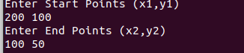

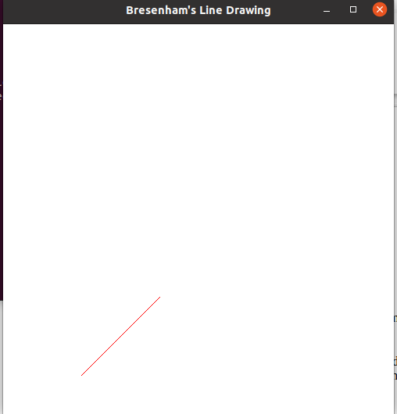



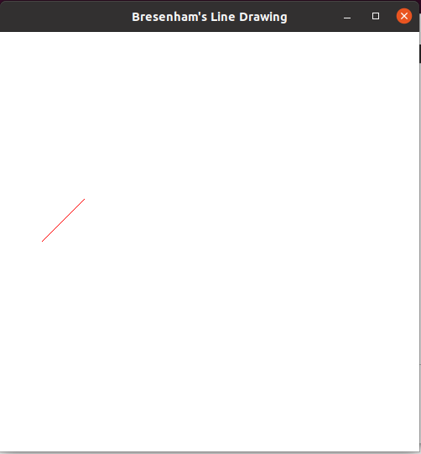

**Program 2**

**Develop a program to demonstrate basic 3D Geometrical operation on 2D object.**

#include <stdio.h>

#include <GL/glut.h>

typedef float point2[2];

/* initial triangle */

point2 v[]={{-1.0, -0.58}, {1.0, -0.58}, {0.0, 1.15}};

int n;

/* display one triangle */

void triangle( point2 a, point2 b, point2 c)

{

glBegin(GL_TRIANGLES);

glVertex2fv(a);

glVertex2fv(b);

glVertex2fv(c);

glEnd();

}

void divide_triangle(point2 a, point2 b, point2 c, int m)

{

/* triangle subdivision using vertex numbers */

point2 v0, v1, v2;

int j;

if(m>0)

{

for(j=0; j<2; j++) v0[j]=(a[j]+b[j])/2;

for(j=0; j<2; j++) v1[j]=(a[j]+c[j])/2;

for(j=0; j<2; j++) v2[j]=(b[j]+c[j])/2;

divide_triangle(a, v0, v1, m-1);

divide_triangle(c, v1, v2, m-1);

divide_triangle(b, v2, v0, m-1);

}

else(triangle(a,b,c)); /* draw triangle at end of recursion */

}

void display(void)

{

glClear(GL_COLOR_BUFFER_BIT);

divide_triangle(v[0], v[1], v[2], n);

glFlush();

}

void myinit()

{

glMatrixMode(GL_PROJECTION);

glLoadIdentity();

gluOrtho2D(-2.0, 2.0, -2.0, 2.0);

glMatrixMode(GL_MODELVIEW);

glClearColor (1.0, 1.0, 1.0, 1.0);

glColor3f(0.0,0.0,0.0);

}

int main(int argc, char **argv)

{

printf(" No. of Subdivisions : ");

scanf("%d",&n);

glutInit(&argc, argv);

glutInitDisplayMode(GLUT_SINGLE | GLUT_RGB );

glutInitWindowSize(500, 500);

glutCreateWindow("Sierpinski Gasket 2D triangle");

glutDisplayFunc(display);

myinit();

glutMainLoop();

return 0;

}

**Output:**

No. of Subdivisions : 2

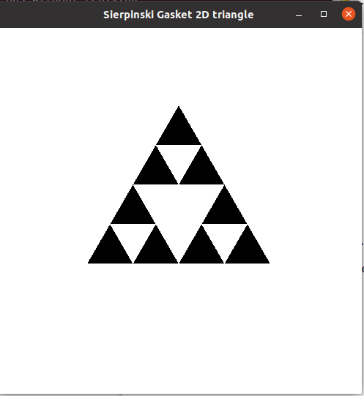

**Program 3**

**Develop a program to demonstrate basic Geometric operation on 3D object.**

#include<stdlib.h>

#include<stdio.h>

#include<GL/glut.h>

typedef float point[3];

point v[]= {{0, 0, 1}, {0, 1, 0}, {-1, -0.5, 0}, {1, -0.5, 0}};

int n;

void triangle(point a, point b, point c)

{

glBegin(GL_POLYGON);

glVertex3fv(a);

glVertex3fv(b);

glVertex3fv(c);

glEnd();

}

void divide_triangle(point a, point b, point c, int n)

{

point v1,v2,v3;

int j;

if(n>0)

{

for(j=0; j<3; j++)

v1[j] = (a[j]+b[j])/2; // calculate mid-point between a and b

for(j=0; j<3; j++)

v2[j] = (a[j]+c[j])/2; // calculate mid-point between a and c

for(j=0; j<3; j++)

v3[j] = (c[j]+b[j])/2; // calculate mid-point between c and b

divide_triangle(a,v1,v2,n-1); // divide triangle between points a, ab/2, ac/2 recursively

divide_triangle(c,v2,v3,n-1);

divide_triangle(b,v3,v1,n-1);

}

else

triangle (a,b,c);// draw triangle

}

void tetrahedron(int n)

{

glColor3f(1, 0, 0); // assign color for each of the side

divide_triangle(v[0], v[1], v[2], n); // draw triangle between a, b, c

glColor3f(0, 1, 0);

divide_triangle(v[3], v[2], v[1], n);

glColor3f(0, 0, 1);

divide_triangle(v[0], v[3], v[1], n);

glColor3f(0, 0, 0);

divide_triangle(v[0], v[2], v[3], n);

}

void display(void)

{

glClear(GL_COLOR_BUFFER_BIT|GL_DEPTH_BUFFER_BIT);

glLoadIdentity();

tetrahedron(n);

glFlush(); // show the output

}

void myReshape(int w,int h) // please see the earlier program for explanation on this

{

glViewport(0, 0, w, h);

glMatrixMode(GL_PROJECTION);

glLoadIdentity();

if(w<=h)

glOrtho(-2, 2, -2*(GLfloat)h/(GLfloat)w, 2*(GLfloat)h/(GLfloat)w, -10, 10);

else

glOrtho(-2*(GLfloat)w/(GLfloat)h, 2*(GLfloat)w/(GLfloat)h, -2, 2, -10, 10);

glMatrixMode(GL_MODELVIEW);

glutPostRedisplay();

}

int main(int argc,char ** argv)

{

printf("No of Recursive steps/Division: ");

scanf("%d",&n);

glutInit(&argc,argv);

glutInitDisplayMode(GLUT_SINGLE|GLUT_RGB|GLUT_DEPTH);

glutCreateWindow(" 3D Sierpinski gasket");

glutReshapeFunc(myReshape);

glutDisplayFunc(display); // call display function

glEnable(GL_DEPTH_TEST); // do depth comparisons and update the depth buffer.

glClearColor(1, 1, 1, 0);

glutMainLoop();

return 0;

}

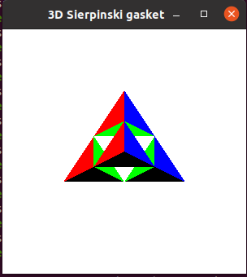**Output**

**No of Recursive steps/Division:1**

**No of Recursive steps/Division:3**

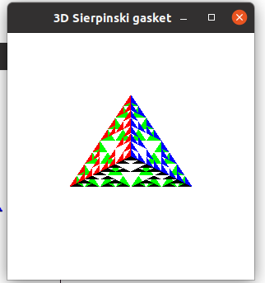

**Program 4**

**Develop a program to demostrate 2D transformations on basic object.**

#include<GL/glut.h>

#include<math.h>

GLfloat vertices[][2]={

{0.1},{-0.5,-0.5},{0.5,-0.5}

};

GLfloat angle=0.0;

GLfloat transalateX=0.0;

GLfloat transalateY=0.0;

GLfloat scaleX=1.0;

GLfloat scaleY=1.0;

void display ();

void menu(int option);

void createMenu();

void display()

{

glClear(GL_COLOR_BUFFER_BIT);

glLoadIdentity();

glTranslatef(transalateX,transalateY,0);

glRotatef(angle,0,0,1);

glScalef(scaleX,scaleY,1);

glColor3f(1,1,1);

glBegin(GL_TRIANGLES);

for (int i=0; i<3; i++)

{

glVertex2fv(vertices[i]);

}

glEnd();

glFlush();

}

void menu (int option)

{

switch(option)

{

case 1:

transalateX-=0.1;

break;

case 2:

transalateX+=0.1;

break;

case 3:

transalateY-=0.1;

break;

case 4:

transalateY+=0.1;

break;

case 5:

scaleX+=0.1;

scaleY+=0.1;

break;

case 6:

scaleX-=0.1;

scaleY-=0.1;

break;

case 7:

angle+=10.0;

if (angle>360)angle-=360;

break;

case 8:

angle-=10.0;

if (angle<0)angle+=360;

break;

case 9:

angle=0.0;

transalateX=0.0;

transalateY=0.0;

scaleX=1.0;

scaleY=1.0;

break;

case 10:

exit(0);

break;

}

glutPostRedisplay();

}

void createMenu()

{

glutAddMenuEntry("Translate left",1);

glutAddMenuEntry("Translate right",2);

glutAddMenuEntry("Translate Down",3);

glutAddMenuEntry("Translate Up",4);

glutAddMenuEntry("Scale Up",5);

glutAddMenuEntry("Scale Down",6);

glutAddMenuEntry("Rotate Clockwise",7);

glutAddMenuEntry("Rotate Anticlockwise",8);

glutAddMenuEntry("Reset",9);

glutAddMenuEntry("Exit",10);

glutAttachMenu(GLUT_RIGHT_BUTTON);

}

void init()

{

glClearColor(0,0,0,1);

}

void reshape(int w, int h)

{

glViewport (0,0,w,h);

glMatrixMode(GL_PROJECTION);

glLoadIdentity();

gluOrtho2D(-1,1,-1,1);

glMatrixMode(GL_MODELVIEW);

}

int main( int argc,char**argv)

{

glutInit(&argc,argv);

glutInitDisplayMode(GLUT_SINGLE|GLUT_RGB);

glutInitWindowSize(800,600);

glutCreateWindow("2D Transformation");

glutDisplayFunc(display);

glutReshapeFunc(reshape);

createMenu();

init();

glutMainLoop();

return 0;

}

**Output**

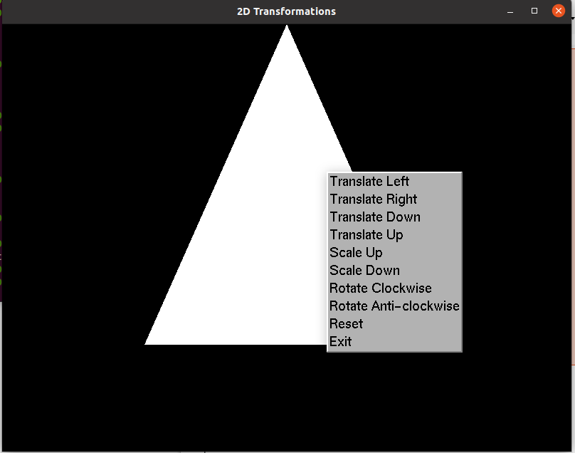

**Program 5**

**Develop a program to demostrate 3D transformations on basic object.**

#include <stdlib.h>

#include <GL/glut.h>

// Define cube vertices

GLfloat vertices[][3] = {

{-1, -1, -1},

{1, -1, -1},

{1, 1, -1},

{-1, 1, -1},

{-1, -1, 1},

{1, -1, 1},

{1, 1, 1},

{-1, 1, 1}

};

// Define cube edges

GLint edges[][2] = {

{0, 1},

{1, 2},

{2, 3},

{3, 0},

{4, 5},

{5, 6},

{6, 7},

{7, 4},

{0, 4},

{1, 5},

{2, 6},

{3, 7}

};

// Define rotation angles

GLfloat angleX = 0.0;

GLfloat angleY = 0.0;

GLfloat angleZ = 0.0;

// Define translation offsets

GLfloat translateX = 0.0;

GLfloat translateY = 0.0;

GLfloat translateZ = 0.0;

// Define scaling factors

GLfloat scaleX = 1.0;

GLfloat scaleY = 1.0;

GLfloat scaleZ = 1.0;

// Display function

void display() {

glClear(GL_COLOR_BUFFER_BIT | GL_DEPTH_BUFFER_BIT);

glLoadIdentity();

// Set up perspective projection

gluLookAt(3, 3, 3, 0, 0, 0, 0, 1, 0);

// Apply transformations

glTranslatef(translateX, translateY, translateZ);

glRotatef(angleX, 1, 0, 0);

glRotatef(angleY, 0, 1, 0);

glRotatef(angleZ, 0, 0, 1);

glScalef(scaleX, scaleY, scaleZ);

// Draw cube

glColor3f(1, 1, 1);

glBegin(GL_LINES);

for (int i = 0; i < 12; i++) {

glVertex3fv(vertices[edges[i][0]]);

glVertex3fv(vertices[edges[i][1]]);

}

glEnd();

glutSwapBuffers();

}

// Idle function

void idle() {

angleX += 0.5;

if (angleX > 360) angleX -= 360;

angleY += 0.5;

if (angleY > 360) angleY -= 360;

angleZ += 0.5;

if (angleZ > 360) angleZ -= 360;

glutPostRedisplay();

}

// Keyboard function for scaling and translation

void keyboard(unsigned char key, int x, int y) {

switch (key) {

case 'w':

translateY += 0.1;

break;

case 's':

translateY -= 0.1;

break;

case 'a':

translateX -= 0.1;

break;

case 'd':

translateX += 0.1;

break;

case 'q':

translateZ += 0.1;

break;

case 'e':

translateZ -= 0.1;

break;

case '+':

scaleX += 0.1;

scaleY += 0.1;

scaleZ += 0.1;

break;

case '-':

scaleX -= 0.1;

scaleY -= 0.1;

scaleZ -= 0.1;

break;

case 'r':

angleX = 0.0;

angleY = 0.0;

angleZ = 0.0;

translateX = 0.0;

translateY = 0.0;

translateZ = 0.0;

scaleX = 1.0;

scaleY = 1.0;

scaleZ = 1.0;

break;

case 27: // ESC key

exit(0);

break;

}

glutPostRedisplay();

}

// Initialization function

void init() {

glClearColor(0, 0, 0, 1);

glEnable(GL_DEPTH_TEST);

}

// Reshape function

void reshape(int w, int h) {

glViewport(0, 0, w, h);

glMatrixMode(GL_PROJECTION);

glLoadIdentity();

gluPerspective(60, (float)w / h, 1, 100);

glMatrixMode(GL_MODELVIEW);

}

// Main function

int main(int argc, char** argv) {

glutInit(&argc, argv);

glutInitDisplayMode(GLUT_DOUBLE | GLUT_RGB | GLUT_DEPTH);

glutInitWindowSize(800, 600);

glutCreateWindow("3D Transformations");

glutDisplayFunc(display);

glutReshapeFunc(reshape);

glutIdleFunc(idle);

glutKeyboardFunc(keyboard);

init();

glutMainLoop();

return 0;

}

**Output**

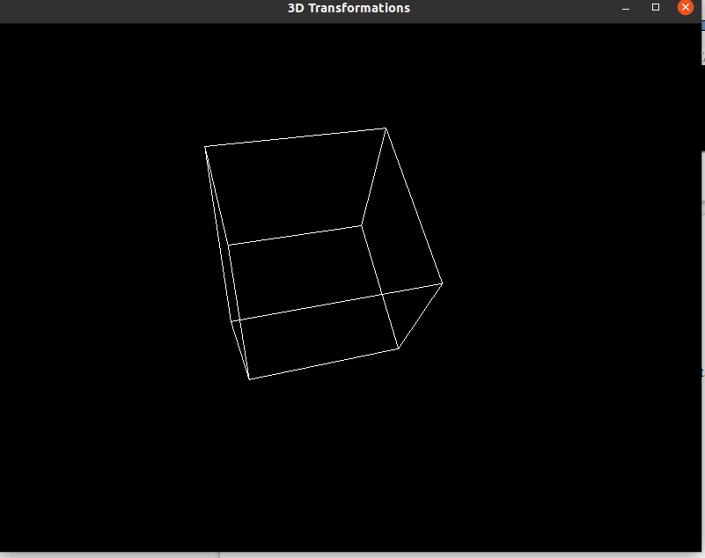

**Program 6**

**Develop a program to demonstrate animation effects on simple objects**

#include <GL/glut.h>

#include <math.h>

int windowWidth = 800;

int windowHeight = 600;

int squareSize = 50;

int squarePosX = 0;

float animationSpeed = 1.0;

void init() {

glClearColor(0.0, 0.0, 0.0, 1.0);

glMatrixMode(GL_PROJECTION);

gluOrtho2D(0.0, windowWidth, 0.0, windowHeight);

}

void drawSquare() {

glColor3f(1.0, 1.0, 1.0);

glBegin(GL_QUADS);

glVertex2i(squarePosX, windowHeight / 2);

glVertex2i(squarePosX + squareSize, windowHeight / 2);

glVertex2i(squarePosX + squareSize, windowHeight / 2 + squareSize);

glVertex2i(squarePosX, windowHeight / 2 + squareSize);

glEnd();

}

void display() {

glClear(GL_COLOR_BUFFER_BIT);

drawSquare();

glutSwapBuffers();

}

void update(int value) {

// Move the square to the right

squarePosX += animationSpeed;

// If the square moves out of the screen, reset its position

if (squarePosX > windowWidth) {

squarePosX = -squareSize; // Start from the left edge again

}

// Varying animation speed

animationSpeed += 0.01; // Increase animation speed linearly

glutPostRedisplay(); // Update the display

glutTimerFunc(1000 / 60, update, 0); // 60 frames per second

}

int main(int argc, char** argv) {

glutInit(&argc, argv);

glutInitDisplayMode(GLUT_DOUBLE | GLUT_RGB);

glutInitWindowSize(windowWidth, windowHeight);

glutInitWindowPosition(100, 100);

glutCreateWindow("Animation Effects with Varying Speed");

init();

glutDisplayFunc(display);

glutTimerFunc(0, update, 0);

glutMainLoop();

return 0;

}

## Program 7

## Write a Program to read a digital image. Split and display image into 4 quadrants, up, down, right and left.

import cv2

import numpy as np

import matplotlib.pyplot as plt

# Read the image

img = cv2.imread(“image_pat.jpeg”)

# Get the height and width of the image

height, width = img.shape[:2]

# Split the image into four quadrants

quad1 = img[:height//2, :width//2]

quad2 = img[:height//2, width//2:]

quad3 = img[height//2:, :width//2]

quad4 = img[height//2:, width//2:]

plt.figure(figsize=(10, 5))

plt.subplot(1, 2, 1)

plt.imshow(quad1)

plt.title("1")

plt.axis("off")

plt.subplot(1, 2, 2)

plt.imshow(quad2)

plt.title("2")

plt.axis("off")

plt.figure(figsize=(10, 5))

plt.subplot(1, 2, 1)

plt.imshow(quad3)

plt.title("3")

plt.axis("off")

plt.subplot(1, 2, 2)

plt.imshow(quad4)

plt.title("4")

plt.axis("off")

plt.show()

**Output**

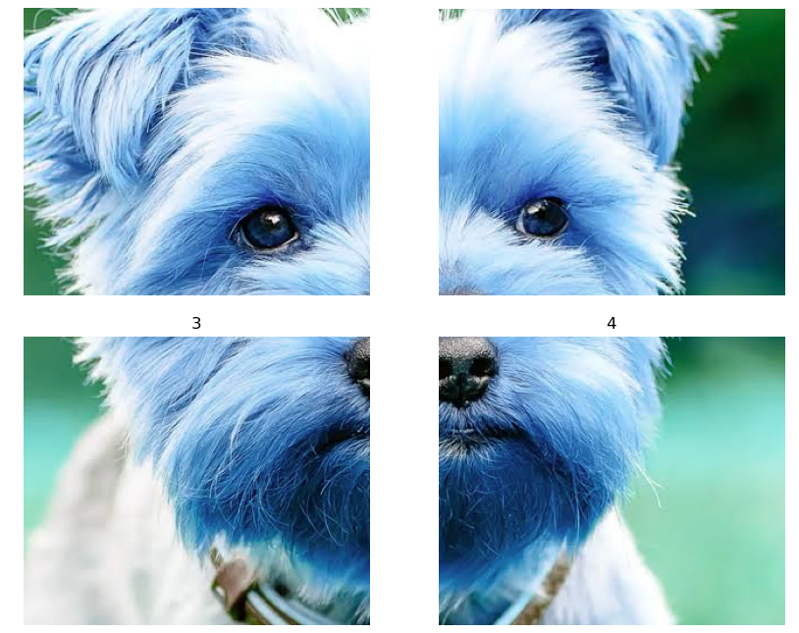

## PROGRAM 8

## Write a program to show rotation, scaling, and translation on an image.

import cv2

import numpy as np

# Load the image

image_path = "grass.jpeg" # Replace with the path to your image

img = cv2.imread(image_path)

# Get the image dimensions

height, width, _ = img.shape

# Define the transformation matrices

rotation_matrix = cv2.getRotationMatrix2D((width/2, height/2), 45, 1) # Rotate by 45 degrees

scaling_matrix = np.float32([[1.5, 0, 0], [0, 1.5, 0]]) # Scale by 1.5x

translation_matrix = np.float32([[1, 0, 100], [0, 1, 50]]) # Translate by (100, 50)

# Apply transformations

rotated_img = cv2.warpAffine(img, rotation_matrix, (width, height))

scaled_img = cv2.warpAffine(img, scaling_matrix, (int(width*1.5), int(height*1.5)))

translated_img = cv2.warpAffine(img, translation_matrix, (width, height))

# Display the original and transformed images

cv2.imshow("Original Image", img)

cv2.imshow("Rotated Image", rotated_img)

cv2.imshow("Scaled Image", scaled_img)

cv2.imshow("Translated Image", translated_img)

# Wait for a key press and then close all windows

cv2.waitKey(0)

cv2.destroyAllWindows()

**Output**

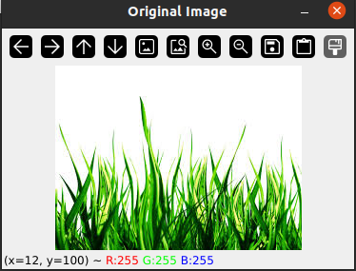

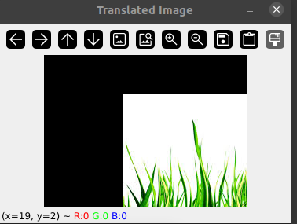

## 

## Program 9

## Read an image and extract and display low-level features such as edges, textures using filtering techniques.

import cv2

import numpy as np

# Load the image

image_path = "image/atc.jpg" # Replace with the path to your image

img = cv2.imread(image_path)

# Convert the image to grayscale

gray = cv2.cvtColor(img, cv2.COLOR_BGR2GRAY)

# Edge detection

edges = cv2.Canny(gray, 100, 200) # Use Canny edge detector

# Texture extraction

kernel = np.ones((5, 5), np.float32) / 25 # Define a 5x5 averaging kernel

texture = cv2.filter2D(gray, -1, kernel) # Apply the averaging filter for texture extraction

# Display the original image, edges, and texture

cv2.imshow("Original Image", img)

cv2.imshow("Edges", edges)

cv2.imshow("Texture", texture)

# Wait for a key press and then close all windows

cv2.waitKey(0)

cv2.destroyAllWindows()

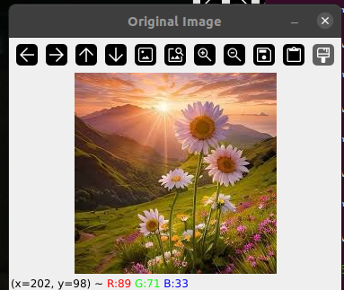**Output**

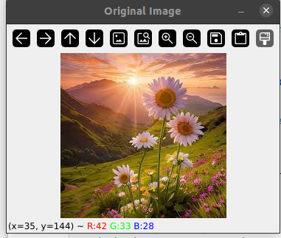

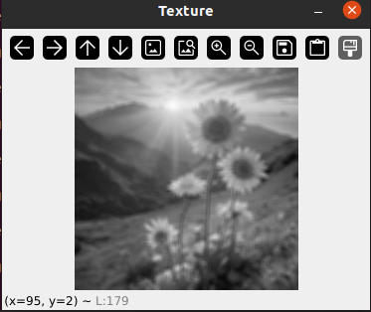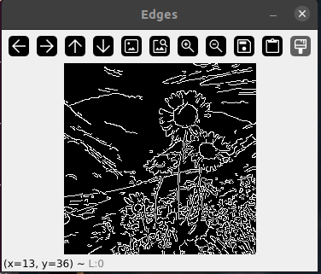

## Program 10

## Write a program to blur and smoothing an image.

import numpy as np

import cv2

import matplotlib.pyplot as plt

img = cv2.imread("tiger.jpeg",cv2.IMREAD_GRAYSCALE)

image_array = np.array(img)

print(image_array)

def sharpen():

return np.array([[1,1,1],[1,1,1],[1,1,1]])

def filtering(image, kernel):

m, n = kernel.shape

if (m == n):

y, x = image.shape

y = y - m + 1 # shape of image - shape of kernel + 1

x = x - m + 1

new_image = np.zeros((y,x))

for i in range(y):

for j in range(x):

new_image[i][j] = np.sum(image[i:i+m, j:j+m]*kernel)

return new_image

# Display the original and sharpened images

plt.figure(figsize=(10, 5))

plt.subplot(1, 2, 1)

plt.imshow(image_array,cmap='gray')

plt.title("Original Grayscale Image")

plt.axis("off")

plt.subplot(1, 2, 2)

plt.imshow(filtering(image_array, sharpen()),cmap='gray')

plt.title("Blurred Image")

plt.axis("off")

plt.show()

**OUTPUT**

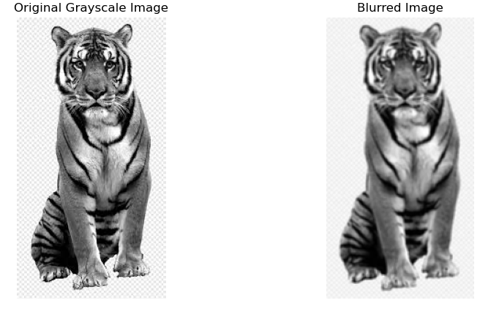

## Program 11

## Write a program to contour an image.

import cv2

import numpy as np

image_path = '1.png'

image = cv2.imread(image_path)

# Convert the image to grayscale (contours work best on binary images)

gray = cv2.cvtColor(image, cv2.COLOR_BGR2GRAY)

# Apply thresholding (you can use other techniques like Sobel edges)

_, binary_image = cv2.threshold(gray, 127, 255, cv2.THRESH_BINARY)

# Find contours

contours, _ = cv2.findContours(binary_image, cv2.RETR_EXTERNAL, cv2.CHAIN_APPROX_SIMPLE)

# Draw all contours on the original image

cv2.drawContours(image, contours, -1, (0, 255, 0), 3)

# Display the result

cv2.imshow('Contours', image)

cv2.waitKey(0)

cv2.destroyAllWindows()

## Output

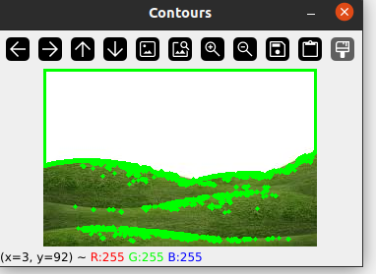

## Program 12

## Write a program to detect a face/s in an image.

import cv2

# Load the pre-trained Haar Cascade classifier for face detection

face_cascade = cv2.CascadeClassifier(cv2.data.haarcascades + 'haarcascade_frontalface_default.xml')

eye_cascade = cv2.CascadeClassifier(cv2.data.haarcascades + 'haarcascade_eye.xml')

# Read the input image (replace 'your_image.jpg' with the actual image path)

image_path = 'face.jpeg'

image = cv2.imread(image_path)

# Convert the image to grayscale

gray = cv2.cvtColor(image, cv2.COLOR_BGR2GRAY)

# Detect faces in the image

faces = face_cascade.detectMultiScale(gray, scaleFactor=1.3, minNeighbors=5)

# Draw rectangles around detected faces

for (x, y, w, h) in faces:

cv2.rectangle(image, (x, y), (x + w, y + h), (255, 0, 0), 2)

# Save or display the result

cv2.imwrite('detected_faces.jpg', image) # Save the result

cv2.imshow('Detected Faces', image) # Display the result

cv2.waitKey(0)

cv2.destroyAllWindows()

**Output**

