AUTO TICKET CLASSIFICATION USING FLOW DESIGNER
Project Documentation | ServiceNow Flow Designer

TEAM ID | SWTID – 2026 - 7454
TEAM LEADER | KEERTHANA S | keerthiselvaraj2007@gmail.com
TEAM MEMBER | DHARSHINI S | dharshiniselvaraju25@gmail.com
TEAM MEMBER | JANANI S | jananiprincess15@gmail.com
TEAM MEMBER | MONISHA K | monilinghes@gmail.com
TEAM MEMBER | SARANYA R | rsaranya5045@gmail.com

1. Introduction

1.1 Project Overview
IT support teams receive tickets about issues such as network access, software errors, employee services, and finance applications. Manually reviewing and assigning every ticket can delay responses and lead to inconsistent routing. This project demonstrates a proposed ServiceNow Flow Designer workflow that classifies incoming tickets and routes them to the appropriate support category.

1.2 Objective
- To design an automated ticket-classification flow.
- To use an AI Classifier step to identify the ticket category.
- To evaluate the classification result with a condition or branching step.
- To set the category variable and route tickets to the appropriate team.
- To notify the responsible team and review the flow output.

1.3 Project Outcome
The example workflow shown in this document illustrates a successful run for ticket TCK-10045. The sample ticket, “Cannot access VPN,” is classified as IT Support with a confidence score of 92%, and an email notification is shown as sent to the IT Support team. These are illustrative sample results for the design, not evidence from a live ServiceNow instance.

1.4 Technologies and Components Used
ServiceNow Flow Designer — visual workflow design and execution.
AI Classifier — identifies the likely ticket category.
Condition / branching — directs processing based on the category.
Set Variable — stores the selected category.
Send Email — notifies the responsible support team.
Ticket record — supplies the subject, description, priority, and ticket identifier.

2. Problem Statement and Proposed Solution

2.1 Problem Statement
When ticket triage is performed manually, staff must read each request, determine its topic, identify the responsible team, and send it to that team. This can increase handling time and create inconsistent assignments.

2.2 Proposed Solution
Use Flow Designer to start when a ticket is submitted, pass the ticket text to a classification step, evaluate the predicted category, set the category field, and notify the team that should handle the request. Low-confidence or unmatched tickets can be sent to a manual-review queue.

2.3 Process Flow
- A user submits a support ticket.
- The flow receives the ticket details.
- The AI Classifier analyses the subject and description.
- A condition checks the predicted category.
- The flow branches to IT Support, HR, Finance, or Other.
- A Set Variable step stores the category and routing value.
- The responsible team receives an email notification.
- The ticket and flow execution result can be reviewed.

2.4 Scope
- Automated category prediction and basic routing.
- Example categories: IT Support, HR, Finance, and Other.
- A sample output panel for a completed flow run.
- Basic validation of category, confidence score, and notification result.

2.5 Out of Scope
- A live ServiceNow implementation or verified production execution.
- Training or fine-tuning a custom AI model.
- Complex SLA management, escalation policies, or integrations with external ticketing platforms.
- Automatic resolution of the underlying issue.

3. Implementation

3.1 Create the Flow
- Open Flow Designer in the ServiceNow instance.
- Create a new flow and give it a clear name, such as “Auto Ticket Classification”.
- Choose the appropriate trigger for new or updated support tickets.
- Add the classification and routing steps.

3.2 Configure the Trigger
Configure the flow to start when a support ticket is created or submitted. Make the ticket identifier, short description, full description, and priority available to later steps. The exact trigger depends on the table and ServiceNow configuration used.

3.3 Add the Classification Step
Add an AI classification action or a configured classification service. Provide the ticket subject and description as input and define the allowed categories. Review the returned category and confidence score before using them for routing.

3.4 Configure Branching and Variables
Add a condition or switch to branch according to the predicted category. Create branches for IT Support, HR, Finance, and Other. Set the category or assignment variable in each branch. Consider routing low-confidence predictions to a manual-review queue.

3.5 Notify the Responsible Team
Add a Send Email action after the routing decision, or within each branch if the message must be team-specific. Include the ticket number, subject, priority, predicted category, and a link to the ticket where available.

3.6 Activate and Test
Save and activate the flow after reviewing the configuration. Submit sample tickets covering each category, verify the predicted result and assigned route, and inspect the execution details. Confirm that notification actions succeed before considering the workflow ready for use.

4. Example Flow Designer Output

4.1 Sample Run Details
Sample ticket ID: TCK-10045
Subject: Cannot access VPN
Description: User is unable to connect to the VPN from home. Getting error 619.
Priority: High
Classification category: IT Support
Confidence score: 92%
Next step: Email notification sent to the IT Support team.

4.2 Output Screenshot
The following screenshot is a conceptual UI mock-up illustrating the proposed workflow and sample output. It is not a screenshot captured from a live ServiceNow system.

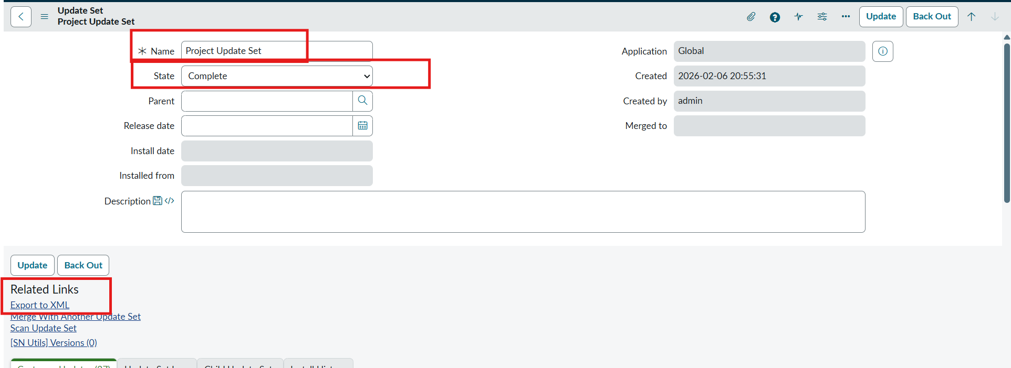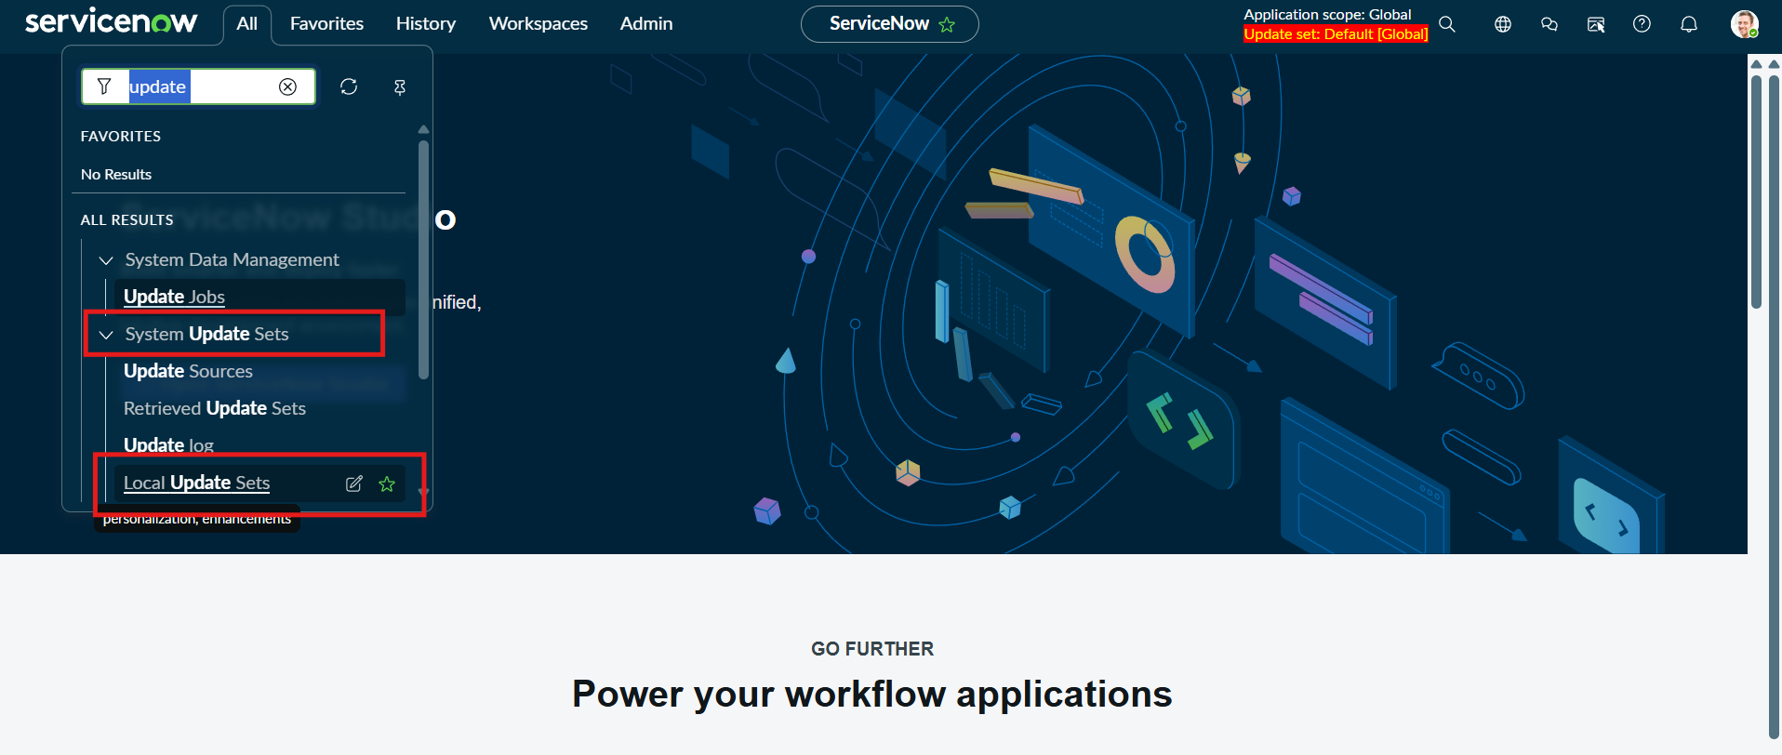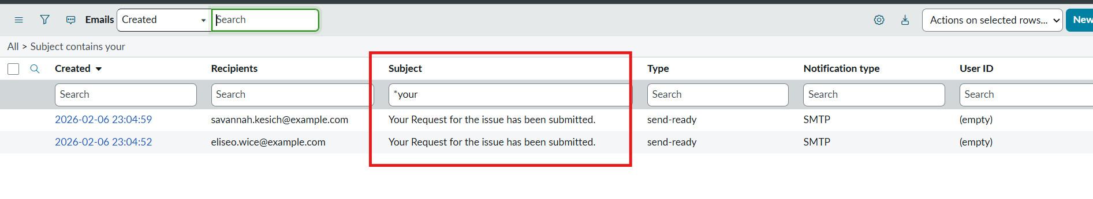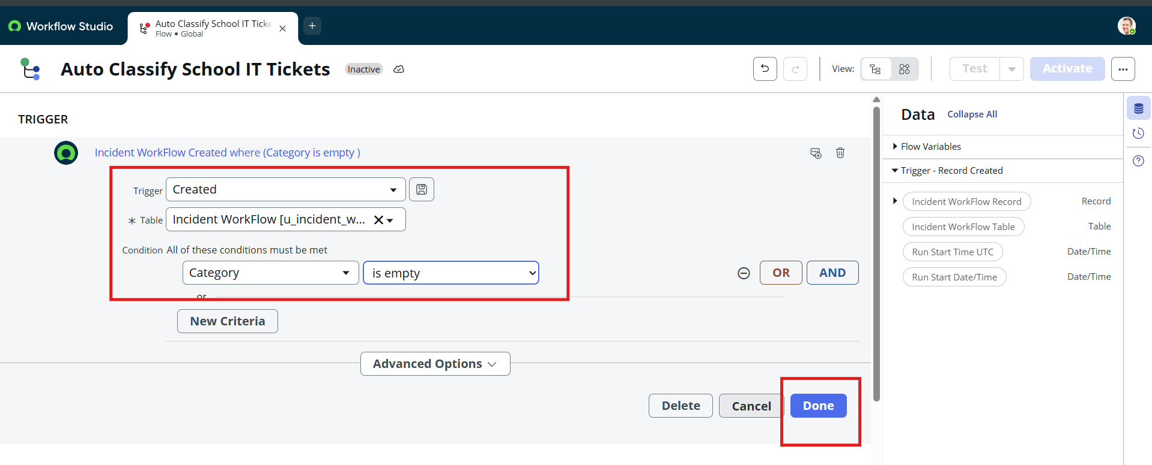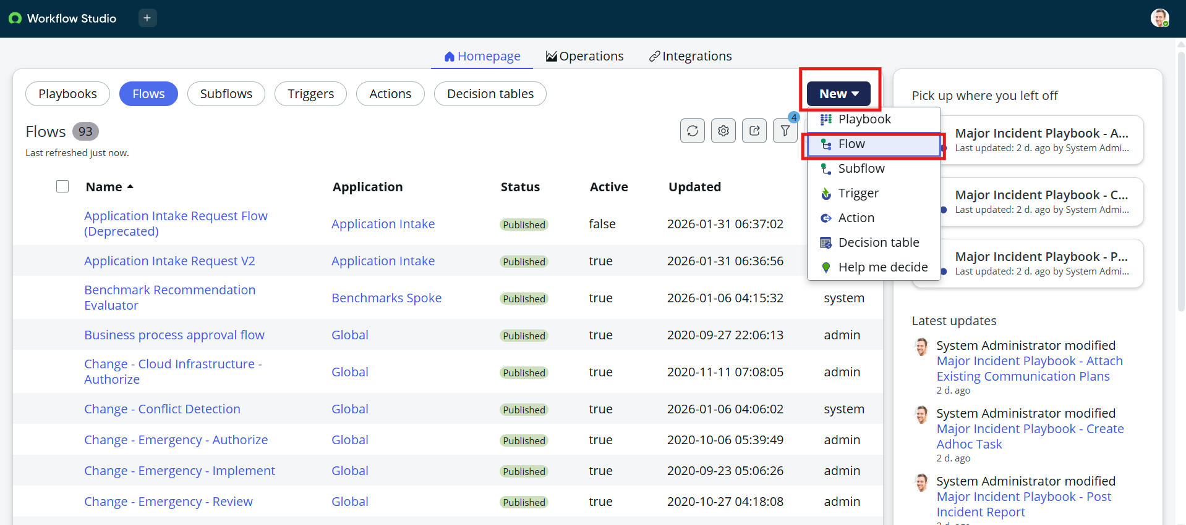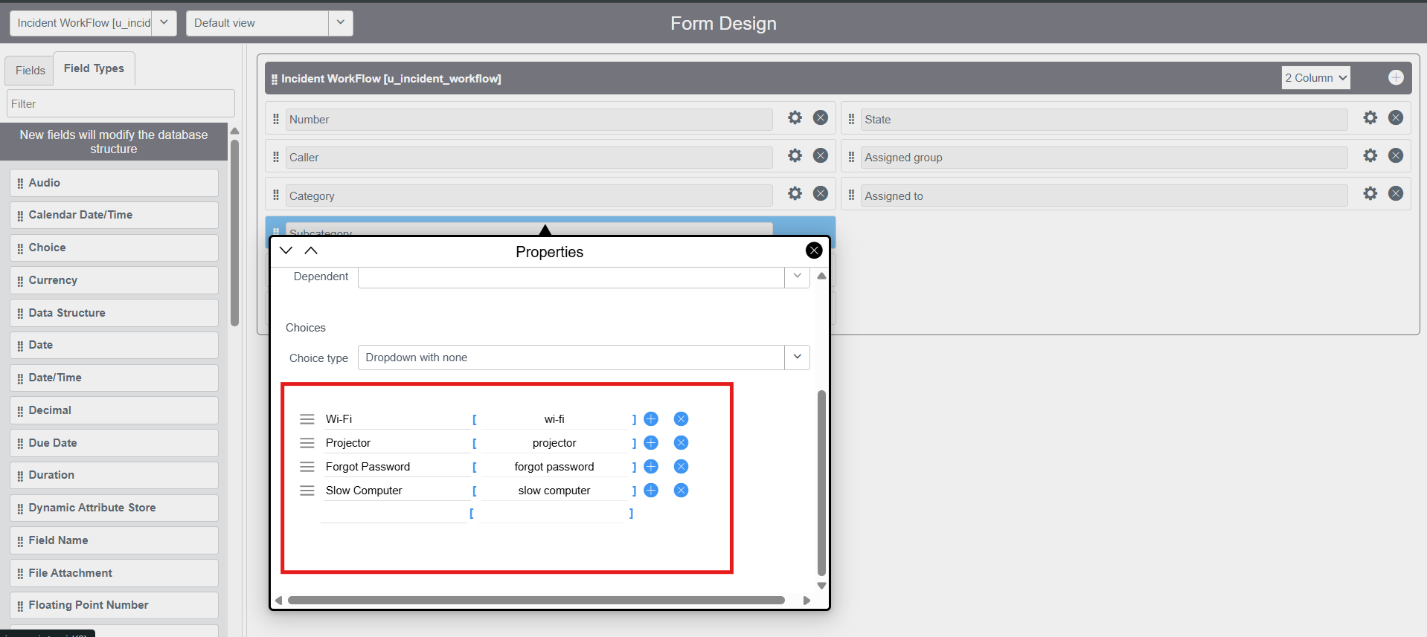

5. Testing and Validation

5.1 Test Cases
Test 1 — Flow configuration: verify the trigger, classifier, condition, variable updates, and notification steps are connected.
Test 2 — IT Support ticket: a VPN-access ticket should be routed to IT Support.
Test 3 — HR ticket: a leave or employee-benefit ticket should be routed to HR.
Test 4 — Finance ticket: a payroll or expense ticket should be routed to Finance.
Test 5 — Low-confidence ticket: the flow should send uncertain predictions for manual review.
Test 6 — Notification: confirm the correct team receives the ticket details.

5.2 Validation Checklist
- The flow starts for a valid ticket.
- Ticket subject and description reach the classifier.
- The predicted category is one of the configured values.
- Branching and assignment values match the category.
- Low-confidence results have a safe fallback.
- Email notification status is checked in the flow execution details.

6. Benefits, Limitations and Future Enhancements

6.1 Benefits
- Reduces repetitive manual triage.
- Encourages consistent ticket categorization.
- Helps route requests to the appropriate support team.
- Improves visibility into workflow execution.
- Provides a foundation for reporting and future automation.

6.2 Limitations
- Classification quality depends on ticket text and model configuration.
- A confidence score does not guarantee that the predicted category is correct.
- The sample screenshot and run data are illustrative only.
- Actual actions, available AI capabilities, and field names depend on the ServiceNow instance and licensed features.

6.3 Future Enhancements
- Add a manual-review path for uncertain results.
- Record classification accuracy and correction rates.
- Add priority-based escalation and SLA rules.
- Integrate assignment groups and ticket links.
- Periodically review misclassified tickets and refine category definitions.

7. Conclusion
Auto Ticket Classification using Flow Designer is a proposed approach for streamlining support-ticket triage. By combining ticket input, AI-based category prediction, conditional routing, variable updates, and team notification, the workflow can help make classification more consistent and reduce manual effort. A production deployment should be tested against real tickets and monitored for accuracy and routing reliability.

8. Key Learnings
- How to organize a workflow into trigger, action, condition, and notification steps.
- Why clear category definitions are important for classification.
- How branch logic can route different ticket types.
- Why confidence thresholds and manual review are useful safeguards.
- How to validate workflow outcomes using execution details.

Appendix A — Configuration Summary
Flow name: Auto Ticket Classification
Trigger: New support ticket (configuration-dependent)
Classification step: AI Classifier / configured classification action
Categories: IT Support, HR, Finance, Other
Routing logic: Condition or switch
Variable action: Set category / assignment value
Notification: Send Email to the responsible support team
Example ticket: TCK-10045 — Cannot access VPN
Example result: IT Support, 92% confidence (illustrative)

