Smart Door bell

**Objectives**  
1. To understand the Smart doorbell using IR sensor and buzzer.  
2. To understand how to control ON/OFF operations automatically using Arduino  
UNO.  
**Learning Outcomes**1. Students will learn about the automatic work of the smart doorbell.  
2. Students will get the knowledge about how the sensors interact with the  
Arduino.  
**Apparatus required**  
● IR sensor  
● Arduino UNO  
● Buzzer  
● Jumper wires  
● Bread boar

**Circuit Diagram**

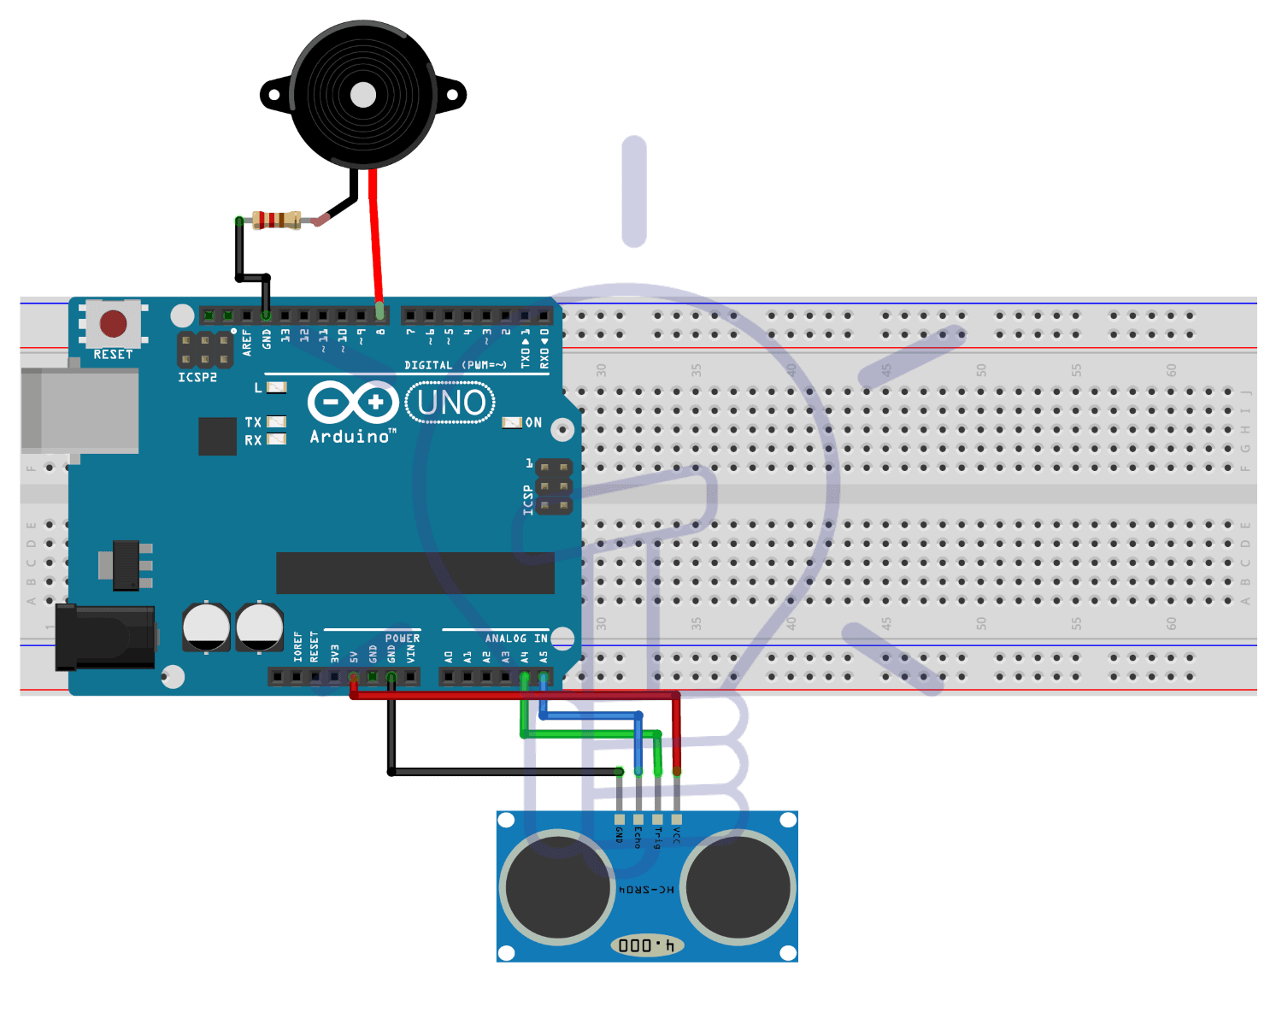

**Components description**  
**IR sensor**  
IR sensors are now widely used in motion detectors, which are used in  
building services to switch on lamps or in alarm systems to detect  
unwelcome guests. In a defined angle range, the sensor elements detect  
the heat radiation (infrared radiation) that changes over time and  
space due to the movement of people.  
**Buzzer**  
A buzzer or beeper is an audio signaling device, which may be mechanical,  
electromechanical, or piezoelectric (piezo for short). Typical uses of  
buzzers and beepers include alarm devices, timers, train and confirmation  
of user input such as a mouse click or keystroke.

**Procedure**  
➢ Take the Arduino uno board, IR sensor and buzzer  
➢ Connect the 5V input terminal of Arduino to the VCC of the ir sensor, GND  
pin of the arduinoz to the GND pin in the ir sensor and power pin of the ir  
sensor to 8th digital pin of the ir sensor.  
➢ Now take the buzzer and connect the positive pin of the buzzer to the 9th  
digital pin of arduino and the negative pin of the buzzer to ground pin of the  
arduino