Database System Engineering and Distributed Backend Development
Course Code: 25CS1302E
ACID PROPERTIES & ISOLATION
Name: M. Keerthi Sri
Roll no: 2520030079

Query 1
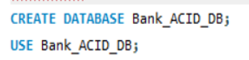
Output
Query 2
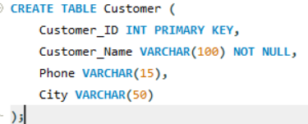
Output
Query 3
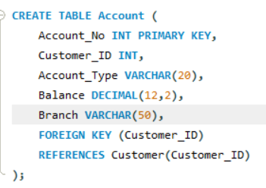
Output
Query 4
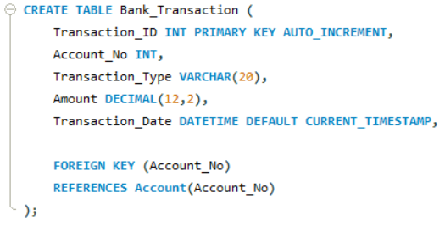
Output

Query 5
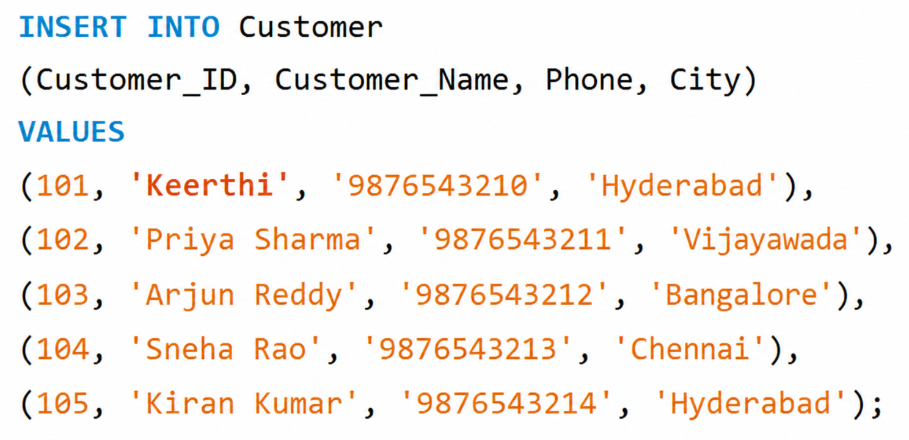
Output
Query 6
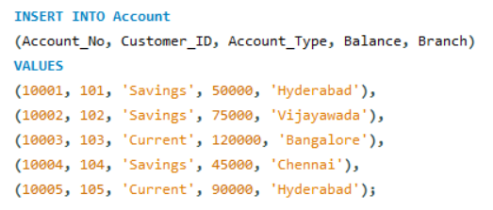
Output
Query 7
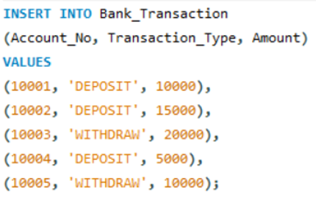
Output
Query 8

Output
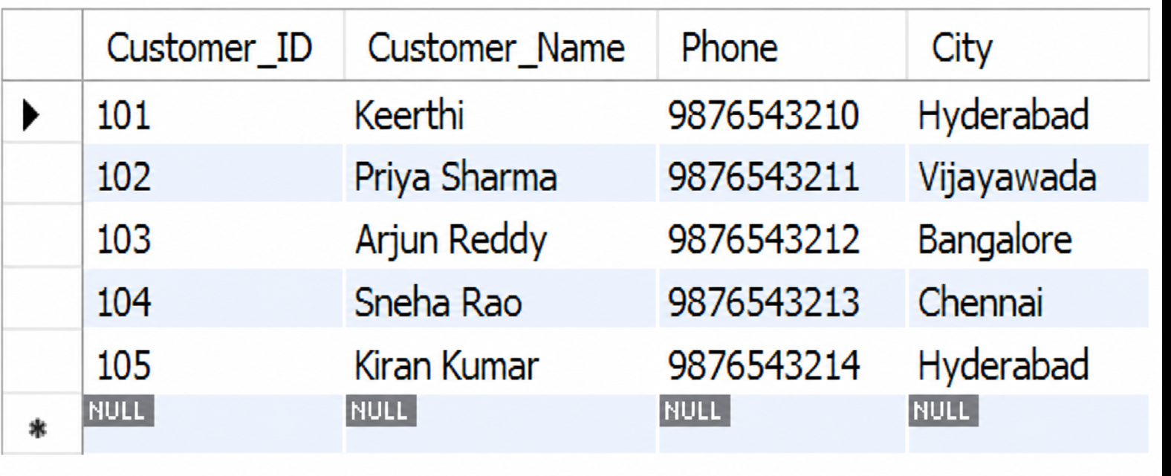
Query 9

Output
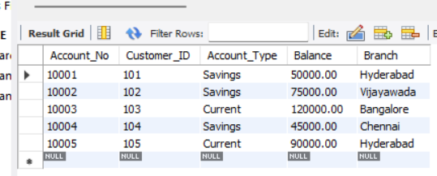
Query 10
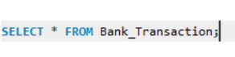
Output
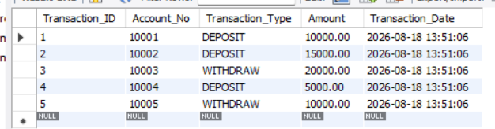
Query 11
Output
Query 12
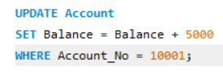
Output
Query 13
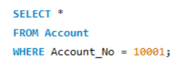
Output
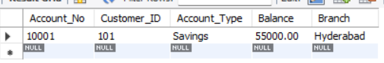
Query 14

Output
Query 15
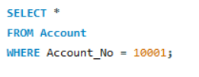
Output
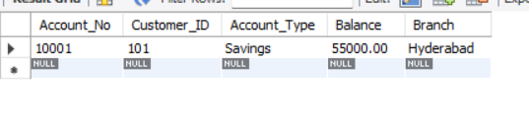
Query 16

Output
Query 17
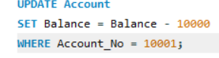
Output
Query 18
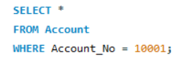
Output
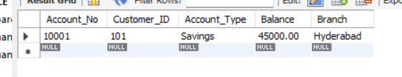
Query 19

Output
Query 20
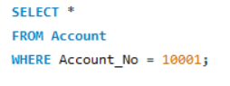
Output
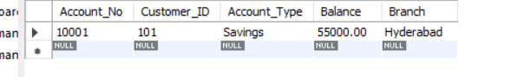
Query 21

Output
Query 22
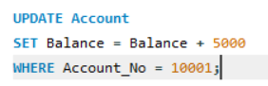
Output
Query 23

Output
Query 24
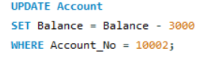
Output
Query 25

Output
Query 26
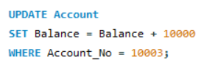
Output
Query 27
Output
Query 28
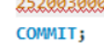
Output
Query 29
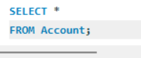
Output
