# E-COMMERCE WEBSITE ON **‘**DIVINE PARADISE’

**A Project work submitted to the RVS College of Arts & Science(Autonomous) in fulfillment of the requirements for the award of the Degree of**

**BACHELOR OF COMMERCE WITH INFORMATION TECHNOLOGY**

**Submitted by**

**MANISH M**

**(Reg no:1U21BI041)**

Under the Guidance of

 **Dr. P. AMUTHA,** M.Com..M.Phil..Ph.D.,

SCHOOL OF COMMERCE

# RVS COLLEGE OF ARTS & SCIENCE (AUTONOMOUS)

**SULUR, COIMBATORE-64140 MARCH-2024**

# CERTIFICATE

This is to certify that this Project entitled **E-COMMERCE WEBSITE ON “DIVINE PARADISE”**submitted in the partial fulfillment of the requirements for the award of the Degree of **BACHELOR OF COMMERCE WITH INFORMATION TECHNOLOGY** to RVS College of Arts & Science (Autonomous), Sulur Coimbatore, is a bonafide record carried out by

**MANISH M**

(Reg.No:1U21BI041)

Under my supervision and guidance and we certify that the work done is original

**HOD GUIDE**

**Viva voce Examination held on**

**External Examiner Internal Examiner**

# DECLARATION

I, hereby, declare that the project work entitled **E-COMMERCE WEBSITE ON “DIVINE PARADISE*”*** submitted to the **RVS College of Arts & Science (Autonomous)** in partial fulfillment of the requirements for the award of the Degree of **BACHELOR OF COMMERCE WITH INFORMATION TECHNOLOGY**, is the original work done by me under the supervision and guidance of **Dr. P. AMUTHA,** M.Com..M.Phil..Ph.D., School of Commerce, RVS College of Arts and Science Autonomous ) , Sulur, Coimbatore and that has not formed the basis for the award of any Degree / Diploma / Associateship / Fellowship or any other similar title to any candidate to any university.

**Signature of the Candidate**

**ACKNOWLEDGEMENT**

I thank the Almighty for the blessing that have been showed upon me to complete the

Project work successfully.

I am also thankful to **Dr. T.SIVAKUMAR, PRINCIPAL,** RVS College of Arts & Science (Autonomous), Sulur, Coimbatore for his encouragement and inspiration in successful completion of this Major Project work.

I would like to thank, **Dr. P. AMUTHA,** M.Com. .M.Phil.. Ph.D., **HEAD OF THE**

**DEPARTMENT**, School of Commerce**,** Department of Commerce with Information Technology, RVS College of Arts & Science (Autonomous), Sulur, Coimbatore for providing all facilities and kind assistance throughout the period of research.

I also express my thanks to my Guide **Dr. P. AMUTHA,** M.Com..M.Phil..Ph.D.,

School of Commerce, Department of Commerce with Information Technology, RVS College of Arts & Science (Autonomous), Sulur, Coimbatore for her benevolent, constant encouragement, help and critical reading of the manuscript to complete this project successfully.

I would like to thank all the staff members of School of Commerce, Department of Commerce with Information Technology my friends and my beloved parents who have helped me, both directly and indirectly during the course of this study.

**TABLE OF CONTENT**

|  |  |  |
| --- | --- | --- |
| **S.NO** | **CONTENT** | **PAGE NO.** |
| **1** | **INTRODUCTION** |  |
| **2** | **E-COMMERCE WEBSITE** |  |
| **3** | **WEB DEVELOPMENT** |  |
|  | **3.1 INTRODUCTION** |  |
|  | **3.1 WEB PAGE** |  |
|  | **3.2 WEBSITE** |  |
| **4** | **TECHNOLOGIES USED** |  |
|  | **4.1 HTML5 STRUCTURE** |  |
|  | **4.2 CSS3 STYLING** |  |
|  | **4.3 JAVASCRIT INTERACTIVITY** |  |
| **5** | **KEY PAGES** |  |
| **6** | **SOFTWARE & HARDWARE REQUIREMENT SPECIFICATION** |  |
| **7** | **OUTPUT SCREENS** |  |
| **8** | **CONCLUSION** |  |
| **9** | **BIBLIOGRAPHY** |  |
| **10** | **SAMPLE SOURCE CODE** |  |

1. **INTRODUCTION**

**E-COMMERCE WEBSITE ON “DIVINE PARADISE”** is the simple shopping solution. This project has been developed on HTML, CSS,. JAVASCRIT. Your premier destination for botanical sanctuary where gardening enthusiasts and nature lovers converge to indulge in a sensory journey of plant exploration and horticultural delight.

**OBJECTIVES**:

1. Offering a diverse selection of high-quality plants , trees, shrubs, and flowers.
2. Providing expert advice on plant selection, care, and maintenance.
3. Promoting environmental sustainability through eco-friendly gardening practices and products.
4. Creating a welcoming and inspiring atmosphere that encourages customer to explore and enjoy gardening.
5. **E-COMMERCE WEBSITE**

**2.1 Introduction**

An e-commerce website, short for electronic commerce website, is an online platform that allows businesses and individuals to conduct buying and selling of goods and services over the internet. These websites facilitate online transactions and the exchange of money for products or services.

**Key features of an e-commerce website typically include:**

**Product Catalog:** A display of products or services with detailed information such as images, descriptions, and prices.

**Shopping Cart:** An interactive feature that allows users to add products to a virtual cart, review their selections, and proceed to checkout.

**Responsive Design:** Ensuring the website is accessible and functional across various devices, including desktops, tablets, and smartphones.

**Search and Navigation:** Easy navigation and search features to help users find products quickly and efficiently.

**Product Reviews :** Customer feedback to assist shoppers in making informed decisions.

1. **WEB DEVELOPMENT**

**3.1 Introduction**

Web development is a broad term for the work involved in developing a web site for the Internet (World Wide Web) or an intranet (a private network). Web development can range from developing the simplest static single page of plain text to the most complex web-based internet applications, electronic businesses, and social network services. A more comprehensive list of tasks to which web development commonly refers, may include web engineering, web design, web content development, client liaison, client-side/side scripting, web server and network security configuration, and e-commerce development. Among web professionals, "web development" usually refers to the main non-design aspects of building web sites: writing markup and coding. Most recently Web development has come to mean the creation of content management systems or CMS. These CMS can be made from scratch, proprietary or open source. In broad terms the CMS acts as middleware between the database and the user through the browser. A principle benefit of a CMS is that it allows non-technical people to make changes to their web site without having technical knowledge.

For larger organizations and businesses , web development teams can consist of hundreds of people (web developers) and follow standard methods like Agile methodologies while developing websites. Smaller organizations may only require a single permanent or contracting developer, or secondary assignment to related job positions such as a graphic designer or information systems technician . Web development may be a collaborative effort between departments rather than the domain of a designated department. There are three kind of web developer specialization: front-end developer, back-end developer, and full-stack developer.

**3.2 WEB-SITE**

A website is a collection of related web pages, including multimedia content, typically identified with a common domain name, and published on at least one web server. A website may be accessible via a public Internet Protocol (IP) network, such as the Internet, or a private local area network (LAN), by referencing a uniform resource locator (URL) that identifies the site.

Websites have many functions and can be used in various fashions; a website can be a personal website, a commercial website for a company, a government website or a non-profit organization website. Websites are typically dedicated to a particular topic or purpose, ranging from entertainment and social networking to providing news and education. All publicly accessible websites collectively constitute the World Wide Web, while private websites, such as a company's website for its employees, and are typically a part of an intranet.

Web pages, which are the building blocks of websites, are documents, typically composed in plain text interspersed with formatting instructions of Hypertext Markup Language (HTML, XHTML). They may incorporate elements from other websites with suitable markup anchors. Web pages are accessed and transported with the Hypertext Transfer Protocol (HTTP), which may optionally employ encryption (HTTP Secure, HTTPS) to provide security and privacy for the user. The user's application, often a web browser, renders the page content according to its HTML markup instructions onto a display terminal.

Hyperlinking between web pages conveys to the reader the site structure and guides the navigation of the site, which often starts with a home page containing a directory of the site web content. Some websites require user registration or subscription to access content. Examples of subscription websites include many business sites, news websites, academic journal websites, gaming websites, file-sharing websites, message boards, web-based email, social networking websites, websites providing real-time stock market data, as well as sites providing various other services. As of 2016 end users can access websites on a range of devices, including desktop and laptop computers, tablet computers, smartphones and smart TVs.

A web site consists of web pages which are interconnected to each other and contain various data and functionalities.

## 3.3 WEB-PAGE

A **web page, or webpage,** is a document that is suitable for the World Wide Web and web browsers. A web browser displays a web page on a monitor or mobile device. The web page is what displays, but the term also refers to a computer file, usually written in HTML or comparable markup language. Web browsers coordinate the various web resource elements for the written web page, such as style sheets, scripts, and images, to present the web page.

Typical web pages provide hypertext that includes a navigation bar or a sidebar menu to other web pages via hyperlinks, often referred to as links.

On a network, a web browser can retrieve a web page from a remote web server. On a higher level, the web server may restrict access to only a private network such as a corporate intranet or it provides access to the World Wide Web. On a lower level, the web browser uses the Hypertext Transfer Protocol (HTTP) to make such requests.

A static web page is delivered exactly as stored, as web content in the web server's file system, while a dynamic web page is generated by a web application that is driven by server­ side software or client-side scripting. Dynamic website pages help the browser (the client) to enhance the web page through user input to the server.

1. **TECHNOLOGIES USED**
2. **HTML5**
3. **CSS3**
4. **JAVASCRIPT**

**4.1 HTML 5**

Hypertext Markup Language (HTML) is the standard markup language for creating web pages and web applications. With Cascading Style Sheets (CSS) and JavaScript it forms a triad of cornerstone technologies for the World Wide Web. Web browsers receive HTML documents from a webserver or from local storage and render them into multimedia web pages. HTML describes the structure of a web page semantically and originally included cues for the appearance of the document.

HTML elements are the building blocks of HTML pages. With HTML constructs, images and other objects, such as interactive forms, may be embedded into the rendered page. It provides a means to create structured documents by denoting structural semantics for text such as headings, paragraphs, lists, links, quotes and other items. HTML elements are delineated by tags, written using angle brackets. Tags such as <img /> and <input /> introduce content into the page directly. Others such as <p>...</p> surround and provide information about document text and may include other tags as sub-elements. Browsers do not display the HTML tags, but use them to interpret the content of the page.

HTML can embed programs written in a scripting language such as JavaScript which affect the behavior and content of web pages. Inclusion of CSS defines the look and layout of content. The World Wide Web Consortium (W3C), maintainer of both the HTML and the CSS standards, has encouraged the use of CSS over explicit presentational HTML since 1997.

HTML markup consists of several key components, including those called tags (and their attributes), character-based data types, character references and entity references. HTML tags most commonly come in pairs like <hl> and </h l>, although some represent empty elements and so are unpaired, for example <img>. The first tag in such a pair is the start tag, and the second is the end tag (they are also called opening tags and closing tags).

Another important component is the HTML document type declaration, which triggers standards mode rendering.

<!DOCTYPE html>

<html>

<head>

<title>This is a title</title>

</head>

<body>

<p>Hello world!</p>

</body>

</html>

(The text between <html> and </html> describes the web page, and the text between <body> and </body> is the visible page content. The markup text "<title>This is a title</title>" defines the browser page title.)

The Document Type Declaration <!DOCTYPE html> is for HTML5. If a declaration is not included, various browsers will revert to "quirks mode" for rendering.

**4.2 CSS 3**

Cascading Style Sheets (CSS) is a style sheet language used for describing the presentation of a document written in a markup language. Although most often used to set the visual style of web pages and user interfaces written in HTML and XHTML, the language can be applied to any XML document, including plain XML, SVG and XUL, and is applicable to rendering in speech, or on other media. Along with HTML and JavaScript , CSS is a cornerstone technology used by most websites to create visually engaging webpages, user interfaces for web applications, and user interfaces for many mobile applications.

CSS is designed primarily to enable the separation of presentation and content, including aspects such as the layout, colors, and fonts. This separation can improve content accessibility, provide more flexibility and control in the specification of presentation characteristics, enable multiple HTML pages to share formatting by specifying the relevant CSS in a separate .css file, and reduce complexity and repetition in the structural content.

Separation of formatting and content makes it possible to present the same markup page in different styles for different rendering methods, such as on-screen, in print, by voice (via speech-based browser or screen reader), and on Braille-based tactile devices. It can also display the web page differently depending on the screen size or viewing device. Readers can also specify a different style sheet, such as a CSS file stored on their own computer, to override the one the author specified.

Changes to the graphic design of a document (or hundreds of documents) can be applied quickly and easily, by editing a few lines in the CSS file they use, rather than by changing markup in the documents.

The CSS specification describes a priority scheme to determine which style rules apply if more than one rule matches against a particular element. In this so-called cascade, prioritis (or weights) are calculated and assigned to rules, so that the results are predictable.

The CSS specifications are maintained by the World Wide Web Consortium (W3C). Internet media type (MIME type) text/css is registered for use with CSS by RFC 2318 (March 1998). The W3C operates a free CSS validation service for CSS documents.

**Types of CSS:**

• **Inline CSS:**

In this CSS is applied in between the tags

Eg: <tag style="styling">Hello World</tag>

• **Internal CSS:**

In this css code is defined inside the style tag in the head section of the HTML page.

General Syntax:

<html>

<head>

<style>

<!-- CSS STYLING -- >

</style>

</head>

</html>

• **External CSS:**

In this the CSS code is written on another page and is linked to the HTML page. It is advantageous to use this type of styling as we can use the same file to style various HTML pages.

External CSS uses the extension .css and is applied using the following syntax

<html>

<head>

<link relation="stylesheet" type="css"href="url to the page">

</head>

</html>

All the CSS style types are important but can be used in different situations.

• Inline CSS is used when only small changes are to be done to the HTML tag and the changes are to be reflected only to that specific tag

• Internal CSS is used when the individual HTML pages have to be designed differently. This also slows the page load system if the internal styling is long.

• External CSS files are maintained to design multiple pages and use common styles over various pages. It is useful as it helps in managing the resources in an easy manner.

**4.3 JAVASCRIPT**

JavaScript, often abbreviated as "JS", is a high-level, dynamic, untyped, and interpreted run-time language. It has been standardized in the ECMAScript language specification. Alongside HTML and CSS, JavaScript is one of the three core technologies of World Wide Web content production ; the majority of websites employ it, and all modem Web browsers support it without the need for plug-ins. JavaScript is prototype-based with first-class functions, making it a multi-paradigm language, supporting object-oriented, imperative, and functional programming styles. It has an API for working with text, arrays, dates and regular expressions, but does not include any 110, such as networking, storage, or graphics facilities, relying for these upon the host environment in which it is embedded.

**What is JavaScript?**

JavaScript (js) is a light-weight object-oriented programming language which is used by several websites for scripting the webpages. It is an interpreted, full-fledged programming language that enables dynamic interactivity on websites when applied to an HTML document. It was introduced in the year 1995 for adding programs to the webpages in the Netscape Navigator browser. Since then, it has been adopted by all other graphical web browsers. With JavaScript, users can build modern web applications to interact directly without reloading the page every time. The traditional website uses js to provide several forms of interactivity and simplicity.

Although, JavaScript has no connectivity with Java programming language. The name was suggested and provided in the times when Java was gaining popularity in the market. In addition to web browsers, databases such as CouchDB and MongoDB uses JavaScript as their scripting and query language.

**Features of JavaScript**

There are following features of JavaScript:

* All popular web browsers support JavaScript as they provide built-in execution environments.
* JavaScript follows the syntax and structure of the C programming language. Thus, it is a structured programming language.
* JavaScript is a weakly typed language, where certain types are implicitly cast (depending on the operation).
* JavaScript is an object-oriented programming language that uses prototypes rather than using classes for inheritance.
* It is a light-weighted and interpreted language.
* It is a case-sensitive language.
* JavaScript is supportable in several operating systems including, Windows, macOS, etc.
* It provides good control to the users over the web browsers.

**History of JavaScript**

In 1993, Mosaic, the first popular web browser, came into existence. In the year 1994, Netscape was founded by Marc Andreessen. He realized that the web needed to become more dynamic. Thus, a 'glue language' was believed to be provided to HTML to make web designing easy for designers and part-time programmers. Consequently, in 1995, the company recruited Brendan Eich intending to implement and embed Scheme programming language to the browser. But, before Brendan could start, the company merged with Sun Microsystems for adding Java into its Navigator so that it could compete with Microsoft over the web technologies and platforms. Now, two languages were there: Java and the scripting language. Further, Netscape decided to give a similar name to the scripting language as Java's. It led to 'Javascript'. Finally, in May 1995, Marc Andreessen coined the first code of Javascript named 'Mocha'. Later, the marketing team replaced the name with 'LiveScript'. But, due to trademark reasons and certain other reasons, in December 1995, the language was finally renamed to 'JavaScript'. From then, JavaScript came into existence.

1. **KEY PAGES**
2. **Home page:**

At the top of the page, the home page contains the website logo, navigation menu, search bar. It provides easy access to key areas of the site. Showcases its latest trends, collections and promotion of divine paradise.

1. **About page:**

The about page contain mission and vision of the divine paradise.

1. **Product Page:**

Displaying verity of flowers, plants, seeds, soil, accessories, home decors. Each product is showcased with multiple images, pricing information and a quick view option for easy browsing.

1. **Contact Page:**

Clear and prominent display of contact details, including the company’s email address, Phone number.

1. **SOFTWARE REQUIREMENT SPECIFICATION**

**6.1 Hardware Requirements**

The selection of hardware is very important in the existence and proper working of any software. When selecting hardware, the size and requirements are also important.

Processor :  APU Quad core A6 processor

RAM : 4.0 GB

Hard Disk Drive : 500 GB

**6.2 Software Requirements**

Operating system : Windows 10

Front End : HTML5, CSS3 & JAVASCRIPT

1. **OUTPUT SCREENS**

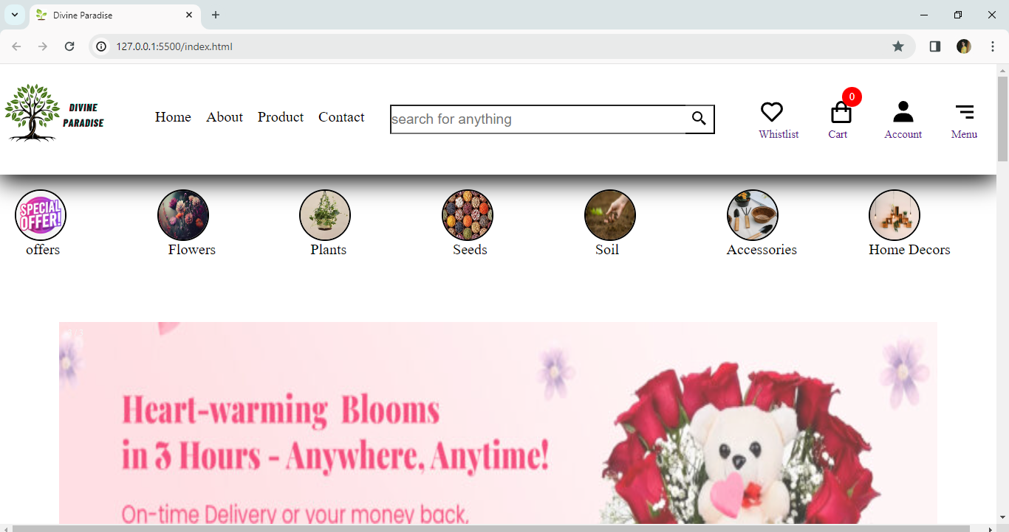

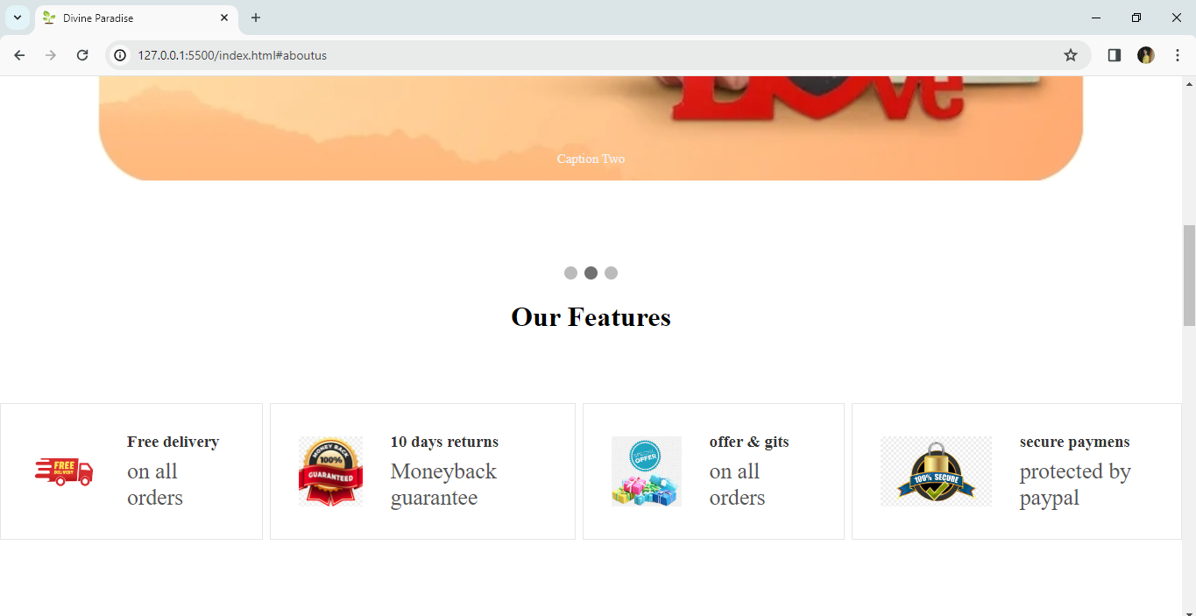

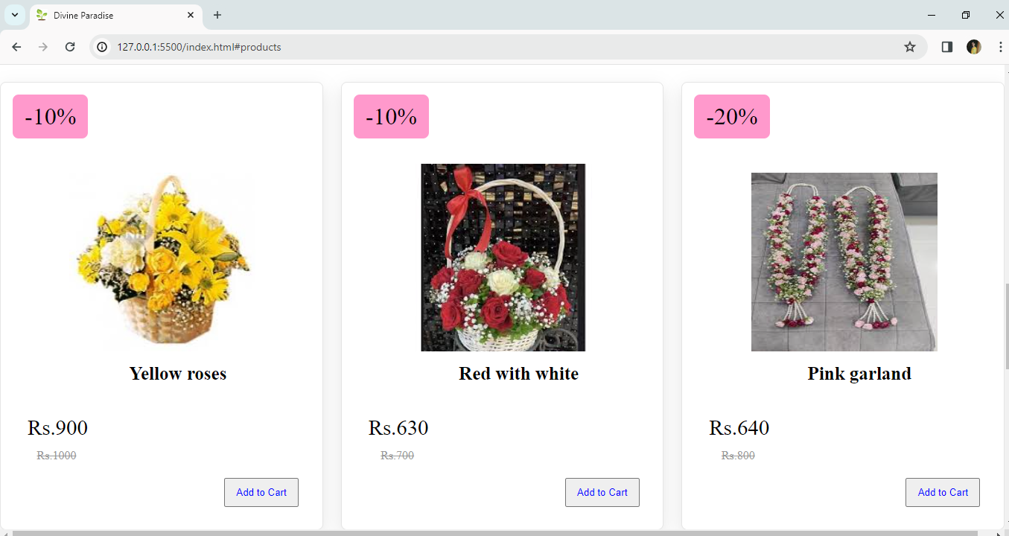

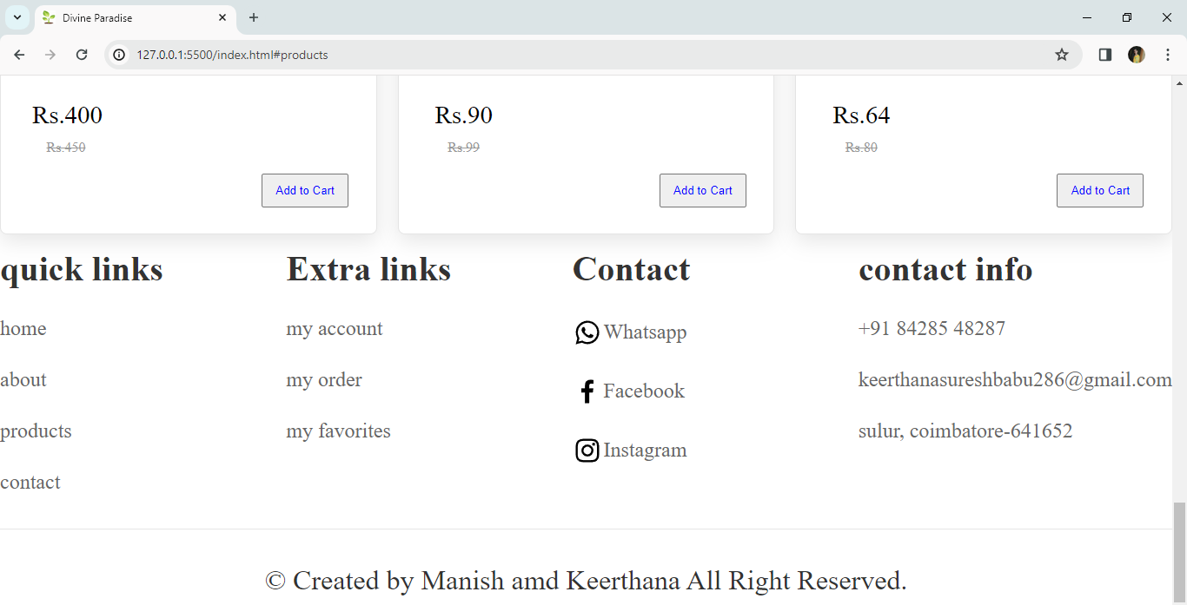

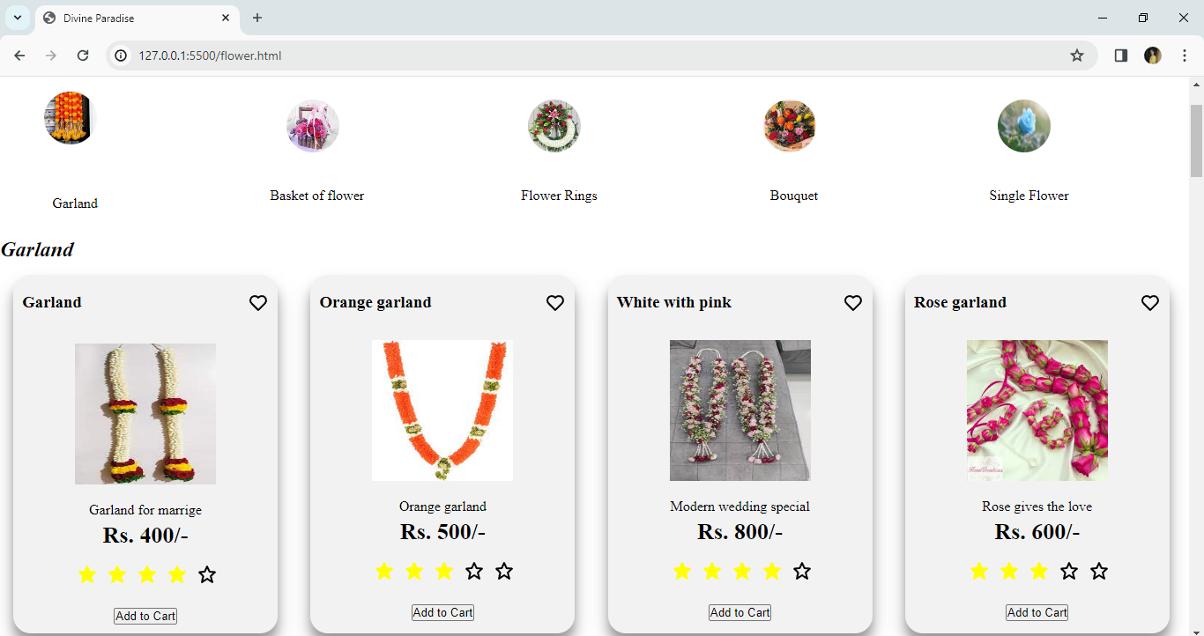

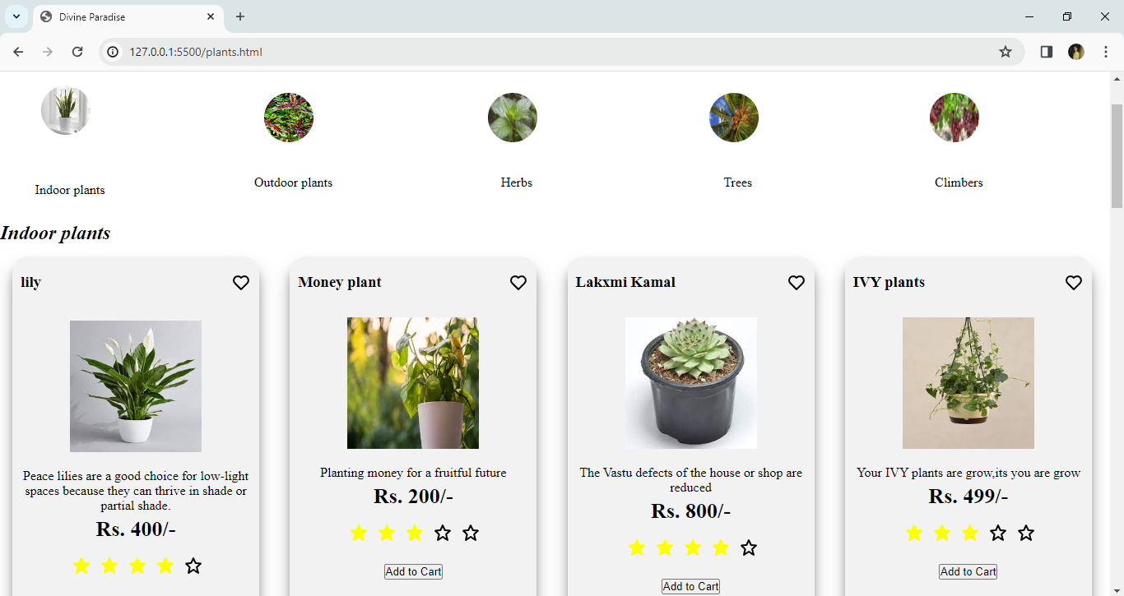

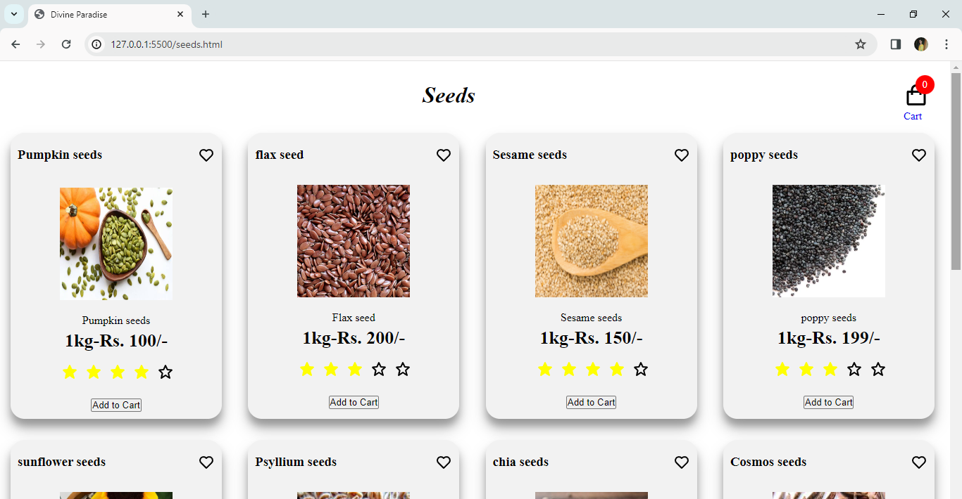

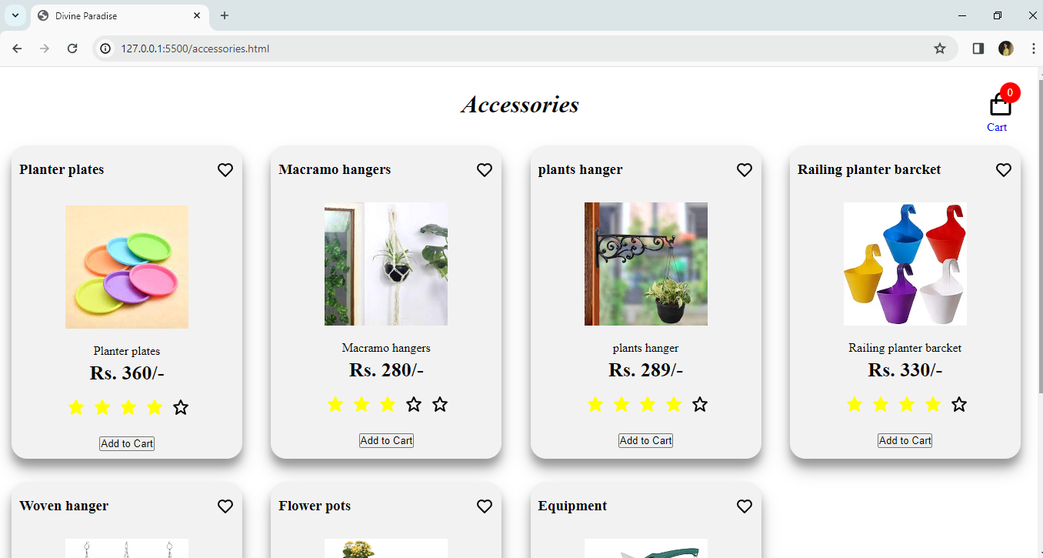

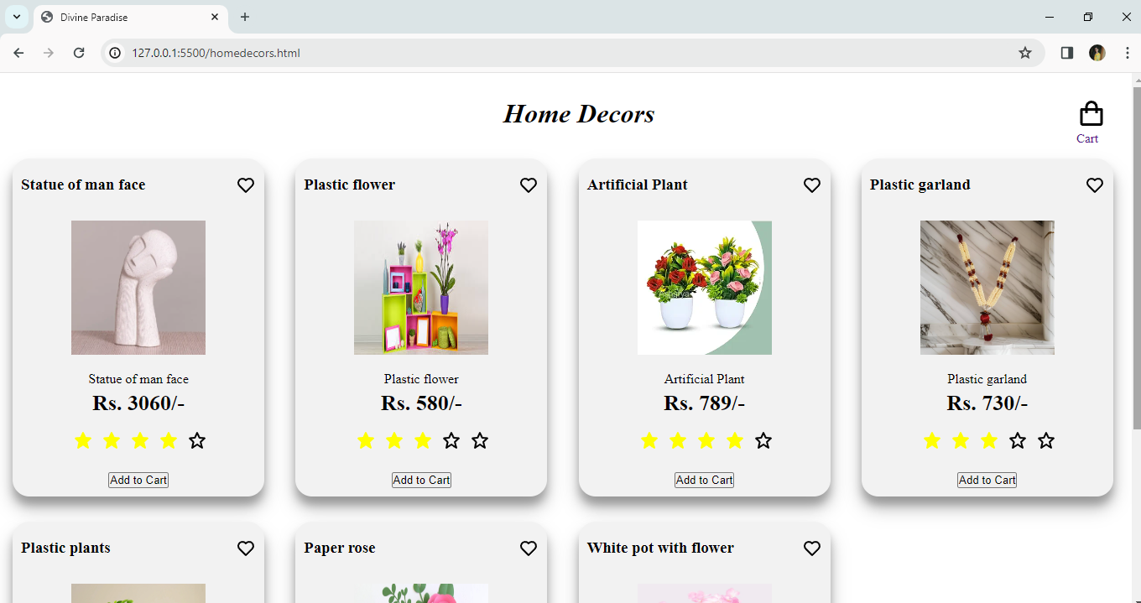

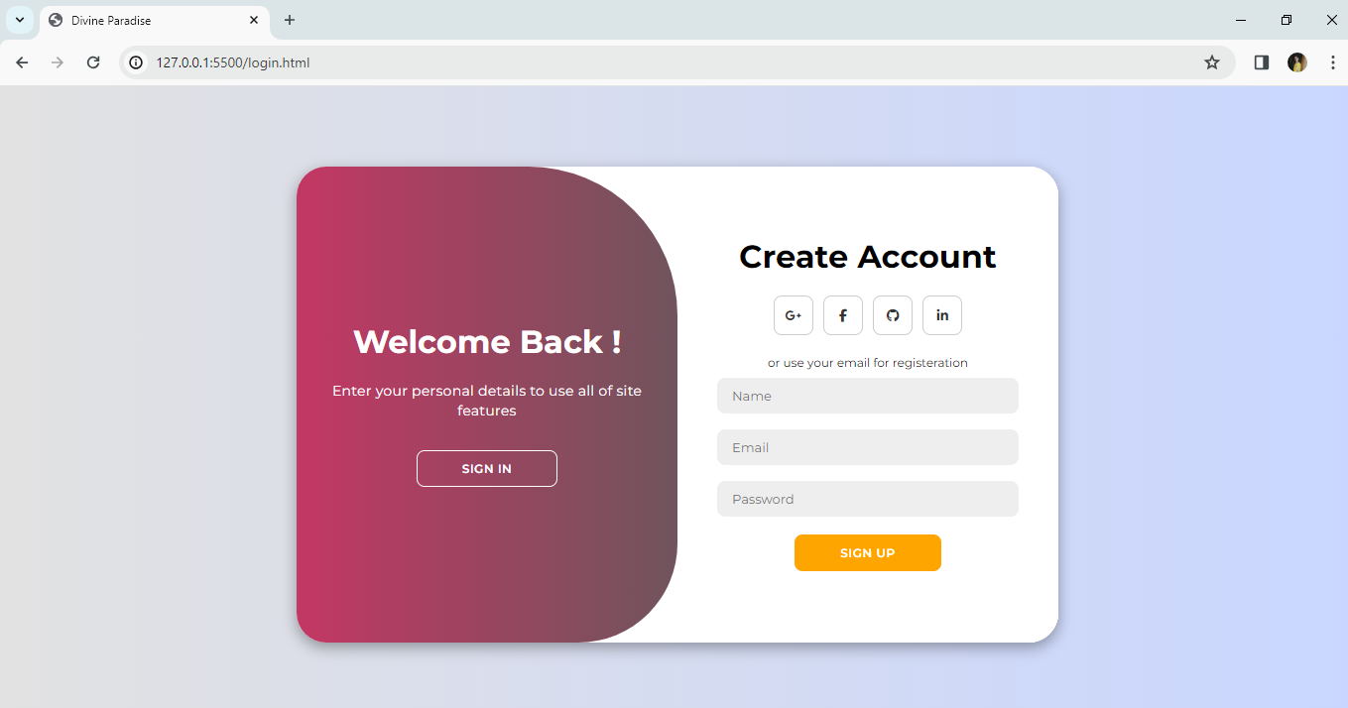

1. **CONCLUSION**

After having detail study on online shopping, we can see a great change in the behavior of people in many manners like their attitude, buying pattern. In earlier times people use to do manual shopping but now as time changed, people are becoming busy and due to which technology has brought a new revolution i.e., online shopping.

we're committed to providing the best for your plants ,flowers and accessories. It serves as a sanctuary for gardening enthusiast, providing a diverse array of high-quality plants ,expert advice and essential supplies to nurture beautiful land spaces and gardens. It’s place where nature’s beauty and the joy of gardening converge, fostering a sense of connection to the earth and a commitment to environmental stewardship. With its welcoming atmosphere knowledgeable staff, and commitment to customer satisfaction, a nursery shop is not just a retail space but a vibrant community hub where passion for plants flourishes and dreams of green spaces come to life.

1. **BIBLIOGRAPHY**

**Reference Books:**

1. HTML 5,CSS 3 and JavaScript Made Easy, written by Dr.T.Vasudev, Dr.Chandrajit M, RO. Aravind G

2. Responsive web design with HTML5 and CSS3, written by Ben Frain

3. HTML5 Quick Markup Reference, written by Wallace Jackson

4. The Complete Reference: JavaScript, written by Thomas Powell

5. JavaScript Programmers Reference, written by Thomas Valentine

**Reference Websites:**

1. www.w3schools.com
2. www.htmlreference.io
3. www.w3docs.com
4. www.cssreference.io
5. www.javascript.info
6. **SAMPLE SOURCE CODE**

<!DOCTYPE html>

<html lang=*"en"*>

<head>

    <meta charset=*"UTF-8"*>

    <meta name=*"viewport"* content=*"width=device-width, initial-scale=1.0"*>

    <title>Divine Paradise</title>

    <link rel=*"icon"* href=*"images/picture.jpg"* type=*"image/x-icon"*>

    <link rel=*"stylesheet"* href=*"https://cdnjs.cloudflare.com/ajax/libs/font-awesome/5.15.3/css/all.min.css"*>

    <link rel=*"stylesheet"* href=*"main.css"*>

</head>

<body>

    <header class=*"header"*>

        <div class=*"left"*>

            <img src=*"images/logo.jpg.jpeg"* alt=*"logo"* width=*"150px"* height=*"150px"* class=*"logo"*>

            <nav class=*"navbar"*>

                <a href=*"#Home"* class=*"anchor"*>Home</a>

                <a href=*"#aboutus"* class=*"anchor"*>About</a>

                <a href=*"#products"* class=*"anchor"*>Product</a>

                <a href=*"#footer"* class=*"anchor"*>Contact</a>

                <button class=*"menu"*>

                    <box-icon name=*'menu'*></box-icon>

                </button>

            </nav>

        </div>

        <div class=*"center"*>

            <form action=*""* class=*"search"*>

                <input type=*"text"* placeholder=*"search for anything"* id=*"searchinput"*>

                <button><box-icon name=*'search-alt-2'* color=*"black"*></box-icon></button>

            </form>

        </div>

        <div class=*"right"*>

            <div class=*"icons"*>

              <a href=*"#"* class=*"iconnav"*><box-icon name=*'heart'* color=*"black"* size=*"md"*></box-icon><br>Whistlist</a>

              <a href=*"#"* class=*"iconnav"*><box-icon name=*'shopping-bag'*size=*"md"*></box-icon><br><span class=*"badge"* color=*"black"*>0</span>Cart</a>

              <a href=*"http://127.0.0.1:5500/login.html"* class=*"iconnav"*>*&nbsp;&nbsp;*<box-icon type=*'solid'* name=*'user'*size=*"md"*></box-icon><br>Account</a>

<a href=*"#"* class=*"iconnav"*><box-icon name=*'menu-alt-right'*size=*"md"*></box-icon><br>Menu</a>

            </div></div>

    </head>

    <div class=*"navpic"*>

         <div class=*"content"*>

            <a href=*"#products"*><img src=*"images/offer.jpg"* alt=*""* class=*"img"*></a>

            <p class=*"word"*>offers</p>

         </div>

         <div class=*"content"*>

            <a href=*"http://127.0.0.1:5500/flower.html"*><img src=*"images/flower.jpg"* alt=*""* class=*"img"*></a>

            <p class=*"word"*>Flowers</p>

        </div>

         <div class=*"content"*>

            <a href=*"http://127.0.0.1:5500/plants.html"*><img src=*"images/IVY PLANT.jpg"* alt=*""* class=*"img"*></a>

            <p class=*"word"*>Plants</p>

        </div>

         <div class=*"content"*>

            <a href=*"http://127.0.0.1:5500/seeds.html"*><img src=*"images/seeds.jpg"* alt=*""* class=*"img"*></a>

            <p class=*"word"*>Seeds</p>

        </div>

         <div class=*"content"*>

            <a href=*"http://127.0.0.1:5500/soil.html"*><img src=*"images/soil &fertility.jpg"* alt=*""* class=*"img"*></a>

            <p class=*"word"*>Soil</p>

        </div>

        <div class=*"content"*>

            <a href=*"http://127.0.0.1:5500/accessories.html"*><img src=*"images/eqp.webp"* alt=*""* class=*"img"*></a>

            <p>Accessories</p>

        </div>

        <div class=*"content"*>

            <a href=*"http://127.0.0.1:5500/homedecors.html"*><img src=*"images/homedecor.jpg"* alt=*""* class=*"img"*></a>

            <p>Home Decors</p>

        </div>

    </div>

    <div class=*"slideshow-container"*>

        <div class=*"mySlides fade"*>

             <div class=*"numbertext"*>1 / 3</div>

            <img src=*"images/IMG_20240313_083025.jpg"* style=*"width:100%"* height=*"600px"* class=*"image"*>

             <div class=*"text"*>Caption Text</div>

        </div>

        <div class=*"mySlides fade"*>

            <div class=*"numbertext"*>2 / 3</div>

            <img src=*"images/IMG_20240313_082629.jpg"* style=*"width:100%"* height=*"600px"* class=*"image"*  >

            <div class=*"text"*>Caption Two</div>

        </div>

        <div class=*"mySlides fade"*>

             <div class=*"numbertext"*>3 / 3</div>

             <img src=*"images/Combo-1-768x278.jpg"* style=*"width:100%"* height=*"600px"* class=*"image"*>

            <div class=*"text"*>Caption Three</div>

         </div>

    </div>

<br>

<div style=*"text-align:center"*>

  <span class=*"dot"*></span>

  <span class=*"dot"*></span>

  <span class=*"dot"*></span>

</div>

**<!-- featurs start -->**

<div class=*"aboutus"* id=*"aboutus"*>

<h1 class=*"Features"*>Our Features</h1>

<section class=*"icons-container"*>

    <div class=*"icons"*>

        <img src=*"images/images.png"* alt=*""*>

        <div class=*"info"*>

            <h3>Free delivery</h3>

            <span>on all orders</span>

        </div>

    </div>

    <div class=*"icons"*>

        <img src=*"images/return.jpg"* alt=*""*>

        <div class=*"info"*>

            <h3>10 days returns</h3>

            <span>Moneyback guarantee</span>

        </div>

    </div>

    <div class=*"icons"*>

        <img src=*"images/offer&gift.jpg"* alt=*""*>

        <div class=*"info"*>

            <h3>offer & gits</h3>

            <span>on all orders</span>

        </div>

    </div

    <div class=*"icons"*>

        <img src=*"images/secure payment.png"* alt=*""*>

        <div class=*"info"*>

            <h3>secure paymens</h3>

            <span>protected by paypal</span>

        </div>

    </div>

</section>

</div>

**<!-- product start -->**

<section class=*"products"* id=*"products"*>

    <h1 class=*"heading"*>Latest <span> *&nbsp;*products</span></h1>

    <div class=*"box-container"*>

        <div class=*"box"*>

            <span class=*"discount"*>-10%</span>

            <div class=*"image"*>

                <img src=*"images/basket of frienship.jpg"* alt=*""*>

            </div>

            <div class=*"content"*>

                <h3>Yellow roses</h3>

                <div class=*"price"*>Rs.900 <span>Rs.1000</span></div>

            </div>

            <button class=*"buy"*>Add to Cart</button>

        </div>

        <div class=*"box"*>

            <span class=*"discount"*>-20%</span>

            <div class=*"image"*>

                <img src=*"images/psylliumseeds.jpg"* alt=*""*>

            </div>

            <div class=*"content"*>

                <h3>psyllium seeds</h3>

                <div class=*"price"*>Rs.64 <span>Rs.80</span></div>

            </div>

            <button class=*"buy"*>Add to Cart</button>

        </div>

    </div>

</section>

**<!--Products section ends-->**

**<!--footer section starts-->**

<section class=*"footer"* id=*"footer"*>

    <div class=*"box-container"*>

        <div class=*"box"*>

            <h3>quick links</h3>

            <a href=*"#"*>home</a>

            <a href=*"#"*>about</a>

            <a href=*"#"*>products</a>

            <a href=*"#"*>contact</a>

        </div>

        <div class=*"box"*>

            <h3>Extra links</h3>

            <a href=*"#"*>my account</a>

            <a hr ef=*"#"*>my order</a>

            <a href=*"#"*>my favorites</a>

        </div>

        <div class=*"box"*>

            <h3>Contact</h3>

               <a href=*"#"* class=*"social"*><box-icon type=*'logo'* name=*'whatsapp'* size=*"md"*></box-icon>Whatsapp</a>

               <a href=*"#"*class=*"social"*><box-icon type=*'logo'* name=*'facebook'*size=*"md"*></box-icon>Facebook</a>

                <a href=*"#"*class=*"social"*><box-icon type=*'logo'* name=*'instagram'* size=*"md"*></box-icon>Instagram</a>

        </div>

        <div class=*"box"*>

            <h3>contact info</h3>

            <a href=*"#"*>+91 84285 48287</a>

            <a href=*"#"*>keerthanasureshbabu286@gmail.com</a>

            <a href=*"#"*>sulur, coimbatore-641652</a>

        </div>

    </div>

    <div class=*"credit"*>

*&copy;* Created by <span> Manish and Keerthana</span> All Right Reserved.

    </div>

</section>

</body>

</html>