CS6364

Last Name: Konuri

First Name: Keerthi Teja

NetID (UTD email): kxk154530@utdallas.edu

Assignment #4 Due: 12/07 Monday

Submission: Create a folder (named assign3-abc123456 where abc123456 is your UTD NetID – email) and submit its zip file. The folder should contains this doc file (in .doc or .rft), with the answers for each parts.

You may use the font size of 8 or 9 for your program listing or output. Format the document, by default, with space=single-spaced, font-size=10, and page-number in the bottom-center of each page. Have a summary of your document to show the table of content, to help your TA/Grader to follow your document.

Please organize your document in a presentable manner (that is, easy-to-follow and professionally formatted, and not overwhelming [that is, to make font size be 14 or bigger, to make it double- or triple-spaced to have the number of pages doubled or tripled, etc.]).

** Do not make any of these problems or your answers posted or available in Internet or do not share with any others. All of the assignment should be done by yourself.

Scoresheet

Part 1 to Part 6 = Total 80% (41 answers and each 2% and Maximum 80%), and Part 7 is 10%, Part 8 is 10%.

Part1  BN | 1 | 2 | 3 | 4 | 5 | 6 | 7 (#3) | 8 (#4) | 9 (#5) | 10 (#6)
Part2  BN | 1 | 2 | 3 | 4
Part3  BN | 1 | 2 | 3 | 4 | 5 | 6 | 7
Part4  ASP | 1 | 2 | 3 | 4 | 5 | 6
Part5  ASP | 1 | 2 | 3 | 4
Part6  ASP | 1 | 2 | 3 | 4 | 5 | 6 | 7 | 8 | 9 | 10
Part7  ASP  10% | 1 | 2 | 3 | 4
Part8  ASP  10% | 1

Use this document for your answers (to be inserted and/or appended), and then to be uploaded to elearning.

For Part 1, 2, 3, You may use a tool like Weka or AISpace tools (or to verify your answers)
For Part 4 – 8, you may use ASP solver to solve and/or verify your answers.
For Part 1, 2, 3, You may use a tool like Weka or AISpace tools.

Part1. Bayesian Network (AI 3e by Russell & Norvig pages 511–526)

As we discussed in the class,
New burglar alarm is installed at home. It is fairly reliable at detecting a burglary, but it also responds on occasion to minor earthquakes. There are 2 neighbors: John and Mary, who have promised to call you at work when they hear the alarm. John always calls when he hears the alarm, but sometimes confuses the telephone ringing with the alarm calls and calls then, too. Mary likes rather loud music and sometimes misses the alarm together. Given the evidence of who has or has not called, we would like to estimate the probability of burglary.

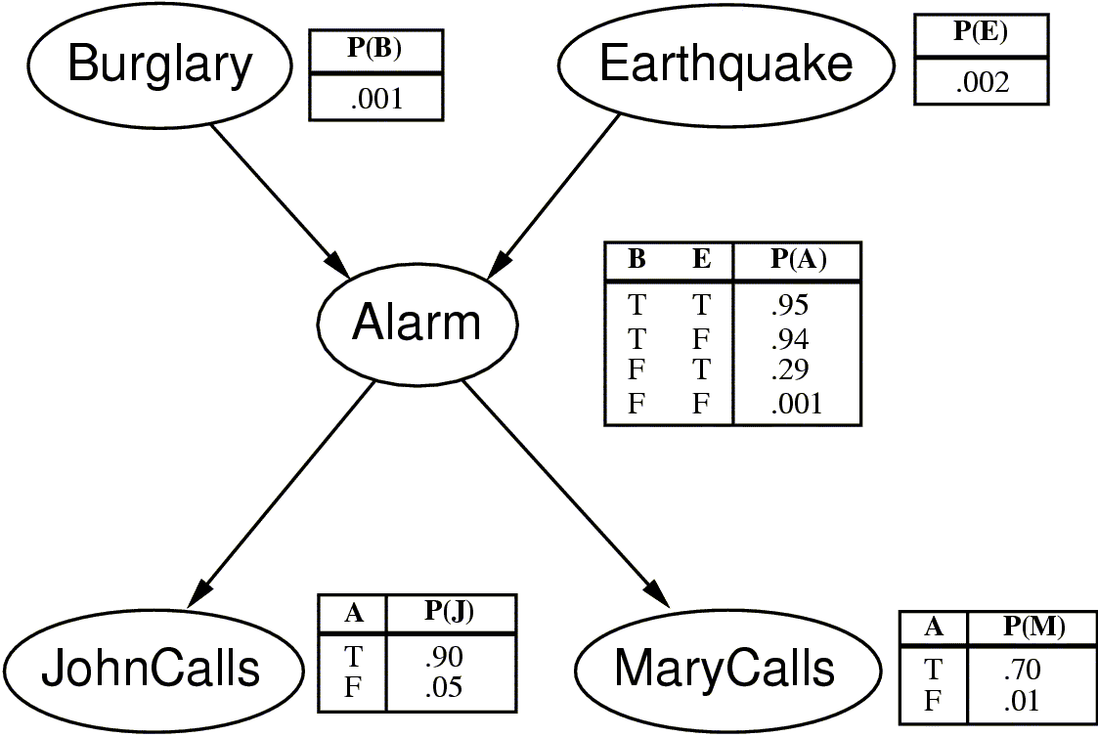

Compute the following probability of ___ [given the observation (evidence) if there is any].

- Alarm
Answer: 0.002509522
(2) JohnCalls
Answer: 0.052133093

(3) Alarm given Burglary = T
Answer: 0.94002

(4) JohnCalls given Burglary=T
Answer: 0.849017
(5) Alarm given JohnCalls=T
Answer: 0.04
(6) Earthquake given JohnCalls=T and MaryCalls=T
Answer: 0.18

Elaborate (show) the steps of how to get the probability of the case for ___. You need to show how to get the answer in steps (instead of getting the answer using the tool).

(7) for the case of (3) Alarm given Burglary = T

ANSWER: P(A|B) = P(A|B,E)*P(E) + P(A|B, ¬E)*P( ¬E)
= .95 * (.002) + .94 * (.998)
= .94002

(8) for the case of (4) JohnCalls given Burglary=T

ANSWER: P(J|B) = P(J|A)*P(A|B) + P(J|¬A)*P(¬A|B)
= .9 * .94002 + .05 * .05998
= 0.849017

(9) for the case of (5) Alarm given JohnCalls=T

ANSWER: P(A|J) = (P(J|A)*P(A)) / (P(J))
= (P(J|A)*P(A)) / (P(J|A)*P(A) + P(J|¬A)*P(¬A))
= (.9 * .00251644) / (.9 * .00251644 + .05 * .997483558)
= (.002264796) / (.002264796 + .0498741779)
= .043437

(10) for the case of (6) Earthquake given JohnCalls=T and MaryCalls=T

ANSWER:
P(J,M|E) = P(J|E) * P(M|E)
= (P(J|A)*P(A|E) + P(J|¬A)*P(¬A|E)) * (P(M|A)*P(A|E) + P(M|¬A)*P(¬A|E))
= (.9 * .29 + .05 * .70934) * (.7 * .29 + .01 * .70934)
= 0.0622

P(J,M|¬E) = P(J|¬E) * P(M|¬E)
= (P(J|A)*P(A|¬E) + P(J|¬A)*P(¬A|¬E)) * (P(M|A)*P(A|¬E) + P(M|¬A)*P(¬A|¬E))
= (.9 * .00194 + .05 * .99806) * (.7 * .00194 + .01 * .99806)
= 0.000585

P(E|J,M) = (P(J,M|E) * P(E)) / (P(J,M))
= (P(J,M|E) * P(E)) / (P(J,M|E) * P(E) + P(J,M|¬E) * P(¬E))
= (.062285 * .002) / (.062285 * .002 + .0005856 * .998)
= 0.175698

Part 2. Bayesian Theorem.

Consider the following case:
Perform a test T to determine if Q is true or not.
If the test comes up positive, how likely is it that Q really happened?
Here is the Bayes analysis for this case:
Given Bayesian theorem
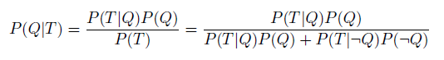

#1. Consider the following case.

Joe is tested for heroin use, and the result comes back positive.

How sure are we that Joe uses heroin? How good is that test?

3% of the general population are heroin users. So Joe would have a 3% chance of getting a positive result to start with. This is called the baseline or "prior" probability.

This particular test correctly identifies heroin users 95% of the time (5% of the time it would come back negative even though the sample was from a user). This is the test's "sensitivity". Using this test, non-users are correctly identified 90% of the time (10% of the time a non-user tests positive). This is the test's "selectivity".

Does this information, which we knew before we tested Joe, affect determination about Joe's use or non-use of heroin? In Joe's case, the relevant formula, applied to the facts above, tells us that there is just a ___ % chance that Joe uses heroin, even though he tested positive. Based on this result, we can conclude that it is more likely that Joe is a user than that the average person is a user, but it is still much more likely that the test is wrong than that Joe uses heroin. The test provides incremental evidence that Joe uses heroin, but the total evidence we have so far still is far from supporting that conclusion.

H – heroin user
T – Test results are positive
P(H) = 0.03
P(T | H) = 0.95
P(T | ¬H) = 0.1

What is P(H | T)?

Answer (and show your steps).

P(H | T)= P(T | H)* P( H)/ (P(T | H)* P( H)+ P(T | ¬H)* P( ¬H))

=>(0.95*0.03)/( (0.95*0.03)+(0.1)*(1-0.03))

=>0.0285/0.1255

=>0.227091

Part 2

#2. Breast Cancers

Say we know, from lots of studies, that 1% of women at age forty have breast cancer. (This means that 99% of women of that age do not have breast cancer.) This is the "prior probability". Mammograms can give us additional information (the "evidence"). Say we know (about the quality of the evidence) that 80% of the women who do have breast cancer will get a positive mammogram (the test's "sensitivity"), and 9.6% of the women who do not have breast cancer will also get a positive mammogram (the test's "selectivity").

If a woman in this age group gets a positive mammogram, how likely is it that she actually has breast cancer? Most doctors, given this statement of the problem, get it wrong. Only 15% get it right! The answer is that if a woman gets a positive result on her mammogram, there is a 7.8% chance that she actually has breast cancer. Of all the women who get positive results, only 7.8% have breast cancer.

This is calculated as follows: Out of 10,000 women, 100 have breast cancer (1%). Eighty of those 100 will have positive mammograms (calculated from the 80% sensitivity of the test). From the same 10,000 women, 9,900 will not have breast cancer (the other 99%) and of those 9,900 women, 950 will also get positive mammograms (the test's 9.6% selectivity). This makes the total number of women with positive mammograms 950+80 or 1,030. Of those 1,030 women with positive mammograms, 80 will have cancer. Expressed as a proportion, this is _____ or _____ %.

So what good was it to have a mammography?

C - has breast cancer
T - test results (mammogram) are positive

P(C) = 0.01
P(T|C) = 0.8
P(T|¬C) = 0.096

That is, what is P(C|T)?

Answer (and show your steps)

P(C|T) = P(T|C)* P(C)/( P(T|C)* P(C)+ P(T|¬C)* P(¬C))

=>(0.8*0.01)/((0.8*0.01)+(0.096*(1-0.01)))

=>0.0776

Part 2

#3.
Given the following case for Bayesian Network
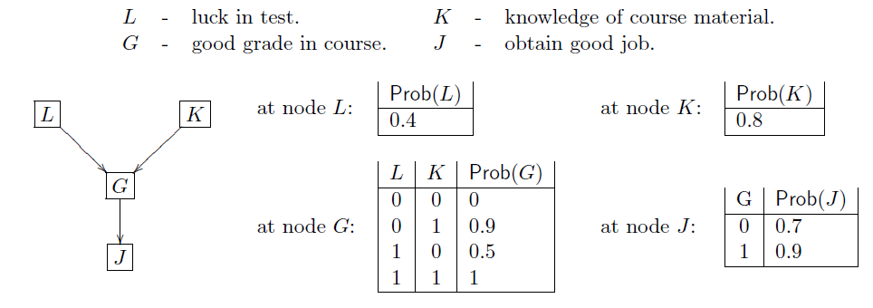

Compute P(G | K, J).

ANSWER: P(K|G) = (P(G|K) * P(K)) / (P(G))
= (P(G|K) * P(K)) / (P(G|K) * P(K) + P(G|¬K) * P(¬K))
= (0.94 * .8) / (0.94 * .8 + .2 * .2)
= 0.94949494949494949494949494949495

P(K|¬G) = (P(¬G|K) * P(K)) / (P(¬G))
= (P(¬G|K) * P(K)) / (P(¬G|K) * P(K) + P(¬G|¬K) * P(¬K))
= (.06 * .8) / (.06 * .8 + .8 * .2)
= 0.23076923076923076923076923076923

P(J|G) = .9

P(J|¬G) = .7

P(G|K,J) = (P(K,J|G) * P(G)) / (P(K,J|G) * P(G) + P(K,J|¬G) * P(¬G))
= (.9494 * .9 * .792) / (.9494 * .9 * .792 + .2307 * .7 * .208)
= 0.95271171574185823042792521884152
Part 2
#4. Consider the following Bayesian network.
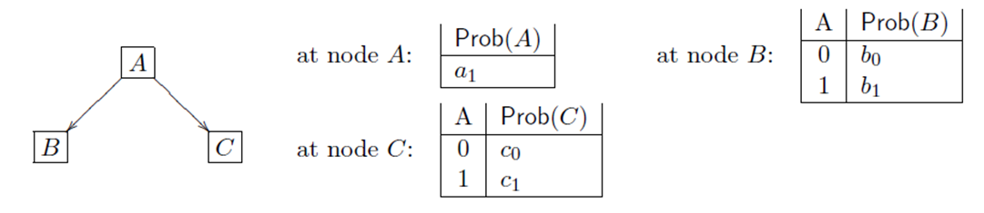

Compute P(A | B, not C)

Answer
P(B|A) = b1

P(¬C|A) = (1 – c1)

P(A|B, ¬C) = (P(B, ¬C|A) * P(A)) / (P(B, ¬C))
= (P(B|A) * P(¬C|A) * P(A)) / (P(B|A) * P(¬C|A) * P(A) + P(B|¬A) * P(¬C|¬A) * P(¬A)))
= (b1 * (1 – c1) * a1) / (b1 * (1 – c1) * a1 + b0 * (1 – c0) * (1 – a1))

Part 3.
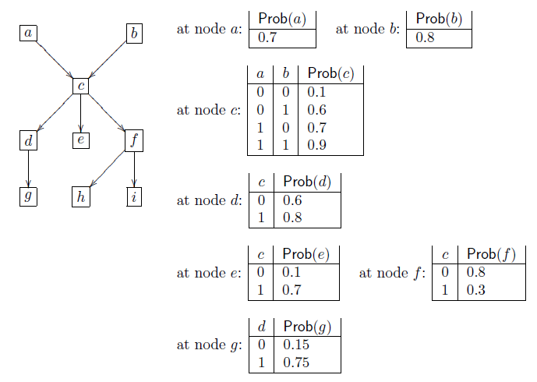

Compute the probability that
1. f = 1
ANSWER: P (F) = P(F|C) * P(C) + P(F|¬C) * P(¬C)
= .3 * .752 + .8 * .248
= 0.424
2. f = 1 given that a = 1.
ANSWER: P (F|A) = P(F|C) * P(C|A) + P(F|¬C) * P(¬C|A)
= .3 * .86 + .8 * .14
= 0.37
3. f = 1 given that c = 0.
ANSWER: P (F|¬C) = .8

4. f = 1 given that a = 1; b = 1.
ANSWER: P (F|A,B) = P(F|C) * P(C|A,B) + P(F|¬C) * P(¬C|A,B)
= .3 * .9 + .8 * .1
= 0.35

5. f = 1 given that a = 1; b = 1; c = 1.
ANSWER: P (F|A,B,C) = P(F|C)
= 0.3

6. a = 1 given that f = 1.
ANSWER: P (F|A) = P(F|C) * P(C|A) + P(F|¬C) * P(¬C|A)
= .3 * .86 + .8 * .14
= 0.37

P(A|F) = (P(F|A) * P(A)) / (P(F))
= (.37 * .7) / (P(F|C) * P(C) + P(F|¬C) * P(¬C))
= (.37 * .7) / (.3 * .752 + .8 * .248)
= 0.61084905660377358490566037735849
7. c = 1 given that g = 1; h = 1.

Part 4

ASP. Given a basic program P, Compute X (a set of atoms) where X is an answer set of program P.
C_{n}(P) corresponds to the smallest model of the set of definite clauses corresponding to P.

Compute Answer Set X of P
(Note: X is a set of atoms of P. P^{X} is a reduct and its minimal model Cn(P^{X}). X is an answer set if Cn(P^{X}) = X).

(1) P = { p. }

Answer: {p.}

(2) P = {p ← p. }

Answer: {}

(3) P = {p ← not p.}

Answer: {}

(4) P = {p ← p. q ← not p}

Answer: {q.}

(5) P = {p ← not q. q ← not p}

Answer: {p},{q}

(6) P = {p ← q. q ← p}

Answer: {}

Part 5.
Answer Set Programming. Compute Answer Set X of P
(Note: X is a set of atoms of P. P^{X} is a reduct, its minimal model Cn(P^{X}). X is an answer set if Cn(P^{X}) = X).

1. P = {p ← p. }
X | P | P^{X} | Cn( P^{X} )
∅ | p ← p. | p ← p. | {}
{ p } | p ← p. | p ← p. | {}

2. P = {p ← not p. }
X | P | P^{X} | Cn( P^{X} )
∅ | p ← not p | p ← | {p}
{ p } | p ← not p |  | Ø

3. P = {p ← p. q ← not p}

X | P | P^{X} | Cn( P^{X} )
∅ | p ← p.  q ← not p | p ← p.  q ← | {q}
{ p } | p ← p.  q ← not p | p ← p. | Ø
{ q } | p ← p.  q ← not p | p ← p.  q ← | {q}
{ p, q } | p ← p.  q ← not p | p ← p. | Ø

4. P = {p ← not q. q ← not p}
X | P | P^{X} | Cn( P^{X} )
∅ | p ← not q.  q ← not p. | p ←  q ← | {p,q}
{ p } | p ← not q.  q ← not p. | p ← | {p}
{ q } | p ← not q.  q ← not p. | q ← | {q}
{ p, q } | p ← not q.  q ← not p. |  | Ø
Part 6 Compute Answer Set for the following Program(s).
 | ASP  move-win | # of ans set | Answer Set(s)
1 | win(X) :- move(X,Y), not win(Y).  move(a,b). | 1 | win(a)
2 | win(X) :- move(X,Y), not win(Y).  move(a,b). move(b,c). | 1 | win(b)
3 | win(X) :- move(X,Y), not win(Y).  move(a,b). move(b,c). move(c,d). | 1 | win(c),win(a)
4 | win(X) :- move(X,Y), not win(Y).  move(a,b). move(b,a). | 2 | {win(b)} , {win(a)}
5 | win(X) :- move(X,Y), not win(Y).  move(a,b). move(b,a). move(a,c). move(c,d). move(d,e). move(c,f). move(e,f). | 2 | {win(e),win(c),win(a)} , {win(e),win(c),win(b)}
6 | win(X) :- move(X,Y), not win(Y).  move(a,b). move(b,a). move(a,c). | 1 | win(a)
7 | win(X) :- move(X,Y), not win(Y).  move(a,b). move(b,a). move(c,a). | 2 | {win(a)} , {win(c),win(b)}
8 | win(X) :- move(X,Y), not win(Y).  move(a,b). move(b,a). move(c,a). move(d,b). | 2 | {win(b),win(c)} , {win(d),win(a)}
9 | win(X) :- move(X,Y), not win(Y).  move(a,b). move(b,a). move(a,c). move(b,d). | 1 | win(b) , win(a)
10 | win(X) :- move(X,Y), not win(Y).  move(a,b). move(b,c). move(c,a). | 0 | No answer sets.

Part 7

Compute the answer(s) of the following program P (or show that there is no answer set).

** Explain or elaborate your answer (for example, by computing its reduct and/or your comment).

(1) P1:
p :- not p, s, t.

Answer.
The Answer Set is an empty answer set {}.
Because a negation of the head is present in its Body hence we get an empty answer set.

(2) P2
p :- not p, s, t.
s.

Answer
The Answer Set is {s}.
Since s is satisfied and the first rule has a negation of the head in the Body hence we get this answer set.

(3) P3
p :- not p, s, t.
s.
t.

Answer:
No Answer Set since presence of s and t creates a loop within the first rule of the program.

(4) P4
p :- not p, s, t.
s.
t.
p.

Answer:
The answer set is {p,t,s}. Since the head of the first rule is already satisfied and hence, no loop is created in this program.
Part 8

Design and Implement the following problems in ASP and solve the problem.

Consider a table with three distinct positions. On the table are a number of blocks which may be stacked on top of each other. The aim is to move the blocks from a given start-state to a goal-state. Only blocks which are free (that is, with no other block on top of them) can be moved. Note that there are three places where one can (or may allow to) place a block. You may work with the sample code as a basis (and see Weekly Activity on ASP).

The start-state is
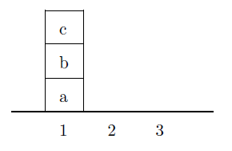

The goal-state is
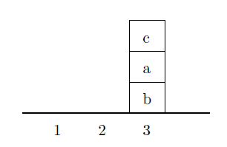

Compute the sequence of actions from the initial state to the goal state. You should have a timer (discrete) for each step (action) and a time-limit for your solution (e.g., up to 10 steps or 15 steps, etc.).

Answer:
path(state(X,Y,Z),state(X,Y,Z),L):-write(state(X,Y,Z)),write("\n").

path(state(X,Y,Z),state(X1,Y1,Z1),L) :- X \== table,ht(X,M,Xc),move(state(on(M,Xc),Y,Z),state(Xc,on(M,Y),Z)),not(member(state(Xc,on(M,Y),Z),L)),addstate(state(on(M,Xc),Y,Z),L,L1),path(state(Xc,on(M,Y),Z),state(X1,Y1,Z1),L1),write(state(X,Y,Z)),write("\n").

path(state(X,Y,Z),state(X1,Y1,Z1),L) :- X \== table,ht(X,M,Xc),move(state(on(M,Xc),Y,Z),state(Xc,Y,on(M,Z))),not(member(state(Xc,Y,on(M,Z)),L)),addstate(state(on(M,Xc),Y,Z),L,L1),path(state(Xc,Y,on(M,Z)),state(X1,Y1,Z1),L1),write(state(X,Y,Z)),write("\n").

path(state(X,Y,Z),state(X1,Y1,Z1),L) :- Y \== table,ht(Y,M,Yc),move(state(X,on(M,Yc),Z),state(on(M,X),Yc,Z)),not(member(state(on(M,X),Yc,Z),L)),addstate(state(X,on(M,Yc),Z),L,L1),path(state(on(M,X),Yc,Z),state(X1,Y1,Z1),L1),write(state(X,Y,Z)),write("\n").

path(state(X,Y,Z),state(X1,Y1,Z1),L) :- Y \== table,ht(Y,M,Yc),move(state(X,on(M,Yc),Z),state(X,Yc,on(M,Z))),not(member(state(X,Yc,on(M,Z)),L)),addstate(state(X,on(M,Yc),Z),L,L1),path(state(X,Yc,on(M,Z)),state(X1,Y1,Z1),L1),write(state(X,Y,Z)),write("\n").

path(state(X,Y,Z),state(X1,Y1,Z1),L) :- Z \== table,ht(Z,M,Zc),move(state(X,Y,on(M,Zc)),state(on(M,X),Y,Zc)),not(member(state(on(M,X),Y,Zc),L)),addstate(state(X,Y,on(M,Zc)),L,L1),path(state(on(M,X),Y,Zc),state(X1,Y1,Z1),L1),write(state(X,Y,Z)),write("\n").

path(state(X,Y,Z),state(X1,Y1,Z1),L) :- Z \== table,ht(Z,M,Zc),move(state(X,Y,on(M,Zc)),state(X,on(M,Y),Zc)),not(member(state(X,on(M,Y),Zc),L)),addstate(state(X,Y,on(M,Zc)),L,L1),path(state(X,on(M,Y),Zc),state(X1,Y1,Z1),L1),write(state(X,Y,Z)),write("\n").

move(state(on(X,NewX),OldY,Z),state(NewX,on(X,OldY),Z)).
move(state(on(X,NewX),Y,OldZ),state(NewX,Y,on(X,OldZ))).
move(state(OldX,on(Y,NewY),Z),state(on(Y,OldX),NewY,Z)).
move(state(X,on(Y,NewY),OldZ),state(X,NewY,on(Y,OldZ))).
move(state(OldX,Y,on(Z,NewZ)),state(on(Z,OldX),Y,NewZ)).
move(state(X,OldY,on(Z,NewZ)),state(X,on(Z,OldY),NewZ)).

addstate(A,B,[A|B]).

ht(on(X,Y),X,Y).

output:

?- [`3.pl'].
Warning: c:/users/mahesh/documents/prolog/3_3.pl:1:
Singleton variables: [L]
true.

