Prover 9

1.Installation of prover9

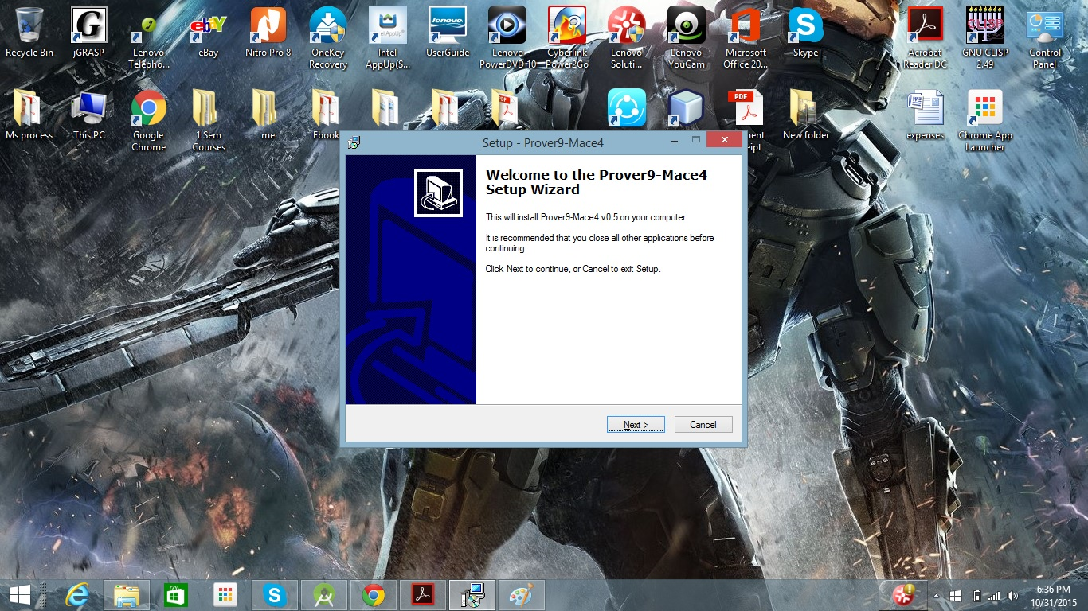

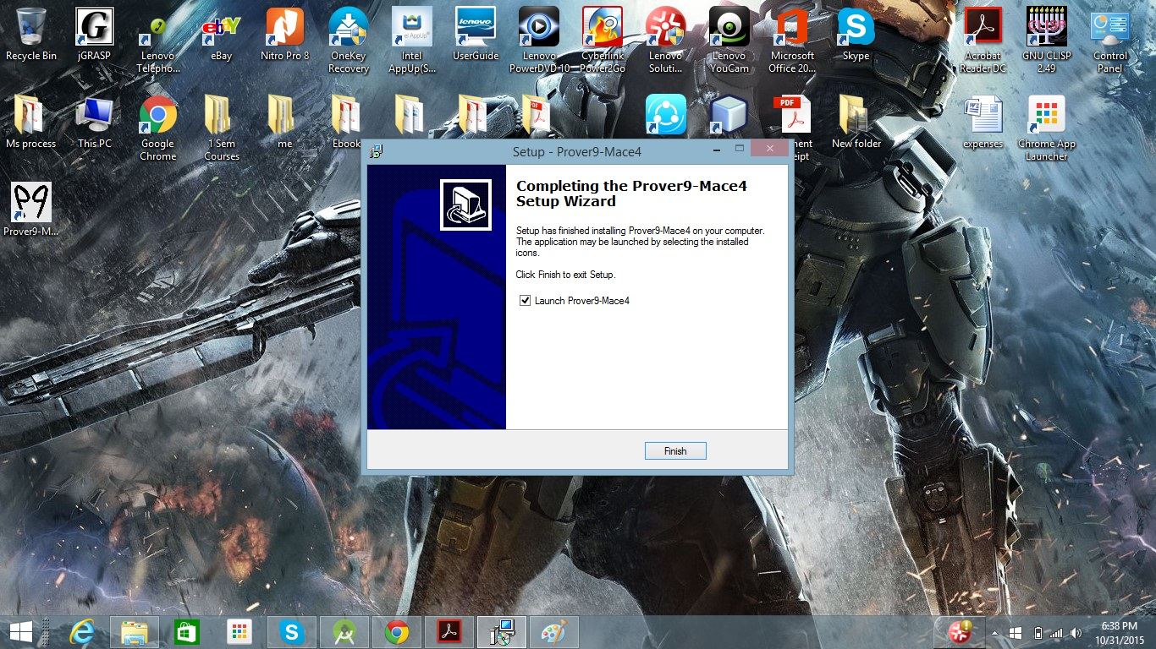

2.After installing prover9

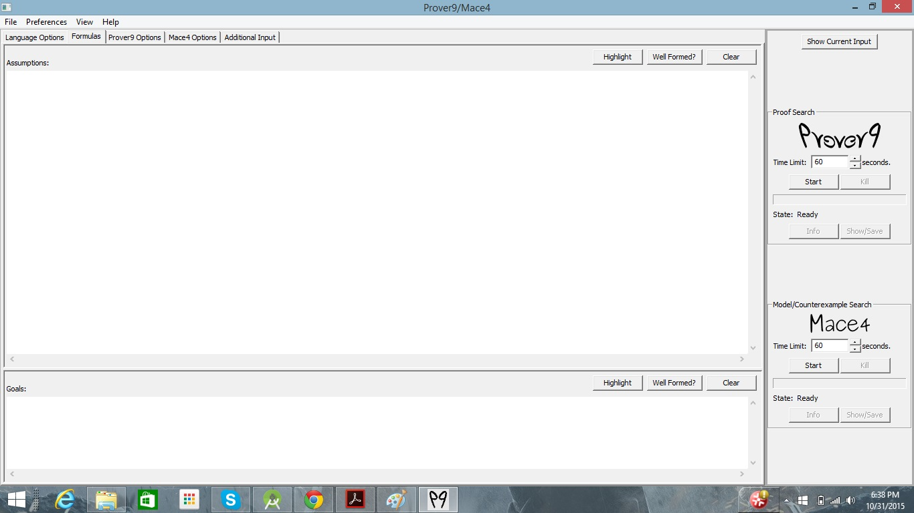

3. Trying to run the code of try1.in

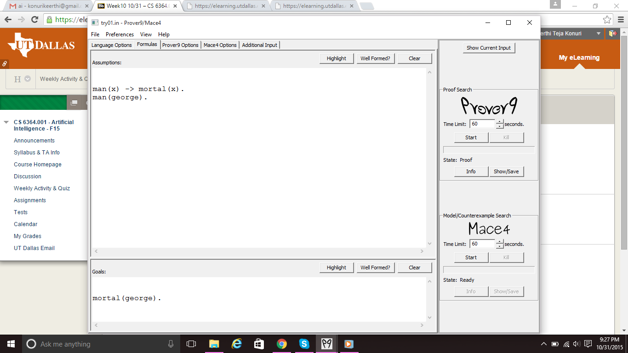

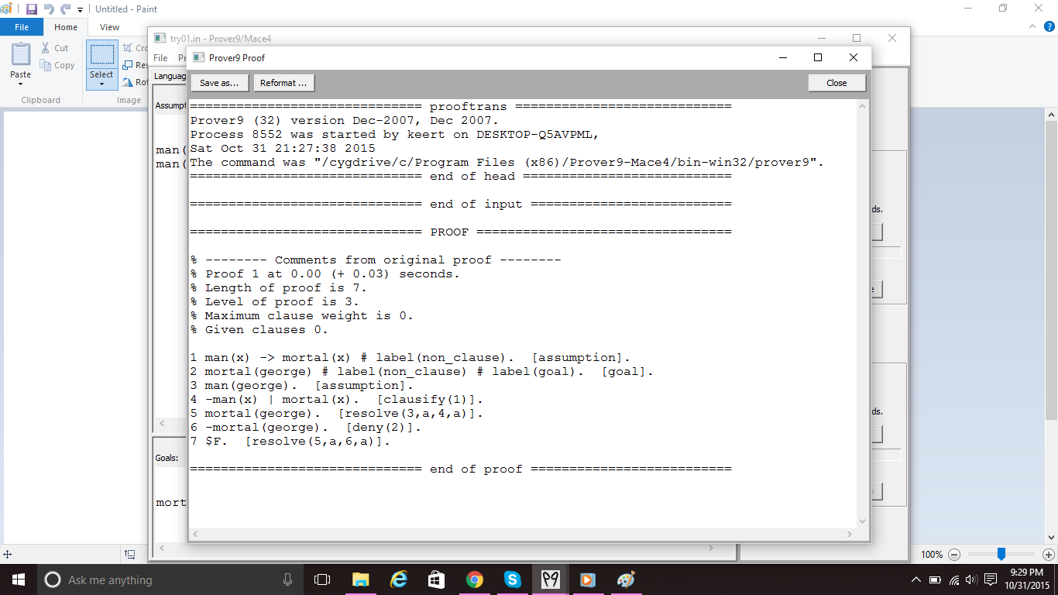

4. After running the code the output of try1.in

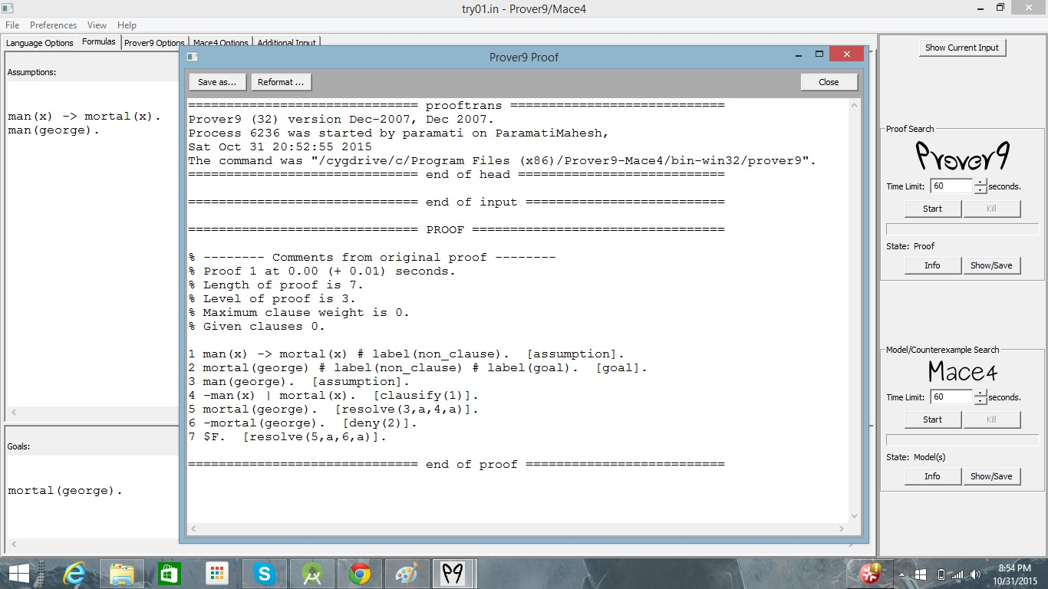

==============================PROOF=============================

% -------- Comments from original proof --------

% Proof 1 at 0.00 (+ 0.03) seconds.

% Length of proof is 7.

% Level of proof is 3.

% Maximum clause weight is 0.

% Given clauses 0.

1 man(x) -> mortal(x) # label(non_clause). [assumption].

2 mortal(george) # label(non_clause) # label(goal). [goal].

3 man(george). [assumption].

4 -man(x) | mortal(x). [clausify(1)].

5 mortal(george). [resolve(3,a,4,a)].

6 -mortal(george). [deny(2)].

7 $F. [resolve(5,a,6,a)].

==========================end of proof==========================

5. Trying to run the code of try2.in

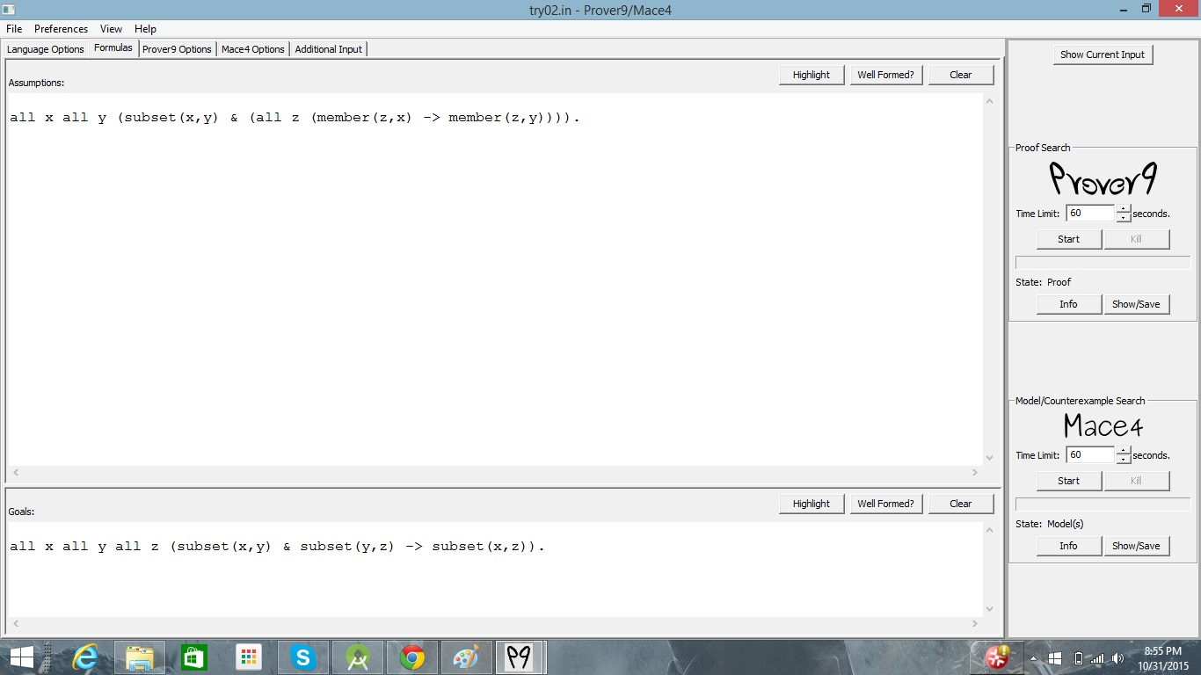

6. Output for the try2.in

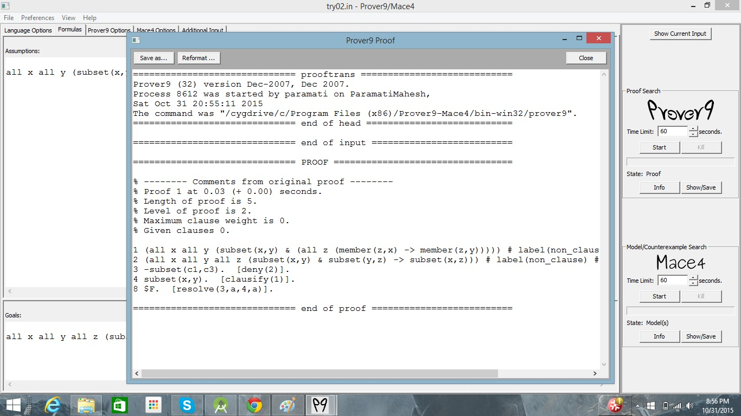

============================ PROOF =============================

% -------- Comments from original proof --------

% Proof 1 at 0.00 (+ 0.01) seconds.

% Length of proof is 5.

% Level of proof is 2.

% Maximum clause weight is 0.

% Given clauses 0.

1 (all x all y (subset(x,y) & (all z (member(z,x) -> member(z,y))))) # label(non_clause). [assumption].

2 (all x all y all z (subset(x,y) & subset(y,z) -> subset(x,z))) # label(non_clause) # label(goal). [goal].

3 -subset(c1,c3). [deny(2)].

4 subset(x,y). [clausify(1)].

8 $F. [resolve(3,a,4,a)].

========================= end of proof =========================