**1.INSTALLATION OF PUTTY AND CONNECTION TO csgrad1.utdallas.edu**

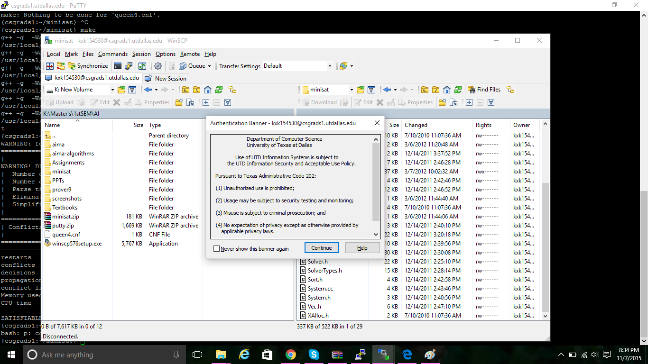

**2.AFTER CONNECTION TO csgrad1.utdallas.edu**

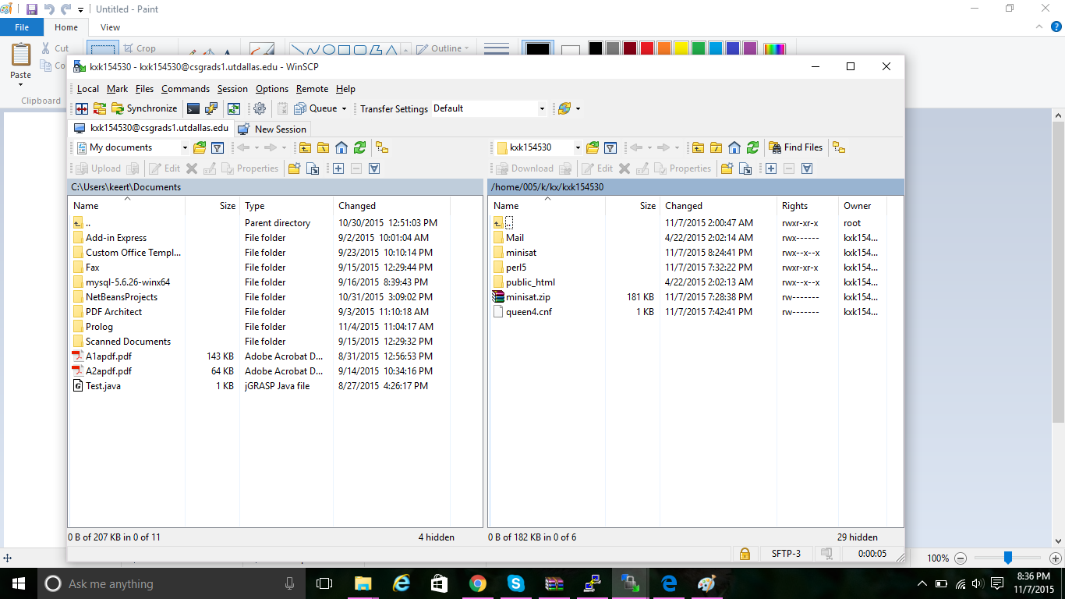

**3.OUTPUT**

