 | 
PROJECT REPORT
on
Doctor Appointment Booking System
Submitted by
KEERTHIVASAN A
Register Number: 711525BCS073
Subject: Database Management Systems (DBMS) – AAT Project
Guided by: [ENTER FACULTY NAME]
in partial fulfilment of the requirements for the award of the degree of
BACHELOR OF ENGINEERING
in
COMPUTER SCIENCE AND ENGINEERING
KALAIGNARKARUNANIDHI INSTITUTE OF TECHNOLOGY
(KIT-CBE)
Affiliated to Anna University, Chennai
DEPARTMENT OF COMPUTER SCIENCE AND ENGINEERING
Academic Year: 2026–2027

CERTIFICATE

This is to certify that the project report entitled “Doctor Appointment Booking System” is the bonafide work of KEERTHIVASAN A (Register Number: 711525BCS073), II Year B.E. Computer Science and Engineering (Class C), carried out for the subject Database Management Systems (DBMS) during the academic year 2026–2027 at Kalaignarkarunanidhi Institute of Technology (KIT-CBE), Affiliated to Anna University, Chennai.

______________________  [ENTER FACULTY NAME]  Faculty / Guide, Dept. of CSE | ______________________  [ENTER HOD NAME]  Head of the Department, CSE

Submitted for the evaluation held on: ____________________

______________________  Internal Examiner | ______________________  External Examiner

DECLARATION

I, KEERTHIVASAN A (Register Number: 711525BCS073), hereby declare that this project report entitled “Doctor Appointment Booking System” is the result of my own work carried out for the subject Database Management Systems (DBMS). Material taken from books or documentation has been acknowledged in the References. This work has not been submitted to any other institution or course.

Place: ____________________
Date: ____________________
KEERTHIVASAN A

ACKNOWLEDGEMENT

I express my sincere gratitude to the Management and the Principal of Kalaignarkarunanidhi Institute of Technology (KIT-CBE), [ENTER PRINCIPAL NAME], for the facilities provided.
I thank [ENTER HOD NAME], Head of the Department of Computer Science and Engineering, for the encouragement given, and my faculty guide, [ENTER FACULTY NAME], for the guidance and feedback during this project.
I also thank my classmates and family for their support, and the open-source communities of Python, Flask and MySQL for their documentation.

TABLE OF CONTENTS

If page numbers are blank, right-click the table in Word and choose Update Field → Update entire table.

LIST OF FIGURES AND TABLES

Figures
Figure 3.1: ER diagram
Figure 4.1: System architecture
Figure 4.2: DFD Level 0
Figure 4.3: DFD Level 1
Figure 4.4: Booking flowchart
Figure 4.5: Cancellation flowchart
Figures 5.1–5.10: Application screenshots (home, doctors, booking form, slots, confirmation, lookup, cancellation, admin appointments, admin doctors, mobile view)

Tables
Table 3.1–3.3: doctors, appointments and admins tables
Table 3.4: Integrity constraints
Table 4.1: Code modules
Table 4.2: Security controls
Table 5.1: Automated test cases
Table 5.2: Manual test cases

ABSTRACT
The Doctor Appointment Booking System (MediBook) is a database management project that lets patients view doctors, choose a free time slot, book an appointment, view the booking and cancel it, while an administrator manages doctors and appointment status. Storing this information in a database removes the double bookings and lost records that occur with phone calls and paper registers.
The system uses a relational MySQL database with three tables: doctors, appointments and admins. One doctor can have many appointments, linked by a foreign key. A UNIQUE constraint on a generated column prevents two active bookings for the same doctor, date and time, while still allowing a cancelled slot to be booked again. The web application is written with HTML5, CSS3 and JavaScript on the front end and Python Flask on the back end. All SQL is parameterized, input is validated on the server, and booking is performed inside a transaction.
The project demonstrates primary and foreign keys, constraints, indexes, normalization, transactions, joins, aggregate functions and CRUD operations in a working application. It is an academic demonstration with fictional sample data and has not had a formal security assessment.
Keywords: Appointment Booking, MySQL, Flask, DBMS, Constraints, Transactions, Relational Database.
Git Hub Link:- [ENTER REPOSITORY URL AFTER UPLOAD]

CHAPTER 1: INTRODUCTION

1.1 Introduction
Clinics handle many patients every day, and giving each patient a convenient time with the right doctor is a basic need. When appointments are managed by telephone and paper registers, the process is slow and error-prone. This project builds a web-based Doctor Appointment Booking System on top of a relational database to show how DBMS concepts support a practical information system.

1.2 Problem Statement
Manual booking can give two patients the same doctor and time, makes it hard to see which doctors are available, scatters appointment records and forces patients to phone the clinic to check or cancel. A structured database with enforced rules is needed to store doctor and appointment data safely and to let patients and administrators work online.

1.3 Objectives
- To design a normalized relational database for doctors, appointments and administrators.
- To let patients view, search and filter doctors and book an appointment.
- To prevent duplicate bookings using a UNIQUE constraint and transactions.
- To let patients view and cancel a booking after verifying the appointment ID and email.
- To provide a password-protected admin module for doctors and appointment status.
- To apply secure coding basics: parameterized queries, validation, CSRF protection and hashed passwords.
- To demonstrate joins, aggregate functions, filtering, sorting and CRUD operations.

1.4 Scope of the Project
The project covers database design and a Flask web application with a patient side (doctor directory, booking, confirmation, lookup, cancellation) and an admin side (login, doctor management, appointment management). Eight fixed one-hour slots per day (09:00–12:00 and 14:00–17:00) are shared by all doctors, and bookings are allowed up to 60 days ahead. Patient accounts, payments, e-mail/SMS notifications, rescheduling, per-doctor schedules and production deployment are outside the scope.

1.5 Existing System
In many clinics, appointments are taken by telephone and written in a register. The receptionist checks the register for a free slot and writes the patient’s details.

Disadvantages of the Existing System
- Available only during office hours.
- Two staff members can give the same slot to two patients.
- Old records are slow to search and easy to lose.
- Patients cannot check or cancel their booking on their own.

1.6 Proposed System
The proposed system keeps doctors and appointments in related MySQL tables behind a web interface. The server validates every booking, and the database itself refuses a second active booking for the same doctor, date and time. Cancelled appointments stay in the table with status Cancelled, so history is preserved.

Advantages of the Proposed System
- Booking is possible at any time from any device.
- Double booking is prevented by the database, not only by application code.
- Appointment history is preserved because cancellation is logical.
- Primary and foreign keys maintain referential integrity.
- Modular code that can be extended with new features.

CHAPTER 2: SYSTEM REQUIREMENTS

2.1 Hardware Requirements
- Processor: dual-core 2 GHz or equivalent.
- RAM: 4 GB minimum (8 GB recommended).
- Storage: at least 2 GB free space.
- Input/Output: keyboard, mouse and monitor.

2.2 Software Requirements
- Operating system: Windows 10/11 (Linux or macOS also work).
- Language: Python 3.10 or newer (development used 3.12).
- Libraries: Flask, Flask-WTF, mysql-connector-python, python-dotenv, pytest (requirements.txt).
- Database: MySQL Server 8.0 or a compatible server, with MySQL Workbench.
- Tools: Visual Studio Code, Git and a GitHub account; a modern web browser.

2.3 Functional Requirements
- Display active doctors with name, specialization, qualification and fee.
- Search doctors by name and filter by specialization.
- Book an appointment with name, email, phone, doctor, date, time slot and reason.
- Reject missing or invalid data, past dates, invalid slots and unknown or inactive doctors on the server.
- Allow only one active appointment per doctor, date and time.
- Generate and display a unique appointment ID after a successful booking.
- View an appointment by appointment ID and booking email.
- Cancel a Booked appointment after ID and email verification; refuse to cancel cancelled or completed ones.
- Admin: log in, add/edit doctors, activate/deactivate doctors, filter appointments and mark Booked appointments Completed or Cancelled.

2.4 Non-Functional Requirements
- Security: parameterized queries, CSRF tokens, hashed passwords, server-side authorization, safe error pages.
- Data integrity: constraints and transactions keep data consistent.
- Usability and accessibility: labelled forms, visible focus, keyboard-friendly pages.
- Responsiveness: works on desktop, tablet and mobile widths.
- Maintainability: modular code and no secrets in source files.
- Performance: indexes on searched columns (no formal performance measurement was carried out).

CHAPTER 3: DATABASE DESIGN

3.1 Database Description
Database name: doctor_appointment_db. Doctor details are stored once in doctors and referenced by appointments through doctor_id, so doctor names are not repeated in every appointment. The admins table stores administrator logins only.
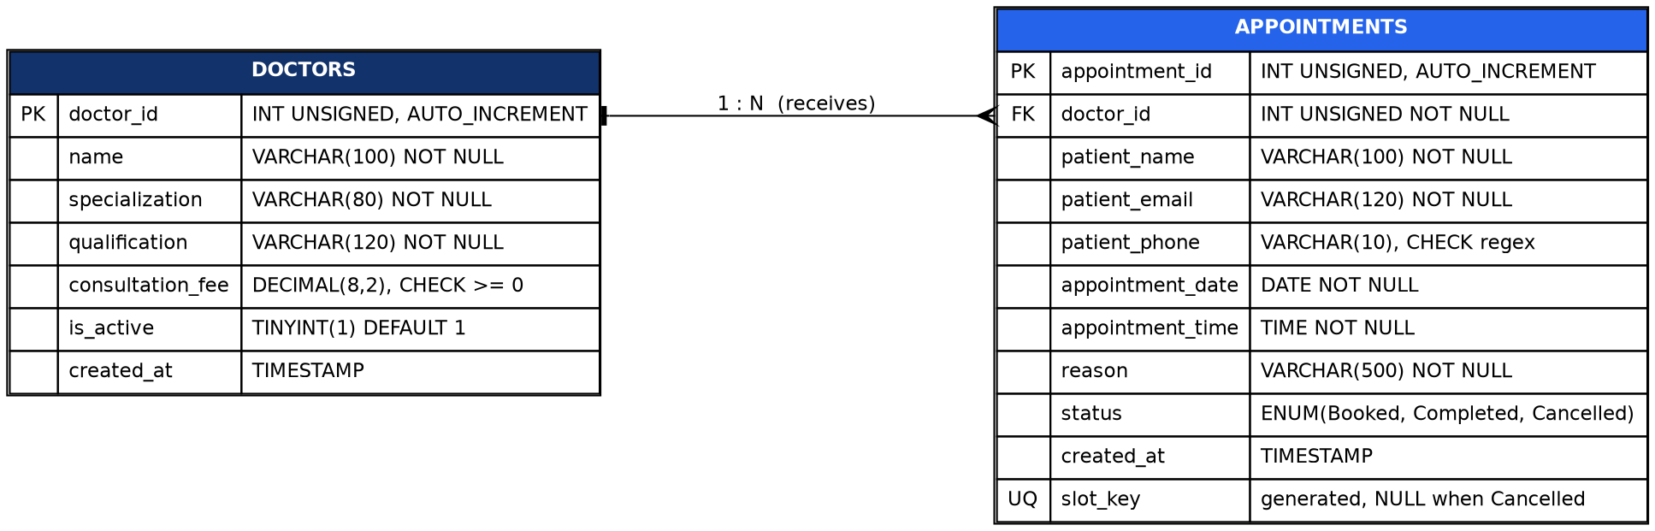
Figure 3.1: ER diagram (one doctor, many appointments)

3.2 Table Structure

Table: doctors
Column | Data Type / Key | Description
doctor_id | INT UNSIGNED, PK, AUTO_INCREMENT | Unique doctor identifier
name | VARCHAR(100), NOT NULL | Doctor name
specialization | VARCHAR(80), NOT NULL, indexed | Medical specialty
qualification | VARCHAR(120), NOT NULL | Degrees
consultation_fee | DECIMAL(8,2), CHECK >= 0 | Fee in rupees
is_active | TINYINT(1), default 1 | 1 = bookable, 0 = hidden
created_at | TIMESTAMP | Record creation time

Table: appointments
Column | Data Type / Key | Description
appointment_id | INT UNSIGNED, PK, AUTO_INCREMENT | Unique appointment number (shown as APT-00001)
doctor_id | INT UNSIGNED, FK, NOT NULL | References doctors
patient_name | VARCHAR(100), NOT NULL | Patient name
patient_email | VARCHAR(120), CHECK, indexed | Email used to verify cancellation
patient_phone | VARCHAR(10), CHECK regex | 10-digit Indian mobile number
appointment_date | DATE, NOT NULL, indexed | Date of visit
appointment_time | TIME, NOT NULL | Slot start time
reason | VARCHAR(500), NOT NULL | Reason for consultation
status | ENUM, default Booked | Booked / Completed / Cancelled
created_at | TIMESTAMP | Booking time
slot_key | VARCHAR(40), STORED generated, UNIQUE | doctor|date|time; NULL when Cancelled

Table: admins
Column | Data Type / Key | Description
admin_id | INT UNSIGNED, PK, AUTO_INCREMENT | Unique admin identifier
username | VARCHAR(50), UNIQUE | Login name
password_hash | VARCHAR(255), NOT NULL | Salted password hash (never plain text)
created_at | TIMESTAMP | Creation time

3.3 Primary and Foreign Keys
- Primary keys: doctors.doctor_id, appointments.appointment_id, admins.admin_id.
- Candidate keys: admins has admin_id and username; doctors has only doctor_id (two doctors may share a name); appointments has appointment_id.
- Foreign key: appointments.doctor_id references doctors.doctor_id (one-to-many).
- ON DELETE RESTRICT keeps history: a doctor with appointments cannot be deleted, so admins deactivate the doctor instead. ON UPDATE RESTRICT is used because MySQL does not allow CASCADE on a column used by a stored generated column; doctor_id is never edited, so nothing is lost.

3.4 Integrity Constraints
Constraint | Where | Purpose
PRIMARY KEY | All tables | Unique, non-null row identity
FOREIGN KEY | appointments.doctor_id | Referential integrity
UNIQUE uq_active_slot | appointments.slot_key | No two active bookings for one doctor/date/time
UNIQUE | admins.username | No duplicate admin names
NOT NULL | Business columns | Required data
CHECK | fee >= 0; phone regex; email pattern | Domain integrity
ENUM / DEFAULT | status, is_active, created_at | Allowed values and initial values
INDEXES | name, specialization, date, status, email, (doctor_id, date) | Faster searching and filtering

3.5 Normalization
- 1NF: every column holds one atomic value; no repeating groups.
- 2NF: every table has a single-column primary key, so there are no partial dependencies.
- 3NF: in all three tables no non-key column determines another non-key column.
Assumption: patient name, email and phone are stored in each appointment because the project has no patients table. The same email may be used for different patients (for example a parent booking for a child), so the design does not assume that email determines name. If that rule were adopted, a separate patients table would be needed to stay in 3NF; it is listed as a future enhancement. slot_key is a generated column used only to enforce the uniqueness rule.

3.6 Preventing Double Booking
A plain UNIQUE(doctor_id, date, time) key would block re-booking after a cancellation because cancelled rows stay in the table. The schema therefore uses a stored generated column slot_key that holds doctor|date|time for active appointments and NULL for cancelled ones. A UNIQUE index allows many NULL values, so only active bookings collide. If two patients submit at the same moment, one INSERT succeeds and the other fails with duplicate-entry error 1062, which the application turns into a friendly message after rollback.

CHAPTER 4: SYSTEM DESIGN AND IMPLEMENTATION

4.1 System Architecture
The browser sends HTTP requests with a CSRF token to Flask routes. Routes pass form data to the validation service, and only clean data reaches models.py, the single place where SQL is written. MySQL stores the data and enforces the constraints.
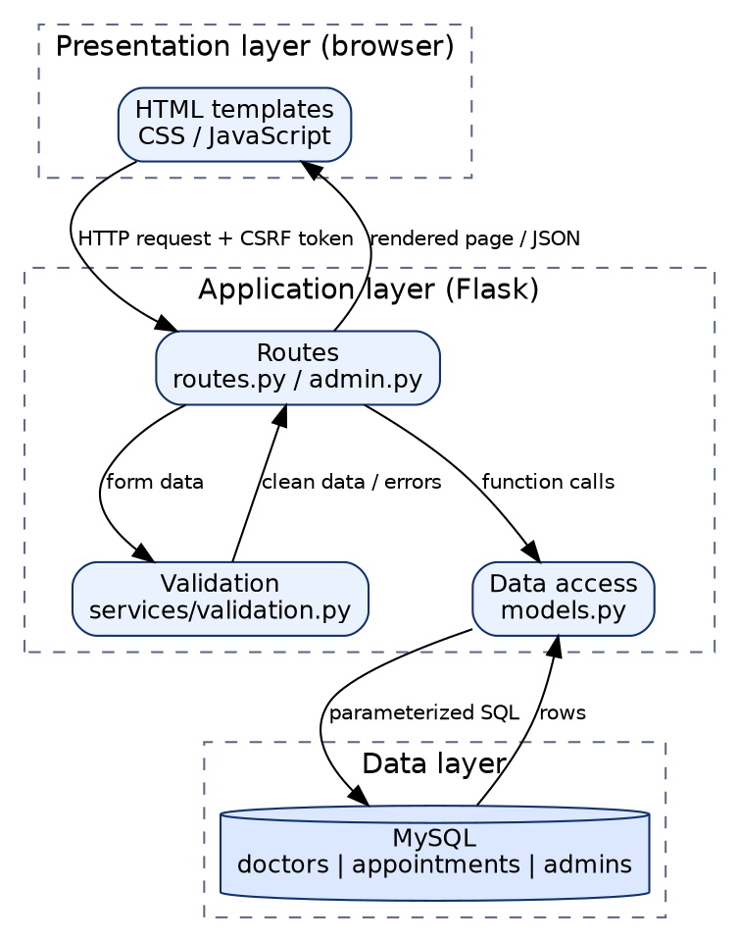
Figure 4.1: System architecture

4.2 Data Flow Diagrams
Level 0 shows the whole system with the Patient and Administrator as external entities and MySQL as the data store. Level 1 shows six processes: selecting a doctor and viewing slots, validating the booking, storing the appointment, viewing, cancelling and administration.
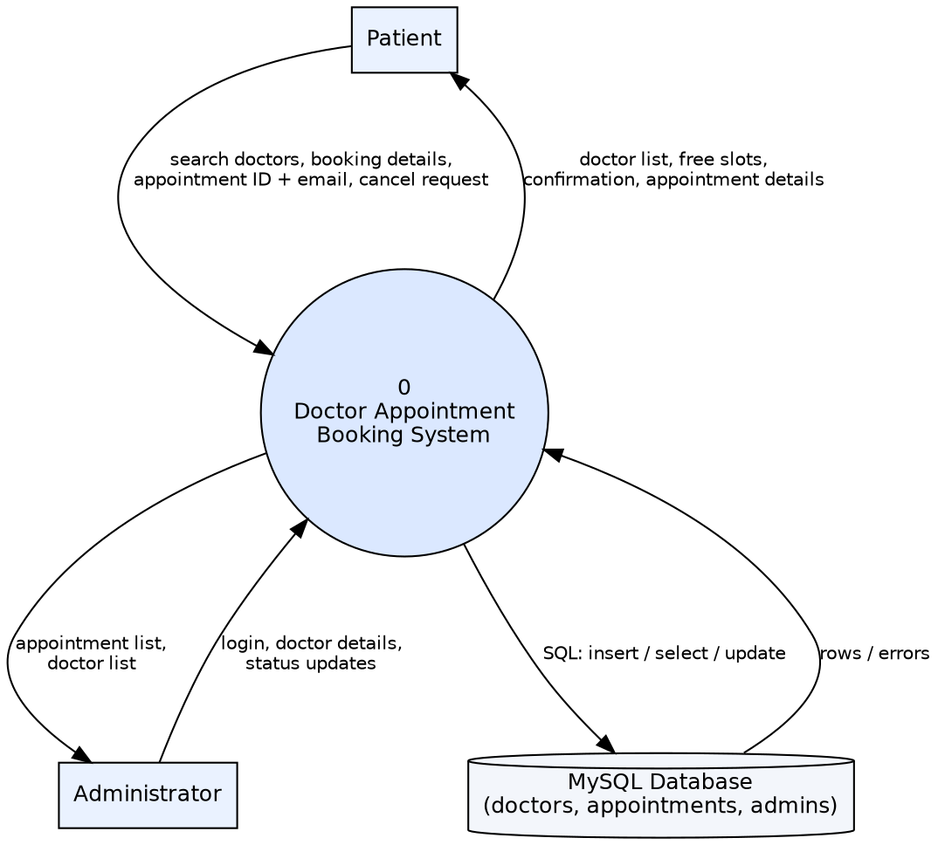
Figure 4.2: Data Flow Diagram – Level 0
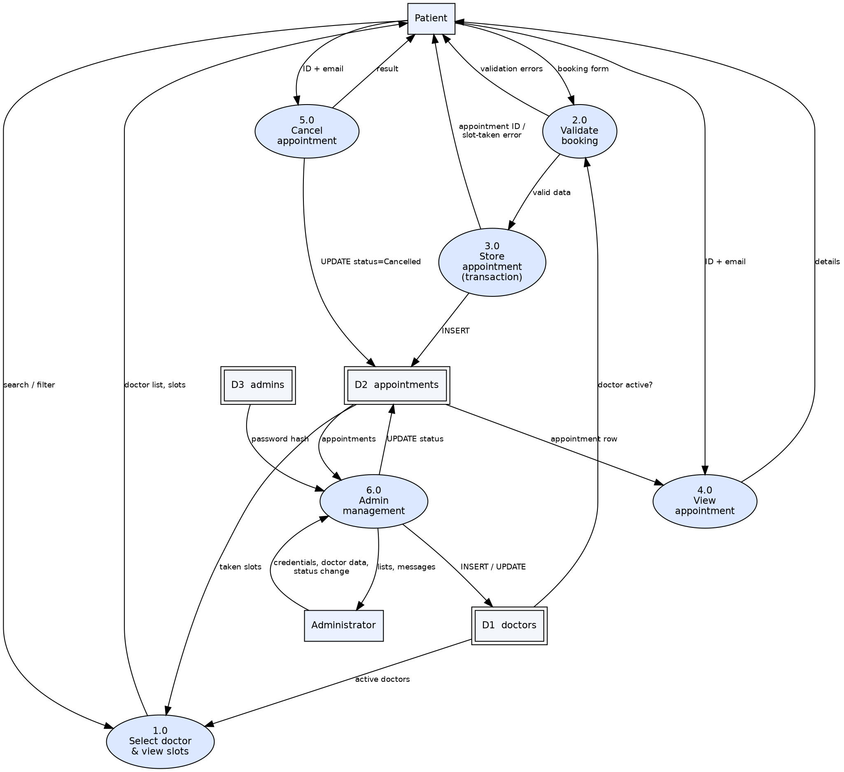
Figure 4.3: Data Flow Diagram – Level 1

4.3 Flowcharts
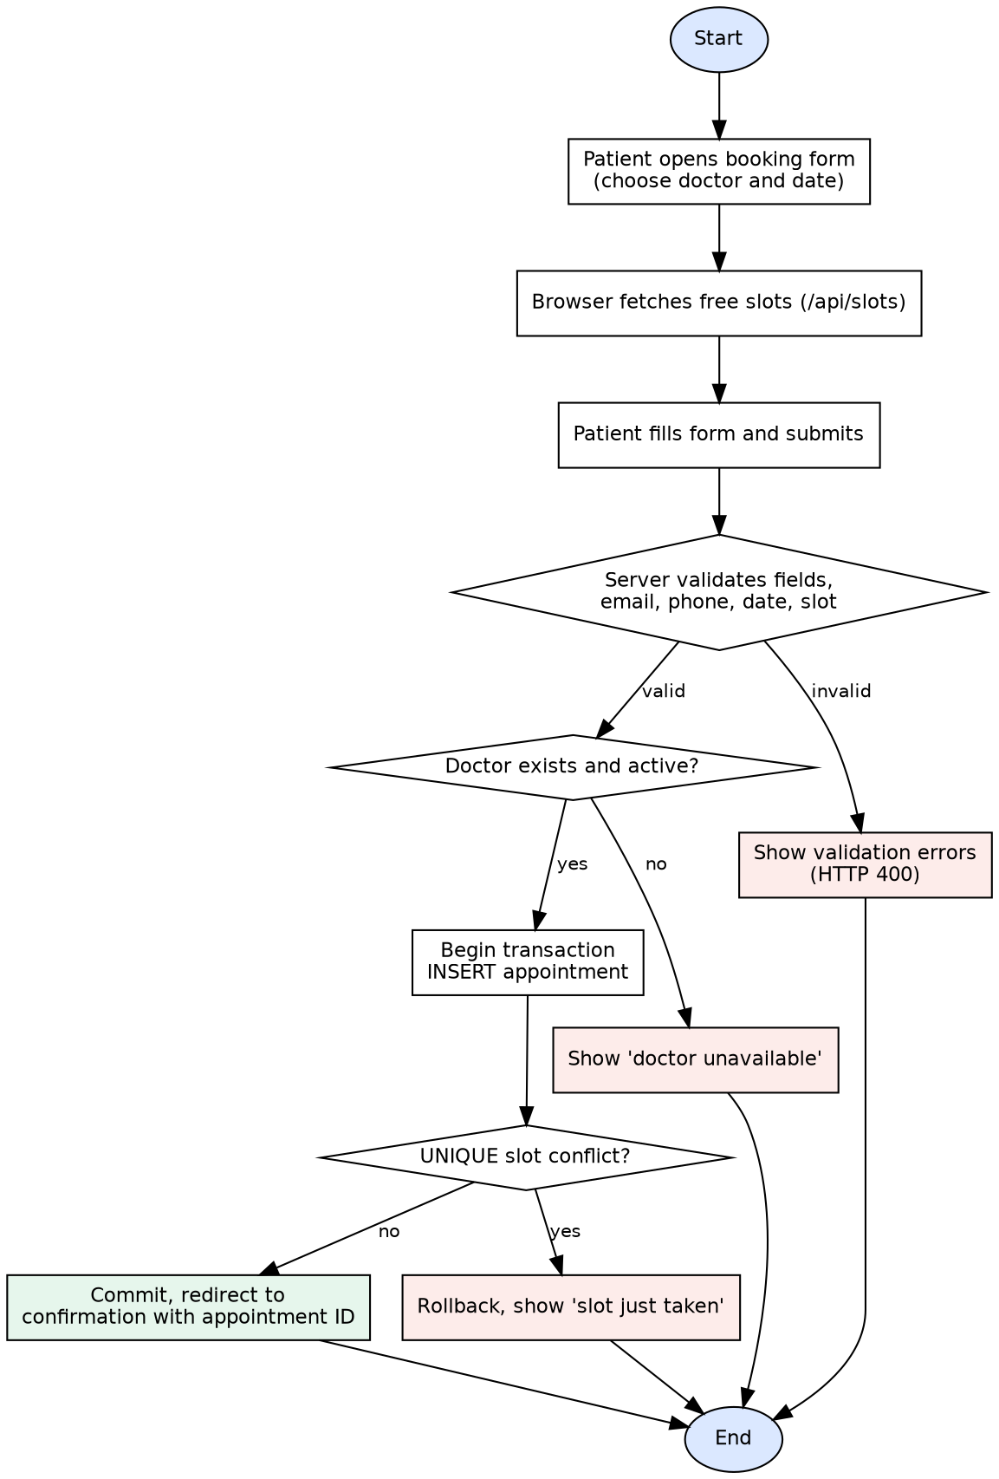
Figure 4.4: Booking process flowchart
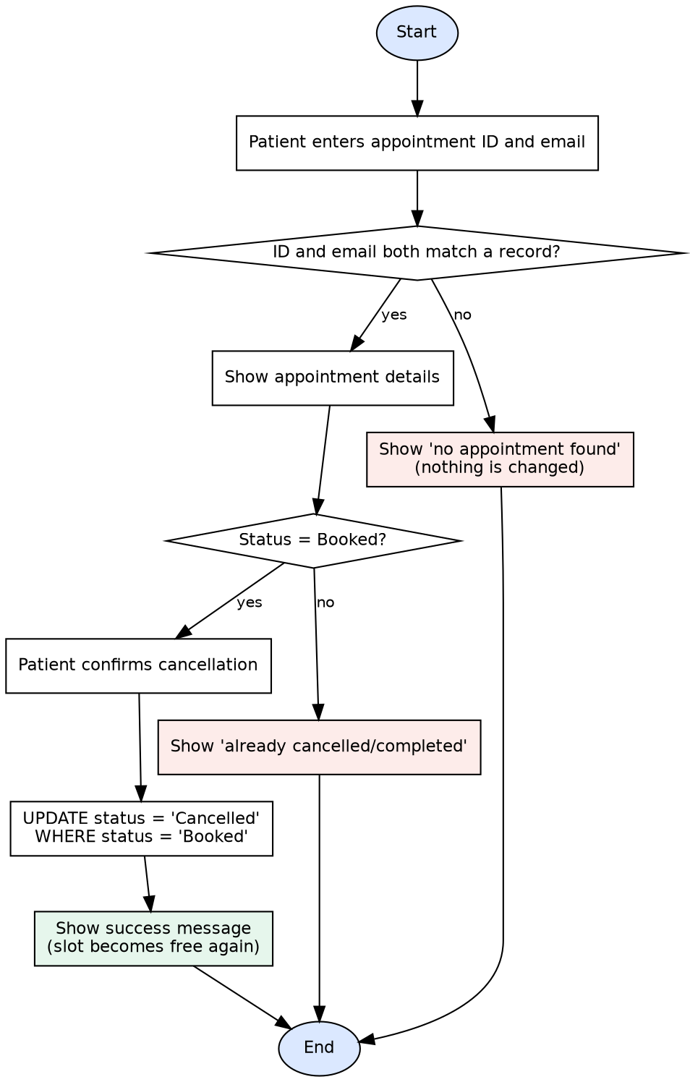
Figure 4.5: Cancellation process flowchart

4.4 Creating the Database and Tables
The full script is database/schema.sql (also in the Appendix). Run it in MySQL Workbench, then run database/sample_data.sql to insert eight fictional sample doctors.
CREATE DATABASE IF NOT EXISTS doctor_appointment_db
CHARACTER SET utf8mb4 COLLATE utf8mb4_unicode_ci;
USE doctor_appointment_db;

4.5 SQL Queries and CRUD Operations
Every query lives in models.py and uses %s placeholders; user input is never concatenated into SQL.

Create
START TRANSACTION;
SELECT doctor_id FROM doctors WHERE doctor_id = %s AND is_active = 1 FOR UPDATE;
INSERT INTO appointments (doctor_id, patient_name, patient_email,
patient_phone, appointment_date, appointment_time, reason)
VALUES (%s, %s, %s, %s, %s, %s, %s);
COMMIT; -- ROLLBACK on any error, including duplicate slot (error 1062)

INSERT INTO doctors (name, specialization, qualification, consultation_fee)
VALUES (%s, %s, %s, %s);

Read
SELECT * FROM doctors WHERE is_active = 1 AND name LIKE %s
AND specialization = %s ORDER BY name;

SELECT a.*, d.name AS doctor_name, d.specialization
FROM appointments a JOIN doctors d ON d.doctor_id = a.doctor_id
WHERE a.appointment_id = %s AND a.patient_email = %s;

SELECT d.name, COUNT(a.appointment_id) AS total
FROM doctors d LEFT JOIN appointments a ON a.doctor_id = d.doctor_id
GROUP BY d.doctor_id, d.name ORDER BY total DESC;

Update
UPDATE appointments SET status = 'Cancelled'
WHERE appointment_id = %s AND status = 'Booked';

UPDATE doctors SET is_active = %s WHERE doctor_id = %s;

Delete
Appointments are never physically deleted by the application; cancellation changes the status. A doctor who has appointments cannot be deleted (foreign key RESTRICT), so the doctor is deactivated instead.

4.6 Backend Modules
File | Responsibility
config.py | Reads settings from environment variables (.env); no hard-coded credentials
app/__init__.py | Application factory, CSRF setup, error handlers
app/routes.py | Public routes: home, doctors, book, confirmation, lookup, cancel, slot API
app/admin.py | Admin login, doctor management, appointment status; admin_required decorator
app/models.py | All parameterized SQL; transaction in create_appointment()
app/services/validation.py | Server-side validation of forms
create_admin.py | Creates an admin with a hashed password
tests/ | pytest test suite using a separate test database

4.7 Frontend Design
All pages extend one base template, so the header, footer and styling are consistent: white background, navy and blue accents, rounded cards, soft shadows. Semantic HTML, labelled fields, a skip link and visible focus outlines support accessibility. Below 820 px the layout stacks and the menu becomes a drop-down. JavaScript loads free slots from /api/slots, repeats the validation rules for quick feedback and disables the submit button after a valid submit. The server repeats every check because browser checks can be bypassed.

4.8 Security Controls
Control | Status
Parameterized SQL queries | Implemented
Server-side validation | Implemented
CSRF tokens on all POST forms | Implemented (Flask-WTF)
Hashed admin passwords | Implemented
Server-side authorization on every admin route | Implemented
Cookie HttpOnly and SameSite flags; Secure via environment setting | Implemented
Secrets only in .env (excluded from Git) | Implemented
Safe error pages without SQL or credentials | Implemented and tested
Login rate limiting | Not implemented (future work)
Patient authentication (accounts/OTP) | Not implemented; ID + email is not real authentication
HTTPS deployment, audit log, formal security assessment | Not implemented (future work)

4.9 System Workflow
- The patient opens Doctors, searches, and clicks Book Appointment on a doctor card.
- On the booking page the doctor is pre-selected; choosing a date loads the free slots.
- The patient submits; the browser and then the server validate the data.
- The server starts a transaction, checks the doctor is active and inserts the appointment; a slot conflict causes rollback and a message.
- On success the server redirects to the confirmation page, so refreshing does not create another booking.
- Later the patient enters the appointment ID and email to view the booking and cancel it if it is still Booked.
- The administrator logs in to review appointments, mark them Completed, or manage doctors.

4.10 Privacy Design Decision
Showing every patient’s name, phone and email on a public page would be a privacy problem, so appointments are not listed publicly. Patients see one appointment only after entering its ID and email; the full list with date and status filters is in the password-protected admin area.

CHAPTER 5: TESTING AND RESULTS

5.1 Testing
23 automated pytest tests (tests/test_app.py) use Flask’s test client against a separate test database built from schema.sql and dropped afterwards. Run them with: python -m pytest -v. A manual checklist is in docs/Testing_Checklist.md.
Status: the 23 tests were executed in the development environment against MariaDB 10.11 (a MySQL-compatible server) and all passed. They have not yet been run on a Windows PC with MySQL Server 8; record your own result after running them.
Test ID | Test Case | Expected Result | Status
TC01 | Open home page | HTTP 200 and page content shown | Passed
TC02 | Doctor list and filters | Active doctors shown, inactive hidden, filters work | Passed
TC03 | Book with valid data | Redirect to confirmation with appointment ID | Passed
TC04 | Empty form or invalid phone | HTTP 400 with error messages | Passed
TC05 | Invalid email | Rejected, nothing stored | Passed
TC06 | Past date | Rejected with message | Passed
TC07 | Unknown, malformed or inactive doctor | Safe message, no crash | Passed
TC08 | Duplicate doctor/date/time (app and database) | Second booking rejected | Passed
TC09 | Retrieve appointment by ID + email | Details displayed | Passed
TC10 | Cancel with correct ID + email; rebook slot | Cancelled; slot becomes free | Passed
TC11 | Cancel with wrong email or ID | Not cancelled | Passed
TC12 | Cancel an already cancelled appointment | Refused (HTTP 409) | Passed
TC13 | Simulated database error | HTTP 500 page without secrets | Passed
TC14 | Admin pages without login; wrong password | Redirect to login / HTTP 401 | Passed
TC15 | Admin adds doctor, completes appointment | Saved; completed cannot be altered | Passed
TC16 | Admin deactivates doctor | Doctor cannot be booked | Passed
TC17 | CSRF enforced | POST without token rejected | Passed
TC18 | Delete doctor having appointments | Blocked by foreign key RESTRICT | Passed
TC19 | Slot API marks booked slot | Slot reported unavailable | Passed
TC20 | SQL-injection-like text in a field | Stored as plain text; tables unaffected | Passed
TC21 | Confirmation page from another session | Redirected; details not shown | Passed

Several rows group more than one test function, so the table has fewer rows than the 23 executed tests.

Manual tests (to be performed by the student)
Test ID | Manual Test | Expected Result | Result
M1 | Book an appointment in the browser | Confirmation with ID | To be recorded
M2 | Open booking form for a doctor/date with a booked slot | Slot shown as (booked) and disabled | To be recorded
M3 | Refresh the confirmation page | No second booking created | To be recorded
M4 | Admin login and mark Completed | Status changes | To be recorded
M5 | View pages at 390 px width | Layout stacks; menu works | To be recorded

5.2 Application Screenshots
These screenshots were captured from the running application (Flask development server, MySQL-compatible database, Chromium browser) with the sample data. The capture machine had no internet access, so the web font fell back to the system font.
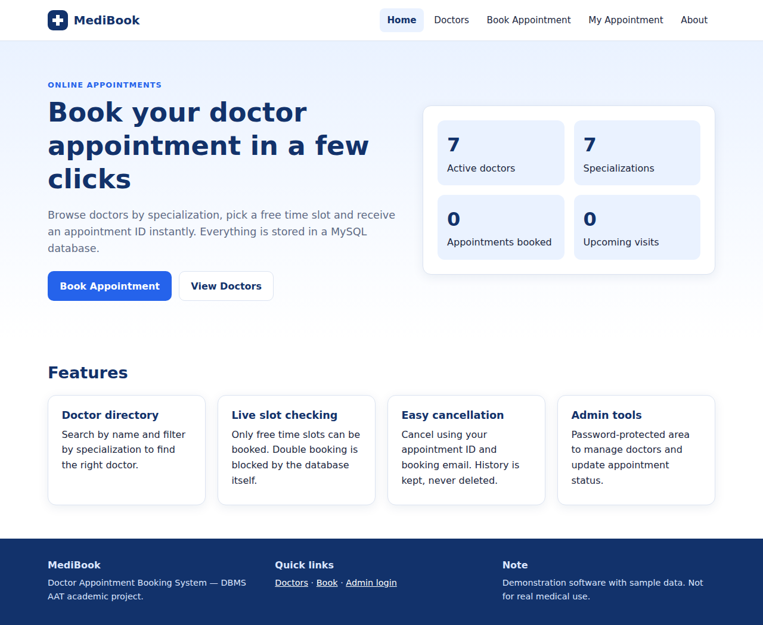
Figure 5.1: Home page
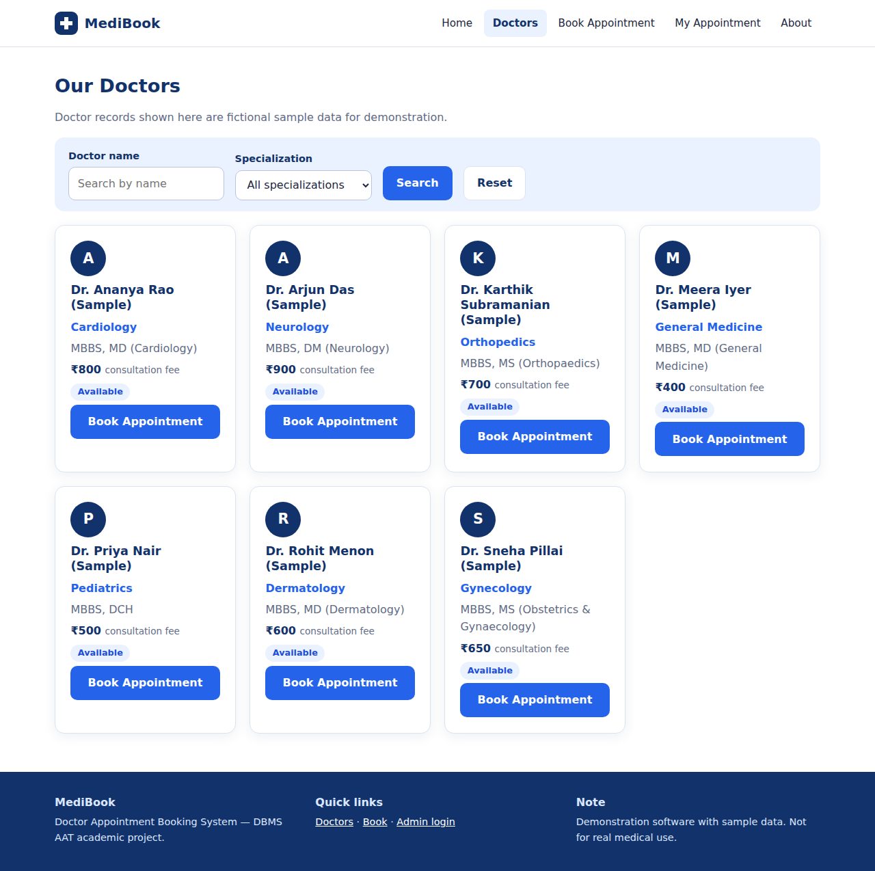
Figure 5.2: Doctor directory
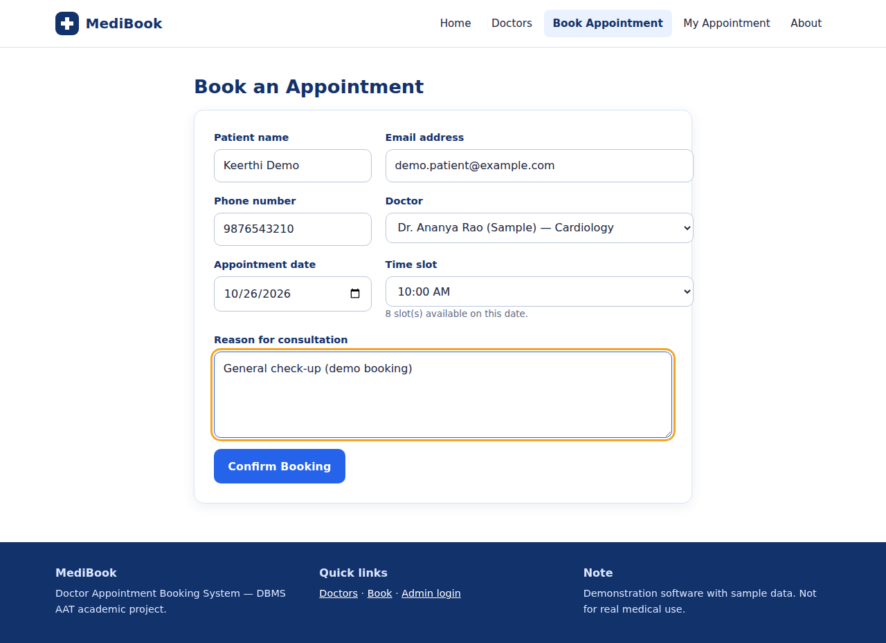
Figure 5.3: Booking form (filled)
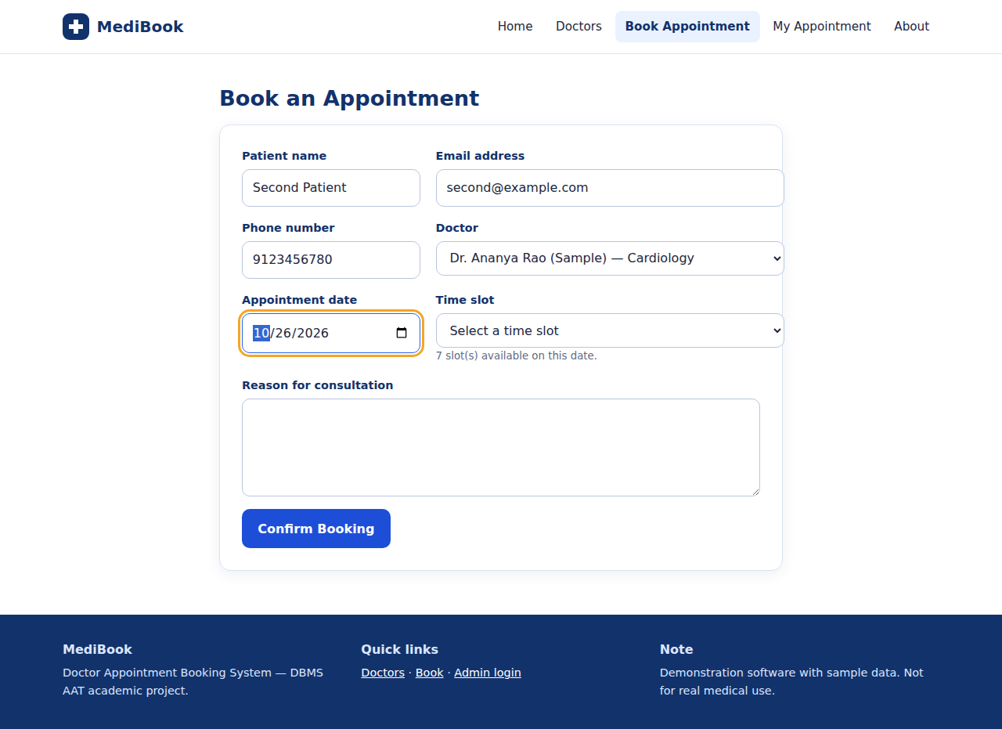
Figure 5.4: Booking form after choosing doctor and date (free slots loaded from the database)
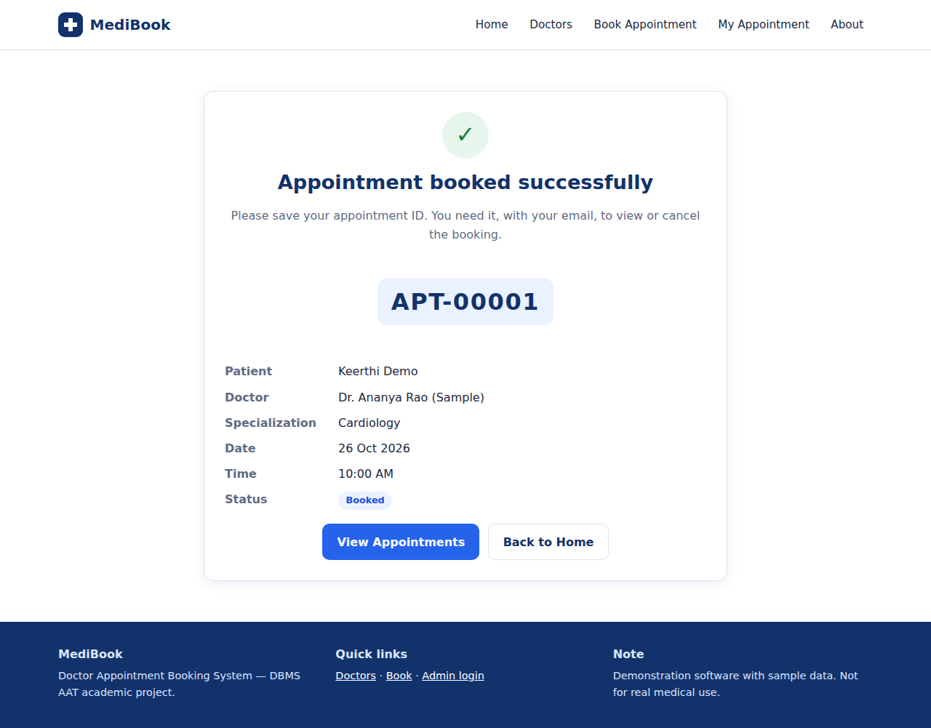
Figure 5.5: Booking confirmation with appointment ID
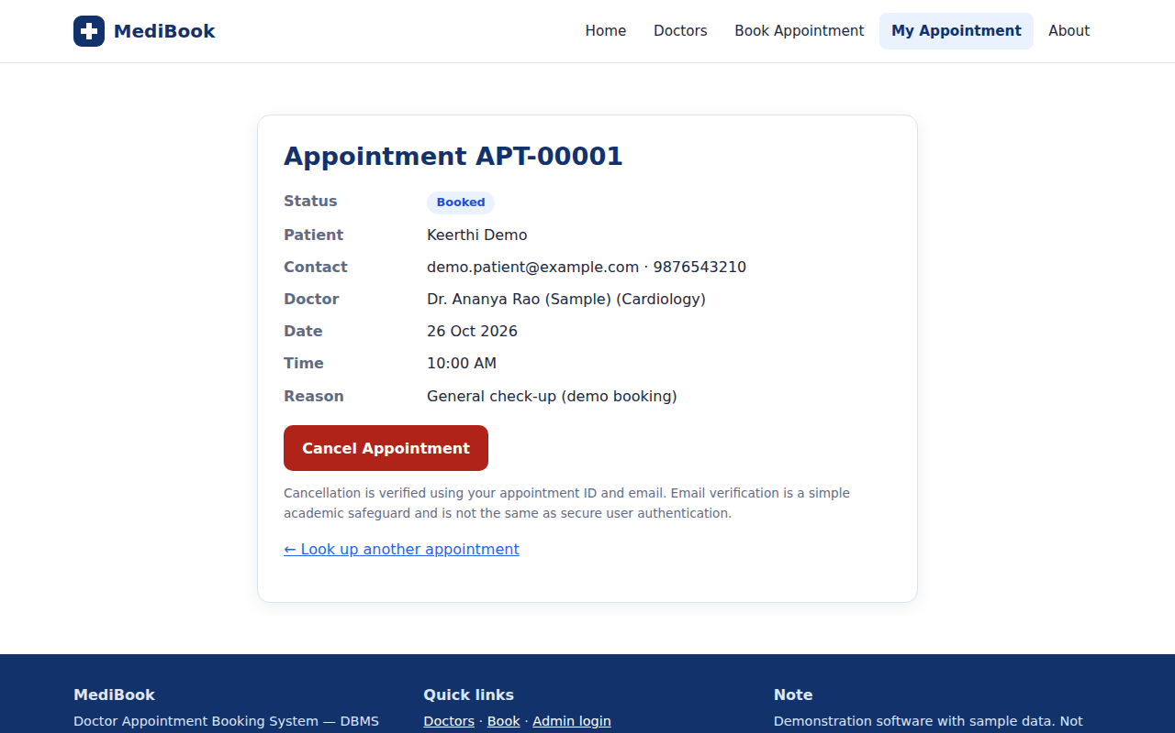
Figure 5.6: Appointment lookup by ID and email
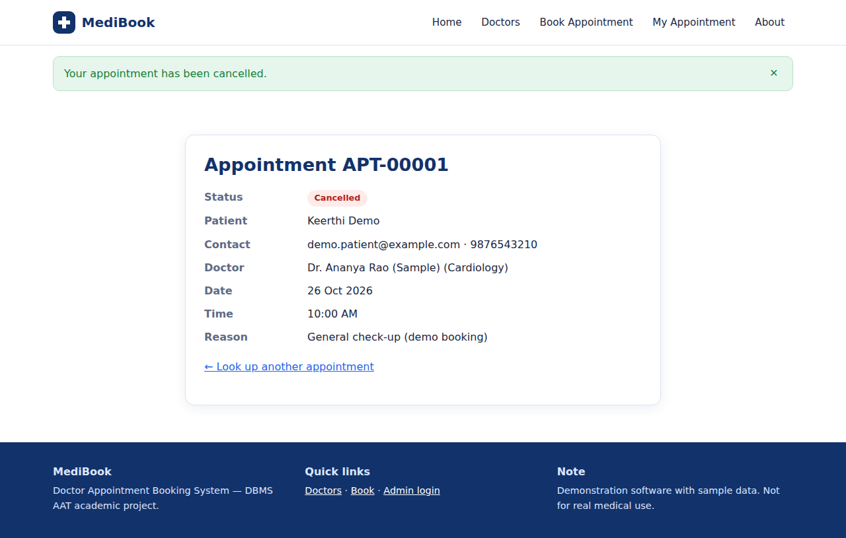
Figure 5.7: Appointment after cancellation
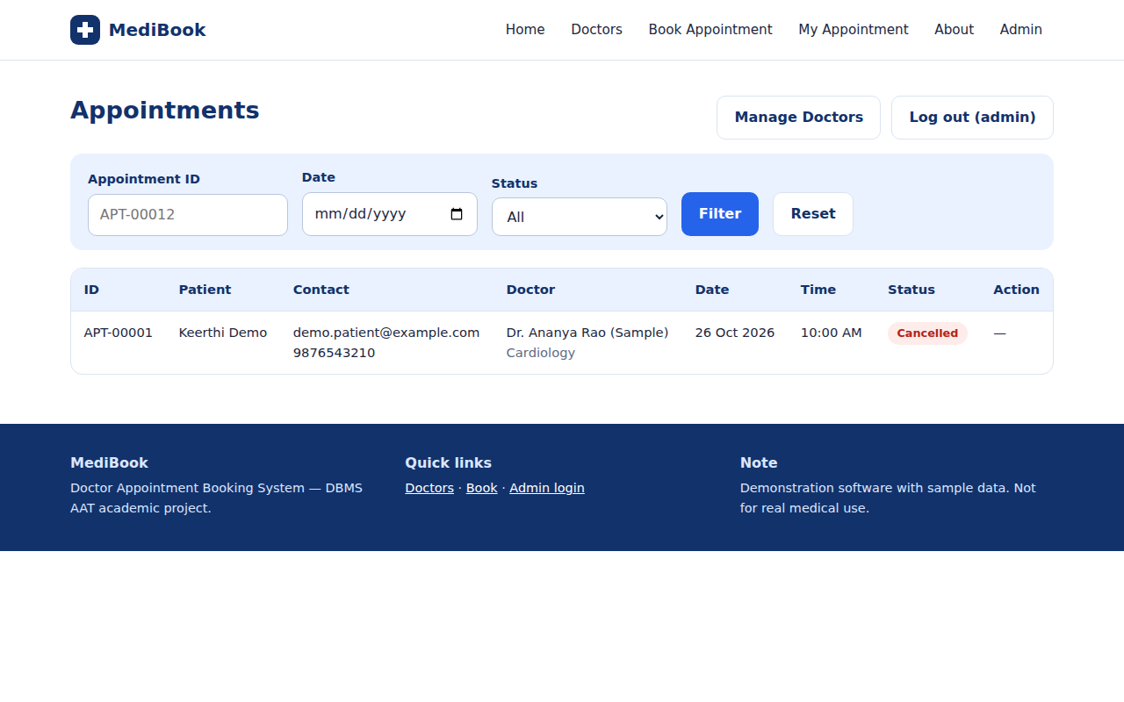
Figure 5.8: Admin – appointments
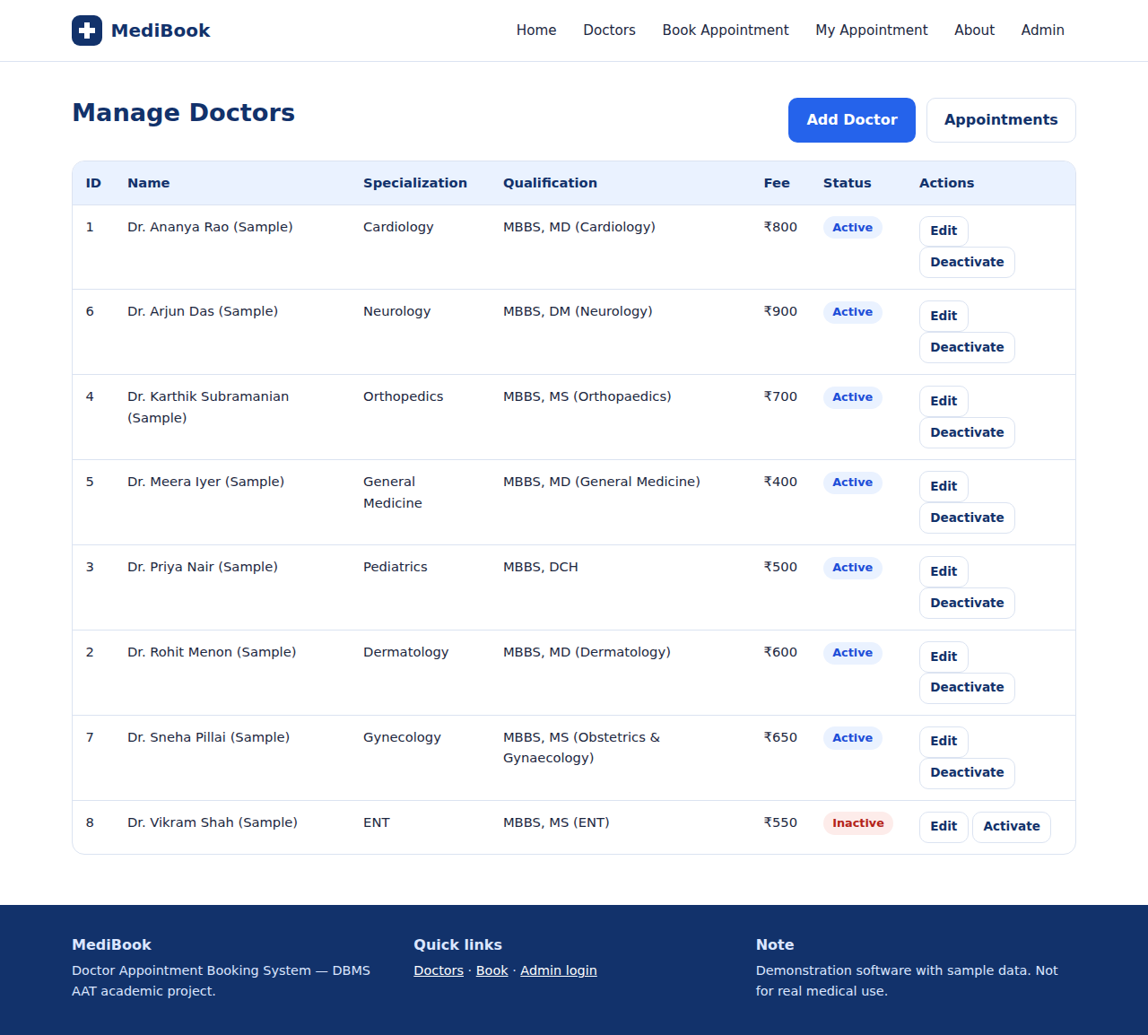
Figure 5.9: Admin – manage doctors
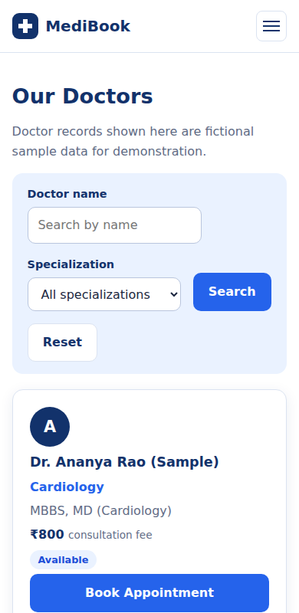
Figure 5.10: Mobile view of the doctor directory

5.3 Results
The application completes the required workflow. In the tests, a second active booking for the same doctor, date and time was refused by the UNIQUE index; a cancelled slot could be booked again; a doctor with appointments could not be deleted; an invalid phone number was refused by the CHECK constraint; and error pages did not reveal database details. No performance benchmarks, load tests or user surveys were carried out, so no claims about speed or user satisfaction are made.

5.4 Advantages
- Online booking at any time; double booking prevented by the database.
- Appointment history is preserved through logical cancellation.
- Demonstrates keys, constraints, indexes, transactions, joins and CRUD in one application.
- Clear modular code with basic security practices built in.

5.5 Limitations
- No patient accounts; ID + email verification is not real authentication.
- All doctors share the same fixed daily slots; no individual schedules or holidays.
- No e-mail/SMS notifications, no rescheduling, no login rate limiting.
- No formal security assessment; not suitable for real patient data or healthcare-privacy compliance.
- Automated tests have been run on MariaDB 10.11, not yet on the student’s MySQL 8 installation.

CHAPTER 6: CONCLUSION AND FUTURE ENHANCEMENTS

6.1 Conclusion
The Doctor Appointment Booking System shows how a relational database supports a practical booking service. The schema stores doctors, appointments and admins in related tables, and the database enforces the most important rule – no double booking – while the Flask application adds validation, security basics and a clean interface.
The project gave practical experience with table design, keys, constraints, normalization, transactions, joins and CRUD operations, and leaves clear paths for improvement.

6.2 Future Enhancements
- Add a patients table with accounts and OTP verification (also improves normalization).
- Add doctor availability schedules and leave days.
- Send confirmation and reminder e-mails or SMS messages.
- Add rescheduling, payments and an admin audit log.
- Add login rate limiting and deploy over HTTPS after a proper security review.
- Evaluate query performance with indexes on a larger data set.

REFERENCES
- MySQL Documentation, MySQL Reference Manual: https://dev.mysql.com/doc/
- MySQL Documentation, CREATE TABLE and generated columns: https://dev.mysql.com/doc/refman/8.0/en/create-table-generated-columns.html
- MySQL Documentation, Data Definition Statements: https://dev.mysql.com/doc/refman/8.0/en/sql-data-definition-statements.html
- Pallets Projects, Flask Documentation: https://flask.palletsprojects.com/
- Flask-WTF Documentation (CSRF protection): https://flask-wtf.readthedocs.io/
- OWASP Foundation, SQL Injection Prevention Cheat Sheet: https://owasp.org/
- R. Elmasri and S. B. Navathe, Fundamentals of Database Systems, Pearson.
- A. Silberschatz, H. F. Korth and S. Sudarshan, Database System Concepts, McGraw-Hill.

APPENDIX A: INSTALLATION AND EXECUTION
- Install Python 3.10+, MySQL Server 8 with MySQL Workbench, Visual Studio Code and Git.
- Open the project folder in VS Code and open a PowerShell terminal.
- Create the virtual environment and install packages (commands below).
- In MySQL Workbench run database/schema.sql, then database/sample_data.sql.
- Copy .env.example to .env and set DB_USER, DB_PASSWORD and SECRET_KEY.
- Run python create_admin.py to create the administrator.
- Run python run.py and open http://127.0.0.1:5000. Run tests with python -m pytest -v.
python -m venv venv
.\venv\Scripts\Activate.ps1
pip install -r requirements.txt
copy .env.example .env
GitHub upload (replace YOUR-USERNAME; the project has not been pushed by the preparer):
git init
git add .
git commit -m "Initial commit: Doctor Appointment Booking System"
git branch -M main
git remote add origin https://github.com/YOUR-USERNAME/doctor-appointment-booking-system.git
git push -u origin main

APPENDIX B: COMPLETE SQL SCRIPT
Execute the following schema and sample data in a fresh MySQL session. The schema script drops and re-creates the tables, so use a test database if you already have data.

schema.sql
-- =====================================================================
-- Doctor Appointment Booking System - MySQL schema
-- Run this whole file in MySQL Workbench (File > Open SQL Script > Run).
-- WARNING: it DROPs and re-creates the three tables below.
-- No passwords or credentials are stored in this file.
-- =====================================================================

CREATE DATABASE IF NOT EXISTS doctor_appointment_db
CHARACTER SET utf8mb4 COLLATE utf8mb4_unicode_ci;
USE doctor_appointment_db;

DROP TABLE IF EXISTS appointments;
DROP TABLE IF EXISTS doctors;
DROP TABLE IF EXISTS admins;

-- ---------------------------------------------------------------------
-- Table 1: doctors (the "one" side of the one-to-many relationship)
-- ---------------------------------------------------------------------
CREATE TABLE doctors (
doctor_id INT UNSIGNED NOT NULL AUTO_INCREMENT,
name VARCHAR(100) NOT NULL,
specialization VARCHAR(80) NOT NULL,
qualification VARCHAR(120) NOT NULL,
consultation_fee DECIMAL(8,2) NOT NULL,
is_active TINYINT(1) NOT NULL DEFAULT 1,
created_at TIMESTAMP NOT NULL DEFAULT CURRENT_TIMESTAMP,
PRIMARY KEY (doctor_id),
CONSTRAINT chk_doctor_fee CHECK (consultation_fee >= 0),
CONSTRAINT chk_doctor_active CHECK (is_active IN (0, 1)),
INDEX idx_doctors_specialization (specialization),
INDEX idx_doctors_name (name)
) ENGINE=InnoDB;

-- ---------------------------------------------------------------------
-- Table 2: appointments (the "many" side)
-- ---------------------------------------------------------------------
CREATE TABLE appointments (
appointment_id INT UNSIGNED NOT NULL AUTO_INCREMENT,
doctor_id INT UNSIGNED NOT NULL,
patient_name VARCHAR(100) NOT NULL,
patient_email VARCHAR(120) NOT NULL,
patient_phone VARCHAR(10) NOT NULL,
appointment_date DATE NOT NULL,
appointment_time TIME NOT NULL,
reason VARCHAR(500) NOT NULL,
status ENUM('Booked','Completed','Cancelled') NOT NULL DEFAULT 'Booked',
created_at TIMESTAMP NOT NULL DEFAULT CURRENT_TIMESTAMP,

-- slot_key is NULL for cancelled appointments, so a cancelled slot can be
-- booked again, while two ACTIVE bookings for the same doctor/date/time
-- collide on the UNIQUE index below (MySQL allows many NULLs in a UNIQUE key).
slot_key VARCHAR(40) GENERATED ALWAYS AS (
CASE WHEN status = 'Cancelled' THEN NULL
ELSE CONCAT(doctor_id, '|', appointment_date, '|', appointment_time) END
) STORED,

PRIMARY KEY (appointment_id),
UNIQUE KEY uq_active_slot (slot_key),

-- RESTRICT (not CASCADE): doctor_id feeds a stored generated column, and MySQL
-- does not allow CASCADE actions on such a column. RESTRICT also protects the
-- appointment history: a doctor with appointments cannot be deleted
-- (use is_active = 0 to deactivate instead).
CONSTRAINT fk_appointments_doctor FOREIGN KEY (doctor_id)
REFERENCES doctors (doctor_id) ON DELETE RESTRICT ON UPDATE RESTRICT,

CONSTRAINT chk_phone CHECK (patient_phone REGEXP '^[6-9][0-9]{9}$'),
CONSTRAINT chk_email CHECK (patient_email LIKE '%_@_%._%'),

INDEX idx_appt_date (appointment_date),
INDEX idx_appt_status (status),
INDEX idx_appt_email (patient_email),
INDEX idx_appt_doctor_date (doctor_id, appointment_date)
) ENGINE=InnoDB;

-- ---------------------------------------------------------------------
-- Table 3: admins (administrator login; only a password HASH is stored)
-- Create the first admin with: python create_admin.py
-- ---------------------------------------------------------------------
CREATE TABLE admins (
admin_id INT UNSIGNED NOT NULL AUTO_INCREMENT,
username VARCHAR(50) NOT NULL,
password_hash VARCHAR(255) NOT NULL,
created_at TIMESTAMP NOT NULL DEFAULT CURRENT_TIMESTAMP,
PRIMARY KEY (admin_id),
UNIQUE KEY uq_admin_username (username)
) ENGINE=InnoDB;

sample_data.sql (fictional sample doctors)
-- =====================================================================
-- SAMPLE DATA - fictional doctors created only for demonstration.
-- They do not represent real people.
-- =====================================================================
USE doctor_appointment_db;

INSERT INTO doctors (name, specialization, qualification, consultation_fee, is_active) VALUES
('Dr. Ananya Rao (Sample)', 'Cardiology', 'MBBS, MD (Cardiology)', 800.00, 1),
('Dr. Rohit Menon (Sample)', 'Dermatology', 'MBBS, MD (Dermatology)', 600.00, 1),
('Dr. Priya Nair (Sample)', 'Pediatrics', 'MBBS, DCH', 500.00, 1),
('Dr. Karthik Subramanian (Sample)', 'Orthopedics', 'MBBS, MS (Orthopaedics)', 700.00, 1),
('Dr. Meera Iyer (Sample)', 'General Medicine', 'MBBS, MD (General Medicine)', 400.00, 1),
('Dr. Arjun Das (Sample)', 'Neurology', 'MBBS, DM (Neurology)', 900.00, 1),
('Dr. Sneha Pillai (Sample)', 'Gynecology', 'MBBS, MS (Obstetrics & Gynaecology)', 650.00, 1),
('Dr. Vikram Shah (Sample)', 'ENT', 'MBBS, MS (ENT)', 550.00, 0);

