Tasks
- Spring data jpa
Spring Data JPA is a part of the Spring ecosystem that simplifies working with relational databases in Java applications by building on top of the Java Persistence API (JPA). It reduces the amount of boilerplate code you need to write for database access.
- Spring data jpa key features
Repository interface, automatic query generation, CRUD operations, Custom querties.
- Components of Spring boot jpa
Entity
Repository
JPA provider
Entity Manager
Persistence context
Repository Interfaces
Query methods
@Query annotation
Transaction management
Service layer
- Spring initializer
package com.example.SpringDay10;
import org.springframework.boot.SpringApplication;
import org.springframework.boot.autoconfigure.SpringBootApplication;
@SpringBootApplication
public class SpringDay10Application {
public static void main(String[] args) {
SpringApplication.run(SpringDay10Application.class, args);
}
}
package com.example.SpringDay10;
import jakarta.persistence.*;
@Entity
public class Customer {
@Id
@GeneratedValue(strategy = GenerationType.IDENTITY)
private Long id;
private String accountType;
public Customer() {
}
public Customer(Long id, String accountType) {
this.id = id;
this.accountType = accountType;
}
public Long getId() {
return id;
}
public void setId(Long id) {
this.id = id;
}
public String getAccountType() {
return accountType;
}
public void setAccountType(String accountType) {
this.accountType = accountType;
}
@Override
public String toString() {
return "Customer{" +
"id=" + id +
", accountType='" + accountType + '\'' +
'}';
}
}
package com.example.SpringDay10;
import org.springframework.data.jpa.repository.JpaRepository;
public interface CustomerRepository extends JpaRepository<Customer, Long>{
}
package com.example.SpringDay10;
import org.springframework.web.bind.annotation.*;
import java.util.List;
@RestController
@RequestMapping("/api/customer")
public class CustomerController {
private final CustomerRepository customerRepository;
public CustomerController(CustomerRepository customerRepository) {
this.customerRepository = customerRepository;
}
@GetMapping
public List<Customer> getAllCustomers() {
return customerRepository.findAll();
}
@PostMapping
public Customer addCustomer(@RequestBody Customer customer) {
return customerRepository.save(customer);
}
@GetMapping("/{id}")
public Customer getCustomerById(@PathVariable Long id) {
return customerRepository.findById(id).orElse(null);
}
}

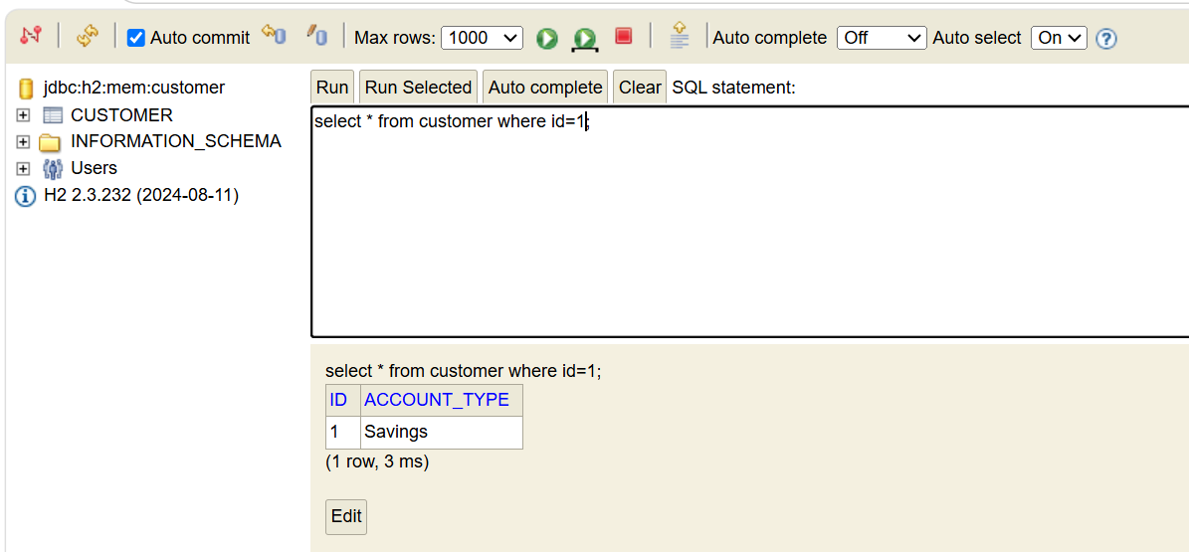

- Application.properties
application.properties is a configuration file in Spring Boot used to store application settings outside of Java code.
- Application.properties uses
It is very much useful for configure server settings like changing port name. Configure database connection.
- application.yml
It is same like application.properties but it uses Yamal(yaml Ain’t markup language).
- Yml over Application.properties
Because its has cleaner structure.
- Eureka server
Eureka Server acts as a centralized service registry that keeps track of all available microservice instances, enabling seamless service registration and discovery.

