Tasks
- Acutator in springboot
Acutator helps to track application status and it boots productivity and customer satisfaction and also it helps for cybersecurity purpose.
- Uses of actuator
Helps track metrics, performance, and system behavior for better management.
- Commonly used actuator endpoints
/acutator/health
/acutator/info
/acutator/env
/acutator/trace
/acutator/caches

- Small demo of actator
@Component
public class DatabaseHealthIndicator implements HealthIndicator {

@Override
public Health health() {
boolean databaseUp = true;

if (databaseUp) {
return Health.up()
.withDetail("Database", "Available")
.build();
}

return Health.down()
.withDetail("Database", "Unavailable")
.build();
}
}
{
"status":"UP",
"components":{
"database":{
"status":"UP",
"details":{
"Database":"Available"
}
}
}
}
- Spring security architecture
Spring security architecture defines the components for providing security for the application.
- Core components of spring security
Security filter chain
Authentication manager
Authentication provider
Password encoder
Security context holder

- Spring security architecture

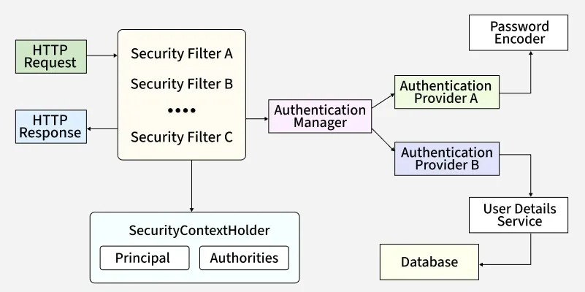
- Security filter chain
Security filter chain is different level of security filter which is responsible for each requirements of security. It will give authentication
- Authentication manager
Authentication manager is responsible for checking weather the user who is try to log in is authorised user without any threat.
- Authentication providers
- DaoAuthentication provider
- LdapAuthentication provider
- OpenIdAuthentication provider
- Jwtauthentication provider
- Rememberme authentication provider
- Userdetails service
UserDetailsService is a Spring Security interface used to load user-specific data during authentication. When a user logs in, Spring Security calls loadUserByUsername() to retrieve the user's details (username, password, and roles).
- Password encoder
Password encoder helps to encode the password before saving it as it is. It helps to save the password in more secure way.

- SecurityContextHeader
Header is the request which is the input to the authentication process meanwhile securitycontext is the result of authentication, allowing the rest of the application to access theresources.
- Security architecture internal functionality
HTTP Request
│
▼
Servlet Container (Tomcat)
│
▼
FilterChainProxy
│
┌─────────┐
│ │
▼ ▼
Security Filters Other Filters
│
▼
Authentication Filter
│
▼
AuthenticationManager
│
▼
AuthenticationProvider
│
▼
UserDetailsService
│
▼
Database
│
▼
UserDetails
│
▼
PasswordEncoder
│
▼
Authentication Object
│
▼
SecurityContextHolder
│
▼
Controller
│
▼
Business Logic
│
▼
HTTP Response
- Thymleaf
Thymeleaf is a server-side Java-based template engine for both web and standalone environments, capable of processing HTML, XML, JavaScript, CSS and even plain text. It is more powerful than JPS and responsible for dynamic content rendering on UI.
- Demo on thymleaf
package com.example.demo;

import org.springframework.stereotype.Controller;
import org.springframework.ui.Model;
import org.springframework.web.bind.annotation.GetMapping;

@Controller
public class HomeController {

@GetMapping("/")
public String home(Model model) {

model.addAttribute("name", "John");
model.addAttribute("city", "Bangalore");

return "home";
}
}
<!DOCTYPE html>
<html xmlns:th="http://www.thymeleaf.org">
<head>
<title>Thymeleaf Demo</title>
</head>
<body>

<h1>Welcome</h1>

<h2 th:text="${name}"></h2>

<p th:text="${city}"></p>

</body>
</html>

- Advantages of thymleaf
Natural html templates
Server side rendering
Easy integration with springboot
Good for highly interactive apps
- Caching
Caching is a technique where frequently used data is stored temporarily in a faster storage area (cache) so that future requests can retrieve it quickly instead of performing the same expensive operation again.

- List down annotations of Caching with usage
Spring Cache that allows you to improve application performance by storing frequently accessed data and avoiding repeated expensive operations.
- Types of caching
• In-Memory Cache (Local Cache) – It stores the data in the RAM in the application.
• Distributed Cache - It stores the data outside the application and shared between different applications.
• Database Cache- It stores the frequently accessed data in the database level.
• Application-Level Cache – Caches managed by application code.
• HTTP Cache – it stores the responses at browser or proxy level.
• Write-Through Cache – write data to both database and cache
• Write-Behind Cache – writes data to only cache.
• Cache-Aside (Lazy Loading) Cache – it checks cache first.
- Annotations
@Cacheable
@CachePut
@CacheEvict
@Caching
@CacheConfig
@EnableCaching
- @InjectMocks
@InjectMocks creates an instance of the class and injects the mocks that are created with the @Mock annotations into this instance.
- @Spy
The @Spy annotation is used to create a real object and spy on that real object. A spy helps to call all the normal methods of the object while still tracking every interaction, just as we would with a mock.

- @Mock
The @Mock annotation is used to create and inject mocked instances. We do not create real objects, rather ask mockito to create a mock for the class.
- Partial mocking
Partial mocking means that some methods of an object use the real implementation, while other methods are mocked.

- verify() is a Mockito method used to check whether a method on a mock object was invoked during the execution of a test.
- Annotations in mock
@Mock | Creates a fake object for testing.

@InjectMocks | Injects mocks into the class under test.

@Spy | Creates a partial mock.

@Captor | Captures arguments passed to mock methods.

@ExtendWith(MockitoExtension.class) | Enables Mockito support in JUnit 5.

