Tasks

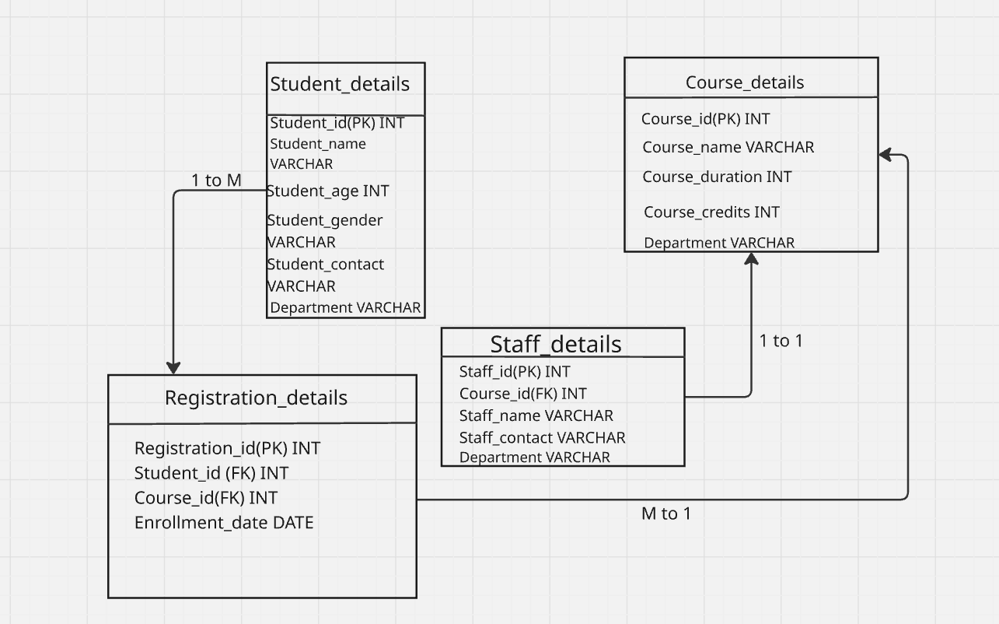
- Indexing
Indexing in dbms is used to retrieve the row very fast like it stores the values of one or more columns along with pointers to the corresponding rows in the table.
- Do you think Indexing strategy improves the query performance ? explain
Yes Indexing strategy improves the query performance like instead of scanning every row indexing helps to locate the row using a special data structure.
- ACID properties
Atomcity – returns proper outcome whether done or not done.
Consistency- did not allows duplicate
Isolation-one work at a time
Durability- changes are permanently saved.
- Alter table college ADD Column college_code INT UNIQUE;
insert into college(college_id,college_name,college_code) values(4,'cit',6786);
select * from college;
Home tasks
- What are window functions in Postgresql?
Window functions perform calculations across a set of rows that are related to the current row without grouping the rows into a single output.
- Keywords
Over(), partition by, order by, range ,groups,unbounded preceding,unbounded following,current row,preceding,following.
- Types of windows function
Ranking function
Aggregate window function
Value functions
Distribution functions
- Rules
Every window function must use the OVER() clause.
ROW_NUMBER() OVER ()
Window functions do not reduce the number of rows.
They are evaluated after WHERE, GROUP BY, and HAVING.
Window functions cannot be used directly in:
- WHERE
- GROUP BY
- HAVING
Instead, use a subquery or Common Table Expression (CTE).
PARTITION BY is optional.
- Without it, the entire result set is treated as one partition.
ORDER BY is required for functions where row order matters, such as RANK(), ROW_NUMBER(), LAG(), and LEAD().
Multiple window functions can be used in the same query.
Aggregate functions can also work as window functions when combined with OVER()
- JSON and JSONB
JSON
• Stores data exactly as provided.
• Preserves whitespace.
• Preserves key order.
• Allows duplicate keys.
• Parsing happens every time it is accessed.
• Faster for inserts.
JSONB
• Stores data in binary format.
• Removes whitespace.
• Does not preserve key order.
• Duplicate keys are removed (last value wins).
• Faster querying.
• Supports indexing (GIN indexes).
• Preferred for most applications.
- Full text search
Full Text Search (FTS) is a PostgreSQL feature that enables efficient searching within large amounts of text.
- Full Text Search is an advanced text-searching mechanism that converts text into searchable tokens and matches them against search queries.
- A SAVEPOINT creates a checkpoint within a transaction. It allows you to roll back part of a transaction without undoing all previous successful operations.

