Tasks
- 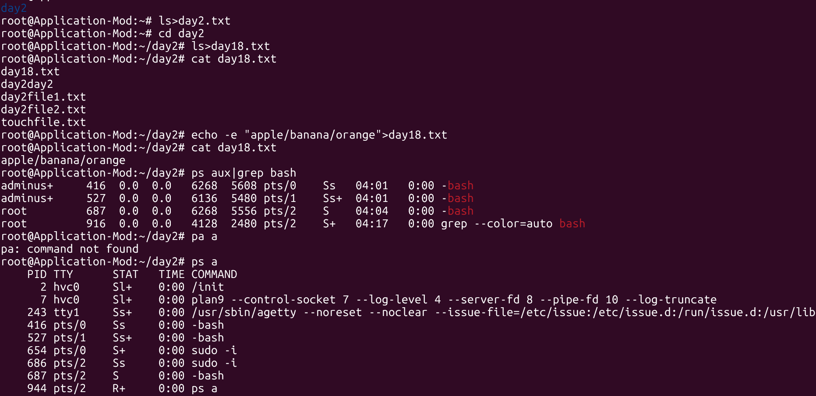
- 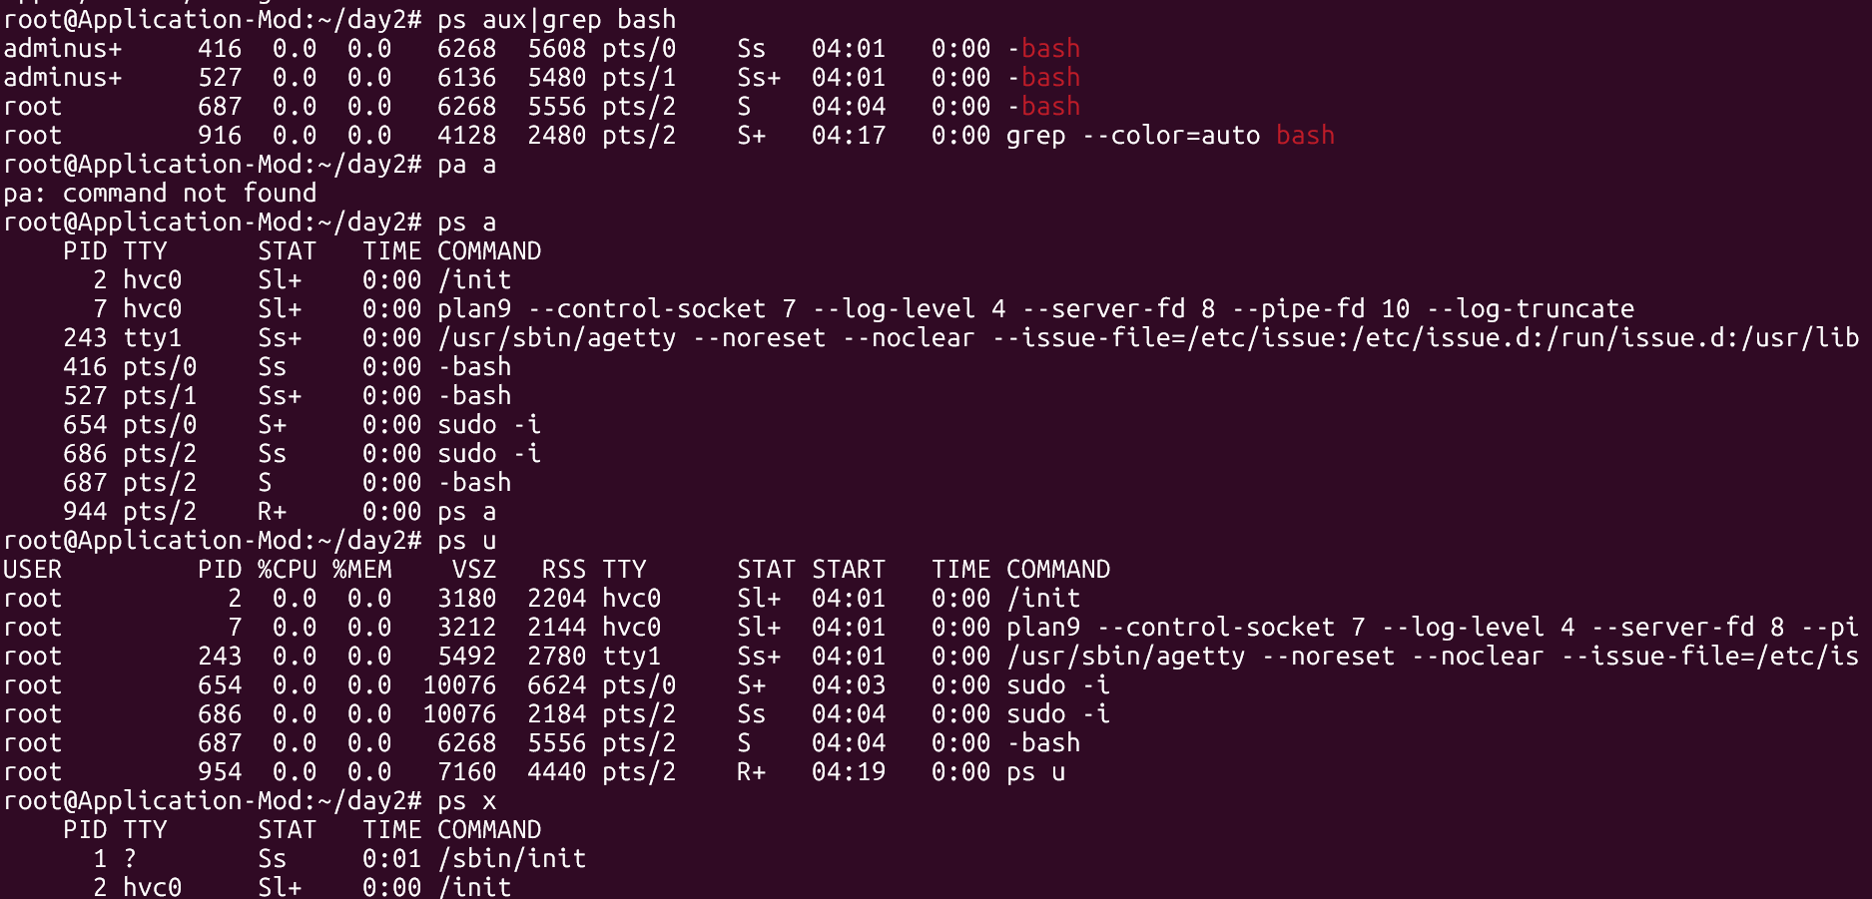
- 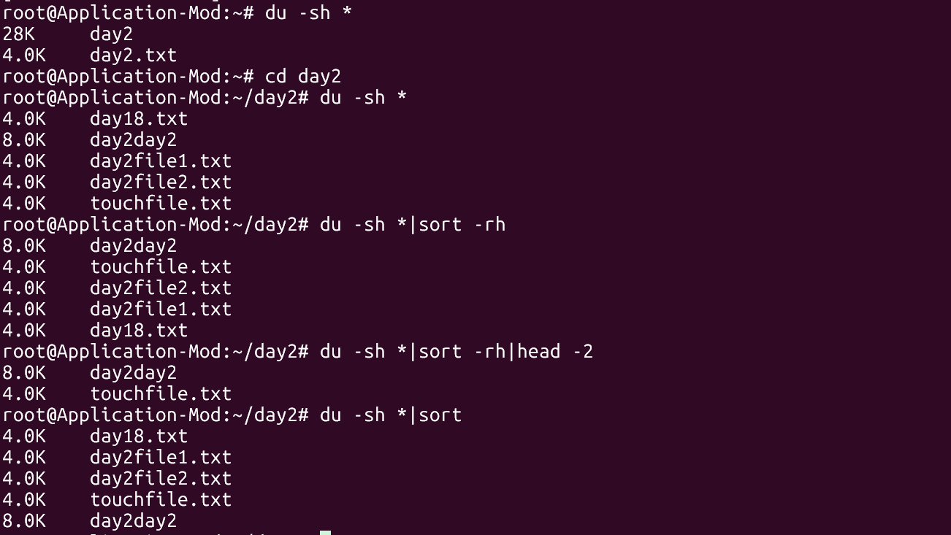
- 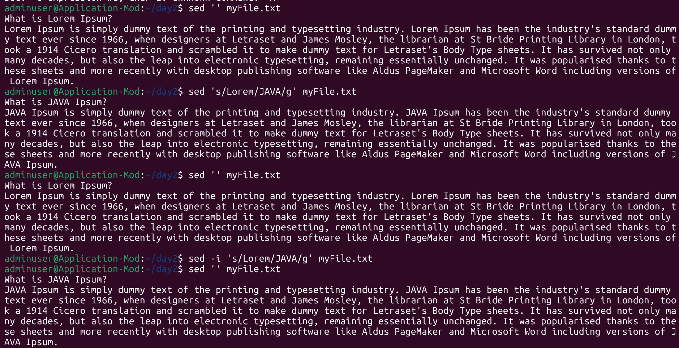
- 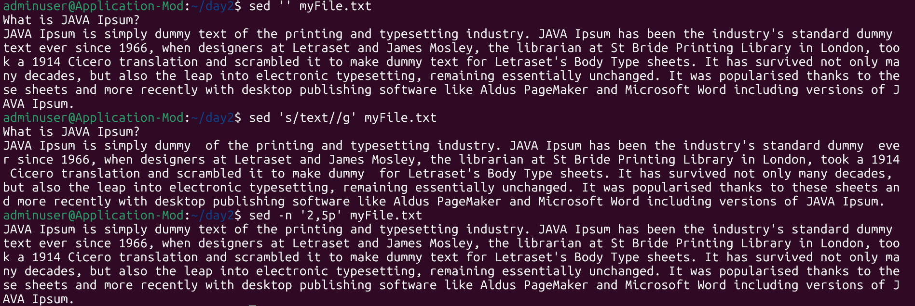
- 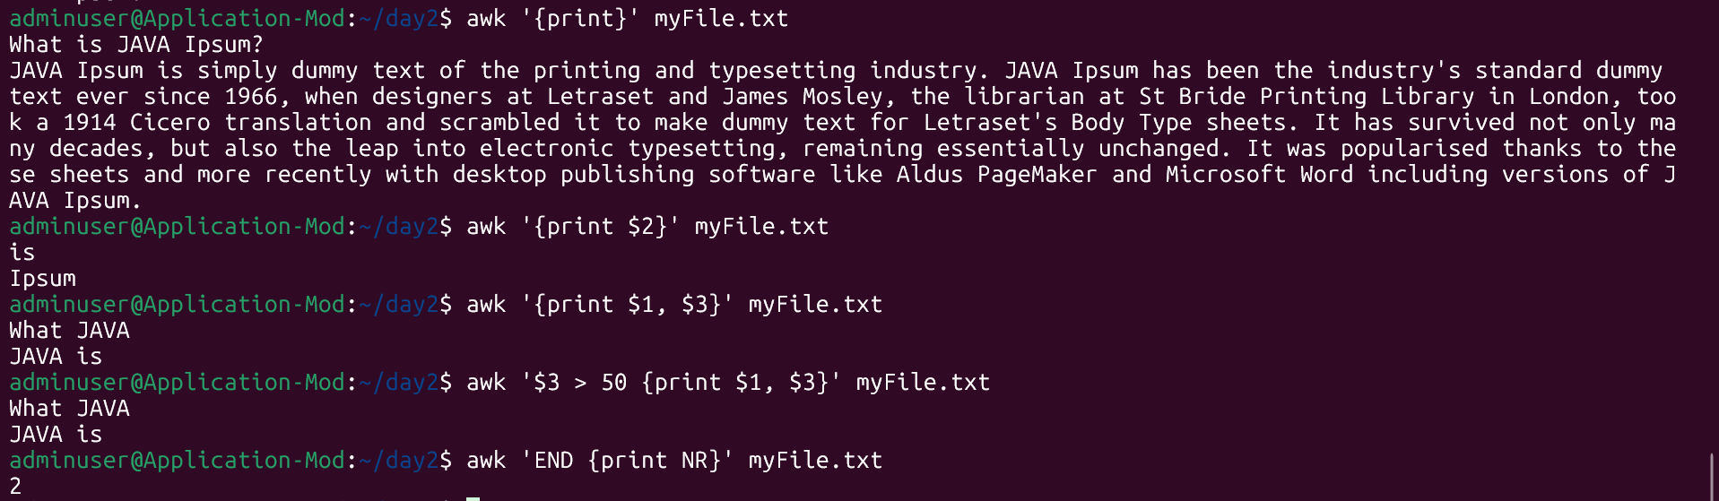
- 
- 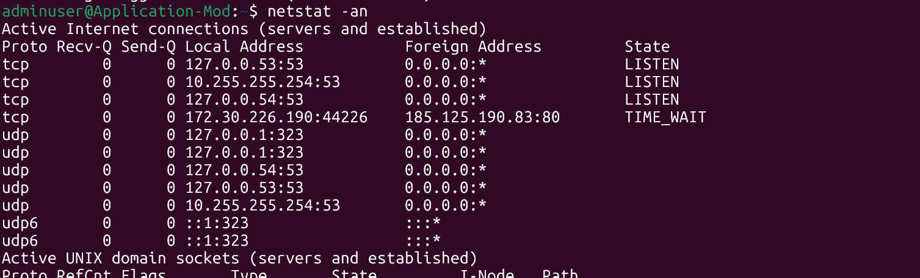
- 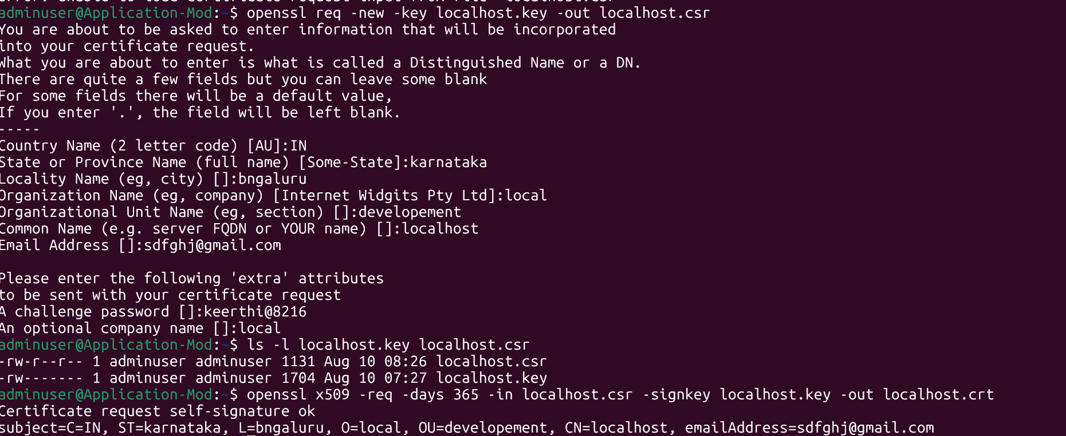
- What are the trees
A Tree is a non-linear data structure used to represent hierarchical relationships between elements. Unlike an array or linked list, where elements are arranged sequentially, a tree has a parent-child relationship. Trees are commonly used when data has a hierarchical structure.

- Types of tree
General tree
Binary tree
Binary search tree
Full binary tree
Complete binary tree
Perfect binary tree
Avl tree
- Binary search tree
BST is a binary tree in which every tree in which every node follow a specific order.
- Tree
import java.util.*;
class Node {
int val;
Node left, right;

Node(int val) {
this.val = val;
}
}

public class BinarySearchTree {

Node root;
Node insert(Node root, int val) {
if (root == null) {
return new Node(val);
} if (val < root.val) {
root.left = insert(root.left, val);
}

// Greater values go to the right
else if (val > root.val) {
root.right = insert(root.right, val);
}

return root;
}

public static void main(String[] args) {

BinarySearchTree tree = new BinarySearchTree();

tree.root = tree.insert(tree.root, 50);
tree.insert(tree.root, 30);
tree.insert(tree.root, 70);
tree.insert(tree.root, 20);
tree.insert(tree.root, 40);
tree.insert(tree.root, 60);
tree.insert(tree.root, 80);

System.out.println("Tree created successfully");
}
}
- Search for a number
boolean search(Node root, int value) {

if (root == null) {
return false;
}

if (root.val == value) {
return true;
}

if (value < root.val) {
return search(root.left, value);
}

return search(root.right, value);
}
public class BinarySearchTree {

Node root;

Node insert(Node root, int val) {

if (root == null) {
return new Node(val);
}

if (val < root.val) {
root.left = insert(root.left, val);
} else if (val > root.val) {
root.right = insert(root.right, val);
}

return root;
}

boolean search(Node root, int value) {

if (root == null) {
return false;
}

if (root.val == value) {
return true;
}

if (value < root.val) {
return search(root.left, value);
}

return search(root.right, value);
}

public static void main(String[] args) {

BinarySearchTree tree = new BinarySearchTree();

tree.root = tree.insert(tree.root, 50);
tree.insert(tree.root, 30);
tree.insert(tree.root, 70);
tree.insert(tree.root, 20);
tree.insert(tree.root, 40);
tree.insert(tree.root, 60);
tree.insert(tree.root, 80);

System.out.println(tree.search(tree.root, 40));
System.out.println(tree.search(tree.root, 100));
}
- Bfs and dfs

BFS | DFS
Breadth first search | Depth first search
Level by level | Goes deep first
Uses Queue | Uses Stack/recursion
Good for shortest path in unweighted graphs | Good for exploring paths/cycles
Can use more memory for wide graphs | Can use more memory for deep graphs
- BFS and DFS data stuructures
In BFS we are using queue(FILO) and in DFS we are using stack(LIFO).
- How do we find the shortest path in DFS
For an unweighted graph, we use BFS to find the shortest path because BFS visits nodes in increasing order of their distance from the source.
- Cycle in a graph
Undirected graph - During DFS, if we reach a node that is already visited and is not the parent of the current node then we have detected a cycle.
Directed graph - If during DFS we reach a node that is already in the current recursion stack, there is a cycle.
- Internal working of a hashmap
Hash map store sthe value in the key value pair.
- Collision in hashmap
If a bucket becomes sufficiently crowded, its linked-list structure can be converted into a balanced tree, specifically a red-black tree, under the relevant conditions.
- Capacity
Capacity = number of buckets in the HashMap's internal table.
Size = number of key-value pairs currently stored
- {null=InterviewBit, 1=Program to store null value}
- Why hash-map is not thread safe
A HashMap is not thread-safe, meaning multiple threads can access/modify it simultaneously without built-in synchronization.
- Yes we can store multiple keys with same value.
- HashMap is not synchronized and allows one null key and multiple null values, whereas Hashtable is synchronized and does not allow null keys or null values. HashMap is generally preferred for non-thread-safe use, while ConcurrentHashMap is usually preferred when thread-safe concurrent access is required.

