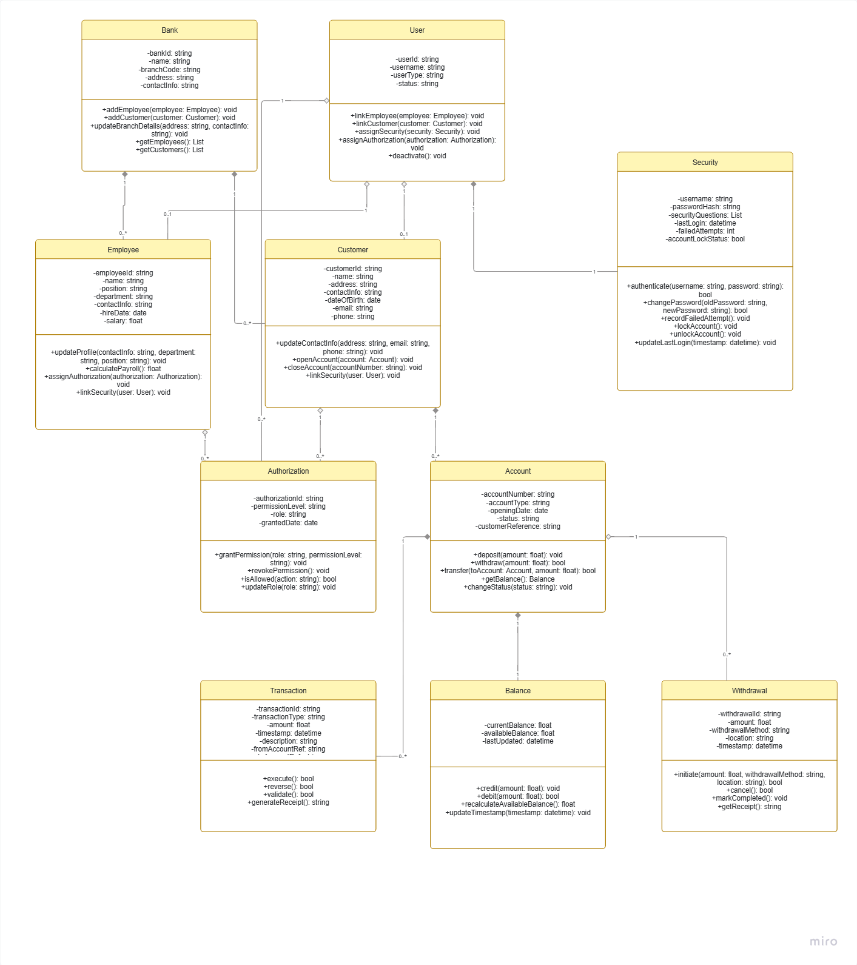
Tasks
- Welcome message
package org.example;
import org.example.Welcomemessage;
import org.springframework.context.ApplicationContext;
import org.springframework.context.support.ClassPathXmlApplicationContext;
public class Main {
public static void main(String[] args) {
ApplicationContext context =
new ClassPathXmlApplicationContext("applicationContext.xml");
Welcomemessage welcome = (Welcomemessage) context.getBean("welcomemessage");
welcome.display();
}
}
package org.example;
public class Welcomemessage {
public void display() {
System.out.println("Welcome to Spring Framework!");
}
}

- Student
package org.example;
import org.springframework.context.ApplicationContext;
import org.springframework.context.support.ClassPathXmlApplicationContext;
public class Main {
public static void main(String[] args) {
ApplicationContext context =
new ClassPathXmlApplicationContext("applicationContext.xml");
Student student = (Student) context.getBean("student");
student.display();
}
}
package org.example;
public class Student {
private int id;
private String name;
public Student() {
}
public Student(int id, String name) {
this.id = id;
this.name = name;
}
public int getId() {
return id;
}
public void setId(int id) {
this.id = id;
}
public String getName() {
return name;
}
public void setName(String name) {
this.name = name;
}
public void display() {
System.out.println("Student ID: " + id);
System.out.println("Student Name: " + name);
}
}

- Bean
- Application context
Application context is the spring Inversion of control which is responsible for creating bean, managing bean and injection of dependencies.
Syntax for Application context is - ApplicationContext context =
new ClassPathXmlApplicationContext("applicationContext.xml");
- Uses of Application context
Application context helps to manage the objects itself otherwise we need to manage the objects manually.
- Spring framework
Spring framework has IoC(Inversion of Control) feature which helps to not to create objects manually.
Another feature is Dependency Injection which helps to provide required dependencies to the object which helps the rogram loosely coupled.
It also supports JDBC code.
- Spring framework
Spring framework helps us to easy communication with the database.
Its provides mvc pattern, so that employees can focus on business logic not on programming.
- Ioc
- Objects are loosely coupled
- Dependencies are injected
- Easy to mock for tests
- Code becomes clean & modular
- Types of Ioc
  - Bean factory container- It is lazy contrainer which creates objects when required.
  - Application context Ioc container – It creates bean during the configuration itself.

- DI
Dependency injection is a spring container which provides objects itself to the class.
- Types of DI
- Constructor injection- Dependencies or injected through constructor.
- Setter Injection- Dependencies or injected through setter.
- Field Injection-Spring injects the dependency directly into a class field using annotations.
- Spring configuration
Spring configuration tells the Spring container which objects to create, how to create them, and how they are connected with each other.
- Types of Configuration
- XML based configuration
- Annotation based configuration
- Java based configuration
- We need spring configuration is to provide instructions to the Spring container about bean creation, dependency injection, and object management, which helps build loosely coupled and maintainable applications.
- Same as 13
- Bean scope
Bean scope tells Spring whether to create a single object or multiple objects of a bean.
Scope | Description
Singleton | Only one instance of the bean is created per Spring container.
Prototype | A new instance is created every time the bean is requested.
Request | One bean instance is created for each HTTP request (web applications).
Session | One bean instance is created for each HTTP session (web applications).
Application | One bean instance is created for the entire web application context.
WebSocket | One bean instance is created for the lifecycle of a WebSocket session.

- Auto wiring
Autowiring allows Spring to automatically find and provide the dependent objects required by a class.
- Normal object vs spring bean
Normal object created by new keyword meanwhile spring bean is create and manage by spring framework.
- @ component and @ bean
@Component- Create an object of this class and manage it as a Spring bean.
@Bean is used at the method level inside a configuration class.
- Program
package com.example.employee;

import org.springframework.boot.SpringApplication;
import org.springframework.boot.autoconfigure.SpringBootApplication;
import org.springframework.context.ApplicationContext;

@SpringBootApplication
public class EmployeeApplication {

public static void main(String[] args) {

ApplicationContext context =
SpringApplication.run(EmployeeApplication.class, args);

Employee employee =
context.getBean(Employee.class);

employee.display();
}
}
package com.example.employee;

import org.springframework.context.annotation.Bean;
import org.springframework.context.annotation.Configuration;

@Configuration
public class AppConfig {

@Bean
public Employee employee() {

return new Employee(
101,
"John",
"IT"
);
}
}
- POJO
package com.example.employee;

public class Employee {

private int id;
private String name;
private String department;

public Employee(int id, String name, String department) {
this.id = id;
this.name = name;
this.department = department;
}

public void display() {
System.out.println("Employee Id: " + id);
System.out.println("Employee Name: " + name);
System.out.println("Department: " + department);
}
}
package com.example.employee;

import org.springframework.context.annotation.Bean;
import org.springframework.context.annotation.Configuration;

@Configuration
public class AppConfig {

@Bean
public Employee employee() {

Employee emp = new Employee(
101,
"Rahul",
"Development"
);

return emp;
}
}
package com.example.employee;

import org.springframework.boot.SpringApplication;
import org.springframework.boot.autoconfigure.SpringBootApplication;
import org.springframework.context.ApplicationContext;

@SpringBootApplication
public class EmployeeApplication {

public static void main(String[] args) {

ApplicationContext context =
SpringApplication.run(EmployeeApplication.class, args);

Employee emp = context.getBean(Employee.class);

emp.display();
}
}
- One line explanation
@Bean | Creates and registers an object as a Spring bean inside a @Configuration class.
@Controller | Marks a class as a Spring MVC controller that handles web requests and usually returns views.
@Value | Injects values from properties files, environment variables, or expressions into fields.
@ComponentScan | Tells Spring where to search for classes annotated with @Component, @Service, @Repository, and @Controller.
@Configuration | Indicates that a class contains Spring bean definitions using @Bean methods.
@Service | Marks a class as a service layer component that contains business logic.
@Repository | Marks a class as a data access component that communicates with the database.
@Qualifier | Specifies which bean to inject when multiple beans of the same type exist.
@Required | Indicates that a setter method must be configured with a value (deprecated since Spring 5.1).
@Component | Marks a class as a Spring-managed bean detected through component scanning.
@Autowired | Automatically injects dependencies into a Spring bean.
@Scope | Defines the lifecycle and scope of a Spring bean (singleton, prototype, request, session, etc.).
- Springboot features
Springboot provides simplifies the java development process by providing features like auto configuration, starter dependicies, profiles, standalone applications, testing support.
- Advantage of springboot
Faster development, less configuration,Easy database integration, Better testing support.
- Key components of springboot
Auto configuration helps us to automatically configures spring components based on the libraries present in the project.
Dependency management helps to manage compatible versions of spring libraries.
- Why springboot over spring
Spring boot is built on the top of the spring framework . It does not replace spring but its implifies the development of spring applications.

- Internal working of spring boot
JVM starts the application
SpringApplication.run()
Creates springApplication object- new SpringApplication(Myapp.class)
Create ApplicationContext
Reads @SpringBootApplication
Reads applicationConfiguration
Creates bean
Dependency Injection
Embedded tomcat
Application Ready
- Starter dependencies
Spring-boot-starter
Spring-boot-starter-web
spring-boot-starter-jdbc
spring-boot-starter-test
- What is the internal working of above code
Step 1:JVM starts execution
Step 2:SpringApplication.run() is called
Step 3:Spring Boot creates a SpringApplication object
Step 4: MyApplication.class is passed to Spring
Step 5: @SpringBootApplication is processed
Step 6: creates application context
Step 7:Reads @SpringBootApplication
Step 8:Reads applicationConfiguration
Step 9:Creates bean
Step 10:Dependency Injection
Step 11:Embedded tomcat
Step 12:Application Ready
- Syntax
Applications properties- server.port=9090
rc/main/resources/application.yml – server: port:9090

