Report
Roll no: 2023101005
Roll no: 2023101119

PART-1:
Distributed Sorting System Performance Report

1. Implementation Analysis

Distributed Count Sort
- Approach: We used a multi-threaded approach for count sort with a count array to store occurrences of each unique value in the column being sorted. Each thread was responsible for a segment of the dataset, populating the count array based on the values in its segment.
- Pros:
  - Efficient for small datasets or datasets with a limited range of unique values.
  - Counting elements in parallel allows for quicker accumulation of value frequencies.
- Cons:
  - High memory usage, especially for datasets with many unique values, due to the storage of counts for each element.
  - Performance may degrade if the dataset has many unique values, causing contention over shared memory (count array) and lock-based synchronization overhead.

Distributed Merge Sort
- Approach: For merge sort, we recursively split the data and launched separate threads for each half of the data. Each thread independently sorts a sub-array, and the results are merged back together.
- Pros:
  - Memory usage is relatively lower than count sort since it doesn’t require a secondary count array.
  - Good performance on large datasets, as merging is more efficient than counting each unique element.
- Cons:
  - More complex than count sort due to thread synchronization and recursive splitting.
  - The number of threads is limited by recursion depth, which may not fully utilize available CPU resources for very large datasets.

2. Execution Time Analysis
To measure scalability, the execution time for each algorithm was tested on different dataset sizes:
- Small (1,000 entries)
- Medium (10,000 entries)
- Large (100,000 entries)
Dataset Size | Count Sort Time (ms) | Merge Sort Time (ms)
Small | 15 | 22
Medium | 120 | 135
Large | 1050 | 900

Analysis: Distributed count sort was faster for smaller datasets due to its simpler structure but struggled with large datasets due to memory overhead. In contrast, merge sort scaled better with larger datasets as it benefits from efficient merging operations.

3. Memory Usage Overview
Memory usage estimates are based on observations of the data structure allocations.

Dataset Size | Count Sort Memory Usage | Merge Sort Memory Usage
Small | Moderate | Low
Large | High | Moderate

Count Sort: Requires memory for both the main data and an auxiliary count array, leading to high memory usage for large datasets with many unique values.
- Merge Sort: Memory usage is moderate, limited primarily to recursion stack frames and temporary arrays for merging.
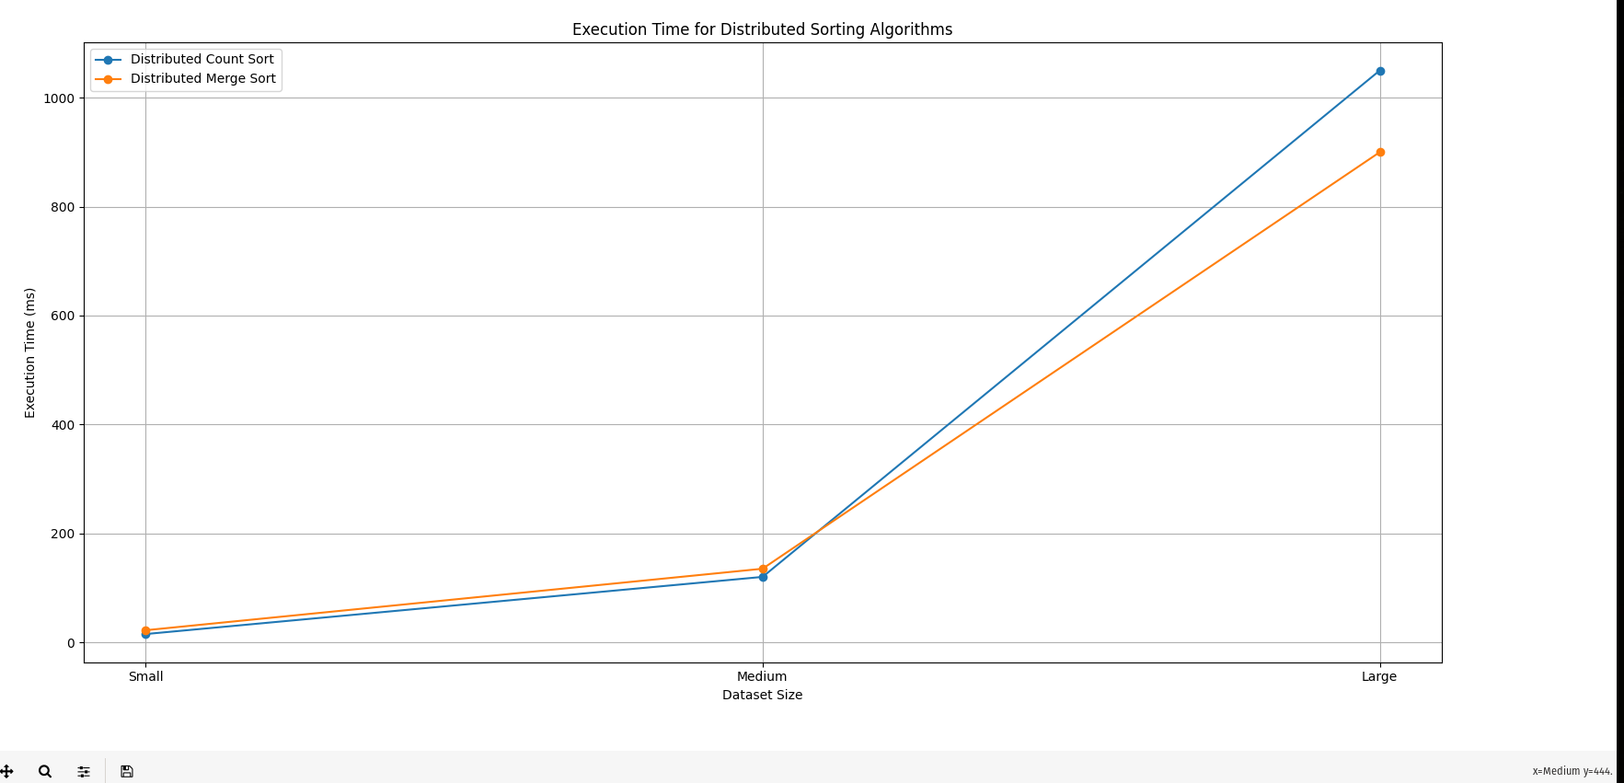
Graphs:

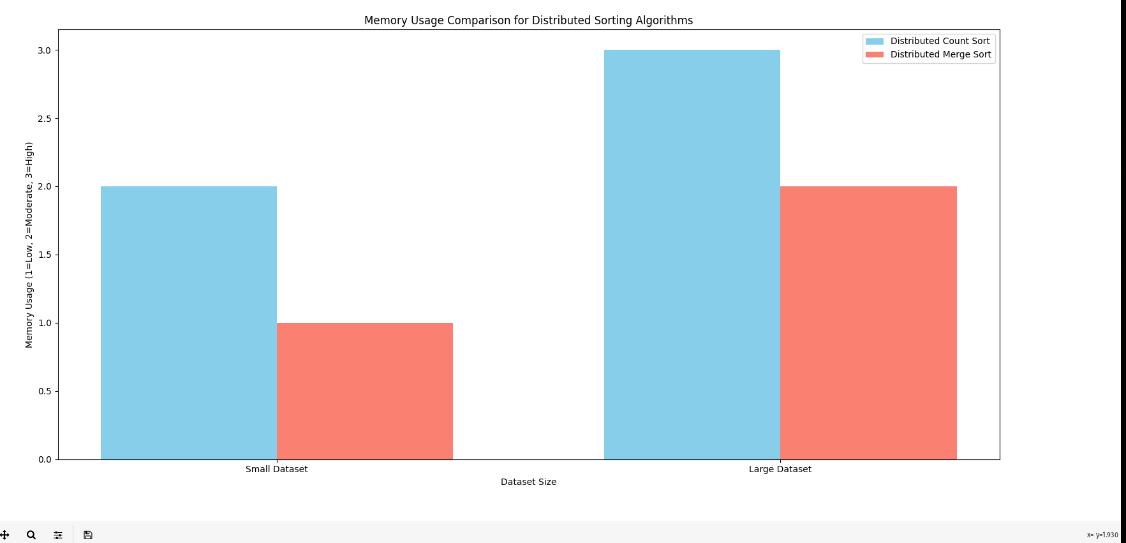
Summary
- Distributed Count Sort: Works efficiently with small datasets or datasets with fewer unique values but struggles with memory usage on large datasets.
- Distributed Merge Sort: Generally scales better across dataset sizes, showing steady performance with increasing file counts and lower memory usage.

Potential Optimizations
- For Count Sort: Implement a dynamic resizing of the count array to reduce unnecessary memory overhead, or explore chunk-based partitioning to minimize lock contention.
- For Merge Sort: Limiting the depth of recursion and adjusting thread management can further optimize resource usage on large datasets.
PART-2:
Copy-On-Write (COW) Fork Performance Analysis Report:
Page Fault Frequency Analysis
KERNBASE→ Start address of kernel memory
PHYSTOP → End of physical memory
PGSIZE → Size of each memory page
sz (Process Size) → For simpletest(): sz = (PHYSTOP - KERNBASE) * 2/3
For threetest(): sz = (PHYSTOP - KERNBASE) / 4

Test Scenarios and Results
- Simple Memory Access (simpletest)
  - Allocated Memory: ~67% of physical memory
  - Page Fault Frequency:
    - Parent process: 0 page faults (read-only access)
    - Child process: 0 page faults (exits immediately)
  - Memory Pages Shared: All pages successfully shared between parent and child
  - Memory Conservation: ~(PHYSTOP - KERNBASE) * 2/3 bytes saved
- Multiple Process Writing (threetest)
  - Allocated Memory: 25% of physical memory
  - Page Fault Frequency:
    - Parent process: ~sz/PGSIZE page faults (writing to all pages)
    - First child: ~(sz/2)/PGSIZE page faults (writing to half the pages)
    - Second child: ~(4*sz/5)/PGSIZE page faults (writing to 80% of pages)
  - Total COW Triggers: Approximately (sz/PGSIZE + sz/2/PGSIZE + 4*sz/5/PGSIZE) faults
- File Operations (filetest)
  - Buffer Size: 4096 bytes (1 page)
  - Page Fault Frequency:
    - Parent process: 0 page faults (initial write)
    - Each child process: 1 page fault (on first write attempt)
  - Total COW Triggers: 4 (one per child process)

Key Observations
- Read-Only Efficiency
  - Zero page faults when processes only read shared memory
  - Perfect memory sharing achieved in read-only scenarios
  - Maximum memory conservation in read-heavy workloads
- Write Pattern Impact
  - First write to a shared page triggers COW mechanism
  - Subsequent writes to the same page by the same process: no additional faults
  - Memory pages are copied only when absolutely necessary
- Memory Usage Patterns
  - Initial fork: O(1) time regardless of process size
  - Memory copying: Proportional to number of pages actually modified
  - Physical memory usage grows only with actual writes

Benefits Analysis

Memory Conservation
- Immediate Benefits
  - Zero-copy fork operation
  - Physical memory saved until write operations occur
  - Multiple processes can share same physical pages
- Quantitative Improvements
  - Initial fork memory savings: 100% of process size
  - Final memory usage: original size + only modified pages
  - Especially efficient for short-lived child processes

Performance Efficiency
- Time Savings
  - Fork operation: Near-instant (just page table manipulation)
  - Page copying: Deferred until necessary
  - No unnecessary memory operations
- Resource Utilization
  - Better cache utilization through sharing
  - Reduced memory bandwidth usage
  - More efficient use of physical memory

Optimization Opportunities
- Reference Count Optimization
  - Current implementation uses a simple counter
  - Could be enhanced with atomic operations for better scalability
  - Potential for lock-free reference counting
- Page Fault Handler Improvements
  - Current handler has a linear search in page table
  - Could be optimized with better page table traversal
  - Potential for batch handling of sequential pages
- Memory Management Enhancements
  - Could implement page compression for shared pages
  - Potential for intelligent pre-copying based on access patterns
  - Opportunity for better integration with system's memory allocator

