Hands on Week 9: DAY-41 Keerthivasan R

Simple Registration & Login API using .NET 8 + SQL Server + BCrypt

Introduction
This document explains how to build a simple registration and login Web API using .NET 8, SQL Server (Code First), and BCrypt password hashing.
Key Concepts:
- Single Entity (User)
- DTOs for input
- Password Hashing using BCrypt
- Entity Framework Core Code First

Architecture Overview
Flow:
1. Register
- Accept user input
- Hash password
- Save to DB
2. Login
- Validate email
- Verify password using BCrypt

NuGet Packages
Install:
- Microsoft.EntityFrameworkCore.SqlServer
- Microsoft.EntityFrameworkCore.Tools
- BCrypt.Net-Next

Model: User.cs
public class User
{
public int Id { get; set; }
public string Name { get; set; }
public string Email { get; set; }
public string PasswordHash { get; set; }
}

DTOs
RegisterDto:
- Name
- Email
- Password
LoginDto:
- Email
- Password

DbContext
public class AppDbContext : DbContext
{
public DbSet<User> Users { get; set; }
}

Controller Logic
Register:
- Check email exists
- Hash password
- Save
Login:
- Validate email
- Verify password using BCrypt

Program.cs Setup
Configure services:
- AddControllers
- AddDbContext
- Swagger

Database Setup
Run:
Add-Migration InitialCreate
Update-Database

Testing
Use Swagger:
- POST /register
- POST /login

Important Note
Passwords are stored as hashed values using BCrypt. Never store plain text passwords.
CODE:
SimpleAuthAPI/ Model/ User.cs
using System.ComponentModel.DataAnnotations;

namespace SimpleAuthAPI.Models
{
public class User
{
[Key]
public int Id { get; set; }

[Required]
public string Name { get; set; } = string.Empty;

[Required]
[EmailAddress]
public string Email { get; set; } = string.Empty;

[Required]
public string PasswordHash { get; set; } = string.Empty;
}
}
SimpleAuthAPI/ DTOs/ RegisterDto.cs
using System.ComponentModel.DataAnnotations;

namespace SimpleAuthAPI.DTOs
{
public class RegisterDto
{
[Required]
public string Name { get; set; } = string.Empty;

[Required]
[EmailAddress]
public string Email { get; set; } = string.Empty;

[Required]
[MinLength(6)]
public string Password { get; set; } = string.Empty;
}
}
SimpleAuthAPI/ DTOs/ LoginDto.cs
using System.ComponentModel.DataAnnotations;

namespace SimpleAuthAPI.DTOs
{
public class LoginDto
{
[Required]
[EmailAddress]
public string Email { get; set; } = string.Empty;

[Required]
public string Password { get; set; } = string.Empty;
}
}
SimpleAuthAPI/ Data/ AppDbContext.cs
using Microsoft.EntityFrameworkCore;
using SimpleAuthAPI.Models;

namespace SimpleAuthAPI.Data
{
public class AppDbContext : DbContext
{
public AppDbContext(DbContextOptions<AppDbContext> options) : base(options)
{
}

public DbSet<User> Users { get; set; }
}
}
SimpleAuthAPI/ Controllers/ AuthController.cs
using Microsoft.AspNetCore.Mvc;
using Shared.DTOs;
using Shared.Models;
using UserService.Services;

namespace UserService.Controllers
{
[ApiController]
[Route("api/[controller]")]
public class AuthController : ControllerBase
{
private readonly IAuthService _authService;

public AuthController(IAuthService authService)
{
_authService = authService;
}
[HttpPost("login")]
public async Task<ActionResult<ApiResponse<AuthResponse>>> Login([FromBody] LoginRequest request)
{
var result = await _authService.Login(request);

if (result == null)
{
return Unauthorized(ApiResponse<AuthResponse>.ErrorResponse("Invalid username or password"));
}

return Ok(ApiResponse<AuthResponse>.SuccessResponse(result, "Login successful"));
}
[HttpPost("register")]
public async Task<ActionResult<ApiResponse<AuthResponse>>> Register([FromBody] RegisterRequest request)
{
var result = await _authService.Register(request);

if (result == null)
{
return BadRequest(ApiResponse<AuthResponse>.ErrorResponse("Username or email already exists"));
}
return Ok(ApiResponse<AuthResponse>.SuccessResponse(result, "Registration successful"));
} }}
SimpleAuthAPI/ appsettings.json
{
"Logging": {
"LogLevel": {
"Default": "Information",
"Microsoft.AspNetCore": "Warning"
}
},
"ConnectionStrings": {
"DefaultConnection": "Server=(localdb)\\mssqllocaldb;Database=SimpleAuthDB;Trusted_Connection=True;MultipleActiveResultSets=true"
},
"AllowedHosts": "*"
}
SimpleAuthAPI/ Program.cs
using Microsoft.EntityFrameworkCore;
using SimpleAuthAPI.Data;

var builder = WebApplication.CreateBuilder(args);

// Add services to the container.
builder.Services.AddControllers();

// Configure DbContext with SQL Server
builder.Services.AddDbContext<AppDbContext>(options =>
options.UseSqlServer(builder.Configuration.GetConnectionString("DefaultConnection")));

// Add Swagger/OpenAPI
builder.Services.AddEndpointsApiExplorer();
builder.Services.AddSwaggerGen();

var app = builder.Build();

// Configure the HTTP request pipeline.
if (app.Environment.IsDevelopment())
{
app.UseSwagger();
app.UseSwaggerUI();
}

app.UseHttpsRedirection();
app.UseAuthorization();
app.MapControllers();

app.Run();

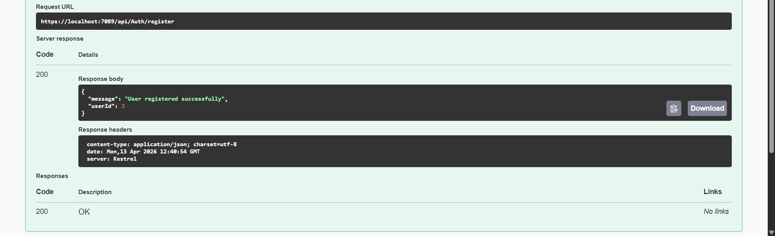
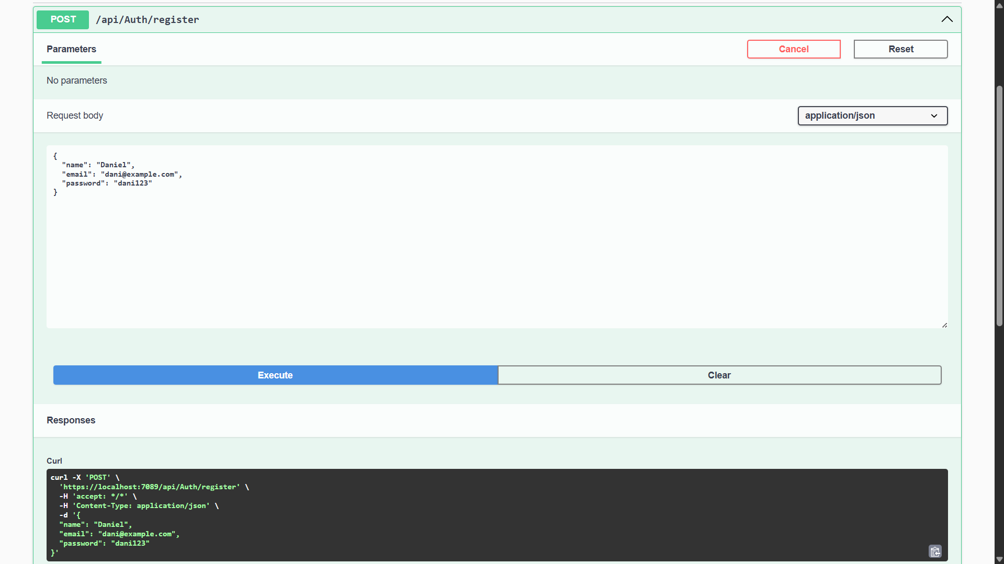
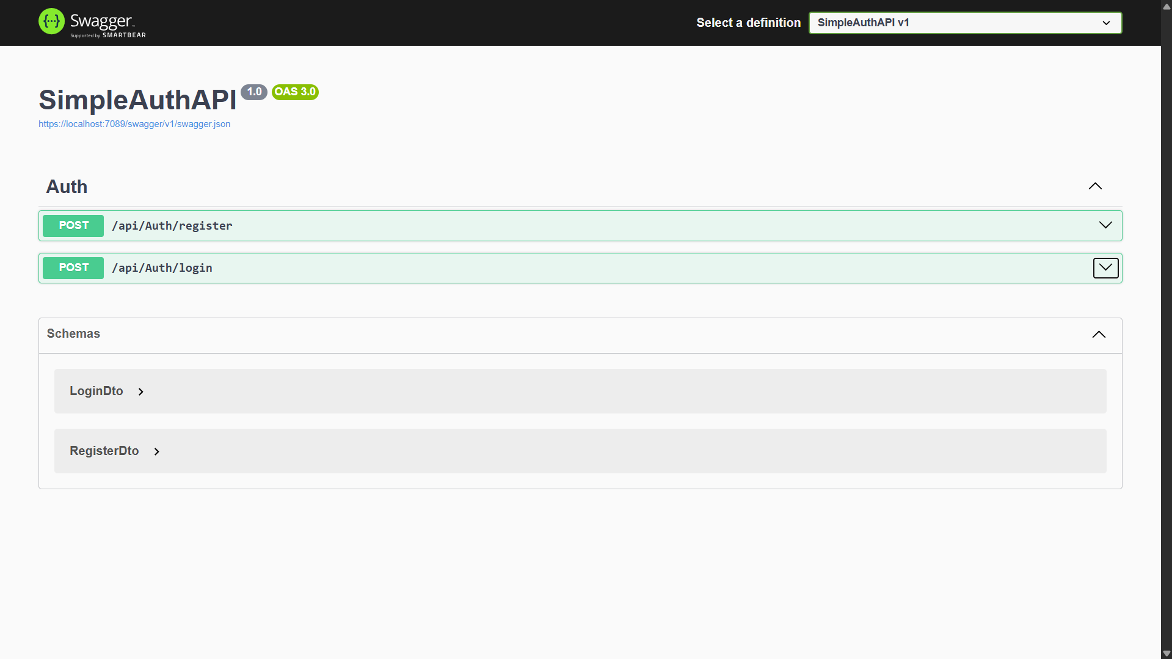
OUTPUT:
