Certification Progress Report: SQL Associate Certification Prerequsites
KEERTHI YALAMANCHILI
FA24

OPTION - 3

I have successfully fulfilled all the prerequisites for the DataCamp SQL Associate Certification. This achievement highlights my dedication to mastering SQL fundamentals and enhancing my expertise in data management and analysis.

Course Completion
I have completed all the pre-requisite courses required for the certification track.
- Introduction to SQL
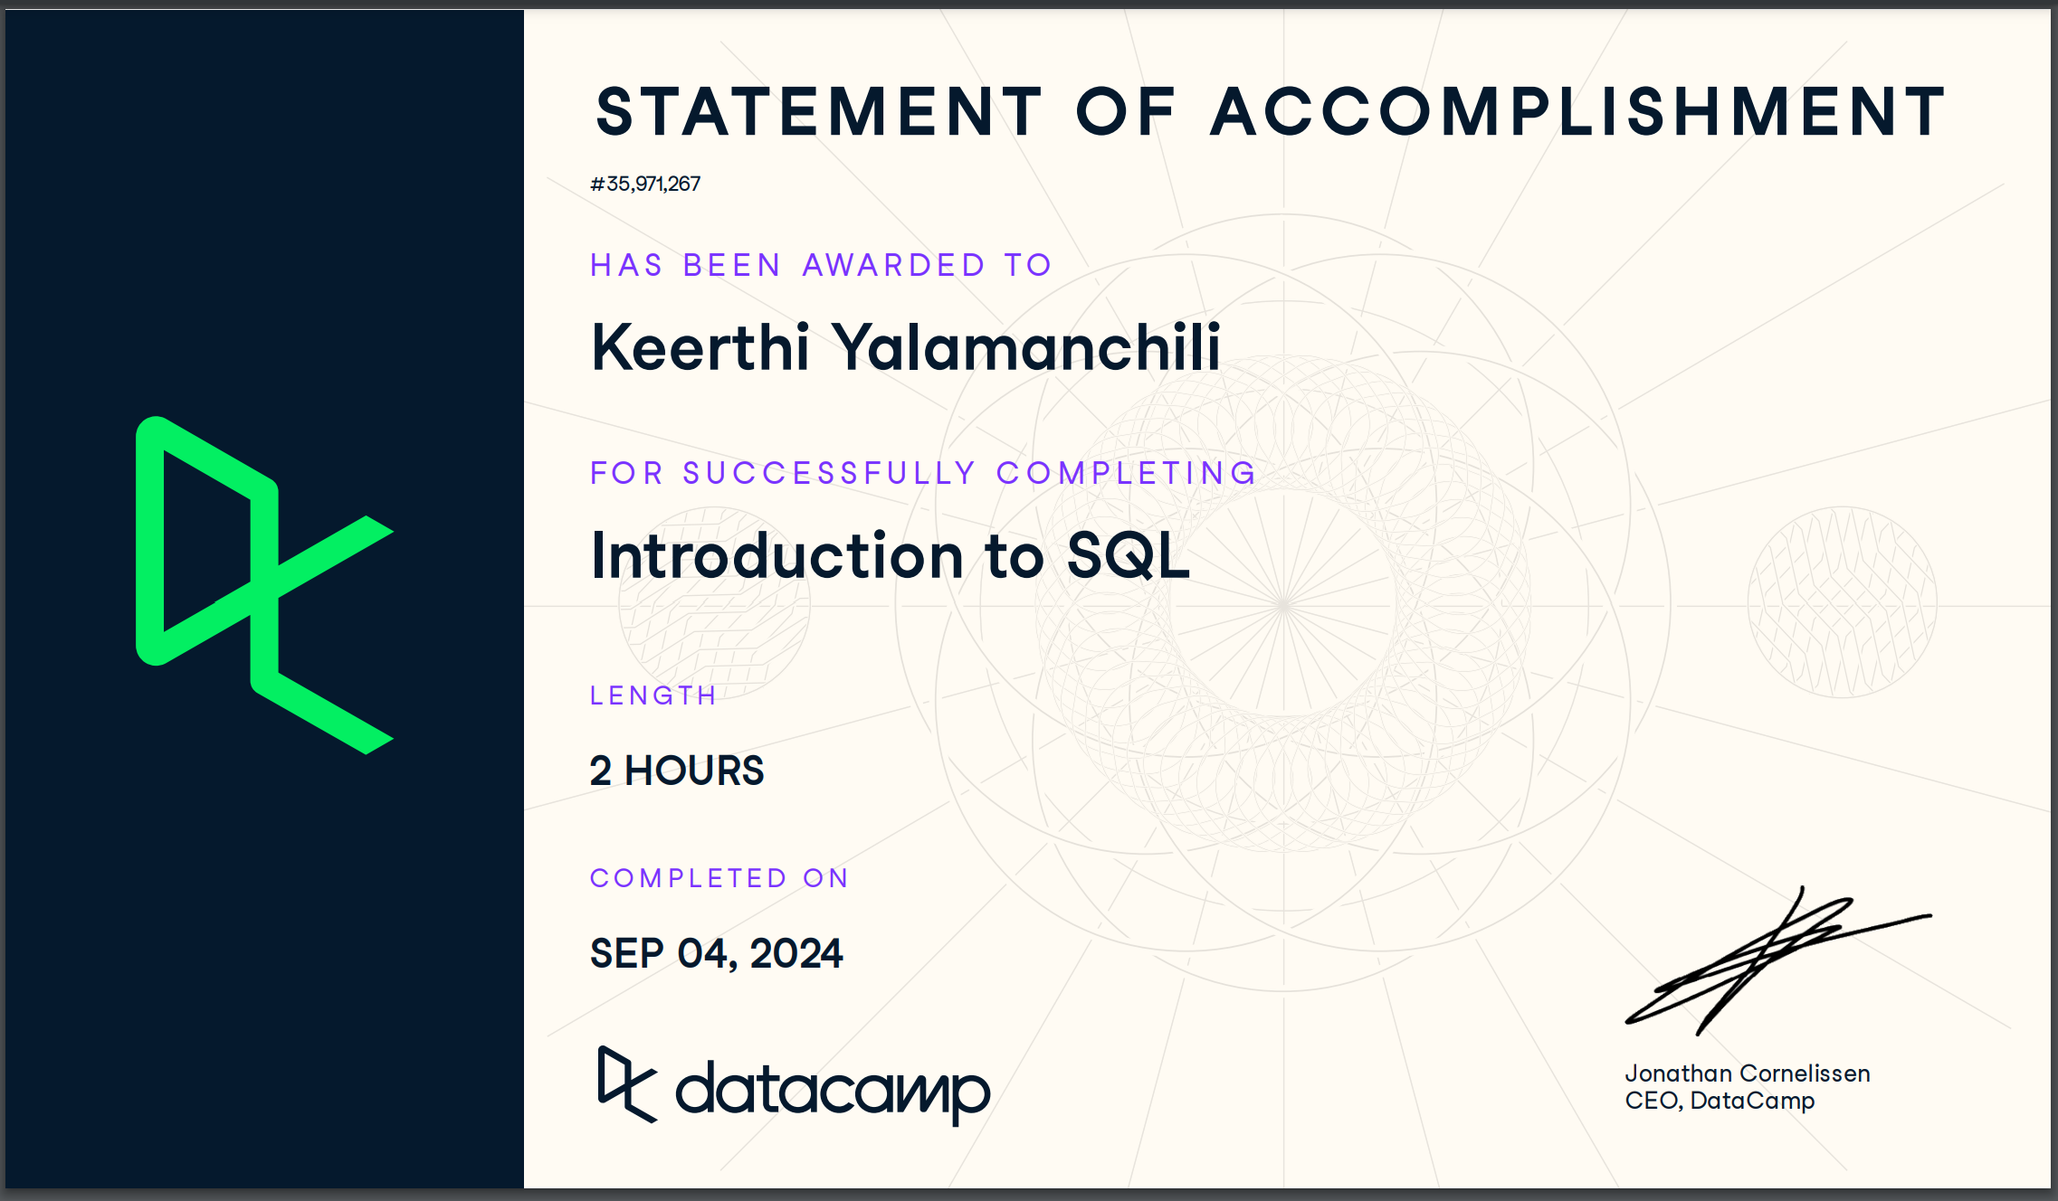
- Intermediate SQL
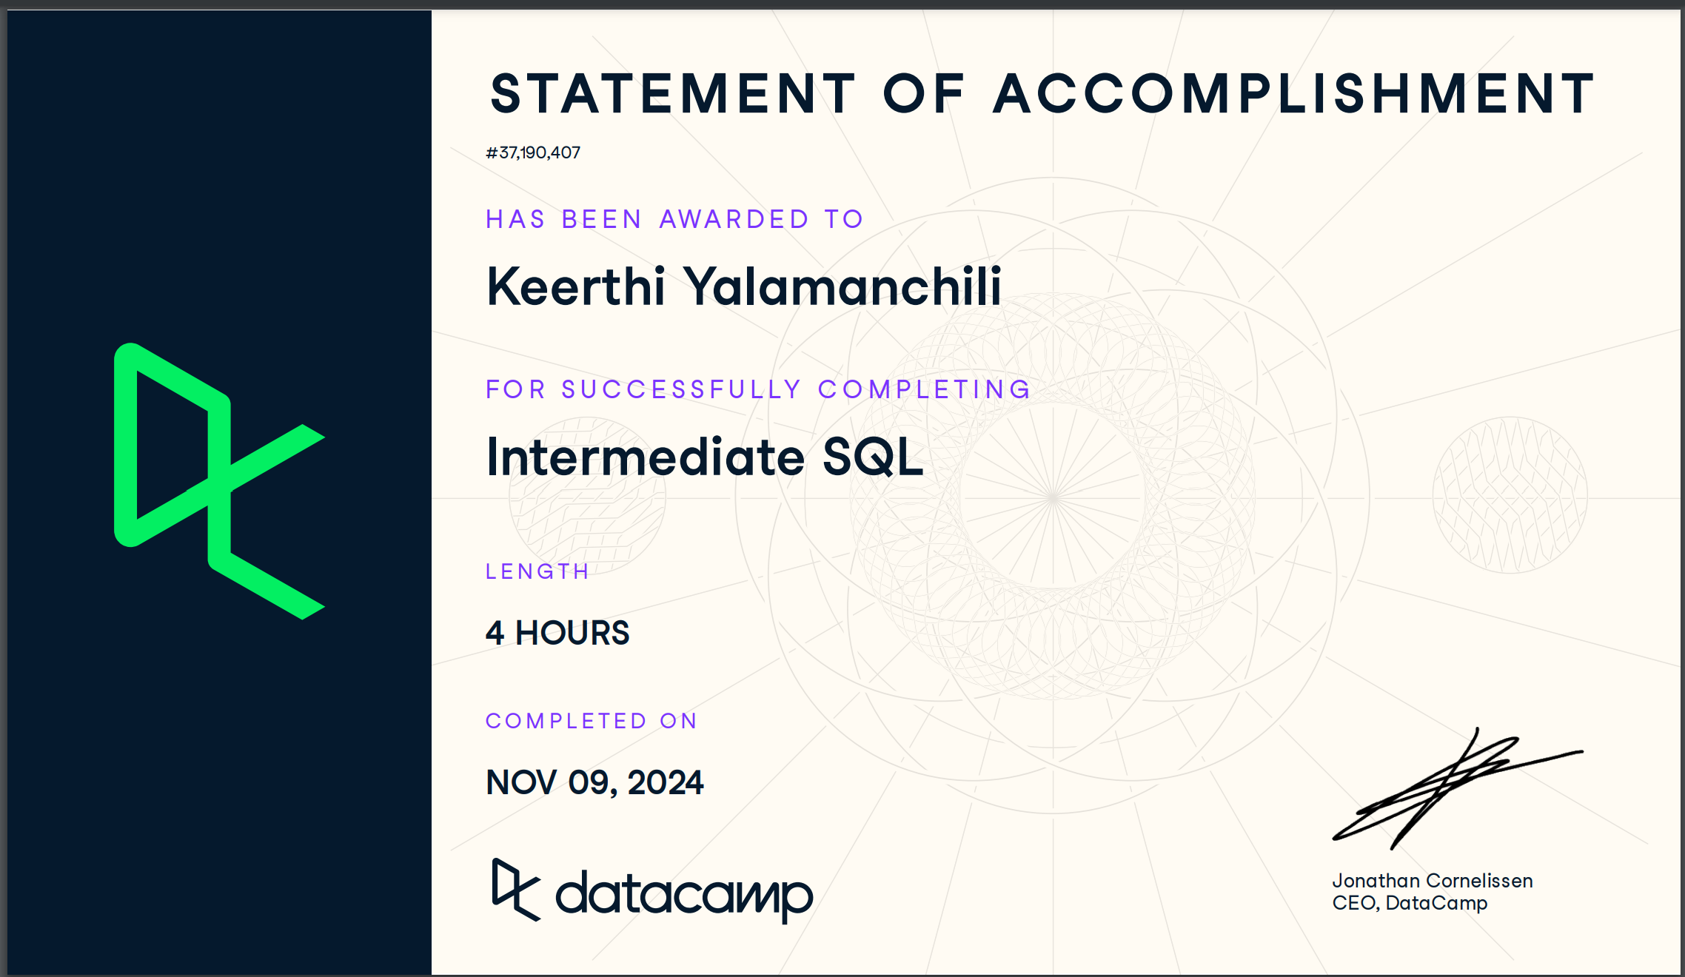

- Joining Data in SQL
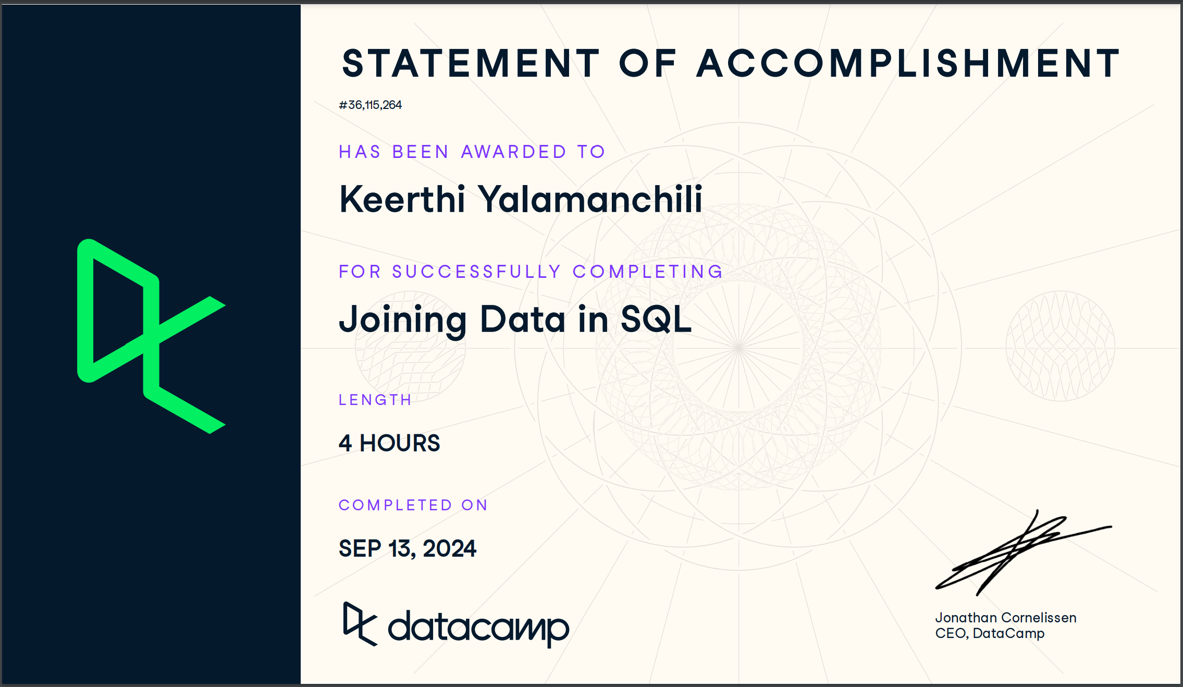
- Data Manipulation in SQL
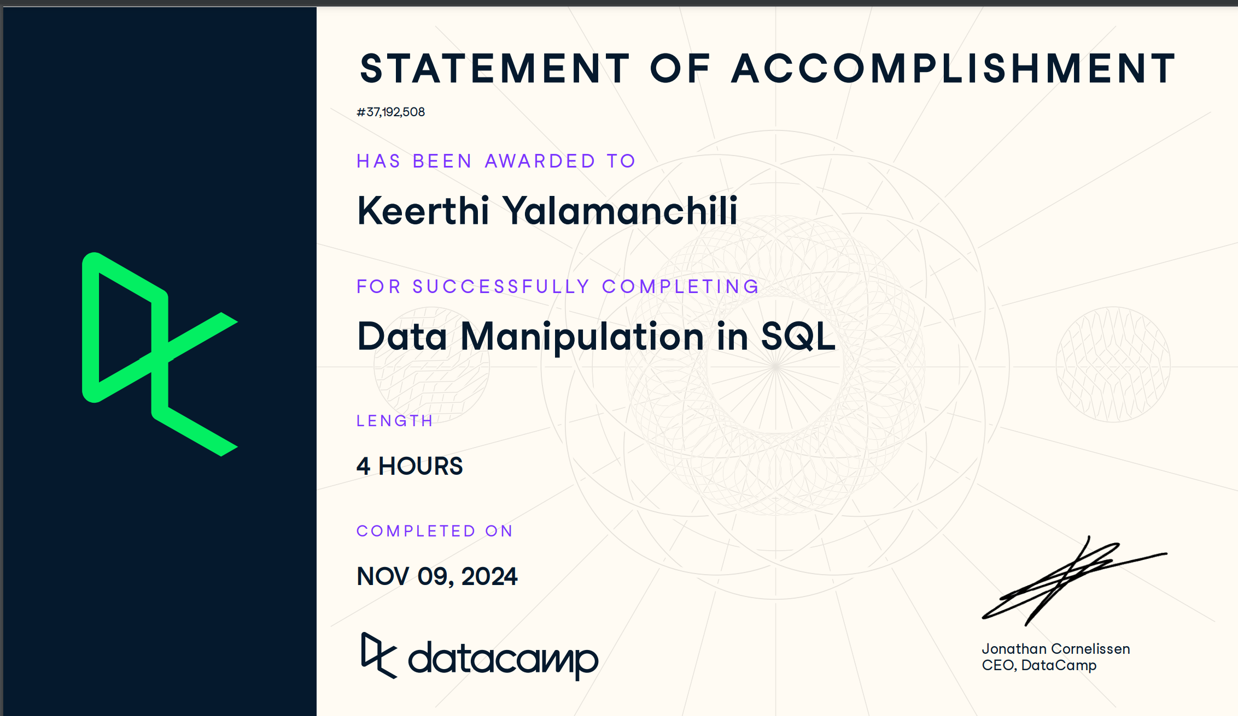

- PostgreSQL Summary Stats and Window Functions
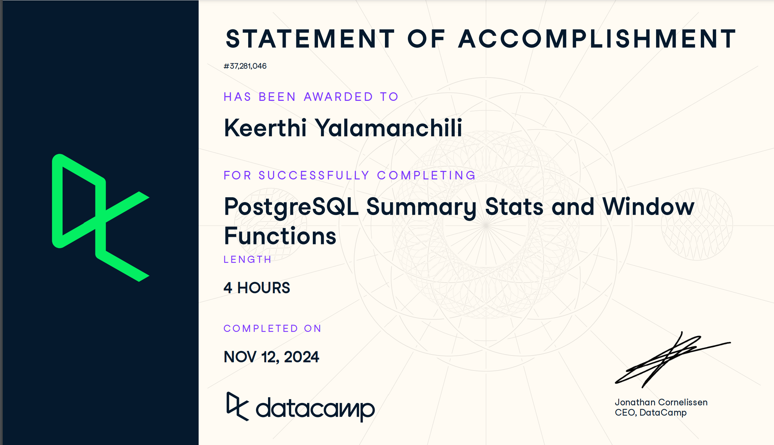
- Functions for Manipulating Data in PostgreSQL
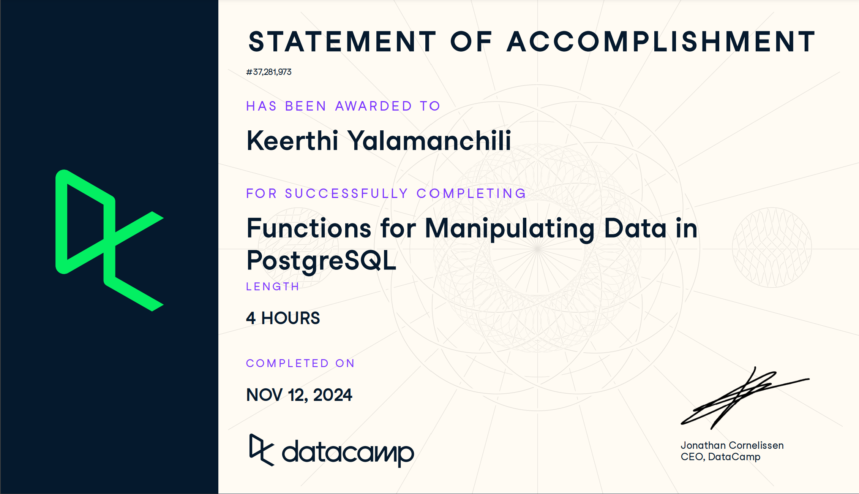

- Database Design
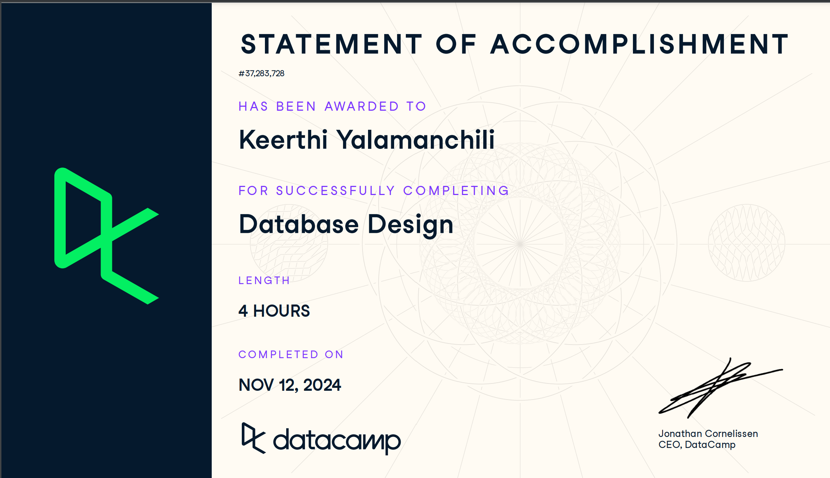
Each training included interactive exercises and practical application of SQL topics. I learned how query databases, manipulate datasets, work with joins, and use sophisticated techniques such as window functions and aggregate operations. The knowledge I gained from these courses has strengthened my understanding of SQL and its relevance in data-driven decision making.

- Track Completion Certificate
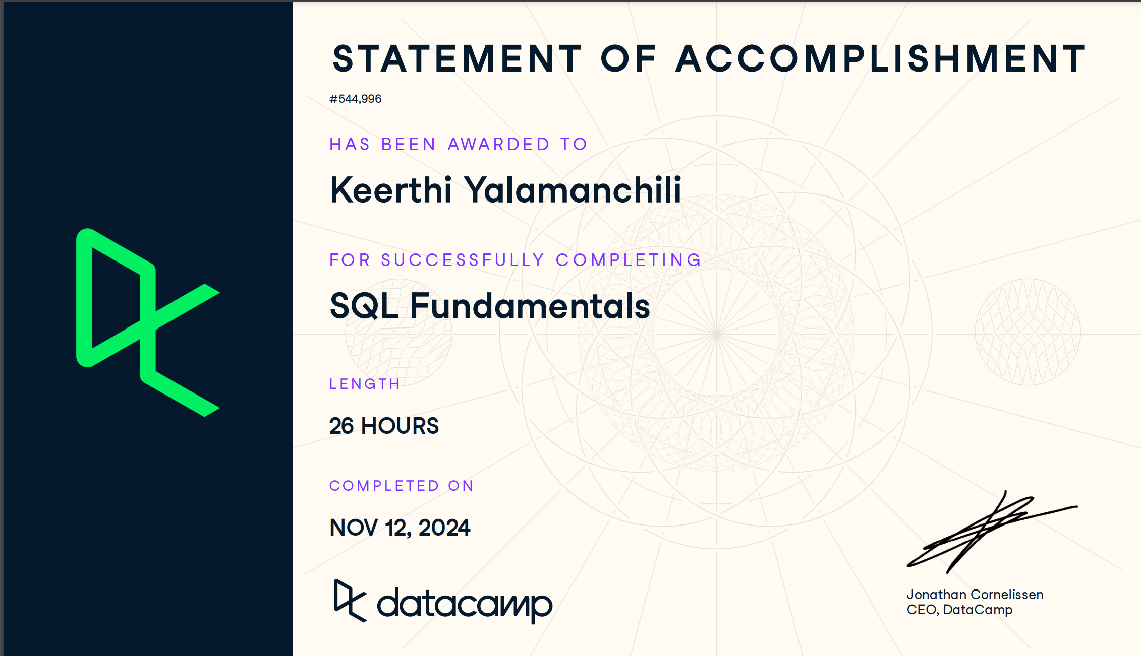
Skill Assessments
In addition to completing the courses, I have passed all the required assessments to qualify for the certification exam. These assessments include:
- Data Analysis in SQL (PostgreSQL)
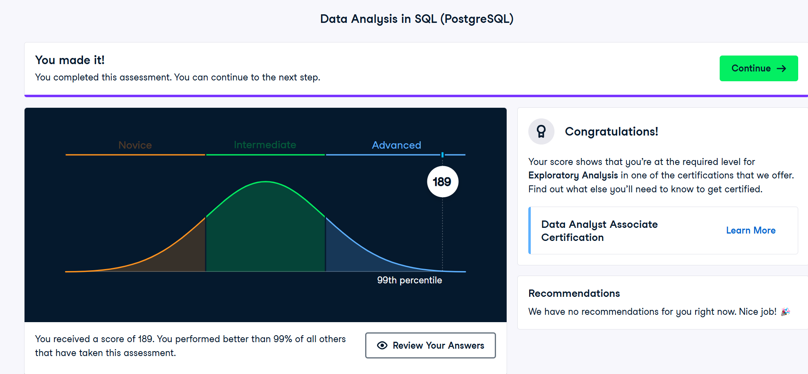
- Data Management in SQL (PostgreSQL)
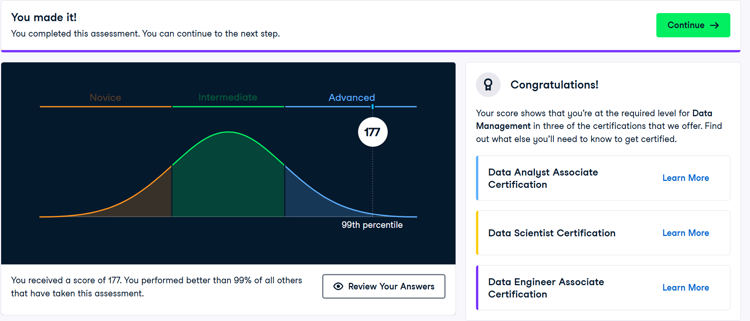

- Data Management Theory
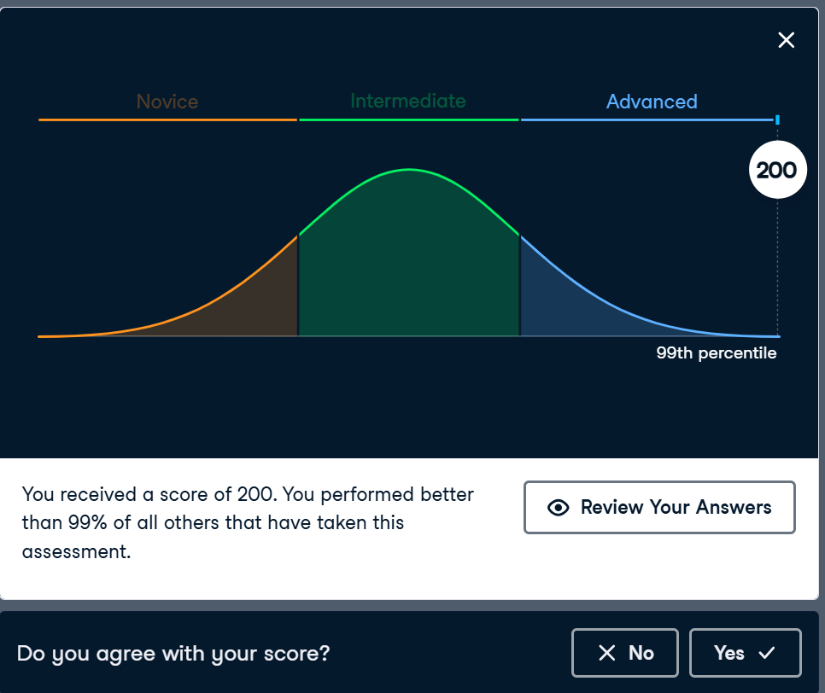
These examinations examined my abilities to interpret datasets, manage complicated data relationships, and apply theoretical knowledge to practical situations. Completing them successfully indicated my willingness to face the standards of the SQL Associate Certification Exam.

Exam Plan Schedule

With all prerequisites met, I am now qualified to register for the SQL Associate Certification Exam. I plan to schedule and complete the exam by November 30, 2024. This timeline gives me plenty of time to review essential topics and do additional exercises to boost my confidence in the exam.

Conclusion
Completing the SQL Associate Certification prerequisites has been a valuable learning experience. The abilities and knowledge I've received will not only prepare me for the exam, but also for future chances in data analytics and database management. I’m eager to take the final step and achieve certification by December 1st, 2024.

