DATA MINING LAB ASSIGNMENT 1

**Load each dataset and observe the following**:

**1**. Loading Germancredit dataset:

**i.** List the attribute names and its types:

|  |  |
| --- | --- |
| **Attribute name** | **Its type** |
| checking_status | Nominal |
| duration | Numeric |
| credit_history | Nominal |
| purpose | Nominal |
| credit_amount | Numeric |
| savings_status | Nominal |
| employment | Nominal |
| installment_commitment | Numeric |
| personal_status | Nominal |
| other_parties | Nominal |
| residence_since | Numeric |
| property_magnitude | Nominal |
| age | Numeric |
| other_payment_plans | Nominal |
| housing | Nominal |
| existing_credits | Numeric |
| job | Nominal |
| num_dependents | Numeric |
| own_telephone | Nominal |
| foreign_worker | Nominal |
| class | Nominal |

**ii.** Number of records in each dataset: 1000(instances)

**iii**. Identify the class attribute(if any):

The class attributes identified are:

class - Nominal

**iv**. Plot Histogram:

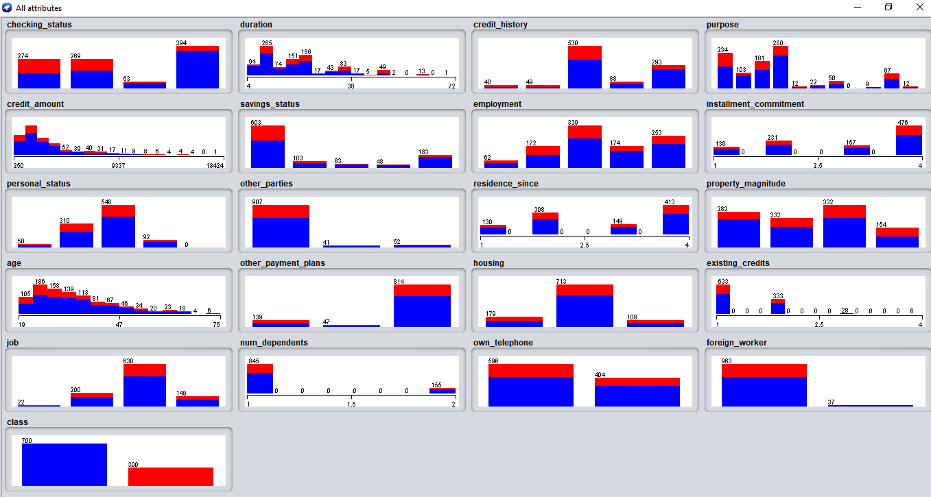

**V.** Determine the number of records in each class:

Number of records for class:

i. good - 700

ii. bad - 300