What is the meaning of adversarial in GANs?
Correct Answer

Two network competing which each other

You Answered

Two network trying to work with bad inputs

Two network trying to help each other directly

One network trying to learn from the bad inputs of another network

Question 2
0 / 5 pts
For a GAN converting Photos to EMojis, what input is shared between G and D network?
Correct Answer
Face

You Answered
Real Emoji

Face & Amoji

Generated Emoji

Question 3
0 / 5 pts
For a GAN converting Photos to EMojis, what is the input to the D network?
Correct Answer
Face, Corresponding EMoji or Generated Emoji

You Answered
Real Emoji and Generated Emoji

Face

Generated Emoji

Question 4
0 / 5 pts
Which of the following networks cannot create a "diversified output"?
Correct Answer
Auto Encoder

Variational AutoEncoder

You Answered
GAN

VAE-GAN

Question 5
5 / 5 pts
Function W can be G or D. If W is G, then D will be shown as V below, and vise versa.
Consider the loss below:
maximize ( log(W(real_image)) + log(1 - W(V(fake_image)))
What is W?
Correct!
Discriminator

Generator

Question 6
5 / 5 pts
Function W can be G or D. If W is G, then D will be shown as V below, and vise versa.
Consider the loss below:
minimize ( - (log(W(V(fake_image)))))
What is W?
Correct!
Discriminator

Generator

Question 7
17.14 / 30 pts
Select all which are true:
Correct!

Discriminator should be trained before training Generator

Correct!
Discriminator should be trained better initially, and then we should try and match D and G's performances
You Answered
Discriminator's architecture should be exactly opposite of Generator's architecture
Correct!
There are infinite number of minimas for GANs

You Answered
If, by mistake, labels for Discriminator are reversed, vanilla GAN trained will act exactly as before
Correct!
Random Vector input to the Generator Network can be controlled to control the output features
Correct!
For a basic GAN, the Information Entropy of the D's output is less than the Information Entropy of the Input to G Network
You Answered
For the trained basic GAN, same random latent vector input can create different outputs
Correct!
Mode collapse happens for a GAN when it generates only one of the possible classes
Correct!
GANs are trained till G and D reaches a Nash Equilibrium

Question 8
5 / 5 pts
Consider an AutoEncoder.
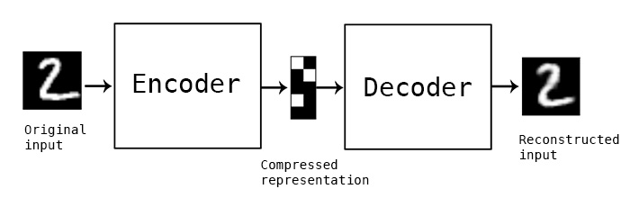
If the Information Entropy (IE) of the input is equal to the Compressed Representation, then it is possible to reconstruct the input without error.
Correct!
Yes

No

Question 9
5 / 10 pts
KL Divergence for Network A, B and C are 0.025, -1 and 1. Which is true?

Network C is better than Network A

Correct!
Network A is a very good representation of the actual dataset.

Correct Answer
KLD calculated for network B is wrong.

Network B is better A, and Network A is better than C

Question 10
0 / 5 pts
In which GAN do we provide the label to both G and D?
Correct Answer
CGAN

ACGAN

You Answered
InfoGAN

PixelGAN

Question 11
20 / 20 pts
Select which all are true?
Correct!
Out of CGAN and DCGAN, it is guaranteed that DCGAN is using convolutional layers
Correct!
In case of CGAN label is provided to both G and G, however in ACGAN, label is not provided to both
Correct!
If, along with D and G, we have another network K, and we train this network K to predict the input to G, given G's output, we can make sure for a specific input G always generates very similar output (given we take care of the loss function to make all of this happen)
Correct!
If the discriminator is too good, then gradients for training G would be too small.
Quiz Score: 57.14 out of 100

