Final Report:

Background/Motivation for the Study
The motivation behind exploring the relationship between physical activity and depression comes from various health, societal, and scientific considerations. Depression is the leading cause of mental health–related disease burden and a major cause of disability worldwide, affecting approximately 280 million people and accounting for more than 47 million disability-adjusted life-years in 2019. Depression is also associated with premature mortality from other illnesses and suicide (Pearce et all, 2022). Prevention of depression requires effective interventions, including modification of established risk factors. Narrative reviews have concluded that physical activity can prevent future depression (Pearce et all, 2022). Studies of older adults and adolescents with depression or anxiety have been limited, but physical activity appears beneficial to these populations (Paluska et all, 2000). Physical activity may play an important role in the management of mild-to-moderate mental health diseases, especially depression and anxiety (Paluska et all, 2000).

Research Question and Hypothesis
Is there any association between physical activity and depression?
Null Hypothesis: There is no relationship between physical activity and depression.
Alternative Hypothesis: There is a significant relationship between physical activity and depression.
Based on the articles I have read, I believe that individuals who engage in physical activity will be less likely to report depression, whereas those who do not engage in physical activity will be more likely to report depression.
There is an inverse relationship between physical activity and depression. Specifically, this research seeks to demonstrate that being physically active is associated with a lower likelihood of experiencing depression.

Data Description and Exploratory Data Analysis
The NHANES target population is “the non-institutionalized civilian resident population of the United States”. NHANES data contains 10,000 observations and 75 variables. I will use the mutate function on the “Depressed (several/most/none)” variable in the NHANES dataset to create a new binary variable, “Depression (yes/no)” and new dataset “NHANESnew”. Additionally, I will filter out participants below 18 years of age and remove any missing values (NA). The two variables “PhysActive” and “Depression” will be needed to answer my research question.
Attaching package: 'dplyr'
PhysActive: A categorical variable indicating whether participants engage in physical activity (yes/no). Reported for participants 12 years or older.
Depression: A categorical variable indicating whether participants felt depressed as assessed via a self-reported survey (yes/no). Reported for participants aged 18 years or older. This variable is created using mutate function on the variable Depressed (several/most/none).
Physical Activity
No Yes Sum
3110 3563 6673
Physical Activity
No Yes
0.47 0.53
Depression
No Yes Sum
5246 1427 6673
Depression
No Yes
0.79 0.21
Depression
Physical Activity No Yes Sum
No 2297 813 3110
Yes 2949 614 3563
Sum 5246 1427 6673
Depression
Physical Activity No Yes
No 0.34 0.12
Yes 0.44 0.09
The top two tables explain PhysActive variable. There are a total of 6673 participants (after the age filter), out of which 3110 are physically inactive and 3563 are physically active. Below the counts, the proportions are shown, 47% are not physically active and 53% are physically active.
The Depression table shows that 5246 participants are not depressed while 1427 are depressed. The proportion of participants who are not depressed are 79% while 21% individuals are depressed.
The contingency table of physical activity and depression is shown, breaking down the counts based on whether the person is physically active or not and whether they have depression or not. 2297 individuals are not physically active and do not have depression while, 813 individuals are not physically active and have depression. 2949 individuals are physically active and do not have depression while, 614 individuals are physically active and have depression. Looking at the proportion table, among those not physically active, 34% have no depression, and 12% have depression. On the other hand, those who are physically active, 44% have no depression, and 9% have depression.
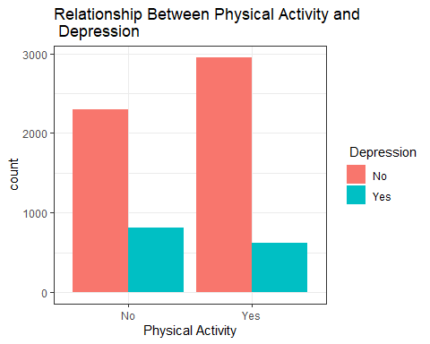
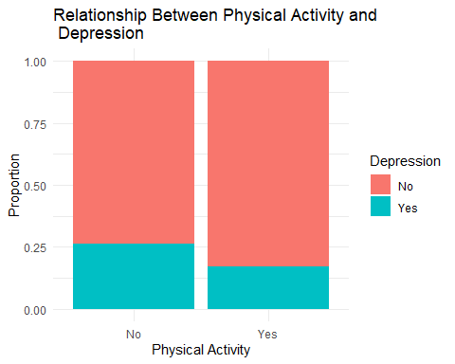
The side by side bar chart shows the absolute counts of individuals based on their physical activity levels (Yes/No) and depression status (Yes/No). Among individuals who do not engage in physical activity, a higher proportion of them report no depression compared to those who report having depression. Similarly, among individuals who do engage in physical activity, a larger proportion do not have depression, but the total counts of people in this group are larger compared to the non-active group. Physical activity seems to have a relationship, as the number of people who do engage in physical activity and do not have depression is visibly larger than those with depression.
The second graph shows proportions of depressed and non-depressed individuals within each physical activity group. The proportions suggest a mild association between physical activity and lower depression rates. The difference is not extreme but may hint that those who are physically active tend to experience slightly less depression.
While the graphs visually suggest some association between physical activity and depression (leaning toward more physical activity being associated with less depression), the visual differences alone are not sufficient to confirm or reject the null hypothesis. Further statistical testing would be needed.

Analysis
Pearson's Chi-squared test with Yates' continuity correction
data: my.ctable
X-squared = 77.865, df = 1, p-value < 2.2e-16
Depression
Physical Activity No Yes
No 2444.936 665.0637
Yes 2801.064 761.9363
Depression
Physical Activity No Yes
No -8.854055 8.854055
Yes 8.854055 -8.854055
For this analysis, we must use the chi-squared test because we are comparing two categorical variables: PhysActive and Depression. These variables have two possible outcomes each labeled as: “Yes” and “No”. We satisfy the assumptions of a chi-squared test where there are random samples, the sample size is smaller than 10% of the population, and the expected counts are greater than 5 for each grouping category. Loking at the result of chi squared test, we can see that X- squared = 77.865, df = 1 and p-value < 2.2 e-16. This p-value is much smaller than significance level of 0.05 and therefore we reject the null hypothesis that there is no association between physical activity and depression. There is significant evidence to conclude that there is an association between physical activity and depression.
From our standardized residuals, we can further assess the results. The interpretation of standardized residuals are as follows-
Depression = No and Physical Activity = No has a standardized residual of -8.85. This means that fewer people than expected have both no depression and no physical activity.
Depression = No and Physical Activity = Yes has a standardized residual of 8.85. This suggests that more people than expected have no depression but are physically active.
Depression = Yes and Physical Activity = No has a standardized residual of 8.85. This indicates that more people than expected have both depression and no physical activity.
Depression = Yes and Physical Activity = Yes has a standardized residual of -8.85. This means fewer people than expected have both depression and physical activity.
This test suggest that people who are physically active are less likely to be depressed than expected under the null hypothesis. Conversely, people who are not physically active are more likely to be depressed than expected.

Conclusions
The analysis supports the conclusion that there is a significant relationship between physical activity and depression. My original hypothesis that the Individuals who engage in physical activity are less likely to experience depression than those who do not, was correct.
This project highlights the importance of physical activity as a factor that can potentially reduce the prevalence of depression and underscores the need for further exploration into how physical activity can be integrated into mental health interventions.
References:
Pearce M, Garcia L, Abbas A, Strain T, Schuch FB, Golubic R, Kelly P, Khan S, Utukuri M, Laird Y, Mok A, Smith A, Tainio M, Brage S, Woodcock J. Association Between Physical Activity and Risk of Depression: A Systematic Review and Meta-analysis. JAMA Psychiatry. 2022 Jun 1;79(6):550-559. doi: 10.1001/jamapsychiatry.2022.0609. PMID: 35416941; PMCID: PMC9008579. https://www.ncbi.nlm.nih.gov/pmc/articles/PMC9008579/
Paluska SA, Schwenk TL. Physical activity and mental health: current concepts. Sports Med. 2000 Mar;29(3):167-80. doi: 10.2165/00007256-200029030-00003. PMID: 10739267. https://link.springer.com/article/10.2165/00007256-200029030-00003

