JSP and HTML Registration Pages (Output)

Overview

This documentation provides a detailed explanation of two web pages involved in a simple registration process. The first page, index.html, contains the registration form, and the second page, register.jsp, processes and displays the submitted data. Both pages use Bootstrap 5 for styling and layout.

1. index.html

The index.html page serves as the initial interface where users can fill out their registration information. It includes fields for the user's name, email, and gender.

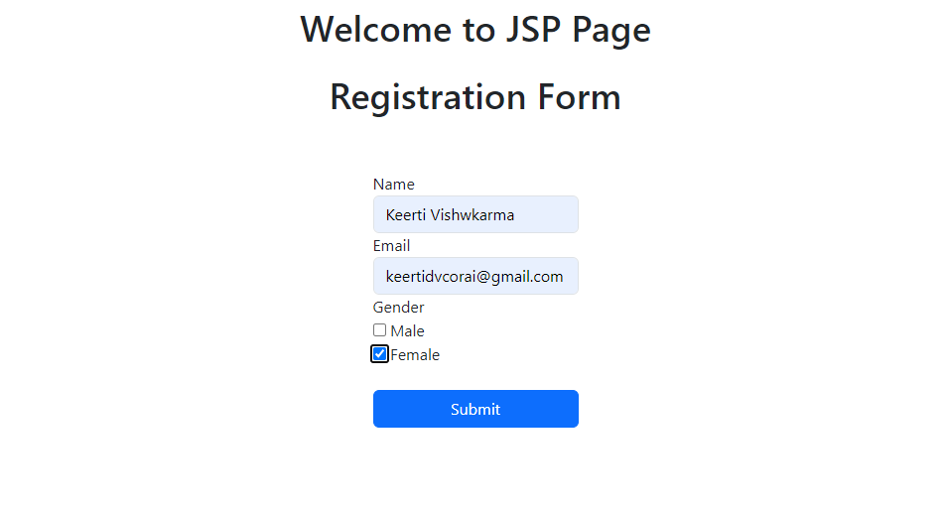

1. register.jsp

The register.jsp page processes the data submitted from the index.html form and displays a confirmation message with the user's input.



1. Conclusion

* **index.html** : A user-friendly form for registration, styled with Bootstrap.
* **register.jsp** : Processes the form data and provides a confirmation message with the user's input.