 | 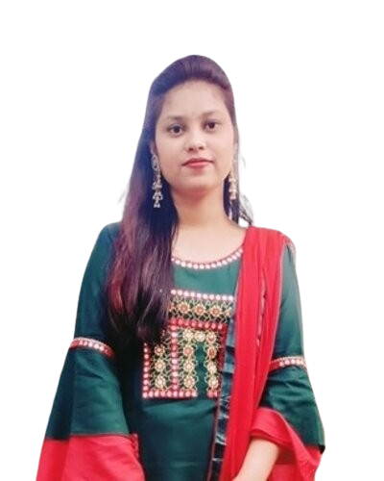 | Keerti Vishwkarma  +91 90055 33066  - keertidvcorai@gmail.com   https://www.linkedin.com/in/keerti-vishwkarma-8ba754243   PortfolioWebiste
 | ‣ Summary  Seeking a challenging role as a Full Stack Developer to utilize my skills and contribute to a dynamic team. Eager to learn and grow professionally.  ‣ Experience  Java Full-Stack Developer Intern  IBM (Remote)  May,2024 – Sep, 2024  (5 Months)  ‣ Skills  Languages :- HTML5, JavaScript, CSS, Python, Java  Technologies :- Bootstrap, React, Angular, Node.js, Django, Spring Boot  Databases :- MySQL, MongoDB  Soft Skills :- Problem-Solving, Communication, Teamwork, Time Management  ‣ Hobbies  - Painting  - Travelling  - Learning languages  - Design  ‣ Languages  - English  - Hindi | ‣ Education  ‣ Projects  - E-learning Website (Link)  The E-learning Website represents a comprehensive and innovative online platform for delivering educational content and facilitating learning experiences.  Technologies - HTML, CSS, Bootstrap, Python, Django, Chatbot and SQLite  - Book Store Website (Link)  The “NovelBook” project is a web-based application designed to provide a convenient platform for users to browse, search, and purchase books online using PHP and MySQL.  Technologies – HTML, CSS, Bootstrap, PHP and MySQL  - Social Networking Site  The platform will facilitate professional networking, job searching, and career development. Users can create profiles, connect with other professionals, search and apply for jobs, and receive job recommendations.  Technologies – HTML, CSS, Bootstrap, Java, Spring Boot and MySQL  ‣ CERTIFICATIONS  Course on Computer Concepts  From NIELET  Introduction to Web Development  From Coursera
  Degree | University | Location | CGPA | Duration
  Advanced Diploma | National Skill Training Institute | Bangalore, India | 9.6 | Sep 2022 - Oct 2024
  Master of Computer Applications | Chandigarh University | Chandigarh, India | 8.0 | July 2023 - Aug 2025
  Bachelor of Science | Bundelkhand University | Jhansi, India | 6.8 | July 2017 - Aug 2020

