KLE TECHNOLOGICAL UNIVERSITY, HUBBALLI.
DEPARTMENT OF BACHELORE IN COMPUTER APPLICATION
KLE Society’s


A Project SRS document
Admission Stage-Wise Screening Register
Submitted in partial fulfilment of the requirement for degree
BACHELORE OF COMPUTER APPLICATION

Submitted by:
Aditya Patil-01FE24BCA270
Keerti G M- 01FE24BCA284
Yashvant T-01FE24BCA288
Bhagyashree M-01FE24BCA292

Under the Guidance of
Prof. Pavankumar Vadavi
Prof. Sayeeda Anjum

Introduction
The admission process in an educational institution involves several activities, including application submission, document collection, document verification, eligibility assessment, department-level review, and the final admission decision. When these activities are managed manually, it can be difficult to maintain consistent applicant records, identify missing documents, monitor review progress, and maintain a clear history of decisions.
The proposed project, ASWSR – Admission Stage-Wise Screening Register, is a campus-based web application designed to organize admission applications and their screening activities in one centralized system. It maintains applicant profiles, programme information, application records, submitted documents, eligibility rules, review outcomes, notifications, and audit information.
The system follows five defined stages: Application Submission, Document Verification, Eligibility Screening, Department Review, and Final Admission Decision. Each application moves through the required stages in sequence. The system records the status of each stage, supporting remarks, pending requirements, and the responsible user. Eligibility is evaluated using institution-configured rules, while authorized staff review documents and assigned applications.
ASWSR provides separate workspaces for Applicants, Admission Officers, Evaluators, and Administrators. Applicants submit applications, provide required documents, and track progress. Admission Officers manage application queues, verify documents, review eligibility information, and process authorized workflow tasks. Evaluators review applications assigned to their department and record assessment remarks or recommendations. Administrators manage users, programmes, eligibility rules, workflow configuration, and final admission decisions.
The project applies concepts from Database Management Systems (DBMS), Object-Oriented Programming (OOP), Web Technologies, Software Engineering, client-server architecture, API development, data validation, and rule-based processing to develop a modular campus admission management system.

1.1 Purpose
The purpose of ASWSR is to provide a centralized and traceable system for managing campus admission applications through a structured, stage-wise screening process.
The system aims to maintain applicant and programme information, collect mandatory and programme-dependent documents, support document verification, evaluate eligibility using configured rules, facilitate department-level assessment, and record the authorized final admission decision.
It is intended to reduce manual record-keeping, improve consistency in document and eligibility reviews, make application progress visible to applicants and staff, and maintain a history of important actions. The project does not include an online payment gateway.

1.2 Scope
The project focuses on campus-based admission application management, document handling, rule-based eligibility screening, department review, workflow tracking, notifications, and administrative configuration.
The main features of the proposed system include:
- Maintaining applicant profiles and role-based user accounts.
- Managing institution-specific programmes and admission information.
- Allowing applicants to submit and track admission applications.
- Collecting mandatory and programme-dependent documents.
- Supporting document verification, rejection with reasons, and resubmission requests.
- Evaluating eligibility against administrator-configured programme rules.
- Supporting department/evaluator review and recording recommendations.
- Tracking applications through five defined admission stages.
- Maintaining review remarks, status changes, and reasons for pending or rejected items.
- Providing notifications for relevant application and review updates.
- Maintaining activity history and audit records for traceability.
- Providing dashboards, application summaries, and reports for authorized users. Online fee payment is outside the project scope.

1.3 Objectives
The main objectives of ASWSR are:
- To maintain applicant, programme, application, and user information systematically.
- To organize the admission process through five clearly defined stages.
- To collect and track mandatory and conditional admission documents.
- To support authorized officers in verifying documents and requesting corrections or resubmission.
- To evaluate applicant eligibility using configurable, rule-based criteria.
- To enable evaluators to review assigned applications and record assessment remarks or recommendations.
- To maintain stage-wise status, reasons, timestamps, and review history.
- To provide separate role-based workspaces for Applicants, Admission Officers, Evaluators, and Administrators.
- To support administrators in managing users, programmes, eligibility rules, and final admission decisions.
- To provide a responsive, maintainable web application with a clear separation between frontend, backend APIs, and database operations.

1.4 Intended Audience
This document is intended for project guides, faculty members, evaluators, developers, administrators, admission staff, and students who need to understand the requirements and expected operation of ASWSR.
It describes the system's purpose, scope, user roles, functional and non-functional requirements, business rules, technical environment, architecture, data design, and process diagrams. It can be used as a reference during implementation, testing, demonstration, and maintenance.

1.5 Document Overview
This Software Requirements Specification (SRS) describes the requirements of ASWSR – Admission Stage-Wise Screening Register.
It includes the project introduction, purpose, scope, objectives, intended audience, functional and non-functional requirements, business rules, system constraints, hardware and software requirements, system architecture, database design, ER and UML diagrams, Data Flow Diagrams, future enhancements, conclusion, and references.
The document provides a common understanding of the expected system behaviour and serves as a reference throughout the development process.

1.6 Foundational Concepts Used
The project applies the following foundational concepts:
- Database Management Systems (DBMS): Used to store and relate user, applicant, programme, application, document, eligibility-rule, review, notification, and audit records.
- Data Structures and Programming: Used to organize application queues, document lists, review assignments, and stage-wise workflow information.
- Object-Oriented Programming (OOP): Used to structure frontend and backend functionality into reusable components, services, and data models.
- Web Technologies: React, JavaScript, HTML, and CSS-based styling are used to build responsive interfaces for the four user roles.
- Software Engineering and SDLC: Used to follow requirement analysis, design, implementation, testing, integration, and maintenance activities.
- Data Validation and Integrity: Used to validate applicant input, document metadata, application references, role permissions, and review updates.
- Rule-Based Processing: Used to evaluate programme eligibility using criteria configured by authorized administrators and to record explainable screening outcomes.

2. Specific Requirements
System requirements describe the functional and operational behaviour expected from ASWSR. They cover applicant operations, officer and evaluator review tasks, administrative configuration, notifications, reporting, and the stage-wise admission workflow.

2.1 Functional Requirements
Functional requirements describe the operations that the system must support.
Requirement ID | Functional Requirement | Description
FR-01 | User and Role Management | The system shall allow authorized administrators to create, update, deactivate, and assign Applicant, Admission Officer, Evaluator, and Administrator roles.
FR-02 | Applicant Profile Management | The system shall allow applicants to maintain personal, contact, and academic profile information.
FR-03 | Programme Management | The system shall allow administrators to create and update institution-specific programmes and their admission information.
FR-04 | Application Submission | The system shall allow applicants to submit an application for an available programme and view its reference and status.
FR-05 | Document Requirement Management | The system shall identify mandatory and conditional documents based on the selected programme and applicant qualification.
FR-06 | Document Upload | The system shall allow applicants to upload supported document files and view the upload status of each required document.
FR-07 | Document Verification | The system shall allow authorized admission officers to preview submitted documents, verify them, reject them with a reason, or request resubmission.
FR-08 | Eligibility Rule Management | The system shall allow administrators to configure and maintain programme-specific eligibility rules.
FR-09 | Eligibility Evaluation | The system shall evaluate applicant information against active eligibility rules and display the result and relevant criteria to authorized reviewers.
FR-10 | Evaluator Review | The system shall allow evaluators to access assigned applications, record assessment remarks, and submit recommendations.
FR-11 | Stage-wise Workflow | The system shall track each application through Application Submission, Document Verification, Eligibility Screening, Department Review, and Final Admission Decision.
FR-12 | Workflow Authorization | The system shall restrict stage updates and decisions according to the authenticated user's role and assigned responsibilities.
FR-13 | Applicant Progress Tracking | The system shall allow applicants to view their application stage, document status, and relevant notifications.
FR-14 | Notifications | The system shall create in-application notifications for relevant application, document, and review updates.
FR-15 | Reports and Dashboard | The system shall provide authorized dashboards and reports based on available application, verification, eligibility, and review records.
FR-16 | Audit History | The system shall record important user actions, decisions, reasons, and timestamps for traceability.

2.2 Non-Functional Requirements
Non-Functional Requirement | Description
Performance | The system should return common dashboard, search, and application-review requests within a reasonable response time under expected project usage.
Reliability | The system shall preserve application and review records and provide consistent status information.
Usability | The system shall provide clear, role-specific workspaces and understandable forms, statuses, and validation messages.
Data Integrity | The system shall use appropriate keys, relationships, constraints, and server-side validation to maintain consistent records.
Security | The backend shall authenticate users, enforce role-based authorization, validate uploads, and prevent unauthorized access to applicant information.
Maintainability | The application shall use modular frontend components, backend routes/services, and organized database structures.
Portability | The frontend shall run in a modern web browser, while the backend shall run in a compatible Node.js and MySQL environment.
Accuracy | Eligibility outcomes shall be based on active administrator-configured rules, and review decisions shall be recorded with their reasons.
Scalability | The system design should support additional programmes, applicants, documents, and review assignments as institutional needs grow.

2.3 Business Rules and System Constraints
- Each user account shall have a unique user identifier and an assigned role.
- Each applicant shall have a unique applicant identifier, and each application shall have a unique application identifier.
- Each programme shall have a unique programme identifier and institution-defined admission requirements.
- An applicant shall be able to submit an application for an available programme according to the configured admission cycle.
- Each application shall follow the configured sequence of admission stages.
- The five stages are Application Submission, Document Verification, Eligibility Screening, Department Review, and Final Admission Decision.
- Document requirements shall be determined by the selected programme and applicant qualification. The common mandatory documents are 10th marks card, 12th/PUC marks card, and leaving certificate; a degree certificate is required when applicable to the applicant's qualification or programme.
- Hostel and mess information, where collected, shall remain optional and shall not block the admission screening process.
- The system shall not process admission fee payments or store payment-gateway transactions.
- Eligibility shall be evaluated against active rules configured by an authorized administrator. Officers and evaluators may review results but shall not modify the institution's rule definitions.
- An application shall not move to a later required stage until the required earlier-stage checks have been completed or an authorized exception has been recorded.
- Document rejection or resubmission requests shall include a reason that can be communicated to the applicant.
- Evaluators shall access only applications or review tasks assigned to them, subject to their role permissions.
- Admission Officers may verify documents, review eligibility information, add remarks, and process authorized workflow tasks. They shall not manage user roles or change institution-wide eligibility rules.
- Administrators shall manage user accounts, role assignments, programmes, eligibility rules, workflow configuration, and authorized final admission decisions.
- Important actions, including document decisions, eligibility reviews, workflow updates, and final decisions, shall be recorded with the responsible user and timestamp.
- The system shall use a React-based frontend, Node.js and Express.js backend APIs, and a MySQL database.
The system shall require a compatible development/runtime environment, database server, and modern web browser.

3.1 Hardware Requirements
- A desktop computer or laptop capable of running a modern web browser, development tools, Node.js, and MySQL.
- A minimum of 4 GB RAM is recommended; 8 GB or more is preferable for development and testing.
- Sufficient disk space for the source code, dependencies, database server, uploaded test documents, and project files.
- A processor capable of running the frontend development server, backend services, and database software.
- Internet connectivity for installing dependencies, accessing development resources, and testing connected services where required.

3.2 Software Requirements
- Operating System: Windows (development environment).
- Frontend: React with Vite, JavaScript, HTML, and Tailwind CSS.
- Backend Runtime: Node.js.
- Backend Framework: Express.js.
- Database: MySQL.
- Database Connectivity: MySQL driver for Node.js.
- Database Tool: MySQL Workbench.
- Development Tool: Visual Studio Code (VS Code).
- API Testing Tool: Postman.
- Version Control: Git and GitHub.
- Web Browser: Google Chrome or Microsoft Edge.

Purpose of the Technologies
- React and Vite: Used to build, organize, and run the responsive frontend application and its role-specific workspaces.
- JavaScript, HTML, and Tailwind CSS: Used to implement application behaviour, page structure, responsive layouts, and interface styling.
- Lucide React and Framer Motion: Used for consistent interface icons and selected user-interface transitions.
- Node.js: Used to execute server-side JavaScript and implement backend application logic.
- Express.js: Used to define API routes, validate requests, apply authorization checks, and connect the frontend with backend services.
- MySQL: Used to store user, applicant, programme, application, document, eligibility, review, notification, and audit records.
- MySQL Driver for Node.js: Used to establish database connectivity from the backend application.
- VS Code: Used for writing, editing, debugging, and managing project code.
- MySQL Workbench: Used to design, inspect, and manage the MySQL database.
- Postman: Used to test backend API requests, responses, validation, and authorization behaviour.
- Git and GitHub: Used for version control, source-code management, and team collaboration.
- Google Chrome or Microsoft Edge: Used to access and test the web application.

4. System Architecture

Working of the Architecture
The user accesses ASWSR through a web browser. The React frontend presents the appropriate workspace based on the authenticated role: Applicant, Admission Officer, Evaluator, or Administrator. The frontend communicates with the Node.js and Express.js backend through API requests.
The backend validates input, checks role permissions, applies application and workflow rules, and reads or updates the MySQL database. Document files are handled through the document-upload service and their metadata and verification states are recorded in the database. The backend returns the relevant data to the frontend, which displays application status, review tasks, notifications, and reports.

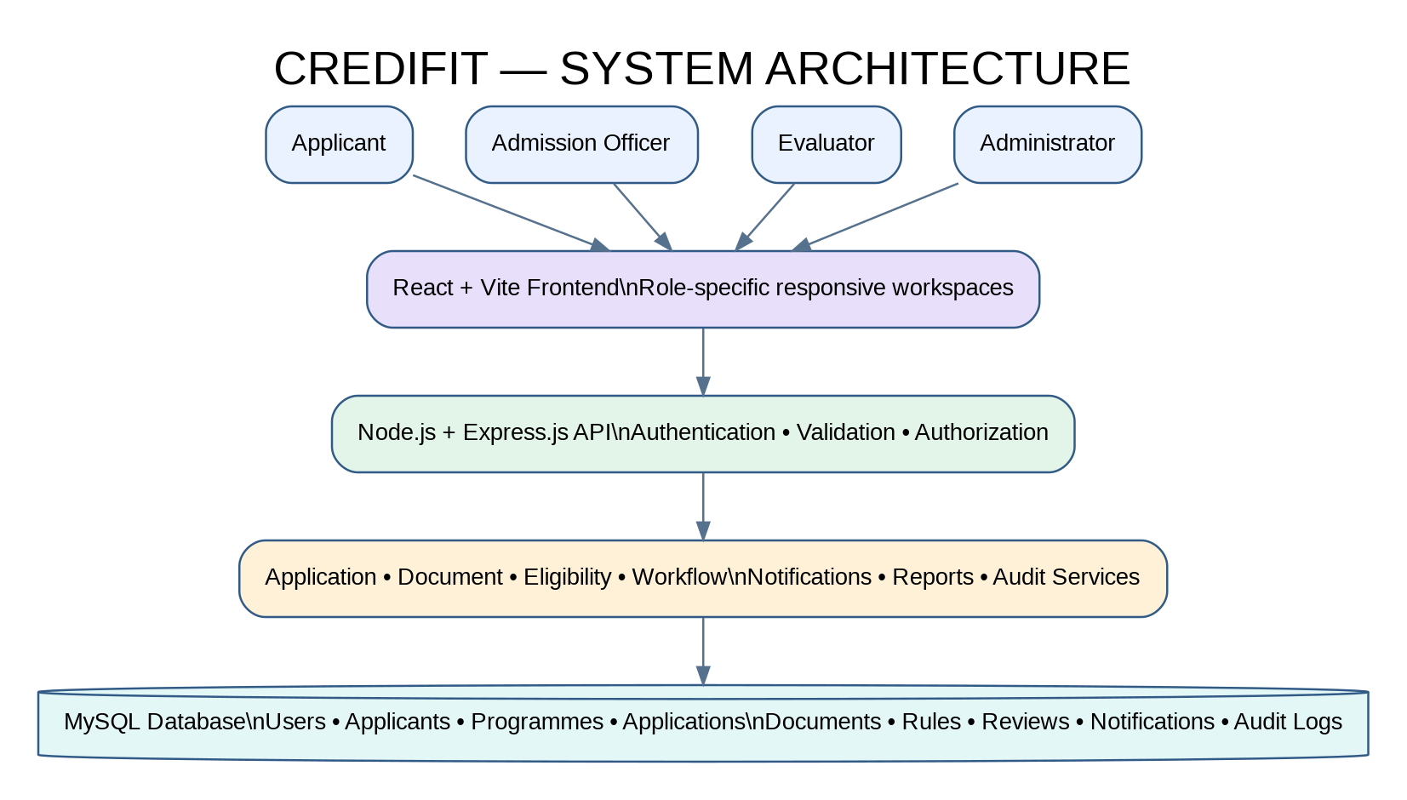

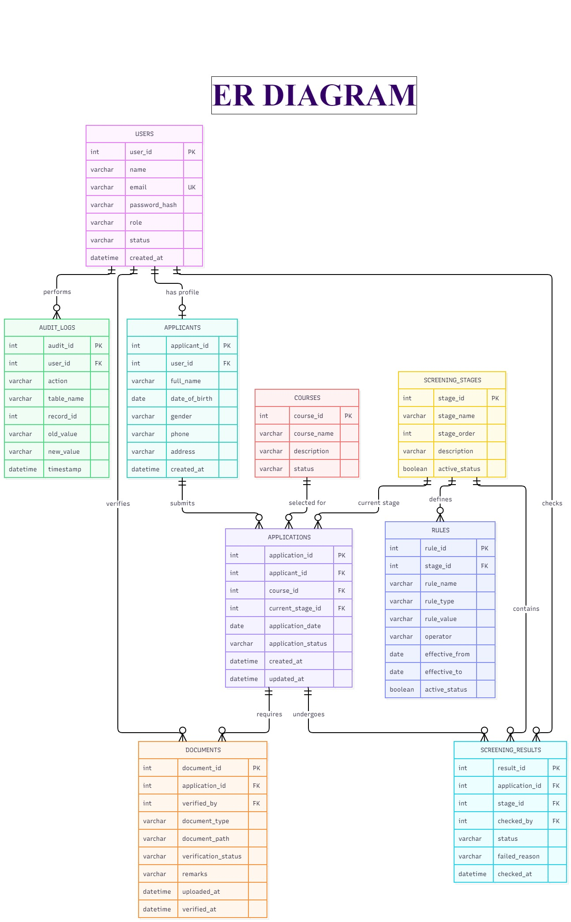
5. ER Diagram

6. UML Diagrams

1) Activity Diagram
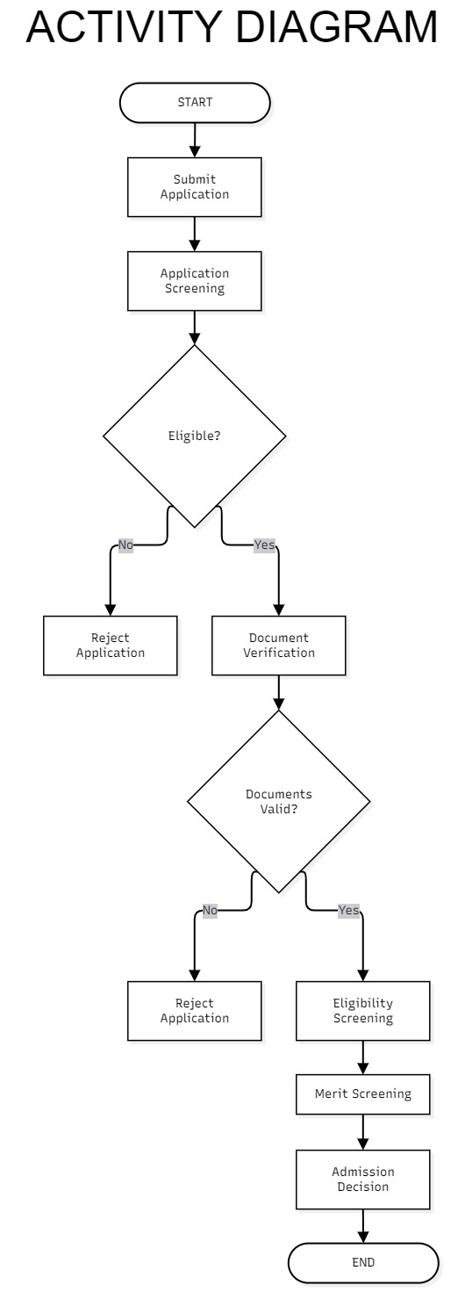

2) Use-case Diagram

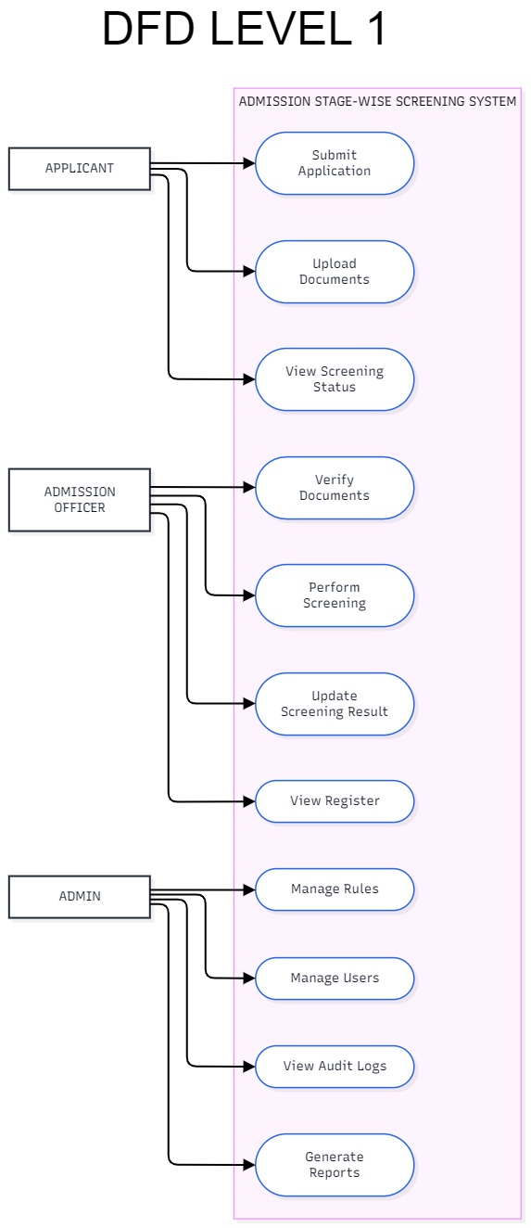

3) Sequence Diagram

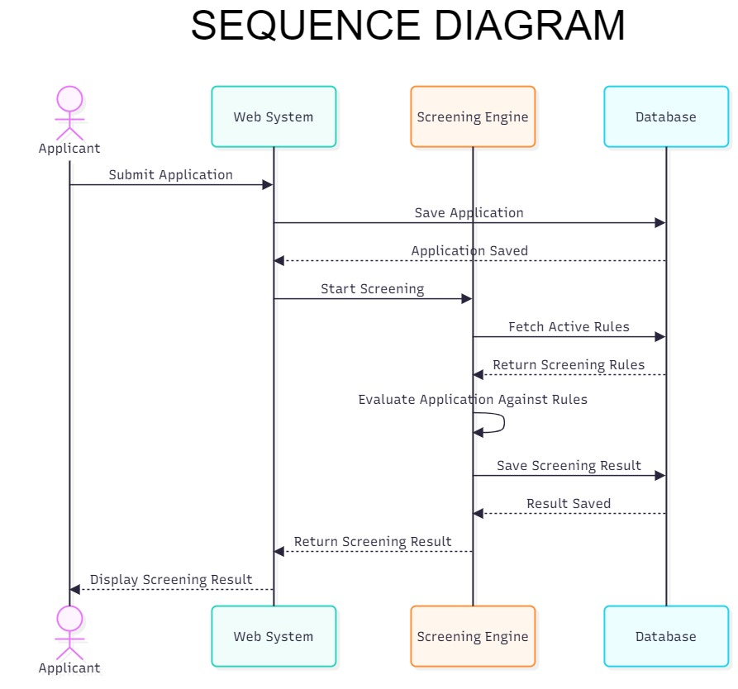

4) Class Diagram
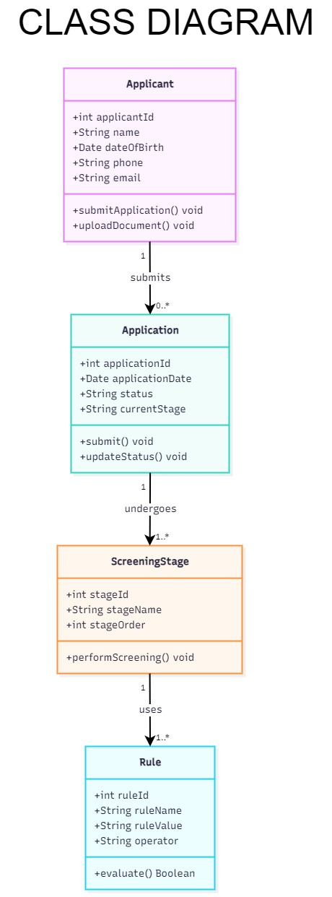

5) State Diagram
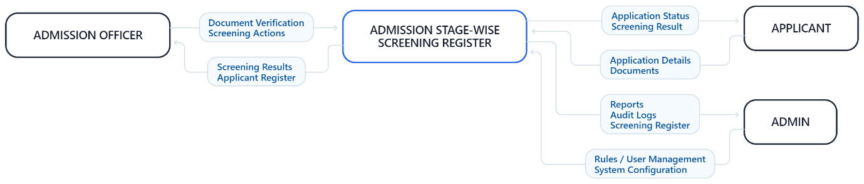

7. Data Flow Diagrams
Data Flow Diagrams represent how information moves through ASWSR between applicants, institutional staff, backend processes, and the database.

1) Level 0 DFD
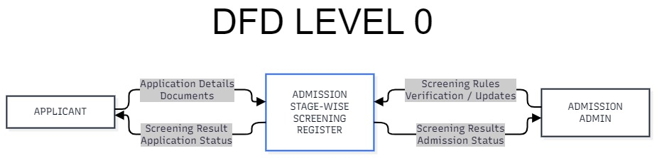

2) Level 1 DFD

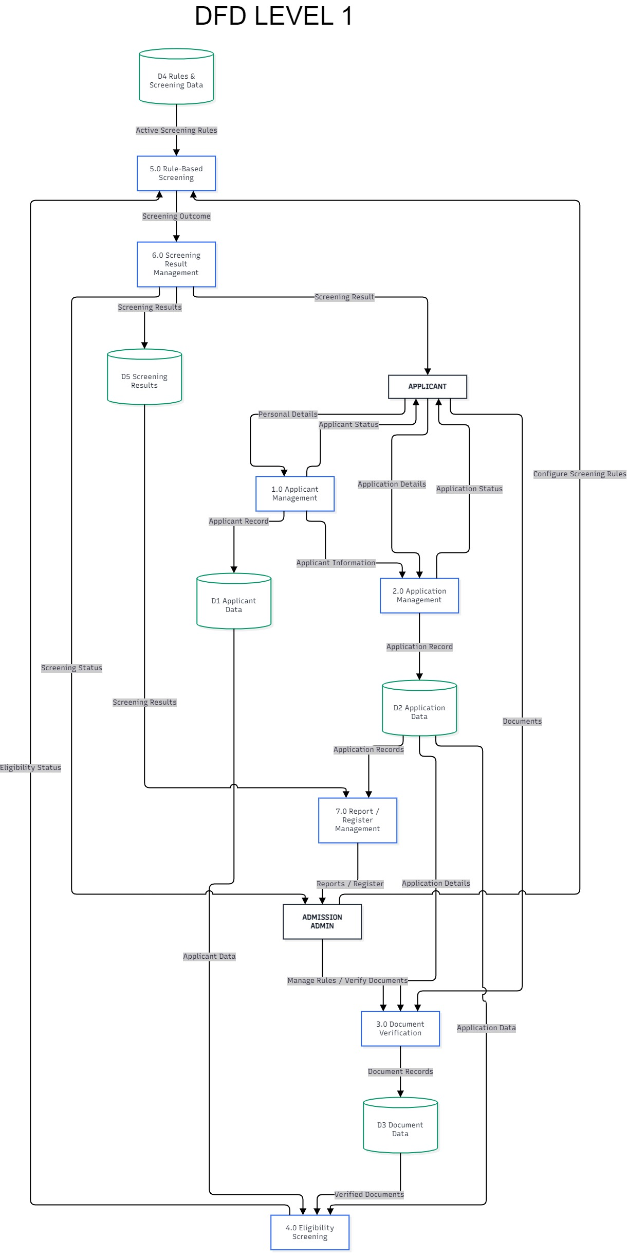

3) Level 2 DFD

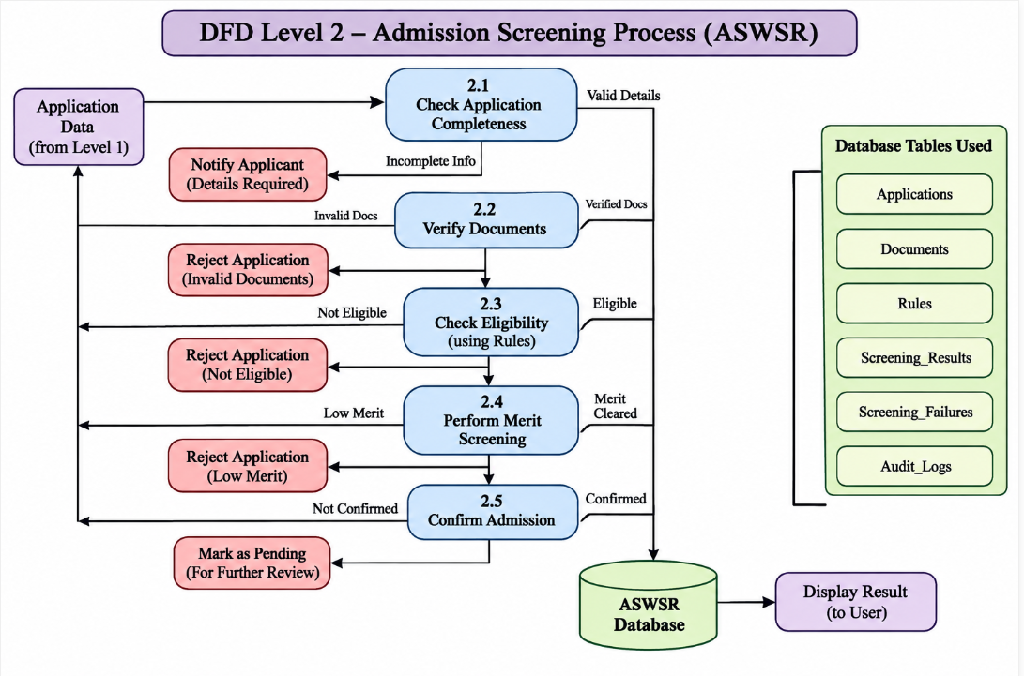

8. Future Enhancements
The current project focuses on campus admission applications, document verification, rule-based eligibility, department review, notifications, and stage-wise tracking. Possible future enhancements include:
- Automated Email and SMS Delivery: Notifications may be extended to external email and SMS services for application and review updates.
- Advanced Analytics: Additional institutional dashboards and configurable reports may be introduced for admission planning and trend analysis.
- Document Management Improvements: More advanced document preview, file-retention, and secure archival features may be added.
- Institutional Portal Integration: ASWSR may be integrated with other university or campus information systems through approved APIs.
- Expanded Workflow Configuration: Institutions may configure additional departments, review steps, and approval paths.
- Enhanced Audit and Compliance Tools: More detailed audit exports and administrative review tools may be introduced.
- Mobile Application: A dedicated mobile application may be developed if required by the institution.
- Accessibility Enhancements: Additional accessibility options and language support may be added.
These are possible future enhancements and are not represented as completed features in the current project scope. Online payment gateway integration is not part of the proposed system.

9. Conclusion
ASWSR – Admission Stage-Wise Screening Register is proposed as a centralized campus-based system for managing admission applications and stage-wise screening. It organizes the process into Application Submission, Document Verification, Eligibility Screening, Department Review, and Final Admission Decision.
The system supports applicant registration and application tracking, mandatory and conditional document collection, officer-led document verification, rule-based eligibility review, evaluator recommendations, notifications, reports, and administrative configuration. It maintains reasons, timestamps, and activity history to improve traceability.
Separate workspaces are provided for Applicants, Admission Officers, Evaluators, and Administrators, with responsibilities limited according to role. The final admission decision and institution-wide configuration remain under authorized administrator control.
The proposed implementation uses React and Vite for the frontend, Node.js and Express.js for backend APIs, and MySQL for persistent data storage. The system applies DBMS, OOP, web development, validation, rule-based processing, and software engineering concepts to provide a maintainable admission screening solution.

10. References
- Oracle. MySQL Reference Manual. MySQL Documentation.
- Node.js. Node.js Documentation.
- Express.js. Express.js Documentation.
- React. React Documentation; Vite. Vite Documentation; Tailwind CSS Documentation.
- MySQL2. MySQL2 Documentation for Node.js.
- Microsoft. Visual Studio Code Documentation.
- Postman. Postman API Documentation.
- Git. Git Documentation.
- Course materials for Database Management Systems (DBMS), Data Structures and Algorithms (DSA), Web Technologies, Object-Oriented Programming (OOP), Software Engineering, and Software Testing.
- BCA Mini Project Framework and Gate Assessment Guidelines provided by the department.

