[Institution name]
[Department / School]
PROJECT REPORT
FEDERATED LEARNING FOR
PRIVACY-PRESERVING CLINICAL
DECISION SUPPORT ACROSS
A HOSPITAL NETWORK
Novelty, design and evaluation of the CarePath federated learning layer (Objective C)
Submitted by
[Student name(s) and register number(s)]
Under the guidance of
[Guide name and designation]
October 2026

ABSTRACT
Hospitals hold the data that clinical decision-support models need, but they cannot pool it. Patient records are regulated, the institutions differ in climate, case mix and volume, and the smaller hospitals see too few cases of a rare disease to learn from it alone. This report describes the federated learning layer (Objective C) of the CarePath decision-support system. It is built with the Flower framework across ten simulated hospitals (H001 to H010) and four models: an XGBoost disease classifier, an XGBoost treatment recommender, a label-free atypical-presentation detector and a cross-hospital outbreak detector.
The novelty lies less in applying federated learning to one model than in making it work, verifiably, for four different kinds of model behind one protocol. The two supervised models are trained by cyclic gradient boosting, in which hospitals take turns adding trees to one shared ensemble. The atypical detector has no weights to average, so it is fitted exactly from sufficient statistics, with distributed expectation-maximisation and histogram quantile sketches. The outbreak detector is calibrated from counts-only summaries and hospital-reported outbreak episodes. The layer reuses the existing production code unmodified, exports drop-in artifacts, authenticates each hospital with TLS and a per-hospital key, and binds every reply to the hospital that sent it.
On 14,155 held-out patients the federated models beat each hospital training alone (disease accuracy 96.74% against 95.85%; rare-disease recall 0.797 against 0.693). They are statistically indistinguishable from the centrally trained originals on seven of eight testable measures, and slightly better on atypical-case AUC (+0.005, 95% interval +0.001 to +0.009). The costs are real: one disease training moves 228 MB over the network, 44 times the 5.2 MB of raw data it keeps in place, and the system has no differential privacy or secure aggregation. All 62 automated tests of the federated layer pass. The data are synthetic, so the figures demonstrate feasibility, not clinical performance.
Keywords: federated learning, cross-silo, gradient-boosted trees, distributed EM, outbreak surveillance, atypical presentation, Flower, healthcare, privacy.

NOVELTY AT A GLANCE
Federated learning itself is not new, and this project does not claim it is. FedAvg, gradient boosting, expectation-maximisation, Poisson outbreak baselines and the Flower framework are all existing work [1, 5, 6, 18, 23]. What the project contributes is a set of design and evidence choices that, in the literature surveyed in Chapter 2, are not found together. Table 1 lists them with the evidence in the repository and an honest rating of how strong each claim is.
Table 1: Contributions, evidence and strength of claim
# | Contribution | Why it is new in this setting | Evidence | Strength
N1 | One federation protocol for four different learning paradigms | A single Flower ClientApp and ServerApp drive cyclic boosting (two tasks), exact sufficient-statistic aggregation with distributed EM (one) and counts-only summary federation (one). Clinical federated work usually covers one model family. | carepath_fl/tasks/*.py behind one task contract; Table 4.1 | Strong (engineering)
N2 | Exact federated fit of a label-free generative atypicality detector | No weights exist to average. Priors, symptom probabilities and vitals mean/SD equal the pooled values; a 3-component Gaussian mixture per disease is fitted by distributed EM; thresholds come from merged histograms that reveal no individual score. | tasks/atypical.py; test_counts_and_means_equal_the_centralised_fit; AUC +0.005 vs original (CI +0.001 to +0.009) | Strong (technical)
N3 | Multi-class, schema-frozen federated boosting where stock tooling is binary-only | Flower's FedXgbBagging hard-codes a single class; a multi-class bagging merge did not beat local-only training. Cyclic training with a fixed 8-class output, a frozen schema built from public reference tables, and a query round for the treatment candidate table avoids pooling anything to agree on the model's shape. | Phase 0 spike (5 seeds); tasks/disease.py, tasks/treatment.py | Moderate
N4 | Counts-only outbreak calibration fed by the federated detector | Hospitals send day x disease counts, built with the federated atypical detector as local flagger, plus their own labelled episodes. The server runs the unmodified Objective B calibration and evaluation. | tasks/outbreak.py; identical to centralised on 21 held-out outbreaks | Moderate (small test set)
N5 | Retrofit by contract, not by rewrite | Production code of Objectives A, B, E is loaded by path and never edited. Exports load in the existing predictors; guard tests assert that copied hyper-parameters and frozen schemas equal the production ones. | test_frozen_schema_, test_hyperparameters_, test_export_* | Moderate (engineering)
N6 | Layered trust with an executable adversarial check | TLS and per-hospital SuperNode keys, plus an application-level registry that rejects unknown, missing, duplicate and impersonating replies. A script verifies each refusal and includes a control run. | deploy/local_federation.py check-security; common/identity.py; 11 identity tests | Moderate (no DP / secure aggregation)
N7 | Evaluation as a deliverable | Three baselines (alone, federated, pooled), per-hospital results, a paired patient-clustered bootstrap against the original models, originals re-checked against their own recorded metrics, and a verdict rule that needs the interval to exclude zero. | carepath_fl/compare.py; Model comparison tab; Chapter 7 | Moderate to strong
N8 | A non-IID benchmark built for federation | The generator gives each hospital its own climate, seasonality, volume and outbreak spill-over, so label skew is part of the data. | data/generated/generators/generate_encounters.py; Figure 1.1 | Limited (synthetic)

What is not claimed
Federated learning does not make these models more accurate than pooling them. Against the centrally trained originals the federated models are indistinguishable on seven of eight testable measures (Section 7.5). The gains in this report are against each hospital training alone.
It is not free. One disease training moves about 44 times more bytes than the raw columns it protects (Section 7.8).
It is not fully private. There is no differential privacy and no secure aggregation, and the shared tree model carries splits learned from earlier hospitals (Section 4.1).
It has not been tested on real patient data. The encounters are synthetic.

TABLE OF CONTENTS
ABSTRACT
NOVELTY AT A GLANCE
TABLE OF CONTENTS
1. INTRODUCTION
1.1 Background
1.2 Motivations
1.3 Scope of the Project
2. PROJECT DESCRIPTION AND GOALS
2.1 Literature Review
2.2 Research Gap
2.3 Objectives
2.4 Problem Statement
2.5 Project Plan
3. TECHNICAL SPECIFICATION
3.1 Requirements
3.1.1 Functional
3.1.2 Non-Functional
3.2 Feasibility Study
3.2.1 Technical Feasibility
3.2.2 Economic Feasibility
3.2.3 Social Feasibility
3.3 System Specification
3.3.1 Hardware Specification
3.3.2 Software Specification
4. DESIGN APPROACH AND DETAILS
4.1 System Architecture
4.2 Design
4.2.1 Data Flow Diagram
4.2.2 Use Case Diagram
4.2.3 Class Diagram
4.2.4 Sequence Diagram
5. METHODOLOGY AND TESTING
5.1 Module Description
5.2 Testing
6. PROJECT DEMONSTRATION
6.1 Running the Federation
6.2 What a Run Prints
6.3 The Web Views
6.4 Security Demonstration
7. RESULT AND DISCUSSION (COST ANALYSIS)
7.1 Disease Classifier (E1)
7.2 Treatment Recommender (E2)
7.3 Atypical-Presentation Detector (A)
7.4 Outbreak Detector (B)
7.5 Federated against the Original Models
7.6 Training Dynamics
7.7 Security Verification
7.8 Communication, Compute and Cost
7.9 Who Benefits Most
7.10 Threats to Validity and Limitations
7.11 Assessment of the Novelty Claims
8. CONCLUSION
8.1 Future Work
9. REFERENCES
APPENDIX A - SAMPLE CODE

If the table above is empty or its page numbers are missing, right-click it in Word and choose Update Field (Update entire table).

1. INTRODUCTION

1.1 Background
Clinical decision-support models learn from encounters: who the patient was, what they presented with, what the diagnosis and treatment were, and how it turned out. The hospitals that generate these records are rarely allowed to copy them to a shared server. Patient data is regulated, the institutions compete or answer to different authorities, and the legal and operational cost of a central data lake is high. The usual consequence is that every hospital trains on its own records alone, and learns least exactly where it needs most: on the rare diseases it meets a few dozen times a year.
Federated learning (FL) inverts the arrangement. Instead of moving data to the model, the model, or a summary of what the model needs, moves to the data. Each participant computes something locally and sends only that result to a coordinator, which combines the results [1, 2]. In the cross-silo form relevant here, a small number of known, reliable institutions take part in every training run, and the main concerns are heterogeneity between sites, trust between the parties and the evidence that the shared model is as good as a pooled one [2, 4].
CarePath is a clinical decision-support prototype built in this repository around eight infectious diseases and 28 symptoms. It has five objectives. Objective D is a standardised database of reference tables and a generator that produces one encounter table for all models. Objective E holds the disease classifier (E1) and the treatment recommender (E2). Objective A flags atypical presentations, which may be a new disease or variant. Objective B detects an outbreak that is rising at several hospitals at once. Objective C, the subject of this report, asks whether A, B, E1 and E2 can all be trained across ten hospitals without any hospital sending a patient row to anyone.
The project uses Flower [5], an open-source FL framework. In Flower, a SuperLink coordinates a run, one SuperNode runs next to each hospital's data, a ServerApp holds the aggregation logic and a ClientApp the local logic. Each model in CarePath existed before federation and was trained on one pooled file (train.csv, 56,620 rows from ten hospitals). The work therefore had a second constraint besides privacy: the federated models had to be drop-in replacements for the pooled ones.

1.2 Motivations
Six observations from the project's own data and code motivate the work.
1. Hospitals cannot pool rows, but can run code.
The shared encounter table has 108 columns including identifiers (encounter_id, patient_token), dates and hospital attributes. A model needs only a subset of them. A federation lets each hospital apply a column whitelist locally, so identifiers never reach any shared artifact, and tests check that this holds (Section 5.2).
2. The hospitals are different from each other.
The ten hospitals differ in region, climate, urban or rural setting and volume, from 3,924 training rows at H009 to 7,043 at H001. Their disease mix differs too: dengue is 7.1% of H005's training rows and 20.3% of H009's, while influenza is 31.2% of H005's and 18.0% of H004's. The average total-variation distance between a hospital's disease mix and the pooled mix is 0.111 (range 0.044 at H007 to 0.131 at H009), and a chi-square test of independence between hospital and disease rejects independence (chi-square = 3,663 on 63 degrees of freedom; Cramer's V = 0.096, a modest effect). Label skew of this kind is the standard difficulty of FL [3, 13, 14], and it means a pooled model and a local model are genuinely different things.
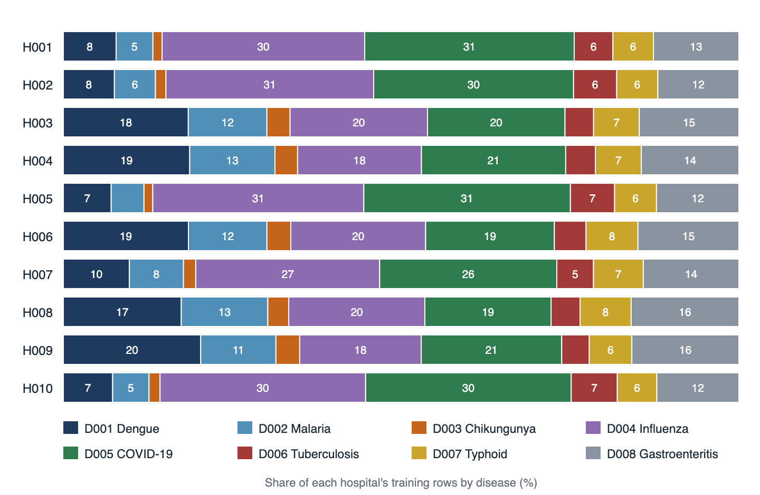
Figure 1.1: Disease mix of each hospital's training rows. Hospitals in the north (continental, urban) are dominated by the two respiratory diseases; the tropical and coastal hospitals have far more vector-borne disease. H007 (semi-arid) sits between the two groups. Source: train.csv, 56,620 rows.
3. Rare diseases starve a lone hospital.
Chikungunya (D003) is 2.4% of the training rows (1,352 of 56,620). A single hospital holds only 79 to 235 training cases of it, and its test split holds 16 to 56. Trained alone, the ten hospitals recover on average only 0.693 of the chikungunya cases (weighted by test cases); the federated model recovers 0.797 (Section 7.1).
4. Outbreak detection is inherently cross-site.
The outbreak detector (Objective B) alerts only when several hospitals signal the same disease at the same time and their symptom signatures agree. In the generator, 96 of the 129 labelled outbreaks are linked, meaning the same disease is active at another hospital in the same region. A detector fitted or calibrated at one hospital cannot see the property it is meant to detect.
5. Existing models should not be rewritten.
Objectives A, B and E already have trained models, APIs and a web front end. A federation that required new model code, or a different file format, would need all of that re-validated. The project therefore treats existing code as a fixed contract and builds around it (Section 4.1).
6. Claims about FL are often unevidenced.
A federated model is routinely reported as "close to centralised" with a single number. The project makes the comparison an artifact in its own right: per hospital, against three baselines, with confidence intervals (Chapter 7).
Table 1.1: The ten federated clients. Institution names are labels from the reference table; the encounters are synthetic.
ID | Hospital (label) | City | Region | Climate, setting | Train rows | Test rows
H001 | AIIMS New Delhi | New Delhi | North | Continental, Urban | 7,043 | 1,792
H002 | PGIMER Chandigarh | Chandigarh | North | Continental, Urban | 5,860 | 1,446
H003 | JIPMER Puducherry | Puducherry | South | Tropical, Urban | 6,849 | 1,730
H004 | CMC Vellore | Vellore | South | Coastal, Urban | 6,148 | 1,518
H005 | KGMU Lucknow | Lucknow | North | Continental, Urban | 6,239 | 1,597
H006 | NIMHANS Bengaluru | Bengaluru | East | Tropical, Mixed | 4,719 | 1,171
H007 | Safdarjung Hospital | New Delhi | West | Semi-arid, Urban | 4,367 | 1,118
H008 | King Edward Memorial Hospital | Mumbai | Central | Tropical, Mixed | 4,903 | 1,199
H009 | Sree Chitra Tirunal Institute | Thiruvananthapuram | South | Coastal, Rural | 3,924 | 988
H010 | SMS Medical College Hospital | Jaipur | North | Continental, Urban | 6,568 | 1,596

1.3 Scope of the Project
In scope
- Federated training of four models across hospitals H001 to H010: the E1 disease classifier, the E2 treatment recommender (success probability and recovery days), the A atypical-presentation detector and the B outbreak detector.
- A simulation mode (all hospitals in one process, for experiments) and a deployment mode on one machine (separate SuperLink and SuperNode processes over TLS with per-hospital keys).
- Authentication of hospitals, binding of each reply to its hospital, and a script that checks the refusals.
- Export of the federated models in the format the existing predictors load, and serving them through the existing APIs.
- Evaluation against each hospital alone, a pooled simulation and the original production models, with a web view of the comparison.

Out of scope
- Differential privacy and secure aggregation. The plan fixed the privacy goal as data staying local, per-hospital authentication and TLS.
- Real patient data. The encounters come from a generator and the institution names only label the simulated nodes.
- Per-hospital API tokens in the web back end. The web API still uses one shared key.
- Scheduled retraining and model promotion. Federated files are written next to the production ones, never over them, and promoting one is an explicit copy.
- Vertical federation (hospitals holding different columns for the same patients).

Threat model
The setting is cross-silo with ten known hospitals. The coordinator is assumed to follow the protocol but may look at everything it receives; it sees each hospital's model increments or statistics individually. Hospitals are authenticated and are assumed not to collude. The design defends against an unauthenticated party connecting, a connection without TLS, a hospital submitting results as another hospital, a hospital answering twice and a hospital missing from a round that pools everyone. It does not defend against inference from the shared model or from the individual statistics (Section 4.1).

2. PROJECT DESCRIPTION AND GOALS

2.1 Literature Review
Foundations of federated learning
McMahan et al. introduced federated averaging (FedAvg), in which clients run several local gradient steps and a server averages the resulting weights, to learn deep networks from decentralised data with far fewer communication rounds than synchronised SGD [1]. Kairouz et al. survey the open problems that followed: communication cost, statistical heterogeneity, privacy and robustness [2]; Li et al. cover the same ground from a systems view [3]. Two results matter here. First, accuracy degrades when clients' label distributions differ, because local objectives pull the weights in different directions [13], and the effect can be studied with synthetic non-identical partitions [14]. Second, averaging has no meaning for models that are not parameter vectors, such as tree ensembles, mixtures of Gaussians or counting detectors.
Federated learning in healthcare
Rieke et al. argue that FL is a route to multi-institutional medical models without data sharing, and list the technical and regulatory problems still open [4]. Early clinical studies used simple models: Brisimi et al. predicted hospitalisations from distributed electronic health records with a sparse support-vector machine [25]. In imaging, Chang et al. compared single and cyclical transfer of weights among institutions [10], and Sheller et al. trained brain-tumour segmentation models across institutions and compared them with a data-sharing model [11]. Dayan et al. trained a clinical-outcome model for COVID-19 patients across twenty institutions [12]. These works are overwhelmingly neural networks on images or on tabular features of one outcome. The cyclical scheme of Chang et al. is the closest ancestor of the turn-taking used here, but it passes network weights rather than adding trees.
Federated tree ensembles
Gradient-boosted trees, and XGBoost in particular [6], are the default for tabular clinical data, but they do not average. Li et al. proposed SimFL, a horizontal federated GBDT that uses locality-sensitive hashing to share similarity information between parties [7]. SecureBoost, a lossless vertical method, uses homomorphic encryption so that parties holding different features can build trees jointly [8]. Federated Forest does the same for random forests [9]. Flower ships two XGBoost strategies for the horizontal case: bagging, in which each client trains a forest and the server concatenates them, and cyclic training, in which clients take turns adding trees to one model [29]. In the version used here the stock bagging merge is written for a single class; the project's own multi-class merge did not beat local-only training (Section 2.2), so cyclic training was used.
Statistical models and distributed estimation
Some models are better federated by sharing statistics than by sharing parameters. The EM algorithm for Gaussian mixtures [18] has an E-step that is local to each row and an M-step that needs only weighted sums, so it distributes exactly; Nowak showed this for density estimation and clustering in sensor networks [19]. Quantiles can be estimated from mergeable histograms [20] or quantile summaries [21] with a bounded error, and robust scaling by the median absolute deviation [22] needs only such quantiles. Anomaly detection is surveyed by Chandola et al. [26]. Federated versions of anomaly or novelty detectors that are fitted without labels, and that are exactly equivalent to the pooled fit, are much less common in the clinical literature than federated classifiers.
Outbreak surveillance
Statistical outbreak detection compares current counts with a baseline built from history. Farrington et al. use a regression-based algorithm with an overdispersed Poisson model for routine surveillance data [23], and Kulldorff's scan statistic searches for clusters in space and time [24]. These systems assume that a public-health agency can see counts from many sites. They do not address how the thresholds of such a detector are calibrated when the sites' encounter rows cannot be pooled, nor how a hospital-level atypicality detector can feed it.
Privacy attacks and defences
Keeping data local is not the same as keeping it private. Shared gradients can be inverted to recover training inputs [17] and trained models can leak membership [31]. Secure aggregation hides individual updates from the server [15] and differential privacy bounds what any output reveals about one record [16]. Both are costly and neither is part of this project, which is stated as a limit and discussed in Section 7.10.
Table 2.1: Selected related approaches compared with this project (characterisations are summaries, not exhaustive)
Approach | Model family | Setting | Heterogeneity / evaluation | Privacy mechanism
FedAvg [1] | Neural network | Horizontal | Studied on label-skew partitions [13] | None by itself
Cyclical weight transfer [10] | Neural network | Cross-silo, imaging | Compared with single transfer | Data local
Multi-institution segmentation [11] | Neural network | Cross-silo, imaging | Federated vs data-sharing | Data local
EXAM, COVID-19 outcome [12] | Neural network | Cross-silo, 20 sites | Per-site generalisation | Data local
SimFL [7] | GBDT | Horizontal | Accuracy vs baselines | Hashing-based similarity
SecureBoost [8] | GBDT | Vertical | Lossless vs pooled | Homomorphic encryption
Flower FedXgbBagging / Cyclic [29] | XGBoost | Horizontal, framework | Not part of the strategy | TLS, node auth [30]
This project | GBDT (2 tasks), generative statistical model, counting detector | Horizontal, cross-silo, 4 tasks in one app | Per hospital, 3 baselines, paired bootstrap vs original | Local data, column whitelist, TLS, per-hospital keys, reply-to-hospital binding

2.2 Research Gap
The review points to gaps that a practical federated clinical system has to close. They are not claimed to be the only gaps, and the project's answer to each is partial. Table 2.2 maps each gap to what was built and where the evidence is.
Table 2.2: Research gaps and how the project addresses them
Gap | State of the art | This project's answer | Evidence
G1 Tabular, multi-class boosting | Clinical FL is dominated by neural networks on images. Stock Flower XGBoost bagging handles a single class. | Cyclic boosting with a fixed 8-class output and a frozen schema; two models (classifier and regressor) share each turn. | Phase 0 spike: bagging merge 95.75% vs local-only 95.84%; cyclic 100 iterations 96.31%, 300 iterations 96.56%, pooled 96.47% (5 seeds)
G2 Models with no weights | Averaging does not apply; federated novelty detectors that equal the pooled fit are rare. | Sufficient statistics, distributed EM and histogram sketches reproduce the pooled fit. | Tests of equal counts and means; EM likelihood at or above scikit-learn's; thresholds within about 1%
G3 Cross-site surveillance | Detectors assume centrally available counts; calibration without pooling is not addressed. | Counts-only summaries and hospital-reported episodes; unmodified detector calibrated on them. | Summaries, truth and thresholds equal the centralised pipeline on identical inputs
G4 Retrofitting existing models | Papers present new models, not federation of deployed ones. | Unmodified production code loaded by path; drop-in artifacts; guard tests. | Export tests load the files in the production predictors
G5 Trust and identity | Authentication is infrastructure; reply attribution is rarely checked. | TLS, per-hospital keys, registry-based binding of replies to hospitals, executable refusal checks with a control. | check-security; 11 identity tests
G6 Evidence quality | One pooled number; no per-site view or interval. | Three baselines, per-hospital wins, paired patient-clustered bootstrap, verdict rule, originals re-checked. | comparison.json; Model comparison tab; Chapter 7

2.3 Objectives
The objectives were set in the project plan and are written so that each can be checked. The status column states what the evidence in Chapter 7 shows.
Table 2.3: Project objectives and status
ID | Objective | Success criterion | Status
O1 | Federate the E1 disease classifier | Better than each hospital alone; within the bootstrap interval of the original | Met: 96.74% vs 95.85% alone; +0.02 pt vs original (CI -0.16 to +0.22)
O2 | Federate the E2 treatment recommender | Success AUC and recovery MAE no worse than alone | Met: AUC 0.615 vs 0.605; MAE 1.518 vs 1.545 days. Signal is weak (AUC about 0.61)
O3 | Federate the A atypical detector exactly | Statistics equal the pooled fit; detection quality at least as good | Met: sums equal; AUC 0.860 vs 0.846 alone; +0.005 vs original
O4 | Federate the B outbreak calibration | Held-out metrics equal the centralised pipeline | Met: identical on 21 held-out outbreaks (small sample)
O5 | No patient row or identifier leaves a hospital | Column whitelists; tests on what shared artifacts and replies contain | Met for the Flower layer; no DP or secure aggregation
O6 | Authenticate hospitals and bind replies to them | Unregistered, plaintext, untrusted-CA and impersonating peers refused | Met in a single-machine deployment
O7 | Drop-in compatibility | Federated files load in the existing predictors and APIs | Met: export tests; the four APIs load model/<task>/
O8 | Evidence and visibility | Per-hospital and paired comparison; web view | Met: comparison.json and Model comparison tab
O9 | State the costs | Communication, compute and size reported | Met: Section 7.8

2.4 Problem Statement
Let H = {1, ..., K} be K = 10 hospitals. Hospital k holds a private dataset D_k of n_k encounters, with the total of n = 56,620 training rows over all hospitals, and a held-out test set T_k. For each task t in {disease, treatment, atypical, outbreak} the existing pooled trainer produces a model M_t^pool from the union of the D_k. The problem is to produce, for each task, a model M_t^fed such that the following four conditions hold.
- Egress. The only data that leaves hospital k is the output of a small, declared set of functions of D_k: a model increment (new trees), a vector of sums or counts, a histogram, or a day-by-disease count summary. No row and no identifier leaves.
- Utility. On T_k, the performance of M_t^fed is no worse than that of M_t^local,k (the model hospital k trains alone) at most hospitals, and indistinguishable from M_t^pool within a paired confidence interval.
- Compatibility. M_t^fed is loadable by the existing predictor of task t without changing that predictor.
- Integrity. Every reply used in training is attributable to exactly one authenticated hospital, and a round that pools all hospitals is refused if any hospital is missing or answers twice.

In symbols, the shared objective of a boosted ensemble F is the pooled loss L(F) = sum over k of (n_k / n) L_k(F), where L_k is the loss on D_k. Cyclic boosting approximates minimising it by letting hospital k(t) at turn t add m trees fitted to the residual of the current ensemble on its own data only:
F_t = F_(t-1) + sum over j = 1..m of eta * h_(t,j), h_(t,j) fitted on D_k(t) given F_(t-1)

The ensemble after T turns has T x m trees. For the disease model T = 30 and m = 10, so 300 trees.

2.5 Project Plan
The plan was written before the work began, approved in stages, and delivered in six phases over the last week of the project. Figure 2.1 shows the timeline reconstructed from the repository's commit dates and session records. The earlier objectives (D, E, A, B) are shown for context.
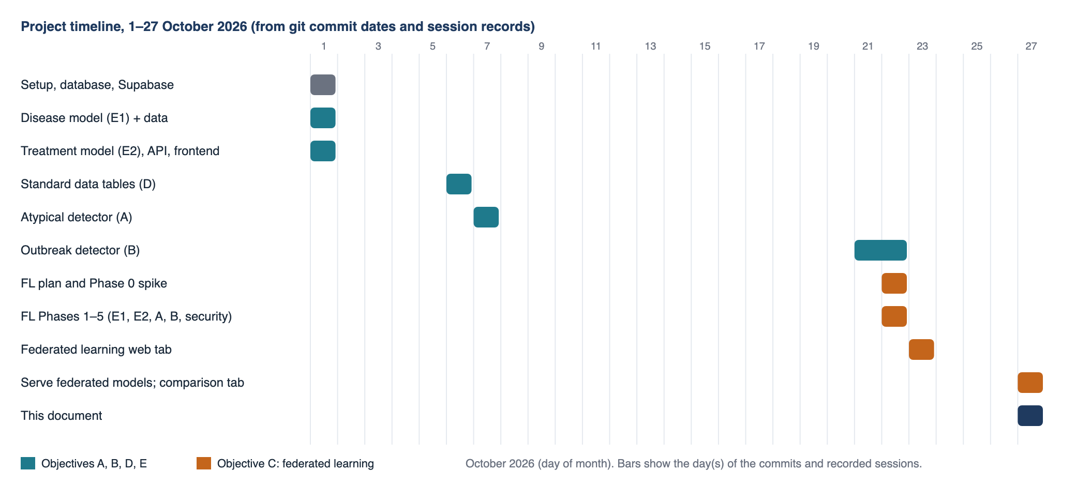
Figure 2.1: Project timeline, 1 to 27 October 2026, from commit dates and session records. Federated learning (Objective C, orange) was built after the objectives it federates.
Table 2.4: Phases, deliverables and results
Phase | Date | Deliverable | Exit criterion | Result
0 Prerequisites and spike | 22 Oct | flwr added to requirements; per-hospital partitioning; strategy spike | Federated model loads in XGBoost and beats local-only | Bagging failed (95.75% vs 95.84%); cyclic passed
1 E1 disease | 22 Oct | tasks/disease.py; 30 turns x 10 iterations; per-hospital report | Beats local-only at every hospital | 96.55 to 96.74% over 6 runs; wins 10 of 10 hospitals
2 E2 treatment | 22 Oct | Two models per turn; candidate table from a query round | Matches the production recommender's format | AUC 0.615 vs 0.605 alone; MAE 1.518 vs 1.545
3 A atypical | 22 Oct | Seven-stage statistics protocol with distributed EM | Sums equal the pooled fit | AUC 0.860 vs 0.846 alone
4 B outbreak | 22 Oct | Summary and episode federation; unmodified calibration | Metrics equal centralised | Identical on 21 events
5 Security and deployment | 22 Oct | Credentials script; SuperLink with TLS and node auth; identity registry; check-security | Refusals verified with a control | All checks passed after two false passes were fixed
6 Web view | 23 Oct | Read-only API and Federated learning view with replay | Numbers match the report JSON | Delivered
7 Serving and comparison | 27 Oct | APIs load federated files; comparison.json and Model comparison tab | Originals reproduce their recorded metrics | 7 of 8 measures indistinguishable; 1 better

Table 2.5: Risk register
Risk | What happened or could happen | Mitigation
Stock tooling does not fit | Flower's bagging merge is binary-only, and a multi-class merge did not help | Cyclic strategy; its built-in evaluation samples one hospital per round, so per-hospital evaluation is a separate step
Optimistic test numbers | Disease turns and iterations were chosen after looking at test-split results | Disclosed in the README, the comparison tab and Section 7.10; treatment settings were chosen on per-hospital validation slices only
Unfair comparison | The federated disease model has 300 iterations; the pooled baselines have 100 and the original 347 (early stopping) | Stated wherever the comparison appears; the originals are checked against their recorded metrics
Verification that does not verify | A first version of the security check had false passes (a port clash and a vacuous OR condition) | Rewritten with a control run and independent evidence for each refusal
Environment | The project virtual environment on a cloud-synced folder was partly evicted and could not import pandas | Runs were made in a separate environment; the project environment needs recreating
State outside the repository | flwr run writes to the user's ~/.flwr; the first environment build took about 250 s | The deployment script isolates state with FLWR_HOME; the app finds data through CAREPATH_ROOT

3. TECHNICAL SPECIFICATION

3.1 Requirements

3.1.1 Functional
Each functional requirement names the automated test or inspection that verifies it. Test names are those in models/objectiveC/tests/.
Table 3.1: Functional requirements and how each is verified
ID | Requirement | Verified by
FR1 | A client reads only its own hospital's rows and only whitelisted columns. | test_partition_returns_only_that_hospital; test_partition_columns_are_whitelisted; test_client_reads_only_whitelisted_columns
FR2 | The disease model is trained by cyclic boosting; every hospital emits an 8-class model even if it has never seen a rare disease; unknown disease ids are rejected. | test_cyclic_turns_add_iterations_and_stay_8_class; test_unknown_disease_id_is_rejected
FR3 | The treatment task trains a success classifier and a recovery regressor in the same turn; the success model stops growing at 60 iterations; the candidate table is the union of the hospitals' observed combinations. | test_both_models_gain_iterations_each_turn; test_success_model_stops_growing_at_its_cap; test_merge_takes_union_and_minimum
FR4 | The atypical task returns only aggregate-shaped arrays; counts and means equal the pooled fit; distributed EM fits as well as scikit-learn; thresholds are close to the centralised calibration. | test_clients_return_only_aggregates; test_counts_and_means_equal_the_centralised_fit; test_distributed_em_fits_as_well_as_sklearn; test_thresholds_are_close_to_the_centralised_calibration
FR5 | The outbreak task sends only day-by-disease counts and episode dates; summaries, truth and calibration equal the centralised pipeline. | test_only_counts_and_episode_dates_leave_the_hospital; test_summaries_equal_the_centralised_node_summaries; test_federated_calibration_equals_the_centralised_one
FR6 | Exported models load in the unmodified production predictors. | test_export_loads_in_the_production_detector (A, B); test_export_is_a_drop_in_for_the_production_recommender
FR7 | Federated output is written under models/objectiveC/model/<task>/, never over a production model directory. | Inspection: OUT_DIR constants in each task module
FR8 | Hospitals connect over TLS with their own key; an unregistered key, a plaintext connection and an untrusted CA are refused. | deploy/local_federation.py check-security
FR9 | The server binds each reply to the authenticated hospital and refuses unknown nodes, missing hospitals, duplicate answers and forged hospital claims. | Eleven tests in test_fl_identity.py
FR10 | Federated, alone and pooled results are reported per hospital and weighted. | carepath_fl/report.py; test_trained_tasks_carry_comparable_numbers
FR11 | The federated models are compared with the original models on the same patients with paired-bootstrap intervals; the run fails if an original does not reproduce its recorded metrics. | carepath_fl/compare.py; five tests in test_fl_compare.py
FR12 | A read-only API serves the reports; it requires the API key and never imports Flower, trains or serves a model. | test_overview_requires_the_api_key; test_comparison_requires_the_api_key; test_response_exposes_no_node_ids_keys_or_paths
FR13 | Training records which hospital took each turn and the shared model's metrics after it. | turn_history() in server_app.py; test_a_report_without_history_still_renders
FR14 | A simulation mode and a multi-process deployment mode run the same app. | flwr run and deploy/local_federation.py run

3.1.2 Non-Functional
Table 3.2: Non-functional requirements
Category | Requirement | How it is met or measured
Privacy | No patient row or identifier in any shared artifact or reply | Column whitelists in each task; shared models carry no identifier columns (tested). No differential privacy or secure aggregation.
Security | Encrypted, authenticated, attributable communication | TLS with a private CA; P-384 keys per hospital; registry binding; check-security. Prototype credentials only.
Compatibility | Do not change production objectives A, B, E | Loaded by path. The git history shows no change to the training or prediction code of A, B or E since the federated work began; only the four api.py loaders were pointed at the federated files. Guard tests compare copied constants with production metadata.
Reproducibility | Same inputs give the same results where randomness allows | Fixed seeds for splits (42) and per-turn seeds. Cyclic hospital order is random per run, so the disease accuracy ranged from 96.55% to 96.74% over six runs.
Performance | A full training must be practical on commodity hardware | One local turn of 10 trees on 7,043 rows takes 0.12 s on an Apple M1; the full simulated disease run took about 42 s; the in-process atypical protocol took 48 s.
Scalability | Cost grows predictably with hospitals and turns | Cyclic training is sequential, so wall-clock time grows with the number of turns. The model grows by about 23.4 KB per boosting iteration (JSON), so traffic grows with the square of the number of turns.
Maintainability | Small, tested, explicit module contract | 2,250 lines of source in the federated layer; 62 tests; one task contract implemented by four modules.
Auditability | Be able to say how a number was produced | meta.json keeps the per-turn history; comparison.json records the time and the number of bootstrap resamples; originals are checked against their recorded metrics.
Usability | Results visible to a reviewer without a terminal | Model comparison tab; Federated learning view (see Section 6.3 for its current status).
Portability | Run on the team's machines | Developed on macOS. Python 3.11 or later is required by the Flower app. Other operating systems were not tested.

3.2 Feasibility Study

3.2.1 Technical Feasibility
The project relies on mature open-source components and one integration risk. XGBoost supports training from an existing booster (xgb_model=), which is exactly what a cyclic turn needs, and serialises to JSON so that the shared model can be passed in a Flower array record. Flower provides the SuperLink and SuperNode processes, TLS and node authentication [30]. Everything else (EM, histograms, Poisson tails) is NumPy and SciPy.
The integration risk was that the stock Flower XGBoost bagging strategy handles a single class, and the first spike confirmed that a multi-class bagging merge written for the project did not beat local-only training. Cyclic training removed the risk. Its cost is that turns are sequential and that the shared model grows with every turn; both are quantified in Section 7.8.
Feasibility was demonstrated rather than assumed. Table 3.3 gives the measurements made on the development machine.
Table 3.3: Measured technical feasibility figures
Measurement | Value | Source
One disease turn (10 trees, H001, 7,043 rows) | 0.12 s (first turn 0.12 s, second 0.13 s) | Measured for this report
Peak memory of that process, including Python, pandas, XGBoost | 222 MB | Measured (resident set size)
Full disease run, 30 turns x 10 iterations, simulation | about 42 s | Project record, 22 Oct
Atypical protocol, 51 stage calls, 10 hospitals, in process | 47.8 s | Measured for this report
First build of the Flower runtime environment | about 250 s (one-off) | Project record
Disease model file | 7.01 MB (300 trees) | Measured
Treatment model files | 0.17 MB and 0.46 MB | Measured
Automated tests of the federated layer | 62 passed in 55.7 s | Run for this report

3.2.2 Economic Feasibility
The software stack has no licence fees. The measured compute is small. The main economic cost of federation is network traffic and operations, not computation. No money figures are given because they would depend on a hospital's bandwidth and staffing rates, which the project does not have; the quantities that drive the cost are measured instead (Section 7.8).
Table 3.4: Cost items and measured quantities
Cost item | Basis | Measured or derived quantity
Software licences | Flower, XGBoost, scikit-learn, pandas, SciPy, FastAPI, cryptography and pytest are open-source (Apache-2.0, BSD, MIT) | None
Local compute per hospital turn | XGBoost on one hospital's rows | 0.12 s per 10-tree turn; a few seconds per training on one laptop-class CPU
Network, one disease training (all hospitals) | Model down and up at each of 30 turns, JSON | 228.2 MB (110.6 down, 117.6 up); about 22.8 MB per hospital on average
Network, one treatment training | 80 turns, both models | 63.3 MB
Network, atypical and outbreak | Uploads only (parameters downloaded are not included) | 38.4 MB and 8.0 MB
Network, all four tasks, one full retraining | Sum of the above | about 337.9 MB across ten hospitals
Storage of artifacts | Model and report files | 7.0 MB disease; 0.6 MB treatment; under 0.1 MB each for atypical and outbreak
Operations | Run a SuperNode per hospital, manage keys and certificates, coordinate schedules | Not measured. This is the dominant cost in practice and depends on the institutions.
Development effort | One development session per phase (Table 2.4) | Not recorded in hours; ask the project team for staff-time figures if a cost estimate is needed.

Against these costs stand two benefits that can be stated in the project's own numbers: the smaller hospitals gain the most from federation (Section 7.9), and no hospital needs the legal and operational arrangements for sending rows off site.

3.2.3 Social Feasibility
Three social factors decide whether such a system is acceptable. Legal and ethical. In India the Digital Personal Data Protection Act, 2023 [27] places duties on those who decide how personal data is processed. Keeping rows in each hospital reduces the number of transfers that must be justified, but it does not remove the duty to examine what the shared model and the statistics reveal, and this report is not a legal opinion. Clinical trust. A decision-support tool is used only if clinicians trust it. The comparison tab is written to say plainly where the federated and original models are not distinguishable, and the interface carries the notice that the tool is not a diagnosis. Equity. The hospitals with the least data are the ones that benefit most (Section 7.9). A federation is a way for a small or rural hospital to use evidence it could not generate alone.

3.3 System Specification

3.3.1 Hardware Specification
Table 3.5: Hardware specification
Role | Specification | Basis
Development and experiments (used) | Apple M1, 8 cores, 16 GB RAM, macOS (Darwin 25.5.0) | The machine on which every result and measurement in this report was produced
Hospital node (SuperNode + ClientApp) | About 4 CPU threads (XGBoost nthread = 4), at least 1 GB RAM, network egress of tens of MB per training | Derived from the 222 MB measured peak and the traffic in Section 7.8. Not benchmarked on a separate machine.
Coordinator (SuperLink + ServerApp) | A small server with a public address for the SuperLink port; memory for one shared model of about 7 MB per task | Derived. In the demonstration the coordinator ran on the same laptop.
Reviewer workstation | Any browser-capable computer | The web app is plain HTML, CSS and JavaScript

3.3.2 Software Specification
Table 3.6: Software specification
Component | Version | Role
Python | 3.11 or later required; 3.13 for the training runs; 3.14.0 for the tests run for this report | Language
Flower (flwr[simulation]) | 1.41 or later; 1.41 for training, 1.42.0 installed when this report was prepared | SuperLink, SuperNode, ServerApp, ClientApp, FedXgbCyclic, simulation engine (Ray 2.55.1)
XGBoost | 3.4.1 (recorded in the model metadata) | Gradient-boosted trees, shared model format
scikit-learn, SciPy, NumPy, pandas | scikit-learn 1.9.1, SciPy 1.18.1, pandas 3.1.0 installed; minimum 1.5 and 2.2 | Metrics, splits, distributions, tabular data
FastAPI, Uvicorn, httpx, Pydantic | FastAPI 0.138.2 installed; minimum 0.115 | Serving layer, test client
cryptography | Installed | TLS CA and certificates, P-384 hospital keys in OpenSSH format
hatchling | Build back end | Packages the Flower app (pyproject.toml)
pytest | 9.1.1 | Automated tests
Front end | Plain HTML, CSS and JavaScript (no framework) | Model comparison and Federated learning views
Headless Chrome with the DevTools protocol | Chrome | Used to check the web views, including phone-width layouts

4. DESIGN APPROACH AND DETAILS

4.1 System Architecture
The federated layer is organised in five layers, shown in Figure 4.1. Hospital nodes hold data and run the local half of each task. A trust boundary of TLS and key-based authentication separates them from the coordinator. The coordinator runs the aggregation half of each task and checks identities. Results are written as plain files, and the serving layer reads those files.
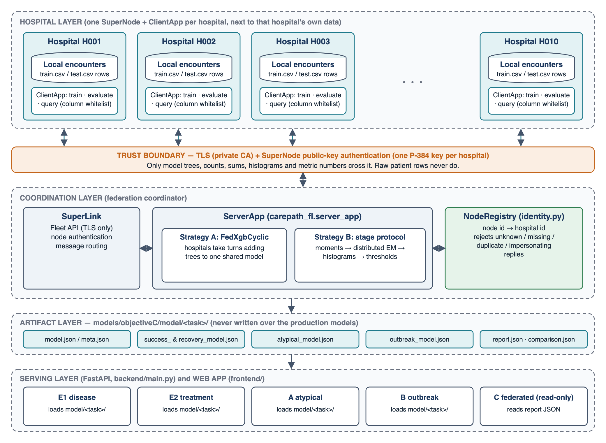
Figure 4.1: System architecture. Only trees, counts, sums, histograms and metric numbers cross the trust boundary; raw patient rows never do.
Design principles
- Rows never leave. Each client reads only a whitelist of columns, and the shared state is made of aggregates. Identifier columns (encounter id, patient token) are never features.
- Existing code is the contract. The loaders of Objectives A, B and E are used unmodified. The federated layer copies hyper-parameters and feature lists only where it has to, and tests compare the copies with the production metadata.
- Output is a drop-in file. The exported files have the same names and structure as the production ones, and are written to a separate directory. Promoting a model is a deliberate copy.
- One task contract. Every task is a module that implements the same small set of functions. The ServerApp and ClientApp never mention a specific model.
- Fail closed. An unknown disease id, a missing hospital, a duplicate reply or an empty model raises an error instead of being skipped.
- Evidence is part of the product. Every task has per-hospital results, three baselines and, for the web app, a paired comparison with the original model.

One protocol, four learning paradigms
The four tasks are different kinds of learning problem, and each is federated in the way that suits it. Table 4.1 summarises how.
Table 4.1: The four tasks and their federation mechanisms
Task | Model (production origin) | Federation mechanism | Rounds | Shared model or output
disease | XGBoost multi:softprob, 8 classes, 38 features (E1) | Cyclic turns: each hospital adds 10 trees to the shared ensemble | 30 turns, 300 trees | model.json 7.01 MB
treatment | XGBoost binary:logistic and reg:absoluteerror, 45 features (E2) | Cyclic turns, both models per turn; success capped at 60 iterations; candidate table from a query round | 80 turns x 2 iterations | success 60 trees; recovery 160 trees
atypical | Per-disease symptom Bernoulli + 3-component Gaussian mixture over 6 vitals (A) | Sufficient statistics, distributed EM, histogram quantiles; seven stages | 51 stage calls (45 EM rounds) | atypical_model.json
outbreak | Poisson baselines with cross-site symptom-signature agreement (B) | Hospitals send day x disease counts (local flagger = federated atypical detector) and labelled episodes; B calibrates on them | 1 stage | outbreak_model.json (thresholds)

Cyclic boosting (disease and treatment)
The server starts from an empty model. At each turn it selects one hospital, sends it the shared model, and the hospital adds trees fitted to its own data on top of it. The hospital order is a random permutation drawn once per run and repeated, so 30 turns are three rounds over the ten hospitals.
- ServerApp creates empty models and starts the FedXgbCyclic strategy for T turns.
- For turn t the strategy sends a TRAIN message with the shared model bytes, local-iters (m) and the turn number, which the client uses as the XGBoost seed.
- The ClientApp loads its whitelisted columns for the training split, builds a DMatrix and calls xgb.train(params, dtrain, num_boost_round=m, xgb_model=previous).
- The client replies with the updated model, the number of rows, and a hospital number that only labels whose turn it was.
- The strategy sends an EVALUATE message and the same hospital scores the new model on its held-out rows. Accuracy, macro F1, top-3 accuracy and chikungunya recall (disease) or AUC, Brier score, log-loss and recovery MAE (treatment) come back.
- After T turns the server writes the model in the production format, together with the history of every turn.

The shared model is always an 8-class model for the disease task, because the class list is fixed up front; a hospital that has never seen a rare disease still emits trees for all eight classes. For the treatment task the category lists and treatment attributes come from public reference tables, not from the data, and the candidate table the recommender ranks (which disease, severity and treatment combinations exist, with their guideline priority) is assembled from one query round in which each hospital reports only the combinations it has seen. The hyper-parameters equal the centralised trainers': learning rate 0.05, subsample 0.8, column sample 0.8, regularisation lambda 1.0, depth 6 (disease) or 5 (treatment).
Exact federation of the atypical detector
Objective A's detector fits, for every known disease d, what a typical patient looks like: a probability for each of 28 symptoms, and a three-component Gaussian mixture over six vital signs (one component per severity level). It does not use the atypical label when fitting, because a genuinely new disease would have none. Every part of it is a function of sums over rows, so hospitals send sums and the server assembles the model. The stages are listed in Table 4.2.
Table 4.2: Stages of the atypical protocol
Stage | Hospital sends | Server computes
moments | Per disease: row count, symptom sums, per-vital count, sum and sum of squares, complete-case moments | Priors, symptom probabilities (Laplace smoothed), vitals mean and SD, the mixture starting point
em (repeated) | Per component: sum of responsibilities, responsibility-weighted sums of x and of x xT, log-likelihood | M-step: weights, means, covariances; stops when the per-row log-likelihood changes by less than 1e-3 (at most 50 rounds)
norm1, norm2 | Histograms of arcsinh of each surprise score, then of the absolute deviations from the medians | Medians, MADs (x 1.4826), 95th percentiles
cal1, cal2, cal3 | Histograms of the three score families on the hospital's own 15% calibration slice | Thresholds for the target false-alarm rate (5%), rescaled for overlap, and the novelty threshold

The distributed EM step is exact. For hospital k, disease d, component j and row i with vitals x_i, the responsibility and the statistics returned are:
r_ij = w_dj N(x_i; mu_dj, Sigma_dj) / sum over l of w_dl N(x_i; mu_dl, Sigma_dl)
N_dj(k) = sum over i of r_ij; S1_dj(k) = sum over i of r_ij x_i; S2_dj(k) = sum over i of r_ij x_i x_i^T
w_dj = sum_k N_dj(k) / sum over j, k of N_dj(k); mu_dj = sum_k S1_dj(k) / sum_k N_dj(k)
Sigma_dj = sum_k S2_dj(k) / sum_k N_dj(k) - mu_dj mu_dj^T + 0.01 I

Because sums over hospitals equal sums over the pooled rows, one federated EM round equals one pooled EM round. Quantiles are the only approximation. Each hospital bins the arcsinh of its scores on a fixed grid of 8,000 bins over [-20, 20], so a bin is 0.005 wide and a quantile is accurate to about half a percent; the histograms reveal neither an individual score nor the range extremes. The README reports agreement with the centralised statistics to about 1% for the quantile-based quantities, and a test checks that histogram quantiles are accurate.
Counts-only outbreak federation
Objective B has a node layer and a central layer. A node sees only its own encounters and produces one row per day and disease with the case count and 28 symptom counts, plus a pseudo-disease row ATYP for cases that the atypical detector flags as atypical or novel. The central detector never sees an encounter. It compares each hospital's last 7 days with the median of eight earlier 7-day totals, skipping a one-week gap so that a growing outbreak does not contaminate its own baseline, and takes the Poisson upper tail. An alert needs at least min_sites hospitals signalling the same disease with agreeing excess-symptom signatures; a separate binomial test on the share of atypical cases raises a possible-novel-disease alert. Thresholds are calibrated on the earlier part of the timeline (from 20 January 2025) and scored on a later held-out part (1 October to 30 December 2025). Federation changes only where the inputs come from: each hospital runs B's own summariser, using the federated atypical detector as its local flagger, and also sends its labelled outbreak episodes (disease, first day, last day), which the server needs as ground truth for calibration. The server then runs B's unmodified calibrate() and evaluate().
Trust and identity
Flower's SuperLink is started with TLS and with SuperNode authentication enabled, so it accepts only nodes whose public key was registered. Each hospital receives its own P-384 key pair in OpenSSH format and a CA certificate to verify the SuperLink. TLS and keys identify a node, but not the hospital a reply claims to describe. The NodeRegistry closes that gap: at registration the deployment script writes a map from node id to hospital id. The ServerApp then (i) refuses to run if a connected node is not in the map, (ii) refuses a stage that pools everyone if a registered hospital is missing, (iii) takes each reply's sender from authenticated message metadata, never from its payload, (iv) rejects a reply whose payload names a different hospital than its sender, and (v) rejects a hospital that answers twice in one stage. Without a registry, as in plain simulation, nothing is enforced and a notice is logged.
In the cyclic strategy the strategy object owns the send and receive loop, so in the current code the registry is applied to the connected nodes before training and not to each turn's reply. The per-reply binding applies to the stage-based tasks (atypical, outbreak) and to the query round.
What leaves a hospital, and what is not protected
Table 4.3: Data that leaves a hospital, by task
Task | Leaves the hospital
disease, treatment | The shared model after the hospital's turn (its new trees) and evaluation metrics. Treatment also sends a list of disease, severity and treatment combinations seen.
atypical | Per-disease counts and sums; per-component sums for each EM round; histograms of one-dimensional scores.
outbreak | Day x disease case counts with 28 symptom counts, and each labelled outbreak's disease and first and last day.

What is not protected
There is no differential privacy and no secure aggregation. Each hospital receives the full shared model, which contains splits learned from earlier hospitals' data. The server sees each hospital's update or statistics individually. Small daily counts can still carry information about individuals: 73% of the non-empty hospital x disease x day counts are below 3.
Suppressing small counts was considered and not done, because it would remove most of the symptom signal the outbreak detector uses. The generated TLS certificates and keys are prototype credentials for a private network; an organisation should use its own PKI and key management.

Deployment topology
In simulation all ten hospitals run in one process and read their rows from the shared CSVs, filtered by hospital id, so a client cannot see another hospital's rows. In the deployment mode the SuperLink listens on port 9092 with TLS and mandatory node authentication, and one SuperNode per hospital connects from its own port with its own key. The web application uses port 8000, so both can run together. In production each hospital would run its own SuperNode next to its own extract and receive only its own key; the demonstration puts all of them on one machine.

4.2 Design

4.2.1 Data Flow Diagram
Figure 4.2 is the context diagram: the system exchanges rows, configuration, predictions and checks with four external actors, listed in Table 4.4. Figure 4.3 decomposes it into seven processes and three data stores, and Table 4.5 gives the code behind each process.
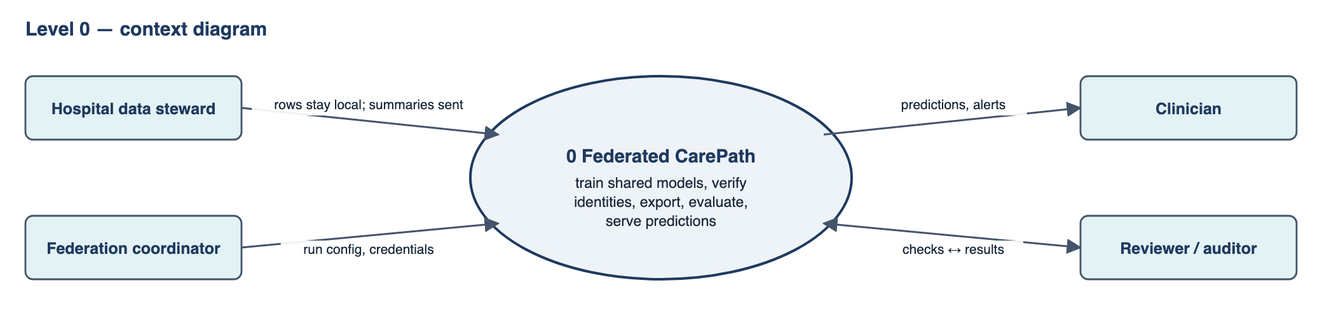
Figure 4.2: Data flow diagram, level 0 (context).
Table 4.4: External entities and data flows at level 0
External entity | Sends to the system | Receives from the system
Hospital data steward | The hospital's own encounter extract (stays inside the hospital's process); the hospital's key | Nothing about other hospitals' rows; the shared model it takes a turn on
Federation coordinator | Run configuration (task, turns, iterations); credentials and the key registry | Progress, per-hospital reports, the exported models
Clinician | A patient presentation | A disease ranking, a treatment plan, an atypical-presentation flag, outbreak alerts
Reviewer / auditor | A request to run the security check or the comparison | PASS / FAIL lines, comparison.json, report.json

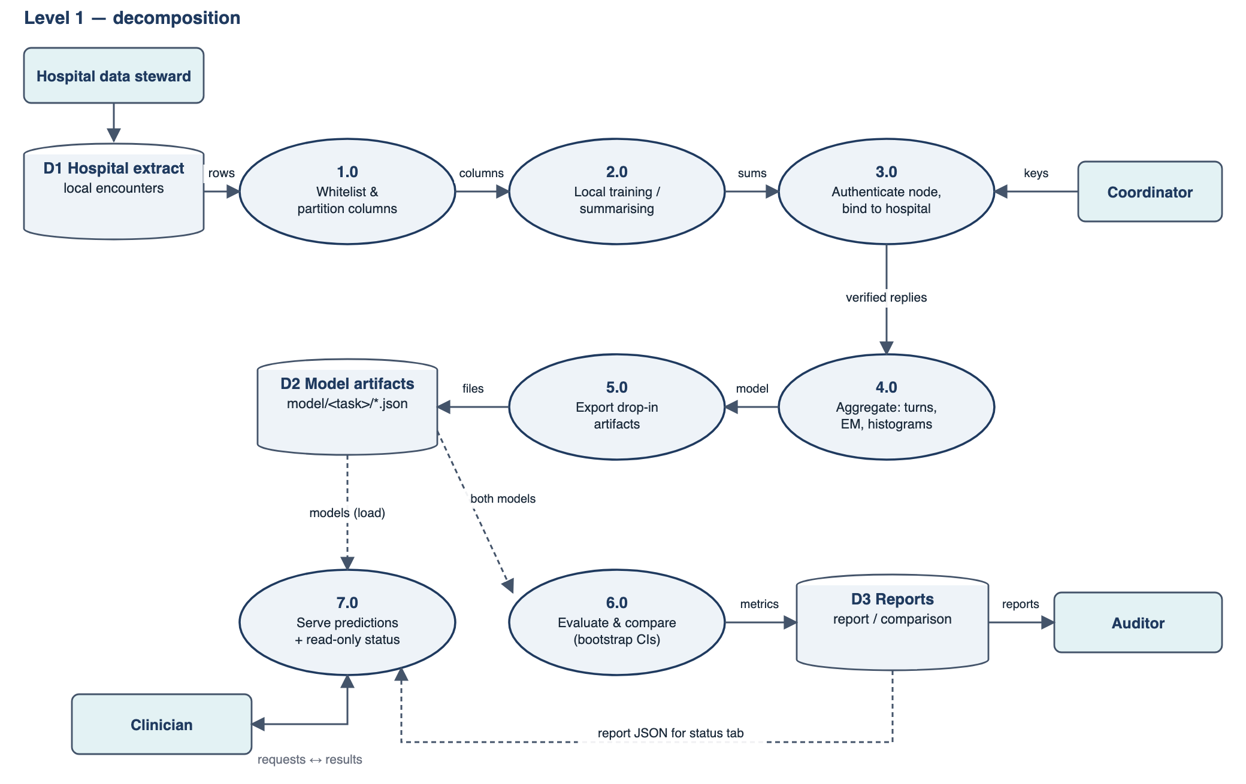
Figure 4.3: Data flow diagram, level 1. Solid arrows are data flows during training; dashed arrows are reads of stored data.
Table 4.5: Processes of the level-1 data flow diagram
Process | Inputs | Outputs | Code
1.0 Whitelist and partition | Hospital extract | Whitelisted columns of one hospital | common/partition.py; COLUMNS in each task
2.0 Local training or summarising | Whitelisted rows; shared model or parameters | Model increment, sums, histograms, counts | client_app.py; tasks/*.client_stage, local_train
3.0 Authenticate and bind | TLS session, node key, registry | Replies tied to a hospital | SuperLink; common/identity.py
4.0 Aggregate | Verified replies | Shared ensemble, or assembled statistics | server_app.py; FedXgbCyclic; tasks/*.run_protocol
5.0 Export artifacts | Shared state | model/<task>/ files in production format | tasks/*.write_model
6.0 Evaluate and compare | Artifacts, test split | report.json, comparison.json | report.py; compare.py
7.0 Serve | Artifacts, reports, requests | Predictions, alerts, status | backend/main.py; the four api.py files; models/objectiveC/api.py

4.2.2 Use Case Diagram
Five actors use the system. The data steward registers and runs a hospital's node. The coordinator runs the federated tasks and exports the models. The auditor checks security, compares models and reviews the evidence. The clinician and the surveillance officer use the predictions and alerts that the federated models now back. The use cases are listed in Figure 4.4, and Table 4.6 specifies three of them.
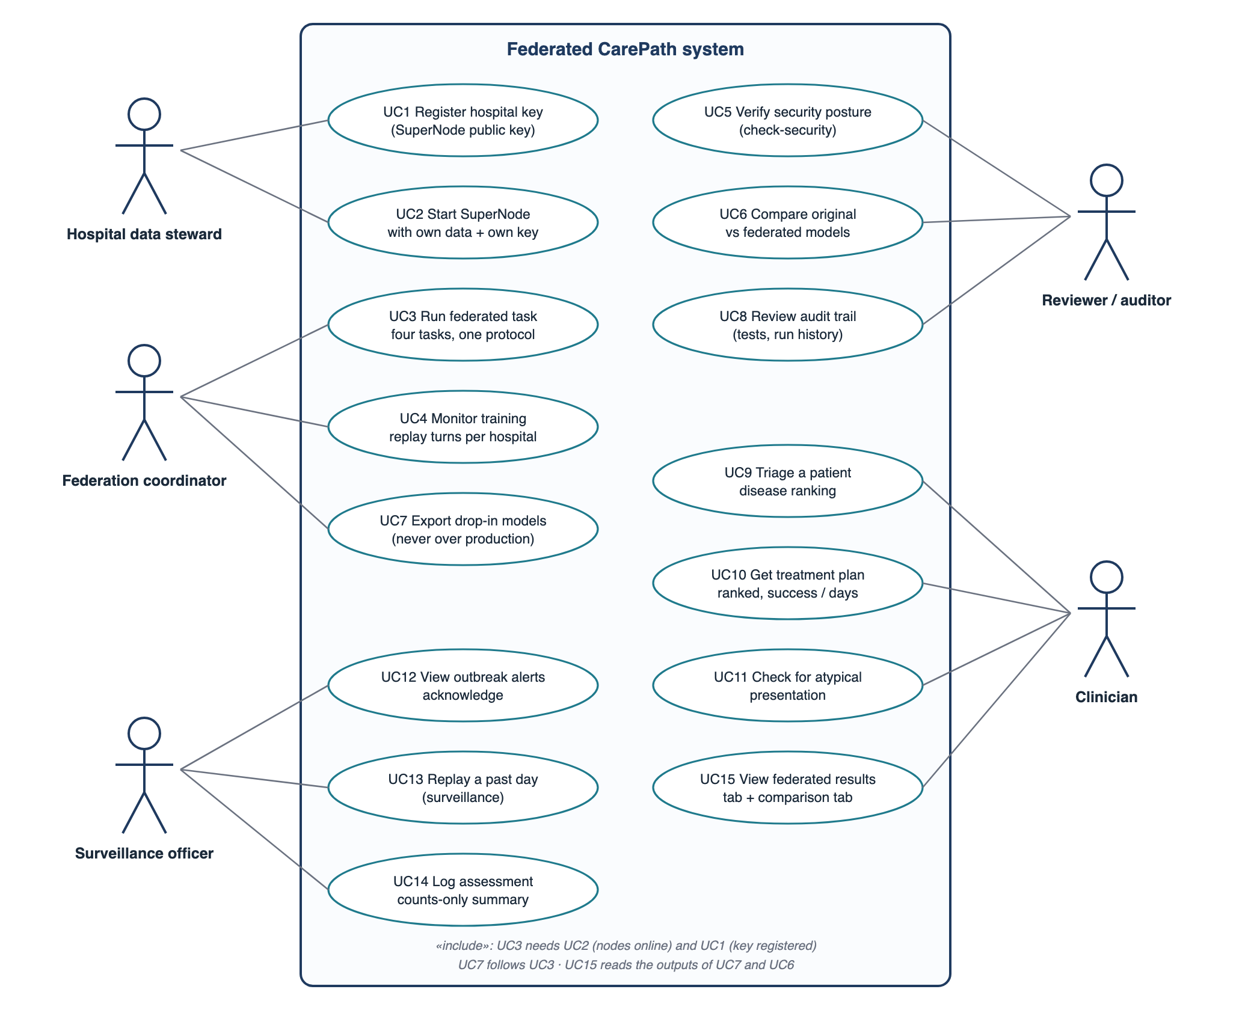
Figure 4.4: Use case diagram of the federated CarePath system.
Table 4.6: Specification of three use cases
Field | UC3 Run a federated task | UC5 Verify security posture | UC6 Compare original and federated models
Actor | Federation coordinator | Reviewer / auditor | Reviewer / auditor
Precondition | Hospitals' keys are registered and their SuperNodes are online; for outbreak, the atypical task has been run | Credentials exist in deploy/secrets | Federated and original models exist; test split available
Main flow | 1. Choose the task and run-config. 2. The ServerApp checks the registry. 3. Turns or stages run. 4. Artifacts are written to model/<task>/. 5. report.py produces per-hospital results. | 1. Start the SuperLink and one registered node. 2. Start an unregistered node, a plaintext node and a node with another CA. 3. Check each log and the number of online nodes. 4. Register the unregistered key and reconnect (control). | 1. Load both model sets as the web app does. 2. Check each original against its recorded metrics. 3. Score both on the same patients. 4. Resample patients 1,000 times for the paired difference. 5. Write comparison.json.
Exceptions | Unknown disease id, missing hospital, duplicate reply, empty model: the run stops with an error | A refusal without a log reason is a failure, not a pass | An original that does not reproduce its recorded metrics fails the run
Postcondition | A federated model in the production format, never over the production files | A list of PASS or FAIL lines | A verdict per measure: better, worse or no clear difference

4.2.3 Class Diagram
The federated layer is mostly functions in modules rather than classes, because Flower's apps are function-based. Figure 4.5 therefore shows the task contract as an interface that four modules realise, alongside the few classes the project does define (NodeRegistry, IdentityError, Deployment) and the Flower classes it uses. The green boxes are production code of Objectives A, B and E that the federated tasks load unmodified.
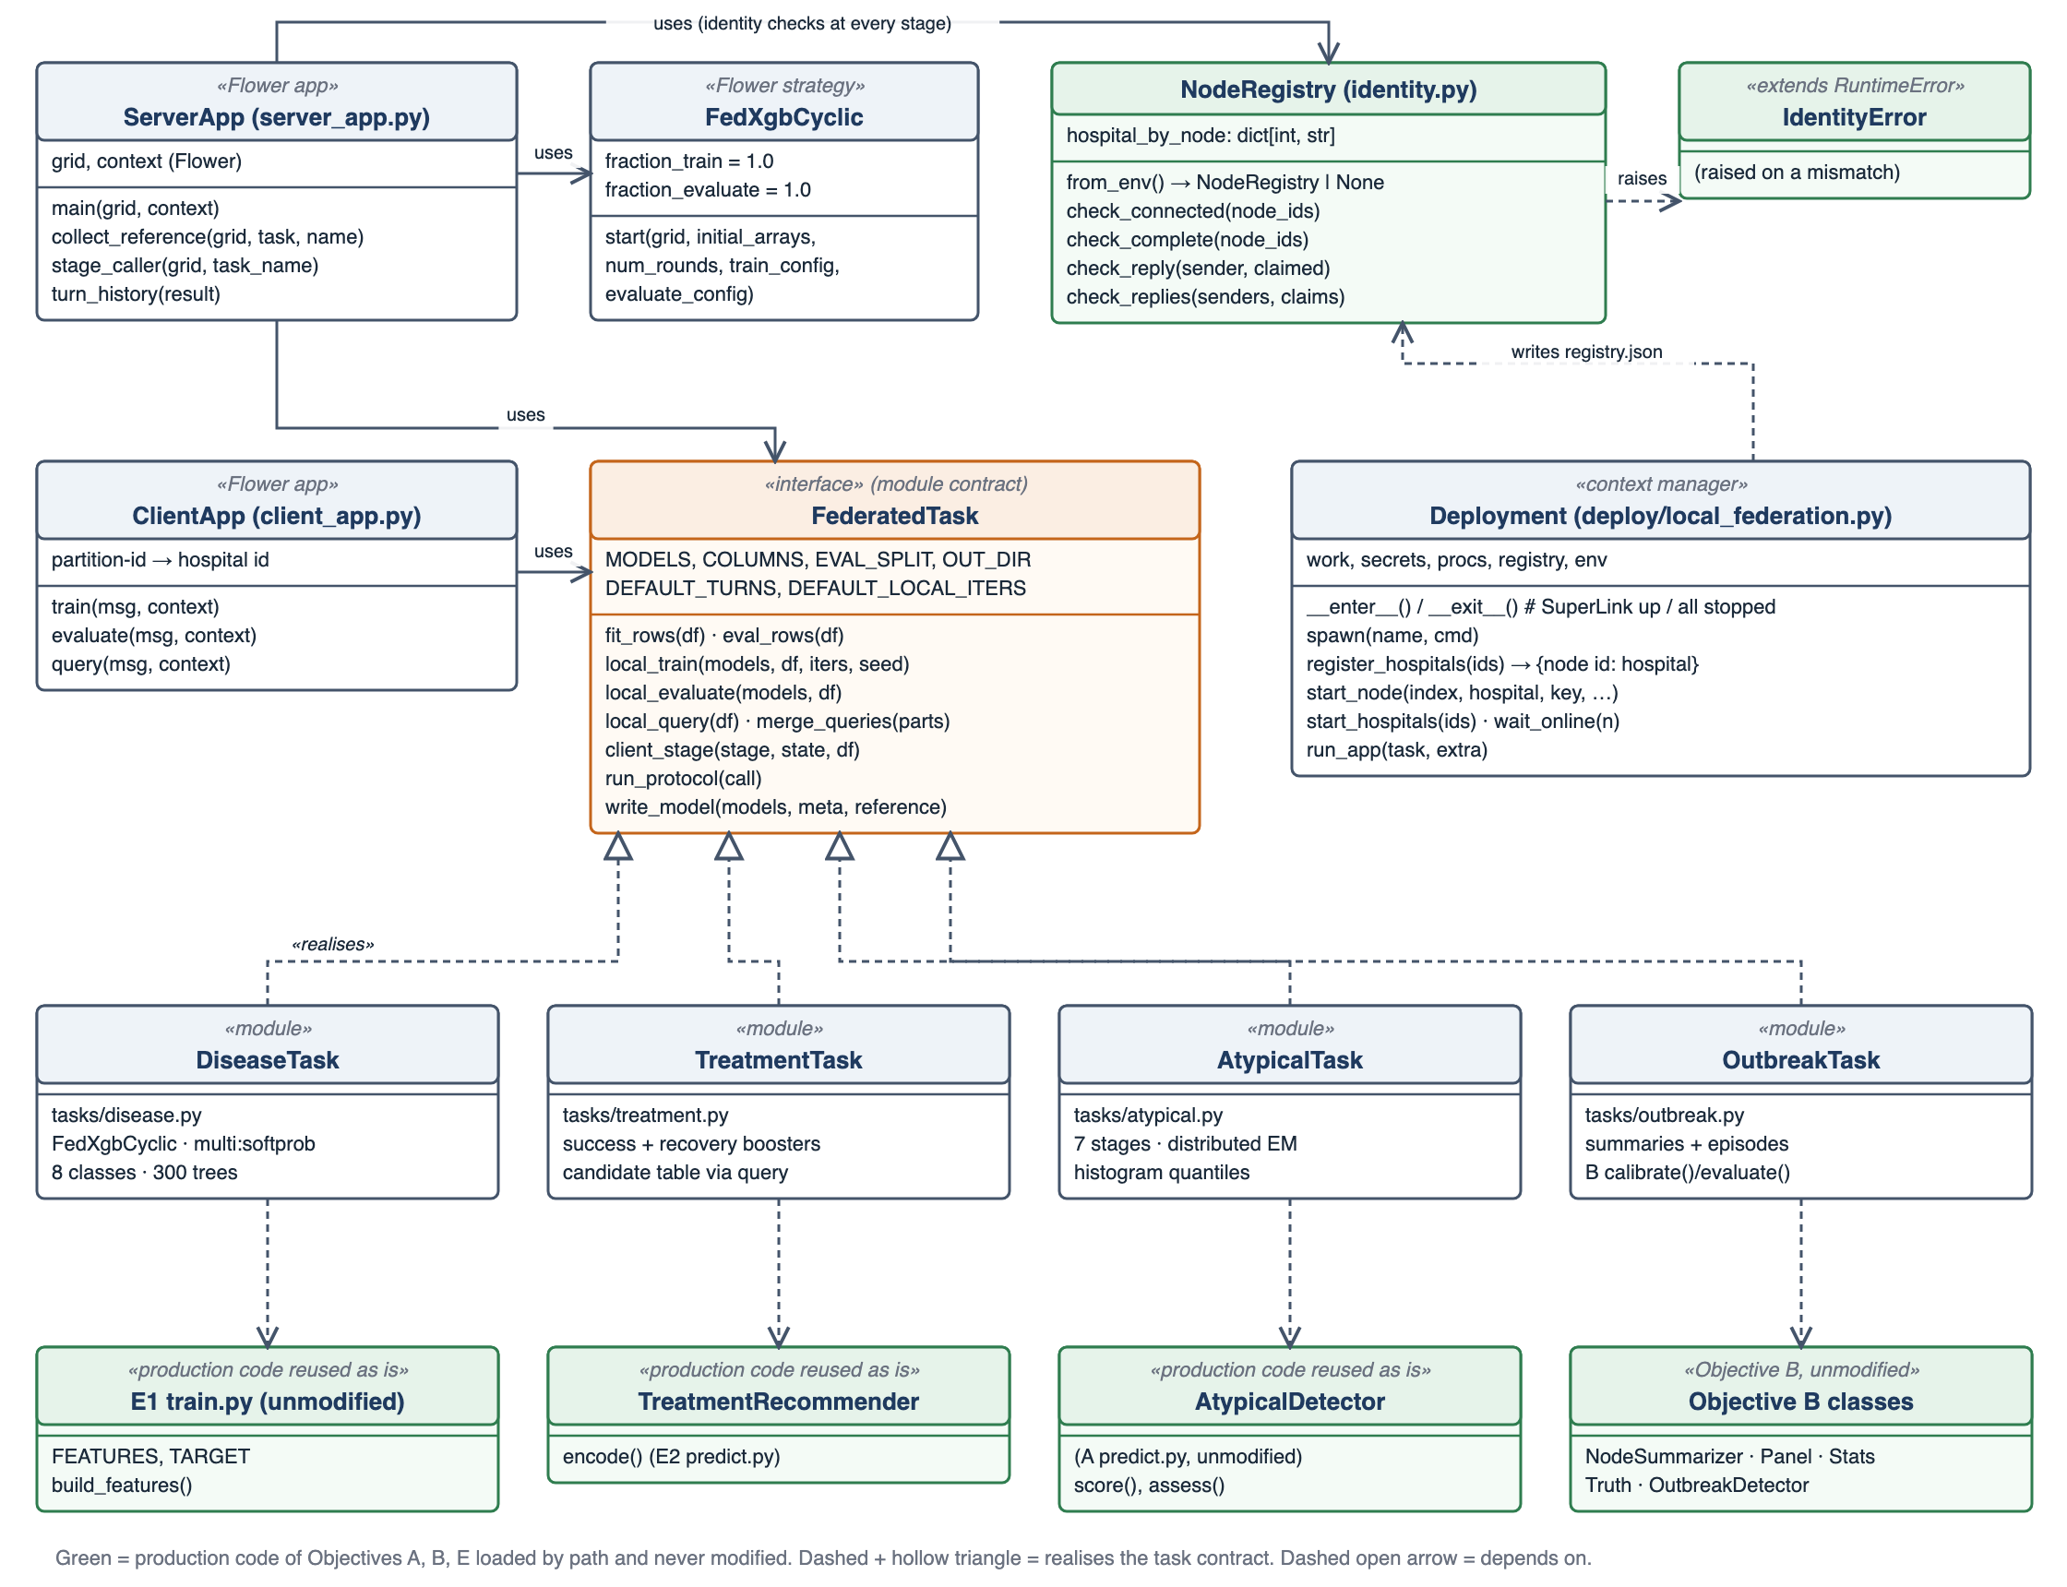
Figure 4.5: Class diagram. FederatedTask is a module contract realised by four task modules; green classes are reused production code.

4.2.4 Sequence Diagram
Figure 4.6 shows one cyclic training run (the disease and treatment tasks). Figure 4.7 shows the statistics protocol used by the atypical task, which also illustrates the identity checks before and after every stage.
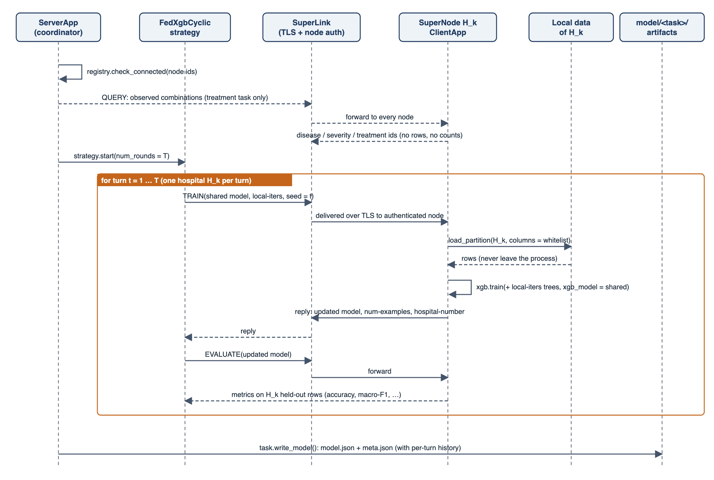
Figure 4.6: Sequence diagram of cyclic federated training (disease and treatment).
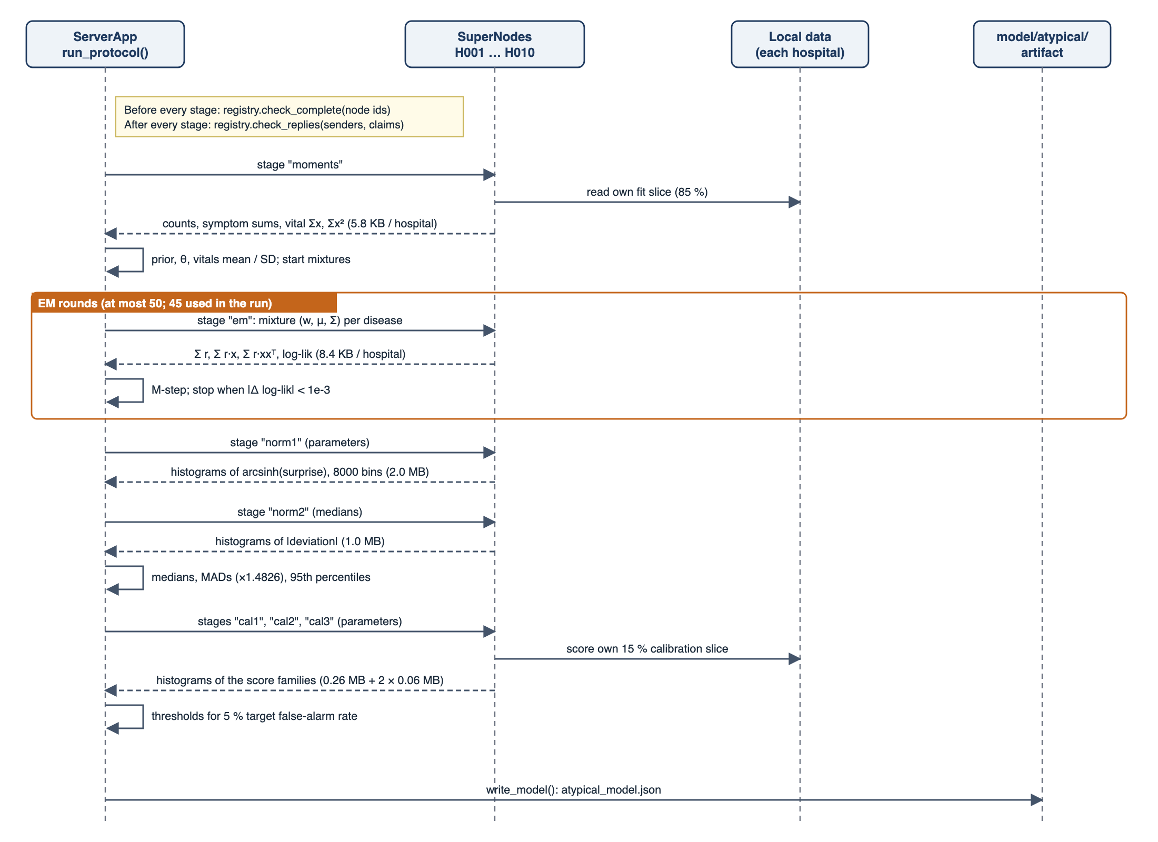
Figure 4.7: Sequence diagram of the statistics protocol (atypical task). Payload sizes are measured per hospital.

5. METHODOLOGY AND TESTING
Data and split
The encounter table has 70,775 rows covering 1 January 2024 to 30 December 2025 and 108 columns, described in a data dictionary that marks each column's role and warns about leakage. It was produced by generate_encounters.py, which simulates for every hospital and day the number of cases of each disease (a Poisson draw whose rate depends on hospital volume, disease prevalence, season, climate and any active outbreak), then the patient, labs, imaging, treatment and outcome. Outbreak episodes start at one hospital and can spill over to others in the same region a few days later, and 7.1% of encounters are generated as atypical presentations. The table was split 80/20, stratified on disease, with seed 42, into 56,620 training and 14,155 test rows.
The split is random within the pooled table. It is therefore not a split by hospital or by time, although the generator's own header recommends those for federated and outbreak experiments. A hospital's test rows come from the same distribution as its training rows, so the results show how well a model fits the hospitals in the federation, not how it would generalise to a new hospital or a later period. The outbreak task is the exception: Objective B uses a time split (calibration from 20 January to 30 September 2025, test from 1 October to 30 December 2025).
Models compared
- Alone. Each hospital trains with the centralised trainer's method on its own rows only (100 boosting iterations for the disease model; early stopping for the treatment model). This is the lower bound that a hospital without federation would have.
- Federated. The models produced by the Flower app.
- Pooled (simulation). The same method on all hospitals' rows pooled. It is only possible in simulation, and is the upper reference.
- Original. The production model of Objectives A, B and E as trained before federation, on pooled data. Used in the web comparison.

Metrics and statistics
The disease model is scored by accuracy, macro F1 (every disease counts equally), top-3 accuracy and recall on chikungunya (D003), the rarest disease. The treatment model is scored by AUC, Brier score and log-loss for success, and mean absolute error in days for recovery. The atypical detector is scored by AUC against the generator's atypical label, precision, recall at its own threshold, false-alarm rate and self-diagnosis accuracy. The outbreak detector is scored on notifications (alerts merged within 14 days), the share of labelled outbreaks alerted, the share of linked outbreaks alerted, the median delay and the number of false notifications per year. Hospital-level numbers are combined as a mean weighted by test rows.
To compare the federated models with the originals the project uses a paired bootstrap. The same resampled test patients are scored by both models, the difference is computed for each of 1,000 resamples, and the 2.5th and 97.5th percentiles give a 95% interval. Where a patient has several rows, whole patients are resampled. A difference is called better or worse only if the interval excludes zero. Several measures are compared, so one clear result among many can still be chance.
How settings were chosen, and what that does to the numbers
- The disease turns and iterations (30 x 10) were chosen after looking at test-split results from a few offline settings. The disease test accuracy is therefore slightly optimistic.
- The treatment settings (80 turns x 2 iterations, success capped at 60) were chosen on each hospital's own validation slice, never the test split.
- The federated disease model has 300 boosting iterations; the alone and pooled baselines have 100, and the production original has 347 after early stopping. The comparison is not like for like in model size.
- Cyclic hospital order is random in each run, so results move a little between runs. Six disease runs gave 96.55% to 96.74%; two treatment runs gave AUC 0.611 to 0.615.

5.1 Module Description
The federated layer lives in models/objectiveC/. It is a Flower app (pyproject.toml names carepath_fl.server_app:app and carepath_fl.client_app:app) plus a read-only API, a deployment script and tests. Table 5.1 lists the modules with their sizes.
Table 5.1: Modules of the federated layer
Module | Lines | Responsibility
carepath_fl/server_app.py | 109 | ServerApp. Runs the strategy or the stage protocol; runs the query round; checks identities; writes the model and the per-turn history.
carepath_fl/client_app.py | 57 | ClientApp. train, evaluate and query handlers; selects the hospital from the partition id; delegates to the task.
carepath_fl/tasks/__init__.py | 28 | Registry that maps a task name to its module.
carepath_fl/tasks/disease.py | 151 | E1 task: feature whitelist, DMatrix, cyclic local_train, evaluation, export; loads the production feature builder by path.
carepath_fl/tasks/treatment.py | 249 | E2 task: frozen schema from reference tables; two boosters per turn; success cap; validation slice; query round; export.
carepath_fl/tasks/atypical.py | 342 | A task: moments, distributed EM, histogram quantiles, calibration; server-side protocol and export.
carepath_fl/tasks/outbreak.py | 193 | B task: summaries and episodes per hospital; assembles B's Panel, Stats and Truth; runs B's calibration and evaluation.
carepath_fl/common/partition.py | 34 | Per-hospital data access; rejects unknown hospitals and splits; reads only the requested columns.
carepath_fl/common/arrays.py | 21 | Packs model bytes and NumPy arrays into Flower records and back.
carepath_fl/common/identity.py | 72 | NodeRegistry and IdentityError: node-to-hospital binding.
carepath_fl/report.py | 73 | Per-hospital comparison of federated, alone and pooled; writes report.json.
carepath_fl/compare.py | 287 | Original vs federated on the same patients, paired bootstrap, original-metric check; writes comparison.json.
api.py | 234 | Read-only FastAPI router: /api/federated/overview and /api/federated/comparison; requires the API key.
deploy/credentials.py | 126 | Creates the private CA, the SuperLink certificate and one P-384 key pair per hospital.
deploy/local_federation.py | 274 | Starts the SuperLink and one SuperNode per hospital, registers keys, runs a task, stops everything; check-security.
frontend/federated.js, comparison.js | 536, 313 | Federated learning view and Model comparison view of the web app.
tests/ (7 files) | 747 | 62 automated tests.

In total the federated layer has 2,250 lines of Python source (1,616 in carepath_fl, 400 in deploy, 234 in api.py) and 747 lines of tests, plus 849 lines of front-end code.

5.2 Testing
Testing has four layers. Unit tests check each task's client and server functions. Equivalence tests check that a federated computation equals the centralised one on identical inputs. Guard tests check that the project's copies of production constants equal the production values, so that an edit to a production model cannot silently break federation. Boundary tests check what leaves a hospital. A script checks the security behaviour of a live deployment, and the web views were checked in a real browser.
Table 5.2: Automated tests of the federated layer
Test file | Tests | What it guards
test_fl_disease.py | 8 | Partitions contain only one hospital, reject unknown hospitals and splits, and carry only whitelisted columns; the frozen schema and hyper-parameters equal the production model; cyclic turns add iterations and stay 8-class; unknown disease ids are rejected; shared models carry no identifier columns.
test_fl_treatment.py | 12 | Frozen schema and hyper-parameters equal production; clients read only whitelisted columns; the validation slice keeps patients together and disjoint; both models gain iterations; the success cap holds; evaluation reports all metrics; the query returns combinations only and merges as a union; the export is a drop-in for the production recommender and is refused without a candidate table; shared models carry no identifiers.
test_fl_atypical.py | 9 | Counts and means equal the centralised fit; distributed EM fits as well as scikit-learn; thresholds are close to the centralised calibration; detection quality on held-out rows; the export loads in the production detector; clients return only aggregates; histogram quantiles are accurate; unknown stages and diseases are rejected; a hospital with one row of a disease still splits.
test_fl_outbreak.py | 8 | Whole-record partitions; summaries equal the centralised node summaries; episodes give the same truth as labelled encounters; only counts and episode dates leave; calibration equals the centralised one; the export loads in the production detector; a missing atypical model is reported clearly; unknown stages are rejected.
test_fl_identity.py | 11 | Registry from the environment; no registry means no enforcement; a missing registry file is an error; one hospital cannot hold two nodes; unregistered and missing nodes are refused; a reply cannot claim another hospital; a hospital cannot answer twice; honest replies are accepted; a forged claim is rejected; a missing hospital is rejected; behaviour without a registry is unchanged.
test_fl_compare.py | 5 | The verdict needs the interval to leave zero; patient clusters are resampled whole; rows are resampled individually without clusters; the paired metric is federated minus original; the saved comparison is internally consistent.
test_fl_api.py | 9 | Overview and comparison need the API key; every task and hospital is listed; trained tasks carry comparable numbers; untrained models say how to train them; a report without history still renders; responses expose no node ids, keys or paths.

Test result
On 27 October 2026, pytest models/objectiveC/tests with Python 3.14.0, XGBoost 3.4.1 and Flower 1.42.0 gave 62 passed in 55.66 s. The slowest step is the setup of the atypical fixture (46.7 s), which runs the entire seven-stage protocol across ten hospitals.

Verification outside pytest
- check-security starts a SuperLink with TLS and node authentication and one registered hospital node, then tries an unregistered key, a plaintext request, a node that refuses TLS and a node that trusts a different CA. It was recorded as passing at the end of Phase 5; it was not run again for this report.
- Browser checks. The web views were checked in headless Chrome over the DevTools protocol: tab routing, hover tooltips, the training replay, and layouts at 390, 360 and 320 pixels wide. A phone-width fix that hid the wordmark below 480 pixels came out of that check.
- Consistency of the comparison. compare.py fails if an original model does not reproduce the metrics its own training recorded, which guards against comparing a federated model with a mis-loaded original.

What the tests do not cover
- There is no test of the cyclic strategy against a registry on every turn; the registry is applied to the connected nodes and to the query and stage rounds (Section 4.1).
- There is no multi-machine test; the deployment is a single machine with separate processes.
- Accuracy is not asserted as a regression threshold for the boosted models, because it depends on the random hospital order; the equivalence and guard tests protect the structure instead.

6. PROJECT DEMONSTRATION

6.1 Running the Federation
The app needs Python 3.11 or later and pip install -r requirements.txt, which adds flwr[simulation]. From the repository root, with CAREPATH_ROOT set (Flower installs a copy of the app, so the app cannot find the data folder from its own location):
export CAREPATH_ROOT=$PWD
flwr run models/objectiveC --run-config 'task="treatment"' # string values must be quoted
python -m carepath_fl.report --task treatment # per-hospital comparison
python -m carepath_fl.compare # original vs federated, about 30 s
pytest models/objectiveC/tests

For a deployment-style run, with separate processes, TLS and per-hospital keys:
python models/objectiveC/deploy/credentials.py # CA, SuperLink certificate, one key pair per hospital
python models/objectiveC/deploy/local_federation.py run --task disease
python models/objectiveC/deploy/local_federation.py check-security

The atypical task must be run before outbreak, because its model is the detector each hospital uses locally. After retraining any task, report and compare refresh what the web views show.

6.2 What a Run Prints
The atypical task is the clearest to watch because its protocol is visible stage by stage. A run over the ten hospitals, made for this report by calling the same run_protocol that the ServerApp calls, printed:
[atypical] vitals mixtures: 45 EM rounds, mean log-likelihood/row -14.634
[atypical] thresholds: sym 2.90, vit 3.68, miss 1.53, unexp 1.86, novelty 0.92

It used 45 EM rounds, fitted on 48,122 rows and calibrated on 8,498 rows, in 48 s on the development machine. No row left a hospital: the server received only the arrays whose sizes are given in Figure 4.7. The disease and treatment runs write the model and a history of every turn, from which the Federated learning view builds its replay.

6.3 The Web Views
The web application is served by FastAPI and shows the federated results to a reviewer. The Model comparison view is reachable from the sidebar under Monitoring. Figure 6.1 is a capture of its summary table: on the eight measures that can be compared fairly, the federated models are clearly better on one, clearly worse on none, and not distinguishable on seven, and the outbreak detector is identical on all eight recorded measures. Below the summary, each model has a hospital-by-hospital chart, a table of how the two were built (iterations, model size, training data) and a collapsed section titled "Read before trusting the numbers", which repeats the caveats of Section 7.10.
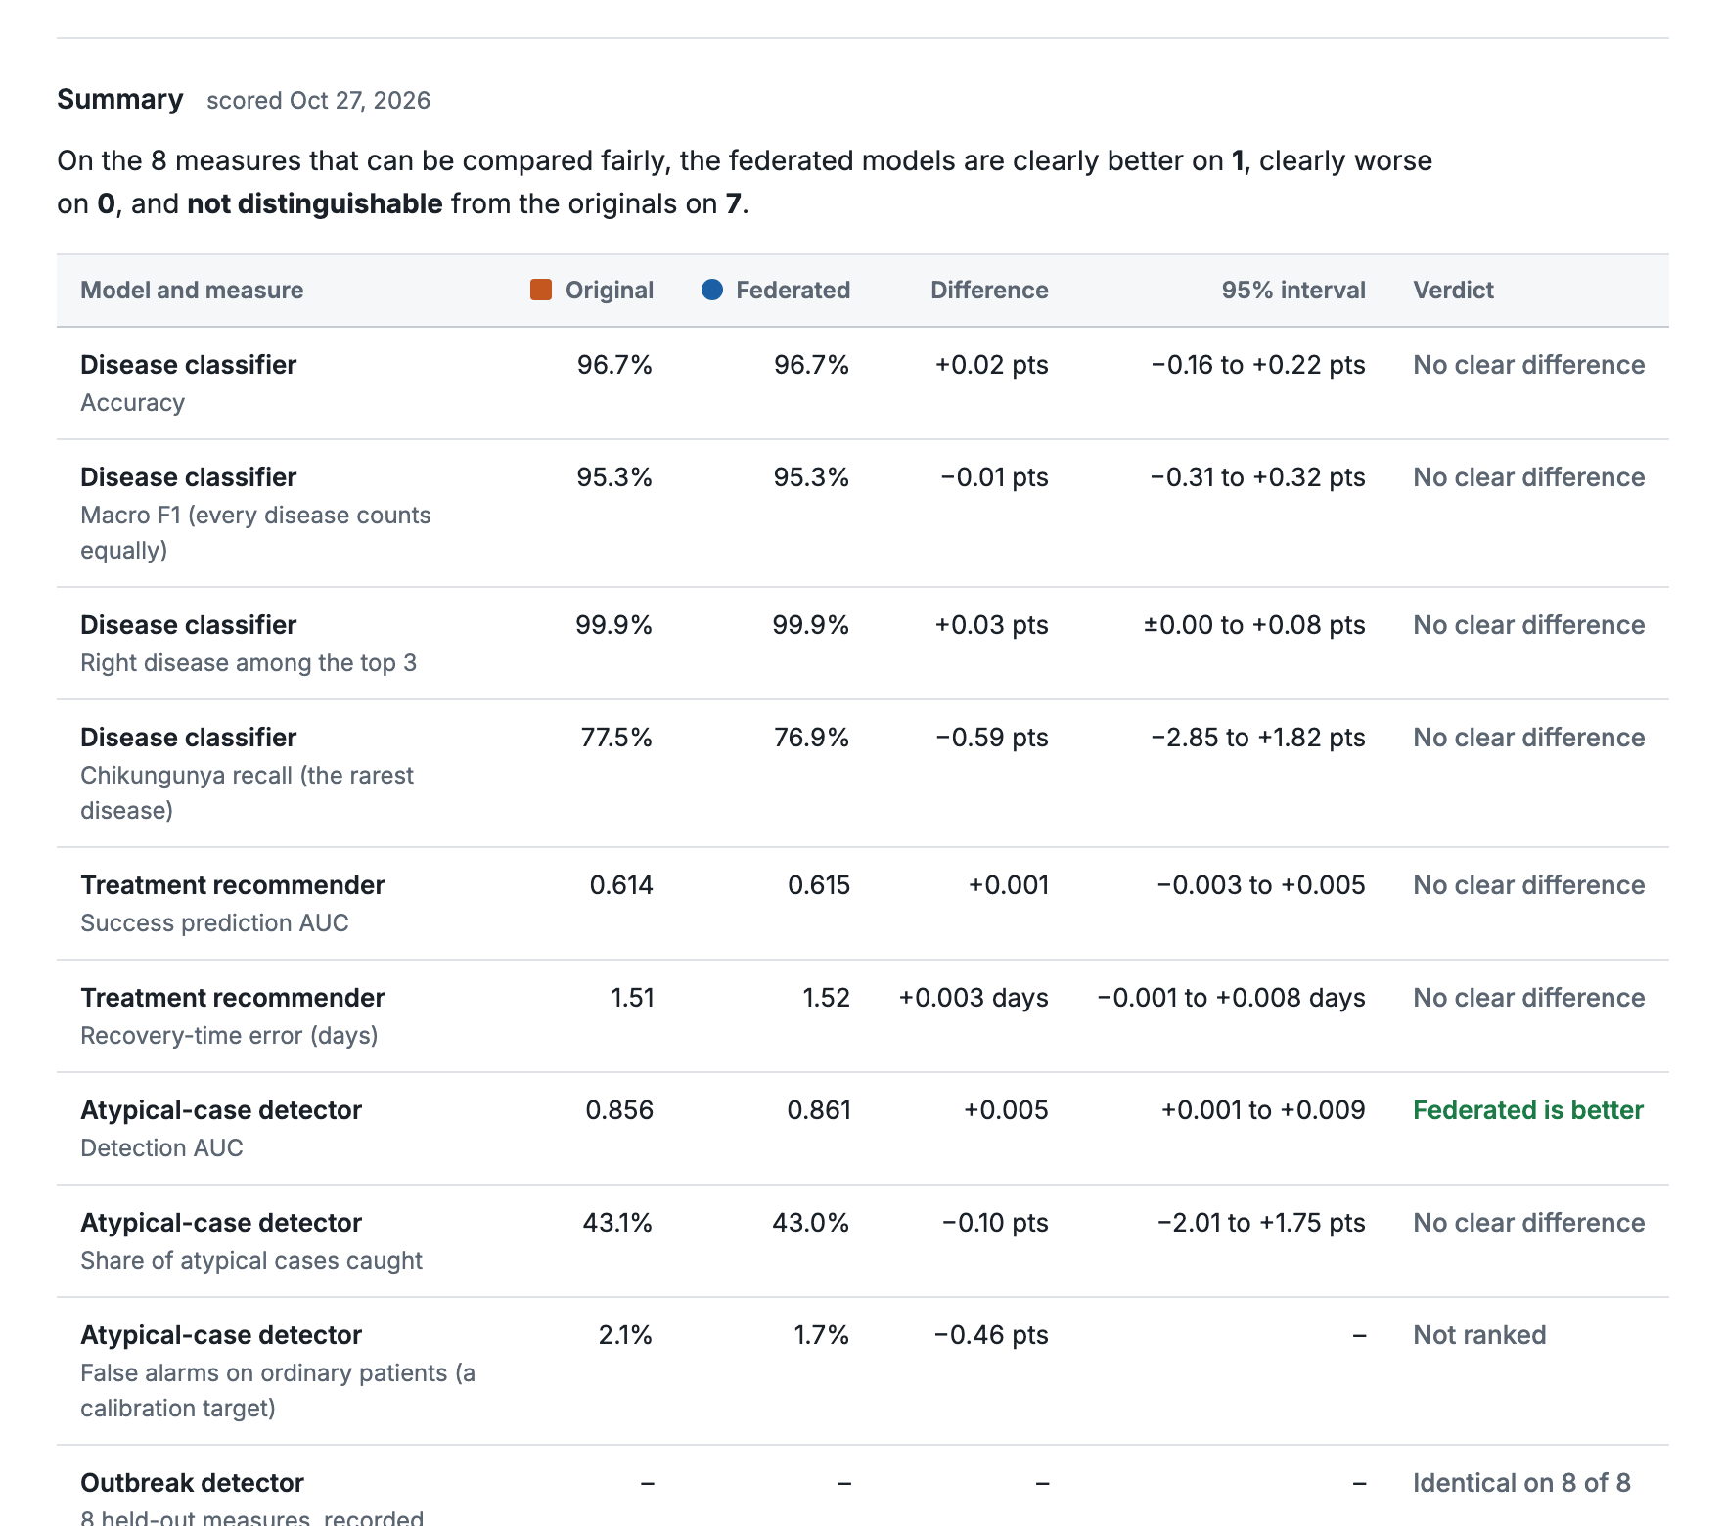
Figure 6.1: The Model comparison view of the web application (screen capture of the running app, 27 October 2026, showing the summary table).
Status of the Federated learning view
A second view, Federated learning (frontend/federated.js, the federated-view section of index.html, and GET /api/federated/overview), shows the hospitals, what travels, the three-way results, the training replay and what is protected. It is still in the page markup and the API answers (with the API key). However, the current sidebar has no link to it: when the running app was opened at #federated on 27 October it displayed the patient-assessment page. The front-end files are among those modified and not yet committed, so this looks like a side effect of the sidebar redesign. Restoring a navigation entry that calls window.carepathTabs.register("federated", ...) should bring it back. The numbers in this report come from the report files, not from that view.

6.4 Security Demonstration
check-security prints one PASS or FAIL line for each of six checks. The recorded final run passed all six; the first version of the script had two false passes (one caused by a port clash and one by an OR condition that was always true) and was rewritten so that each refusal has independent evidence.
Table 6.1: Checks made by check-security
Check | What it proves
A registered hospital connects over TLS | The positive path works, so the later refusals are not caused by a broken setup
An unregistered key is refused | Node authentication is enforced; the node started, tried to connect and was refused for the stated reason, and the number of online nodes did not grow
Control: the same key connects once registered | Registration was the only difference between the refused and accepted node
The SuperLink does not answer plaintext HTTP on its Fleet port | The server side is TLS only
A SuperNode refuses to authenticate over plaintext | The client side will not send its key without TLS (the node exits with an error saying a secure TLS connection is required)
A node that does not trust the SuperLink's CA does not connect | The CA actually matters; a certificate from another CA is not accepted

7. RESULT AND DISCUSSION (COST ANALYSIS)
All results are on the held-out test split, weighted over hospitals unless stated, and all come from the files report.json and comparison.json written by the code. The data are synthetic. Differences between a federated model and the pooled or original model are small relative to the noise of a single test set, so the intervals of Section 7.5 should be read before the point values.

7.1 Disease Classifier (E1)
Table 7.1: Disease classifier, per hospital (test split)
Hospital | Test rows | Alone acc. % | Federated acc. % | Pooled acc. % | Fed - alone (pt) | D003 recall alone % | D003 recall fed. %
H001 | 1,792 | 95.70 | 96.60 | 96.43 | 0.89 | 77.4 | 77.4
H002 | 1,446 | 96.54 | 97.65 | 97.17 | 1.11 | 88.0 | 96.0
H003 | 1,730 | 95.55 | 96.19 | 95.84 | 0.64 | 58.9 | 60.7
H004 | 1,518 | 95.78 | 96.84 | 96.71 | 1.05 | 73.6 | 79.2
H005 | 1,597 | 95.80 | 96.37 | 96.12 | 0.56 | 55.0 | 80.0
H006 | 1,171 | 95.82 | 96.67 | 96.41 | 0.85 | 69.8 | 81.4
H007 | 1,118 | 95.80 | 97.14 | 97.32 | 1.34 | 93.8 | 100.0
H008 | 1,199 | 94.75 | 96.33 | 96.08 | 1.58 | 53.3 | 68.9
H009 | 988 | 95.65 | 96.56 | 96.36 | 0.91 | 55.6 | 70.4
H010 | 1,596 | 96.87 | 97.12 | 96.74 | 0.25 | 68.2 | 86.4
All | 14,155 | 95.85 | 96.74 | 96.50 | 0.88 | 69.3 | 79.7

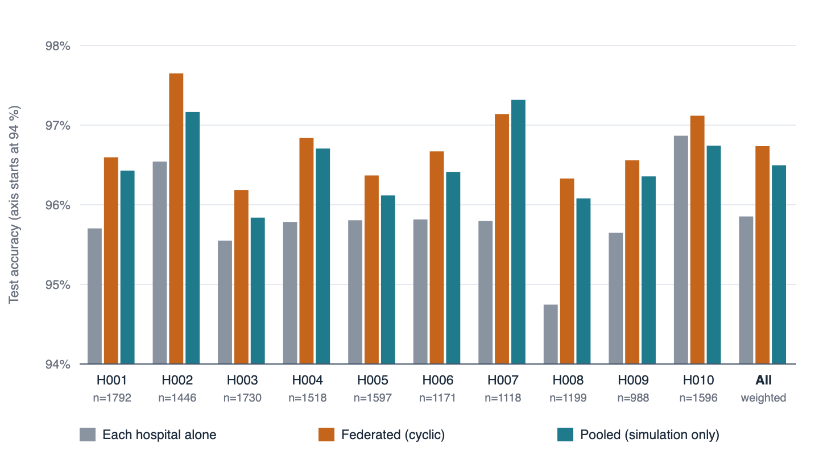
Figure 7.1: Test accuracy of the disease classifier per hospital: each hospital alone, federated, and pooled (simulation only). The vertical axis starts at 94%.
Federated training beats each hospital training alone at all ten hospitals on accuracy (96.74% against 95.85% weighted, a gain of 0.88 points) and is slightly above the pooled simulation (96.50%), which has a third of the trees. Macro F1 rises from 0.9403 to 0.9536 and top-3 accuracy from 99.70% to 99.90%. The largest gain is at H008 (1.58 points) and the smallest at H010 (0.25 points).
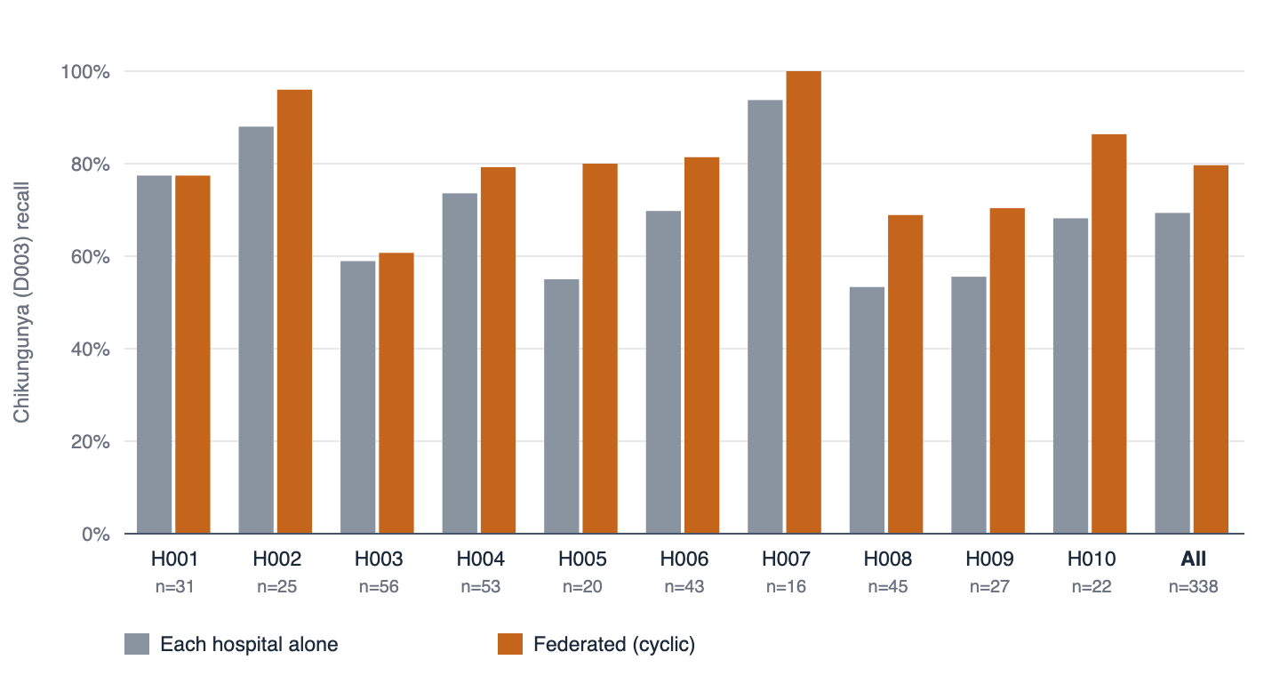
Figure 7.2: Recall for chikungunya (D003), the rarest disease, per hospital. The number of test cases is shown under each hospital; per-hospital values rest on 16 to 56 cases and are noisy.
The rarest disease shows the benefit most clearly. Weighted recall for chikungunya is 0.797 federated against 0.693 alone and 0.718 pooled, and the federated model is better than the lone model at 9 of 10 hospitals. The pooled simulation is itself below the federated model on this measure, which is a reminder that a number resting on a few dozen cases at each hospital moves with the random hospital order and the number of trees. Against the production original the difference is not distinguishable (Section 7.5).

7.2 Treatment Recommender (E2)
Table 7.2: Treatment recommender, per hospital: success AUC and recovery MAE (days)
Hospital | AUC alone | AUC fed. | AUC pooled | MAE alone (d) | MAE fed. (d) | MAE pooled (d)
H001 | 0.5956 | 0.5983 | 0.5972 | 1.512 | 1.497 | 1.483
H002 | 0.5957 | 0.6126 | 0.6101 | 1.575 | 1.546 | 1.546
H003 | 0.6252 | 0.6354 | 0.6303 | 1.538 | 1.511 | 1.503
H004 | 0.6196 | 0.6395 | 0.6325 | 1.598 | 1.554 | 1.559
H005 | 0.6065 | 0.6050 | 0.6040 | 1.536 | 1.521 | 1.511
H006 | 0.5853 | 0.5954 | 0.5985 | 1.531 | 1.496 | 1.497
H007 | 0.5678 | 0.5868 | 0.5844 | 1.544 | 1.516 | 1.514
H008 | 0.6310 | 0.6458 | 0.6635 | 1.525 | 1.516 | 1.509
H009 | 0.6137 | 0.6462 | 0.6490 | 1.594 | 1.535 | 1.531
H010 | 0.5996 | 0.5931 | 0.6014 | 1.521 | 1.492 | 1.491
All | 0.6047 | 0.6151 | 0.6159 | 1.545 | 1.518 | 1.513

Federated success AUC is 0.6151 against 0.6047 alone and 0.6159 pooled; recovery error is 1.518 days against 1.545 alone and 1.513 pooled. Brier score (0.1830 against 0.1849) and log-loss (0.5507 against 0.5553) improve as well. The federated model improves recovery error at 10 of 10 hospitals and success AUC at 8 of 10.
Do not oversell this task
The treatment signal in the data is weak: an AUC of about 0.61 for every model, original, alone, pooled or federated. A 0.01 AUC gain is a gain on a weak signal, and per-hospital AUCs are noisy. The task shows that the federated recommender is as good as the pooled one, not that treatment success is well predicted.

7.3 Atypical-Presentation Detector (A)
Table 7.3: Atypical-presentation detector, per hospital
Hospital | AUC alone | AUC fed. | AUC pooled | Recall alone | Recall fed. | Recall pooled
H001 | 0.833 | 0.856 | 0.848 | 0.357 | 0.421 | 0.400
H002 | 0.849 | 0.861 | 0.857 | 0.432 | 0.411 | 0.400
H003 | 0.823 | 0.832 | 0.830 | 0.337 | 0.386 | 0.396
H004 | 0.868 | 0.891 | 0.887 | 0.417 | 0.524 | 0.515
H005 | 0.840 | 0.848 | 0.849 | 0.327 | 0.346 | 0.327
H006 | 0.885 | 0.888 | 0.893 | 0.565 | 0.536 | 0.507
H007 | 0.803 | 0.819 | 0.814 | 0.403 | 0.375 | 0.347
H008 | 0.867 | 0.860 | 0.859 | 0.383 | 0.404 | 0.394
H009 | 0.841 | 0.853 | 0.857 | 0.448 | 0.493 | 0.478
H010 | 0.857 | 0.893 | 0.883 | 0.376 | 0.444 | 0.427
All | 0.846 | 0.860 | 0.858 | 0.397 | 0.430 | 0.416

Detection AUC is 0.860 federated against 0.846 alone and 0.858 pooled, better than a lone hospital at 9 of 10. Precision rises from 0.579 to 0.651 and recall from 0.397 to 0.430, with a lower measured false-alarm rate (1.66% against 2.15%). The federated detector is slightly above the pooled simulation. A likely explanation, which was not tested, is that the federated fit differs from the pooled fit only in how the calibration slice is carved (15% of each hospital rather than 15% of the pooled rows) and in the histogram quantiles, and both move the thresholds slightly. The test confirms that the statistics that are sums equal the pooled values exactly, so this is not evidence that federation improves a detector in general.

7.4 Outbreak Detector (B)
Table 7.4: Outbreak detector, held-out period
Measure (held-out, 1 Oct to 30 Dec 2025, 91 days) | Federated | Centralised
Labelled outbreaks in the period | 21 | 21
... that spread between hospitals ("linked") | 14 | 14
Outbreaks with a site signal | 71.4% | 71.4%
All outbreaks alerted | 38.1% | 38.1%
Linked outbreaks alerted | 42.9% | 42.9%
Median delay to alert (days) | 8 | 8
Notifications sent | 4 | 4
Notifications that were correct | 75% | 75%
False notifications per year | 4.0 | 4.0
Novel-disease alert days per year | 0.0 | 0.0

Every recorded measure is identical to the centralised pipeline. That is the expected result and the intended one: the detector works on count summaries, the federated and centralised summaries are equal by test, and the thresholds calibrated on them are equal. The detection quality itself is modest (a median delay of 8 days; 43% of linked outbreaks alerted), and with 21 labelled outbreaks in the test period the numbers are weak evidence in either direction. Two further limits apply. The possible-novel path is validated only for false alarms (the generator injects no novel pathogen). The local atypical detector was fitted on a random split that includes the months of the outbreak test period, so for the ATYP path the test is not strictly out of time.

7.5 Federated against the Original Models
The comparison that matters for a deployment is against the model that exists today, trained on pooled data. Figure 7.3 shows the difference between the federated and original models with its 95% paired-bootstrap interval for seven measures; Table 7.5 lists all eight with the recovery error.
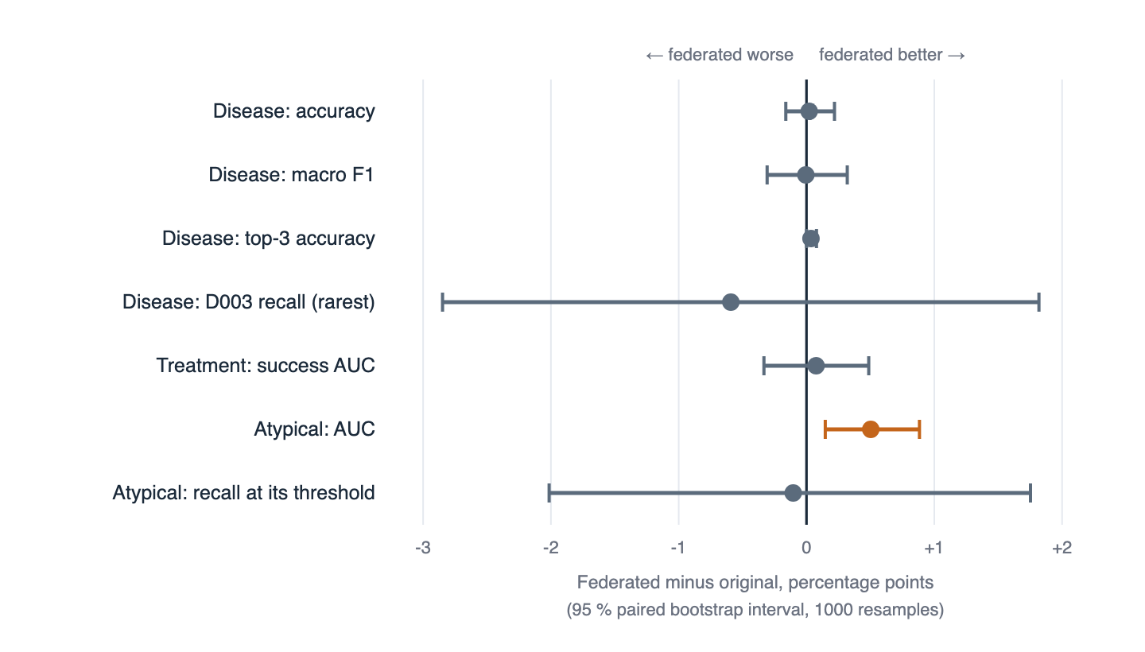
Figure 7.3: Federated minus original, in percentage points, with 95% paired-bootstrap intervals (1,000 resamples) on 14,155 held-out patients. Orange marks the one interval that excludes zero.
Table 7.5: Federated vs original on the same held-out patients
Measure | Original | Federated | Difference | 95% interval | Verdict
Disease: accuracy | 96.71% | 96.74% | +0.02 pt | -0.16 pt to +0.22 pt | no clear difference
Disease: macro F1 | 95.27% | 95.27% | -0.01 pt | -0.31 pt to +0.32 pt | no clear difference
Disease: top-3 accuracy | 99.87% | 99.90% | +0.03 pt | 0.00 pt to +0.08 pt | no clear difference
Disease: D003 recall | 77.52% | 76.92% | -0.59 pt | -2.85 pt to +1.82 pt | no clear difference
Treatment: success AUC | 0.6142 | 0.6150 | +0.0008 | -0.0033 to +0.0049 | no clear difference
Treatment: recovery MAE | 1.5145 d | 1.5177 d | +0.0033 d | -0.0009 d to +0.0075 d | no clear difference
Atypical: AUC | 0.8559 | 0.8609 | +0.0050 | +0.0015 to +0.0088 | better
Atypical: recall | 43.14% | 43.04% | -0.10 pt | -2.01 pt to +1.75 pt | no clear difference

On seven of the eight testable measures the federated model is not distinguishable from the original. On atypical-case AUC the federated detector is better by 0.005 (interval +0.001 to +0.009). The false-alarm rate of the atypical detector is shown but not ranked, because each detector sets its own threshold to a calibration target. The size differences are large: the federated disease model has 300 iterations in 7.01 MB, the original 347 in 14.65 MB; the treatment files are 0.63 MB against 1.21 MB.
The honest reading
The result is parity, not improvement. The earlier gains in this chapter are against each hospital training alone. Against the pooled original the federated models are as good, within the noise of a 14,155-patient test set, and that is the claim the project can support: not pooling the data cost no measurable accuracy.
Eight measures were compared with intervals that each exclude zero only 5% of the time by chance, so the single better result (atypical AUC) should be confirmed on another test set before being relied on.

7.6 Training Dynamics
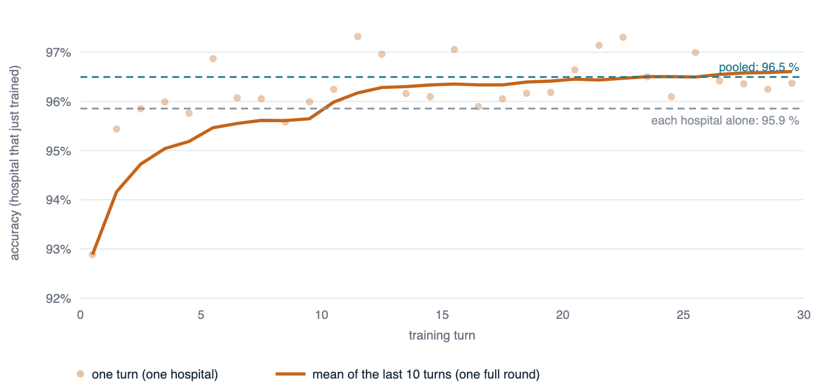
Figure 7.4: Disease model: accuracy of the shared model on the hospital that has just trained, after each of the 30 turns. Dots are single turns, which zigzag with the difficulty of the hospital; the line is the mean over the last ten turns, one full round of hospitals.
The first turn gives 92.9% (the first hospital, H004, trained alone on 10 trees). The rolling mean passes the lone-hospital level of 95.9% after about ten turns, one full round, and reaches the pooled level of 96.5% at about turn 25. The mean accuracy over turns 1 to 10, 11 to 20 and 21 to 30 is 95.65%, 96.41% and 96.61%. Most of the benefit therefore arrives in the first two rounds, and the third adds little, which is why 30 turns were enough.
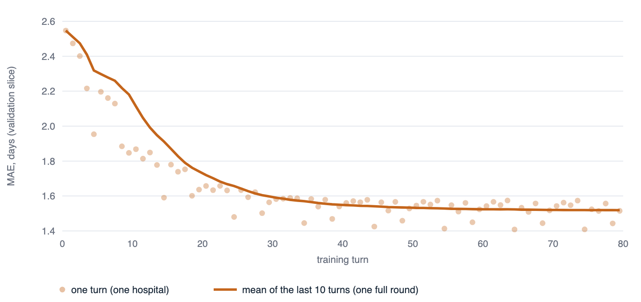
Figure 7.5: Treatment model: recovery-days error (MAE) on each hospital's own validation slice after each of the 80 turns, with the mean of the last ten turns.
The recovery error falls from 2.55 days at the first turn to 1.52 at the 80th and flattens between turn 40 and turn 50. The success model stops growing at 60 iterations (turn 30), after which its validation AUC is constant at 0.625; the cap was set because the success model overfits beyond that.

7.7 Security Verification
The security results are the checks of Section 6.4 and the eleven identity tests of Section 5.2. They show that, in the single-machine deployment, an unauthenticated peer, a plaintext connection, an untrusted certificate, a forged hospital claim, a duplicate answer and a missing hospital in a pooled stage are all refused, and that the same key connects once it is registered. They do not show resistance to a malicious but authenticated hospital submitting poisoned statistics, to collusion, or to leakage through the shared model; none of these was tested or defended.

7.8 Communication, Compute and Cost
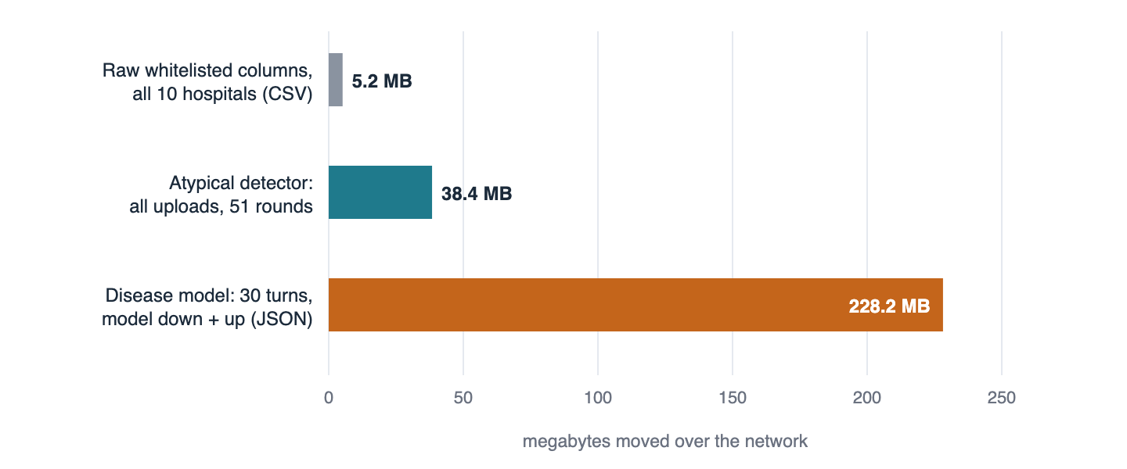
Figure 7.6: Network volume of federated training compared with the raw columns it keeps in place. Disease: model sent down and up at each of 30 turns, in XGBoost JSON. Atypical: all uploads over 51 stage calls.
Table 7.6: Communication volume per task (measured by serialising the same objects the app sends)
Task | Mechanism | Network volume | Per hospital | Model or output size
disease | Cyclic; the whole model goes down and back up each turn | 228.2 MB (110.6 down, 117.6 up) | about 22.8 MB (average) | 7.01 MB
treatment | Cyclic; two models per turn, 80 turns | 63.3 MB | about 6.3 MB (average) | 0.63 MB (0.17 + 0.46)
atypical | 51 stage calls; 45 EM rounds of 8.4 KB; 3.1 MB of histograms | 38.4 MB uploaded | 3.84 MB | 0.05 MB
outbreak | One stage; day x disease counts and episodes | 8.0 MB uploaded | 0.80 MB | < 0.1 MB

The disease federation moves 228.2 MB, 44 times the 5.2 MB of whitelisted raw columns that a pooled training would need to copy. The reason is structural. In cyclic training the whole model travels in both directions at every turn, and the model grows by about 23.4 KB per boosting iteration in JSON, so the total traffic grows with the square of the number of turns. The statistics-based tasks are far cheaper and independent of the number of rows: the atypical detector sends 3.84 MB per hospital whether the hospital has 4,000 or 40,000 rows, and the outbreak detector 0.8 MB.
Federation therefore trades bandwidth for the legal and operational ability not to move rows. One full retraining of all four tasks moves about 337.9 MB across ten hospitals (uploads only for the atypical and outbreak tasks), about 34 MB per hospital. That is small for a hospital network. Compute is smaller still: a 10-tree turn takes 0.12 s, a full simulated disease run about 42 s, and the atypical protocol 48 s. The larger costs are human ones: provisioning a SuperNode, key and certificate management, and scheduling, which this project did not measure. Section 3.2.2 lists the cost items; staff time and money figures need inputs from the institutions.
Three cheap reductions are available and were not implemented: send the XGBoost model in its binary format rather than JSON (the disease model file is 7.0 MB in JSON), upload only the trees added in a turn instead of the whole model (the server already holds the rest), which would at most halve the traffic, and cap the number of turns, since most of the gain arrives in the first two rounds.

7.9 Who Benefits Most
Table 7.7: The three smallest hospitals, disease classifier
Hospital | Train rows | Accuracy alone % | Accuracy fed. % | D003 recall alone % | D003 recall fed. %
H009 | 3,924 | 95.65 | 96.56 | 55.6 | 70.4
H007 | 4,367 | 95.80 | 97.14 | 93.8 | 100.0
H006 | 4,719 | 95.82 | 96.67 | 69.8 | 81.4

The three smallest hospitals (H009, H007, H006) all gain on both accuracy and chikungunya recall. Across the ten hospitals, the correlation between training-set size and the accuracy gain from federation is r = -0.54 (n = 10). With ten points a correlation must exceed 0.63 in magnitude to reach the 5% level, so the size of a hospital is not a statistically reliable predictor of how much it gains. The more reliable observation is the direct one: every hospital gains on accuracy, and the gain in chikungunya recall runs from 0.0 points at H001 to +25.0 points at H005, each on a few dozen test cases.

7.10 Threats to Validity and Limitations
- Synthetic data. The encounters come from a generator written by the same team. The structure the models learn is the structure the generator put there. The results show that the machinery works; they say nothing about clinical accuracy.
- Random split. The test set comes from the same distribution as training at every hospital. Generalisation to a new hospital or a later period was not tested.
- Selection on the test split. The disease turns and iterations were chosen after seeing test results, so the disease accuracy is slightly optimistic. The comparison tab and README say so.
- Unequal model sizes. The federated disease model has three times the trees of the pooled baseline and a smaller file than the original (early stopping chose 347 iterations for the original). A difference may come from size as well as from how the model was trained.
- A weak treatment signal (AUC about 0.61) makes that task a poor discriminator between methods.
- A small outbreak test (21 events) and an atypical detector fitted on a random split that includes the outbreak test months.
- Multiple comparisons. Eight measures were compared; the single better result should be confirmed.
- Random hospital order. Cyclic results move between runs (96.55% to 96.74% over six disease runs). A single run is one draw.
- Privacy. There is no differential privacy or secure aggregation; the shared tree model carries splits learned from earlier hospitals; small daily counts can identify individuals.
- Web-layer authentication. Outside the Flower trust layer, the web API still uses one shared key. In the code reviewed for this report, POST /api/treatment/recommend has no API-key requirement (its sibling /recommend-treatment does) and POST /api/outbreak/summaries accepts the hospital id from the request body behind that one shared key, so a holder of the key can submit counts as any hospital. Per-hospital tokens for the web back end were listed as not done in the plan.
- Identity on every cyclic turn. The registry is applied to the connected nodes before cyclic training, not to each turn's reply (Section 4.1).
- Deployment. The deployment runs ten processes on one machine with prototype credentials. Network faults, stragglers and dropout were not tested; cyclic training waits for each hospital in turn.
- Navigation. The Federated learning view is not linked from the current sidebar (Section 6.3).

7.11 Assessment of the Novelty Claims
Table 7.8 returns to the claims of the opening Table 1 and states what the evidence in this chapter supports.
Table 7.8: Novelty claims, evidence and what would strengthen them
Claim | What the evidence supports | What would strengthen it
N1 one protocol, four paradigms | Shown: one ClientApp and ServerApp, four task modules, all four trained and exported, 62 tests. | A fifth, different task added without changing the apps would show the contract is general.
N2 exact federated atypicality detector | Shown: sums equal; EM matches scikit-learn; AUC +0.005 vs original (CI excludes zero). | Confirmation on another synthetic seed or real data; the +0.005 is small.
N3 multi-class boosting with frozen schema | Shown: 8-class federated model equal to the original within the interval; bagging comparison from a 5-seed spike (kept outside the repository). | Keep the spike as a script in the repository and test other class counts.
N4 counts-only outbreak federation | Shown: equality with the centralised pipeline on identical inputs. | A larger test period or more outbreaks; real surveillance data.
N5 retrofit by contract | Shown: unmodified production code; drop-in exports; guard tests. | Run the guard tests in continuous integration.
N6 layered trust | Shown in a single-machine deployment, with a control. | A multi-machine run; secure aggregation; per-reply checks in the cyclic strategy; per-hospital web tokens.
N7 evaluation as a deliverable | Shown: three baselines, per-hospital results, paired intervals, verdicts, originals re-checked. | Hospital-held-out and time-held-out splits.
N8 non-IID benchmark | Shown: measurable label skew (mean total-variation distance 0.111). | Skew in features and in outcomes, not only in disease mix.

8. CONCLUSION
This report described the federated learning layer of CarePath and argued for its novelty on specific, checkable grounds. Federated learning as such is established. The contribution is a working federation in which four models of different kinds, a multi-class gradient-boosted disease classifier, a two-headed boosted treatment recommender, a label-free generative atypicality detector and a cross-hospital outbreak detector, are trained across ten hospitals behind one Flower app and one task contract; in which each model is federated in the way its mathematics allows, by cyclic boosting, by exact sufficient statistics with distributed EM and histogram sketches, or by counts-only summaries; in which the existing production code is reused unmodified and the exports are drop-in files; in which every hospital is authenticated and every reply is bound to its sender; and in which the evidence for equivalence with pooled training is produced by the code, per hospital and with paired intervals, rather than asserted.
The results support three statements. First, federation helps every hospital relative to training alone: disease accuracy 96.74% against 95.85%, with the gain at all ten hospitals, and rare-disease recall 0.797 against 0.693. Second, against the centrally trained originals the federated models are statistically indistinguishable on seven of eight testable measures and better on one (atypical-case AUC, +0.005), so not pooling the data cost no measurable accuracy on this data. Third, the price is bandwidth, not accuracy: one disease training moves about 228 MB, 44 times the raw columns it keeps in place, while the statistics-based tasks move a few megabytes per hospital.
The results do not support three things the project could be mistaken for. They do not show that federation makes models more accurate than pooling, because the originals are matched, not beaten. They do not show clinical performance, because the data are synthetic and the split is random within hospitals. And they do not show that the system is private against a determined observer, because there is no differential privacy or secure aggregation and the shared model carries information from earlier hospitals.

8.1 Future Work
Table 8.1: Future work
# | Item | Why it matters
1 | Differential privacy and secure aggregation on top of the same strategies | Closes the largest stated gap; the plan left both out by decision
2 | Per-reply identity binding in the cyclic strategy; per-hospital tokens for the web back end; authentication for POST /api/treatment/recommend; hospital id taken from the authenticated caller in POST /api/outbreak/summaries | The trust layer should cover every path that carries hospital data or a prediction
3 | A multi-machine deployment with the institution's own PKI | Tests network faults, stragglers and dropout, which a single machine cannot
4 | Hospital-held-out and time-held-out evaluation, and real data under governance approval | Moves the evidence from "fits the federation" to "generalises"
5 | Reduce traffic: binary model format, upload only the new trees, cap the turns | The 44-fold overhead is the main practical cost
6 | A retraining scheduler, a promotion step with the guard tests in continuous integration | Turns the layer from an experiment into a maintained pipeline
7 | Personalised or clustered federation for the two hospital groups (north urban, tropical coastal) | Label skew is measurable; one shared model may not be optimal for both groups
8 | Contribute a multi-class bagging merge to Flower, and keep the Phase 0 spike as a script in the repository | Makes the strategy comparison reproducible and reusable
9 | Restore the sidebar link to the Federated learning view | The view exists in the page and API but is currently unreachable from the navigation

9. REFERENCES
[1] B. McMahan, E. Moore, D. Ramage, S. Hampson and B. A. y Arcas, "Communication-efficient learning of deep networks from decentralized data," in Proc. 20th Int. Conf. Artificial Intelligence and Statistics (AISTATS), PMLR vol. 54, 2017.
[2] P. Kairouz et al., "Advances and open problems in federated learning," Foundations and Trends in Machine Learning, vol. 14, no. 1-2, pp. 1-210, 2021.
[3] T. Li, A. K. Sahu, A. Talwalkar and V. Smith, "Federated learning: challenges, methods, and future directions," IEEE Signal Processing Magazine, vol. 37, no. 3, pp. 50-60, 2020.
[4] N. Rieke et al., "The future of digital health with federated learning," npj Digital Medicine, vol. 3, art. 119, 2020.
[5] D. J. Beutel et al., "Flower: A friendly federated learning research framework," arXiv:2007.14390, 2020.
[6] T. Chen and C. Guestrin, "XGBoost: A scalable tree boosting system," in Proc. 22nd ACM SIGKDD Int. Conf. Knowledge Discovery and Data Mining, 2016, pp. 785-794.
[7] Q. Li, Z. Wen and B. He, "Practical federated gradient boosting decision trees," in Proc. AAAI Conf. Artificial Intelligence, vol. 34, 2020.
[8] K. Cheng, T. Fan, Y. Jin, Y. Liu, T. Chen, D. Papadopoulos and Q. Yang, "SecureBoost: A lossless federated learning framework," IEEE Intelligent Systems, vol. 36, no. 6, 2021.
[9] Y. Liu et al., "Federated Forest," IEEE Transactions on Big Data, vol. 8, no. 3, 2022.
[10] K. Chang et al., "Distributed deep learning networks among institutions for medical imaging," Journal of the American Medical Informatics Association, vol. 25, no. 8, pp. 945-954, 2018.
[11] M. J. Sheller et al., "Federated learning in medicine: facilitating multi-institutional collaborations without sharing patient data," Scientific Reports, vol. 10, art. 12598, 2020.
[12] I. Dayan et al., "Federated learning for predicting clinical outcomes in patients with COVID-19," Nature Medicine, vol. 27, pp. 1735-1743, 2021.
[13] Y. Zhao, M. Li, L. Lai, N. Suda, D. Civin and V. Chandra, "Federated learning with non-IID data," arXiv:1806.00582, 2018.
[14] T.-M. H. Hsu, H. Qi and M. Brown, "Measuring the effects of non-identical data distribution for federated visual classification," arXiv:1909.06335, 2019.
[15] K. Bonawitz et al., "Practical secure aggregation for privacy-preserving machine learning," in Proc. ACM SIGSAC Conf. Computer and Communications Security (CCS), 2017.
[16] C. Dwork and A. Roth, "The algorithmic foundations of differential privacy," Foundations and Trends in Theoretical Computer Science, vol. 9, no. 3-4, pp. 211-407, 2014.
[17] L. Zhu, Z. Liu and S. Han, "Deep leakage from gradients," in Advances in Neural Information Processing Systems (NeurIPS), vol. 32, 2019.
[18] A. P. Dempster, N. M. Laird and D. B. Rubin, "Maximum likelihood from incomplete data via the EM algorithm," Journal of the Royal Statistical Society, Series B, vol. 39, no. 1, pp. 1-38, 1977.
[19] R. D. Nowak, "Distributed EM algorithms for density estimation and clustering in sensor networks," IEEE Transactions on Signal Processing, vol. 51, no. 8, pp. 2245-2253, 2003.
[20] Y. Ben-Haim and E. Tom-Tov, "A streaming parallel decision tree algorithm," Journal of Machine Learning Research, vol. 11, pp. 849-872, 2010.
[21] M. Greenwald and S. Khanna, "Space-efficient online computation of quantile summaries," in Proc. ACM SIGMOD Int. Conf. Management of Data, 2001.
[22] C. Leys, C. Ley, O. Klein, P. Bernard and L. Licata, "Detecting outliers: Do not use standard deviation around the mean, use absolute deviation around the median," Journal of Experimental Social Psychology, vol. 49, no. 4, pp. 764-766, 2013.
[23] C. P. Farrington, N. J. Andrews, A. D. Beale and M. A. Catchpole, "A statistical algorithm for the early detection of outbreaks of infectious disease," Journal of the Royal Statistical Society, Series A, vol. 159, no. 3, pp. 547-563, 1996.
[24] M. Kulldorff, "A spatial scan statistic," Communications in Statistics - Theory and Methods, vol. 26, no. 6, pp. 1481-1496, 1997.
[25] T. S. Brisimi, R. Chen, T. Mela, A. Olshevsky, I. C. Paschalidis and W. Shi, "Federated learning of predictive models from federated electronic health records," International Journal of Medical Informatics, vol. 112, pp. 59-67, 2018.
[26] V. Chandola, A. Banerjee and V. Kumar, "Anomaly detection: A survey," ACM Computing Surveys, vol. 41, no. 3, art. 15, 2009.
[27] Government of India, "The Digital Personal Data Protection Act, 2023," Act No. 22 of 2023.
[28] B. Efron and R. J. Tibshirani, An Introduction to the Bootstrap. New York: Chapman and Hall, 1993.
[29] Flower documentation, "Quickstart XGBoost," https://flower.ai/docs/framework/tutorial-quickstart-xgboost.html (accessed October 2026).
[30] Flower documentation, "Authenticate SuperNodes," https://flower.ai/docs/framework/how-to-authenticate-supernodes.html (accessed October 2026).
[31] R. Shokri, M. Stronati, C. Song and V. Shmatikov, "Membership inference attacks against machine learning models," in Proc. IEEE Symposium on Security and Privacy, 2017.
Note on the references
The references were written from the author's knowledge of the literature and were not checked against the publishers' pages while this report was prepared. Volume, page and year details should be verified before submission. References [29] and [30] are the Flower pages cited in the project plan.

APPENDIX A - SAMPLE CODE
The excerpts below are copied from the repository (line numbers refer to the files as of 27 October 2026). They are the parts that carry the novelty: the coordinator, the hospital-side handlers, one cyclic turn, the identity check, one federated EM step, and the bootstrap.
A.1 Coordinator: strategy or stage protocol, then export (models/objectiveC/carepath_fl/server_app.py, lines 78-108)
@app.main()
def main(grid: Grid, context: Context) -> None:
cfg = context.run_config
task_name = str(cfg["task"])
task = get_task(task_name)

if hasattr(task, "run_protocol"): # statistics-based task, no boosting turns
params, info = task.run_protocol(stage_caller(grid, task_name))
if cfg.get("save-model", True):
print(f"[export] federated {task_name} model written to {task.write_model(params, info)}")
return

# 0 = use the task's own default
turns = int(cfg["num-server-rounds"]) or task.DEFAULT_TURNS
local_iters = int(cfg["local-iters"]) or task.DEFAULT_LOCAL_ITERS

registry = NodeRegistry.from_env()
if registry:
registry.check_connected(grid.get_node_ids())
reference = collect_reference(grid, task, task_name) if hasattr(task, "local_query") else None

# Each model is created by the first hospital's turn; the server starts from empty ones.
strategy = FedXgbCyclic(fraction_train=1.0, fraction_evaluate=1.0)
result = strategy.start(
grid=grid, initial_arrays=pack({name: b"" for name in task.MODELS}), num_rounds=turns,
train_config=ConfigRecord({"task": task_name, "local-iters": local_iters}),
evaluate_config=ConfigRecord({"task": task_name}))

if cfg.get("save-model", True):
out = task.write_model(unpack(result.arrays), {"turns": turns, "local_iters": local_iters,
"history": turn_history(result)}, reference)

A.2 Hospital: train and evaluate handlers (models/objectiveC/carepath_fl/client_app.py, lines 24-48)
@app.train()
def train(msg: Message, context: Context) -> Message:
cfg = msg.content["config"]
task = get_task(cfg["task"])
if hasattr(task, "client_stage"): # statistics-based task: return summaries for this stage
rows = _rows(context, task, getattr(task, "STAGE_SPLIT", "train"))
stats = task.client_stage(str(cfg["stage"]), json.loads(cfg["state"]), rows)
return Message(content=RecordDict({"arrays": pack_arrays(stats)}), reply_to=msg)
df = task.fit_rows(_rows(context, task, "train"))

# Different seed per turn, so subsampling differs between a hospital's turns.
models, n = task.local_train(unpack(msg.content["arrays"]), df, int(cfg["local-iters"]),
seed=int(cfg["server-round"]))

# hospital-number only labels whose turn it was in the recorded training history (an id, not data)
metrics = MetricRecord({"num-examples": n, "hospital-number": int(_hospital(context)[1:])})
return Message(content=RecordDict({"arrays": pack(models), "metrics": metrics}), reply_to=msg)

@app.evaluate()
def evaluate(msg: Message, context: Context) -> Message:
task = get_task(msg.content["config"]["task"])
df = task.eval_rows(_rows(context, task, task.EVAL_SPLIT, evaluation=True))
metrics = task.local_evaluate(unpack(msg.content["arrays"]), df)
return Message(content=RecordDict({"metrics": MetricRecord(metrics)}), reply_to=msg)

A.3 One cyclic turn: add trees on top of the shared model (models/objectiveC/carepath_fl/tasks/disease.py, lines 82-100)
def booster_params(seed: int, nthread: int = 4) -> dict:
return {**XGB_PARAMS, "objective": "multi:softprob", "num_class": len(CLASSES),
"nthread": nthread, "seed": seed}

def load_booster(model_bytes: bytes) -> xgb.Booster | None:
if not model_bytes:
return None
booster = xgb.Booster()
booster.load_model(bytearray(model_bytes))
return booster

def local_train(models: dict[str, bytes], df, local_iters: int, seed: int) -> tuple[dict[str, bytes], int]:
"""Add `local_iters` boosting iterations on this hospital's rows on top of the shared model."""
dtrain = to_dmatrix(df)
booster = xgb.train(booster_params(seed), dtrain, num_boost_round=local_iters,
xgb_model=load_booster(models["model"]))
return {"model": bytes(booster.save_raw("json"))}, dtrain.num_row()

A.4 Binding a reply to the authenticated hospital (models/objectiveC/carepath_fl/common/identity.py, lines 59-72)
def check_reply(self, sender_node_id: int, claimed_hospital: str | None) -> str:
"""The hospital behind an authenticated sender; raises if the payload claims to be someone else."""
hospital = self.hospital_by_node.get(sender_node_id)
if hospital is None:
raise IdentityError(f"reply from unregistered node {sender_node_id}")
if claimed_hospital is not None and claimed_hospital != hospital:
raise IdentityError(f"node {sender_node_id} is {hospital} but its reply claims to be {claimed_hospital}")
return hospital

def check_replies(self, senders: list[int], claims: list[str | None]) -> list[str]:
hospitals = [self.check_reply(s, c) for s, c in zip(senders, claims)]
if len(set(hospitals)) != len(hospitals):
raise IdentityError("a hospital answered more than once in the same stage")
return hospitals

A.5 Distributed EM, hospital side: responsibility-weighted sums (models/objectiveC/carepath_fl/tasks/atypical.py, lines 150-168)
def _em(df: pd.DataFrame, gmm: dict) -> dict[str, np.ndarray]:
S, V, k = _arrays(df)
w, mu, cov = (np.asarray(gmm[x]) for x in ("weights", "means", "covs"))
p = len(VITALS)
out = {"nk": np.zeros((D, N_COMP)), "sx": np.zeros((D, N_COMP, p)), "sxx": np.zeros((D, N_COMP, p, p)),
"ll": np.zeros(D), "n": np.zeros(D)}
for d in range(D):
Vd = V[k == d]
Vd = Vd[~np.isnan(Vd).any(axis=1)]
if not len(Vd):
continue
logp = np.stack([np.log(w[d, j]) + multivariate_normal.logpdf(Vd, mean=mu[d, j], cov=cov[d, j], allow_singular=True)
for j in range(N_COMP)], axis=1)
ll = logsumexp(logp, axis=1)
resp = np.exp(logp - ll[:, None])
out["nk"][d], out["sx"][d] = resp.sum(axis=0), resp.T @ Vd
out["sxx"][d] = np.einsum("nk,ni,nj->kij", resp, Vd, Vd)
out["ll"][d], out["n"][d] = ll.sum(), len(Vd)
return out

A.6 Distributed EM, server side: the M-step (models/objectiveC/carepath_fl/tasks/atypical.py, lines 238-250)
prev_ll, iters = None, 0
for iters in range(1, EM_MAX_ITERS + 1):
parts = call("em", {"gmm": _listify({"weights": w, "means": mu, "covs": cov})})
nk = _sum(parts, "nk") + 10 * np.finfo(float).eps
sx, sxx = _sum(parts, "sx"), _sum(parts, "sxx")
w = nk / nk.sum(axis=1, keepdims=True)
mu = sx / nk[..., None]
cov = sxx / nk[..., None, None] - np.einsum("dki,dkj->dkij", mu, mu) + REG_COVAR * np.eye(p)
ll = _sum(parts, "ll") / _sum(parts, "n")
if prev_ll is not None and np.abs(ll - prev_ll).max() < EM_TOL:
break
prev_ll = ll
log(f"[atypical] vitals mixtures: {iters} EM rounds, mean log-likelihood/row {ll.mean():.3f}")

A.7 Histogram quantile sketch on the arcsinh grid (models/objectiveC/carepath_fl/tasks/atypical.py, lines 106-120)
def _hist(x) -> np.ndarray:
u = np.arcsinh(np.asarray(x, dtype=float))
idx = np.clip(((u + LIM) / _WIDTH).astype(int), 0, BINS - 1)
return np.bincount(idx, minlength=BINS).astype(np.int64)

def _quantile(counts: np.ndarray, q: float) -> float:
cum = np.cumsum(counts)
if cum[-1] == 0:
raise ValueError("cannot take a quantile of an empty histogram")
target = q * cum[-1]
i = min(int(np.searchsorted(cum, target, side="left")), BINS - 1)
before = cum[i - 1] if i else 0
frac = (target - before) / max(counts[i], 1)
return float(np.sinh(-LIM + (i + frac) * _WIDTH))

A.8 Paired bootstrap with whole-patient resampling and the verdict rule (models/objectiveC/carepath_fl/compare.py, lines 66-85)
def _resamples(n: int, clusters: np.ndarray | None, rng) -> list[np.ndarray]:
"""Index sets for the paired bootstrap; with `clusters`, whole clusters (patients) are drawn."""
if clusters is None:
return [rng.integers(0, n, n) for _ in range(RESAMPLES)]
order = np.argsort(clusters, kind="stable")
bounds = np.flatnonzero(np.r_[True, clusters[order][1:] != clusters[order][:-1], True])
members = [order[a:b] for a, b in zip(bounds[:-1], bounds[1:])]
return [np.concatenate([members[i] for i in rng.integers(0, len(members), len(members))])
for _ in range(RESAMPLES)]

def _verdict(ci, higher):
if ci is None or higher is None:
return None
if ci[0] > 0:
return "better" if higher else "worse"
if ci[1] < 0:
return "worse" if higher else "better"
return "no clear difference"

