Game Design Document

Fill up the Following document

1. Write the title of your project.

Need for speed

1. What is the goal of the game?

It’s a multiplayer game. The players have to race, whosoever reaches the finish line first wins.

1. Write a brief story of your game?

The players have to race among each other. The game is about speed. For making it tough for them to reach the end point, obstacles have been added touching which the player will stop in between.

1. Which are the playing characters of this game?

* Playing characters are the ones which respond to the user based on the input from the user
* Cars, monkeys, dinos, wizards etc, are the playing characters in the game.

|  |  |  |
| --- | --- | --- |
| Number | Character Name | What can this character do? |
| 1 | Random name | 1st player |
| 2 | Random name | 2nd player |
| 3 | Random name | 3rd player |
| 4 | Random name | 4th player |

1. Which are the Non Playing Characters of this game?

* Non Playing characters are the ones which don't have an action or a behavior when the user interacts with the game.
* Hurdles, stones, bananas, coins, etc are non playing characters in the game.

|  |  |  |
| --- | --- | --- |
| Number | Character Name | What can this character do? |
| 1 | Rocks | If they hit the rocks the player will stop there. |

Draw your imagination of this game. What does this game look like?

* Draw the game either on your computer or on paper,
* Add images of scenes of the game to show each of the playing and non-playing characters at least once.

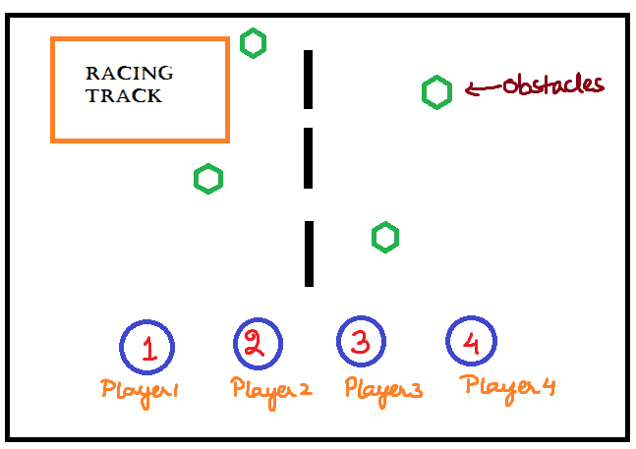

How do you plan to make your game engaging?

We are going to make it in Visual studio code, along with a database using firebase since it is a multiplayer racing game. With the help p5play.js we can create sprites, interesting animations, different obstacles and the game is totally fun and engaging in terms of the racing all the way to the end with dodging the obstacles in between.