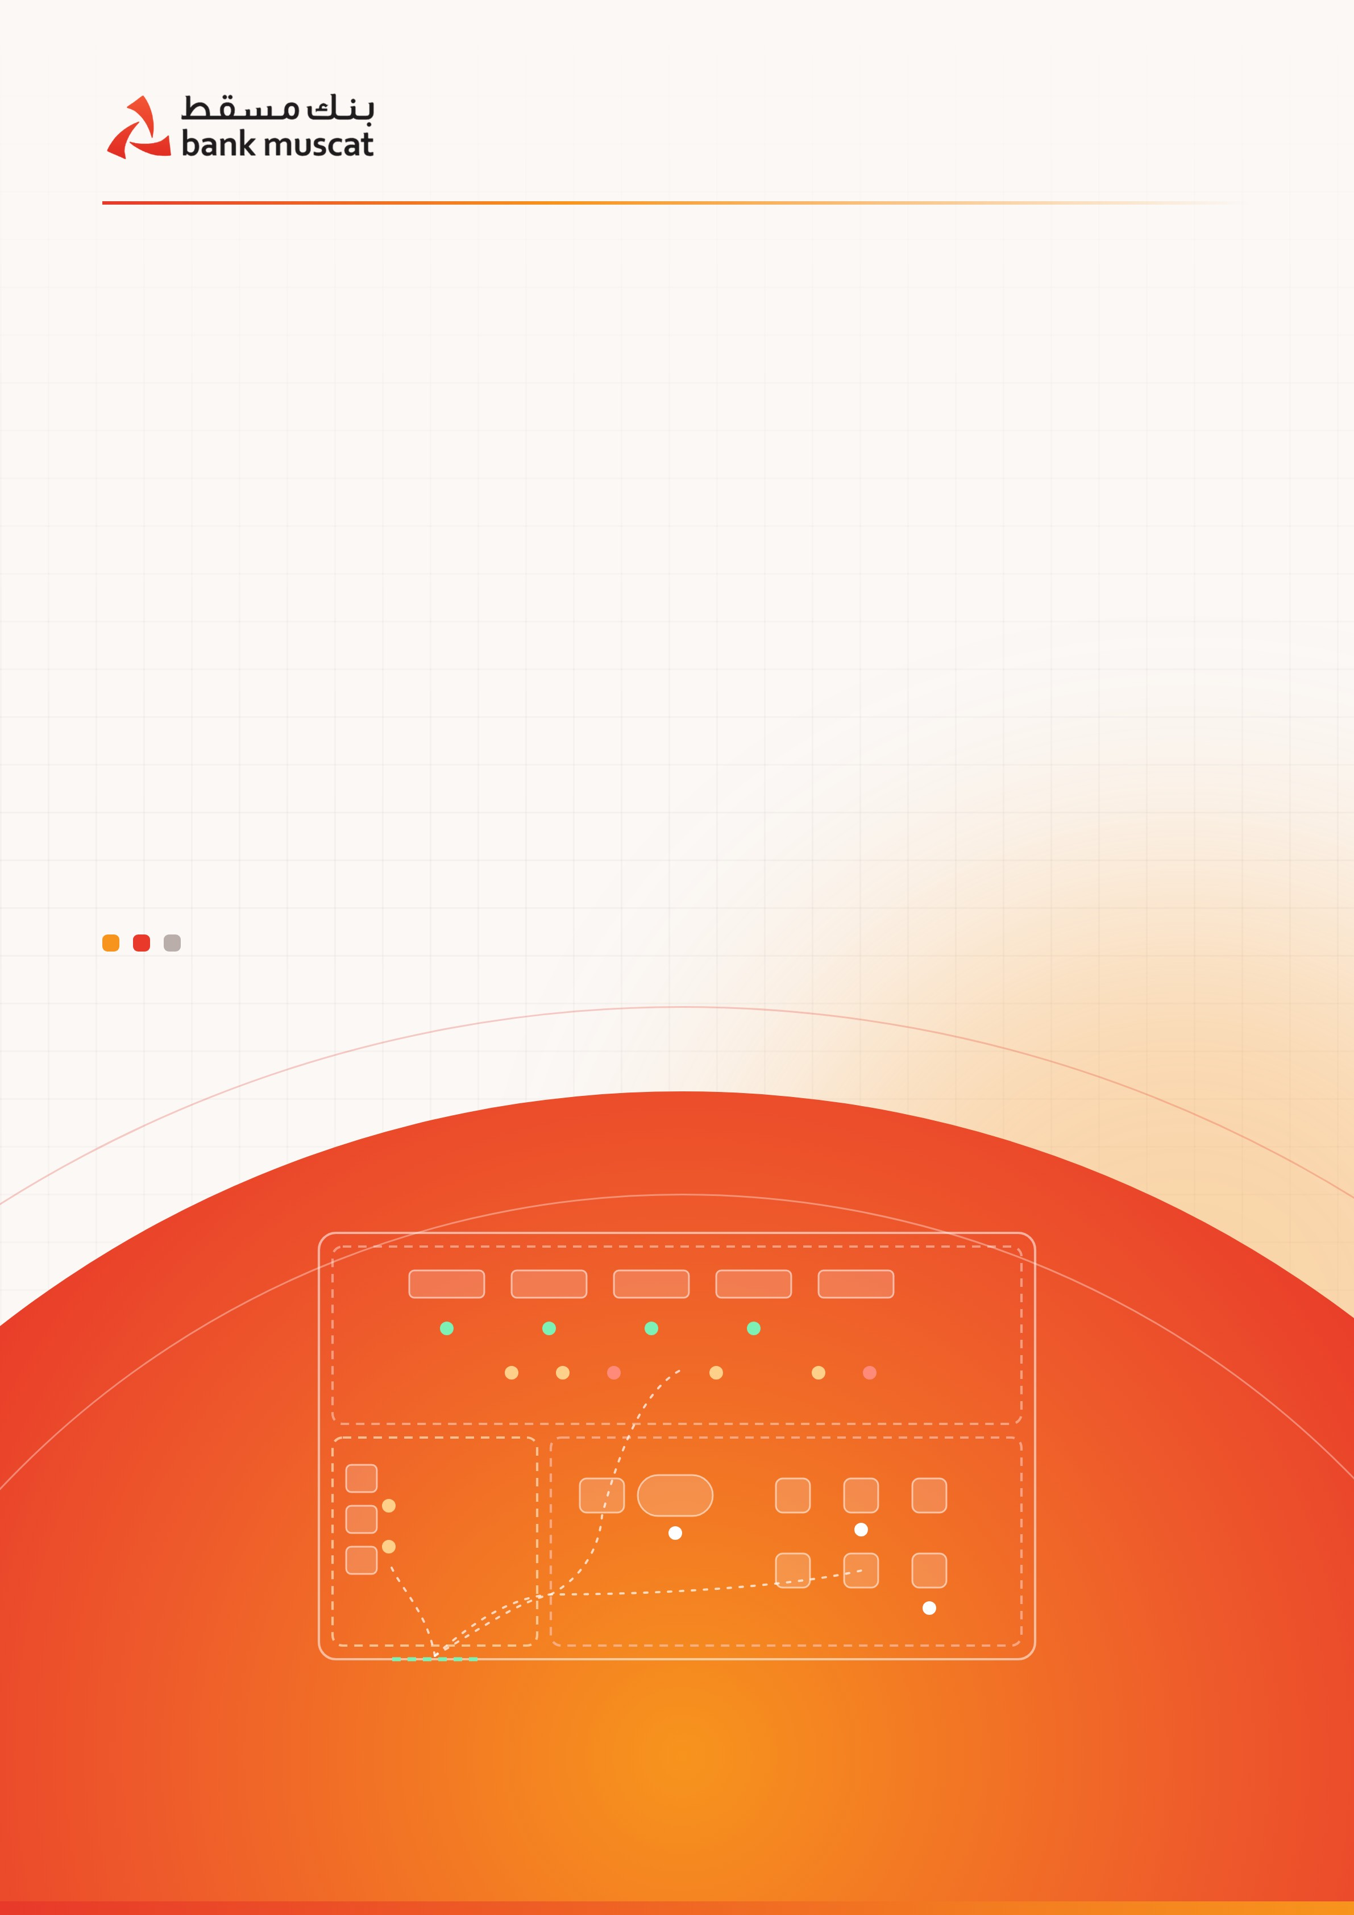
TECHNICAL AND COMMERCIAL PROPOSAL · STAGE 1
Smart Branch Analytics and AI-Assisted Customer Guidance
Turning every branch visit into a measured, guided journey, from the ATM lobby to the counter
Prepared for Bank Muscat
Prepared by AI Integration SPC · Muscat, Sultanate of Oman
October 2026 · Confidential
AT A GLANCE

Stage 1 in one page
Bank Muscat has built strong self-service and digital channels. Stage 1 helps customers use them by showing every branch, hour by hour, which work belongs at the ATM, which belongs on a tablet with the guide, and which needs a counter officer.
198  branches across Oman on one live network view | 3  zones measured, from the ATM lobby to the counter | ≥ 95%  people-counting accuracy, validated on site | 15–25%  of counter tickets moved to Zones 1 and 2
−78%  modelled peak-hour wait with 15% of tickets moved | 60–100  full-time equivalents of counter time released | OMR 1.2M  indicative annual value at target (OMR 0.7M if conservative) | 100%  of the platform runs on Bank Muscat’s own servers

What is inside this proposal
01 | Executive summary | The problem, the opportunity and what Stage 1 commits to
02 | Ten questions a branch cannot answer today | Why the need is urgent
03 | How a branch works: three zones, one journey | ATM lobby, digital and guide area, counters
04 | Right service, right zone | Service mapping and smart triage at the kiosk
05 | What Stage 1 delivers | Capabilities, live tracking, five recommendations
06 | Two dashboards, one network | Branch and head-office views, KPI framework
07 | Optional modules | Customer feedback by SMS; staff attendance and workforce analytics
08 | Privacy, security and compliance by design | Oman PDPL, privacy tiers, staff data
09 | Platform architecture and access control | Monorepo, services, databases, who can access what
10 | Expected impact and estimates | Queue model, capacity and value
11 | Risks, governance and service levels | How the programme stays on track
12 | Looking ahead: Stage 2 | Multilingual voice assistant
13 | What we need and next steps | Pilot requirements, assumptions and sources
SECTION 01

Executive summary
Every morning, customers walk into Bank Muscat branches with different needs. One needs cash, which takes two minutes. Another needs a cheque book the app could have ordered from home. A third needs advice on home finance that only a trained officer can provide.
Today, all three can take a ticket and join the same queue. The branch cannot see who came in, what they came for, where they went or how long they waited. As a result, the most expensive resource in the building, the counter officer, handles work that does not need a counter, and customers with complex needs wait behind them.
Bank Muscat already has the channels to change this. The bank operates 198 branches across Oman and more than 900 ATMs, CDMs and multi-use machines, and serves more than 2.5 million customers. Its redesigned mobile app offers over 200 banking services, with face and fingerprint login. What is missing is an intelligence layer that connects the physical branch to those channels and shows, hour by hour, where each service belongs.
Stage 1 builds that layer. Computer vision running on the cameras already installed in each branch turns every visit into an anonymous journey across the branch’s three zones. The journey is then combined with ATM, tablet and queue-ticket data. Four outputs turn the data into daily decisions:
- A branch dashboard for every branch manager and Zone 2 guide
- An HQ network dashboard covering all branches, regions and services
- An AI insight assistant that answers questions in English and Arabic
- Real-time alerts sent to the right person when waits, crowding or idle counters need action

Those decisions include which services to move away from the counter, when to open another counter, how the Zone 2 guide should support customers, and which branches lead in digital migration.
Two optional modules can be added to the same platform: customer feedback by SMS after every visit, and staff attendance and workforce analytics that can replace or complement today’s attendance devices (Section 07).

Stage 1 commitments
To be confirmed against a baseline measured during the pilot:
- At least 95% accuracy in people counting, validated against manual counts
- 15–25% of counter tickets moved to Zones 1 and 2
- Peak-hour counter waits cut by more than half
- A daily forecast and staffing recommendation for every branch

The goal of Stage 1 is simple: fewer customers need the counter, and those who do wait less. Stage 2, a multilingual voice assistant, later builds on the same data.

Project structure at a glance
Part | What it covers
Stage 1 · this proposal | Smart Branch Analytics and AI-Assisted Customer Guidance: vision analytics, branch and HQ dashboards, AI insight assistant and real-time alerts
Optional modules | A · customer feedback by SMS after each visit. B · staff attendance and workforce analytics. Both run on the same platform and can be added at any time
Stage 2 · next | A multilingual, real-time voice assistant trained on Bank Muscat’s products, fees and procedures
Zone 1 · ATM lobby (24/7) | With its own entrance and an internal connection to the digital and guide area. ATMs, CDMs and multi-use machines for self-service
Zone 2 · digital and guide (until 7 PM) | An independent entrance and an internal door to the lobby; tablets for online requests, with the guide desk and ticket kiosk side by side
Zone 3 · counters (until 2–3 PM) | Bank officers for the work that genuinely needs a person

What changes for each audience
Audience | What changes
Customers | Shorter waits, fewer wasted trips, and help to finish simple requests in minutes at the ATM or on a tablet
Branch managers | A live view of the branch, early warnings and a daily staffing recommendation instead of guesswork
Zone 2 guides | A clear list of who to help next, and which customers can finish their request digitally
Head office | One comparable picture of all 198 branches, with the data to decide staffing, service design and branch formats
IT and compliance | A platform that runs entirely inside the bank, with no vendor access and a full audit trail

SECTION 02

Ten questions a branch should be able to answer today
A branch manager or a head-office executive should be able to answer these questions every day. Today, the data is not available to answer them.
# | The question | What Stage 1 gives you
1 | How many people walked into each branch today, and how many left without being served? | Door-to-door counts per zone, live occupancy and walk-away rate per branch and hour
2 | How many customers took a counter ticket for something an ATM, tablet or the app can complete in three minutes? | Avoidable-ticket rate by service, branch and hour
3 | Why does a customer with a simple question wait 40 minutes behind a home-finance application? | Queue analysis by service, plus smart triage at the ticket kiosk
4 | When is one more officer needed, and when are three sitting idle? | Arrival forecasts against counter capacity, with staffing advice; with Module B, who was actually at post
5 | Is the Zone 2 guide moving people to self-service, or just handing out tickets? | Guide conversion rate and digital completion after guidance
6 | Which services keep bringing the same customers back? | Repeat-visit detection for the same service within 7 days
7 | How long does a visit really take, from entry to exit rather than from ticket issue to call? | Full journey time, split by zone
8 | What happens to customers who arrive after the counters close at 2–3 PM? | After-hours demand, and how much of it Zone 2 resolves
9 | Which of the 198 branches is best at moving customers to digital, and what does it do differently? | Network league table and best-practice comparison
10 | How did customers feel when they left, and do we find out before they post online? | With Module A: an SMS review within about a minute of exit, linked to zone, service and wait

Unanswered questions carry a cost: idle or overloaded counters, customers who walk out, and routine work done at the most expensive point in the branch.
SECTION 03

How a branch works today: three zones, one journey
Bank Muscat organises its branches into three zones, and serving customers in each zone costs less and takes less time than in the next. Customers can enter the ATM lobby or the digital and guide area through separate entrances. An internal door connects the two areas; access to the counters is through the digital and guide area.
- Zone 1 · ATM lobby (open 24/7). With its own entrance and an internal connection to the digital and guide area. ATMs, CDMs and full-function machines already handle cash and cheque deposits, bill and school-fee payments, PIN changes and cheque book requests.
- Zone 2 · digital and guide (open until 7 PM). Beside the lobby, with its own entrance and an internal door to the lobby. Customers complete requests on tablets, the guide helps them, and the ticket kiosk next to the guide desk issues tickets only for work that requires a counter officer.
- Zone 3 · counters (open until 2–3 PM). Above and behind Zone 2. Officers handle the work that requires their expertise.

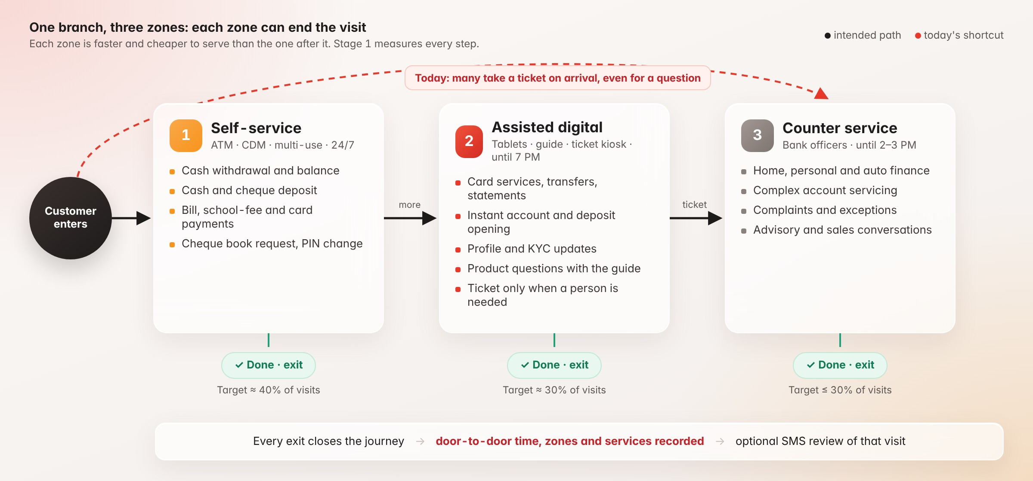
Figure 1 · Every zone can end the visit. The goal is to end as many visits as possible before the counter.
The design is right. The gap is that there is no measure of whether customers follow it. Many take a ticket the moment they reach the kiosk and go straight to Zone 3, including those who only have a question. Stage 1 makes this flow visible and measurable so each branch can manage it.
SECTION 04

Right service, right zone
We mapped the services that bring customers to a Bank Muscat branch against the capabilities of the bank’s existing channels. The app alone lets customers order cheque books, open fixed deposits, link or block cards, switch international card use on or off, open a savings account instantly and set a card PIN instantly. Internet banking also supports personal-detail updates. Yet much of this work still reaches the counter.
Service | Target zone | What Stage 1 adds
Cash withdrawal, balance, mini-statement | Zone 1 | Flags tickets the ATM could have handled
Cash and cheque deposit | Zone 1 (CDM, multi-use machine) | Shows deposit tickets by branch and hour
Card PIN, block, international use | Zone 2 (app with the guide) | Alerts the guide when such a ticket is taken
Cheque book request, stop cheque | Zone 1 or 2 | Tracks avoidable tickets
Bill, school-fee and credit-card payments | Zone 1 or 2 | Tracks avoidable tickets
Transfers and remittances | Zone 2 | Measures completion with the guide
Statements and standard letters | Zone 2 (statement printer, app) | Detects repeat visits
Savings account and fixed deposit opening | Zone 2 (instant opening in the app) | Tracks conversion
Personal details and KYC updates | Zone 2 where supported | Measures completion against referral to a counter
Product questions and general enquiries | Zone 2 (guide, and later the Stage 2 voice assistant) | Logs question topics as training data
Home, personal and auto finance; complex cases; complaints | Zone 3, with information gathered in Zone 2 | Measures wait and service time by case type

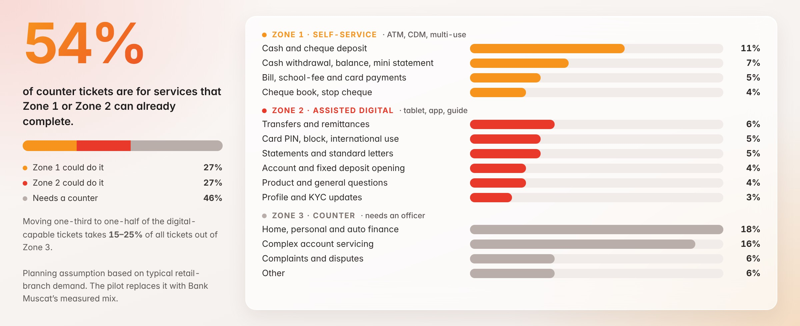
Figure 2 · Planning assumption for the counter-ticket mix. About 54% of tickets are for services Zone 1 or Zone 2 can already complete.
If roughly 54% of counter tickets are technically digital-capable, redirecting a third to a half of them moves 15–25% of all counter tickets out of Zone 3. That is the target range used in Section 10. The mix is a planning assumption based on typical retail-branch demand; the pilot replaces it with Bank Muscat’s measured data.

Smart triage at the ticket kiosk
The most effective change is to ask for the service before printing a ticket. The kiosk then routes each request to the lowest-cost zone that can complete it, and the guide is alerted the moment a digital-capable request appears.
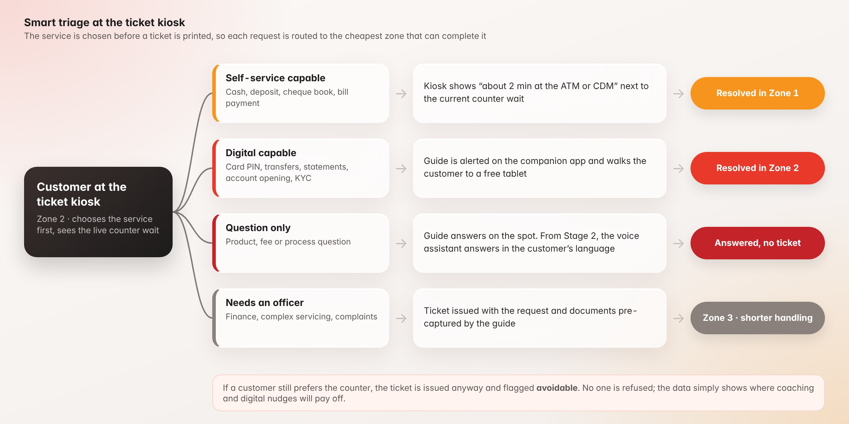
Figure 3 · Smart triage at the ticket kiosk. No customer is refused a ticket; avoidable tickets are simply made visible.
SECTION 05

What Stage 1 delivers
Capability | What it does
People counting and live occupancy | Counts entries, exits and people in each zone in real time from existing cameras, with at least 95% accuracy validated against manual counts
Cross-zone journey tracking | Follows each visitor from either entrance through the ATM lobby, the internal connection, Zone 2 and Zone 3 as applicable under an anonymous visitor ID, measuring time in each zone and the path taken
Known journeys (consent-based) | Links the visit to the customer, within Bank Muscat’s own systems, when they authenticate: at an ATM (card and PIN, OTP, or fingerprint where the device supports it), on a tablet, or by taking a ticket with civil ID or mobile number. The service used and the outcome are then known
Queue and wait intelligence | Combines queue-system tickets with the camera journey to show real waits by service, service time per counter, and walk-aways before being called
Behaviour segments | Groups visits into journey types per branch and hour: express ATM, self-starter, guided convert, counter-required, avoidable counter, returner, walk-away
Guide effectiveness | Measures how many guided customers finish digitally rather than take a ticket, and which services the guide is most effective at redirecting
Forecasting and staffing | Predicts arrivals by hour and service, including salary days and month-end, and recommends counter and guide schedules
AI insight assistant | Answers questions in English or Arabic, writes weekly briefs and flags anomalies. Runs on the bank’s infrastructure
Alerts and role-based access | Sends SMS, Teams or in-app alerts to the right role (HQ, regional manager, branch manager, guide) for long waits, crowding, offline devices or an unattended desk
Export and integration | PDF and Excel export, scheduled reports, and an API for Bank Muscat’s BI and CRM tools

Two optional modules, customer feedback by SMS and staff attendance, can be added to the same platform (Section 07).

Seeing the branch as it really is
All cameras in a branch are fused into one live floor map. Each dot is an anonymous visitor; colour shows whether they are being served, waiting or past the wait target. Managers see the whole branch at once instead of switching between camera feeds.
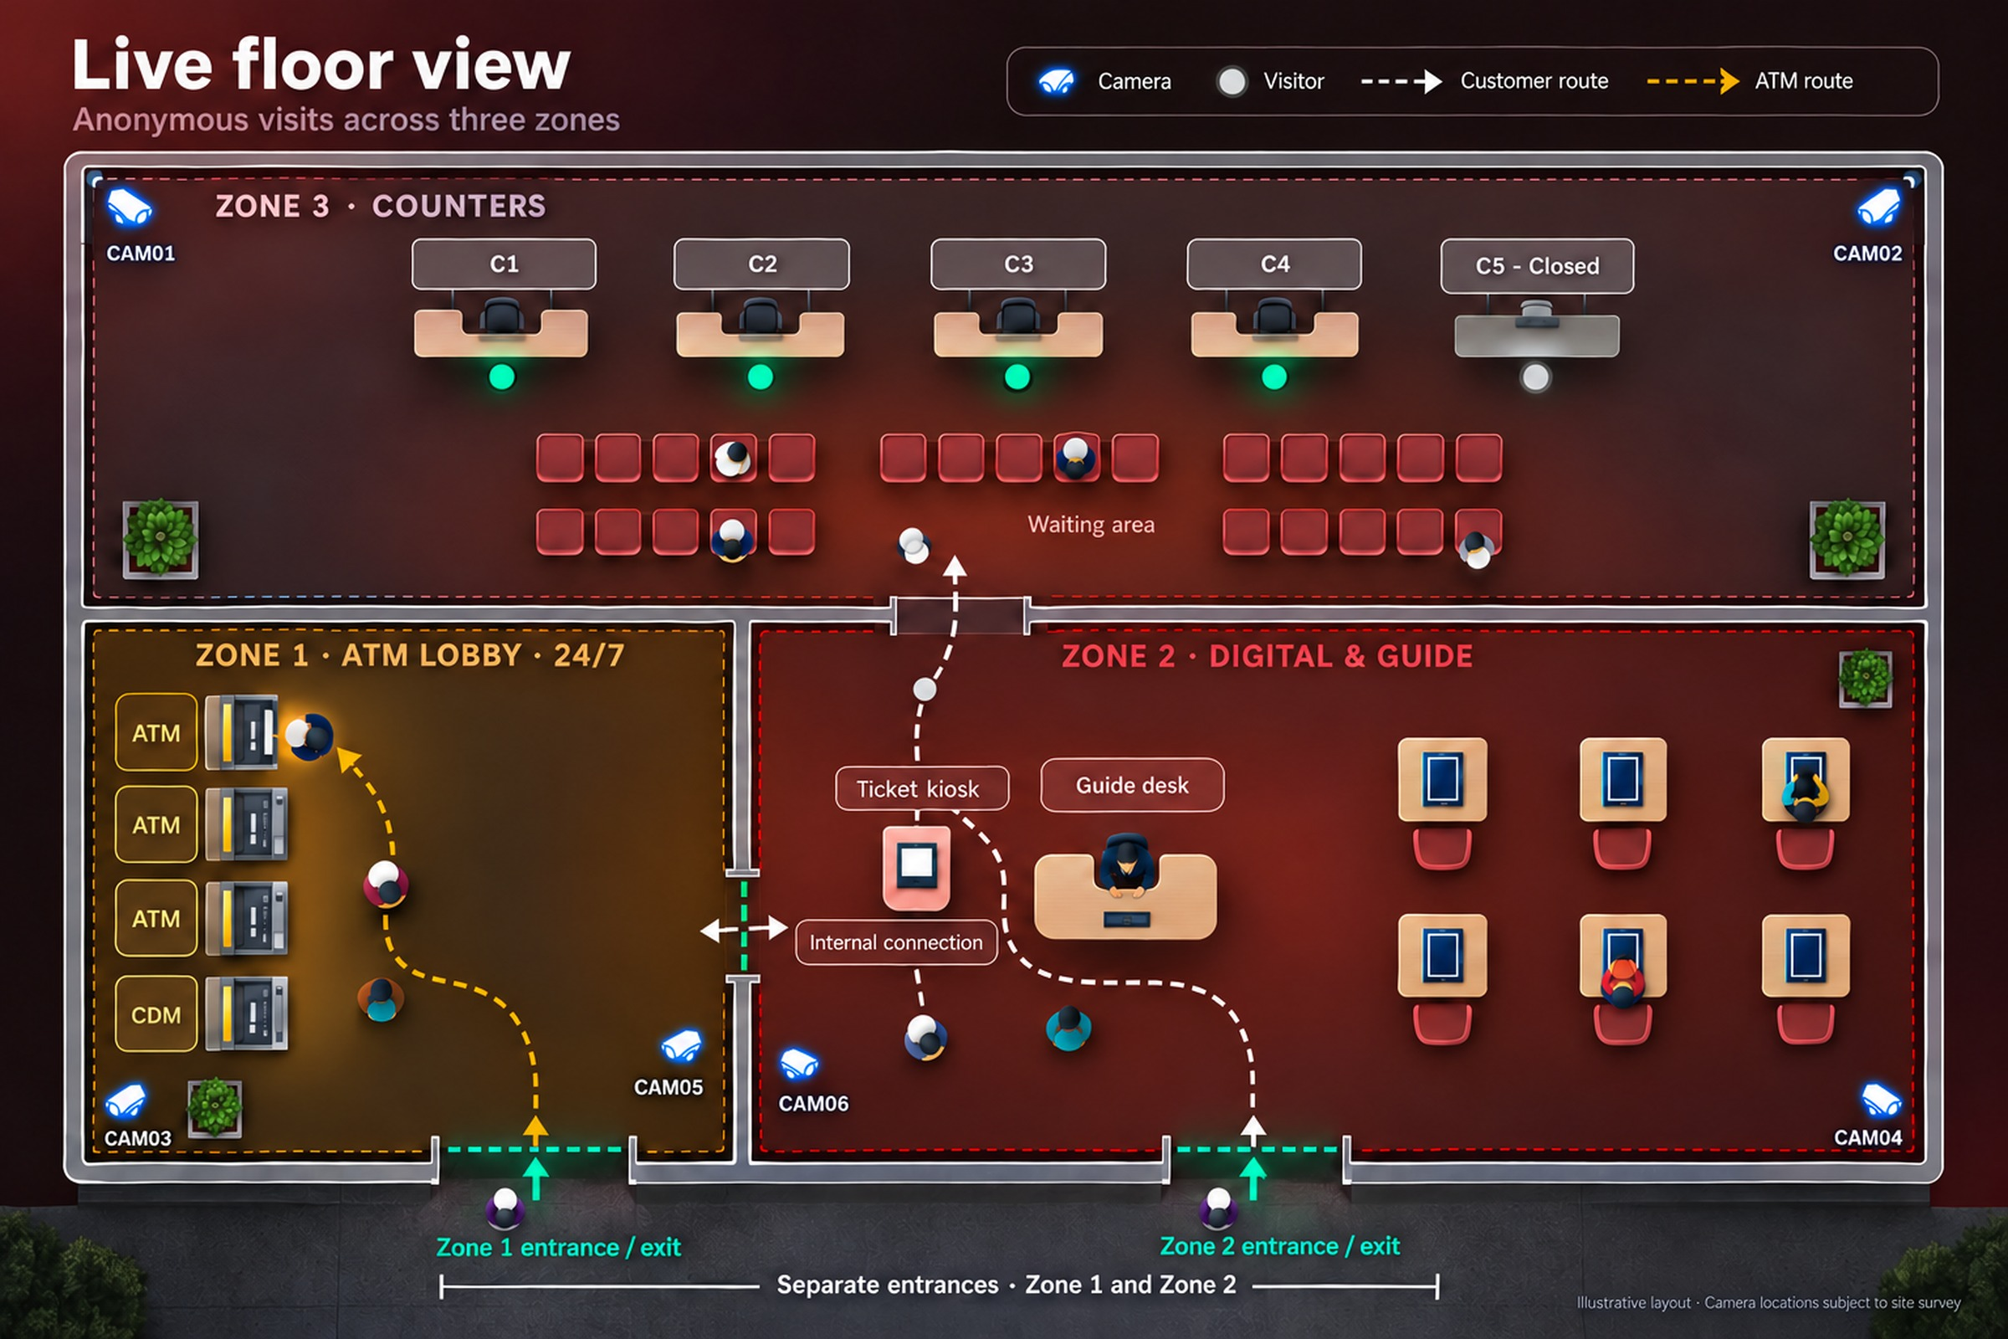
Figure 4 · Live floor view of one branch. Six cameras fused into one anonymous map: separate entrances serve the ATM lobby and the adjacent digital and guide area, an internal door links them, and the counters sit above.
Behind the map, each camera produces tracking events like the examples below. Faces are blurred in these illustrations; in production, no images are stored at all.
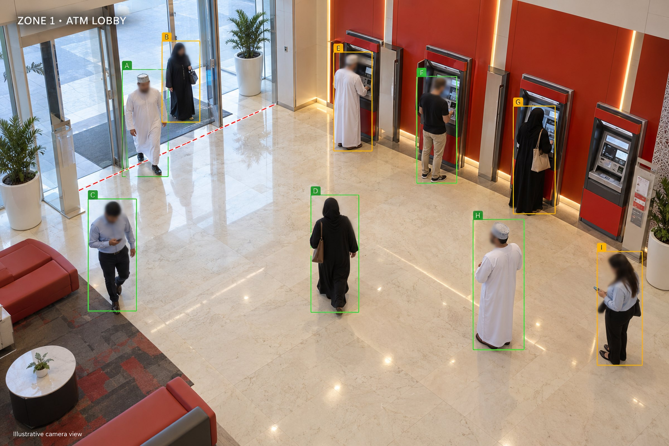
Figure 5 · Zone 1 · ATM lobby. Visitors are counted at the entrance and their ATM time is measured.
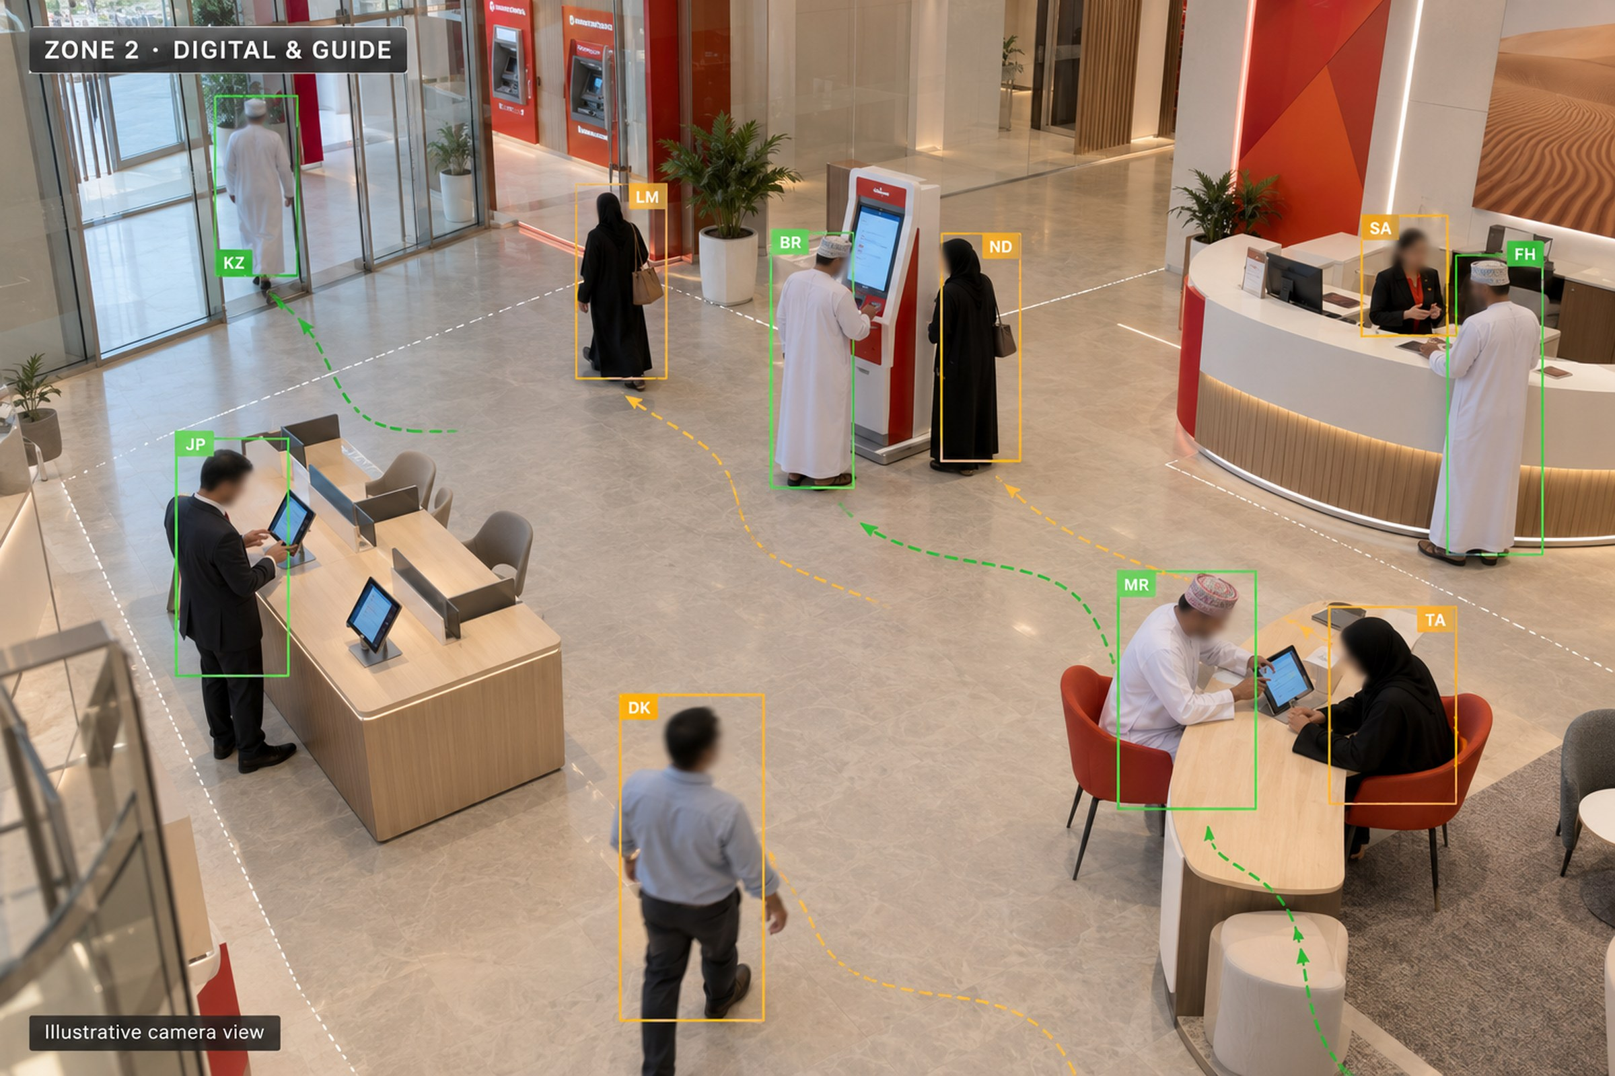
Figure 6 · Zone 2 · digital and guide area. Tablet use, guide conversations and ticket-kiosk decisions are linked to each visit.
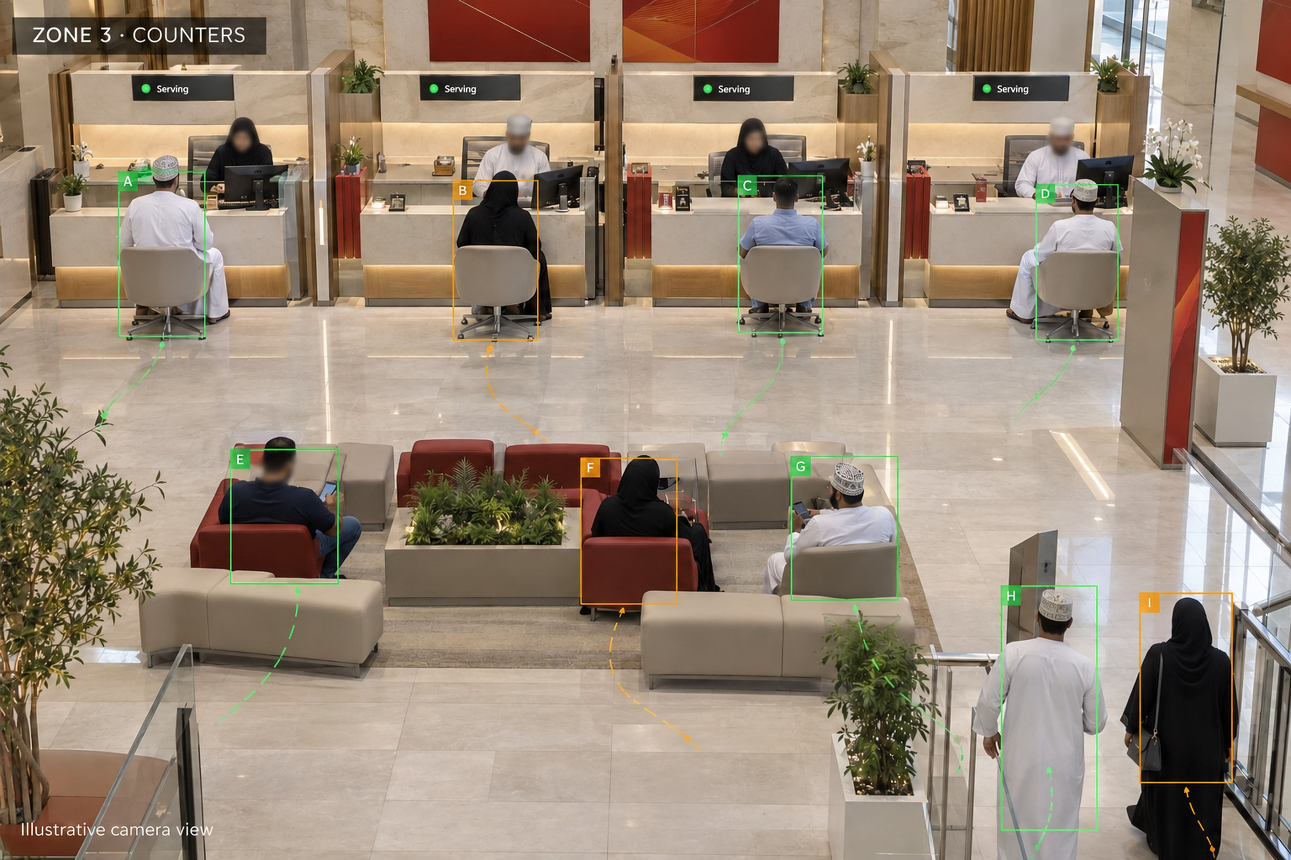
Figure 7 · Zone 3 · counters. Each tracked visitor is matched to a queue ticket, so real waits are measured against the target.

Five recommendations for branch operations
Recommendation | Why it matters
Smart ticket triage. The kiosk asks for the service first. For a digital-capable service it shows the counter wait next to “done in 3 minutes with the guide” and alerts the guide | Stops avoidable tickets at the moment they are created
Guide companion app. The Zone 2 guide sees who is waiting, what they probably need and who has waited longest | Helps the guide move from issuing tickets to coaching customers on digital services
After-hours mode. Once counters close at 2–3 PM, dashboards switch to Zone 2 capacity, and the AI drafts a next-day callback list for unresolved needs | Protects satisfaction during the 4–5 hours when Zone 2 runs alone
Salary-day and month-end playbooks. Forecasts inform staffing in advance and send digital nudges by SMS before peak days | The worst queues are predictable
Branch digital score. A monthly ranking of branches on digital resolution, wait and walk-away rate, with the practices of top branches shared network-wide | Makes improvement visible and competitive

One morning in a branch, with Stage 1
Moment | What happens | What Stage 1 does
Before opening | The forecast shows a salary-day peak from mid-morning | Advises the manager to open counter 5 at the peak and place a second guide in Zone 2
At the kiosk | A customer chooses “cheque book” | Offers the tablet route and alerts the guide, who helps the customer finish in a few minutes
Queue builds | Three customers pass the wait target | Alerts the branch manager and flags a counter that is idle while customers wait
Machine offline | Deposit tickets start rising | Alerts IT and the manager; the guide redirects customers to the working machine
Counters close | Customers keep arriving | Switches to after-hours mode and prepares a next-day callback list
End of day | The branch closes | Sends a daily summary to the manager and updates the head-office league table

SECTION 06

Two dashboards, one network
Stage 1 delivers two connected dashboards. Every branch has its own live view, and head office sees all branches together, and can examine any branch in detail.
Branch dashboard · for the branch manager and the Zone 2 guide
- Live occupancy of each zone and a floor map with anonymous visitors
- Queue by service and the longest current waits
- Counter status from the queue system: serving, idle while customers wait, closed
- Arrival forecast for the next few hours, with a staffing recommendation
- Guide companion list, and today’s reviews with Module A

HQ dashboard · for retail-banking leadership, regional managers and the digital team
- Network KPIs and where each visit ended: Zone 1, Zone 2, Zone 3 or walk-away
- Avoidable tickets by service
- Load by governorate and hour
- Branch league table and live alerts
- The AI insight assistant, for questions and reports in English or Arabic

Both dashboards are shown on the next two pages.

KPI framework
KPI | Definition | Stage 1 target
People-counting accuracy | Measured against manual counts over agreed sample periods | 95% or higher
Resolved before the counter | Share of visits completed in Zones 1–2 | +10 to +15 points
Avoidable counter tickets | Tickets taken for digital-capable services | −40%
Peak-hour counter wait | Average wait during the two busiest hours | −50% or better
Walk-away rate | Customers who leave before being called | Below 3%
Guide conversion | Guided customers who finish digitally | Above 50%
Repeat visits | Same service again within 7 days | −30%
Visit rating · Module A | SMS review score, 1–5 | 4.4 or higher
Counter availability · Module B | Staffed minutes against scheduled opening minutes | 95% or higher

HQ network dashboard
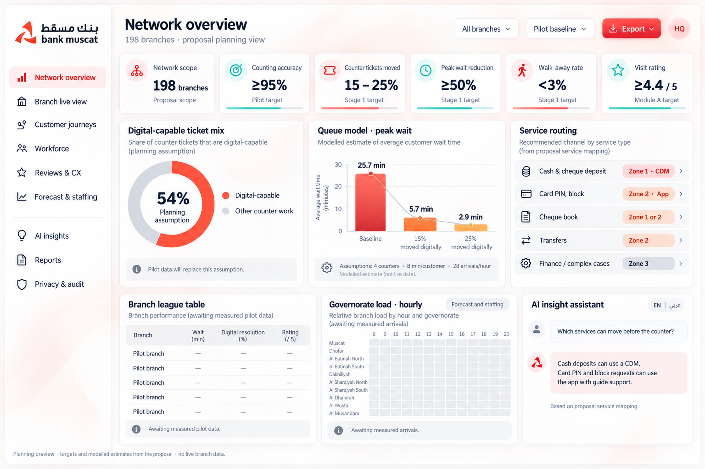
Figure 8 · HQ network dashboard: network KPIs, where visits ended, arrivals by hour and zone, avoidable tickets, branch league table, governorate load and the AI insight assistant.

Branch dashboard
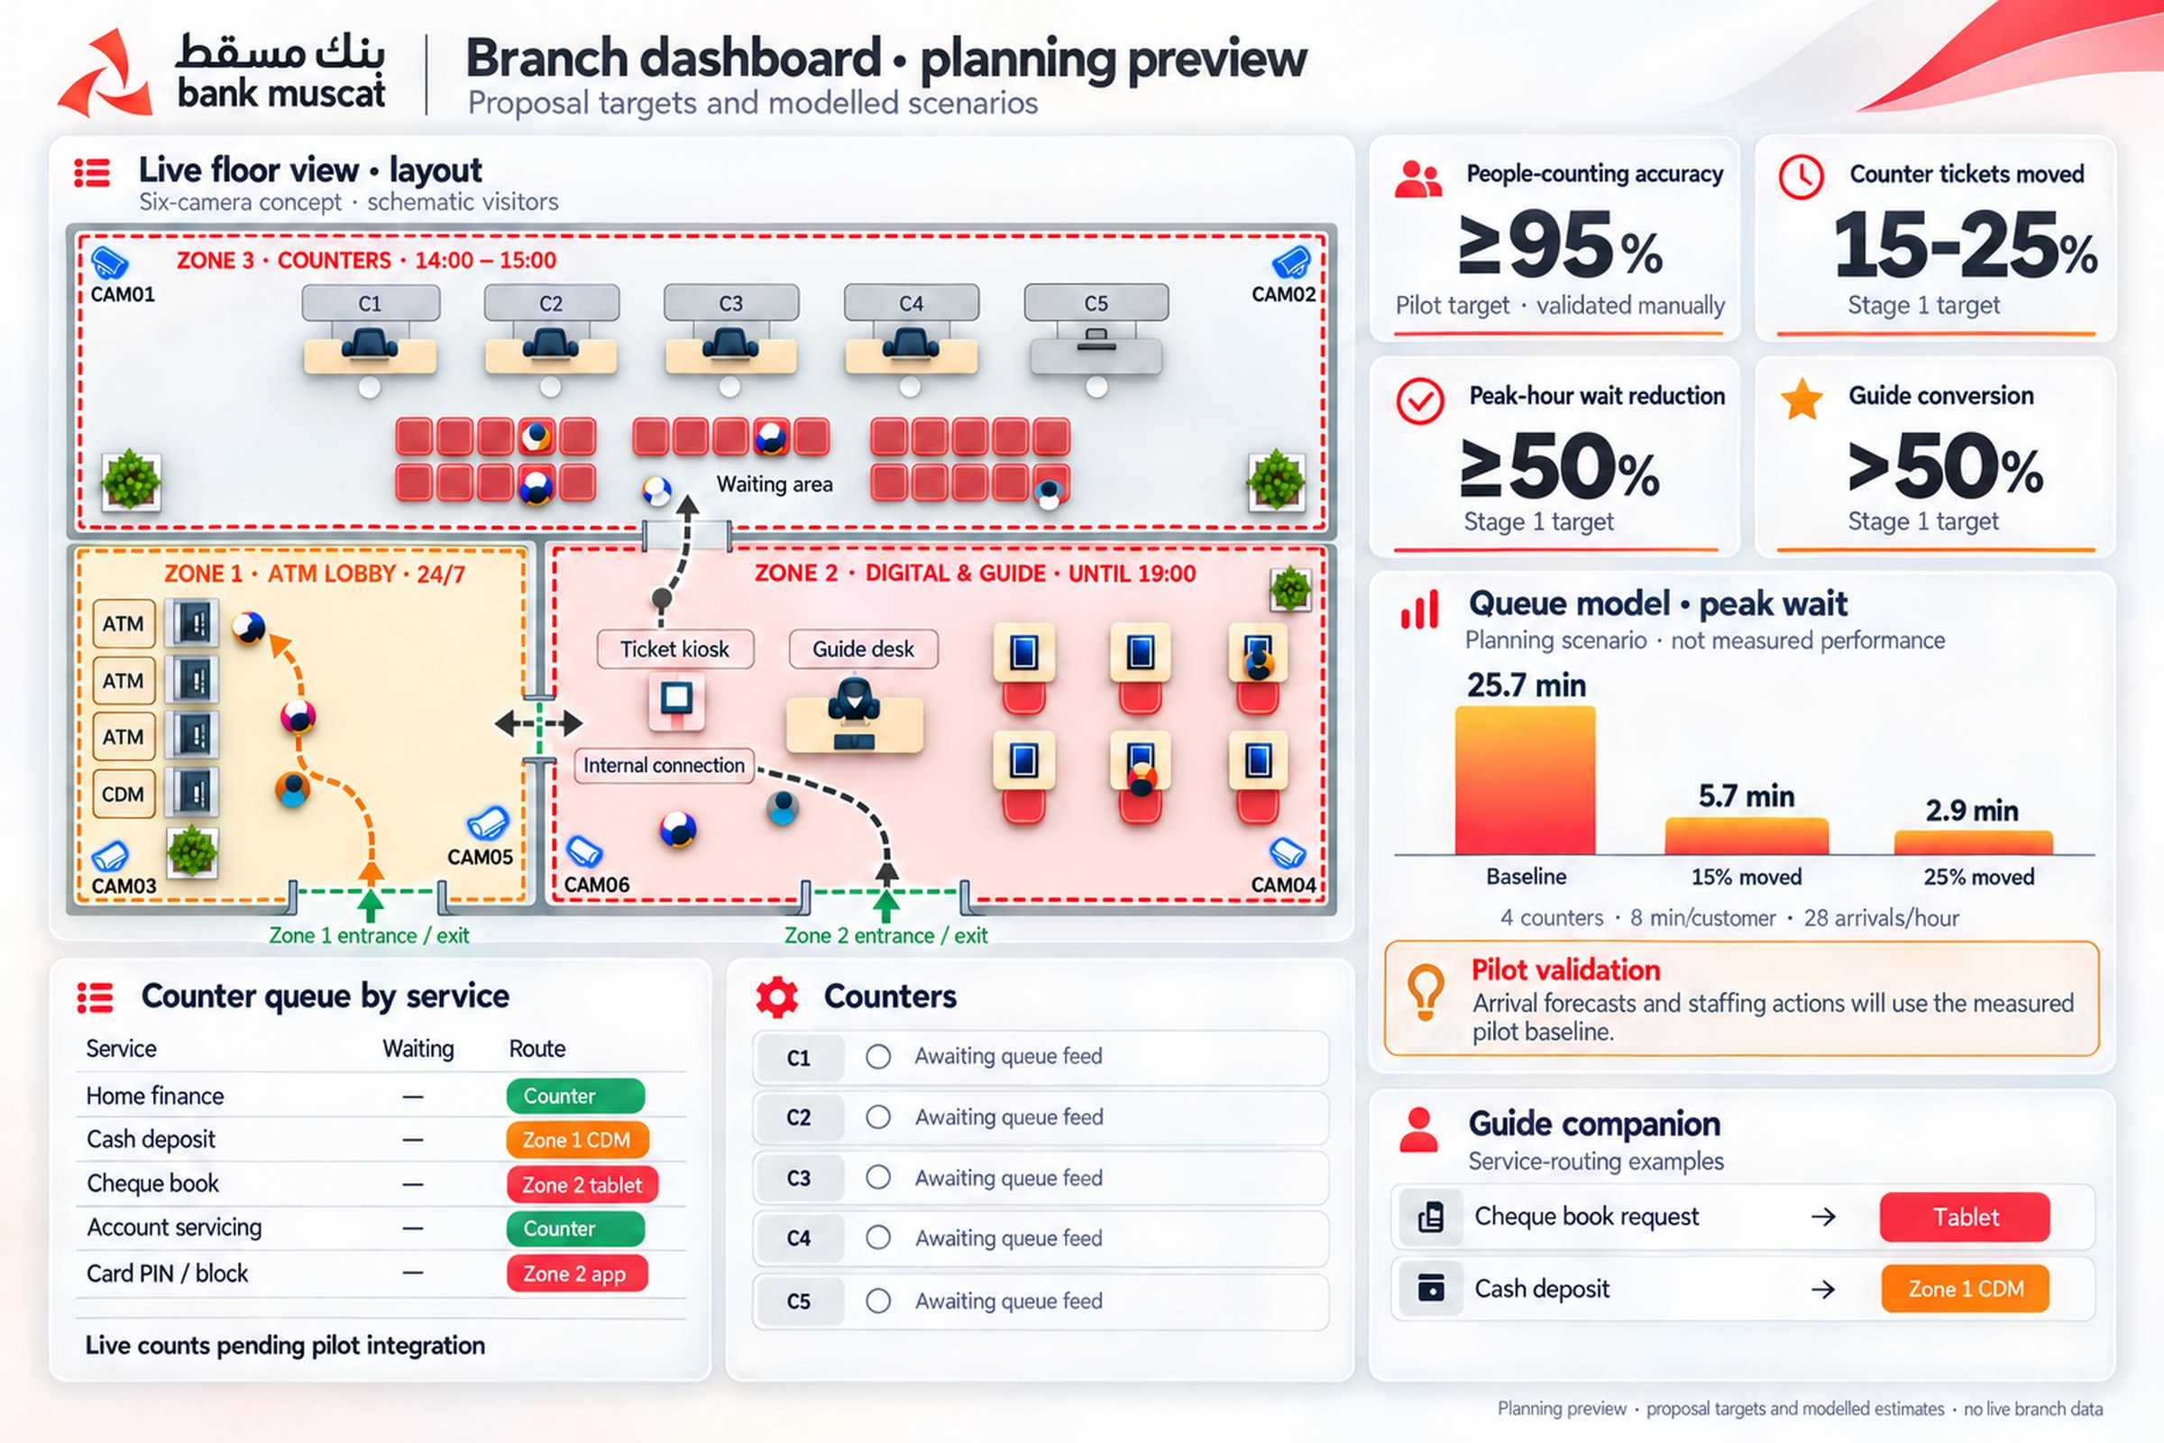
Figure 9 · Branch dashboard: live floor map, queue by service, counter status, arrival forecast with a staffing recommendation, and the guide companion.
SECTION 07

Optional modules
Two modules can be added to the Stage 1 platform, at the start or at any later time. Both run on the same central server, dashboards and access rules, and use the cameras already installed. Bank Muscat decides whether and when to switch each one on.
Module | What it adds | Who benefits
A · Customer feedback by SMS | A 30-second survey after every identified visit, linked to the zone, service, wait and counter | Branch managers, retail banking, customer experience
B · Staff attendance and workforce analytics | Automatic attendance, breaks and time at post for every employee, from the same cameras | Branch managers, HQ, HR and payroll

Module A · Customer feedback by SMS
When an identified customer crosses the exit line, the system closes the journey and, within about a minute, sends an SMS through the bank’s existing SMS gateway to the customer’s registered mobile number. The link opens a 30-second survey in English or Arabic, already filled in with the services used on that visit.
- Every answer comes with its cause. The score is linked to the branch, zone, service, wait and counter of that visit, so a low score points to what went wrong, not just to a feeling.
- Same-day recovery. A low score creates a callback task for the branch manager, tracked until it is closed.
- What customers say, summarised. The AI insight assistant groups written comments by topic every week, in English and Arabic.
- Respectful by design. At most one survey per customer per week, opt-out honoured, sent only to the number the bank already holds.

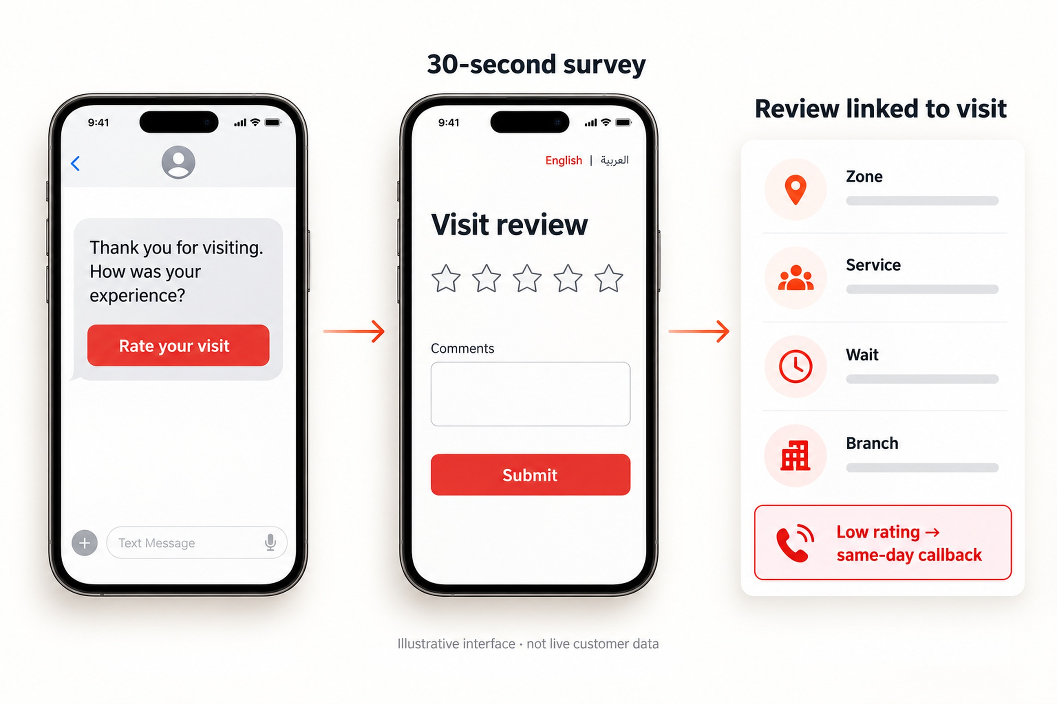
Figure 10 · Module A: the SMS and 30-second survey a customer receives after leaving, and what the branch and HQ see.
Module A measure | Target
Visit rating, 1–5 | 4.4 or higher
Survey response rate | 15% or higher
Low-score callbacks closed the same day | 90% or higher

Module B · Staff attendance and workforce analytics
Counter officers and Zone 2 guides are the branch’s most valuable resource. Module B shows, for every employee and every day, when they arrived and left, how long they spent at their post, how many breaks they took and for how long, and when they were away from their post during working hours.
Each employee is enrolled once by HR. From then on the system recognises them by face at the staff entrance and on the branch floor, keeps them apart from customers, and builds an accurate daily record in the dashboard. Separating staff from customers also makes customer counts and waiting times more accurate.
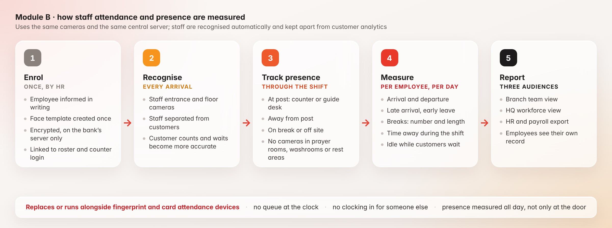
Figure 11 · Module B: staff are enrolled once, recognised automatically, and measured through the whole shift.
Metric | What it shows | Seen by
Arrival and departure | First and last recognition at the staff entrance, for each employee and day | Branch, HQ, HR
Late arrival and early leave | Arrival and departure against the roster | Branch, HQ, HR
Time at post | Minutes at the assigned counter or guide desk | Branch, HQ
Breaks | Number and total length of breaks, against policy | Branch, HR
Away from post during the shift | Each absence from the post while on duty, with its length | Branch
Idle while customers wait | At post but not calling customers while customers are queuing | Branch, HQ
Counter availability | Staffed minutes against scheduled opening minutes | Branch, HQ
Tickets per hour at post | Productivity, adjusted for service mix | Branch, HQ
Handling time by service | Average time per service against the peer band for the same service | Branch, HQ
Overtime | Time on site beyond the roster | Branch, HR
Rating by counter | Customer score for the counter that served them, with Module A | Branch, HQ

Replacing or complementing attendance devices
- No new devices in most branches. The cameras already installed do the work; a camera is added at a staff entrance only where the site survey shows one is needed.
- No queue at the clock, and no clocking in for someone else. Recognition is automatic and personal.
- More than arrival and departure. Presence at the post is measured all day, which a fingerprint or card device cannot do.
- A smooth switch. The module can run alongside existing devices for a parallel period and then replace them branch by branch. Attendance is exported to the HR and payroll system in the format it already uses.

Two views
- Team view for branch managers: who is in, who is at post, breaks and time away today, a timeline for each counter, and individual scorecards.
- Workforce view for HQ and HR: attendance and punctuality across all branches, counter availability and productivity, peer benchmarks, and capacity against demand.

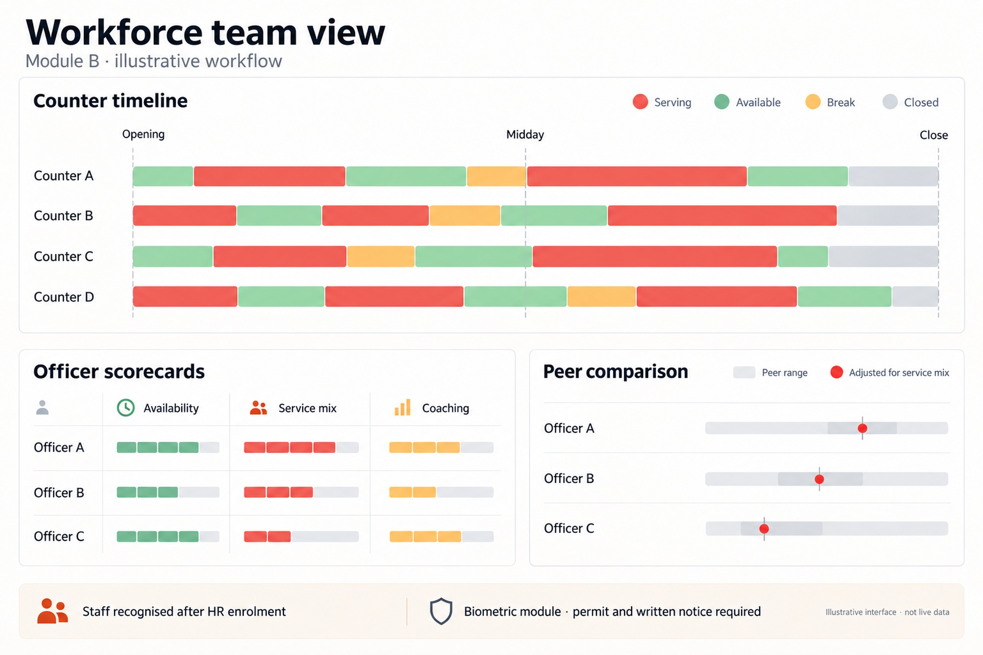
Figure 12 · Module B team view: attendance and time at post for each employee, breaks and time away, the counter timeline for the day, and a benchmark against similar branches.
Clear rules for staff data
- Employees are informed in writing before enrolment and can see their own records.
- Face templates are encrypted, kept only on the bank’s server, used only to recognise enrolled employees, and deleted when employment ends.
- There are no cameras in prayer rooms, washrooms or rest areas; time spent there simply counts as away from post.
- Metrics are adjusted for service mix and system downtime. A manager decides what action to take; the system never initiates disciplinary action independently.
- Module B runs under the ministry permit for biometric processing described in Section 08.
SECTION 08

Privacy, security and compliance by design
Oman’s Personal Data Protection Law (Royal Decree 6/2022) treats facial images as biometric data, and biometric data may only be processed with a permit from the ministry. The Executive Regulations (Ministerial Resolution 34/2024) set out the permit process and require a personal data protection officer. The law has been fully enforceable since 5 February 2026. Stage 1 is designed around these rules from day one, with three tiers that Bank Muscat switches on in order. The same rules cover staff data in Module B.
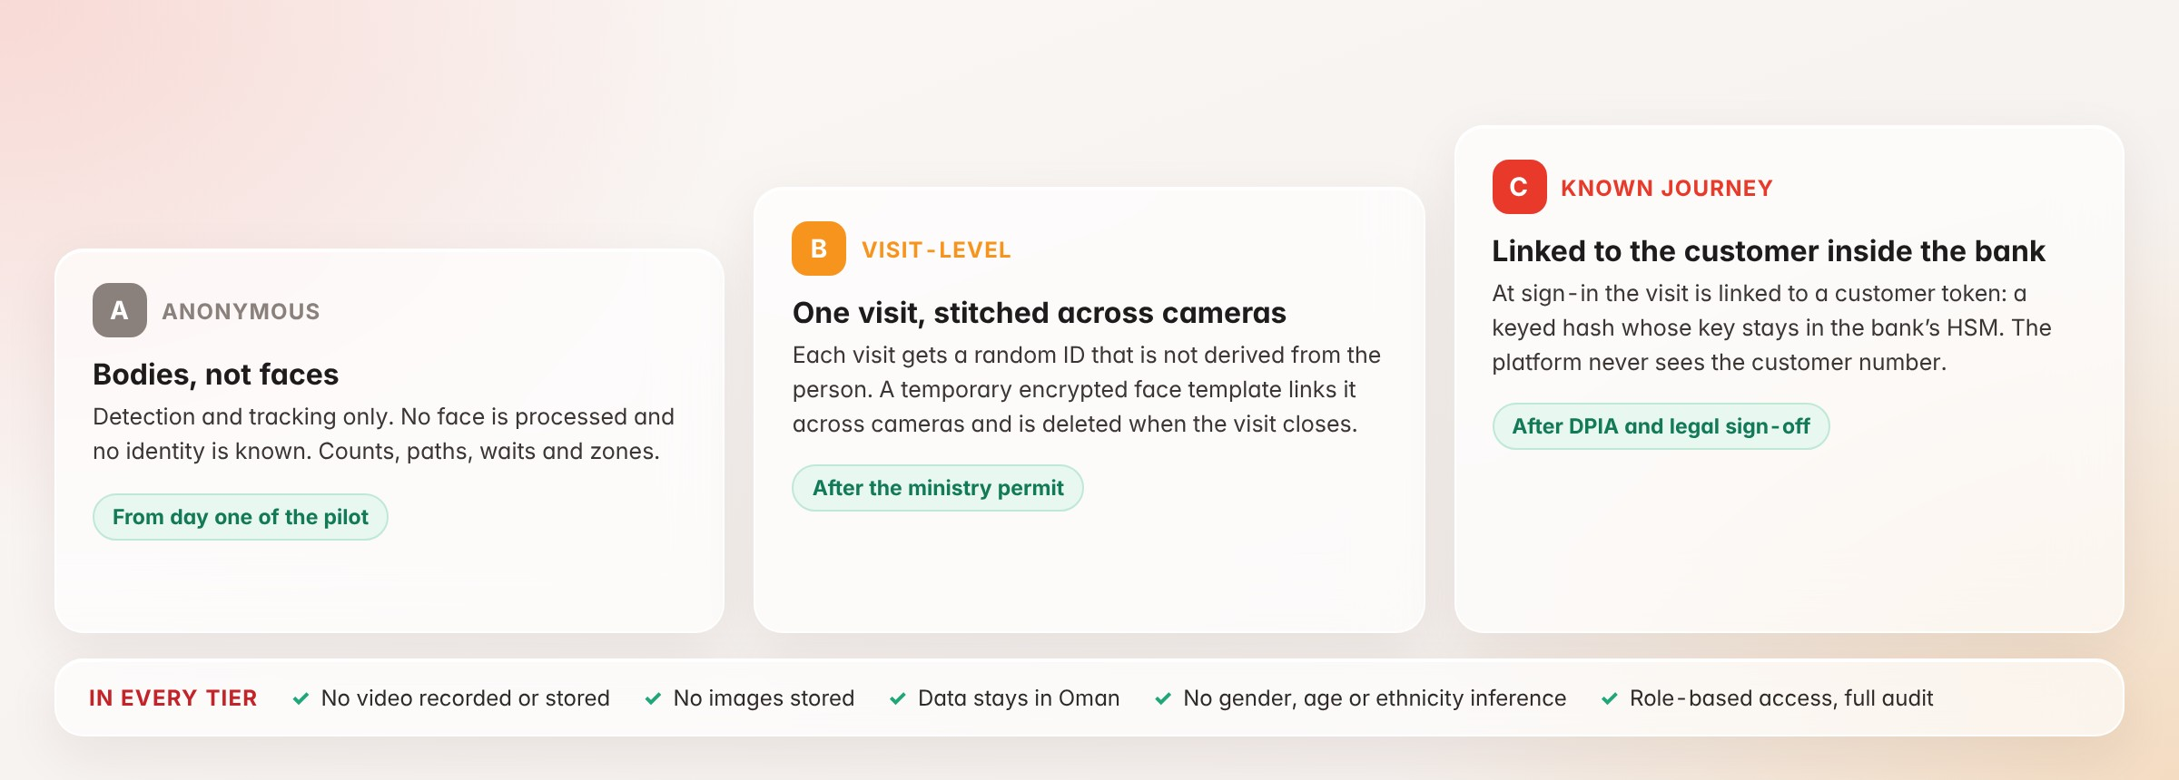
Figure 13 · Three privacy tiers. The pilot starts in Tier A on day one; Tiers B and C follow the permit and legal sign-off.
Tier | What is processed | When it switches on
A · Anonymous | Body detection and tracking only; no faces, no identity | Day one of the pilot
B · Visit-level | Each visit gets a random ID that is not derived from the person. A temporary, encrypted face template links that visit across cameras and is deleted when the visit closes | After the permit is granted
C · Known journey | At sign-in (ATM, tablet or kiosk) the visit is linked to a customer token: a keyed hash (HMAC-SHA-256) whose key is held only in the bank’s HSM, so the platform never sees the customer number. A privacy notice is displayed at the entrance | After a data protection impact assessment and legal sign-off
Staff · Module B | Encrypted face templates of enrolled employees only, used for attendance and presence, and deleted when employment ends | After the permit and written notice to staff

In every tier
- Video is analysed in memory on the bank’s own server. It is never recorded, never stored and never leaves the bank’s private network.
- All data stays in Bank Muscat’s data centre in Oman, which avoids the restrictions on transferring personal data abroad.
- The system makes no inference of gender, age, ethnicity or any other sensitive trait.
- Access is role-based, data is encrypted in transit and at rest, full audit logs are kept, and data is deleted on a fixed retention schedule.
- The vendor has no access to the system or its data (Section 09).
SECTION 09

Platform architecture and access control
The platform is built to run entirely inside Bank Muscat. Branch cameras and systems send data over the bank’s private network to the bank’s central server, where every service runs. Head office controls the platform, branch managers see only their own branch, and we, as the builders, have no way in.
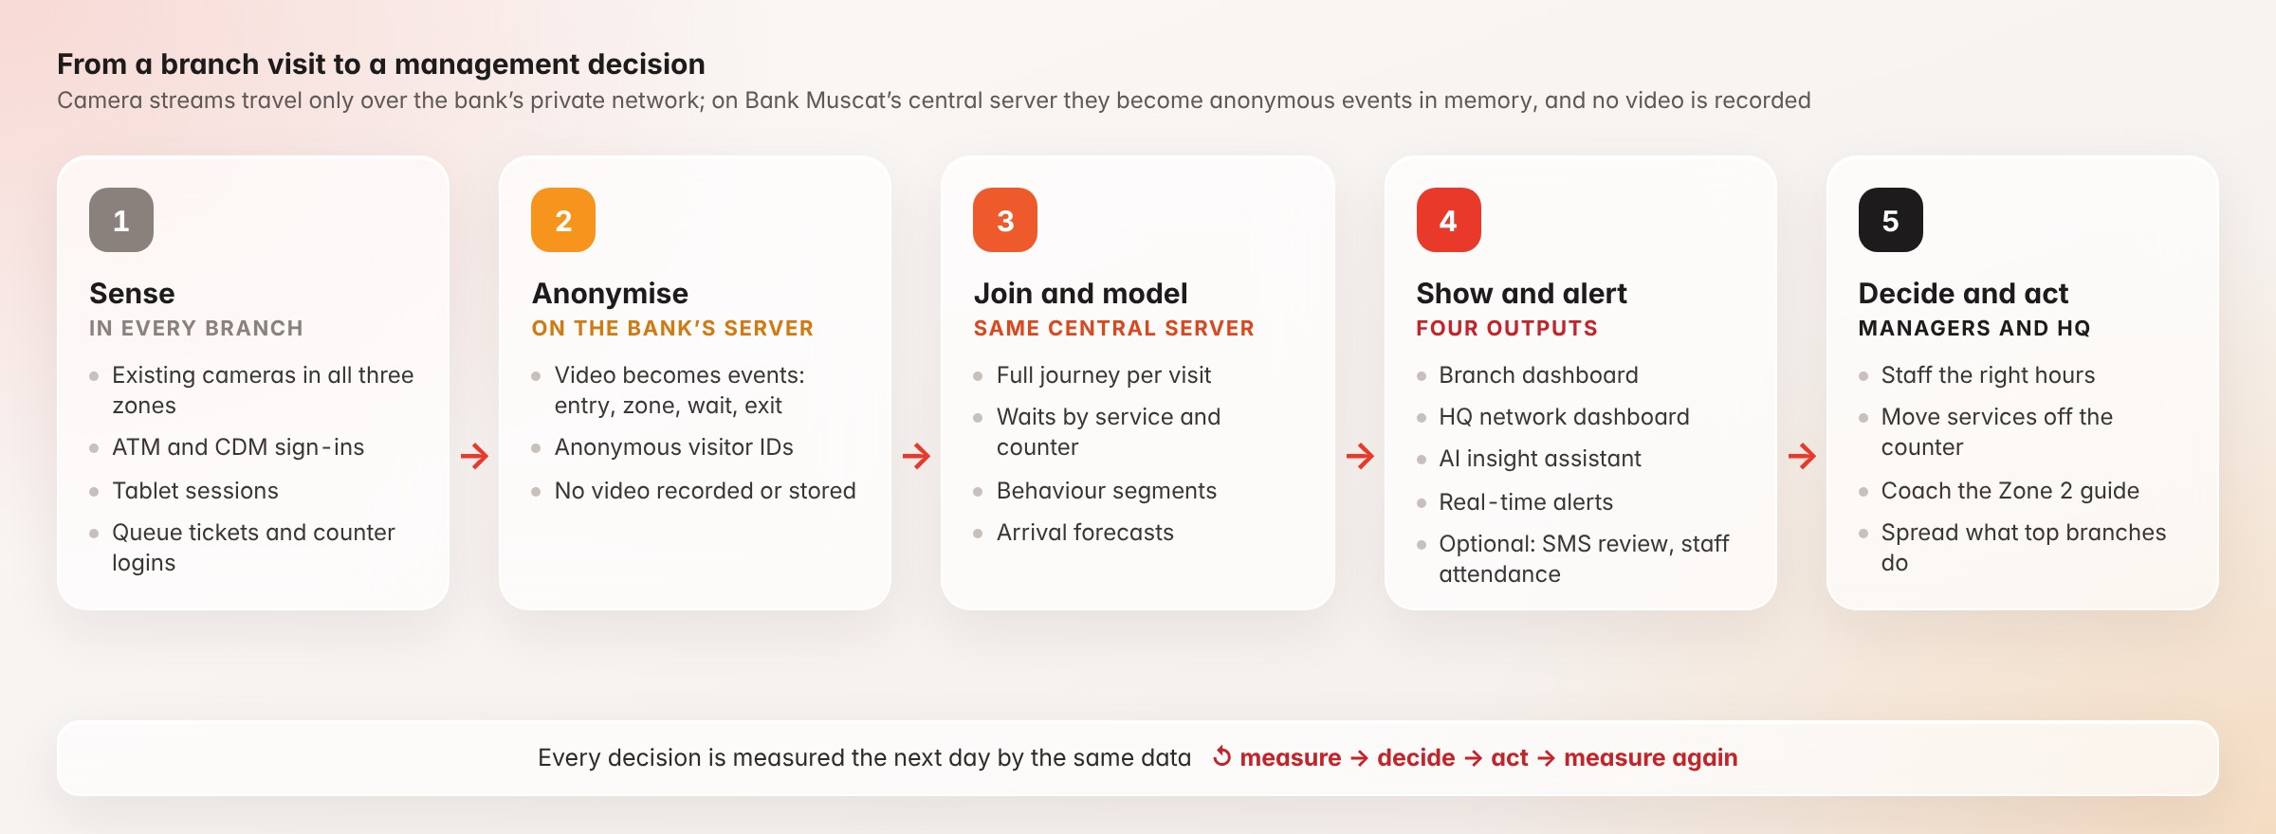
Figure 14 · From a branch visit to a management decision, and back again to measure the effect.

One codebase, four languages, two databases
The whole platform lives in one large monorepo, so every service shares the same data contracts, tests and release process. Each layer is written in the language best suited to it.
Layer | Language | What it runs
Real-time core | Rust | Camera stream ingest and decoding, cross-camera fusion and the event pipeline: the heavy, always-on parts that must be fast and memory-safe
Vision and intelligence | Python | Detection, tracking and re-identification models, analytics and forecasting, the AI insight assistant, and staff face matching for Module B
Business back end | Node.js | API gateway, identity and access, integrations with the queue, ATM, tablet and HR systems, alerts, and the SMS service for Module A
Interface | React | HQ dashboard, branch panels and the guide companion
Data | PostgreSQL and a vector database | PostgreSQL holds events, aggregates, settings, users and the audit log. The vector database holds visit embeddings (deleted daily), enrolled staff templates and the AI assistant’s knowledge index

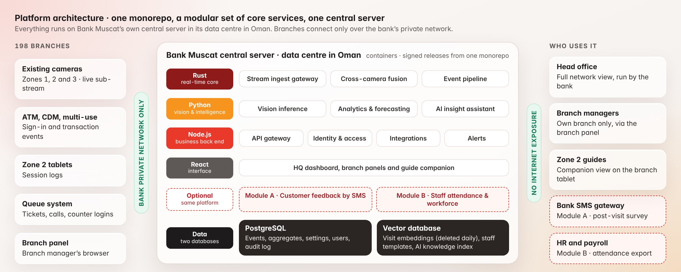
Figure 15 · Platform architecture: the core services on Bank Muscat’s central server, two optional modules and two databases.
The platform is split into a modular set of core services, around a dozen in the current design; the final number depends on the detailed design and the modules selected. They run side by side in containers on Bank Muscat’s central server in its data centre in Oman, and each optional module adds its own service when switched on. Cameras send a reduced live stream over the bank’s private network, frames are analysed in memory, and only events are stored. Nothing is exposed to the internet. Releases are built from the monorepo as signed, versioned packages that the bank’s IT team reviews and installs.

Who can access what
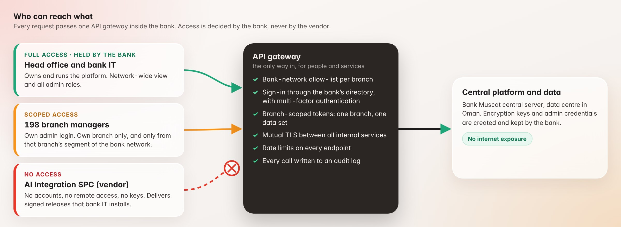
Figure 16 · Access control: head office holds full access, each branch manager sees one branch, and the vendor has none.
- Head office. The central platform, the network-wide dashboard and every admin role are held by Bank Muscat head office and the bank’s IT team.
- Branch managers. Each branch manager gets a login to the branch panel with their own admin account, issued by the bank through its existing directory with multi-factor sign-in. They see their own branch only. The panel reaches the platform only through the API, and only from that branch’s segment of the bank’s network.
- The vendor. We have no user accounts, no remote access, no stored passwords and no encryption keys. Keys and admin credentials are created and kept by the bank, so even we cannot log in. Support happens only in a session the bank opens and supervises, or from log bundles the bank reviews before sharing.
- The API. Network allow-lists per branch, branch-scoped tokens, mutual TLS between all services, rate limits on every endpoint, and an audit log of every call.

Accuracy on Bank Muscat’s own footage
The vision models are fine-tuned on Bank Muscat’s own branch footage, covering traditional Omani dress, crowded peak hours and varied lighting. This fine-tuning raises accuracy from demonstration level to the standard required for banking. Existing cameras are reused wherever the site survey confirms they are fit for purpose.

Operations, updates and support
- Health monitoring. Bank IT sees the status of every service, camera stream and branch link on one operations screen, with alerts when anything stops.
- Scales with demand. Services run in containers, so capacity grows by adding instances or servers. The number of services can grow or shrink as the design evolves, without changing the architecture.
- Backup and recovery. Databases are backed up inside the bank’s own environment, following the bank’s existing recovery policy.
- Controlled updates. New versions arrive as signed packages with release notes; the bank tests them and decides when to install.
- Handover. Admin guides, runbooks and training for bank IT, branch managers and guides, so the bank can run the platform independently.

SECTION 10

Expected impact and estimates
Queues behave non-linearly. When counters run close to full capacity, a small drop in arrivals produces a large drop in waiting time. Figure 17 applies a standard queueing model (Erlang C) to a typical branch at peak: four open counters, about 8 minutes per customer and 28 arrivals an hour.
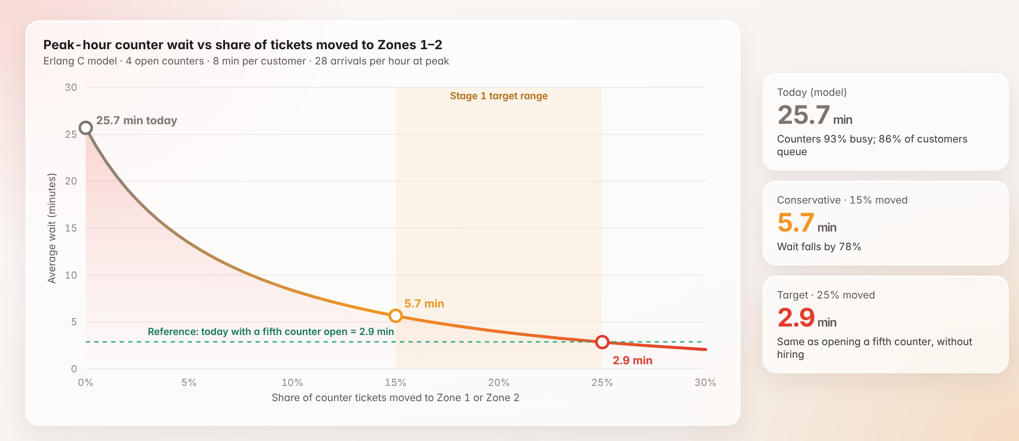
Figure 17 · Moving 15% of counter tickets to Zones 1–2 cuts the modelled peak wait from 25.7 minutes to 5.7. Moving 25% has the same effect as opening a fifth counter, without hiring.

Network-wide estimate
Planning assumptions: 198 branches; 110 counter tickets per branch per day; 8 minutes average handling time per ticket; 22 working days a month; 160 working hours per full-time employee per month; a fully loaded staff cost of OMR 1,000 per month (to be replaced with the bank’s own figure).
 | Conservative · 15% moved | Target · 25% moved
Tickets moved per branch per day | 16.5 | 27.5
Counter hours released per branch per day | 2.2 | 3.7
Counter hours released network-wide per month | 9,583 | 15,972
Full-time equivalents released | about 60 | about 100
Indicative annual value | about OMR 719,000 | about OMR 1.2 million
Modelled peak-hour wait (4 counters) | 25.7 min → 5.7 min | 25.7 min → 2.9 min

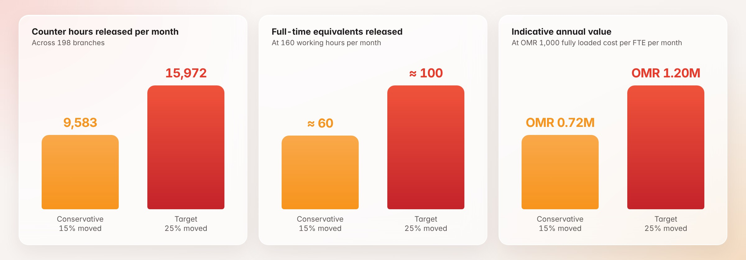
Figure 18 · Released capacity under the conservative and target scenarios.
The released capacity is best redeployed rather than cut: into Zone 2 guidance, sales and advisory conversations, and longer afternoon service. Customers also benefit. If the average counter wait falls by 6 minutes across the network, roughly 40,000 hours a month are returned to customers.

Benefits beyond the numbers
- A better branch experience. Less waiting, fewer unnecessary tickets, and help at the right moment.
- A fairer workload. Officers spend more time on work that needs their expertise and less on routine requests.
- Evidence for network planning. Real demand by branch and hour supports decisions on branch formats, opening hours and machine placement.
- Faster digital adoption. Every guided tablet session teaches a customer to use the bank’s digital channels next time.
- Audit-ready compliance. Every access and every rule is logged, which supports internal audit and regulators.
- A foundation for Stage 2. The questions customers ask become training material for the multilingual voice assistant.

SECTION 11

Risks, governance and service levels
Risk | How we manage it
Existing cameras do not cover a zone well enough | A site survey of every branch before installation; reuse suitable cameras and add or reposition only where accuracy requires it
Branch network links cannot carry the camera streams | Cameras send a reduced sub-stream (about 720p at 10 frames a second, roughly 1 Mbps each). The site survey measures every branch link; where one is too small, the same vision service can run on a small unit inside that branch without changing the platform
The biometric permit takes longer than planned | Tier A (anonymous) runs from day one and already delivers counts, paths and waits; Module B starts once the permit is granted
Accuracy drops in crowded peaks or with similar clothing | Fine-tuning on Bank Muscat footage; accuracy audited against manual counts before go-live and quarterly thereafter
Queue-system or ATM data is hard to access | Read-only log exports as a fallback; no change to core banking systems
Staff see Module B as surveillance | Written notice before enrolment, clear rules, employees see their own records, no cameras in private areas
Low survey response (Module A) | 30-second bilingual form, sent within a minute of exit, pre-filled from the visit
A branch link drops | That branch’s live view pauses and resumes automatically; other branches are unaffected and the gap is flagged

Governance
- A monthly steering committee with retail banking, digital, IT, compliance and the data protection officer
- A weekly working group during the pilot and rollout
- A shared benefits tracker that compares every KPI against the pilot baseline

Service levels
Service level | Commitment
Platform availability during branch hours | 99.5% or higher
Alert delivery | Within 60 seconds of the event
Dashboard refresh | Every 15 seconds or faster
People-counting accuracy | 95% or higher, audited quarterly
Critical incident response | Within 1 hour, 7 days a week
SECTION 12

Looking ahead: Stage 2
Stage 1 shows exactly what customers ask and where they encounter difficulties. Stage 2 answers those questions. It is a real-time voice assistant on Zone 2 tablets and kiosks that listens and replies in the customer’s own language: Arabic, English and the main languages of Oman’s residents. It streams over WebSocket, so the conversation feels natural.
The assistant is trained on Bank Muscat’s products, fees and procedures. It helps the customer complete simple requests and hands over to the guide or a counter with the context already captured. Every question that Stage 1 records becomes training material for Stage 2.
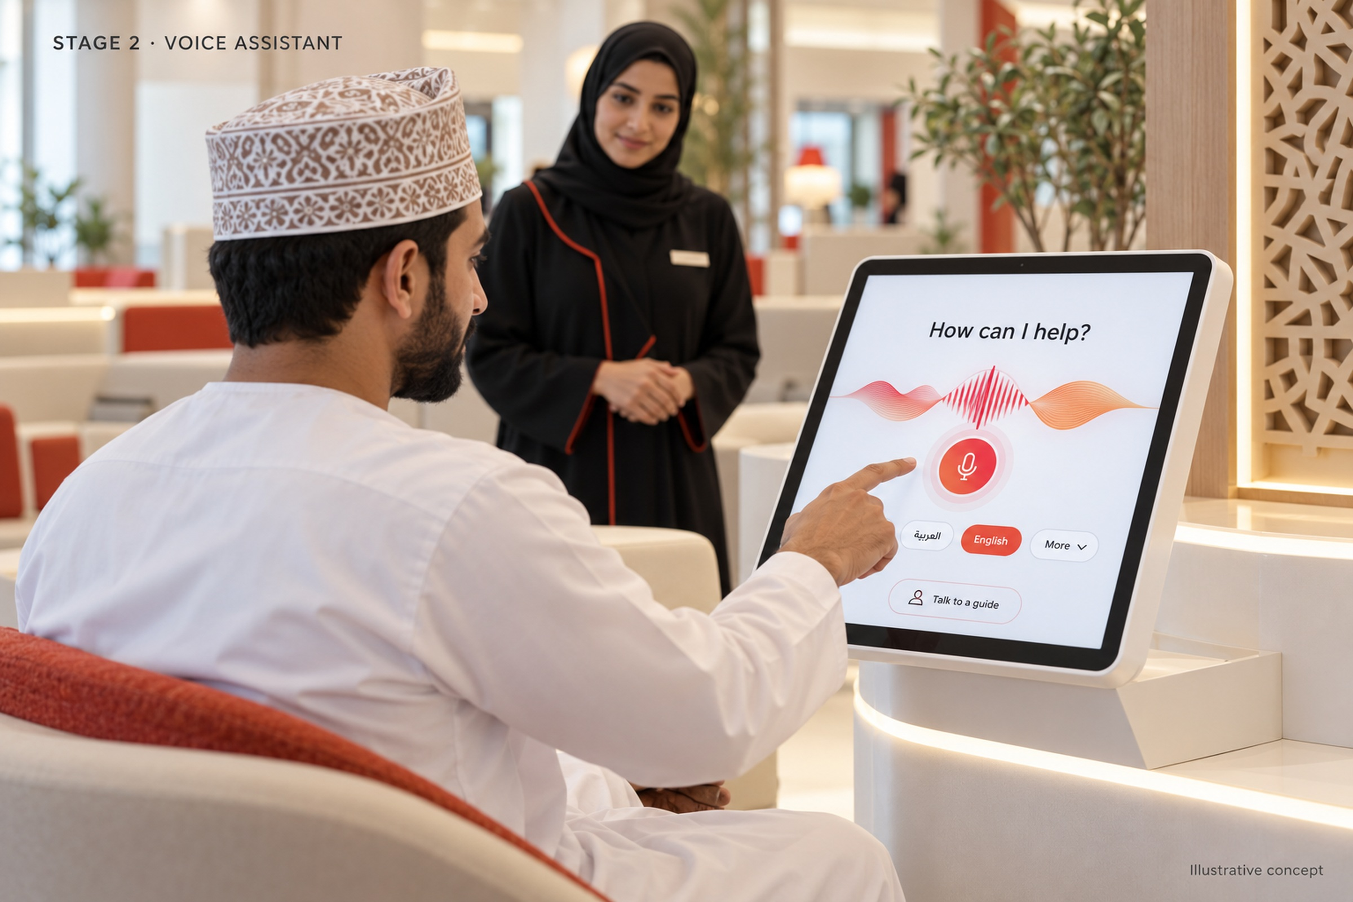
Figure 19 · Stage 2: a multilingual voice assistant on Zone 2 tablets and kiosks.
SECTION 13

What we need from Bank Muscat, and next steps
To start the pilot we need:
- Five pilot branches of different sizes, including one Meethaq branch (Meethaq, the bank’s Islamic banking window, now runs 32 branches) and one branch with heavy afternoon traffic.
- Camera access: camera streams (RTSP) and floor plans for each pilot branch.
- System logs: read access to queue-system, ATM and tablet session logs.
- People: a business owner from retail banking, and the bank’s data protection officer.
- Optional modules: whether to include Module A and Module B in the pilot; for Module B, an HR contact and the staff list for enrolment.

We propose a kick-off workshop, followed by a site survey of the pilot branches and a joint sign-off of the pilot results. The commercial schedule is provided as a separate attachment.

Why AI Integration SPC
- Registered in Oman, based in Muscat. We work on site, side by side with the bank’s teams.
- One team, the whole platform. Vision, data, back end and dashboards are built and supported by the same team.
- Built for the bank’s control. The platform runs inside Bank Muscat, and the bank holds every key and admin role.
- Measured before scaled. Results are proven against the pilot baseline before the network rollout.

Assumptions and sources
The branch count (198 branches across Oman, as of December 2025) comes from Forbes Middle East’s 2026 company list; the Meethaq branch count (32) and the machine count (more than 900) come from May 2026 reports; other network figures come from Bank Muscat’s public announcements. Regulatory points come from published summaries of Royal Decree 6/2022 and Ministerial Resolution 34/2024. The service mix, ticket volumes, handling time and staff cost are planning assumptions, to be replaced with measured pilot data. Dashboard screens and camera views are illustrative. Numeric dashboard values reproduce proposal targets and modelled estimates; operational values await pilot data. Faces are blurred in camera illustrations.

