

**Course Name**: Computer Architecture Lab

**Course Number and Section**: **14:332:333:0A**

**Experiment**: Lab 1: Intro and Number Representation

**Lab Instructor**: Mengmei Ye

**Date Performed**: February 5th 2019

**Date Submitted**: February 12th, 2019

**Submitted by**: Keeyan Haghshenas 171000841

Shazidul Islam 171001540

--------------------------For Lab Instructor Use ONLY--------------------------

GRADE: _______________

COMMENTS: 

Electrical and Computer Engineering Department

School of Engineering

Rutgers University, Piscataway, NJ 08854

1. **Unsigned Integers**

**1.1:Conversions:**

A:

|  |  |  |  |  |  |
| --- | --- | --- | --- | --- | --- |
| **Given:** | | **First Conversion:** | | **Second Conversion:** | |
| **Type:** | **Quantity** | **Type:** | **Quantity** | **Type:** | **Quantity** |
| Binary | 0b10101000 | Hex | 0xA8 | Decimal | 168 |
| Hex | 0xB3 | Binary | 0b10110011 | Decimal | 179 |
| Decimal | 29 | Binary | 0b00011101 | Hex | 1D |
| Binary | 0b00101001 | Hex | 0x29 | Decimal | 41 |
| Hex | 0xAC9F | Binary | 1010110010011111 | Decimal | 44191 |
| Decimal | 0 | Binary | 0 | Hex | 0 |

B:

|  |  |
| --- | --- |
| **Given** | **Converted** |
| 2^11 | 2Ki |
| 2^35 | (2^5) Gi |
| 2^22 | 2Mi |
| 2^81 | 2Yi |
| 2^69 | (2^9)Ei |
| 2^58 | (2^8)Pi |

**C:**

|  |  |
| --- | --- |
| **Given** | **Converted** |
| 4Ti | 2^42 |
| 32Ei | 2^65 |
| 512Gi | 2^39 |
| 2Yi | 2^81 |
| 8Mi | 2^23 |
| 64Ki | 2^16 |

**2.2 Exercises:**

**1: What is the largest integer? The largest integer +1?**

|  |  |  |
| --- | --- | --- |
| **xxxxxx** | **Unsigned** | **Two’s Complement** |
| Largest | 11111111 | 01111111 |
| Largest +1 | overflow | 10000000 |

**2. How do you represent the numbers 0, 4, and -4?**

|  |  |  |
| --- | --- | --- |
| **Number** | **Unsigned** | **Two’s Complement** |
| 0 | 00000000 | 00000000 |
| 4 | 00000100 | 00000100 |
| -4 | DNE | 11111100 |

**3. How do you represent 29, -29?**

|  |  |  |
| --- | --- | --- |
| **Number** | **Unsigned** | **Two’s Complement** |
| 29 | 00011101 | 00011101 |
| -29 | DNE | 11100011 |

**4. What is the largest integer that can be represented by any encoding scheme that only uses 8 bits?**

**Answer: 255**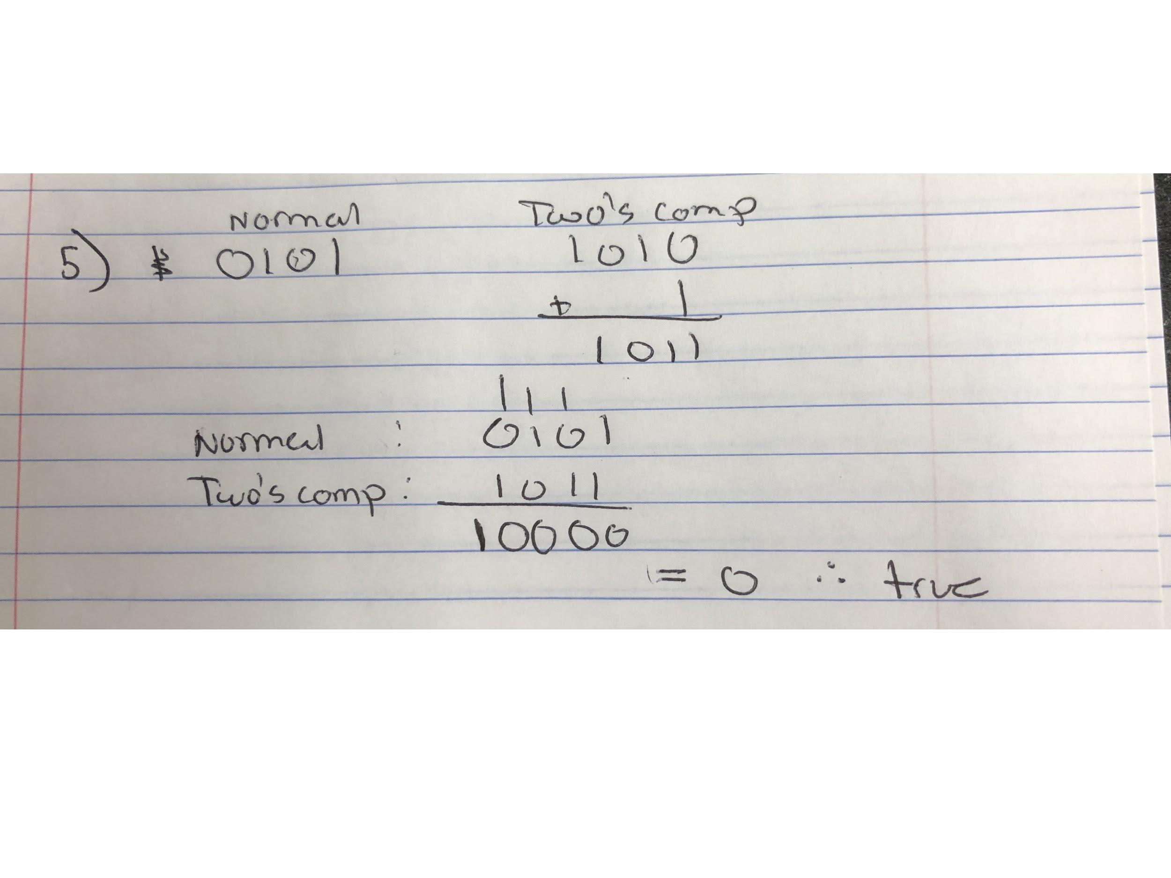

**5:**

**6:**

Decimal: Decimals are generally prefered when we are doing human hand calculations. The reason is because our count system is based around 10 due to the fact that we have 10 fingers. This lets us visualize the equal distribution.

Binary: Binary is prefered for computer calculation due to the fact that it will not get jumbled up as easy as the other two radices. The reason is because they can only have a value of 1 or 0 which is true or false. But then a combination can mean something else. But in the base there is only two options.

Hex: Hexadecimal is very useful due to the fact one hex is equal to 4 binary. So basically if we want to represent a large binary number and save space, we can represent that number in hex

**3.1:Exercises:**

**1: 2^2**

**2: 2^12**

**3: 1 bit**