# Command 1

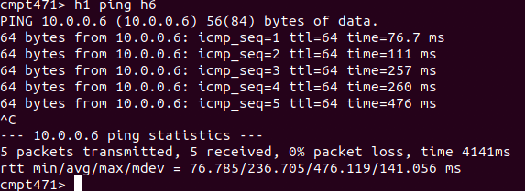

Here is the flow table for all switches after executing the L2 command as the operator.

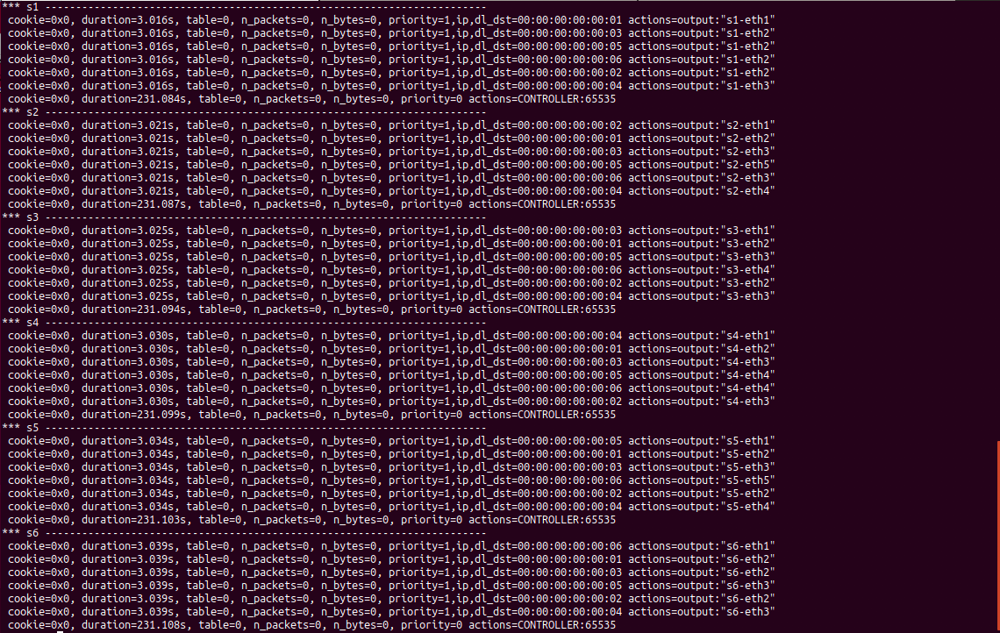

The flow tables are now populated. Analyzing the flow tables, we see that the ‘actions’ is set to forward packets to the output port that will lead them towards their destination based on their destination MAC address. For example, we see that for s2, a destination MAC address of 00:00:00:00:00:02 is forwarded along s2-eth1, which corresponds to the host for switch 2. This host has MAC address 00:00:00:00:00:02. S4 sends packets with destination MAC address 00:00:00:00:00:02 along output port s4-eth3. This is the output port that shares a link with s2, so again, this checks out. In general, this flow table makes it so packets are routed along the shorted path (in terms of number of links used) to reach their destination.