# Knowledge Clipper User Guide



# Functionality

The Knowledge Clipper is used for Knowledge Clip creation from existing lectures or events by defining a start and end time for an existing video.

# Screen Sections

Header

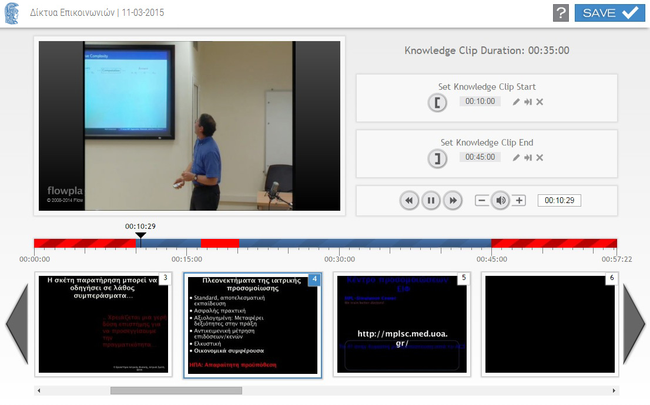

Slides Thumbnails

TimeLine

Video Buttons

Video Player

Knowledge Clip Duration

Buttons and controls for each section:

## Header

Information concerning the title and the date of the lecture/event are displayed.

| Button | Function |
| --- | --- |
|  | Saves the start and end time that have been created or modified during the editing. The button is activated upon the creation or modification of the start or end time. |
|  | Displays the User Guide. |

## Video Player

The actual video player where the video frames are displayed.

| Button | Function |
| --- | --- |
| Video | [Click] to play/pause the video. Double [click] for full screen mode. |

## Video Buttons

| Button | Function |
| --- | --- |
| fback | Fast backwards (5'' time interval). |
| play | Play/Pause video.  Trims and Cuts (that are defined by the video editor  or the Knowledge Clipper ) are skipped during playing. |
| fforward | Fast forward (5'' time interval). |
| vol- | Volume down. |
| vol | Mute/Unmute. |
| Vol+ | Volume up. |
| Time field | The current time.  This field is editable (edit/copy/paste) – Press [Enter] in order to go to the defined time. |

**Knowledge Clip Duration**

The Knowledge Clip’s start and end time are defined:

| Button | Function |
| --- | --- |
| F:\data\Christopher\GUnet\VideoIcons\Final_Buttons\set-start-time.png | [Set Knowledge Clip Start Time]: Sets the cut-off section from the beginning of the video to the time where the timeline’s slider indicator is positioned. |
| F:\data\Christopher\GUnet\VideoIcons\Final_Buttons\set-end-time.png | [Set Knowledge Clip End Time]: Sets the cut-off section from the end of the video to the time where the timeline’s slider indicator is positioned. |
| Edit | [Edit]: Start and End time modifications. |
| GotoMarker | [Goto & Check]:Goes to the specific time. |
| DeleteMarker | Deletes the cut-off section. |
| Time  field | Displays the time of start and end point in HH:MM:SS form. |

*Note: If the Knowledge clip start time is not defined, the video start time (as it is defined by the Video editor) is considered as start time.*

*If the Knowledge clip end time is not defined, the video end time (as it is defined by the Video editor) is considered as end time.*

**TimeLine**

A horizontal timeline which displays the video duration and the defined trims and cuts. The time indicators bellow the timeline are of HH:MM:SS form.

The time above the slider indicator displays the current time of the video (HH:MM:SS).

The red sections on the timeline represent the trim and cut sections as they are defined by the Video Editor (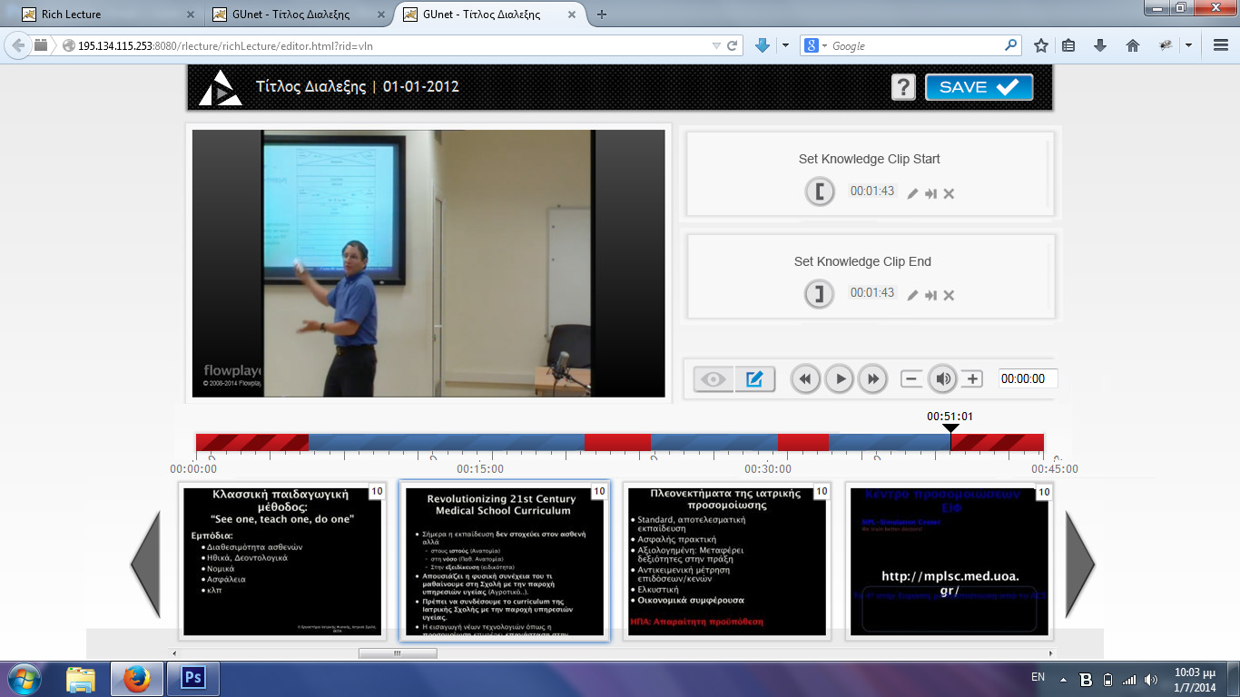) and the striped red sections represent the trim sections (start and end time) as they are defined by the Knowledge Clipper ().

| Button | Function |
| --- | --- |
| Time | While dragging, the slider goes to any point of video’s time. |

## Slides Thumbnails

A horizontal thumbnail list with all the syncronized slides is presented.

| Button | Function |
| --- | --- |
| ff - ff | Quick forward scrolling. Quick backward scrolling. |
| [Click] on a thumbnail | Sets the current video time to the slide’s synchronized time marker. |

The blue color of the slide’s number background and the thumbnail’s frame indicates the synchronized slide to the video’s current time.

*Note: The slides’ thumbnails will be displayed only if the slides have been synchronized with the video.*