# Slide Synchronization Editor User Guide



# Functionality

The Slide Synchronization Editor is used as a tool in order to synchronize slides with a video. The slides can be displayed at a defined time and period while the video is playing. In order to achieve the synchronization we define a timing marker for each slide. The slide’s appearance starts from the defined timing marker and lasts until the next timing marker or the end of the video.

The application has two modes:

(a) **Edit Mode** in order to define and edit the time markers

(b) **Preview Mode** in order to check the markers, to preview/simulate the video playback and the simultaneous display of the synchronized slides.

# Screen Sections

Marker List

Header

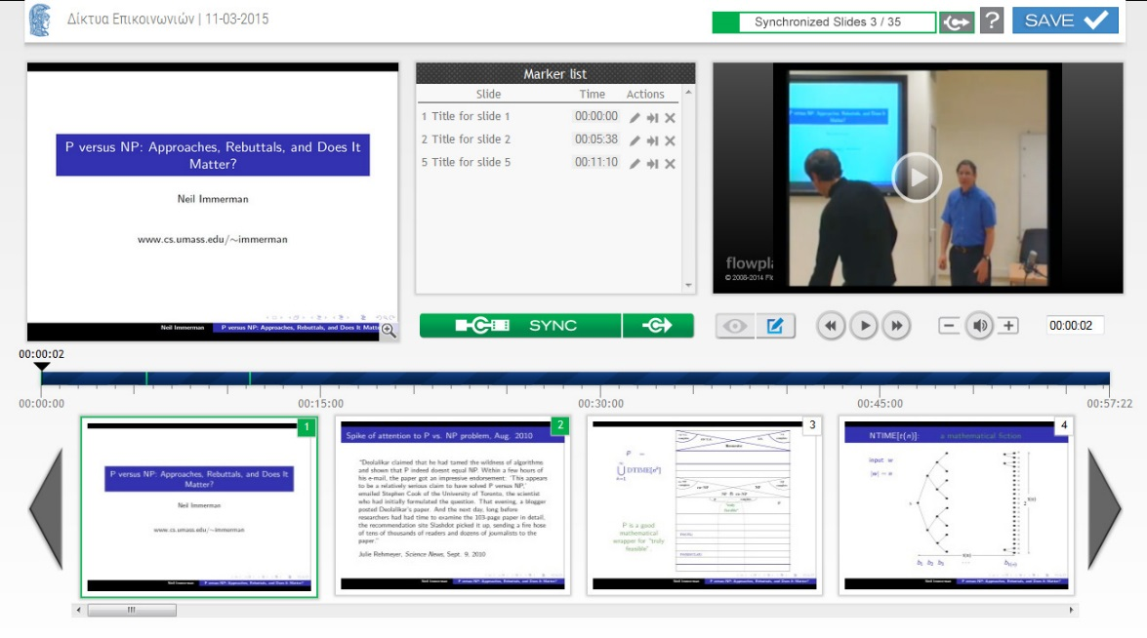

Slides Thumbnails

TimeLine

Video

Selected   
slide

Buttons and controls for each section:

## Header

Information concerning the title and the date of the lecture/event are displayed.

A progress bar which indicates the number of synchronized slides vs the total number of slides is displayed in order to provide us an overview of the synchronization’s completion.

| Button | Edit Mode  PreviewEditMode | Preview Mode  PreviewModeEditMode |
| --- | --- | --- |
|  | Goes to the first slide which is not synchronized with the video. | - |
|  | Saves all the timing markers. The button is activated upon the creation or modification of any marker, otherwise it is disabled. | |

## Selected Slide

In Edit Mode the selected slide which will be synchronized with the video is displayed.   
In Preview Mode the slide which is synchronized to the current time of video is displayed.

| Button | Edit Mode  PreviewEditMode | Preview Mode  PreviewModeEditMode |
| --- | --- | --- |
| Maginfy Glass | Displays the selected slide enlarged. | |

## Marker List

The list displays the slides defined timing markers sorted by time and all the relevant buttons:

* The number and the title of Slide
* The timing marker in a form of hh:mm:ss. (The starting time of slide showing)
* The control buttons for each marker.

| Button | Edit Mode  PreviewEditMode | Preview Mode PreviewModeEditMode |
| --- | --- | --- |
| sync | Creates a new timing marker and synchronizes the selected slide to the current time of video.  Each slide can be synchronized to multiple timing points. | - |
| Sync&Go | Creates a new timing marker, synchronizes the selected slide to the current time of video and automatically selects the next slide for synchronization (Sync & Go). | - |
| Edit | Edits the marker’s time | - |
| [Shift] + Edit | Time shifts the selected and all the following markers. (Shifting +/- by a defined number of seconds or at a specific time of video). | - |
| GotoMarker | Goes video time 5’’ before the timing marker. | |
| DeleteMarker | Deletes the timing marker. | - |

## Video

In this area are displayed the follwing:

* The Preview/Edit switch button
* The Video, the playback and the audio buttons,
* Τα button ελέγχου του ήχου και
* The current time field.

| Button | Edit Mode  PreviewEditMode | Preview Mode  PreviewModeEditMode |
| --- | --- | --- |
| PreviewMode | Enables Preview mode in order to check the markers, to preview the video playback and the simultaneous display of the synchronized slides (according to timing markers).  The video playback starts 5’’ before the current time and in the selected slide’s area, the synchronized slide to the current time of video is displayed.  By selecting a slide thumbnail, the video goes to the slide’s synchronized time marker. | - |
| EditMode | - | Enables Edit Mode in order to define and edit the slides’ time markers.  In the selected slide’s area, the slide which will be synchronized with the video is displayed (by selecting a slide thumbnail). |
| fback | Fast backwards (5'' time interval). | |
| play | Play/Pause video. | |
| fforward | Fast forward (5'' time interval). | |
| vol- | Volume down. | |
| vol | Mute/Unmute. | |
| Vol+ | Volume up. | |
| Time field | The current time.  This field is editable (edit/copy/paste) – Press [Enter] in order to go to the defined time. | |
| Video | [Click] to play/pause the video. Double [click] for full screen mode. | |

## Χρόνος (TimeLine)

A horizontal timeline which displays the video duration and the defined timing markers. The time indicators bellow the timeline are of HH:MM:SS form.

The time above the slider indicator displays the current time of the video (HH:MM:SS).

The vertical lines on the timeline represent the timing markers, while the time duration of each synchronized slide is indicated on mouse over each row of the marker list.

| Button | Edit Mode  PreviewEditMode | Preview Mode  PreviewModeEditMode |
| --- | --- | --- |
| Time | While dragging, the slider goes to any point of video’s time. | |

## Slides thumbnails

A horizontal thumbnail list with all the available slides is presented. On the upper right corner of each thumbnail the number of slide is displayed and a green background color is used to indicate that the slide is synchronized.

In the second place of the list, the thumbnail of the selected slide is displayed.

| Button | Edit Mode  PreviewEditMode | Preview Mode  PreviewModeEditMode |
| --- | --- | --- |
| ff - ff | Quick forward scrolling. Quick backward scrolling. | |
| [Click] on a thumbnail | Selects the slide for synchronization and updates the selected slide. | Sets the current video time to the slide’s synchronized time marker. |
| Double [Click] on a thumbnail | Selects and synchronizes the slide to the current video time (creates a new timing marker). | - |