# Video Editor User Guide



# Functionality

The Video editor is used as simple video processing tool. The user may define the starting and ending time of the video (Trims) as well as intermediate sections to be skipped during playback (Cuts).

# Screen Sections

Header

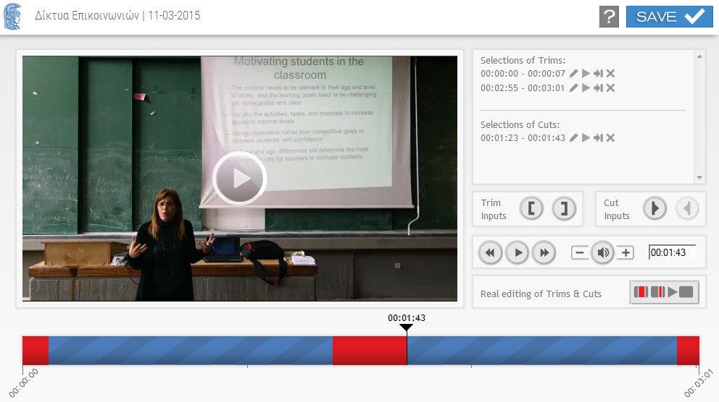

Real Edit

Video Buttons

Trim & Cut Buttons

List of Trims & Cuts

TimeLine

Video Player

Buttons and controls for each section:

## Header

Information concerning the title and the date of the lecture/event are displayed.

| Button | Function |
| --- | --- |
|  | Saves all the trims and cuts that have been created or modified during the video editing. The button is activated upon the creation or modification of any trim or cut. |
|  | Displays the User Guide. |

## Video Player

The actual video player where the video frames are displayed

| Button | Function |
| --- | --- |
| Video | [Click] to play/pause the video. Double [click] for full screen mode. |

## Video Buttons

| Button | Function |
| --- | --- |
| fback | Fast backwards (5'' time interval). |
| play | Play/Pause video.  Trims and Cuts are skipped during playing. |
| fforward | Fast forward (5'' time interval). |
| vol- | Volume down. |
| vol | Mute/Unmute. |
| Vol+ | Volume up. |
| Time field | The current time.  This field is editable (edit/copy/paste) – Press [Enter] in order to go to the defined time. |

**Trims & Cuts Lists**

This list shows the cut-off sections of the video:

Selection of Τrims: Trims from the start and the end of the video.

Selection of Cuts: Intermediate cut-off sections with start-end time indications sorted by time.

With mouse over each row, the equivalent cut-off section on the time line is display with green color. In each row are displayed: The start time, the end time and the appropriate control buttons for the cut-off section.

| Button | Function |
| --- | --- |
| Edit | [Edit]: Displays a pop up window where the start and stop time of the cut-off section can be edited. |
| PlayCuttedSection | [Play]: Displays a pop up window with the cut-off section’s video. |
| GotoMarker | [Goto & Check]: Goes video time 5’’ before the cutoff section, so we can play the video and check the playback while skipping the cut-off section. |
| DeleteMarker | [Delete]: Deletes the cut-off section. |

**Trim & Cut Buttons**

| Button | Function |
| --- | --- |
| Trim Inputs Buttons | |
| Z:\data\Christopher\GUnet\VideoIcons\Final_Buttons\set-start-time.png | [Set Start Time]: Sets the cut-off section from the beginning of the video to the time where the timeline’s slider indicator is positioned. (Simultaneously, necessary controls are performed in order to prevent overlapping with other cut-off sections). |
| Z:\data\Christopher\GUnet\VideoIcons\Final_Buttons\set-end-time.png | [Set End Time]: Sets the cut-off section from the end of the video to the time where the timeline’s slider indicator is positioned. (Simultaneously, necessary controls are performed in order to prevent overlapping with other cut-off sections). |
| Cut Inputs Buttons | |
| Z:\data\Christopher\GUnet\VideoIcons\Final_Buttons\begin-cut.png | [Begin Cut]: Sets the beginning of a new cut-off section to the to the time where the timeline’s slider indicator is positioned, activates [End Cut] button in order the ending time setting to be available and updates the Cuts’ list. (Please notice that through the list we can cancel the creation of this new cut-off section.) |
| Z:\data\Christopher\GUnet\VideoIcons\Final_Buttons\end-cut.png | [End Cut]: Sets the end of cut-off a section to the time where the timeline’s slider indicator is positioned by dragging the slider, or setting the time by using the appropriate video buttons. This button is activated only when the beginning of a new cut-off section has been defined. (Simultaneously, necessary controls are performed in order to avoid invalid time setting). |

*Note: Only one trim section for the beginning of the video and one from the end of the video can be defined. Intermediated cut-off sections can be defined by using the Begin Cut και End Cut buttons.*

## Real Edit

The Trims and Cuts that are skipped during playing will be actually deleted from the video and a new one with shorter duration will be created.

| Button | Function |
| --- | --- |
|  | Start the Real editing.  *Note: The new video must be previewed and accepted from the Content Administration in order to replace the existing one.* |

**TimeLine**

Horizontal timeline which displays the video duration and the defined trims and cuts. The time indicators bellow the timeline are of HH:MM:SS form.

The time above the slider indicator displays the current time of the video (HH:MM:SS).

The red sections on the timeline represent the trim and cut sections (and are updated by the relevant Trim & Cut List buttons (Edit, Delete, Set start Time, Set end Time, Begin cut, End cut). With mouse over each red section the start-end time of the represented cut-off section is displayed.

| Button | Function |
| --- | --- |
| Time | While dragging, the slider goes to any point of video’s time. |