**Project Report**

**On**

**Blog Now (Blogging System)**

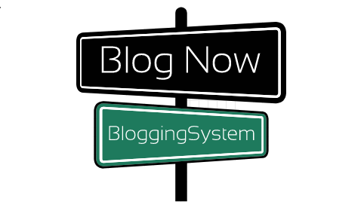

**Keeyoshi Pyakurel**

**College ID: 170334**

**Batch: 22 B**

**Computing Project**

**Softwarica College of IT & E-Commerce**

**Kathmandu, Nepal**

**Submitted on: 31st January 2020**

**Submitted to: Mr. Niman Maharjan**

**Abstract**

Blog Now, a blogging system a web-based application that help people to post blogs related to their lifestyle, hacks, tricks, entertainment or any other advertisements which can be view by every other individual. Blogs can be added, altered and even deleted.

**Acknowledgement**

Blog Now, Blogging System which has been successfully completed so I would like to express my deepest gratitude for providing me opportunity to start and completed the project. Also, I am thankful for helping and guiding me throughout the project.

Finally, I would like to thank all my friend and teacher who helped me completed the project

Contents

Chapter 1: Introduction 6

a. Introduction of the project 6

b. A Background of the project 6

c. Aims and Objectives 6

d. Description of the project 6

Chapter 2: Analysis 7

a. Introduction to analysis 7

b. Advantages and Disadvantages of the system 8

c. Requirements Analysis 8

MoSCoW prioritization 8

Functional Requirements 9

Non-Functional Requirements 11

d. Initial Class Diagram (NLA) 13

e. Use Case Diagram 14

f. Feasibility Study 15

Chapter 3: Design 16

a) Introduction of the design 16

b) Dynamic Modelling 16

I. Activity Diagram 16

II. Sequence Diagram 17

III. Final Class Diagram 17

IV. Database Design 18

A. Data Dictionary 18

B. ER Diagram 18

V. Architectural Design 18

i. UI: Prototyping 18

Chapter 4: Implementation 18

Chapter 5 Testing 19

References 19

**Table of Figure**

Figure 1 Waterfall model 7

Figure 2 MoSCoW Prioritization 9

Figure 3 Example of Non-Functional Requirement 12

Figure 4 Class Diagram 14

Figure 5 Use Case Diagram 15

Figure 6 Activity Diagram 16

Figure 7 Login Sequence Diagram 17

# Chapter 1: Introduction

## Introduction of the project

In modern era of time people love to share the thing that they found fascinating. People see and learn new thing every day and are really excited to share their point of view and are looking for a way to share in different ways. The world is full of information and people want to learn and share the information. Some people like to share their information by uploading the video where many other wants to share by writing and expressing by words. So, I have developed “**Blog** **Now**” – A Blogging System that help people to share the information that they want, their expression etc.

## A Background of the project

Blog Now- A Blogging system is a web-based application where people can share information related to lifestyle, tricks, hacks, advertisements and other offers. In recent years people who want to share their information are growing rapidly as the world is a large place with a lot of new activities that we get to see. With the help of html, php, SQL, XAMPP I have developed this project.

## Aims and Objectives

* **Aims**

The main aim of Blog Now – a blogging system is to provide user opportunity to share the information that they desire at any time from any device thorough internet,

* **Objectives**

The main objectives of the Blog Now are as follows:

* Manage the details

## Description of the project

* **Features**
* **Simple and user Friendly:** The website will be simple and user friendly so anyone can easily learn how to use without any problems.
* **Better Management System:** The website major focus is to stored details about users and what user want to upload. The system saves the data without any major problems and are easily retrievable.
* **Faster and Reliable:** Online Blog system overcome the difficulty of sharing information from one person to another or from on place to another as user can share without any problems and can be received/view by many users from different places.
* **Performs CRUD operation:** The application major features are to store, record, update and view to users’ details and what they like to share
* **Effective:** The system is very effective as every detail stored can updated or deleted. Record that are stored double can be removed easily and no data are loss

# Chapter 2: Analysis

The approach for the completion of the project that I have chosen is Software Development Life Cycle or SDLC in short which is a systematic way to completed the program. I have chosen the earliest SDLC approach which is The **Waterfall model**. The reason I have chosen waterfall model for the completion of the project is as this approach is very easy to learn and understand. The stages don’t overlap between each stage as each stage must be completed before beginning the next stages. (Lakhsay Sharma, 2016). Waterfall model has six stages that includes

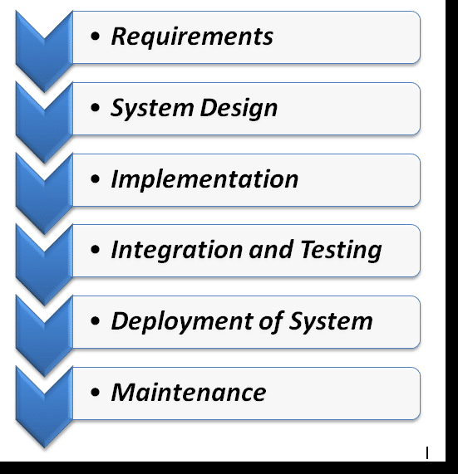

Figure 1 Waterfall model

## Introduction to analysis

Analysis is the first stage of the waterfall model where all the requirements are gathered and analyzed. This stage where we learn about the project and what are needed to completed the system. We can get all kind of information about the system as the developer can understand about the project needs. Without proper analysis the system won’t be able to satisfy users and customer as many bugs, error, etc. can occur. The final system can be completed changes from what the user wants if the analysis of the system is not done properly. Analysis can be done in many different ways they are as follows:

## Advantages and Disadvantages of the system

Blog Now- the blogging management system has its own advantages and disadvantages. Some are listed below:

* **Advantages**
* The system helps user to share their point of view, interest, lifestyle, hacks etc. and also companies can share the information about their products, offers etc.
* Being user friendly any user can use this system without any problems and view the information that is being share on the website.
* Being internet-based application, user can share information from any place from any device with the help of internet.
* Basic features that the blog system should consist are available in the system so user can freely use this system without any problems.
* **Disadvantages**
* The system doesn’t allow user to share/ comment on the blog.
* The system still lacks many other features that can make this project more appeal to the users.

## Requirements Analysis

### MoSCoW prioritization

MoSCoW prioritization can also be known as MoSCoW method or analysis that is very popular for arranging the available requirement. The shortening, MoSCoW stands for four different types of categories of initiatives that can be explains as follow

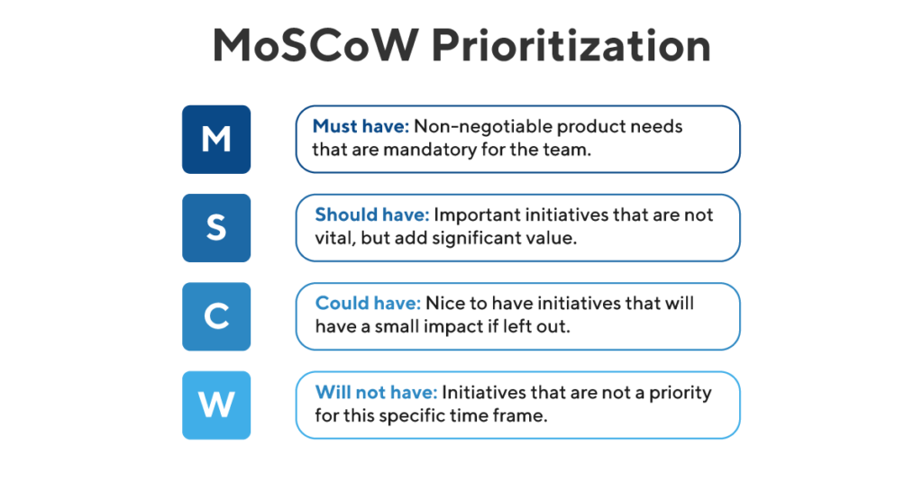

Figure 2 MoSCoW Prioritization

* **Must Have:** As from the name we can understand that the requirements are the most important part of the project and are non-negotiable. It is denoted by “**M**” during MoSCoW Prioritization. The final product doesn’t work or becomes useless without this initiative.
* **Should Have:** Should have includes those requirements that are important for the project but are not vital. It is denoted by “**S**” during MoSCoW prioritization. The final product still functions but if added in the system then they improve the project significantly.
* **Could Have:** Could have can also called as those requirements that are nice to have which are neither importance or vital for the system. It is denoted by “**C**” during MoSCoW prioritization.
* **Won’t Have:** Won’t have or also can be known as will not have this time that are not really necessary for the completion of the project. It is denoted by “**W**” during MoSCoW prioritization. (Product Plan, 2019)

### Functional Requirements

Functional requirements are those that explains what the system does, explaining the behavior and function of the system when certain condition is met. Functional requirement for the Blog-Now, the blogging management system are as follow:

|  |  |  |  |  |  |
| --- | --- | --- | --- | --- | --- |
| **ID** | **Title** | **Description** | **Rational** | **Dependency** | **MoSCoW** |
| FR1 | User Registration | User should be able to register for login | To be able create profile and login | N/A | M |
| FR2 | User login | User login helps for access to system, profile etc. | To access the system, profile and security measure | FR1 | M |
| FR3 | Edit/Delete User profile | User should be able to edit/delete their profile. | To manage profile, update profile or delete profile. | FR2 | M |
| FR4 | Create Blog | User/Admin can add blog | To be able to add blog with different types of categories | FR2 | M |
| FR5 | Edit/Delete Blog details | User/Admin can alter, delete blog description | To be able to update, deleted blog details | FR4 | M |
| FR6 | View Blog Details | User, Guest can view Blog added by User | To be able to view details from different user | N/A | M |
| FR7 | Share Blog Details | Admin can edit information about following | To be able to edit or remove league, team, player and coach | FR4 | S |
| FR8 | Search Blogs | User can search blog | To be able to search blog from search bar | FR2 | C |
| FR9 | Contact Admin | User can directly contact for more details, new or ask question or complain | To be able to contact with the administrator without any problems through email, phone etc. | FR2 | S |
| FR10 | Comment | User are able to comment on the blog | To be able to express their view about the post | FR2 | W |

### Non-Functional Requirements

A Non-functional requirement are those requirements that shows how the system performs a certain function. It explains the quality attributes of a software. If the final project lacks on the non-functional requirement then the system can result to failure and the users will never be satisfied.

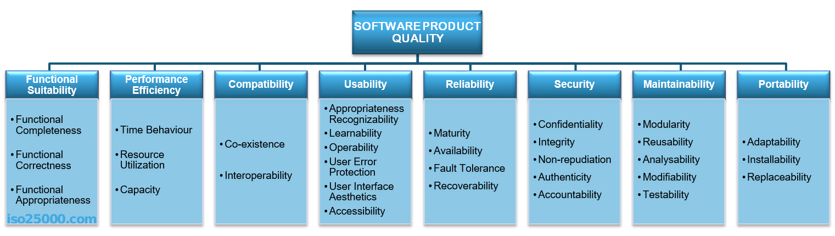

Figure 3 Example of Non-Functional Requirement

|  |  |  |  |
| --- | --- | --- | --- |
| **ID** | **Title** | **Description** | **Rational** |
| NF1 | Performance | System must be able to perform all required task without problem. | Best performance system makes it easier and faster to user |
| NF2 | Security | System must be secured to protect user and system | Secure system helps to store information and protect system |
| NF3 | User Friendly | System need to be easy to understand so any user can use the system | To make the system easier to use and learn |
| NF4 | Reliable/Data Integrity | System reliable is essential to the system as it helps user get accurate information | To provide information correctly so user is able to trust the system |
| NF5 | Efficiency | System need to be efficient as it allows user to use the system without other problem | To run system smoothly without any major problems like bugs, glitch etc. |
| NF6 | Capacity/  Scalability | System should have capacity or  Scalability for storage purpose | To have ability to store large amount of data and allows multiple user at same time |
| NF7 | Maintainability | System should be maintained regularly | To prevent errors and remove bugs system should be maintained |
| NF8 | Availability | Availability means information been available when needed | To provide information available to every user |
| NF9 | Environmental | System should not harm nature or environment | To make system eco- friendly |
| NF10 | Recoverability | Recoverability is like a data backup | To be able to recover and regained past data |

**Justification**

By using MoSCoW prioritization and listing possible requirement we can get information about the importance of each requirements and sort them basic of which requirement are essential for successfully developing the system. It helps to set a plan and track the progress of developing the system.

## Initial Class Diagram (NLA)

Class diagram a way of static structure diagram that help to explain the structure of the system by explaining the system class, their attributes, operation and the relationship among the object. (Visual Paradigm, 2015)

Natural Language Analysis is another way to analyzed the requirement for the system. It helps to identify possible classes, attributes and the relationship between different classes written through natural language. The system data written from analyzed data need to be filtered by different process.

By listing all the nouns also known as classes, verbs which are method and adjective which can also call attributes from the listed scenario.

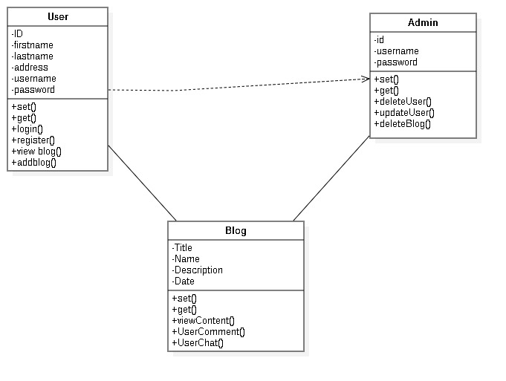

Figure 4 Class Diagram

## Use Case Diagram

Use case diagram are mostly simple that shows the expected behavior about how the system works but are not the exact method of how the system will works. It is the visual diagram that explain how each actor cooperates with each feature, function of the system.

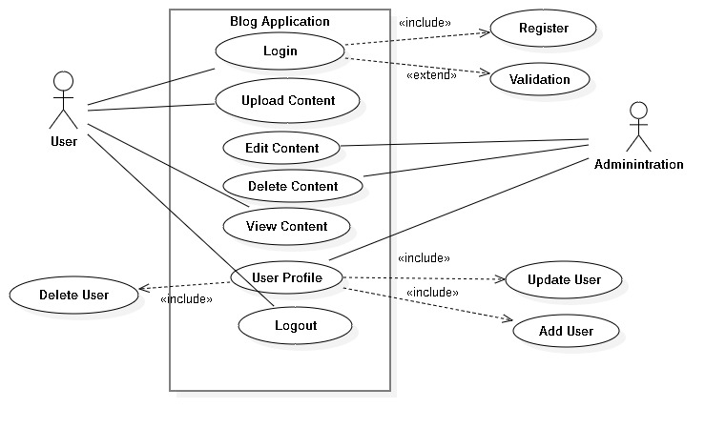

Figure 5 Use Case Diagram

## Feasibility Study

A feasibility study is done to measure the ability and likelihood for the project to be successful. It is done to check if the project Blog Now is different from what the project must be due to many reasons as explain:

* **Technical feasibility:** Technical feasibility helps to check if the technology for the project completion is available or not. Do the available resources help to improve the project in any ways? The technical resources used for completing the project are Laptop, internet, XAMPP, etc.
* **Schedule Feasibility:** Schedule feasibility helps to check if the project can be completed on time or are the project different stages are completed on time.
* **Legal/Ethical Feasibility:** Legal/Ethical feasibility is also one of the importance as it help to check if the project is not illegal and affect ethical of other. Blog Now- the system is clear from both legal and ethical problems.
* **Operational Feasibility:** Operational feasibility helps to check how well the developer can and are able to solve the problem and take advantage of opportunities.

# Chapter 3: Design

Design is the third stages of waterfall model that helps to identify hardware and system requirement and also helps to defining overall system architecture. Design or system design can also be known as drawing of the system that shows how the system works, database design etc.

## Introduction of the design

System design helps to plan the elements of a system that includes system architecture, modules and components etc. It helps to define, developed and design the project which will satisfy the detailed wants and requirements of the system. If the system design is correctly done then it makes the development of the project easier and more reliable.

## Dynamic Modelling

### Activity Diagram

Activity diagram is one of the importance diagrams as it shows the flow from one activity to another activity. In the system, activity is a particular operation that shows the control flow from one operation to another. As explain above, Activity diagram shows the function of a system.

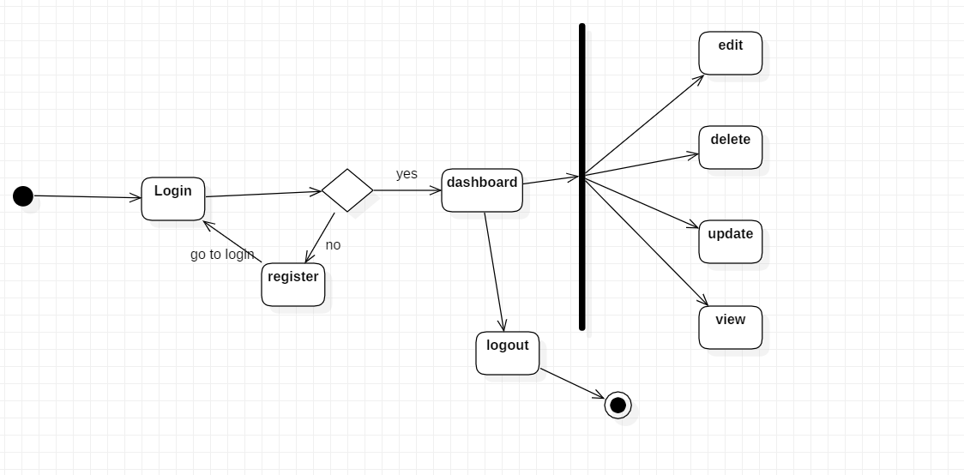

Figure 6 Activity Diagram

The activity diagram above shows registration and login for the user. As user are able to login once user has been registered. After registration user can login to view dashboard where user can edit, update, deleted and view the blog.

### Sequence Diagram

Sequence diagram are interaction illustration that shows information on how the operation should be carried out. It shows the interaction between objects in the context of a collaboration. Sequence diagram are very importance as

* It shows the interaction between object in the chronological order that those interaction occur.
* It shows how the system works by showing how different system object interact.
* **Login Sequence Diagram**

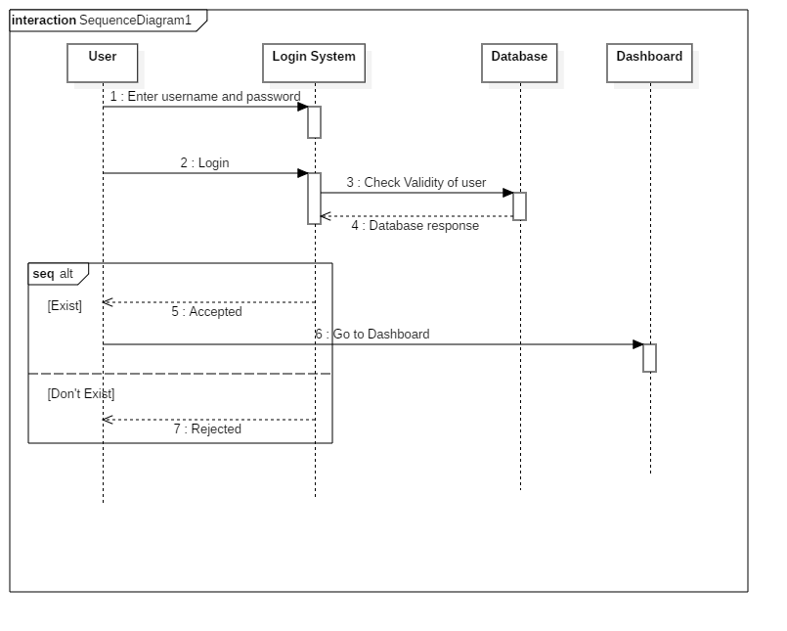

Figure 7 Login Sequence Diagram

The login sequence diagram above explain how the system involves. As explain from the figure, user beginning

## Final Class Diagram

## Database Design

### Data Dictionary

Data dictionary can be explained as the dictionary about the data that are store in the database. A data dictionary holds all the information about the data object. Data dictionary is very important as:

* It makes easier to identify and understand the factors about the object
* It provides information related to
* Names of all tables in database
* Names of all indexes and the columns to which the tables in those indexes is related
* Defining constraints on the table, including key relationship to other tables and constraints

The following are the list of data dictionary required for the Blog Now system.

### ER Diagram

ER diagram stands for entity relationship diagram that is use in database design. ER diagram shows the connection between different entities and its attributes of the system

ER diagram is very importance before developing the system. ER diagram make database design to understand more easily and well design. It helps to show interlinked between tables with their cardinality/relationship.

## Architectural Design

### UI: Prototyping

A prototype is an early sample, model, concept or process of the final system. Digital prototype is a digital simulation or demo which provide conceptual design that help to

Virtually explore a complete product before it’s built. Prototyping helps to provide information about what the system might look liked and how the system works

# Chapter 4: Implementation

The implementation stage is when we write the code to build the project. The stage begins by taking all the analysis and design and then writing code for developing fully functional system.

For the project I have developed a web-based system for creating and managing a Blog management system named Blog Now. For developing the system, I have used HTML, PHP,

CSS, BOOTSTRAP, XAMPP etc.

# Chapter 5 Testing

# Chapter 6 Other Topic

## Scheduling

### Work Breakdown Structure

Work Breakdown Structure also known as WBS is an outline in which the basic work component, called tasks, of the system are drawn to show their relationship between each task to the project as whole. By identifying the importance tasks that is connected to the system/project then we can create Work breakdown structure. (Margaret Rouse, 2011)

### Milestones

For the completed development of the project I have created milestone so I can keep track the progress.

|  |  |
| --- | --- |
| **Milestones** | **Date (Total Days)** |
| **Proposal**  Work Breakdown Structure  Risk Management  Configuration Management  Final Proposal | **(2019-03-25 to 2019-04-09) (16 days)**  2019-03-25 to 2019-03-26  2019-03-27 to 2019-03-28  2019-03-29 to 2019-03-31  2019-04-01 to 2019-04-09 |
| **Analysis**  Collecting Information  Gathering Information  Analysis requirement  Planning | **(2019-04-10 to 2019-05-08) (29 days)**  2019-04-10 to 2019-04-14  2019-04-15 to 2019-04-19  2019-04-20 to 2019-04-27  2019-04-28 to 2019-05-08 |
| **Design**  GUI design  Database Design | **(2019-05-09 to 2019-06-03) (25 days)**  2019-05-09 to 2019-05-22  2019-05-23 to 2019-06-03 |
| **Implementation**  Database Implementation  Coding | **(2019-06-04 to 2019-06-24) (20 days)**  2019-06-04 to 2019-06-12  2019-06-13 to 2019-06-24 |
| **Testing**  Unit Testing  Error Checking  Black Box Testing  White Box Testing | **(2019-06-25 to 2019-07-01)7 days)**  2019-06-25 to 2019-06-26  2019-06-27 to 2019-06-28  2019-06-29 to 2019-06-30  2019-06-31 to 2019-07-01 |
| **Final Documentation** | **(2019-07-02 to 2019-07-12) (11 days)** |

#### Description

As from the given figure we get information about how project has been developed. The above timeline shows how each key stage is completed at certain time. By following the milestone, I have successfully developed the project Blog Now- a blogging system. As from above table and explain at start I have chosen water model which has five key stages. I Have removed maintenance as the project is submitted to the teacher.

### Time Estimated Table

The below images show the estimated time for the project completion. It shows the time and duration for each stage and has been divided into tiny stages so the project can be developed more effectively.

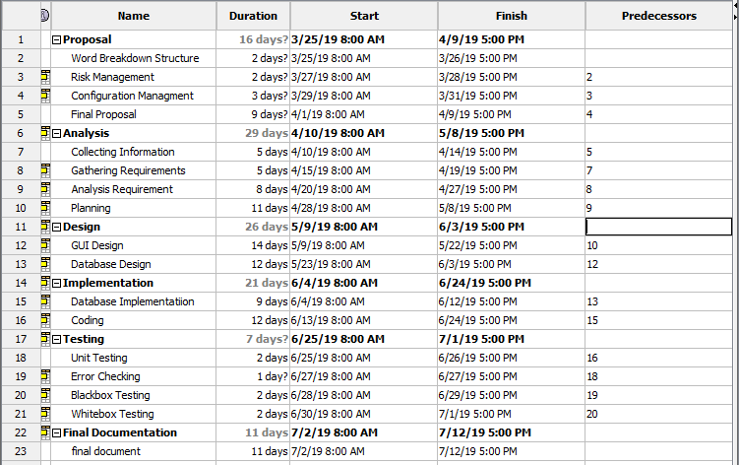

Figure 8 Scheduling

### GANTT chart

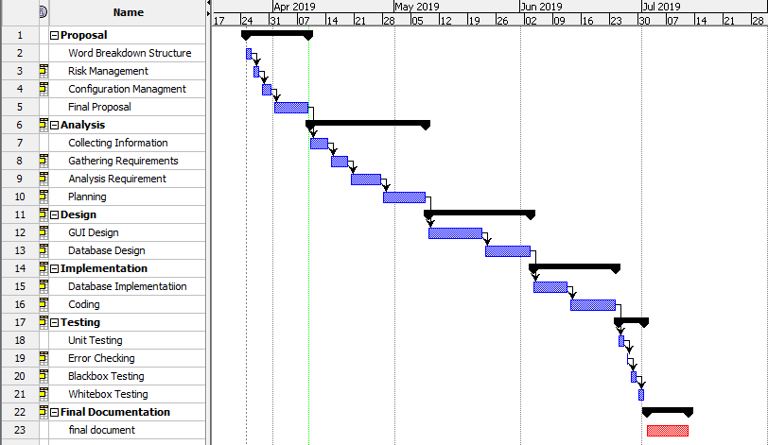

Figure 9 GANTT chart

The Gantt chart above for the system Blog Now- a blogging system shows the timeline for the completion of the project. It shows timeline in horizontal bar chart, Gantt chart provide graphical diagram of the schedule that helps in planning, coordinate and track specific task of the project.

## Risk Management

Risk management is the way of identifying, assessing and controlling threats (Margaret Rouse, 2016). Risk management not only identify risk but also analyze, monitor the risk. Also measure the risk to determine the risk impact from checking it likelihood and consequences.

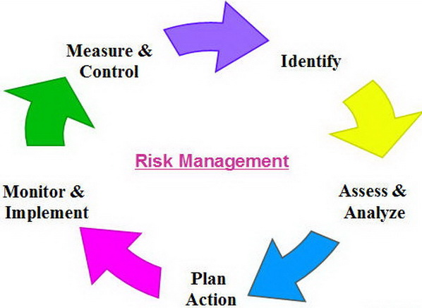

Figure 10 Risk Management

Risk Likelihood value from low to high as follow

|  |  |
| --- | --- |
| **Likelihood** | **Value** |
| Low | 1 |
| Medium | 2 |
| High | 3 |

And Risk Consequences value is given as:

|  |  |
| --- | --- |
| **Consequences** | **Value** |
| Very Low | 1 |
| Low | 2 |
| Medium | 3 |
| High | 4 |
| Very High | 5 |

|  |  |  |  |  |  |
| --- | --- | --- | --- | --- | --- |
| **SN** | **Risk** | **Likelihood** | **Consequence** | **Impact** | **Action** |
| 1 | System Failure | 1 | 5 | 5 | Proper Backup and System Maintenance |
| 2 | Malware | 2 | 3 | 6 | Antivirus Software |
| 3 | Server Failure | 1 | 5 | 5 | Proper Backup with security and maintenance |
| 4 | Inappropriate Design | 2 | 4 | 8 | Proper analysis and clear vison for the system design |
| 5 | Inaccurate Estimates of time(milestone) | 2 | 4 | 8 | Need to estimate the time properly and followed the timetable |
| 6 | Insufficient equipment | 3 | 3 | 6 | Regular check and update on equipment |
| 7 | Natural Disaster | 1 | 3 | 3 | Proper Backup and Safety of the equipment |

## References

Sharma, L. (2016) “Waterfall model” *What is Waterfall Model* [online] accessed from

<<https://www.toolsqa.com/software-testing/waterfall-model/>> [27 January 2020]

Product Plan (2019) “Project Management” *MoSCoW Prioritization* [online] accessed from

<<https://www.productplan.com/glossary/moscow-prioritization/>>[27 January 2020]

Visual Paradigm (2015) *Class Diagram* [online] accessed from

<<https://www.visual-paradigm.com/guide/uml-unified-modeling-language/what-is-class-diagram/> > [29 January 2020]

Rouse, M. (2011) *Work Breakdown Structure* [online]

<<https://searchsoftwarequality.techtarget.com/definition/work-breakdown-structure>>

[29 January 2020]

Rouse, M. (2016) *Risk Management* [online]

<<https://searchcompliance.techtarget.com/definition/risk-management>>[29 January 2020]