**Computing Project Proposal**

**On**

**Football League Management System**

**Name: Keeyoshi Pyakurel**

**NCC ID: 00175008**

**Batch: 22 ‘D’**

**Email: Keeyoshi99@gmail.com**

**Level 5 Diploma in Computing**

**Softwarica College of IT and E-Commerce**

**Submitted 9Th April 2019**

**Table of Contents**

1. Introduction 1

1.1. Project Introduction 1

1.2. Justification for Project 1

a. Background of the project 1

b. Problem Statement 2

1.3. Description of the project 2

a. Features 2

1.4. Overview of the project 3

2. Scope of the Project 4

2.1. Scope 4

2.2. Limitation 4

2.3. Aims 4

2.4. Objectives 5

2.5. Overview of the scope 5

3. Development Mythology 6

3.1. Waterfall Model 6

3.2. Design Patterns 7

a. Model View Controller (MVC) 7

3.3. System Architecture 8

4. Project Plan and Work Breakdown Structure 9

4.1. Work Bresakdown Structure 9

4.2. Milestones 10

4.3. Scheduling 11

a. Time Estimated table 11

b. GANTT chart 12

5. Risk Management 13

6. Configuration Management 15

7. Conclusion 17

8. References 18

**Table of Figure**

Figure 1 Waterfall Model 6

Figure 2 Model View Controller 7

Figure 3 System Architecture 8

Figure 4 WBS for Football League System 9

Figure 5 Scheduling 11

Figure 6 GANTT chart 12

Figure 7 Risk Management Info 13

Figure 8 Project in Github 15

Figure 9 project directory and sub directory 16

# Introduction

Football is the world biggest global sport in the world. It is also known as soccer in many countries. Nepal has also been playing football for generations but still there seems to be lack on management sector. This project will help to bring improvement to management sector. Football League Management System will manage both men football club and female football club, international and domestic league, etc. In long terms, to improve the football league management system is it goal and make it easier, reliable, etc.

## Project Introduction

Football league Management System help to manage and provide details about the marches between national and domestic cups. It includes record of previous match, fixture, player information, league information, etc.

Football League Management System also provide some information on what the football world is up to and how it affect other. It also provide information about world best player, club, different nation’s league winner etc. As football fan has been increasing rapidly the project helps them to keep touch and updated.

## Justification for Project

### Background of the project

Football being world biggest sport also has increase in popularity in Nepal. People in Nepal loved and support their country but mostly people can’t get updated on many matches on Nepal or the fixture of many matches. Mostly Men nation matches are updated or fixture are shown which doesn’t support fans to known about other equally importance match. Many fans are unaware about their favorite team fixture or team information. With this Project many football fans can get informed about thing they need to know. Being a football fan myself I know what the user wants and what the system needs.

### Problem Statement

The major problems lies with the domestic league. The league matches fixture can’t be found and result or scores or even stats in properly. They managed if using old system like using pen and paper. The league stats can only be found in newspaper with chances of being error. We can’t find the team who is winning or the best player, top scorer even team member information.

With this project the leagues information can be found with the fixture, stats, team information, etc. It also help to keep record safe and secure with less chances of being error. People can find information about what going on through my project.

## Description of the project

### Features

Some features that can help to improve system management system for football league are as follows.

* **Better Management System:** The major focus of the system is to improve the management system that consist better record system, database etc.
* **User Friendly and Easy to learn:** The system will be User friendly, Easy to learn and simple as people won’t be confuse about how to use.
* **Effective and Reliable:** Provide effective and reliable information to the user. No loss of data and misplaced of data. Double record of data can be removed.
* **Football information:** Fans want to get information about their favorite club or player so Player Information/stats, stadiums, clubs and International team, Competition Etc.
* **News and Blogs:** Regular updated on what happening around the world related to football. News and Blog about the changes in new update etc.

Some of the features listed above are the main focused feature that the system will provide to the system explain as above. There will be some more feature added updated at the future.

## Overview of the project

Football league management system project focus on managing football league including player information, stats, and match result. I have selected above explained feature for the project as for now that the most importance that the project required. With their being already major of big website that provide information like soccerway, ESPN, etc. those website doesn’t help for all the country like Nepal so the fans can’t get information about the matches etc. This project focused to decrease the gap for the information that the user can get that the user are unable to get till now.

# Scope of the Project

## Scope

Football being the world biggest sport has many fans. Football fans needs every single information about their favorite player, club and international team. But the information cannot be gather easily due to many reason. So to change and provide information easily, I am creating this project Football League Management System.

## Limitation

The current Limitation for this project is that it will not provide streaming of any matches and provide more details about player, leagues as it will only provide limited but required/ satisfied information. User are unable to share information to other platforms and unable to communicated with their friend. For now the website only focus on Nepali league and international team rather than other league. The app for the software has not been released or the plan for the app is not out yet. The project doesn’t focus on real time update for now. People need to search for specific information as some information might get hidden.

## Aims

The System aims to provide information to the user. Update the result faster than old paperwork and newspaper. It aim to improve the management system for the league and improve user/fans interaction. Also to provide better and easy features and protected user privacy and security. User can create their own profile to log in which can help them more than the normal user. With the increase on the competition the system aims to provide more updates to make the system easier, more reliable, more efficient etc.

## Objectives

The major objective of the Football Management system are

* To computerized all details, record etc.
* Update information
* To provide database to create, update, edit user information
* To make list of teams with associated player within the team
* Record match details, player stats, result
* View league stats, top scorer, top assist, etc.

## Overview of the scope

This project major scope is to provide information to the user about different fixture, league, player stats or information, etc. This will help user to get information easily and faster. It also provide match score sheet. It helps user to create their own account and login so they can post on help forum to ask question. With the website people all over the world can accessed with the help of internet. Football is world famous, biggest sport on the planet. Being biggest sport means there is huge fans all over the world that include country like Nepal so this project focus Mainly for Nepal’s football fans.

# Development Mythology

## Waterfall Model

To develop my project I have used “**Waterfall model**” than other model. As the project is small the best choice is to use waterfall model. The reason I have choose waterfall model is because:

* The model is easy simple and easy to understand
* Easy to manage
* Stages doesn’t overlap with each other
* It best for smaller project

Waterfall model includes following stages they are requirement, analysis, design, implementation, testing, and development.

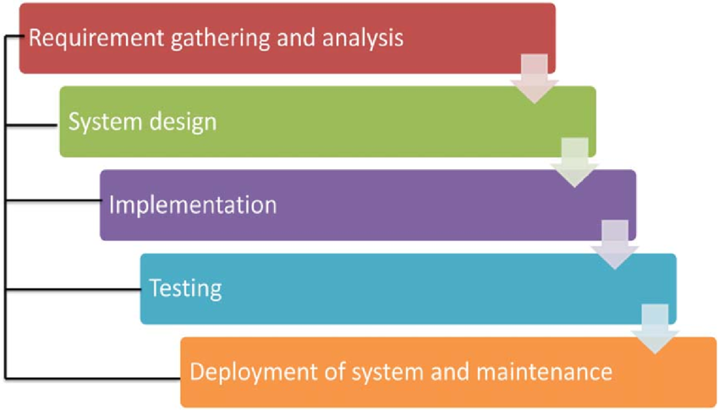

Figure 1 Waterfall Model

## Design Patterns

### Model View Controller (MVC)

For design patterns I have selected Model View Controller (MVC). MVC is the name of a methodology or design patterns for effectively and productively relating the UI to basic information models. (Margaret Rouse, 2011)

* **Model:** which defines all the state and functionality of a system
* **View:**  which handles the presentation. It the user interface with absolutely no code for altering the state of the system
* **Controller:** which is what provides the user’s ability to manipulate the system

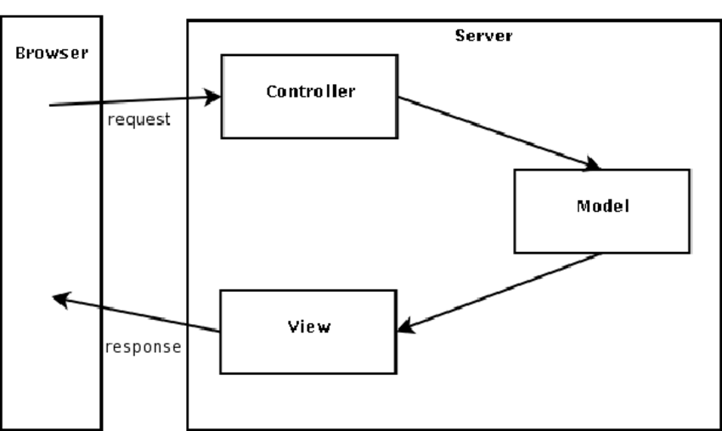

Figure 2 Model View Controller

The above is the figure for Model View Controller for website where user request from browser to server and we can see how MVC works to get the response back from server to browser. MVC work is to keep display and data separated so change in one doesn’t affect the other and vice versa.

## System Architecture

System architecture is an outline in which the basic work components, called assignments, of a task are represented to depict their connections to one another and to the undertaking all in all (Margaret Rouse, 2011). I prefer using 3- Tier Architecture

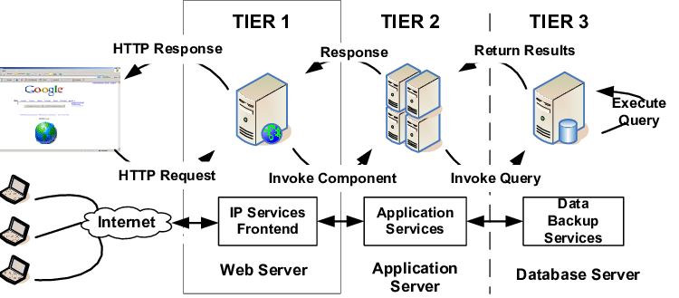

Figure 3 System Architecture

The above is the figure for 3 tier system architecture for website. 3 tier architecture is a client-server architecture and it very useful. It allows us to update of one tier without affecting the other areas of the application. It helps in managing presentation code, maintenance the code base and business logic separately so one chance doesn’t affect other like chance in business logic doesn’t affect chance in presentation code.

# Project Plan and Work Breakdown Structure

## Work Breakdown Structure

Work Breakdown Structure also known as WBS is an outline in which the basic work components, called assignments, of a task are represented to depict their connections to one another and to the undertaking all in all (Margaret Rouse, 2011).

The work breakdown structure for the project is shown below:

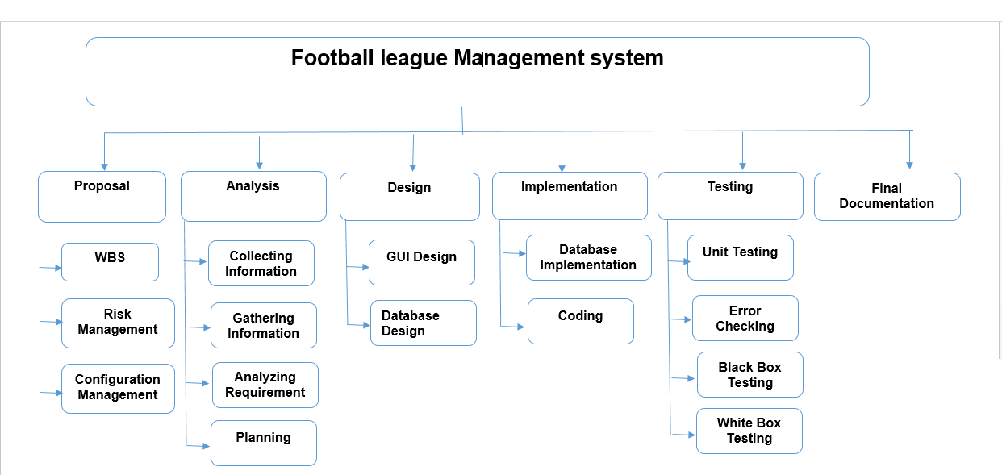

Figure 4 WBS for Football League System

The above WBS diagram show how the project work structure is breakdown which help to reduce complicated activities to the collection of task which make the project more effective, reliable and easy.

## Milestones

I have created milestone for my project to mark specific point along a project timeline.

|  |  |
| --- | --- |
| **Milestones** | **Date(Total Days)** |
| **Proposal**  Work Breakdown Structure  Risk Management  Configuration Management  Final Proposal | **(2019-03-25 to 2019-04-09) (12 days)**  2019-03-25 to 2019-03-26  2019-03-27 to 2019-03-28  2019-03-29 to 2019-04-02  2019-04-03 to 2019-04-09 |
| **Analysis**  Collecting Information  Gathering Information  Analysis requirement  Planning | **(2019-04-10 to 2019-05-08)(28 days)**  2019-04-10 to 2019-04-15  2019-04-16 to 2019-04-20  2019-04-21 to 2019-04-29  2019-04-30 to 2019-05-08 |
| **Design**  GUI design  Database Design | **(2019-05-09 to 2019-06-03)(25 days)**  2019-05-09 to 2019-05-22  2019-05-23 to 2019-06-03 |
| **Implementation**  Database Implementation  Coding | **(2019-06-04 to 2019-06-24)(20 days)**  2019-06-04 to 2019-06-12  2019-06-13 to 2019-06-24 |
| **Testing**  Unit Testing  Error Checking  Black Box Testing  White Box Testing | **(2019-06-25 to 2019-07-01)6 days)**  2019-06-25 to 2019-06-26  2019-06-27 to 2019-06-28  2019-06-29 to 2019-06-30  2019-06-31 to 2019-07-01 |
| **Final Documentation** | **(2019-07-02 to 2019-07-12)(11 days)** |

## Scheduling

### Time Estimated table

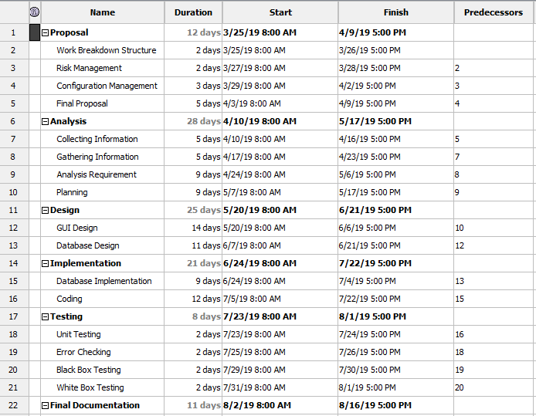

Figure 5 Scheduling

With the above figure the time and duration for each stage has been divided so it helps to create the project more effectively by following the timetable.

### GANTT chart

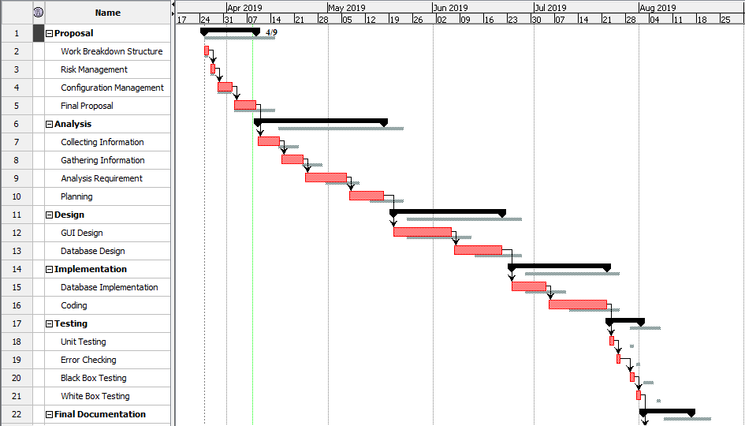

Figure 6 Gantt chart

The Gantt chart of football league management system is shown above. It show timeline in horizontal bar chart. Gantt chart provide graphical diagram of the schedule that help in planning, coordinate and track specific task in the project.

# Risk Management

Risk management is the way of identifying, assessing and controlling threats (Margaret Rouse, 2016) Risk management not only identify risk but also analyze, monitor the risk. Also measure the risk to determine the risk impact from checking it likelihood and consequences.

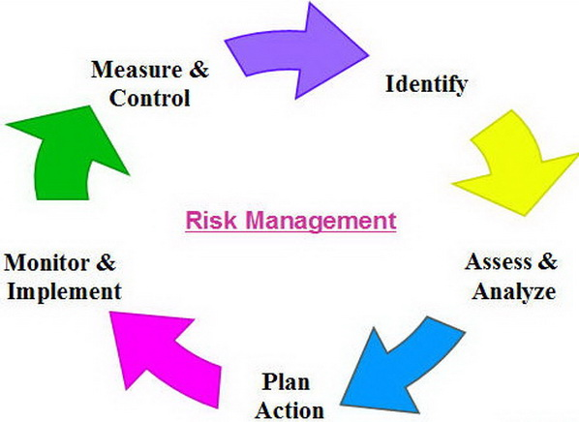

Figure 7 Risk Management Info

Risk Likelihood value from low to high as follow

|  |  |
| --- | --- |
| **Likelihood** | **Value** |
| Low | 1 |
| Medium | 2 |
| High | 3 |

And Risk Consequences value is given as:

|  |  |
| --- | --- |
| **Consequences** | **Value** |
| Very Low | 1 |
| Low | 2 |
| Medium | 3 |
| High | 4 |
| Very High | 5 |

|  |  |  |  |  |  |
| --- | --- | --- | --- | --- | --- |
| **S.N** | **Risk** | **Likelihood** | **Consequences** | **Impact** | **Actions** |
| 1 | System Failure | 1 | 5 | 5 | Proper Backup and System Maintenance |
| 2 | Malware | 2 | 3 | 6 | Antivirus Software |
| 3 | Server  Failure | 1 | 5 | 5 | Proper Backup with security and maintenance |
| 4 | Inappropriate Design | 2 | 4 | 8 | Proper analysis and clear vison for the system design |
| 5 | Inaccurate Estimates of time(milestone) | 2 | 4 | 8 | Need to estimate the time properly and followed the timetable |
| 6 | Insufficient equipment | 3 | 3 | 6 | Regular check and update on equipment |
| 7 | Natural Disaster | 1 | 3 | 3 | Proper Backup and Safety of the equipment |

# Configuration Management

Configuration Management is the process of efficiently dealing with the changes to a system in a way that it maintains consistence in performance over time. (Erika Heidi, 2016). It used for tracking and controlling of software changes in a system.

Git id for the project is: <https://github.com/keeyoshi/Football-League-Management-System>

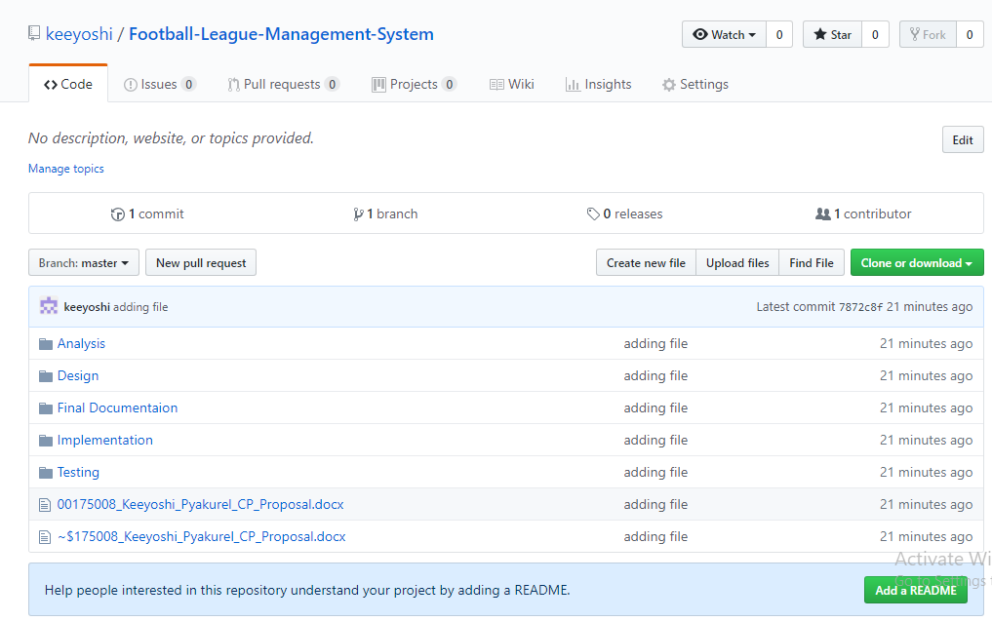

Figure 8 Project in Github

With the help of Git I have uploaded my files and folder on Github where anyone accessed with the Git Id given below.

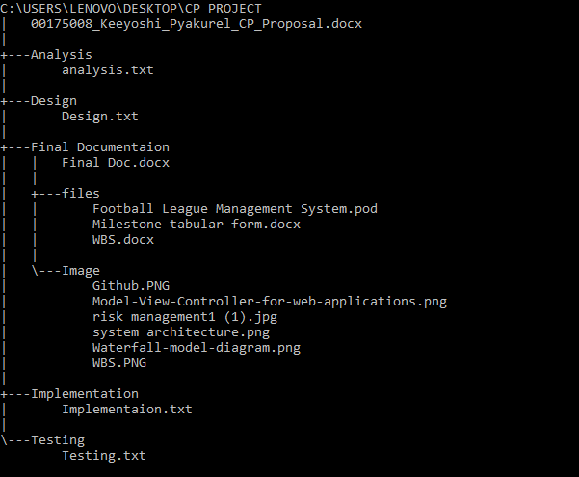

Figure 9 project directory and sub directory

# Conclusion

The website or my project Football league management system proposal describe all the requirements, aims, objectives and scope as explain above with the time estimated for each process. It shows possible risk while creating the system and how we can prevent our project/system from that risk will the impact, likelihood and risk. With the completion of this project football fans can get news, updates, information about their team without any major problems with just one search away from their devices.

# References

[Online]

(Margaret Rouse, 2011), WBS, URL: <https://searchsoftwarequality.techtarget.com/definition/work-breakdown-structure>

Accessed on: 4th April 2019

[Online]

(Margaret Rouse, 2011), MVC, URL: <https://whatis.techtarget.com/definition/model-view-controller-MVC> Accessed on: 5th April 2019

[Online]

(Margaret Rouse, 2016) Risk Management, URL: <https://searchcompliance.techtarget.com/definition/risk-management>

Accessed on: 5th April 2019

[Online]

(Erika Heidi, 2016), Configuration Management, URL: <https://www.digitalocean.com/community/tutorials/an-introduction-to-configuration-management>

Accessed on: 6th April 2019