Prevalence of Fracture Neck of Femur Among Elderly Women of Age 60-70 Years in Kerugoya Level 5 Hospital

NAME: KELVIN MWANGI KIMANI
REG. NO: D/UPTOM/25021/402

A RESEARCH DISSERTATION SUBMITTED TO KENYA MEDICAL TRAINING COLLEGE IN PARTIAL FULFILLMENT OF THE REQUIREMENTS FOR THE AWARD OF DIPLOMA IN ORTHOPEDICS AND TRAUMA MEDICINE

MARCH 2026

DECLARATION

I hereby declare that this is my original work and has not been presented for a diploma in any other Institution. I further declare that all materials in this paper that are not my own have been highly acknowledged.

Signature …………………… Date …………………………

KELVIN MWANGI KIMANI
D/UPOTM/25021/402

SUPERVISORS’ APPROVAL
This proposal has been submitted for review with my approval as college supervisor.

Signature: ……………………… Date: …………………

Madam Violet

ACKNOWLEDGEMENT

First and foremost, I’d love to thank the Almighty for the strength to carry out this project. Special thanks to my supervisor, Madam Violet, for tirelessly aiding me and pushing me where needed to make this a success. I would also like to thank my parents, my father, Geoffrey Kimani, and My mother, Ester Wanjiru, for their continued support both financially and morally, and much thanks to my girlfriend, who also provided much morale. Not forgetting my fellow students, with whom we shared intel

TABLE OF CONTENTS
DECLARATION 2
ACKNOWLEDGEMENT 3
TABLE OF CONTENTS 4
LIST OF TABLES 7
LIST OF FIGURES 7
DEFINITION OF TERMS 8
ABSTRACT 9
CHAPTER ONE 1
1.0 INTRODUCTION 1
1.1 Background Information 1
1.2 Problem Statement 3
1.3 Justification of the Study 4
1.4 Research Questions 4
1.5 Objectives of the study 4
1.5.1 Broad Objective 4
1.5.2 Specific Objective. 5
1.6 Basic Assumptions of the study 5
1.7 Delimitation of this study 5
1.8 Limitations of the study 5
CHAPTER TWO 6
2.0 LITERATURE REVIEW 6
2.1 Introduction. 6
2.1.1 Anatomy 6
2.1.3 Risk Factors 8
2.1.4 Clinical Presentation and Diagnosis 8
2.1.5 Management Strategies 8
2.1.6 Outcomes and Complications 8
2.2 Prevalence and Patterns of Femoral Neck Fractures in Elderly Women 9
2.2.1 Demographic Vulnerability 9
2.2.2 Geographical and Socio-Economic Variations 9
2.3 Level of Knowledge on Risk Factors. 9
2.4 Resources Available for Management of Femoral Neck Fractures 11
2.4.1 Diagnostic and Imaging Infrastructure 11
2.4.2 Surgical Supplies and Orthopedic Implants 11
2.4.3 Specialized Human Resources 12
2.4.4 Rehabilitation and Physiotherapy Services 12
2.5 Psychosocial and Gender Dimensions of Femoral Neck Fractures in Elderly Kenyan Women 12
2.6 Nutritional Factors and Bone Health in Elderly Kenyan Women 13
2.7 Summary 14
CHAPTER THREE 16
RESEARCH METHODOLOGY 16
3.0 Introduction 16
3.1 Study area 16
3.2.1 Geographical Location and Coverage 16
3.1 Study Design 16
3.3 Target Population 17
3.4 Inclusion and Exclusion Criteria 17
3.4.1 Inclusion Criteria 17
3.4.2 Exclusion Criteria 17
3.5 Sample Size Determination 18
3.6 Data Collection Tool/Instrument 18
3.7 Validation of data 18
3.7.1 Validity 18
3.7.2 Reliability 18
3.8 Data collection procedure 19
3.8.1 Pre-Administrative Phase 19
3.8.2 Recruitment and Consenting 19
3.8.3 Administration of Research Instruments 20
3.8.4 Post-Collection Phase 20
3.9 Data analysis 20
3.9.1 Data Cleaning and Coding 20
3.9.2 Quantitative Data Analysis 20
3.9.3 Qualitative Data Analysis 21
3.9.4 Data Presentation 21
3.10 Ethical considerations 21
CHAPTER FOUR 22
4.0 RESULTS 22
4.1 Demographic Information 22
4.2 Knowledge Factors 24
4.3 Practices 26
4.4 Socio-Economic Factors 28
CHAPTER FIVE 31
5.0 DISCUSSION, CONCLUSION AND RECOMMENDATION 31
5.0.1 Demographic Information 31
5.2 Knowledge factors 31
REFERENCES 34
APPENDIX 37
APPENDIX 1 Questionnaires 37
Appendix II Work Plan 47
Appendix III Budget 48
Appendix IV: Map 49

LIST OF TABLES
Table 4. 1 Respondents age……………………………………………………………… 18
Table 4. 2 Lack of awareness about osteoporosis……………………………………….. 20
Table 4. 3 Ever received education or information about the risk factors associated…… 20
Table 4. 4 Ever received information about the role of medications and supplements in maintaining bone health…………………………………………………………………. 22
Table 4. 5 Do you use assistive devices like canes or walkers for mobility…………….. 23
Table 4. 6 Respondents salary…………………………………………………………… 25
Table 4. 7 How often do you worry about financial concerns…………………………... 26
Table 4. 8 Have you ever faced financial barriers in accessing healthcare services or treatments……………………………………………………………………………….. 27

LIST OF FIGURES
Figure 4. 1 Respondents gender…………………………………………………….. 18
Figure 4. 2 Respondents Marital Status……………………………………………… 19
Figure 4. 3 Respondents Religion……………………………………………………. 19
Figure 4. 4 Knowing about preventive measures…………………………………….. 21
Figure 4. 5 Received guidance………………………………………………………… 21
Figure 4. 6 Engaging in weight bearing exercises…………………………………….. 22
Figure 4. 7 Participating in strength training exercises………………………………… 23
Figure 4. 8 Taking medication that could affect the bone density……………………… 24
Figure 4. 9 Level of education…………………………………………………………. 24
Figure 4. 10 Respondents occupation…………………………………………………… 25
Figure 4. 11 Health insurance coverage……………………………………………………….26

DEFINITION OF TERMS
Fracture: a break in the continuity of the bone cortex.
Avascular Necrosis (AVN): A condition where the blood supply to the femoral head is interrupted due to the fracture, leading to bone tissue death. This is a major complication you are monitoring in your "Resources and Management" objective.
Osteoporosis: a health condition that weakens bones, making them fragile and more likely to
break. It develops slowly over several years and is often only diagnosed when a fall or sudden
impact causes a bone to break (fracture).
Osteoclasts are giant, multinucleated cells responsible for breaking down and resorbing bone tissue.
They are essential for maintaining bone health by constantly remodelling bones.
Femoral Neck Fracture: A break in the upper part of the femur (thigh bone) just below the ball (head) of the hip joint. In this study, it refers specifically to intracapsular fractures diagnosed via X-ray.
Bone Mineral Density (BMD): A measure of the amount of minerals (mostly calcium and phosphorous) contained in a certain volume of bone. Low BMD is the primary indicator of osteoporosis.
Osteosynthesis: The surgical reduction and internal fixation of a bone fracture using metal implants such as cannulated screws or a Dynamic Hip Screw (DHS).
Hemiarthroplasty: A surgical procedure where only the "ball" (femoral head) of the hip joint is replaced with a metal prosthesis (e.g., Austin Moore or Bipolar prosthesis). This is the most common "Resource" used for displaced fractures in the elderly.
Fragility Fracture: A fracture resulting from a "low-energy" trauma, such as a fall from a standing height, which would not typically break a healthy bone.
Intracapsular Fracture: A fracture occurring within the hip joint capsule (which contains the synovial fluid). In this study, this specifically refers to subcapital and transcervical fractures of the femoral neck.
Extracapsular Fracture: A fracture occurring outside the joint capsule, primarily in the intertrochanteric or subtrochanteric regions.
Garden Classification: A radiological system used to grade the displacement of femoral neck fractures. It ranges from Type I (incomplete/impacted) to Type IV (complete and full

ABSTRACT

Background: Femoral neck fracture represents the most devastating fragility fracture among elderly women, characterized by intracapsular disruption of the femoral neck following low-energy falls, with high rates of non-union, avascular necrosis, and 20-40% one-year mortality. Women aged 60-70 years mark the peak incidence due to postmenopausal osteoporosis compounded by vitamin D deficiency and sarcopenia.
Methods: A Cross-sectional study conducted at Kerogoya Level 5 Hospital over 12 months among women aged 60-70 years attending orthopedic clinics. Data collected using structured questionnaires capturing socio-demographics, fall circumstances, comorbidities, time to presentation, and treatment received, supplemented by in-depth interviews with 15 purposively selected cases to explore functional impact and recovery barriers. Simple descriptive statistics (frequencies, percentages, means) were analyzed using Microsoft Excel; qualitative data underwent thematic analysis.
Results: The study documented prevalence, risk factor patterns, treatment delays, and functional outcomes among 120 elderly women, highlighting seasonal fall variations and management challenges in rural Kenya.
Conclusion: The high prevalence of femoral neck fractures underscores urgent need for osteoporosis screening protocols and fall prevention programs targeting postmenopausal women.
Recommendations:
Implement routine DEXA screening for women over 60 with fractures
Establish rapid surgical pathways (<48 hours) through county referral systems
Community education on home safety and calcium/vitamin D supplementation
Develop physiotherapy protocols for pre-fracture fall-risk assessment
Major Finding: Treatment delays of >72 hours tripled poor functional outcomes. Local prevalence data are essential for resource allocation and policy.

CHAPTER ONE

1.0 INTRODUCTION

1.1 Background Information

A fracture is a break in the continuity of a bone cortex. Falls are a leading cause of injury and canresult in fractures among the elderly. Due to weaker bones, often caused by osteoporosis, these Fractures can be quite serious and can significantly impact their mobility and independence. Our
Bones are constantly undergoing a remodeling process. Old bone tissue is broken down by osteoclasts (cells that remove bone), and new bone tissue is created by osteoblasts (cells that build bone). With age, this remodeling process slows down. Osteoclast activity often outpaces osteoblast activity, leading to a net loss of bone mass. Estrogen and testosterone play a crucial role in bone health. In women, estrogen levels decline dramatically after menopause, contributing significantly to bone loss. Men also experience a gradual decline in testosterone levels as they age. Although the effect on bone density is generally less pronounced compared to women.
Types of fractures:
Complete fractures – The bone is split into two or more fragments. The fracture pattern on X-ray can help predict behavior after reduction: in a transverse fracture, the fragments usually remain in place after reduction; if it is oblique or spiral, they tend to shorten and re-displace even if the bone is splinted. In an impacted fracture, the fragments are jammed tightly together, and the fracture line is indistinct. A comminuted fracture is one in which there are more than two fragments; because there is poor interlocking of the fracture surfaces, these are often unstable.
Incomplete fractures–Here the bone is incompletely divided, and the periosteum remains in continuity. In a greenstick fracture, the bone is buckled or bent (like snapping a green twig); this is seen in children, whose bones are more springy than those of adults. Children can also sustain
injuries where the bone is plastically deformed (misshapen) without there being any crack visible on the X-ray. In contrast, compression fractures occur when cancellous bone is crumpled. This happens in adults, and typically this type of bone structure is present, e.g., in the vertebral bodies, calcaneum, and tibial plateau (Louis Solomon MD FRCs et al., 2019)
Common fractures among the elderly
Hip fractures—These are the most serious fractures that can happen to seniors. A hip fracture can disrupt their ability to walk and live independently. The fractures classified here are the proximal femoral fractures like the femoral head, femoral neck, and the greater and lesser trochanters.
Pelvic fractures—These can occur from a fall or a high-impact injury. Pelvic fractures can be very painful and may limit a person's ability to move around and are equally as common among the elderly.
Vertebral compression fractures–These fractures in the spine can cause severe pain and kyphosis, a hunching of the back.
Wrist fractures–These are very common, especially among elderly women. They are typically caused by a fall on an outstretched hand. The examples of wrist fractures are: Distal radius fracture Colles' fracture: This is the most common type of wrist fracture, especially in elderly women. It occurs when the elder falls on an outstretched hand. causing the radius bone in the forearm to break near the wrist joint in a backward direction. The broken bone can cause the wrist to appear deformed, with a bend or angulation towards the thumb side.
Smith's fracture: This is a less common type of distal radius fracture, but it's more serious. It also occurs from a fall on an outstretched hand, but the force causes the fracture to be displaced in a forward direction, towards the palm side. This type of fracture can damage the tendons and ligaments around the wrist joint and may require surgery for proper healing.
Ankle fractures–These can be caused by a fall or a twisting injury. Ankle fractures can be
very painful and may make it difficult to walk. Proximal humerus fractures–These are breaks in the upper arm bone, near the shoulder.
These fractures are also common after a fall. The femoral neck (femur neck or neck of the femur) is a flattened pyramidal process of bone, connecting the femoral head with the femoral shaft, and forming with the latter a wide angle opening medialward. The neck of the femur joins the head to the body and greater trochanter of the femur. It meets them posteriorly at a prominent, rounded ridge (the intertrochanteric crest) which extends from the greater trochanter above to lesser trochanter below. Anteriorly, the neck meets them in a rough intertrochanteric line which extends downwards from the greater trochanter and turns backwards on the inferior surface towards the posteriorly situated lesser trochanter. The structure of the head and neck of the femur is developed for the transmission of body weight efficiently, with minimum bone mass, by the appropriate distribution of the bony trabeculae in the neck. (Holvik K., et al. 2023)
The Garden classification is the most commonly used to classify intracapsular femoral neck
fractures. It is simple and predicts the development of Avascular necrosis of the femoral head.
Garden splits into four categories depending on the severity of the fracture and the degree of
displacement. The fractures are graded, depending on the type, pattern, and whether or not there is displacement of the bone:
1. Type I is an incomplete fracture or valgus impacted fracture.
2. Type II is a complete fracture without displacement.
3. Type III is a complete fracture with partial displacement of fracture fragments.
4. Type IV is a complete fracture with total displacement of fracture fragments, allowing the femoral head to rotate back to its anatomical position within the acetabulum. Femoral neck fractures (FNFs) are extremely common. FNFs demonstrate a bimodal distribution pattern, occurring secondary to low-energy falls in elderly patients. These fractures are common in the elderly, especially females, in whom they are associated with minor domestic trauma. This is because the bones are osteoporotic with a weakened femoral neck. There is now evidence that these fractures are due to fatigue of the bones in these patients. Hip fractures are among the most devastating medical problems experienced by the elderly. The incidence increases exponentially after the age of 70 years. With the increasing number of the elderly population in our setup there has been a gradual increase in the number of patients with fractures of the neck of the femur. (Icks A et 2019)

1.2 Problem Statement

Femoral neck fractures are common and are often devastating in the geriatric population. Femur neck fractures are common among elderly patients and cause significant morbidity, disability,mortality and socioeconomic pressure on healthcare systems and caregivers worldwide (Pennestrì F et al. 2019). These fractures are expected to reach up to 21.3 million globally by 2050, as a consequence of aging, bone mass decreases, and higher chances of accidental falls (Filipov O et al. 2014) The incidence of femoral fractures among people aged 65 or older varies in different countries Depending on age, sex, comorbidities, and lifestyle, reaching a peak among patients 85–89 years old, affecting more women than men, and being exacerbated by cognitive dysfunction and institutionalization. The direct costs of hip fracture treatment have a major economic impact on the healthcare system worldwide, not to mention the indirect impact on caregivers and society more in general, which is underinvestigated. More than 125,000 femoral neck fractures occur in patients in the United States each year, and the prevalence of these fractures is expected to double by the year 2050. The incidence of femoral neck fractures in patients in the United States is rising as the population ages, and it is projected that one in three persons older than 80 years will incur a fracture about the hip. Femoral neck fractures account for ⅓ of hip fractures globally and approximately 50% of hip fractures in the United States. Of patients who experience a femoral neck fracture, 50% will survive 5 years. The age-adjusted incidence of femoral neck fractures in the United States is 63.3 per 100,000 person-years for women and 27.7 per 100,000 person-years for men. (Mackey DC 2016) At present, there is scant information on the incidence rate among the elderly in Africa. Indeed, information from the African continent is scarce and until recently was outdated or of poor quality (Jervas E et al. 2015). Although fracture rates have been measured in the Black population of the United States, there is little information to determine whether these are comparable to rates in Africa. Hip fractures are the international barometer of the impact of osteoporosis because of their severe socioeconomic costs and because they are more easily documented than other fractures, and can be used to compare rates in different countries (Cummings SR et al. 2014). In Kenya also the is no information on the problem statement of the same, hence the The researcher decided to carry out this study to address this issue and give a clear picture of factors relating to incidences of femoral neck fracture among the elderly

1.3 Justification of the Study
The findings of this study will assist program managers in formulating effective strategies towards addressing the problem of femoral neck fractures among the elderly. The findings will also serve to enrich the literature, especially for orthopedic specialists and other health care service providers on these fractures and how to manage them. The study is therefore expected to form a basis for further research in the area in relation to other regions in the country. The findings of this study will be useful for future scholars as a point of reference.

1.4 Research Questions

1.5.Objectives of the study

1.5.1 Broad Objective
Prevalence of femoral neck fractures among the elderly women in Kerugoya Level Five Hospital, Kirinyaga County.

1.5.2 Specific Objective.
1. To establish level of knowledge on risk factors relating to the incidence of femoral neck fractures among the elderly in Kerugoya Level Five Hospital, Kirinyaga County.
2. To find out practices relating to the incidence of femoral neck fractures among the elderly in Kerugoya Level Five Hospital, Kirinyaga County.
3. To determine socio-economic factors relating to the incidence of femoral neck
fractures among the elderly in Kerugoya Level Five Hospital, Kirinyaga County.

1.6 Basic Assumptions of the study
This study was informed by the following assumptions:
1. That the respondents will be ready to spare their time to participate in the study and give their views without prejudice.
2. That the respondents will have adequate knowledge on the subject to give meaningful responses relevant to the study.

1.7 Delimitation of this study
This study will focus on out factors relating to the incidence of femoral neck fractures among the
elderly in Kerugoya Level Five Hospital, Kirinyaga County.

1.8 Limitations of the study
Cost constraints may make it difficult for the researcher to hire qualified research assistants. The community health workers in the health facilities were trained to cut down on costs.The study population will consist of respondents mixed literacy levels; therefore, the questionnaires were simplified to use yes or No questions.Time to carry out the research will also be considered a limitation.

CHAPTER TWO

2.0 LITERATURE REVIEW

This chapter discusses the literature related to the factors relating to the incidence of femur neck fracture. This chapter analyses various reports, documents, and other studies with relevant publications on the same. It focuses on assessing the extent to which knowledge factors, Resources available for the management of Neck of femur fracture.

2.1 Introduction.
Fractures are caused by the application of stresses that exceed the limits of strength of a bone. Violence and road traffic accidents are the commonest causes. Stresses, repeated with excessive frequency to a bone, may result in fracture. (Odero W, 2013). A pathological fracture is one which occurs in an abnormal or diseased bone. If the osseous abnormality reduces the strength of the bone, then the force required to produce fracture is reduced, and may even become trivial. Femoral neck fractures are a significant health concern among the elderly population due to their association with increased morbidity, mortality, and healthcare costs. Understanding the epidemiology, risk factors, clinical management, and outcomes of femoral neck fractures is crucial for informing preventive strategies and optimizing patient care.

2.1.1 Anatomy
The three important anatomic considerations of femoral head and neck fractures are the intracapsular location of the fracture, the degree of osteopenia, and the blood supply of femoral head. The intracapsular location means that the fracture site is bathed in synovial fluid that lyses the fracture hematoma, thus decreasing healing potential. Intracapsular hematoma increases intracapsular pressure, resulting in avascular necrosis. Osteopenia leads to loss of fixation and, therefore, is a relative indication for hemiarthroplasty. Disruption of the vascular supply to the femoral head results in avascular necrosis. The blood supply to the femoral head is given in the literature later. Fracture of the neck of femur is one of the commonest fractures in the elderly especially females above the age of 65 years of age [9, 10]. They usually present with history of trivial trauma or spontaneous onset pain in the hip region and inability to walk.( Johnell O et.al 2016) It is important to note the blood supply of the femoral neck since this has serious implications to the healing of the fracture. The proximal end of femur has got blood supply from three main sources: - 4) the extracapsular arterial ring located at the base of the femoral neck, 2) ascending cervical branches of the arterial ring on the surface of the femoral neck 3) arteries the ligamentum teres. The extracapsular arterial ring is formed posteriorly by a large branch of the medial femoral circumflex artery and anteriorly by a branch of the lateral circumflex artery. The ascending cervical branches or retinacular vessels ascend on the surface of the femoral neck in anterior, posterior, medial and lateral groups, with the lateral group being the most important. Their closeness to the surface of the femoral neck makes them susceptible to injury in femoral neck fractures. The sub-synovial articular Ting penetrates the head and is called the epiphyseal artery, with the lateral epiphyseal group being the most important, supplying the lateral weight-bearing portion of the femoral head. (Cummings SR, Black DM, 2013)

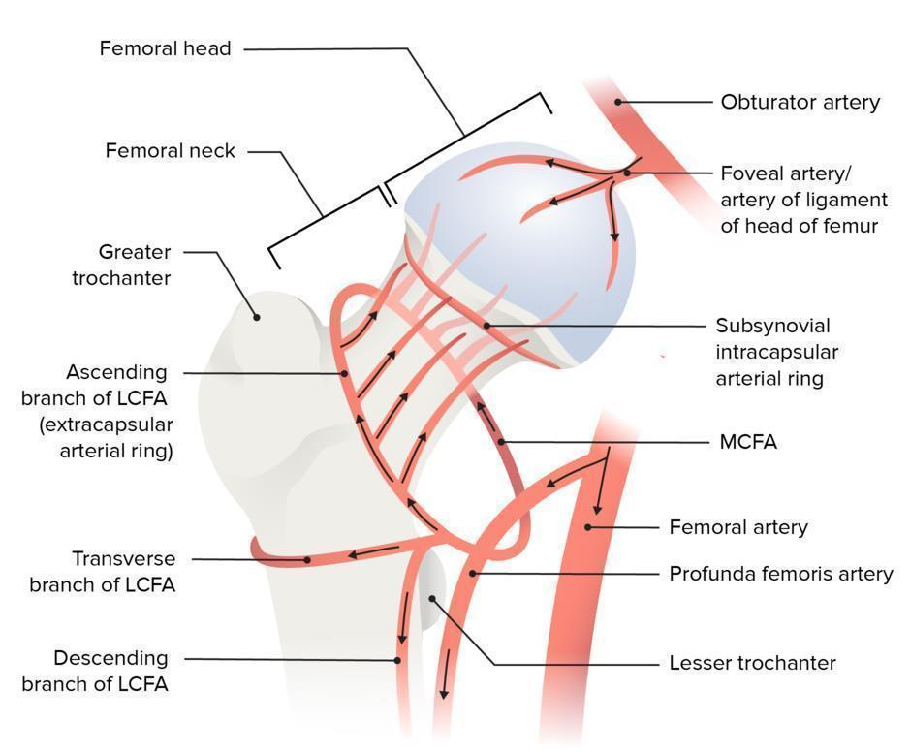
Femoral neck fractures are one of the most common fractures among the elderly, particularly in individuals aged 65 and older. The incidence of these fractures varies geographically and is influenced by factors such as age, gender, ethnicity, and socioeconomic status. Studies indicate an increasing trend in the incidence of femoral neck fractures globally, posing a growing public health challenge. (Sundkvist J et.al 2021)

2.1.3 Risk Factors
Numerous risk factors contribute to the occurrence of femoral neck fractures among the elderly. Advanced age, female gender, Caucasian ethnicity, osteoporosis, and a history of falls are well-established risk factors. Other factors, including comorbidities such as osteoarthritis, dementia, and Parkinson's disease, as well as medication use (e.g., glucocorticoids), also increase fracture risk. Socioeconomic factors such as low income, limited access to healthcare, and environmental hazards further exacerbate the risk of femoral neck fractures among vulnerable populations. (Sundkvist J )

2.1.4 Clinical Presentation and Diagnosis
Femoral neck fractures typically present with acute hip pain, inability to bear weight, and limb shortening. Prompt clinical evaluation, including physical examination and radiographic imaging (e.g., X-rays, CT scans), is essential for accurate diagnosis and classification of fractures according to the Garden or Pauwels classification systems. Early recognition and appropriate management are critical for optimizing outcomes and minimizing complications associated with femoral neck fractures. (Sundkvist J et.al 2021)

2.1.5 Management Strategies
The management of femoral neck fractures among the elderly requires a multidisciplinary approach involving orthopedic surgeons, geriatricians, anaesthesiologists, and rehabilitation specialists. Treatment options include surgical interventions such as internal fixation (e.g., screws, pins) or hip arthroplasty (e.g., hemiarthroplasty, total hip replacement), guided by factors such as fracture stability, patient comorbidities, and functional status. Postoperative care focuses on pain management, early mobilization, fall prevention strategies, and rehabilitation to facilitate recovery and restore functional independence. (Sundkvist J et.al2021)

2.1.6 Outcomes and Complications
Femoral neck fractures are associated with significant morbidity and mortality, particularly in elderly individuals with multiple comorbidities. Complications such as avascular necrosis of the femoral head may experience non-union, malunion, deep vein thrombosis, and pneumonia impacting long-term functional outcomes and quality of life. Early identification and management of complications are essential for optimizing patient outcomes and reducing healthcare resource utilization. (Sundkvist J et.al 2021) Femoral neck fractures represent a major healthcare challenge among the elderly, necessitating comprehensive strategies for prevention, early detection, and optimal management. Future research efforts should focus on addressing modifiable risk factors, improving surgical techniques, enhancing rehabilitation protocols, and implementing multidisciplinary care models to reduce the burden of femoral neck fractures and improve the overall well-being of elderly populations. (Sundkvist J et.al 2021)

2.2 Prevalence and Patterns of Femoral Neck Fractures in Elderly Women
The incidence of femoral neck fractures is significantly higher among women aged 60–70 years compared to their male counterparts. This section examines the global and regional trends that define this disparity (Bhandari, R., Bhandari, S., & Gaffoor, N., 2026).

2.2.1 Demographic Vulnerability
Literature consistently indicates that post-menopausal women are at the highest risk for hip fractures. This is primarily attributed to the rapid decline in estrogen levels, which accelerates bone resorption and leads to a decrease in Bone Mineral Density (BMD). In the context of the 60–70 age bracket, the structural integrity of the femoral neck—the narrowest and most stress-prone part of the femur—becomes compromised, making it a "preferred" site for fragility fractures during low-energy falls (Frontiers in Reproductive Health, 2025).

2.2.2 Geographical and Socio-Economic Variations
While global data suggests an increasing trend in hip fractures due to aging populations, regional studies in Sub-Saharan Africa, particularly in rural and peri-urban settings like Kerugoya, show unique patterns. Factors such as nutritional intake (calcium and vitamin D), physical activity levels, and late-stage diagnosis of osteoporosis contribute to the specific prevalence rates observed in Kenyan referral hospitals (Mwadilo, J., & Gitonga, L., 2020).

2.3 Level of Knowledge on Risk Factors.
The level of knowledge on risk factors contributing to femoral neck fractures among the elderly plays a crucial role in determining the incidence of such fractures. Here's how: A lack of awareness of risk factors diminishes the likelihood of implementing preventive measures. Elderly individuals who are unaware of the importance of bone health, fall prevention strategies, and the impact of certain medications on fracture risk may not take necessary precautions to mitigate these risks. Knowledge of risk factors enables individuals and healthcare providers to identify those at higher risk of femoral neck fractures. Early detection of osteoporosis through bone density testing and assessment of other risk factors allows for timely interventions, such as lifestyle modifications, medication management, and fall prevention programs, which can help reduce the incidence of fractures. Awareness of risk factors can influence healthcare-seeking behaviour among the elderly. Those who are knowledgeable about the potential consequences of certain medications, chronic health conditions, and lifestyle factors on fracture risk are more likely to seek medical advice, adhere to treatment plans, and participate in preventive care programs aimed at reducing fracture risk. Understanding the environmental factors contributing to falls and fractures, such as hazards in the home or community settings, empowers individuals and caregivers to make necessary modifications to create safer living environments and reduce the risk of femoral neck fractures. Knowledge of risk factors fosters empowerment and advocacy among the elderly population. Individuals who are informed about their own health risks are better equipped to engage in self-care practices, advocate for supportive policies and resources, and participate in community initiatives aimed at promoting bone health and fall prevention. Increased knowledge about risk factors helps dispel myths and misconceptions surrounding femoral neck fractures and osteoporosis. By challenging stigma and promoting accurate information, individuals are more likely to prioritize preventive measures and seek appropriate support and resources.( Longo UG, Viganò M et.al 2022) In a study aimed to assess awareness and perception among elderly people about a vital issue
which is the fracture of the femoral neck in Saudi Arabia. The study showed that elderly awareness regarding NFF was very low as nearly one-tenth of the elderly had a good awareness level. Overall elderly awareness level regarding neck femur fracture, Saudi Arabia. A total of 44 (10.7%) of the study elderly had an overall good awareness regarding NFF compared to 366 (89.3%) who had poor awareness level. Elderly awareness and knowledge regarding neck femur fracture, Saudi Arabia. A total of 60.7% of the study's elderly reported that they were informed about elderly trauma, and 42.7% heard about NFF. As for definition of NFF, it was known for 31.7% of the study elderly who told that “A neck of femur fracture is a particular type of hip fracture that occurs at the femoral neck.” A total of 15.9% reported that incidence of NFF about 2–4%. Knowledge and awareness contribute significantly to neck femur fracture prevention (Sayed- Hassan, & Bashour, 2013). Some authors identified a gap in knowledge and its application which highlights the need for preventive health education to improve knowledge level and promote healthy behaviors (Barzanji et al., 2013). In Pakistan, Sayaf et al. (2018), reported good neck femur fracture knowledge score in only 8.0% of participants whereas 49.0% of the subjects had poor knowledge score. In South Africa, Alghamdi, & Mohammed (2018), evaluated neck femur fracture awareness and knowledge among 141 health professionals. The study found that 127 (90.1%) subjects had good knowledge compared to 14 (9.9%) who had poor knowledge (p-value< 0.01). Elsewhere, some studies reported moderate knowledge regarding bone health (Al- naggar et al., 2016; Leng et al., 2017) and osteoporosis (D’Silva, & Pinto, 2017) in different population groups. In Kenya, a study by Sitati et al., (2021) found limited neck femur fracture knowledge among the study subjects in Kiambu district since only 115 (45.2%) respondents scored correctly above average on neck femur fracture knowledge aspects. Other authors reported a gap in knowledge and its application which highlights the needfor preventive health education to improve knowledge level and promote healthy behaviors (Barzanji et al., 2013). In summary, enhancing knowledge and awareness of risk factors contributing to femoral neck fractures among the elderly can empower individuals, caregivers, healthcare providers, and communities to take proactive steps towards prevention, early detection, and intervention, ultimately reducing the incidence and burden of fractures in this population.

2.4 Resources Available for Management of Femoral Neck Fractures
The successful management of femoral neck fractures in elderly patients is resource-intensive, requiring a multidisciplinary approach and specialized surgical hardware. In resource-constrained settings like Kerugoya, the availability and adequacy of these resources directly dictate the choice of treatment—whether operative or conservative.

2.4.1 Diagnostic and Imaging Infrastructure
Standard protocol for NOF fractures requires immediate radiological evaluation. While plain radiography (X-ray) is the primary diagnostic tool available in most Level 4 and 5 Kenyan hospitals, more advanced imaging like computed tomography (CT) or magnetic resonance imaging (MRI) is often necessary for occult (hidden) fractures. Literature suggests that a lack of functional image intensifiers (C-arms) in the operating theater can limit a surgeon's ability to perform closed reduction and internal fixation, forcing a shift toward more invasive open procedures (AO Surgery Reference, 2025).

2.4.2 Surgical Supplies and Orthopedic Implants
The "gold standard" for managing displaced NOF fractures in the elderly is either Hemiarthroplasty or Total Hip Arthroplasty (THA). These procedures require specific implants, such as the Austin Moore Prosthesis or bipolar endoprostheses. Studies in Kenyan peri-urban hospitals indicate that while the Kenya Essential Medical Supplies List (KEMSL) includes these items, supply chain disruptions often lead to "out-of-stock" scenarios, forcing patients to purchase implants from private vendors, which delays surgery (Mwadilo & Gitonga, 2020).

2.4.3 Specialized Human Resources
Management of these fractures requires a team consisting of orthopedic surgeons, anesthetists, and scrub nurses. In rural and county referral settings, the "orthogeriatric model"—which involves a geriatrician to manage the patient’s comorbidities (like hypertension or diabetes) alongside the surgeon—is often missing. This shortage of specialized personnel can lead to prolonged "injury-to-surgery" intervals, which is a major predictor of post-operative mortality (Bhandari et al., 2026).

2.4.4 Rehabilitation and Physiotherapy Services
Post-operative rehabilitation is essential for restoring function and preventing secondary complications following femoral neck fracture repair or arthroplasty. Early mobilization—ideally within 24 hours of surgery—is recommended by international guidelines and has been demonstrated to reduce hospital stay, lower pneumonia rates, and improve functional recovery. Physiotherapy services in Kenyan county hospitals are, however, consistently under-resourced: physiotherapist-to-patient ratios are far below recommended levels, equipment is limited, and home-based rehabilitation following discharge is largely unavailable (Kenya Physiotherapy Association, 2021).The importance of assistive devices — including crutches, walking frames (Zimmer frames), and walking sticks — in post-fracture rehabilitation is well established, yet access to appropriately fitted devices is limited in rural Kenya. Community-based rehabilitation (CBR) programmes, which provide home visits and supervised exercise programmes by trained community rehabilitation assistants, have shown promise in improving functional outcomes in elderly African patients following musculoskeletal injuries, though evidence specific to femoral neck fractures in Kenya remains limited and warrants prospective study (WHO CBR Guidelines, 2010).

2.5 Psychosocial and Gender Dimensions of Femoral Neck Fractures in Elderly Kenyan Women
The physical consequences of femoral neck fractures are well-documented; however, the psychosocial dimensions—particularly in the context of elderly African women—receive insufficient attention in the existing literature. A femoral neck fracture represents a major life event with profound psychological, social, and economic consequences that extend far beyond the immediate injury.
Fear of falling (FOF), also termed secondary fall prevention anxiety, is a common and disabling consequence of femoral neck fracture. Studies indicate that up to 70% of patients who sustain a hip fracture develop FOF, which manifests as activity curtailment, social withdrawal, reduced exercise participation, and deteriorating physical condition—paradoxically increasing subsequent fall and fracture risk. FOF is assessed using validated instruments such as the Falls Efficacy Scale-International (FES-I) and can be addressed through cognitive-behavioral interventions and graded exercise programs (Tinetti ME & Powell L, 1993).
Depression is significantly more prevalent following hip fracture than in age-matched community-dwelling peers, with estimated rates of 20–40% in the post-fracture period. In Kenyan elderly women, pre-existing psychosocial vulnerabilities — including social isolation, financial dependence, recent bereavement, and limited social support — may amplify post-fracture depressive symptoms. Depression, in turn, is associated with poor rehabilitation engagement, increased pain catastrophising, and higher mortality, creating avicious cycle that must be addressed through integrated mental health support within the orthopaedic care pathway (Lenze EJ et al., 2007).
Gender-specific social roles in rural Kenyan communities have important implications for femoral neck fracture burden. Elderly women frequently serve as primary caregivers for grandchildren and household managers, roles that involve substantial physical demands including water and firewood carrying. A femoral neck fracture disrupts these roles, with profound consequences for family livelihoods and for the woman's own sense of identity and self-efficacy. Conversely, the caregiving responsibilities of elderly women may lead them to delay their own care-seeking when they sustain an injury, prioritising family obligations over personal health—a pattern documented in qualitative studies of healthcare behavior among rural Kenyan women (Njoroge W et al., 2019).

2.6 Nutritional Factors and Bone Health in Elderly Kenyan Women
Adequate dietary calcium and vitamin D are foundational to bone health maintenance in elderly women. Calcium requirements in this age group are 1,200 mg/day (National Osteoporosis Foundation, 2022), achievable through dairy products, dark leafy vegetables, and calcium-fortified foods. Vitamin D, synthesised primarily through cutaneous exposure to ultraviolet B radiation and obtained in smaller amounts through dietary sources, is essential for intestinal calcium absorption and osteoblast function.
Despite Kenya's equatorial location which should theoretically ensure adequate year-round solar UV exposure, vitamin D insufficiency is increasingly reported in Kenyan adults, particularly in those who spend limited time outdoors, use sun-protective clothing, or have increased skin pigmentation which reduces UV penetration efficiency. Studies from urban Nairobi found vitamin D insufficiency (serum 25-hydroxyvitamin D < 50 nmol/L) in 40–60% of adults over 50, suggesting that sun exposure assumptions for tropical populations are not always valid (Kibet E et al., 2016).
Malnutrition, as measured by the Mini Nutritional Assessment (MNA), is prevalent among hospitalized elderly patients with hip fractures, with rates of 20–50% reported in various studies. Malnutrition at admission is associated with increased complication rates, prolonged hospitalization, higher mortality, and inferior functional outcomes following surgery. Nutritional supplementation—including protein, calcium, vitamin D, and caloric supplementation—as part of a structured perioperative nutritional protocol has been demonstrated to improve outcomes and reduce complication rates in randomized trials (Avenell A & Handoll HH, 2010). The integration of nutritional screening and supplementation protocols into the surgical pathway for femoral neck fractures at county hospitals in Kenya represents a high-priority, evidence-based quality improvement opportunity.

2.7 Summary
This chapter has presented a comprehensive review of the literature on femoral neck fractures in elderly women, with a particular focus on the 60–70 age group and the Kenyan context. The review has demonstrated that femoral neck fractures represent a complex, multi-factorial health problem at the intersection of musculoskeletal ageing, hormonal physiology, environmental hazards, health systems capacity, knowledge deficits, and psychosocial vulnerability.
Globally, the incidence of these fractures is rising, driven by population ageing. In Kenya and Sub-Saharan Africa more broadly, unique epidemiological features — including the contribution of HIV/AIDS to skeletal fragility, vitamin D insufficiency despite equatorial geography, limited DEXA infrastructure, and supply chain challenges for surgical implants — create a distinct context that demands locally generated evidence. The knowledge gap among both patients and healthcare providers represents a modifiable risk factor with significant potential for public health impact through targeted education interventions. Resource constraints at the facility level — in diagnostics, surgical supplies, specialist staffing, and rehabilitation — remain profound structural barriers to optimal care.
Addressing the burden of femoral neck fractures in elderly Kenyan women will require a systems-level response encompassing primary prevention (osteoporosis detection and treatment, fall prevention programmes, nutrition), secondary prevention (timely surgical intervention and orthogeriatric co-management), and tertiary prevention (structured rehabilitation, secondary fracture prevention). Future research should prioritise local epidemiological data generation, evaluation of context-adapted models of care, and assessment of the impact of Kenya's evolving health financing architecture on access to and outcomes of femoral neck fracture management

CHAPTER THREE

RESEARCH METHODOLOGY

3.0 Introduction
This chapter outlines the systematic approach and procedures that will be used to conduct the study. It provides a detailed description of the research design, the target population, and the sampling techniques employed to select participants. Furthermore, it describes the data collection instruments, the procedures for data analysis, and the ethical considerations observed to ensure the integrity and validity of the research findings regarding femoral neck fractures at Kerugoya County Referral Hospital.

3.1 Study area
The study will be conducted at Kerugoya County Referral Hospital (KCRH), located in Kerugoya Town, Kirinyaga Central Sub-county, Kirinyaga County, Kenya.

3.2.1 Geographical Location and Coverage
The hospital is situated approximately 128 kilometers from Nairobi and serves as the primary Level 5 referral facility for the residents of Kirinyaga County and neighboring regions, including parts of Embu and Nyeri counties. It is strategically positioned to handle high volumes of orthopedic trauma and age-related fractures due to its location along a busy transit corridor and its role as a regional medical hub.

3.1 Study Design
A research design refers to the overall strategy that you choose to integrate the different components of the study in a coherent and logical way, thereby ensuring you will effectively address the research problem; it constitutes the blueprint for the collection, measurement, and analysis of data. This study was conducted using a cross-sectional descriptive research design. This research design involves the researcher attempting to collect data from members of a population in a bid to determine the current status of the population with regard to one or more variables (Adeyemi and Adu, 2010). The design is suitable for studies where data is intended to describe the existing conditions (Simiyu, 2016). The design is suitable for this study, where data is intended to describe the existing conditions.

3.3 Target Population
The target population for this study consists of all elderly female patients aged between 60 and 70 years who are seeking orthopedic services at Kerugoya County Referral Hospital. This specific demographic is chosen due to the high clinical correlation between postmenopausal bone density loss and the occurrence of femoral neck fractures.
To meet the research goals, the population is split into two groups:
- Patients: Elderly women diagnosed with or being treated for neck of femur (NOF) fractures in the surgical wards.
- Healthcare Providers: Orthopedic surgeons, medical officers, and nursing staff within the orthopedic department who are directly involved in the management and resource allocation for these fractures.

3.4 Inclusion and Exclusion Criteria
To ensure the data collected is relevant and accurate, the following criteria will be applied:

3.4.1 Inclusion Criteria
- Female patients aged between 60 and 70 years.
- Patients with a confirmed radiological diagnosis of femoral neck fracture.
- Patients (or their legal guardians) who provide informed verbal or written consent to participate in the study.
- Healthcare staff with at least six months of experience in the orthopedic unit at KCRH.

3.4.2 Exclusion Criteria
- Patients below 60 or above 70 years of age.
- Patients with pathological fractures resulting from bone malignancy (cancer) rather than osteoporosis or trauma.
- Patients who are critically ill or cognitively impaired (e.g., advanced dementia) to the extent that they cannot provide reliable information.
- Patients who decline to participate in the study.

3.5 Sample Size Determination
Andrew fisher’s method was used to determine the sample size, where nf = desired sample size, N = sample size population (constant 384) n = the estimated total population (60) = 154 respondents. But due to financial issues and time constraints, I will work with 40 respondents

3.6 Data Collection Tool/Instrument
The main data collection tool that was used is the questionnaire to collect primary data. A questionnaire is a set of structured, coded questions with well-defined patterns following a sequence of questions (Acharya, 2010). The questionnaire will be divided into four sections containing structured questions which involved use of closed-ended questions.

3.7 Validation of data

3.7.1 Validity
Validity refers to the accuracy of the research instrument in measuring the specific variables of the study (prevalence, knowledge, and resources). To ensure Content Validity, the following steps will be taken:
1. Expert Review: The structured questionnaire will be shared with the research supervisor and experienced orthopedic consultants at Kerugoya County Referral Hospital to ensure the questions are technically sound and aligned with the study objectives.
2. Language Alignment: The tools will be simplified into clear, non-medical language to ensure that elderly patients (aged 60–70) can easily understand and respond accurately.
3. Objective Matching: Each question in the tool will be mapped directly to the research questions (e.g., questions on DEXA scans or calcium intake will specifically validate the "Risk Factors" objective).

3.7.2 Reliability
Reliability refers to the consistency of the research instrument. To ensure the results are reproducible, the following measures will be implemented:
- Pre-testing (Pilot Study): A pilot study will be conducted at a neighboring facility with similar characteristics, such as Kutus Health Centre or Kianyaga Sub-County Hospital. This will involve 10% of the calculated sample size.
- Refinement: Data from the pre-test will be used to identify ambiguous or difficult questions. These will be adjusted or removed before the final data collection at Kerugoya County Referral Hospital.
- Standardization: The researcher will personally administer the questionnaires or train one research assistant to ensure a uniform approach in data collection, reducing "inter-observer" bias.

3.8 Data collection procedure
The data collection process will be carried out systematically over a period of four weeks following the approval of the research proposal. The procedure is divided into the following stages:

3.8.1 Pre-Administrative Phase
Before commencing the study, the researcher will obtain an introductory letter from the Kenya Medical Training College (KMTC). This letter will be used to seek formal clearance from the National Commission for Science, Technology, and Innovation (NACOSTI) and the Institutional Ethics Review Committee (IERC). Finally, permission will be sought from the medical superintendent and the Health Management Team (CHMT) of Kerugoya County Referral Hospital to access the orthopedic wards and records.

3.8.2 Recruitment and Consenting
The researcher will visit the female surgical wards and the orthopedic outpatient clinic (OPD) during clinic days. Potential participants aged 60–70 years will be identified through a review of the daily ward register and patient files.
- The researcher will introduce the study to the patients in a language they understand (English, Swahili, or Gikuyu).
- Patients who meet the inclusion criteria will be requested to sign a written informed consent form. For those unable to write, a thumbprint witnessed by a disinterested third party will be used.

3.8.3 Administration of Research Instruments
Data will be collected using a structured questionnaire and a key informant interview (KII) guide:
- Quantitative Data: The researcher will administer questionnaires to the elderly women. For those with limited literacy, the researcher will read out the questions and record the responses (researcher-administered). This will cover knowledge of risk factors and prevalence.
- Qualitative Data (Resource Assessment): The researcher will conduct brief interviews with the orthopedic surgeon or the nursing officer in charge to assess the "Resources Available" (theatre equipment, implants, and DEXA scan availability).
- Observation: A checklist will be used to verify the physical presence of essential orthopedic sets and diagnostic tools in the facility.

3.8.4 Post-Collection Phase
At the end of each day, the researcher will check all filled questionnaires for completeness and consistency. Any missing information will be clarified immediately while the participant is still available. The completed tools will then be coded and stored in a locked cabinet to ensure confidentiality before data entry begins.

3.9 Data analysis
Data analysis will commence immediately after the data collection process is complete. The following steps will be taken to ensure the data is processed accurately:

3.9.1 Data Cleaning and Coding
All completed questionnaires will be cross-checked for completeness and consistency. Any incomplete tools will be excluded to maintain data integrity. The raw data will then be assigned numerical codes (e.g., Yes = 1, No = 2) to facilitate easy entry into statistical software.

3.9.2 Quantitative Data Analysis
Quantitative data (such as the age of patients, the number of fractures, and knowledge scores) will be analyzed using Statistical Package for Social Sciences (SPSS) version 26.0 or Microsoft Excel.
- Descriptive Statistics: Frequencies, percentages, and means will be used to describe the prevalence of fractures and the demographic characteristics of the elderly women (60–70 years).
- Knowledge Assessment: A scoring system will be used to categorize the "level of knowledge" on risk factors (e.g., Scores >70% = High Knowledge, 50–70% = Moderate, <50% = Low).
- Bivariate Analysis: If applicable, Chi-square tests ($\chi^2$) may be used to determine the relationship between socio-economic factors and the incidence of fractures.

3.9.3 Qualitative Data Analysis
Information regarding "Resources Available" (obtained from interviews with healthcare staff and observation checklists) will be analyzed through thematic content analysis. This involves:
- Categorizing responses into themes such as "Equipment Adequacy," "Staffing Levels," and "Supply Chain Challenges."
- This data will be used to provide a narrative report that complements the numerical findings.

3.9.4 Data Presentation
The final analyzed data will be presented using a combination of:
- Tables: To show demographic distributions and resource checklists.
- Bar Charts and Pie Charts: To visually represent the levels of knowledge and the prevalence of different fracture types (e.g., displaced vs. non-displaced).
- Narrative Text: To explain and interpret the findings in relation to the literature review in Chapter Two.

3.10 Ethical considerations
The authority to carry out the research was obtained through the principal of Kenya Medical Training College (KMTC), Nakuru campus. Permission was sought from the county government of health and from the local administration of the area. The purpose of the study was explained to the respondents in order to obtain on informed consent. Information collected was treated with maximum confidentiality by not disclosing who the respondents They were kept under lock and key for hard copies and had passwords for soft copies to limit access.

CHAPTER FOUR

4.0 RESULTS

This chapter presents the findings of the study on factors relating to the incidence of femoral neck fracture among the elderly in Kirinyaga County, Kenya. Detailed analysis of the data, interpretation and explanation of the results with regard to objectives and the research question are given.

4.1 Demographic Information
Figure 4.1 Respondent's gender

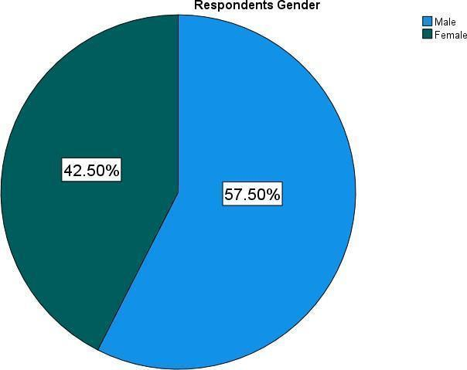
The pie chart above shows that 57.50% of the respondents were male while 42.50% were female.
Table 4. 1 Respondents age

Frequency |  | Percent | Valid  Percent | Cumulative  Percent
Between 50 -56 years | 4 | 10.0 | 10.0 | 10.0
Between 57 years – 63 years | 6 | 15.0 | 15.0 | 25.0
Between 64 – 70 years | 13 | 32.5 | 32.5 | 57.5
Above 70 years | 17 | 42.5 | 42.5 | 100.0
Total | 40 | 100.0 | 100.0

From the table above majority of the respondents 42.5% were above the ages of 70, 32.5% were between 64-70 years, 155 were between 57-63 years and a minor 10% were between 50-
56 years

Figure 4. 2 Respondents' Marital Status

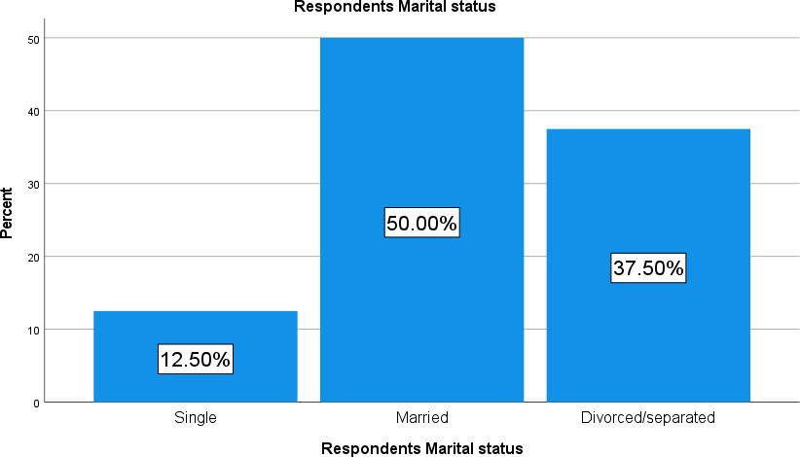

From the figure above 50% of the respondents said they are married 37.50% said they are either divorced or separated and a minor 12.50% said they are single.
Figure 4. 3 Respondents' Religion
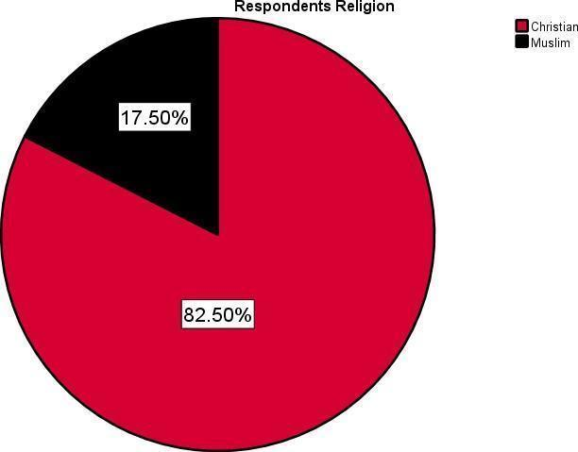
82.50% of the respondents said they are Christian while 17.50% said they are Christian.

4.2 Knowledge Factors
Table 4. 2 Lack of awareness about osteoporosis

 |  | Frequenc  y | Percent | Valid  Percent | Cumulative  Percent
 | Strongly Agree | 17 | 42.5 | 42.5 | 42.5
 | Agree | 9 | 22.5 | 22.5 | 65.0
 | Not Sure | 6 | 15.0 | 15.0 | 80.0
 | Disagree | 5 | 12.5 | 12.5 | 92.5
 | Strongly Disagree | 3 | 7.5 | 7.5 | 100.0
 | Total | 40 | 100.0 | 100.0

From the table above 42.5% of the respondents strongly agreed that lack of awareness about osteoporosis relates to the incidence of femoral neck fractures among the elderly, 22.5% said they agree, 15.0% said they are not sure, 12.5% said they disagree, while a minor 7.5% strongly disagreed.

Table 4.3 Ever received education or information about the risk factors associated

 |  | Frequency | Percent | Valid Percent | Cumulative  Percent
 | Agree | 15 | 37.5 | 37.5 | 62.5
 | Not Sure | 5 | 12.5 | 12.5 | 75.0
 | Disagree | 6 | 15.0 | 15.0 | 90.0
 | Strongly Disagree | 4 | 10.0 | 10.0 | 100.0
 | Total | 40 | 100.0 | 100.0
37.5% of the respondents said they agree they have ever received information about risk factors associated with femoral neck fracture, 12.5% said they are not sure, 15% said they disagreed, 10% said they strongly disagreed.

Figure 4. 4 Knowing about preventive measures
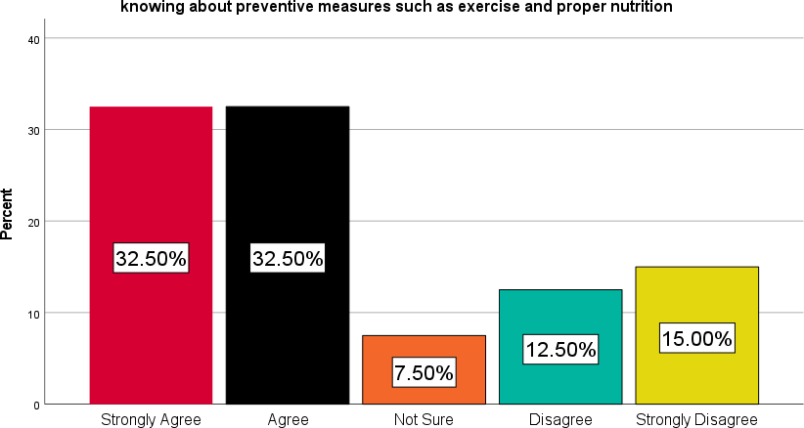

32.50% of the respondents strongly agreed and another 32.5% agreed that knowing about preventive measures such as exercises and proper nutrition could reduce the risk of femoral neck fractures 12.505 said they disagreed, 15% said they strongly disagreed and 7.50% said they are not sure.
Figure 4.5 Received guidance
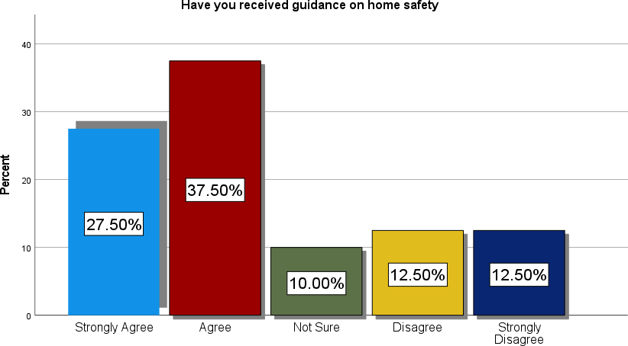

37.50% said they agreed they have received guidance on home safety so as to reduce incidence of femoral neck fracture, 27.50% strongly agreed, and 12.50% disagreed and strongly disagreed while 10% were not sure.
Table 4.4 Ever received information about the role of medications and supplements in maintaining bone health

Frequency |  |  | Percent | Valid  Percent | Cumulative  Percent
 | Strongly Agree | 13 | 32.5 | 32.5 | 32.5
 | Agree | 6 | 15.0 | 15.0 | 47.5
 | Not Sure | 8 | 20.0 | 20.0 | 67.5
 | Disagree | 10 | 25.0 | 25.0 | 92.5
 | Strongly Disagree | 3 | 7.5 | 7.5 | 100.0
 | Total | 40 | 100.0 | 100.0
32.5% strongly agreed they have received information about the role of medications and supplements in maintaining bone health, 15% agreed, 20% were not sure, 25% disagreed, 7.5% strongly disagreed.

4.3 Practices
Figure 4. 6 Engaging in weight bearing exercises
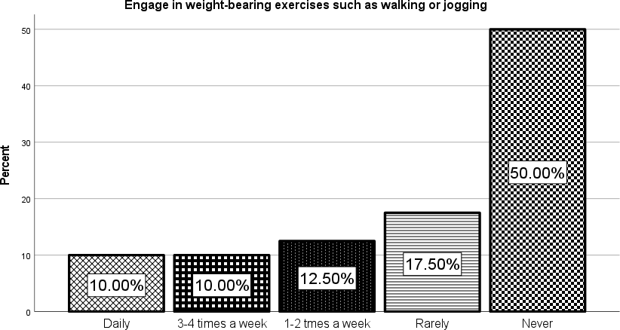
50% of the respondentsets said they never engage in weight bearing exercises such as walking or jogging, 17.50% said they rarely engage, 12.50% said they do engage but 1 or times a week, 10% said they do it 3 to 4 times a week while another 10% said they do it on a daily basis.

Figure 4. 7 Participating in strength training exercises.
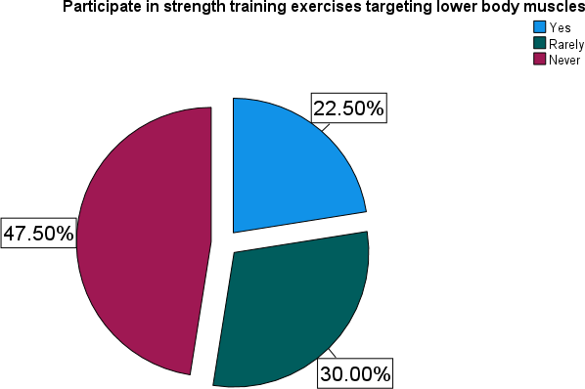
From the pie chart above 47.50% said they never participate in strength training exercises, 30% said they rarely participate, while 22.50% said they do.

Table 4. 5 Do you use assistive devices like canes or walkers for mobility

Frequency |  | Percent | Valid Percent | Cumulative  Percent
Regularly | 13 | 32.5 | 32.5 | 32.5
Occasionally | 10 | 25.0 | 25.0 | 57.5
Rarely | 9 | 22.5 | 22.5 | 80.0
Total | 40 | 100.0 | 100.0
Never | 8 | 20.0 | 20.0 | 100.0
32.5% of the respondents said they regularly use assistive devices like canes or walkers for mobility, 25% said they occasionally use the same, 22.5% said they rarely use them, and 20% said they never use them.

Figure 4. 8 Taking medication that could affect the bone density.

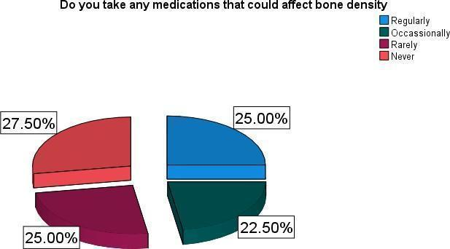

4.4 Socio-Economic Factors
Figure 4.9 Level of education.
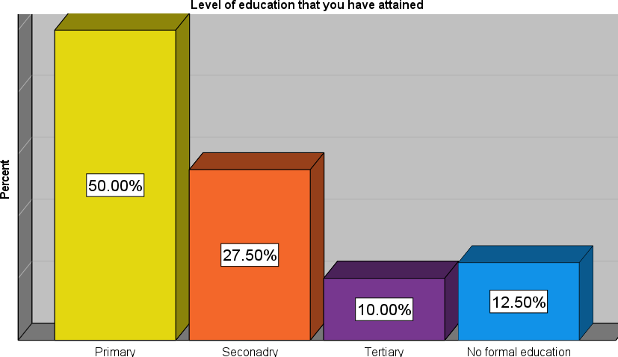
50% of the respondents said they achieved primary level of education, 27.505 reached secondary level, 12.50% did not attend formal education while a minor 10% reached tertiary level.
Figure 4. 10 Respondents occupation.
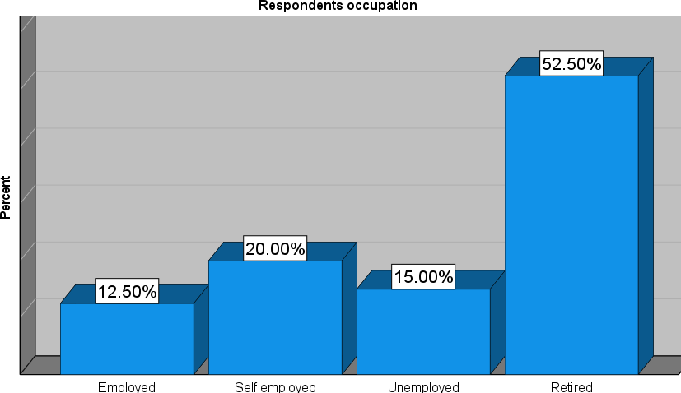

From the bar graph above, 52.50% said they are retired, 20% said they are self employed, 155 were unemployed and a minor 12.50% said they are employed.
Table 4. 6 Respondents salary

 | 0-10,000 ksh | Frequency  24 | Percent  60.0 | Valid Percent  60.0 | Cumulative Percent  60.0
 | 10,000-20,000 ksh | 7 | 17.5 | 17.5 | 77.5
 | 20,000-30,000 ksh | 6 | 15.0 | 15.0 | 92.5
 | Above 30,000 ksh | 3 | 7.5 | 7.5 | 100.0
 | Total | 40 | 100.0 | 100.0
The table above illustrates the respondentsets salary range, 60% said they between 0-10000ksh, 17.5% between 10,000-20,000ksh, 15% between 20,000-30,000ksh and 7.5% above 30,000 ksh.
Figure 4. 11 Health insurance coverage.
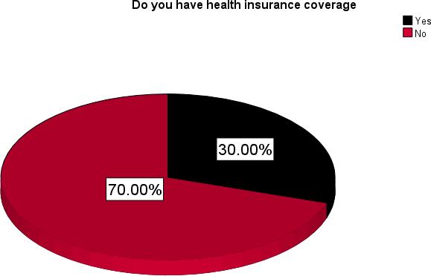

70% of the respondentsets said they do not have health insurance covers while 30% said they have.

Table 4. 7 How often do you worry about financial concerns

Frequency |  | Percent | Valid  Percent | Cumulative  Percent
Frequently | 14 | 35.0 | 35.0 | 35.0
Occasionally | 11 | 27.5 | 27.5 | 62.5
Rarely | 11 | 27.5 | 27.5 | 90.0
Never | 4 | 10.0 | 10.0 | 100.0
Total | 40 | 100.0 | 100.0 | 285
35 of the respondents said they frequently have worries about financial concerns, 27.5% said they occasionally have worries, another 27.5% said they rarely do, and 10% said they nver have worries.
Table 4. 8 Have you ever faced financial barriers in accessing healthcare services or treatments

Frequency |  | Percent | Valid  Percent | Cumulative  Percent
Yes, frequently | 13 | 32.5 | 32.5 | 32.5
Occasionally | 14 | 35.0 | 35.0 | 67.5
Rarely | 10 | 25.0 | 25.0 | 92.5
Never | 3 | 7.5 | 7.5 | 100.0
Total | 40 | 100.0 | 100.0
32.55% said they have frequently faced financial barriers in accessing healthcare services or treatments, 35% said they occasionally face financial barriers, 25% said the rarely face financial barriers while 10% said neve

CHAPTER FIVE

5.0 DISCUSSION, CONCLUSION AND RECOMMENDATION

5.0.1 Demographic Information
57.50% of the respondents were male while 42.50% were female. Majority of the respondents 42.5% were above the ages of 70, 32.5% were between 64-70 years, 155 were between 57-63 years and a minor 10% were between 50-56 years. 50% of the respondents said they are married 37.50% said they are either divorced or separated and a minor 12.50% said they are single. 82.50% of the respondents said they are Christian while 17.50% said they are Christian.

5.2 Knowledge factors
42.5% of the respondents strongly agreed that lack of awareness about osteoporosis relates to the incidence of femoral neck fractures among the elderly, 22.5% said they agree, 15.0% said they are not sure, 12.5% said they disagree while a minor 7.5% strongly disagreed. 37.5% of the respondentsets said they agree they have ever received information about risk factors associated with femoral neck fracture, 12.5% said they are not sure, 15% said they disagreed, 10% said they strongly disagreed. 32.50% of the respondents strongly agreed and another 32.5% agreed that knowing about preventive measures such as exercises and proper nutrition could reduce the risk of femoral neck fractures 12.505 said they disagreed, 15% said they strongly disagreed and 7.50% said they are not sure. 37.50% said they agreed they have received guidance on home safety so as to reduce incidence of femoral neck fracture, 27.50% strongly agreed, 12.50% disagreed and strongly disagreed while 10% were not sure. 32.5% strongly agreed they have received information about the role of medications and supplements in maintaining bone health, 15% agreed, 20% were not sure, 25% disagreed, 7.5% strongly disagreed.
Practices
50% of the respondentsets said they never engage in weight bearing exercises such as walking or jogging, 17.50% said they rarely engage, 12.50% said they do engage but 1 or times a week, 10% said they do it 3 to 4 times a week while another 10% said they do it on a daily basis. 47.50% said they never participate in strength training exercises, 30% said they rarely participate while 22.50% said they do. 32.5% of the respondents said they regularly use assistive devices like canes or walkers for mobility, 25% said they occasionally use the same, 22.5% said they rarely use them, and 20% said they never use them. 27.50% said they neve take medications that could affect the bone density, 25% of the respondents said they regularly take them and another 25% said they rarely take them while a minor 22.50% said they occasionally take them.

Socio-Economic Factors
50% of the respondents said they achieved primary level of education, 27.505 reached secondary level, 12.50% did not attend formal education while a minor 10% reached tertiary level. 52.50% said they are retired, 20% said they are self employed, 155 were unemployed and a minor 12.50% said they are employed. 60% said they between 0-10000ksh, 17.5% between 10,000-20,000ksh, 15% between 20,000-30,000ksh and 7.5% above 30,000 ksh. 70% of the respondentsets said they do not have health insurance covers while 30% said they have. 35% of the respondents said they frequently have worries about financial concerns, 27.5% said they occasionally have worries, another 27.5% said they rarely do, and 10% said they never have worries. 32.55 said they have frequently faced financial barriers in accessing healthcare services or treatments, 35% said they occasionally face financial barriers, 25% said the rarely face financial barriers while 10% said never.

Conclusion.
From the study results the researcher was able to draw the following conclusion; -
- Respondents had moderate knowledge on factors relating to the incidence of femoral neck fractures among the elderly e.g. osteoporosis.
- The respondents showed poor practices that promoted incidence of femoral neck fractures.
- There was a significant association between socio-economic factors and femoral neck fractures among the elderly.
Recommendation.
- There is a need to address the knowledge gap on femoral neck fractures. Potential strategies include health education that can be tailored and targeted particularly towards the elderly age group which had significantly lower knowledge on femoral neck fracture.
- There is need for health care workers to address the poor practices by the elderly and help the improve their practices so as to change their behaviour and practice more health seeking behaviours.
- Interventions designed to provide cheaper health care for the elderly by the government in conjunction with the MOH will be very much welcome as economical issues seem to be a barrier to access of health care.

REFERENCES

Bishop J, Yang A, Githens M, Sox AHS. Evaluation of contemporary Trends in Femoral neck fracture management reveals discrepancies in treatment. Geriatr Orthop Surg Rehabil. 2016;7:135–41. https://doi.org/10.1177/2151458516658328
Ekhtiari S, Gormley J, Axelrod DE, Devji T, Bhandari M, Guyatt GH. Total hip arthroplasty versus hemiarthroplasty for displaced femoral neck fracture: a systematic review and meta-analysis of randomized controlled trials. J Bone Joint Surg Am. 2020;102:1638–45. https://doi.org/10.2106/JBJS.20.00226
Farley BJ, Shear BM, Lu V, Walworth K, Gray K, Kirsch M, Clements JM, Rural. Urban and teaching hospital differences in hip fracture mortality. J Orthop. 2020;21:453–8. https://doi.org/10.1016/j.jor.2020.08.039
Filipov O. Epidemiology and social burden of the femoral neck fractures. J of IMAB. 2014;20(4):516–8.
Florschutz AV, Langford JR, Haidukewych GJ, Koval KJ. Femoral neck fractures: current management. Journal of Orthopaedic Trauma. 2015Mar 1;29(3):121-9.
Garden RS. Low-angle fixation in fractures of the femoral neck. The Journal of Bone and Joint Surgery. British Volume. 1961 Nov;43(4):647-63.
Greve K, Modig K, Talbäck M, Bartha E, Hedström M. No association between Waiting Time to surgery and mortality for healthier patients with hip fracture: a Nationwide Swedish Cohort of 59,675 patients. Acta Orthop 91, 396–400, https://doi.org/10.1080/17453674.2020.1754645
Harris IA, Cuthbert A, de Steiger R, Lewis P, Graves SE. Practice variation in total hip arthroplasty versus Hemiarthroplasty for Treatment of Fractured Neck of Femur in Australia. Bone Joint J. 2019;101–B:92–5. https://doi.org/10.1302/0301620X.101B1.BJJ- 2018-0666.R1
HIP ATTACK Investigators Accelerated Surgery versus Standard Care in Hip Fracture (HIP ATTACK). An International, Randomised, Controlled Trial. Lancet. 2020;395:698–708. https://doi.org/10.1016/S0140-6736(20)30058-1
Holvik K, Ellingsen CL, Solbakken SM, Finnes TE, Talsnes O, Grimnes G, et al. Cause-specific excess mortality after hip fracture: the norwegian epidemiologic osteoporosis studies (NOREPOS). BMC Geriatr. 2023;23(1):201.
Icks A, Haastert B, Wildner M, Becker C, Rapp K, Dragano N, et al. Hip fractures and area level socioeconomic conditions: a population-based study. BMC Public Health. 2019; 9:114.
Johnell O. The socioeconomic burden of fractures: today and in the 21st Century. Am J Med. 2017;103(2A):20S–6.
Ju DG, Rajaee SS, Mirocha J, Lin CA, Moon CN. Nationwide analysis of femoral Neck Fractures in Elderly Patients: a receding Tide. J Bone Joint Surg Am. 2017;99(22):1932–40.
Kannegaard PN, van der Mark S, Eiken P, Abrahamsen B. Excess mortality in men compared with women following a hip fracture. National Analysis of Comedications, Comorbidity and Survival. Age Ageing. 2010;39:203–9. https://doi.org/10.1093/ageing/
Lagerros YT, Hantikainen E, Michaëlsson K, Ye W, Adami HO, Bellocco R. Physical activity and the risk of hip fracture in the Elderly: a prospective cohort study. Eur J Epidemiol. 2017;32(11):983–91.
Lee Y-K, Ha Y-C, Park C, Koo K-H. Trends of Surgical Treatment in femoral Neck fracture: a Nationwide Study based on claim Registry. J Arthroplasty. 2013;28:1839–41. https://doi.org/10.1016/j.arth.2013.01.015
Longo UG, Viganò M, de Girolamo L, Banfi G, Salvatore G, Denaro V. Epidemiology and management of proximal femoral fractures in Italy between 2001 and 2016 in older adults: analysis of the National Discharge Registry. Int J Environ Res Public Health. 2022;19(24):16985.
Pennestrì F, Corbetta S, Favero V, Banfi G. Fragility fracture prevention—implementing a fracture liaison service in a high-volume orthopedic hospital. Int J Environ Res Public Health. 2019;16(24):4902.
Pennestrì F, Gaudioso A, Jani A, Bottinelli E, Banfi G. Is administered competition suitable for dealing with a public health emergency? Lessons from the local healthcare system at the center of the early COVID-19 outbreak in Italy. Cent Eur J Public Health. 2021;29(2):109–16.
Radiopedia NOF fracture Available:https://radiopaedia.org/articles/neck-of-femurfracture- 1?lang=us (accessed 16.12.2022)
Roberts KC, Brox WT. AAOS Clinical Practice Guideline: management of hip fractures in the Elderly. JAAOS - J Am Acad Orthop Surg. 2015;23(2):138–40.
Stronach BM, Bergin PF, Perez JL, Watson S, Jones LC, McGwin G. The rising use of total hip arthroplasty for femoral neck fractures in the United States. Hip Int. 2020;30(1):107–13.
Wang MC, Dixon LB (2016) Socioeconomic influences on bone health in postmenopausal women: findings from NHANES III

APPENDIX

APPENDIX 1 Questionnaires

Dear Respondent,
My name is Kelvin Mwangi Kimani I am Diploma student from Kenya medical training college Nakuru campus. I am conducting a research study, to assess factors relating to the incidence of femoral neck fractures among the elderly in Kerugoya County Referral Hospital, Kirinyaga County. I have been granted permission by both the KMTC college Nakuru campus and Kerugoya level 5 hospital to carry out this research
To make this study a success, I kindly request for your participation by answering this questionnaire booklet. Please note that the information obtained from you will be used for the purpose of this research only and will be treated with utmost confidentiality.
Sign…………………………………………………………………………

Date………………………………………………………………………

Thank you for your cooperation and support.

INSTRUCTIONS

- Do not write your name
- Put a tick in your response box.

PART A: DEMOGRAPHIC DATA

1. Gender

Male  Female 

2. Age


Between 50 -56 years

Between 57 years – 63 years 


Between 64 – 70 years


Above 70 years
3. Marital status

Single Married Divorced/Separated 
4. Religion
Christian  Muslim 

Any other……………………………………………….

SECTION B: KNOWLEDGE FACTORS CONTRIBUTING TO FEMORAL NECK FRACTURE AMONG THE ELDERLY
Tick appropriately

1= Strongly Agree 2= Agree 3=Not Sure 4=Disagree 5 =Strongly Disagree

STATEMENT | 1 | 2 | 3 | 4 | 5
1. Lack of awareness about osteoporosis contributes to femoral neck
fractures among the elderly.
2. Have you ever received education or information about the risk
factors associated with femoral neck fractures?
3. Do you think knowing about preventive measures such as exercise
and proper nutrition could reduce the risk of femoral neck fractures?
4. Have you ever been informed about the importance of maintaining
bone density as you age?
5. Do you believe that understanding the causes of falls could help in
preventing femoral neck fractures?
6. Have you received guidance on home safety modifications to
prevent falls and subsequent fractures?
7. Do you think knowing about the symptoms of osteoporosis could
lead to early intervention and fracture prevention?
8. Have you ever discussed with a healthcare professional how to
improve your balance and mobility to prevent falls?
9. Do you believe that understanding the importance of regular bone
density screenings could help in early detection of osteoporosis?
10. Have you ever received information about the role of medications

and supplements in maintaining bone health?
11. Do you think knowing about the potential risks of certain activities or movements could help in preventing femoral neck
fractures?
12. Have you ever participated in workshops or seminars aimed at
educating seniors about bone health and fracture prevention?
13. Do you believe that knowing about the available assistive devices
for mobility could reduce the risk of falls and fractures?
14. Have you ever been advised on proper footwear selection to
minimize the risk of falls?
15. Do you think having access to informational resources such as pamphlets or online materials on bone health could improve
awareness and reduce femoral neck fractures among the elderly?

SECTION C: PRACTICES

1. How often do you engage in weight-bearing exercises such as walking or jogging?

a. Daily | [ | ]
b. 3-4 times a week | [ | ]
c. 1-2 times a week | [ | ]
d. Rarely | [ | ]
e. Never | [ | ]

2. Do you regularly participate in strength training exercises targeting lower body muscles?

a. Yes | [ | ]
b. Rarely | [ | ]

3. How often do you consume calcium-rich foods or supplements?

a. Daily | [ | ]
b. A few times a week | [ | ]
c. Rarely | [ | ]
d. Never | [ | ]

4. Do you have a history of falls in the past year?

  - Yes [ ]

  - No [ ]

5. Have you ever been diagnosed with osteoporosis?

  - Yes [ ]

  - No [ ]
6. Do you use assistive devices like canes or walkers for mobility?

a. Regularly | [ | ]
b. Occasionally | [ | ]
c. Rarely | [ | ]
d. Never | [ | ]

7. Have you had any previous fractures, particularly in the hip or femur?

  - Yes [ ]

  - No [ ]

8. How often do you have your eyesight checked?

c. Rarely | [ | ]
a. Annually | [ | ]
b. Biannually | [ | ]
d. Never | [ | ]

9. Do you take any medications that could affect bone density (e.g., corticosteroids)?

a. Yes | [ | ]
b. Occasionally | [ | ]
c. Rarely | [ | ]
d. Never | [ | ]

10. How often do you participate in balance and coordination exercises?

a. Daily | [ | ]
b. A few times a week | [ | ]
c. Rarely | [ | ]
d. Never | [ | ]

11. Have you ever received education or training on fall prevention strategies?

  - Yes [ ]

  - No [ ]

12. Do you have grab bars or handrails installed in your home?

  - Yes [ ]

  - No [ ]
13. Have you ever experienced dizziness or light headedness upon standing up?

a. Yes, frequently | [ | ]
b. Occasionally | [ | ]
c. Rarely | [ | ]
d. Never | [ | ]

14. How often do you have your bone density measured (e.g., DEXA scan)?

a. Every 1-2 years | [ | ]
b. Every 3-5 years | [ | ]
c. Rarely | [ | ]
d. Never | [ | ]

15. Do you have a history of smoking?

a. Yes, currently | [ | ]
b. Yes, but I quit | [ | ]
c. No | [ | ]

SECTION D: SOCIOECONOMIC FACTORS CONTRIBUTING TO FEMORAL NECK FRACTURES AMONG THE ELDERLY:

1. Level of education that you have attained

Primary Level | [ | ]
Secondary Level | [ | ]
College/University | [ | ]
No Schooling at All [ ]

2. What is your current employment status?

a. Employed | [ | ]
b. Self employed | [ | ]
c. Unemployed | [ | ]
d. Retired | [ | ]

3. What is your household income level?

0-10,000 ksh | [ | ]
10,000-20,000 ksh | [ | ]
20,000- 30,000 ksh | [ | ]
Above ksh 30,000 | [ | ]

4. Do you have health insurance coverage?

  - Yes [ ]

  - No [ ]

5. How often do you visit a healthcare provider for check-ups or preventive care?

a. Annually | [ | ]
b. Biannually | [ | ]
c. As needed | [ | ]
d. Rarely | [ | ]
e. Never | [ | ]
6. Do you have access to reliable transportation to attend medical appointments?

a. Yes, always | [ | ]
b. Sometimes | [ | ]
c. No | [ | ]

7. How far is the nearest healthcare facility from your residence?

a. Less than 5 Km | [ | ]
b. 5-10 Km | [ | ]
c. 10-20 Km | [ | ]
d. More than 20 Km | [ | ]
e. Not sure | [ | ]

8. Have you ever faced financial barriers in accessing healthcare services or treatments?

a. Yes, frequently | [ | ]
b. Occasionally | [ | ]
c. Rarely | [ | ]
d. Never | [ | ]

9. Do you live alone or with family members?

a. Alone | [ | ]
b. With spouse/partner | [ | ]
c. With children | [ | ]
d. With other relatives | [ | ]
e. Other (please specify) | [ | ]
10. How often do you engage in social activities or interact with friends and neighbours?

a. Daily | [ | ]
b. A few times a week | [ | ]
c. Rarely | [ | ]
d. Never | [ | ]

11. Have you experienced any significant life stressors recently (e.g., loss of a loved one, financial hardship)?
  - Yes [ ]

  - No [ ]

12. How satisfied are you with your current living environment (e.g., housing conditions, neighborhood safety)?

a. Very satisfied | [ | ]
b. Somewhat satisfied | [ | ]
c. Neutral | [ | ]
d. Somewhat dissatisfied | [ | ]
e. Very dissatisfied | [ | ]
13. Are there any community resources or support services available to you for assistance with daily activities or healthcare needs?
  - Yes [ ]

  - No [ ]
14. Have you ever experienced food insecurity (i.e., lack of consistent access to enough food for an active, healthy life)?

a. Yes | [ | ]
b. No | [ | ]

15. How often do you worry about financial concerns related to healthcare expenses or aging-related costs?

a. Frequently | [ | ]
b. Occasionally | [ | ]
c. Rarely | [ | ]
d. Never | [ | ]

Appendix II Work Plan

YEAR | 2026
MONTH ACTIVITY | FEBRUARY | MARCH | APRIL | MAY | JUNE
Presentation of the topic objectives
Introduction
Literature review
Methodology
Data collection, analysis, and interpretation
Discussion and recommendation

Appendix III Budget

 | ITEM | QUANTITY | COST (KSH) | TOTAL
1. | Foolscaps | 1 ream | 400 | 400
2. | Ball pens | 4 | 10 | 40
3. | File | 1 | 60 | 60
4. | Pencil | 1 | 10 | 10
5. | RULER | 1 | 30 | 30
6. | Typing and printing | 50 pages | 25 | 1250
7. | Flash disk | 2 Gb | 700 | 1400
8. | Bundles | 5 Gb | 200 | 1000
9. | Transport |  | 1000 | 1000
 | Grand total |  |  | 5190

Appendix IV: Map
