SYS-ARCH-006: S1 Structure Scheme - Heatsink as Central Spine
Date: 2026-05-27 | Related document: SYS-ARCH-006 v0.1 | Proposal: A - Heatsink as structural core
------------------------------------------------------------

Structure Concept Summary
The heatsink (350x150x50mm aluminum extrusion) serves as the central structural spine of the enclosure. Front and rear panels bolt directly to the heatsink ends. PCBs mount on standoffs attached to the heatsink flat face. SPCC steel enclosure panels (top, bottom, sides) attach to the heatsink flange edges, forming a "heatsink spine + wrapped shell" sandwich structure.

Rationale: Heatsink (~2.5kg) is the heaviest single component. Using it as the structural element eliminates redundant frame weight. Critical given our <5kg target and 131W/L power density.

Visual Diagrams
Refer to the embedded diagram below showing 4 views: structure exploded view, front panel layout, rear panel layout, and internal top view.
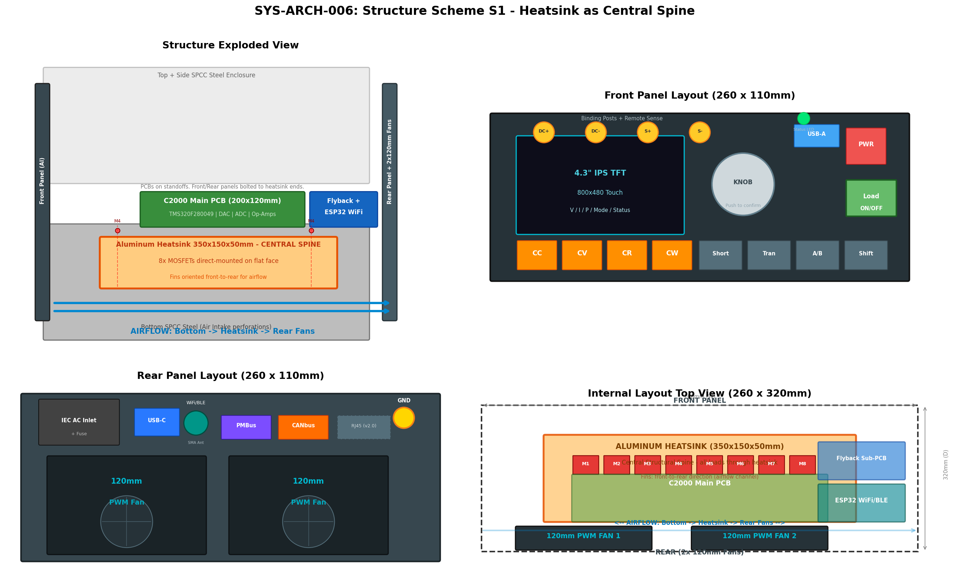
Figure 1: SYS-ARCH-006 S1 Structure Scheme - 4-View Diagram

Key Dimensions Summary
Enclosure: W260 x D320 x H110mm (9.15L)
Heatsink: 350 x 150 x 50mm aluminum extrusion
Main PCB: 200 x 120mm (C2000 TMS320F280049)
Flyback sub-PCB: ~70 x 50mm
Fans: 2x 120mm PWM, rear exhaust
Airflow: Bottom intake -> heatsink fins -> rear fan exhaust

Weight Estimation
Heatsink: ~2.5kg | Enclosure (SPCC): ~1.0kg | PCBs + components: ~0.5kg | Fans: ~0.3kg | Other (transformer, wiring, posts): ~0.7kg | TOTAL: ~5.0kg
Risk: Weight target (<5kg) is very tight. Recommend relaxing to 6-7kg if thermal/structural margin needed.

