1200W 电子负载 - 同类产品外观结构参考报告

Doc: REF-STRUCT-001 | Date: 2026-05-27 | Version: v2.2
------------------------------------------------------------

Report Note
This report focuses on 1200W-class programmable DC electronic load products. Product images are sourced from official manufacturer websites and authorized distributor product pages.

1. 1200W Competitive Product Lineup
Brand | Model | Power | V/I | Form | Dims(mm) | Weight | Price
ITECH | IT8814B | 1200W | 500V/60A | Bench/3U | 440x530x176 | ~20kg | $1200-1800
ITECH | IT8812C | 1200W | 120V/120A | Bench/3U | 440x530x176 | ~20kg | $1200-1800
BK Precision | 8616 | 1200W | 500V/60A | Bench/3U | 440x510x155 | ~18kg | $2500-3000
BK Precision | 8614 | 1200W | 120V/120A | Bench/3U | 440x510x155 | ~18kg | $2500-3000
Maynuo | M9715 | 1800W | 150V/240A | Bench/3U | 428x454x207 | ~31kg | $1500-2000
Chroma | 63204E | 1200W | 1200V/160A | Rack/4U | 446x581x176 | ~22kg | $5000+
Array | 3710A | 1200W | 500V/60A | Bench/2.5U | 355x415x132 | ~12kg | $1200-1600
Faith | FT6800A | 1200W | Multi | Bench/3U | 440x525x178 | ~18kg | 8-15k RMB
GW Instek | PEL-3111 | 1050W | 150V/210A | Bench/3U | 430x500x155 | ~18kg | $1500-2200

>> Key: All 1200W competitors use 3U-4U large bench/rack form factors (19-46L, 12-31kg). Our design (260x320x110mm, 9.15L, <5kg) has 1/5 the volume and 1/4 the weight, with 4-8x the power density. This is the core design challenge.

2. Competitor Appearance Details

2.1 ITECH IT8814B (1200W / 500V / 60A)
ITECH IT8800 series. IT8814B is the 1200W model. Below: IT8811 photo (entire series shares same external design):
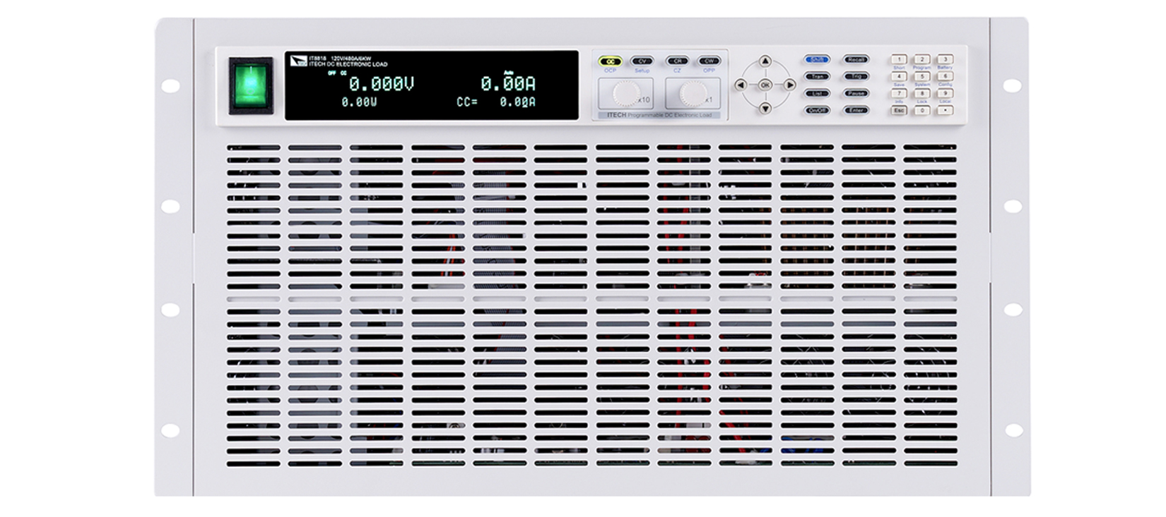
Fig 2.1: ITECH IT8800 Series Front Panel (Source: ITECH Official)
External Features:
- Standard bench instrument; folding carry handle + folding front support feet (panel tilt)
- Enclosure: cold-rolled steel stamping + powder coating (off-white); front: brushed Al + silkscreen. 440x530x176mm (41L), ~20kg
- Display: VFD (green), ~140x35mm, 2-line (large actual values + set values & status)
- Knob: right-mid, ~30mm Al knurled rotary encoder, push-to-confirm/edit
- Keys: Mode shortcuts (CC/CV/CR/CW) + Function (A/B,Short,Tran,Shift) + Numpad + Arrows
- Posts: bottom, 2 pairs large (DC+/DC-) + 1 pair Remote Sense (S+/S-)
- Switches: bottom-left rocker power, bottom-right Load On/Off (backlit LED)
Rear: IEC+fuse, USB-B, RS-232(DB9), GPIB(opt), multi-80mm fan exhaust, ground.
Internal: 3-board (front panel + main (MCU+DAC+ADC) + power (MOSFET bank + heatsink)). Large Al heatsink, rear fans, front-to-back airflow.

2.2 BK Precision 8616 (1200W / 500V / 60A)
BK 8616: North American mainstream 1200W. 8614/8616 share the same 3U chassis. 8614 = 120V/240A, 8616 = 500V/60A. Below: 8614 photo (same chassis as 8616):
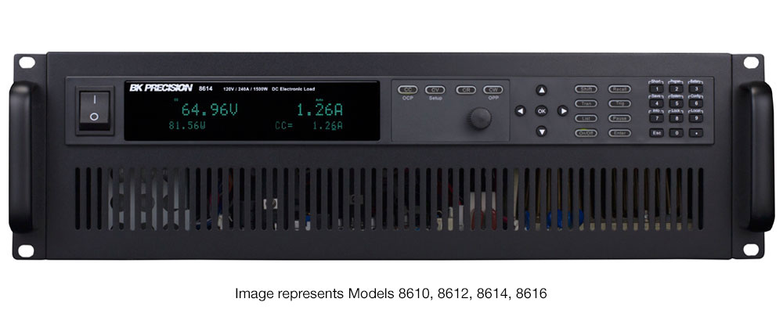
Fig 2.2-1: BK Precision 8614 Front Panel (same 3U chassis as 8616, Source: TTiD / BK Precision)
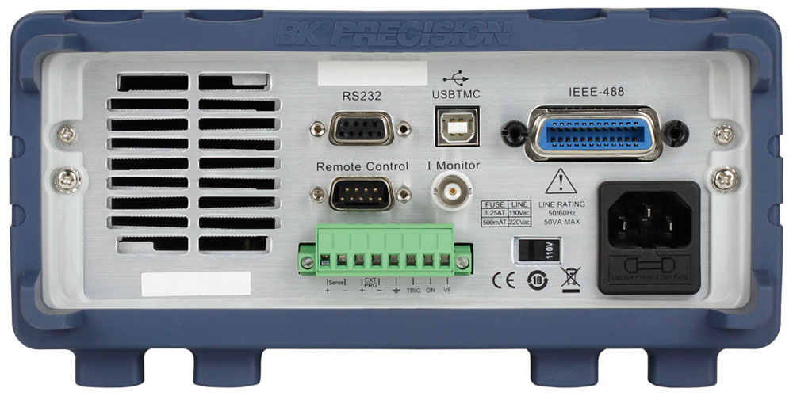
Fig 2.2-2: BK 8600 Series Rear Panel (8614/8616 3U model layout, Source: TTiD)
External Features:
- Benchtop 3U, dark gray enclosure + dark brushed Al front. 440x510x155mm (35L), ~18kg
- Display: VFD green high-bright, 4-line (best info hierarchy among competitors)
- Knob: right side, silver Al knurled (~28mm), push-to-confirm
- Keys: Mode (CC/CV/CR/CW/CR+CV) + Numpad + Arrows + Shift system
- Posts: bottom-left, 2 pairs heavy-duty (metal+insulation sleeve) + Remote Sense (S+/S-)
- Front USB Host (rare among competitors!), Load On/Off large button (green backlight)
Rear (Fig 2.2-2): IEC+fuse, USB-B, RS-232(DB9), GPIB(STANDARD), RJ45 LAN, 80mm fans x2, ground. BK has the most comprehensive interfaces. 3U models have binding posts on rear.
Internal: 3-layer (top I/O comm + middle main (DSP+DAC/ADC) + bottom power (Al heatsink+MOSFET array)). Ribbon/board-to-board, front-to-back airflow. Teardown issues: I/O FR4 ~1.2mm thin, encoder eccentric.

2.3 Maynuo M97 Series (M9715: 1800W)
Maynuo M97 series: mid-high-end Chinese electronic load, covers 150W-1800W. Consistent design from M9710 to M9715:
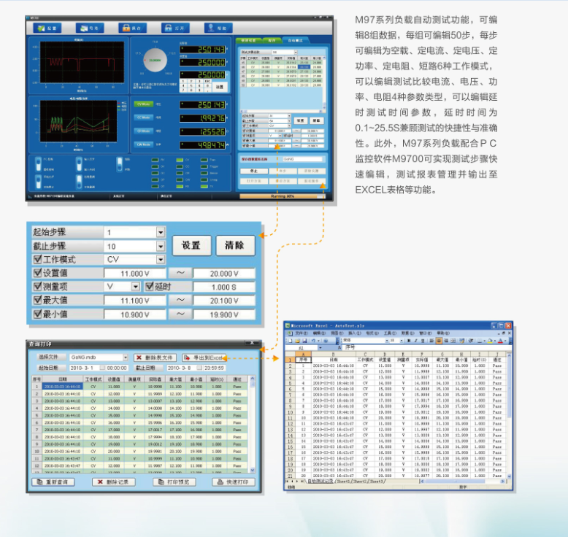
Fig 2.3-1: Maynuo M97 Series Front Panel (Source: Maynuo Official)
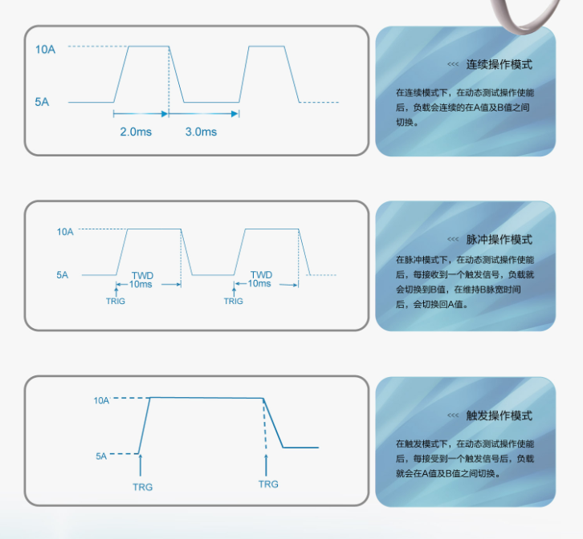
Fig 2.3-2: Maynuo M97 Front Detail (Source: Maynuo Official)
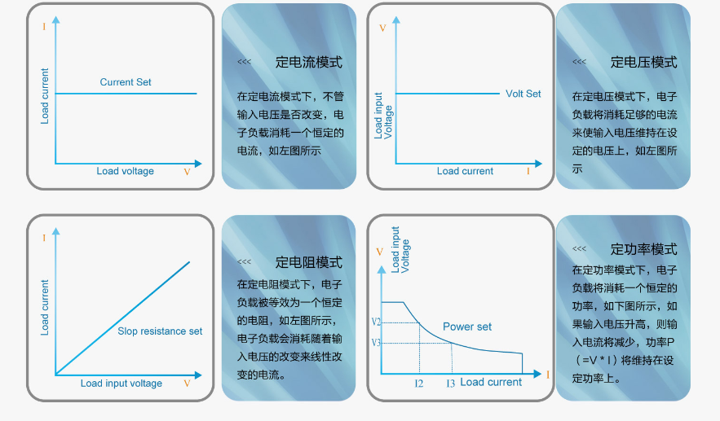
Fig 2.3-3: Maynuo M97 Front View (Source: Maynuo Official)
External Features:
- Benchtop 3U, silver-gray brushed Al front + light gray painted enclosure. 428x454x207mm (40L), ~31kg
- Display: large VFD (160x40mm, ~70% panel width), 4-line. Largest in class
- Knob: bottom-right, single (Al knurled) with LED ring showing status - strong brand identity
- Keys: Mode (CC/CV/CR/CW/CC+CV/CR+CV/Dynamic/Short) + Numpad + Arrows
- Posts: bottom, 2 pairs metal + Remote Sense. Compatible with banana plugs and fork terminals
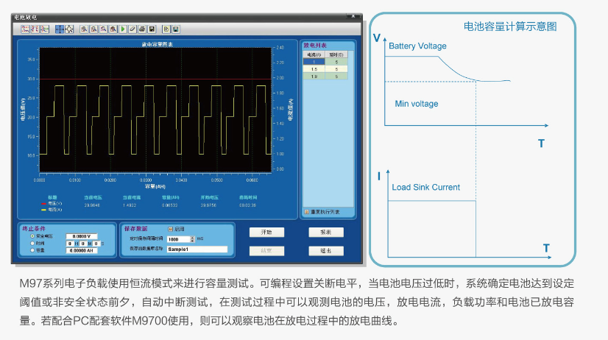
Fig 2.3-4: Maynuo M97 Rear Panel (Source: Maynuo Official)
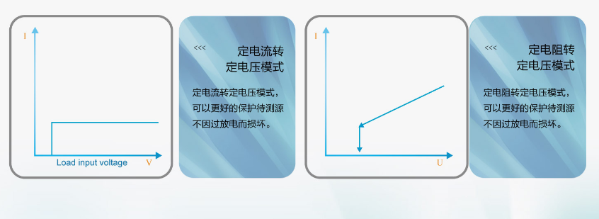
Fig 2.3-5: Maynuo M97 Detail (Source: Maynuo Official)
Rear: IEC+fuse, USB-B, RS-232(DB9), RS-485(terminal block - differentiating), dual 120mm fans, ground.
Internal highlight: SPLIT DUAL HEATSINK - two independent heatsinks each with MOSFET bank. Even thermal distribution, no hot spots. Measured ~43C at 230W (excellent). AD/BB/NXP/TI brand components. Modular connectors for easy service.

3. Internal Structure Comparison
Aspect | ITECH IT8814B | BK 8616 | Maynuo M9715 | Rigol DL3021 | Our Design
PCB arch | 3-board split | 3-board split | 3-board split | 3-board:dig+UI+pwr | C2000+flyback+ESP32
Interconnect | Ribbon cables | Ribbon+B2B | Modular connectors | PCIe(dig-UI)+ribbon | TBD
Controller | MCU | DSP | DSP/ARM | FPGA+ARM dual-core | C2000+ESP32
Power | MOSFET multi-parallel | MOSFET array | MOSFET dual-group | MOSFET bank | MOSFET parallel
Heatsink | Single large Al | Single large Al | Dual Al (split) | Large Al | Al ext 350x150x50
Fan | Multi x80mm rear | 2x80mm rear | 2x120mm rear | Single rear | 2x120mm rear
Airflow | Front-to-back | Front-to-back | Bottom-to-back | Front-to-back | Bottom->HS->rear
Enclosure | Steel+Al panel | Steel+Al panel | Steel+Al panel | Steel stamping | Al frame+SPCC

Structure Design Rules
1. Control-Power board separation = industry iron law. High-current paths independent; control via ribbon/connectors.
2. All MOSFETs linear region; all heat via heatsink+fans. Power devices mounted directly on heatsink.
3. Airflow always front-to-back or bottom-to-back; fans always at rear. Never side exhaust.
4. Maynuo split dual heatsink = most noteworthy. Even thermal distribution, no hot spots. Optimal for high power.
5. Rigol PCIe interconnect = good signal integrity. Consider for high-speed board-to-board comm.
6. 100% sheet metal stamping+paint enclosure + brushed Al front. Zero competitors use full Al CNC.
7. 1200W competitors weigh 12-31kg (far > our <5kg), 4-8x volume. Thermal solutions cannot be directly copied.

4. Front Panel Design Comparison

4.1 Display
Brand | Tech | Color | Size | Lines | Feature
ITECH IT8814B | VFD | Green | 140x35mm | 2 | High brightness
BK 8616 | VFD | Green | 150x40mm | 4 | Best info hierarchy
Maynuo M9715 | VFD | Green | 160x40mm | 4 | Largest area (70% panel)
Chroma 63204E | OLED | Amber | ~120x30mm | Multi | Only OLED, best contrast
**OURS** | **IPS TFT** | **Color** | **4.3"** | **Touch GUI** | **Unique in class**

4.2 Knob
Brand | Qty | Type | Position | Dia | Push
ITECH | 1 | Rotary encoder | Right | ~30mm | Confirm/Edit
BK 8616 | 1 | Rotary encoder | Right | ~28mm | Confirm
Maynuo | 1 | Encoder+LED ring | Bottom-right | ~30mm | Confirm
Chroma | 1 | Rotary encoder | Right | ~32mm | Confirm
**OURS** | **1** | **Encoder w/ button** | **Right of LCD** | **TBD** | **Confirm**

4.3 Standard Front Panel Layout
All competitors follow the same proven ergonomic layout:
[Power Switch] [ D I S P L A Y ] [Vent]
[Mode: CC / CV / CR / CW] [K N O B]
[Func: Short/Tran/A/B/Shift] [Numpad 0-9]
[Arrow Keys] [Enter/Esc]
[Binding Posts +/-] [Remote Sense] [Load On/Off]
Frequency layers: High (mode/OnOff/short)=one-touch / Medium (params)=knob+numpad / Low (config)=menu

4.4 Binding Posts
Brand | Type | Qty | Sense | Rating | Compatibility
ITECH | Large metal posts | 2pr | 1pr S+/- | 60A | Banana+Fork+M6
BK 8616 | Heavy-duty (insulated) | 2pr | 1pr S+/- | 60A | Banana+Fork+M6
Maynuo | Large metal posts | 2pr | 1pr S+/- | 240A | Banana+Fork
Chroma | Bolt terminals | 1pr | Independent S+/- | 160A | Thick cable bolt

5. Rear Panel Interface Comparison
Interface | ITECH | BK 8616 | Maynuo | Chroma | Array | Ours
AC | IEC+fuse | IEC+fuse | IEC+fuse | IEC/Bus | IEC | IEC+fuse
USB Dev | USB-B | USB-B | USB-B | USB-B | USB | USB-C
USB Host | None | Front | None | None | None | USB-A (Front)
RS-232 | DB9 | DB9 | DB9 | DB9 | DB9 | None
GPIB | Optional | **Standard** | None | Optional | None | None
RS-485 | None | None | **Terminal** | Optional | None | None
LAN | None | **Standard** | None | Optional | None | Reserved
WiFi/BLE | None | None | None | None | None | **SMA Antenna**
PMBus | None | None | None | None | None | **2pin (unique)**
CANbus | None | None | None | None | None | **2pin (unique)**
Fan | Multi 80 | 2x80mm | 2x120mm | Multi 80 | 2x80mm | 2x120mm

>> Differentiator: PMBus + CANbus industrial fieldbus = unique in 1200W class. Competitors still use RS-232 + GPIB.

6. Power Density & Thermal Challenge
Product | Power | Vol(L) | Wt(kg) | W/L | W/kg
ITECH IT8814B | 1200W | 41.0 | ~20 | 29 | 60
BK 8616 | 1200W | 34.8 | ~18 | 34 | 67
Maynuo M9715 | 1800W | 40.2 | ~31 | 45 | 58
Chroma 63204E | 1200W | 45.6 | ~22 | 26 | 55
Array 3710A | 1200W | 19.4 | ~12 | 62 | 100
GW Instek PEL-3111 | 1050W | 33.3 | ~18 | 32 | 58
**OURS** | **1200W** | **9.15** | **<5** | **131** | **240**

!! Our power density (131 W/L) = 3.8x competitor avg, 2.1x most compact (Array).
Thermal implications: 1) Need 2-4x competitor efficiency 2) Noise > competitors (55-65dBA) 3) Fin density/fan selection critical 4) Array 3710A closest ref (62W/L) 5) Consider derating 6) Heatsink needs thermal sim

7. Teardown Lessons
# | Issue | Found In | Sev | Implication
1 | Poor ground: paint blocks path | Kunkin KP184 | H | Remove paint at contact points
2 | Bad thick-wire solder joints | Kunkin KP184 | H | Special process for power board
3 | Knob eccentric/not flush | BK 8600 | M | Precise shaft & cutout tolerance
4 | I/O board FR4 ~1.2mm | BK 8616 | M | PCB >=1.6mm, add stiffeners
5 | Flux residue not cleaned | BK 8600 | M | Wash or no-clean process
6 | Panel silkscreen/UI crude | Rigol DL3021 | M | Invest in professional design
7 | Post ID too small | Kunkin KP184 | H | Verify banana plug compatibility
8 | Buzzer poor quality | BK 8600 | L | Driver circuit + component test
9 | Full-load 55-65dBA noise | Multiple | M | Higher density = higher noise
10 | Inconsistent thermal protection | Multiple | H | Define OTP & derating strategy

8. Design Recommendations for SYS-ARCH-006
Form factor: All 1200W competitors = 3U-4U (19-46L, 12-31kg). Ours (9.15L, <5kg) = new category: compact high-power electronic load. No direct competitor. Differentiated positioning, but serious thermal risk.
Front panel: Standard layout market-proven. 4.3" IPS TFT touchscreen unique in class. Recommend physical shortcut keys (CC/CV/CR/CW) as touchscreen redundancy.
Rear panel: PMBus+CANbus = unique advantage. USB-C for PC comm to compensate for no RS-232. Front USB-A superior to competitors.
Internal: Control/power separation mandatory. Maynuo split dual heatsink worth adopting. Rigol PCIe interconnect worth referencing. Heatsink requires thermal simulation.
Thermal: Dual 120mm rear exhaust + bottom intake correct. But 131W/L needs 2-4x competitor efficiency. Recommend: higher fin density, high-static-pressure fans, air duct guide vanes.
Material: Al profile frame + SPCC steel = industry standard. Zero competitors use full Al CNC.
Weight: Competitors 12-31kg. Heatsink alone ~2-3kg, plus enclosure/transformer/PCB/fans easily exceeds 5kg. Consider relaxing to 6-7kg.
Quality: Knob feel, panel silkscreen, post compatibility, ground safety - four non-negotiable baselines.

--- End of Report ---

