Kegan Sanchez

December 7, 2020

Foundations of Programming (Python)

Assignment 08

<https://github.com/kegans/IntroToProg-Python-Mod08>

Objects and Classes

# Introduction

This week, I modified a program that uses objects and classes to read and write to a file. This assignment included new components such as constructors, classes, methods, the self keyword, properties, attributes, and exception handling.

# Creating the Program

In addition to reviewing the module notes provided by the instructor, Randal Root, I began by reviewing the starter .py file and attempting to determine what I would need to incorporate within this program. I had a harder time grasping the subject matter of this module enough to apply it effectively, so my ability to complete the assignment on my own and before the deadline was limited.

## The Product Class

Since I didn’t get a good enough grasp on the topics to apply them, I used the assignment answer code and review video to supplement my knowledge. The entire section devoted to handling the data was predominantly made up of a Product class which stored data about a product in a list of product objects (Figure 1).

*# Data -------------------------------------------------------------------- #*

*strFileName = 'products.txt'*

*lstOfProductObjects = []*

*class Product:*

*"""Stores data about a product:*

*properties:*

*product_name: (string) with the product's name*

*product_price: (float) with the product's standard price*

*methods:*

*changelog: (When,Who,What)*

*RRoot,1.1.2030,Created Class*

*KSanchez,2020.12.09,Modified code to complete assignment 8*

*"""*

*# TODO: Add Code to the Product class (Done)*

*# -- Constructor --*

*def __init__(self, product_name: str, product_price: float):*

*"""Set name and price of a new object"""*

*# -- Attributes --*

*try:*

*self.__product_name = str(product_name)*

*self.__product_price = float(product_price)*

*except Exception as e:*

*raise Exception("Error setting initial values:\n" + str(e))*

*# -- Properties --*

*# product name*

*@property*

*def product_name(self):*

*return str(self.__product_name)*

*@product_name.setter*

*def product_name(self, value: str):*

*if str(value).isnumeric():*

*self.__product_name = value*

*else:*

*raise Exception("Names cannot be numbers.")*

*# product price*

*@property*

*def product_price(self):*

*return float(self.__product_price) # cast to float*

*@product_price.setter*

*def product_price(self, value: float):*

*if str(value).isnumeric():*

*self.__product_price = float(value) # cast to float*

*else:*

*raise Exception("Prices must be numbers.")*

*# -- Methods --*

*def to_string(self):*

*"""alias of __str__(), converts product data to string"""*

*return self.__str__()*

*def __str__(self):*

*"""Converts product data to string"""*

*return self.__product_name + "," + str(self.product_price)*

*# Data -------------------------------------------------------------------- #*

***Figure 1: Data – Product Class***

## The FileProcessor Class

After reviewing the Product class, I looked at the processing portion of the program, which was also made up of a single class called FileProcessor which handled data to and from a file and a list of product objects (Figure 2).

# Processing ------------------------------------------------------------- #

class FileProcessor:

"""Processes data to and from a file and a list of product objects:

methods:

save_data_to_file(file_name, list_of_product_objects):

read_data_from_file(file_name): -> (a list of product objects)

changelog: (When,Who,What)

RRoot,1.1.2030,Created Class

KSanchez,2020.12.09,Modified code to complete assignment 8

"""

# TODO: Add Code to process data from a file (Done)

@staticmethod

def save_data_to_file(file_name, list_of_product_objects):

"""Writes data to a file from a list of product rows

:param file_name: (string) with name of file

:param list_of_product_objects: (list) of product objects data saved to file

:return: (bool) with status of success status

"""

success_status = False

try:

file = open(file_name, "w")

for product in list_of_product_objects:

file.write(product.__str__() + "\n")

file.close()

success_status = True

except Exception as e:

print("There was a general error!")

print(e, e.__doc__, type(e), sep="\n")

return success_status

# TODO: Add Code to process data to a file (Done)

@staticmethod

def read_data_from_file(file_name: str):

"""Reads data from a file into a list of product rows

:param file_name: (string) with name of file

:return: (list) of product rows

"""

list_of_product_rows = []

try:

file = open(file_name, "r")

for line in file:

data = line.split(",")

row = Product(data[0], data[1])

list_of_product_rows.append(row)

file.close()

except Exception as e:

print("There was a general error!")

print(e, e.__doc__, type(e), sep="\n")

return list_of_product_rows

# Processing ------------------------------------------------------------- #

***Figure 2: Processing – FileProcessor Class***

## The IO Class

The next portion of the program handled the presentation processes, or input/output and was mostly comprised of code that was used in previous file handling program assignments (Figure 3).

# Presentation (Input/Output) -------------------------------------------- #

class IO:

# TODO: Add docstring (Done)

"""A class for performing Input and Output

methods:

print_menu_items():

print_current_list_items(list_of_rows):

input_product_data():

changelog:

KSanchez, 2020.12.09, Modified code to complete assignment 8

"""

# TODO: Add code to show menu to user (Done)

@staticmethod

def print_menu_items():

"""Displays a menu of choices for the user."""

print("""

Menu of Options

1) Show current data

2) Add a new item

3) Save data to a file

4) Exit program

""")

print() # Adds an extra line for looks

# TODO: Add code to get user's choice (Done)

@staticmethod

def input_menu_choice():

"""Gets the menu choice from a user

:return: string

"""

choice = str(input("Which option would you like to perform? [1 to 4]: ")).strip()

print() # Adds an extra line for looks

return choice

# TODO: Add code to show the current data from the file to user (Done)

@staticmethod

def print_current_list_items(list_of_rows: list):

"""Prints the current items in the list of rows.

:param list_of_rows: (list) of rows you want to display

"""

print("*******The current product items are:*******")

for row in list_of_rows:

print(row.product_name + "(" + str(row.product_price) + ")")

print("*******************************************")

print() # Adds an extra line for looks

# TODO: Add code to get product data from user (Done)

@staticmethod

def input_product_data():

"""Gets data for a product object

:return: (Product) object with input data

"""

try:

name = str(input("Product name: ").strip())

price = float(input("Product price: ").strip())

print() # Adds an extra line for looks

p = Product(product_name=name, product_price=price)

except Exception as e:

print(e)

return p

# Presentation (Input/Output) -------------------------------------------- #

***Figure 3: Presentation – IO Class***

## The Main Body

The last portion of the program was the main body, which took each of these classes and ran them in a while loop with exception handling to catch any errors (Figure 4).

# Main Body of Script ---------------------------------------------------- #

# TODO: Add Data Code to the Main body (Done)

# Load data from file into a list of product objects when script starts

try:

lstOfProductObjects = FileProcessor.read_data_from_file(strFileName)

while True:

# Show user a menu of options

IO.print_menu_items()

# Get user's menu option choice

strChoice = IO.input_menu_choice()

if strChoice.strip() == "1":

# Show user current data in the list of product objects

IO.print_current_list_items(lstOfProductObjects)

continue

elif strChoice.strip() == "2":

# Let user add data to the list of product objects

lstOfProductObjects.append(IO.input_product_data())

continue

elif strChoice.strip() == "3":

# let user save current data to file and exit program

FileProcessor.save_data_to_file(strFileName, lstOfProductObjects)

continue

elif strChoice.strip() == "4":

break

except Exception as e:

print("There was an error! Check file permissions.")

print(e, e.__doc__, type(e), sep="\n")

# Main Body of Script ---------------------------------------------------- #

***Figure 4: Main Body***

# Testing

When I began creating this program, I completed all coding and testing primarily in the PyCharm IDE. To complete this assignment, I also tested in the command terminal.

## PyCharm and Command Terminal

I tested in PyCharm and then opened a command terminal, changed the directory to my assignment folder, and ran portions of my Assignment07.py script file. I received the desired output here, as well (Figures 5 and 6).

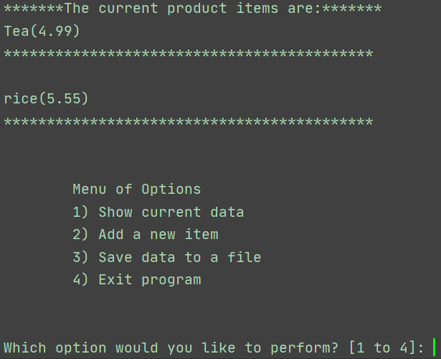

***Figure 5 : PyCharm Testing***

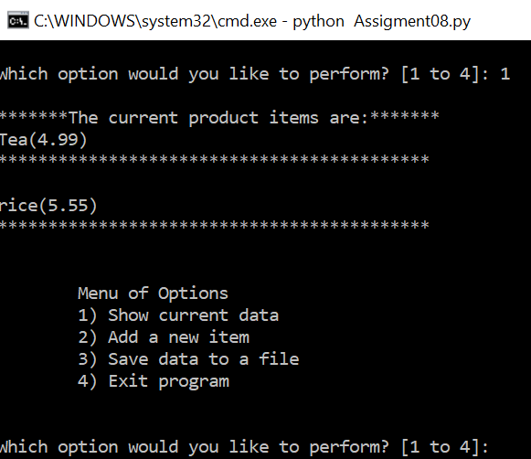

***Figure 6: Command Terminal Testing***

Finally, I checked that the text document was saved in my assignment folder (Figure 7).

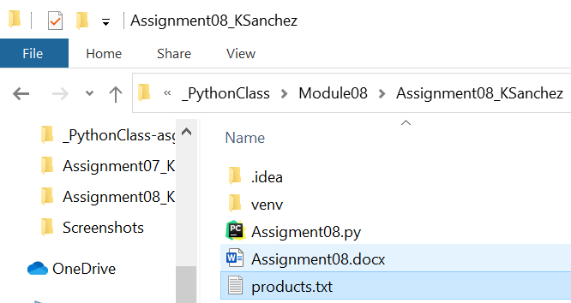

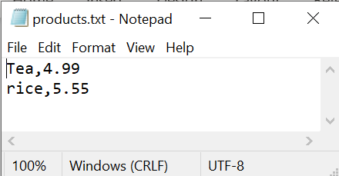

***Figure 7: Verifying Data File Exists***

# Summary

After modifying the starter file and using the assignment answer to complete this assignment, I reflected on what I had learned. I not only gained exposure to objects and classes, but now have a better understanding of how they can be incorporated into a single program. It was difficult to fully understand the content with portions explained in notes or videos, but helps when I can see it applied together. I will keep this in mind for future projects and continue looking for ways to enhance my ability to learn and apply new concepts.