Smart Alignment

EE523: Smart Alignment
Kevin Egedy
Smart alignment passively improves posture by notifying the user’s spine curvature. This product is based on existing uprightpose solution, however it is composed of common devices available through Arduino. Smart Alignment consists of two modes depending on the user’s preferences. Mode 1 will operate in runtime only and collect data for an allowed window, approximately 5 minutes. Mode 2 extends data collection across multiple days for monitoring progress. Ultimately, this design will create a cheap, open-source alternative to Uprightpose.

Uprightpose Uprightpose

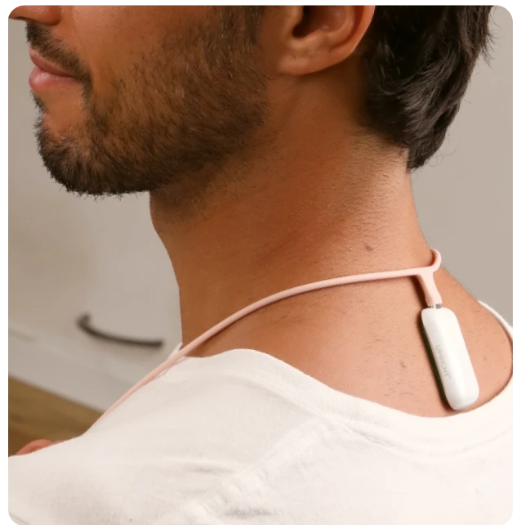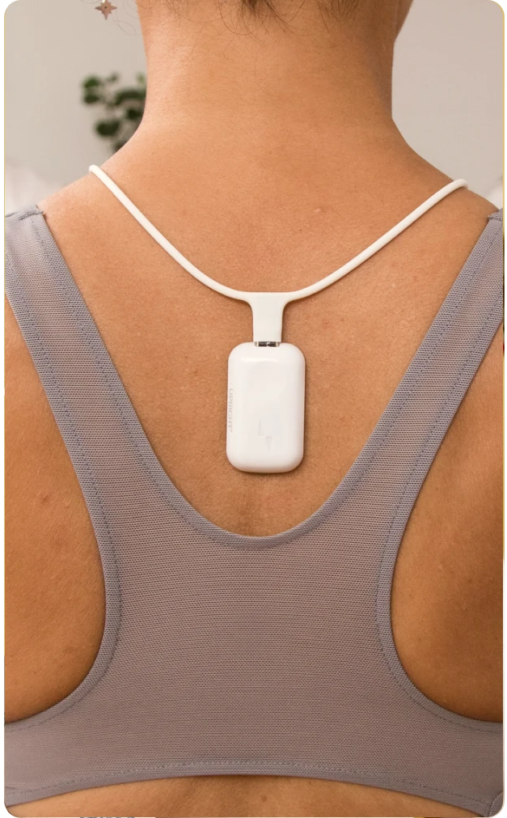

Devices

Arduino Nano 33 BLE
Form Factor | 45 x 18 mm
Sensor | 9 axis inertial measurement unit

I2C OLED Display Module
Form Factor | 38 x 12 mm

Arduino Nano 33 BLE Silicone Case OLED

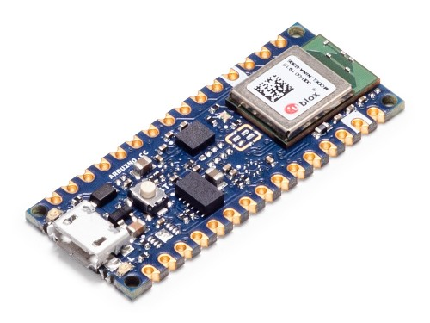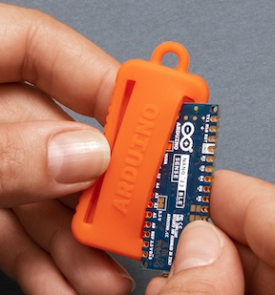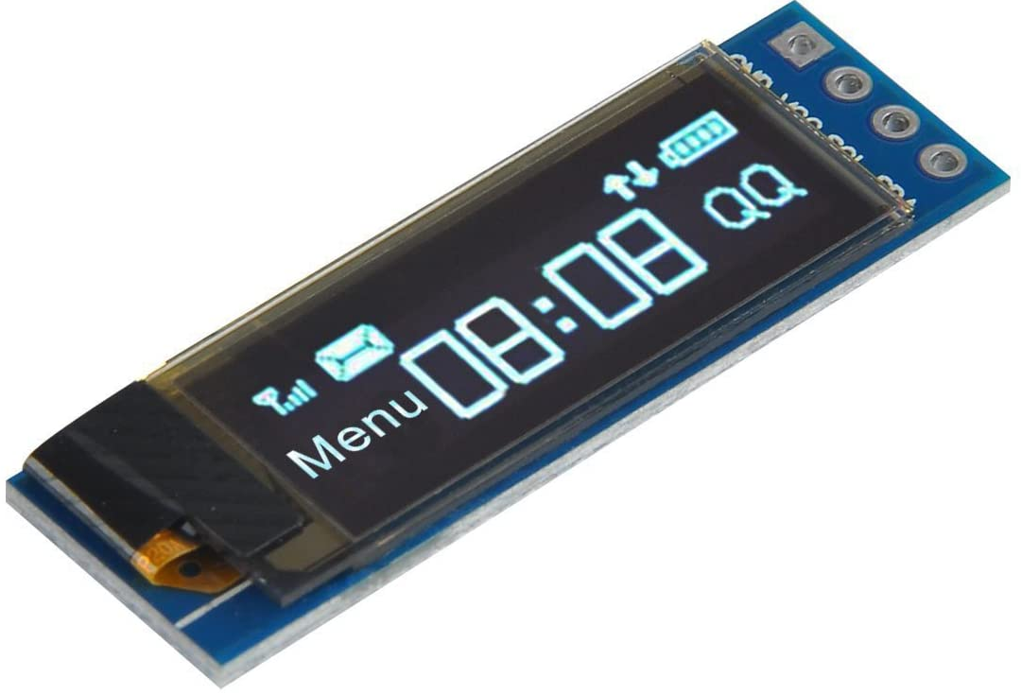

App

Arduino Nano transmits measurements on OLED and to the app via Bluetooth. Main display will consist of a person and a dial indicating the current spine curvature form 0 to 90 degrees. Main display is responsible for mode 1 (runtime only). Additional display shows single day metrics over time and as distribution. Large timeline view includes monthly calendar with daily average stats . Goal is to complete mode 1 functionality and stretch goal is to complete mode 2.

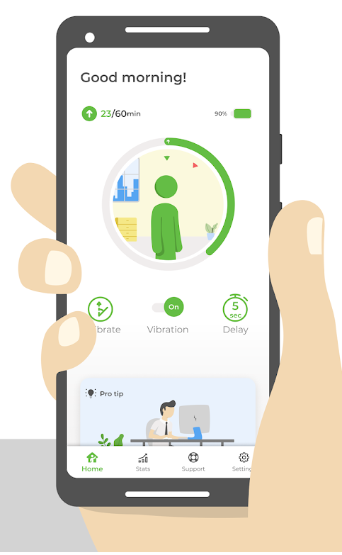

Timeline

TODO | Date
Display IMU on OLED | July 24, 2021
Configure app Bluetooth and storage | July 31, 2021
Display IMU on app (no visuals) | Aug 07, 2021
Create mode 1 screen | Aug 14, 2021

Completed | Date
Purchased all components | July 07, 2021
Layout OLED pin connection | July 09, 2021

Challenges and Obstacles
- Determine power source that balances form factor and longevity. Must provide 3.3V input to Arduino Nano.
- Determine necklace design. The position of the device is critical for accurate measurements.
- Compare different health trackers. Provide graphs/visuals for tracking goals.
- Calculate device lifespan with chosen power source.
- Accumulate data strategically to not waste storage. Also determine maximum number of days to store.
- Determine notification frequency/ summary reports.

