Smart Alignment Device

EE523: Smart Alignment
August 21, 2021
Smart alignment passively improves posture by notifying the user’s spine curvature. This project was inspired by Uprightpose to create an open-source alternative from common devices available through Arduino. For comparison, Smart Alignment device is shown on the left and Uprightpose is on the right. Portable power source design will be focused in next iteration. Batteries will need to balance lifespan and form factor.

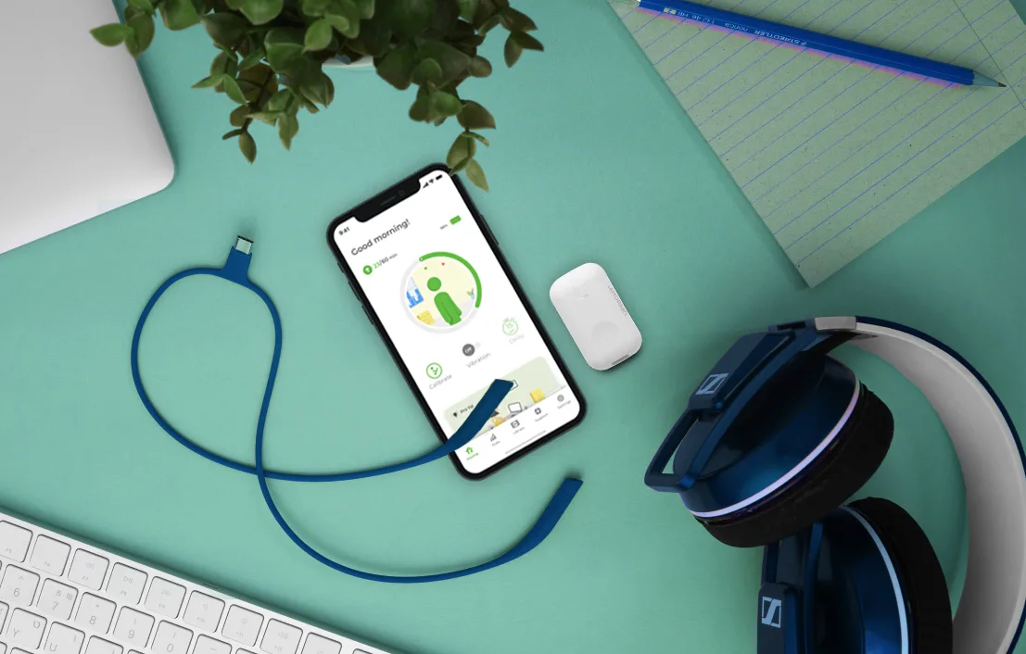
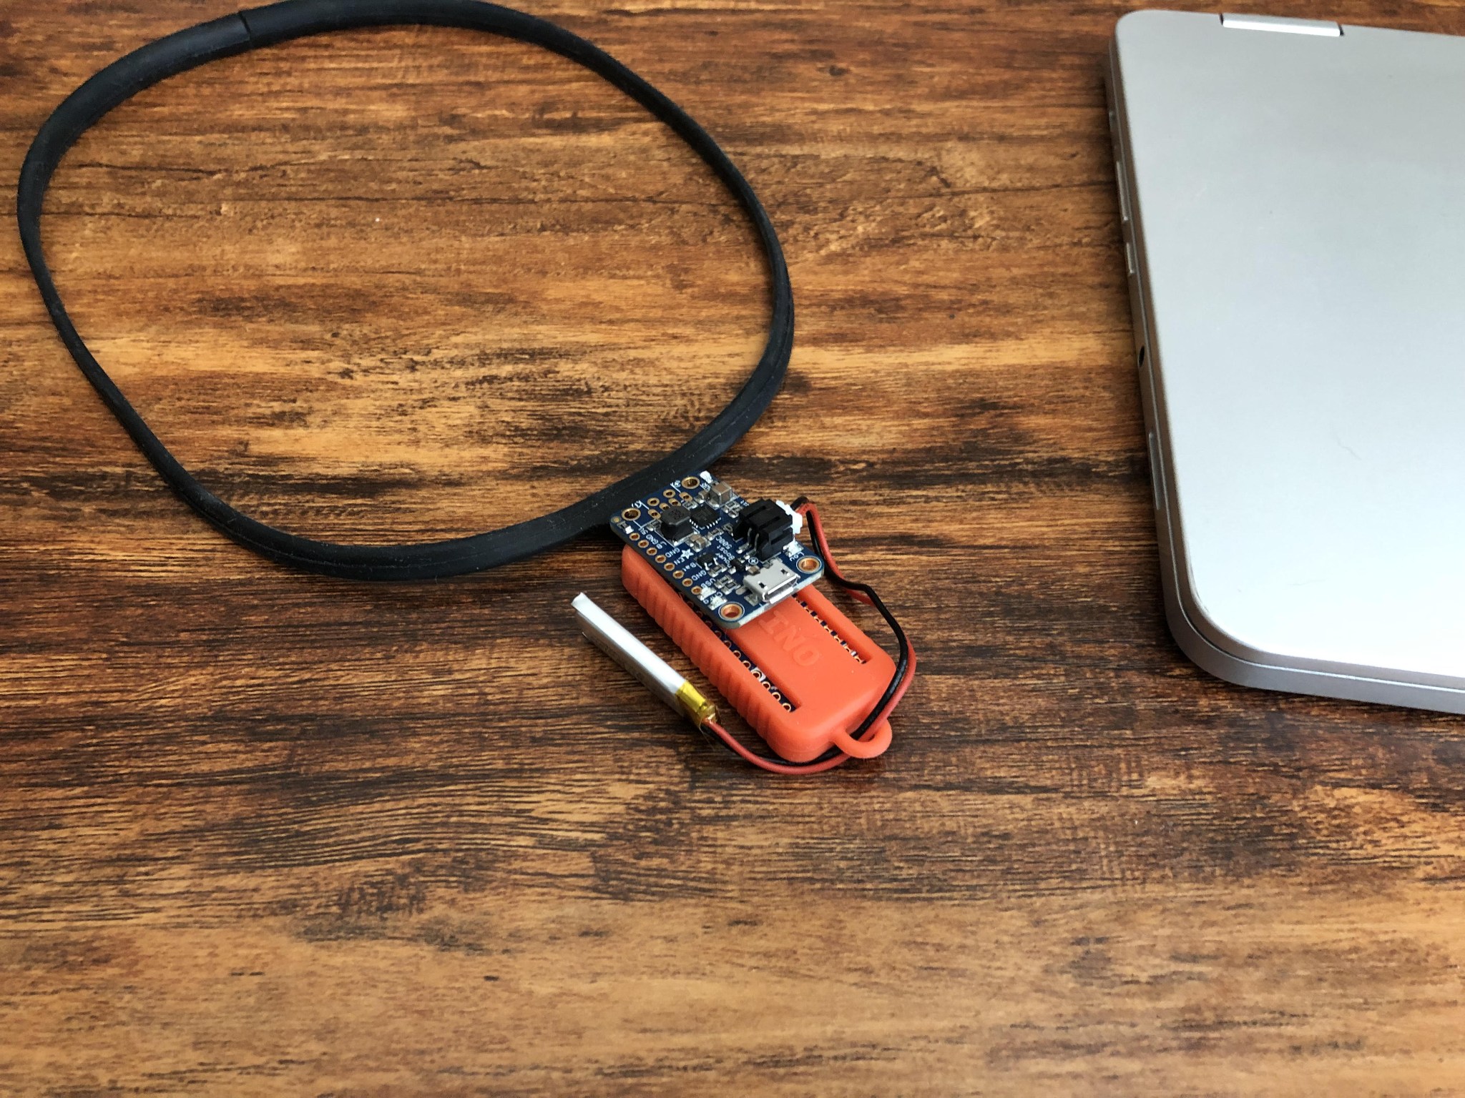
Smart Alignment Uprightpose

Health Trackers

Inspiration form Apple and Uprightpose health apps were used in this design. Specifically, the heart rate tracker and blood glucose views from Apple provide the most valuable information to the user. Additionally, I liked the Upright pie chart for a quick daily summary.

Uprightpose Apple
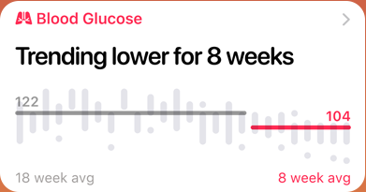
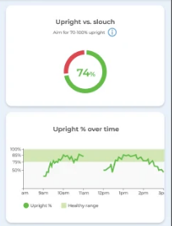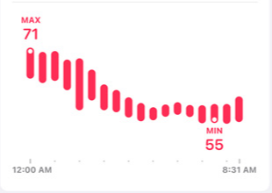

Sensors

The Arduino Nano 33 BLE was chosen for this design for its onboard LSM9DS1 inertial measurement unit (IMU). It provides 9 degrees of information via accelerometer, gyroscope, and magnetometer. The IMU data is passed to an altitude and heading reference system (AHRS) and returns the exact orientation including pitch, yaw, and roll. I chose the Madgwick filter, however the calibration of the sensors is still an issue and worked on by Kris Winer. Smart Alignment implements a simplified filter provided by Feeme Verbeek that mostly uses the accelerometer to find the necessary pitch. The device is orientated so that when it lays flat on the user’s back, the sensor returns -90 degrees.

In addition, a single BLE service and characteristic transmits the pitch of the device. Future work will include a more efficient method for connecting to a central. The current solution scans indefinitely which rapidly depletes the battery charge. The app uses an open source framework provided by punchthrough. They provide a best practice guide for implementing Bluetooth in Android devices.

App

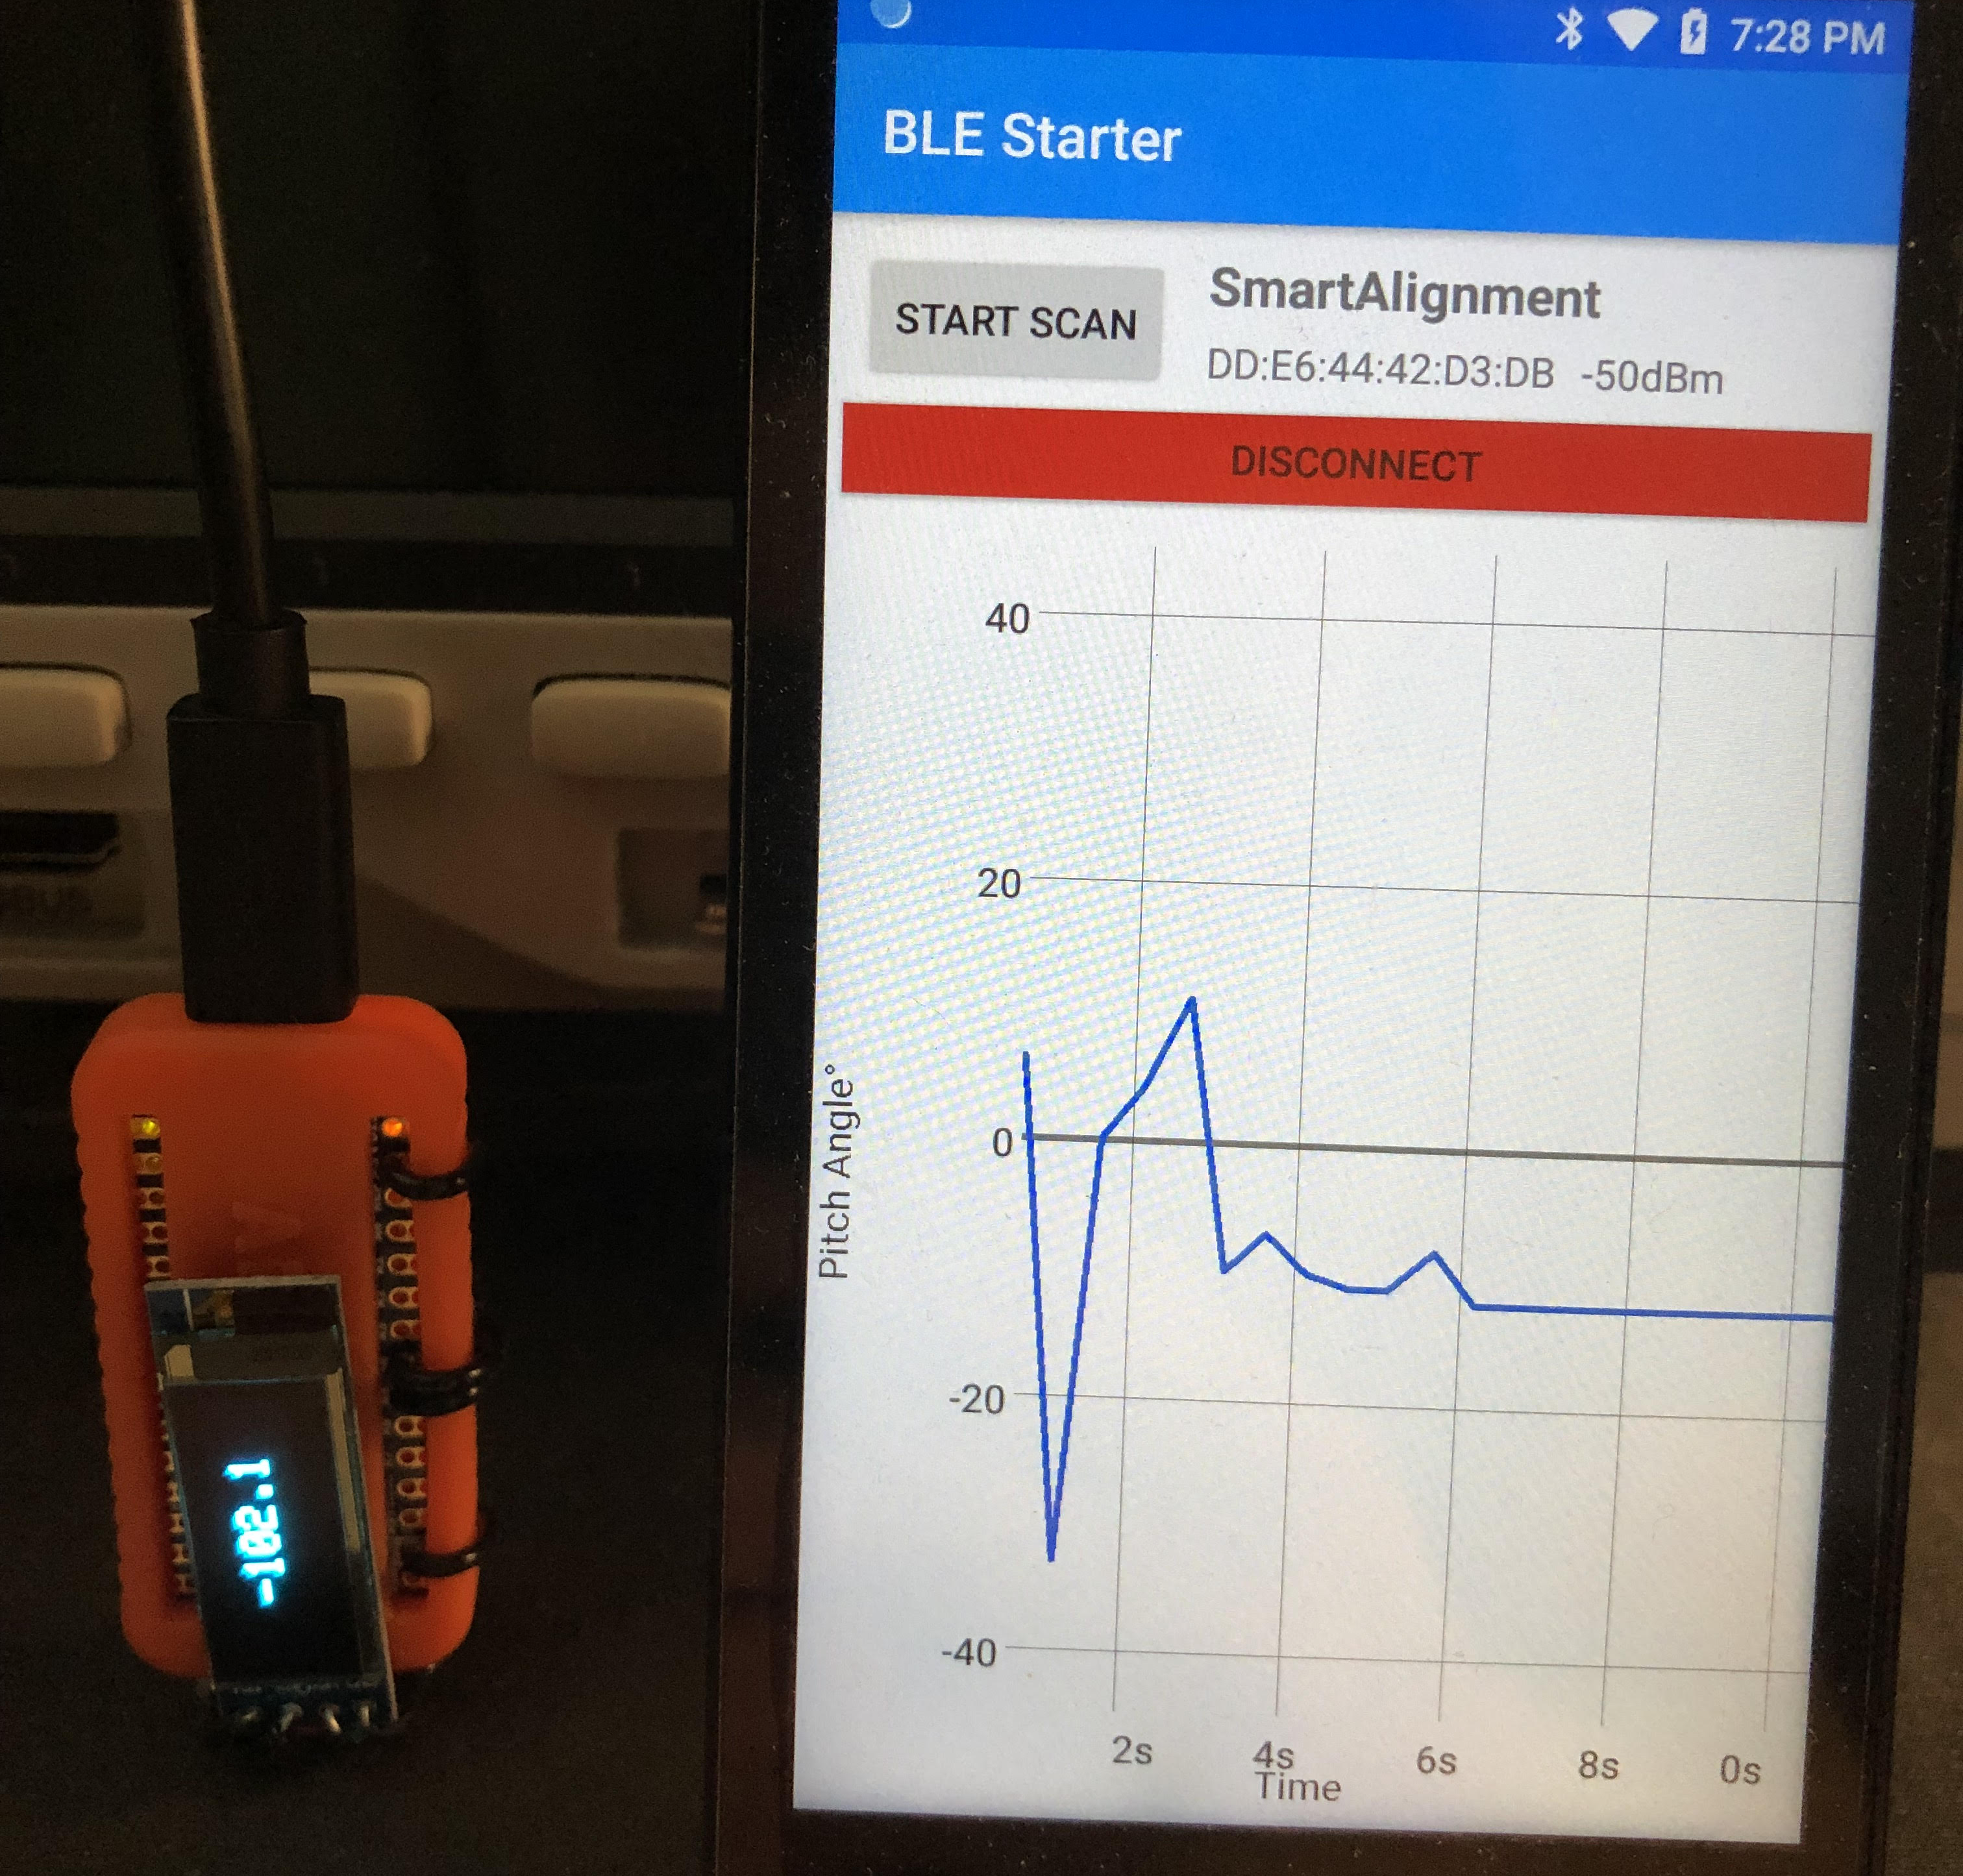
Smart Alignment App

The Smart Alignment solution provides a user the ability to connect to the posture device via Bluetooth low energy and view a time series of the pitch. The app shifts the sensor data such that 0° is defined as perfect posture. Positive degrees on the y-axis refers to a user that is slouching and negative degrees refer to an over arched spine. The next iteration of this solution will implement bar graphs similar to the apple health tracker, as well as provide previous trends and user defined notifications.
Summary

I learned a lot from developing Smart Alignment and from this course. I’m strongly interested in embedded devices and I discovered new opportunities available though mobile apps. I’m excited to work on future iterations of this solution especially in regards to handling large data over multiple days.

Upright Products

Products | Price
Upright Go S | $59.95
Upright Go 2 | $79.95

Smart Alignment Bill of Materials

Products | Price
Arduino Nano 33 BLE | $20.20
Silicone Sleeve | $08.00
5V Lipo Boost | $14.95
Lithium Ion Polymer Battery | $05.95
Total | $43.15

