Smart Alignment Device

EE523: Smart Alignment
Project Update
Objective is to create an open-source alternative to Uprightpose. For comparison, Uprightpose is shown on the right and the Smart Alignment device is on the left. Portable power source and necklace will be in the next iteration. Current design doesn’t leave space for battery supply. Makerfocus provides several batteries that can be adapted to meet the necessary form factor. Most batteries range from 1000-10,000 mAh.

Libraries for design are provided in table.

Component | Library
I2C OLED Display Module | Adafruit_SSD1306
Bluetooth Low Energy (BLE) | ArduinoBLE
Arduino Nano IMU | LSM9DS1

Smart Alignment Uprightpose

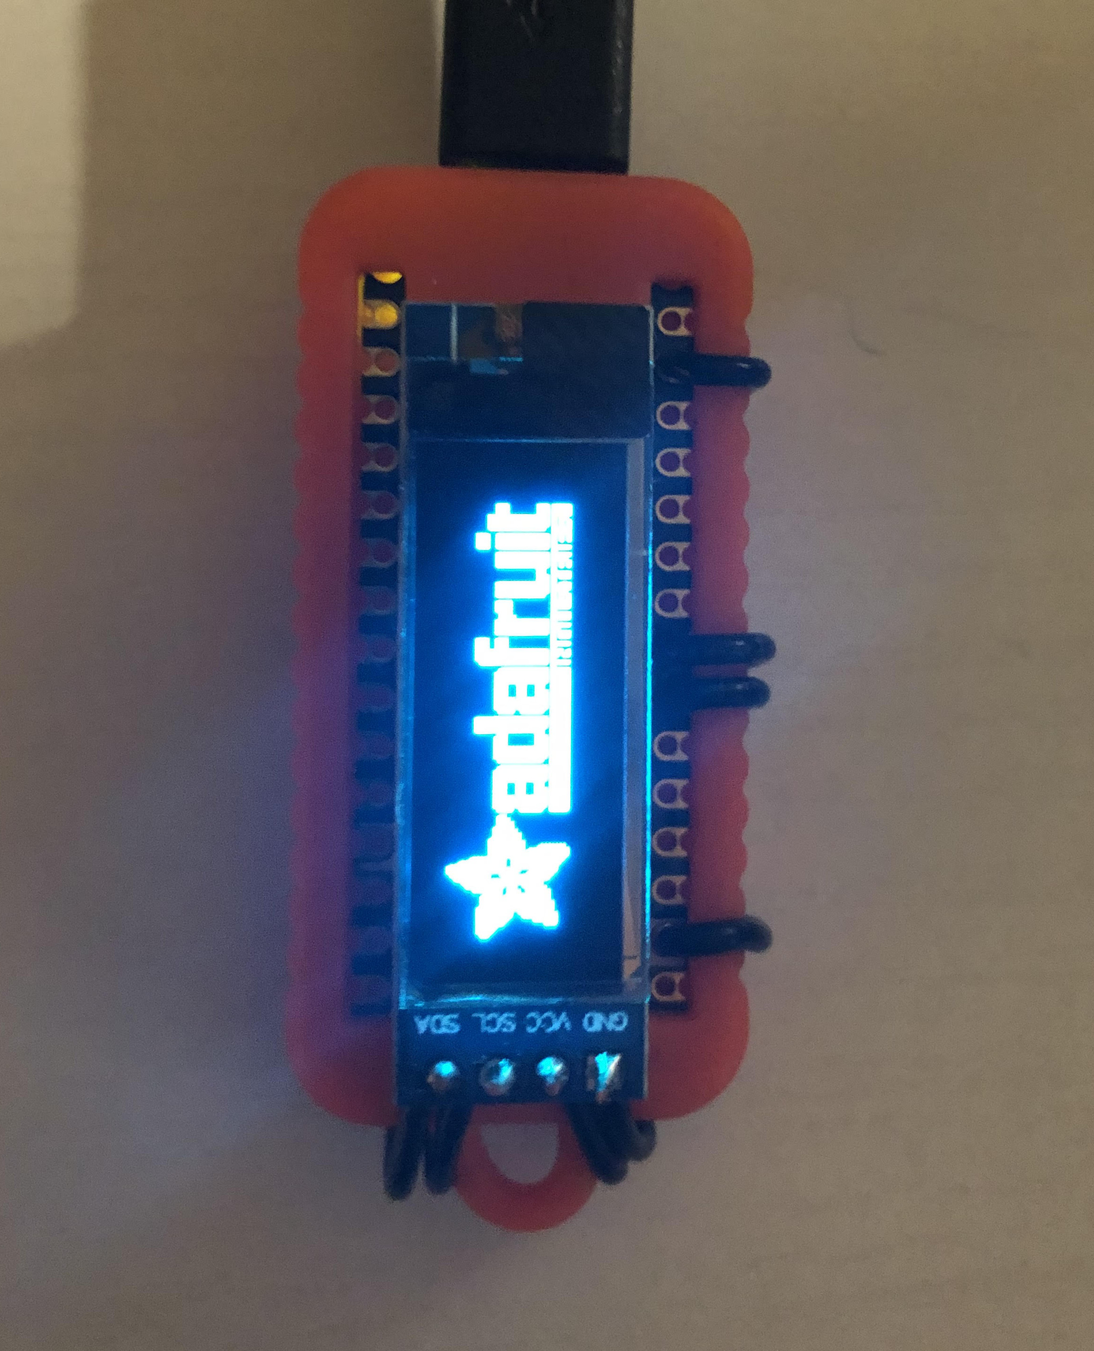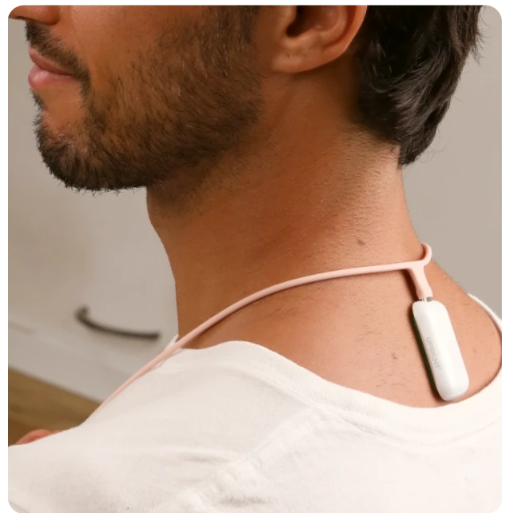

App

Main display will no longer consist of person and spine curvature dial. Some sample images are provided. Platform sketch.io is free and speeds up image creation. *Images don’t currently display curving of the spine. Posture indicator information is not as valuable as metric displays.

Priority is to display accumulated metrics and timeline views. The second assignment will provide experience for necessary graphs. See health trackers section.

(Uprightpose) (SA) (SA) (SA)
Main Display 0° 45° 90°
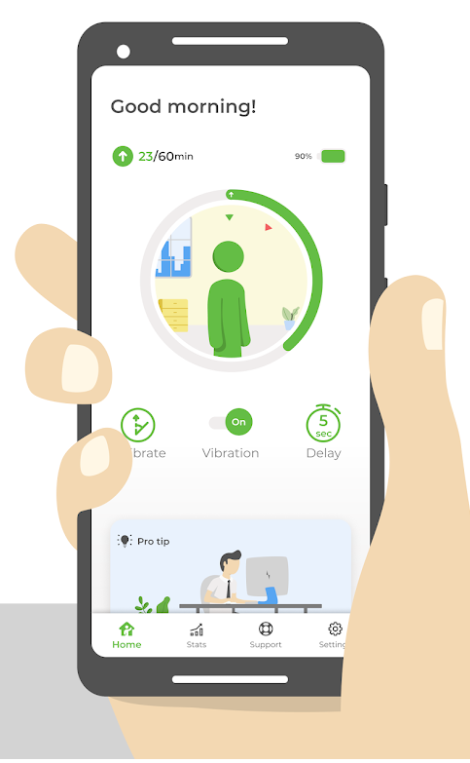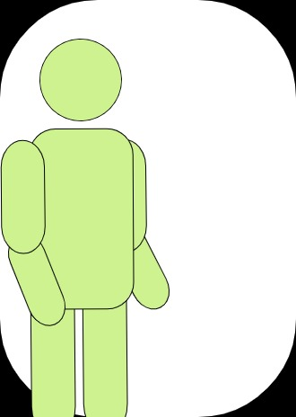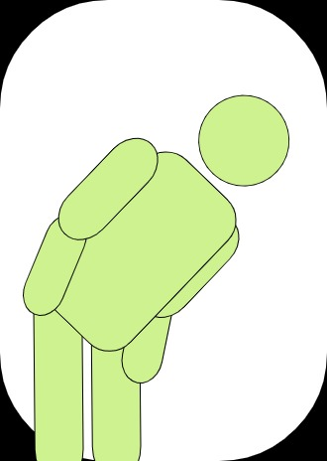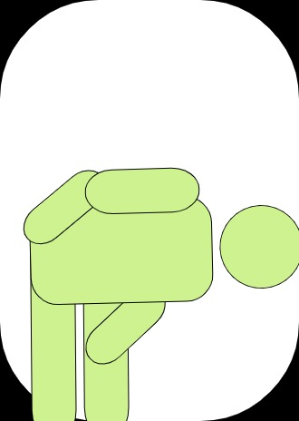
Timeline

TODO | Date
Display IMU on OLED | Aug 07, 2021
Configure app Bluetooth and storage | Aug 07, 2021
Display IMU on app (no visuals) | Aug 14, 2021
Create metric screens | Aug 20, 2021

Completed | Date
Purchased all components | July 07, 2021
Layout OLED pin connection | July 09, 2021
Tested OLED functionality | July 31, 2021
Tested SimpleAccelerometer/SimpleGyro | July 31, 2021

Challenges and Obstacles
- Determine power source that balances form factor and longevity. Must provide 3.3V input to Arduino Nano. Prototype will run from micro USB. *Make sure cable is long enough for demo. Next iteration will remove screen and include portable power source.
- Determine necklace design. The position of the device is critical for accurate measurements. Included in next iteration.

- Compare different health trackers. Provide graphs/visuals for tracking goals. *See health trackers section.
- Accumulate data strategically to not waste storage. Also determine maximum number of days to store. Choose design pattern to store one sensor or actuator value per characteristic, in ASCII encoded values. *Only care about one motion angle.
- Determine notification frequency/ summary reports.

Health Trackers

Uprightpose Apple
